INDOOR AIR QUALITY ASSESSMENT
Sewage Backup Investigation

Department of Children and Families
151 West Boylston Street
Worcester, Massachusetts

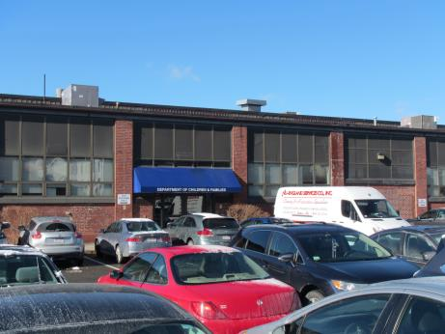

Prepared by:
Massachusetts Department of Public Health
Bureau of Environmental Health
Indoor Air Quality Program
February 2018

BACKGROUND
Building: | Department of Children and Families (DCF)
Address: | 151 West Boylston Street, Worcester
Assessment Contact: | Erin McCabe, Field Operations Manager, Executive Office of Health and Human Services
Reason for Request: | Sewage backup and general IAQ
Date of Assessment: | 2/2/2018
Massachusetts Department of Public Health/Bureau of Environmental Health (MDPH/BEH) Staff Conducting Assessment: | Jason Dustin, Environmental Analyst/Inspector, Indoor Air Quality (IAQ) Program
Date of Building Construction: | 1968
Building Description: | Brick building with flat rubber roof
Windows: | Not openable

METHODS
Please refer to the IAQ Manual and appendices for methods, sampling procedures, and interpretation of results (MDPH, 2015).

IAQ Testing Results
The following is a summary of indoor air testing results (Table 1).
- Carbon dioxide levels were above 800 parts per million (ppm) in most of the areas assessed, indicating inadequate air exchange throughout the space.
- Temperature was within the recommended range of 70°F to 78°F in all areas on the day of assessment.
- Relative humidity was below the recommended range of 40 to 60% in the areas tested which is typical during the heating season.
- Carbon monoxide levels were non-detectable in all areas tested.
- Fine particulate matter (PM2.5) concentrations measured were below the National Ambient Air Quality (NAAQS) limit of 35 μg/m³ in all but one area tested.
- Total volatile organic compounds (TVOCs) were non-detectable in all areas except for one office which had a humidifier with added fragrances running.

RESULTS and DISCUSSION

Ventilation
A heating, ventilating, and air conditioning (HVAC) system has several functions. First it provides heating and, if equipped, cooling. Second, it is a source of fresh air. Finally, an HVAC system will dilute and remove normally occurring indoor environmental pollutants by not only introducing fresh air, but by filtering the airstream and ejecting stale air to the outdoors via exhaust ventilation. Even if an HVAC system is operating as designed, point sources of respiratory irritation may exist and cause symptoms in sensitive individuals.
The DCF space utilizes air handling units (AHUs) to filter and heat or cool the supply air. The conditioned supply air is distributed through supply diffusers located throughout the space. Return air is drawn into exhaust/return vents and brought back to the AHUs.
Many areas assessed had elevated carbon dioxide levels. This is likely due to the fact that all thermostats observed were set on the fan “auto” setting (Picture 1). MDPH recommends these thermostats remain on the fan “on” setting during occupied hours. This is especially important in buildings where there are no openable windows such as in this DCF space. Some occupants may express discomfort with drafts if they are seated directly in the flow of the supply air diffusers. In these cases, either the occupant desk location or the location and direction of the vent should be adjusted rather than limiting the air supply.
In order to have proper ventilation with a mechanical supply and exhaust system, these systems must be balanced to provide an adequate amount of fresh air while removing stale air from a room. It is recommended that existing ventilation systems be re-balanced every five years to ensure adequate air systems function (SMACNA, 1994). It is unknown the last time these systems were balanced.

Microbial/Moisture Concerns
The primary reason for this visit was to assess the conditions in the DCF space following a backup of sewage on the evening of January 29, 2018. According to DCF management and the contractor (Nu England Services, Inc.), the backup occurred at approximately 5pm that evening and the contractor responded within 45 minutes of the beginning of the incident. The contractor used wet/dry vacuums to extract water as well as fans, dehumidifiers, and HEPA scrubbers during the remediation effort (Pictures 2 and 3). The contractor reported that the affected nonporous surfaces were also sanitized. Nonporous surfaces such as concrete may be sanitized and are not conducive to mold growth.
IAQ staff noted that the remediation contractor removed the baseboard coving and flooring tiles in affected areas (Pictures 4 and 5) and planned to remove the gypsum wallboard (GW) from the janitor closet where the sewer ejector pump chamber is located (Picture 6). It was reported by the contractor that the sewage water (i.e., blackwater) did not rise high enough to wet the GW in the restrooms and other walls surrounding the restrooms due to a half inch gap beneath the GW and floor drains in the restrooms intercepting the effluent. However, during the assessment DCF staff revealed pictures that showed many of these areas were in fact impacted by the blackwater. Using a moisture meter, IAQ staff and the contractor tested these GW walls for moisture and found that they were still wet even four days after the sewage backup (Pictures 7 through 9).
It is important to note that porous materials (e.g., GW, carpet, cardboard) that have been in contact with blackwater cannot be effectively cleaned/sanitized or dried and must be disposed of properly.The contractor agreed at that time that these affected GW walls also needed to be cut out 12 inches above the highest affected area and disposed of properly. IAQ staff also stated that the tile walls in the restroom would need to be cut one foot above the high water mark if the backerboard behind the tile wall is GW (Picture 10). Typically the blackwater permeates the grout between the tiles and may impact any GW behind the nonporous tile. It is very likely that the drains in the bathroom were backing up during the event and unable to receive the blackwater since they lead to the same effluent pump chamber. These drains would only be effective if the clog was at the point of a fixture (e.g., toilet) and not in the pump chamber itself.
Property management representatives reported that the sewer ejector pump in the DCF space had tripped the circuit due to blockages around the pumps in the pump chamber. It was further reported that this situation has occurred multiple times in the past 4 years. DCF staff reported that the high water alarm in the pump chamber never sounded prior to the sewer backup but the pumps were very loud before tripping the circuit. It is possible that the pumps and alarm share the same circuit rather than separate circuits as required (Picture 11) or that the float switch in the pump chamber is not functioning properly. In either case, the high water alarm is essentially disabled and ineffective. Further, the pump chamber capacity is a very important consideration. Due to the large building population, the emergency storage capacity of the pump chamber should be inspected so that if the alarm sounds, there should be ample storage volume in the event of system failure. This ejector pump chamber is the sole means of removing sewage from the DCF space since the effluent needs to be pumped up to the street in the current building sewer configuration. When this setup fails, the DCF office is essentially left without working plumbing.
The Mass Lottery has office space in the building as well (Picture 12). It was reported by property management that the building sewer in this section of the building flows by gravity to the sewer line at the street. DCF and lottery officials confirmed reports of multiple backups in this sewer line as well. Unless the backups on the Lottery side of the building were confined to clogs at the fixtures (e.g. toilet), it brings to question the integrity of the building sewer line going out to the street as well as the street sewer line itself. Since there is no ejector pump on this side of the building, it is very likely that there may be recurring problems in the building sewer line (or city line) in this area.
The restrooms near the DCF lobby receive a high number of visitors daily and it was reported that the visitors represent a higher risk for flushing prohibited items down the toilets (e.g., baby wipes, paper towels). IAQ staff noted that there were very thick paper towels and Lysol wipes in these restrooms and there were no electric hand dryers. Hand dryers may substantially reduce the risk of future backups by enabling the removal of the paper towels from these restrooms. Installing signs to prohibit flushing non-flushable items may also deter some visitors from flushing wipes and other items. More focus and action toward preventative solutions is needed since these recurring backups represent a major disruption to DCF staff and clients who are without operable restrooms when the pumps are down and especially after a sewage flooding event in the space.
Water-damaged ceiling tiles were observed in some areas (Picture 13; Table 1). Some of these stains may be from historic leaks while others were reportedly due to active roof leaks reported by occupants.
Some areas were noted to have mini refrigerators placed directly on carpeting. Spills/leaks from these units may lead to microbial colonization and carpet degredation.
Indoor plants were observed in some areas. Plants can be a source of pollen and mold, which can be respiratory irritants to some individuals. Plants should be properly maintained and equipped with drip pans and should be located away from air diffusers to prevent the aerosolization of dirt, pollen and mold.
IAQ staff noted a few areas with personal humidifiers (Picture 14). Although the winter heating season is very dry, these devices are not typically recommended in offices. The water vapor represents a moisture concern since it will condense on surfaces below the dew point temperature and may wet porous building materials. Also, if they are not cleaned regularly according to manufacturer recommendations, these devices may serve as a source of odors and microbial contamination.
During the building envelope inspection, IAQ staff noted many gaps in the brickwork which may allow water infiltration into occupied spaces (Pictures 15 and 16). A number of occupants expressed concerns regarding active leaks especially those situated along the front of the building (Pictures 17 and 18).

Other Concerns
IAQ staff noted several areas with air fresheners, scented cleaning products, and hand sanitizers (Picture 19; Table 1). These products contain volatile organic compounds (VOCs) and other fragrances which may cause irritation of the eyes, nose, and respiratory system. Note that the humidifier shown in Picture 14 was also dispensing a fragrance. The only measureable TVOCs during the assessment were in the vicinity of this device and the PM2.5 results in this area were also much higher than elsewhere.

CONCLUSIONS/RECOMMENDATIONS
In view of the findings at the time of the visit, the following recommendations are made:
- Continue to follow EPA and industry guidelines concerning methods used to remediate buildings that are impacted by sewage (i.e., blackwater). Some of these guideline links include: https://www.epa.gov/sites/production/files/2015-09/documents/floods.pdf and ANSI/IICRC S500 - Standard and Reference Guide for Professional Water Damage Restoration.
- Ensure that all porous items and building materials (e.g., carpet tiles, GW, papers) that were damaged by the backup of blackwater are removed and discarded. This would include wallboard behind tiles in restrooms if it is deemed porous (GW) and not able to be properly sanitized.
- Ensure proper containment strategies are being utilized while work is being performed (e.g., sealed return ducts, depressurization methods) to avoid further contamination.
- Ensure that all nonporous building materials, items, and surfaces impacted are properly disinfected prior to replacing building materials/furnishings.
- Have the building sewer line inspected out to the city sewer line at the street to find any clogs or breaks in the line.
- Have an electrician confirm if the high water alarm float is wired/operating properly. Also ensure that the pumps and the alarm are all on separate circuits back to the main electrical panel so that one tripped circuit does not disable the alternate pump or the high water alarm.
- Consider installing electric hand dryers in restrooms off of the main lobby and removing the paper towels/wipes. Install signs that explicitly prohibit items such as wipes and paper wfrom being flushed down the toilets.
- Implement the suggestion by the property manager of installing an alarm that is triggered by an increase in amperage drawn by the pump(s). If set at the correct amperage, this will send an audible/visual alarm based on a pump that is showing signs of straining due to clogs rather than wait for the pump(s) to trip the circuit and shut down. Property management can then be contacted to perform maintenance before a sewer backup occurs.
- Contact the local plumbing inspector (City of Worcester) to inspect the current ejector system to see if it meets the plumbing code for a commercial application with this building population and emergency capacity.
- If problems persist or code dictates, contact a licensed professional engineer to design a permanent building sewer system that matches the DCF population/client’s needs. The system should remove the risk of recurring sewage backups in the space regardless of the occaisional flushing of prohibited items which may be inevitable due to the high risk cliental and should provide for ample emergency capacity (~24 hours?). Explore re-plumbing building sewer around building to provide for gravity to the Lottery side (should elevation/pitch allow) or installing a high-capacity, multi-compartment pump chamber outside (H 20-rated) to separate out prohibited items prior to the pump chamber and allow for ample emergency backup storage of effluent.
- Fix roof leaks and replace water-damaged ceiling tiles.
- Inspect the building envelope for gaps/cracks in brickwork and problems with flashing. Seal these openings to prevent the infiltration of moisture into occupied spaces.
- Set all thermostats to fan “on” to provide for continuous fresh air exchange during occupied hours. Consider locking these thermostats to prevent tampering. Change supply diffusers (or desk orientation) to direct air flow away from occupants who express discomfort with direct/constant air flow.
- Consider adopting a balancing schedule of every 5 years for all mechanical ventilation systems, as recommended by ventilation industrial standards (SMACNA, 1994).
- Place a waterproof mat/tray under mini fridges that are on carpeting or relocate the units to a room with tile flooring.
- Properly maintain plants, including drip pans, to prevent water damage to porous materials. Plants should also be located away from air diffusers to prevent the aerosolization of dirt, pollen, and mold.
- Reduce or eliminate the use of products containing VOCs (e.g., air fresheners, scented cleaning products, and hand sanitizer).
- Discontinue the use of all humidifiers in the space to reduce the possibility of condensation or microbial colonization. Do not use fragances in humidifiers.
- For buildings in New England, periods of low relative humidity during the winter are often unavoidable. Therefore, scrupulous cleaning practices should be adopted to minimize common indoor air contaminants whose irritant effects can be enhanced when the relative humidity is low. To control for dusts, a high efficiency particulate arrestance (HEPA) filter equipped vacuum cleaner in conjunction with wet wiping of all surfaces is recommended. Avoid the use of feather dusters. Drinking water during the day can help ease some symptoms associated with a dry environment (throat and sinus irritations).
- Refer to resource manual and other related indoor air quality documents located on the MDPH’s website for further building-wide evaluations and advice on maintaining public buildings. These documents are available at http://mass.gov/dph/iaq.

REFERENCES
MDPH. 2015. Massachusetts Department of Public Health. Massachusetts Department of Public Health Indoor Air Quality Manual: Chapters I-III. Available at: http://www.mass.gov/eohhs/gov/departments/dph/programs/environmental-health/exposure-topics/iaq/iaq-manual/.
SMACNA. 1994. HVAC Systems Commissioning Manual. 1st ed. Sheet Metal and Air Conditioning Contractors’ National Association, Inc., Chantilly, VA.
Picture 1
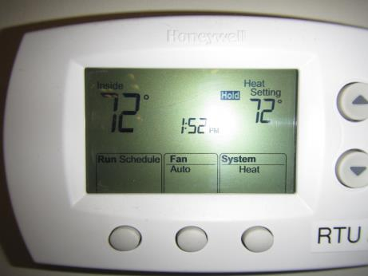
Thermostat showing fan set to “auto” rather than recommended “on” setting
Picture 2
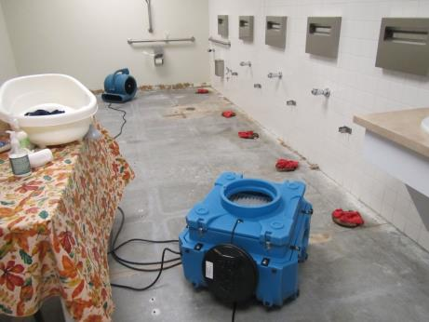
Fan and HEPA scrubber being used during the remediation effort
Picture 3
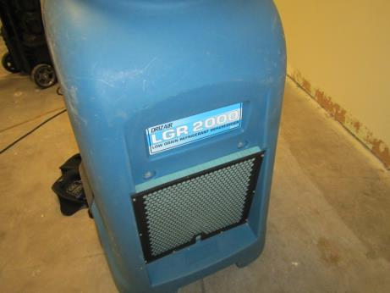
Dehumidifier used during the remediation effort
Picture 4
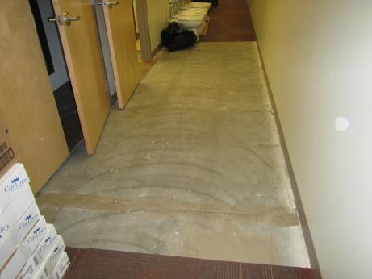
Carpet tiles removed in hall near janitor closet
Picture 5
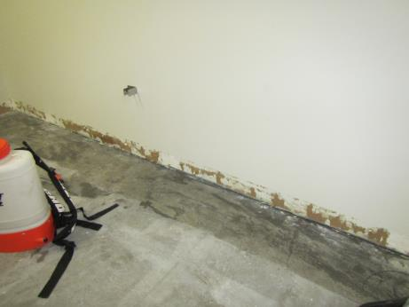
Coving in restroom removed but GW was still in place
Picture 6
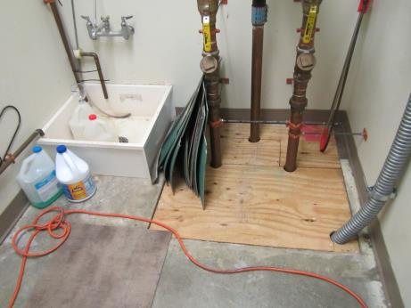
Janitor closet housing sewer ejector pump chamber (GW to be removed)
Picture 7
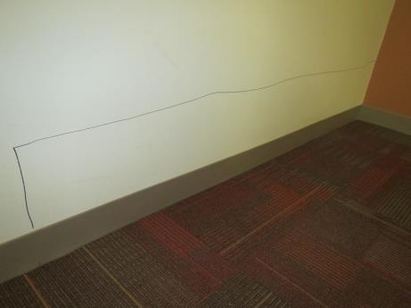
GW behind restrooms found wet during assessment (must be removed)
Picture 8
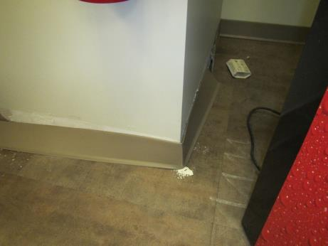
GW behind soda machine in break room found to be wet (must be removed)
Picture 9
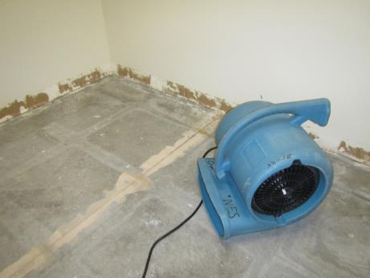
Water-damaged GW in restrooms (must be removed)
Picture 10
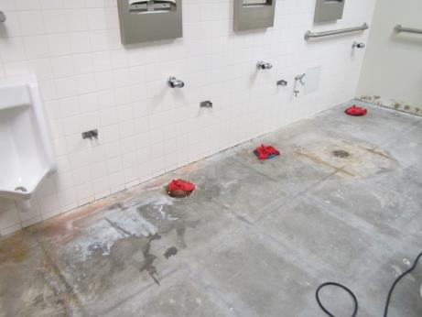
Affected tile walls should be cut 12” above high water mark if GW is backer material
Picture 11
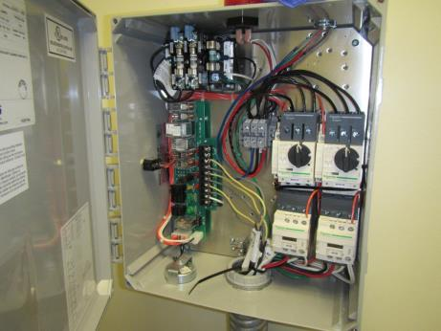
Pumps and alarm should be on separate circuits back to main electric panel

Picture 12
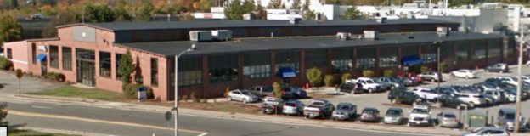
Lottery
DCF
DCF and Lottery locations in the building (Google Maps)

Picture 13
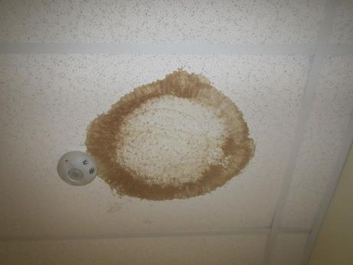
Water-damaged ceiling tile
Picture 14
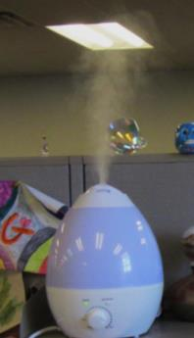
Humidifier in office area
Picture 15
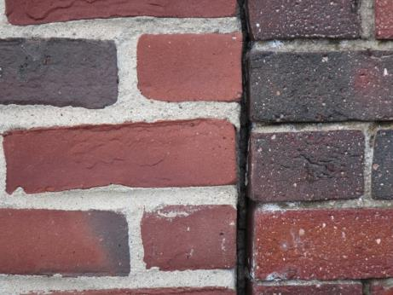
Large gaps in brickwork
Picture 16
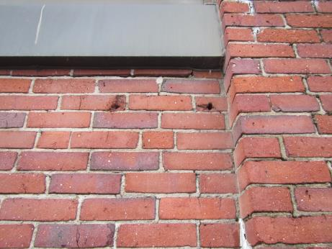
Holes/gaps in brickwork beneath window
Picture 17
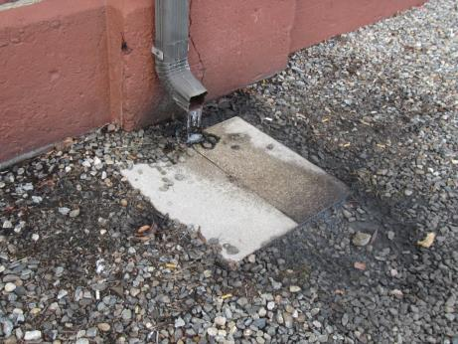
Gutter draining in close proximity to the foundation
Picture 18
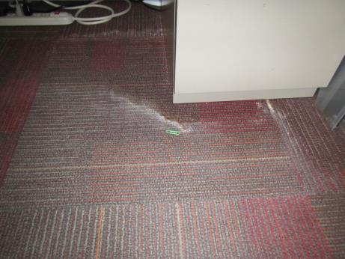
Water-damaged carpet due to infiltration from front of building
Picture 19
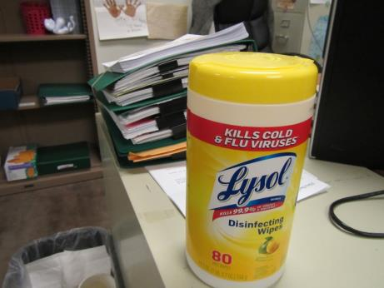
Scented cleaning products (contain VOCs) in use at the office

Location | Carbon  Dioxide  (ppm) | Carbon Monoxide  (ppm) | Temp  (°F) | Relative  Humidity  (%) | PM2.5  (µg/m³) | TVOCs  (ppm) | Occupants  in Room | Windows  Openable | Ventilation |  |  | Remarks
 |  |  |  |  |  |  |  |  | Intake | Exhaust
Background | 372 | ND | 30 | 38 | 15 | ND | - | - | - |  | -
1109 | 667 | ND | 71 | 18 | 3 | ND | 0 | N | Y |  | Y | CP, personal air filter
1020 | 798 | ND | 72 | 20 | 5 | ND | 7 | N | Y |  | Y | Carpet
1108 Break | 795 | ND | 73 | 20 | 17 | ND | 5 | N | Y |  | Y | Popcorn odor
1016 | 807 | ND | 72 | 20 | 7 | ND | 7 | N | Y |  | Y | Carpet, couch
1017 | 966 | ND | 74 | 21 | 5 | ND | 6 | N | Y |  | Y | DEM
1018 | 1091 | ND | 73 | 21 | 4 | ND | 3 | N | Y |  | Y
1019 | 1014 | ND | 75 | 20 | 9 | ND | 3 | N | Y |  | Y | Carpet tile
1201 | 1203 | ND | 74 | 20 | 22 | ND | 3 | N | Y |  | Y | HS
1202 | 1231 | ND | 74 | 20 | 27 | ND | 1 | N | Y |  | Y | Upholstered furniture, HS
1304 open cubes | 1180 | ND | 74 | 20 | 22 | ND | 4 | N | Y |  | Y
Phil’s area- open cubes | 1067 | ND | 74 | 19 | 18 | ND | 5 | N | Y |  | Y
1405 | 862 | ND | 74 | 17 | 6 | ND | 0 | N | Y |  | Y
1403 | 998 | ND | 75 | 20 | 9 | ND | 1 | N | Y |  | Y | HS, personal fan
1802 | 978 | ND | 74 | 18 | 7 | ND | 2 | N | Y |  | Y | DEM
Tara’s area- open cubes | 961 | ND | 73 | 18 | 6 | ND | 2 | N | Y |  | Y | Carpet, AI
Lynn’s area- open cubes | 882 | ND | 74 | 17 | 8 | ND | 5 | N | Y |  | Y
1101 | 864 | ND | 74 | 17 | 6 | ND | 0 | N | Y |  | Y | Personal fan, HS
1102 | 861 | ND | 73 | 17 | 6 | ND | 0 | N | Y |  | Y
Tara F- open cubes | 913 | ND | 74 | 18 | 5 | ND | 6 | N | Y |  | Y
Eilleen- open cubes | 932 | ND | 74 | 18 | 6 | ND | 4 | N | Y |  | Y
1804 | 972 | ND | 74 | 18 | 6 | ND | 0 | N | Y |  | Y | HS
1901 | 925 | ND | 73 | 18 | 4 | ND | 1 | N | Y |  | Y | WD CT
1902 | 1002 | ND | 74 | 19 | 76 | 2.3 | 2 | N | Y |  | Y | Humidifier with fragrance
1903 | 882 | ND | 74 | 20 | 3 | ND | 1 | N | Y |  | Y
1904 | 1134 | ND | 74 | 20 | 5 | ND | 5 | N | Y |  | Y | WD CTs
1905 | 1076 | ND | 74 | 20 | 3 | ND | 2 | N | Y |  | Y | Plant, WD CT
1906 | 919 | ND | 74 | 17 | 3 | ND | 0 | N | Y |  | Y | DEM
1907 | 897 | ND | 74 | 17 | 3 | ND | 3 | N | Y |  | Y | WD CTs
Monique’s area- open cubes | 933 | ND | 74 | 17 | 4 | ND | 3 | N | Y |  | Y
1908 | 783 | ND | 74 | 16 | 17 | ND | 0 | N | Y |  | Y
1909 | 782 | ND | 74 | 17 | 3 | ND | 4 | N | Y |  | Y | WD CTs
1910 | 583 | ND | 73 | 15 | 3 | ND | 2 | N | Y |  | Y
Torrie’s area- open cubes | 765 | ND | 73 | 17 | 5 | ND | 3 | N | Y |  | Y
1103 | 1086 | ND | 73 | 19 | 5 | ND | 3 | N | Y |  | Y | WD carpet, fridge
1805 | 1025 | ND | 74 | 19 | 3 | ND | 1 | N | Y |  | Y | HS, CPs
Unit B- open cubes | 1023 | ND | 74 | 19 | 5 | ND | 4 | N | Y |  | Y | HS
1803 | 1027 | ND | 74 | 19 | 4 | ND | 1 | N | Y |  | Y
Unit C- open cubes | 994 | ND | 74 | 19 | 5 | ND | 3 | N | Y |  | Y | Carpet
1607 | 910 | ND | 73 | 18 | 4 | ND | 0 | N | Y |  | Y | Reports of WD wall, AI, HS
1606 | 944 | ND | 73 | 19 | 5 | ND | 0 | N | Y |  | Y | Mini fridge on carpet, AI
1605 | 936 | ND | 73 | 18 | 6 | ND | 0 | N | Y |  | Y | HS, DEM, AI
1604 | 1159 | ND | 71 | 19 | 4 | ND | 2 | N | Y |  | Y
1603 | 973 | ND | 74 | 18 | 5 | ND | 0 | N | Y |  | Y | DEM, Reed AF
1602 | 950 | ND | 74 | 18 | 2 | ND | 0 | N | Y |  | Y | DEM, AI, CPs
1601 | 1022 | ND | 74 | 19 | 3 | ND | 2 | N | Y |  | Y | Carpet, fridge on carpet
Family Resource-open cubes | 985 | ND | 73 | 19 | 4 | ND | 4 | N | Y |  | Y | HS
1402 | 916 | ND | 73 | 18 | 4 | ND | 0 | N | Y |  | Y | CPs, HS
1404 | 928 | ND | 73 | 17 | 6 | ND | 0 | N | Y |  | Y | DEM, upholstered furniture
Adoption area | 915 | ND | 74 | 17 | 5 | ND | 5 | N | Y |  | Y | HS, AI
Lobby | 788 | ND | 73 | 14 | 4 | ND | 7 | N | Y |  | Y
1001 | 693 | ND | 72 | 14 | 4 | ND | 0 | N | Y |  | Y
1003 | 697 | ND | 72 | 13 | 5 | ND | 0 | N | Y |  | Y
1010 | 1300 | ND | 74 | 22 | 6 | ND | 4 | N | Y |  | Y
1011 | 868 | ND | 74 | 15 | 5 | ND | 0 | N | Y |  | Y
1004 | 1002 | ND | 74 | 16 | 4 | ND | 6 | N | Y |  | Y
1005 | 712 | ND | 73 | 13 | 8 | ND | 0 | N | Y |  | Y
1006 | 644 | ND | 74 | 14 | 5 | ND | 0 | N | Y |  | Y | WD carpet under desk from infiltration at front of bldg.
1014 | 741 | ND | 73 | 14 | 11 | ND | 0 | N | Y |  | Y | AI, dusty/debris, personal air filter on-filter appears dirty
1007 | 765 | ND | 73 | 14 | 4 | ND | 0 | N | Y |  | Y

