WATER DAMAGE INVESTIGATION

Department of Children & Families
Shetland Park Office Complex
45 Congress Street
Salem, Massachusetts

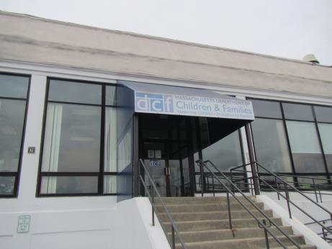

Prepared by:
Massachusetts Department of Public Health
Bureau of Environmental Health
Indoor Air Quality Program
September 2018

BACKGROUND
Building: | Department of Children & Families (DCF)
Address: | 45 Congress Street Salem, MA
Assessment Requested by: | Christian Arrieta-Rodriguez, Site Manager, DCF
Reason for Request: | Water damage and health concerns
Date of Assessment: | September 12, 2018
Massachusetts Department of Public Health/Bureau of Environmental Health (MDPH/BEH) Staff Conducting Assessment: | Jason Dustin, Environmental Analyst/Inspector, Indoor Air Quality (IAQ) Program
Building Description: | The DCF office is located in a one-story building built the 1800’s that was converted to office space. The office contains carpet tile, gypsum wallboard (GW) and suspended ceiling tiles.
Windows: | Windows are not openable.

IAQ Testing Results
Please refer to the IAQ Manual for methods, sampling procedures, and interpretation of results (MDPH, 2015). The following is a summary of testing results (Table 1).
- Carbon Dioxide measurements were below the MDPH recommended guideline of 800 ppm in about 70% of areas tested. Four areas were slightly above this guideline.
- Temperature was within the MDPH recommended range of 70°F to 78°F at the time of assessment.
- Relative humidity was above the MDPH recommended range of 40 to 60% in all areas tested at the time of assessment. This is reflective of the high outdoor humidity level as well as the inability of the older heating, ventilation and air conditioning (HVAC) system to adequately remove moisture in the air.
- Carbon Monoxide levels were non-detectable (ND) in all areas assessed.
- Fine particulate matter (PM2.5) concentrations measured were below the National Ambient Air Quality Standard (NAAQS) level of 35 micrograms per cubic meter (μg/m³) in all areas assessed.
Background and Discussion
The BEH/IAQ Program was asked to examine the DCF office for the presence of water damage with a focus on areas that were affected by chronic HVAC leaks throughout the space as well as some window areas that are affected by wind driven rain infiltration.
According to DCF staff members the HVAC leaks have been occurring for about two years (Picture 1). Occupants reported that ceiling tiles were chronically moistened during the operation of the HVAC system and that the ceiling tiles were badly stained due to long term water damage. Most leaks appeared to occur in the vicinity of markings on the ceiling tile frame which likely indicates the location of HVAC units above the ceiling (Pictures 2 and 3). It was not clear whether the leaks were due to overflows of the drip pans, condensation on the cooling lines, or both. The leaks reportedly resulted in wet carpet tiles as well as some other porous items such as boxes, papers, and personal effects. In some instances occupants reported that property management responded to these leaks by drying the carpets with fans, however, in other incidents, occupants reported that puddles were allowed to gather in the carpet for some time and were visibly soiled (e.g., Intake unit B, Picture 4).
At the time of this assessment, most water-damaged ceiling tiles had been replaced. Leaks will likely persist until these older, inefficient HVAC units are replaced in the coming weeks as reported by Shetland Property management. Although occupants did report musty odors in the past, BEH staff did not observe any visible mold or associated odors during this inspection.
In general, the US Environmental Protection Agency (US EPA) and the American Conference of Governmental Industrial Hygienists (ACGIH) recommends that porous materials (e.g., wallboard, carpeting) be dried with fans and heating within 24 to 48 hours of becoming wet (US EPA, 2008; ACGIH, 1989). If porous materials are not dried within this time frame, mold growth may occur.
Property management staff reported that the carpet tiles in the DCF space had just been cleaned and plans were scheduled to replace carpet tiles in some areas. Carpets should be vacuumed regularly with a high efficiency particulate arrestance (HEPA) filter equipped vacuum cleaner and cleaned annually (or semi-annually in soiled/high traffic areas) in accordance with Institute of Inspection, Cleaning and Restoration Certification (IICRC) recommendations, (IICRC, 2012). Most modern commercial carpet tiles are synthetic and somewhat mold-resistant but if the regular HEPA vacuuming is not completed, the dust/debris itself may serve as a reservoir for microbial growth when given chronically moist conditions. If porous carpeting had become mold-colonized in areas not cleaned and properly dried, they cannot be effectively cleaned therefore must be discarded.
Some occupants that were located near east-facing windows reported that water infiltrates around the window frame regularly following rain events (Picture 5). Some windows in these areas were noted to have dislodged gaskets and/or gaps in the exterior masonry/caulking (Pictures 6 and 7).
Other IAQ Evaluations
Exposure to low levels of total volatile organic compounds (TVOCs) may produce eye, nose, throat, and/or respiratory irritation in some sensitive individuals. To determine if VOCs were present, BEH/IAQ staff examined rooms for products containing VOCs. BEH/IAQ staff observed air fresheners, hand sanitizers, cleaners, and dry erase materials in use within the building (Table 1). All of these products have the potential to be irritants to the eyes, nose, throat, and respiratory system of sensitive individuals. Note that scented products such as air fresheners do not remove odors; they only mask odors with another scent.
BEH/IAQ staff noted the presence of rodent bait boxes in some areas. Rodents and rodent wastes are a common allergen. The principles of Integrated Pest Management (IPM) should be used to reduce incidence of rodents, including removing/containing food and food waste, removing access to water and harborage, and reducing pathways for rodents to travel into and through the building. Note that after rodents have been removed from the building, thorough cleaning is required to remove rodent-related allergens. DCF staff reported that the building is under contract with a pest control company. The document “Integrated Pest Management Kit for Building Managers” provides additional strategies for IPM (MDFA, 1996).
In some areas, items such as books, papers, and other items were on floors, tabletops and desks, which may make it more difficult to clean. Surfaces should be kept clear of items, or items should be moved periodically for thorough cleaning.

Conclusions/Recommendations
Based on the observations made during the visit, the following recommendations are made:
- Continue with plans to install newer HVAC systems that will adequately handle the needs of the DCF space. Inspect drip pans for proper drainage and cooling lines for proper insulation to prevent future leaks.
- Use EPA recommended drying techniques on porous items to fully dry them within 24-48 hours should future leaks occur.
- Discard any porous items (e.g., carpeting, cardboard, ceiling tiles) that were previously water-damaged and not dried within the recommended 24-48 hour time frame.
- Replace any damaged window gaskets and repair gaps around exterior window frames to prevent further water infiltration.
- Regularly HEPA vacuum and clean carpeting in accordance with IICRC recommendations (IICRC, 2012).
- Increase fresh air supply to air handling units serving areas shown to have slightly elevated carbon dioxide readings in Table 1.
- Continue to operate HVAC system with thermostat set to fan “on” (continuous) mode vs “auto” to facilitate air exchange and assist drying.
- Reduce the use of VOC-containing cleaners and sanitizers and avoid the use of air fresheners and scented candles.
- Use the principles of IPM to reduce pest issues in the building, including the sealing of pathways and reduction in sources of food and harborage. Consult “Integrated Pest Management Kit For Building Managers” (MDFA, 1996), http://www.mass.gov/eea/docs/agr/pesticides/publications/ipm-kit-for-bldg-mgrs.pdf.
- For more information on water damage/mold refer to the US EPA’s “Mold Remediation in Schools and Commercial Buildings”. Available at: http://www.epa.gov/mold/mold-remediation-schools-and-commercial-buildings-guide.
- Refer to resource manuals and other related IAQ documents for further building-wide evaluations and advice on maintaining public buildings. Copies of these materials are located on the MDPH’s website: http://mass.gov/dph/iaq.

REFERENCES
ACGIH. 1989. Guidelines for the Assessment of Bioaerosols in the Indoor Environment. American Conference of Governmental Industrial Hygienists, Cincinnati, OH.
IICRC. 2012. Institute of Inspection, Cleaning and Restoration Certification. Carpet Cleaning: FAQ.
MDFA. 1996. Integrated Pest Management Kit for Building Managers. Massachusetts Department of Food and Agriculture, Pesticide Bureau, Boston, MA.
MDPH. 2015. Massachusetts Department of Public Health. “Indoor Air Quality Manual: Chapters I-III”. Available at: http://www.mass.gov/eohhs/gov/departments/dph/programs/environmental-health/exposure-topics/iaq/iaq-manual/.
US EPA. 2008. Mold Remediation in Schools and Commercial Buildings. US Environmental Protection Agency, Office of Air and Radiation, Indoor Environments Division, Washington, D.C. EPA 402-K-01-001. http://www.epa.gov/mold/mold-remediation-schools-and-commercial-buildings-guide.
Picture 1
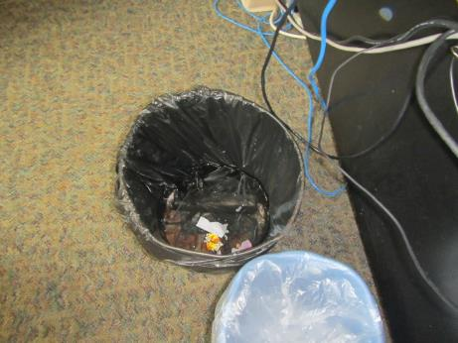
Trash barrel being used to capture leaks from above ceiling tiles
Picture 2
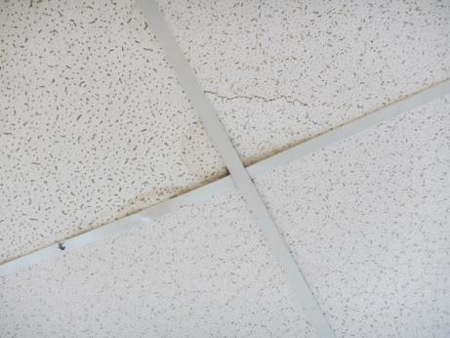
Water-stained ceiling tiles that were recently replaced (note marking on frame)
Picture 3
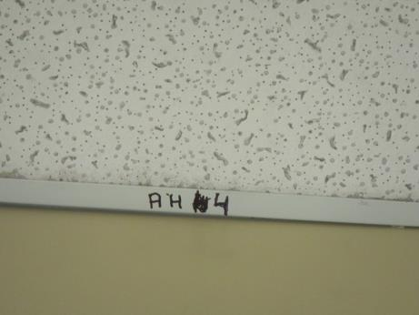
Marking on ceiling tile frame (for AHU) in vicinity of an active leak
Picture 4
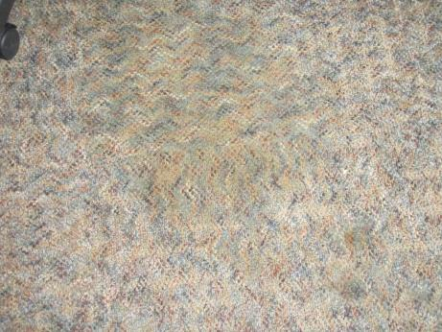
Water-damaged/soiled carpet tiles
Picture 5
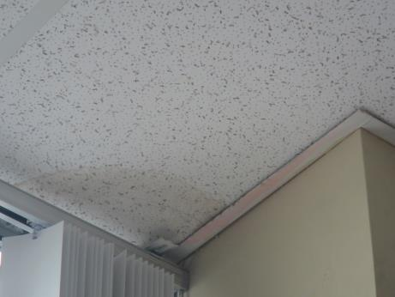
Water-damaged ceiling tile adjacent to window
Picture 6
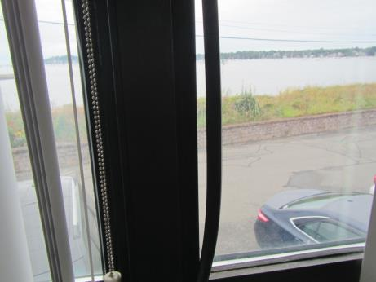
Window gasket dislodged in area of leaks (arrow)
Picture 7
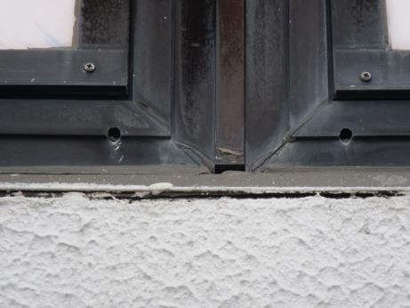
Gaps in stucco and caulking around exterior of window frames

Location | Carbon  Dioxide  (ppm) | Carbon Monoxide  (ppm) | Temp  (°F) | Relative  Humidity  (%) | PM2.5  (µg/m³) | Occupants  in Room | Windows  Openable | Ventilation |  | Remarks
 |  |  |  |  |  |  |  | Supply | Exhaust
Background | 442 | ND | 71 | 85 | 24 | - | - | - | - | Overcast, humid
Clerks | 679 | ND | 75 | 73 | 15 | 2 | Y | Y | Y | Window leaks, AI, carpet tile soiled in corner
Resolution | 694 | ND | 75 | 73 | 15 | 0 | Y | Y | N | WD window sill, DEM, carpet
Christian | 701 | ND | 74 | 72 | 15 | 1 | Y | Y | N | Exhaust vents located in hall
Intake unit A | 733 | ND | 75 | 71 | 14 | 2 | Y | Y | Y | PF, AI, HS, DEM, chronic WD CTs reports
Intake unit B | 756 | ND | 76 | 69 | 16 | 4 | Y | Y | Y | Plants, WD carpet/soiled, CPs
Intake unit C | 773 | ND | 76 | 69 | 18 | 1 | Y | Y | Y | Window leaks, WD carpet
Unit C (corner) | 859 | ND | 77 | 67 | 20 | 3 | Y | Y | Y | WD carpet, window seal leaks
Family resource | 674 | ND | 76 | 71 | 16 | 7 | Y | Y | Y | WD Carpet from HVAC leaks, AI, plants, DEM
Open desks | 680 | ND | 76 | 72 | 14 | 2 | N | Y | Y | PC, AF
Legal | 760 | ND | 76 | 74 | 15 | 2 | N | Y | N | AI
Intake D | 832 | ND | 75 | 66 | 15 | 4 | N | Y | Y | AI, AF, mini fridge on carpet
Rear hall | 852 | ND | 75 | 64 | 15 | 3 | N | Y | Y
Office across from server room | 857 | ND | 76 | 65 | 17 | 1 | N | Y | N | WD gypsum wallboard from HVAC leaks above, carpet

