WATER DAMAGE INVESTIGATION

Department of Children and Families
1 Washington Street
Mill River Place, Suite 21
Taunton, Massachusetts

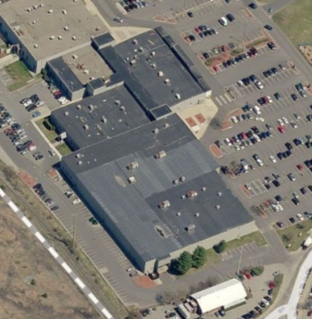

Prepared by:
Massachusetts Department of Public Health
Bureau of Environmental Health
Indoor Air Quality Program
March 2017

Executive Summary

This water damage investigation was requested by union personnel via the Executive Office of Health & Human Services (EOHHS). At the time of the assessment, roof leaks were repaired, water-damaged ceiling tiles were replaced and no further leaks/damage was reported or observed.

BACKGROUND
Building: | Department of Children and Families (DCF)
Address: | 1 Washington Street, Mill River Place, Suite 21, Taunton
Assessment Requested by: | Sharlene Sharif, Field Operations Unit, EOHHS
Reason for Request: | Mold/water damage concerns
Date of Assessment: | February 28, 2017
Massachusetts Department of Public Health/Bureau of Environmental Health (MDPH/BEH) Staff Conducting Assessment: | Cory Holmes, Environmental Analyst/Inspector, Indoor Air Quality (IAQ) Program

Background and Discussion
It was reported via EOHHS that DCF staff had concerns regarding possible mold growth/lingering water damage due to roof leaks that occurred during the last week of January 2017. Two areas experienced water-damaged ceiling tiles; the Investigations Unit and Ongoing Unit B. No other wet building materials were reported (e.g., carpet, walls). According to Area Director, Joseph Pacheco and Assistant Facility Manager, Jeanie Ydiarte, a roofing contractor was contacted the first week in February and the contractor examined the roof membrane and found and repaired several breaches (Appendix A). Water-damaged ceiling tiles were replaced, with the exception of one in Ongoing Unit B, which is difficult to change because it surrounds components of the fire suppression system (Picture 1).
BEH/IAQ staff gained access to the ceiling plenum in these areas to observe conditions; no evidence of current water damage or visible mold growth was observed. The above-plenum space is a large open area ~15-20 feet high, which facilitates drying. In addition, the space consists of metal and other non-porous building components (corrugated metal ceiling, iron pipes, metal supports, wiring etc.), which are not conducive to mold growth (Pictures 2 and 3). Finally, moisture testing of the stained tile in Ongoing Unit B was conducted and the tile was found to be dry at the time of assessment.
The US Environmental Protection Agency (US EPA) and the American Conference of Governmental Industrial Hygienists (ACGIH) recommends that porous materials be dried with fans and heating within 24 to 48 hours of becoming wet (US EPA, 2008; ACGIH, 1989). If porous materials (e.g., cardboard, paper) are not dried within this time frame, mold growth may occur.

Conclusions/Recommendations
Based on the observations made during the visit, the following recommendations are made:
- When the opportunity exits (e.g., fire alarm testing), change water-damaged ceiling tile in Ongoing Unit B.
- Continue to monitor for any additional leaks, if leaks reoccur contact building management for prompt remediation.

REFERENCES
ACGIH. 1989. Guidelines for the Assessment of Bioaerosols in the Indoor Environment. American Conference of Governmental Industrial Hygienists, Cincinnati, OH.
US EPA. 2008. Mold Remediation in Schools and Commercial Buildings. US Environmental Protection Agency, Office of Air and Radiation, Indoor Environments Division, Washington, D.C. EPA 402-K-01-001. http://www.epa.gov/mold/mold-remediation-schools-and-commercial-buildings-guide.
Picture 1

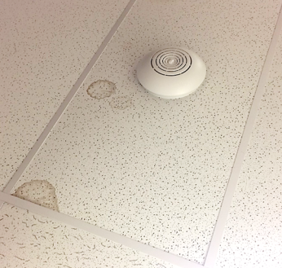

Water-damaged ceiling tile surrounding fire equipment in Ongoing Unit B

Picture 2
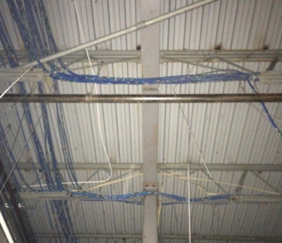

Metal building components above ceiling tile system

Picture 3

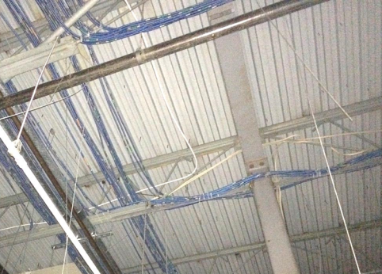

Metal building components above ceiling tile system

Roof Repair Work Order and Pictures
Taunton DCF, 1 Washington St, Suite 21

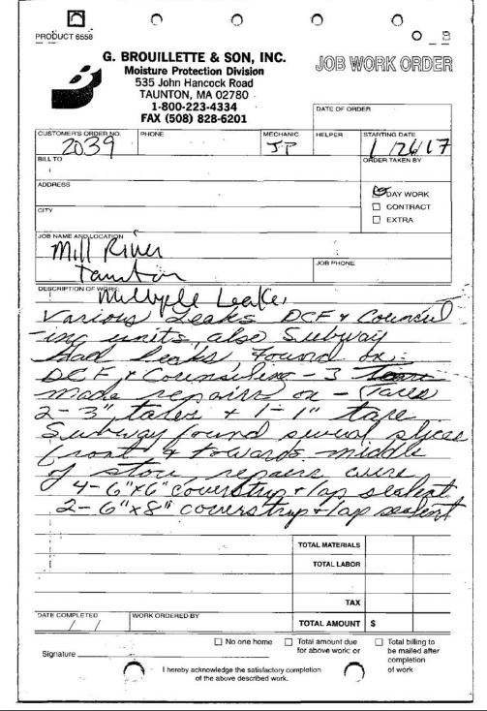
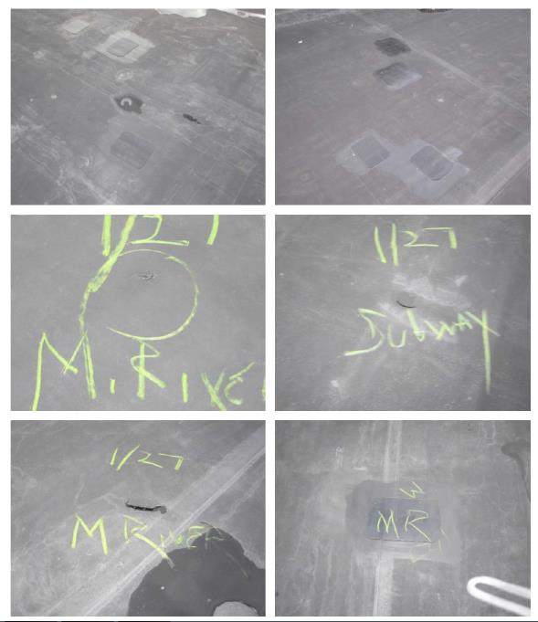
Pictures courtesy of Assistant Facility Manager, Jeanie Ydiarte, Facility Management Group Inc.

