# 

**INDOOR AIR QUALITY**

**ASSESSMENT**

**Department of Children and Families**

**112 Industry Avenue**

**Springfield, MA**

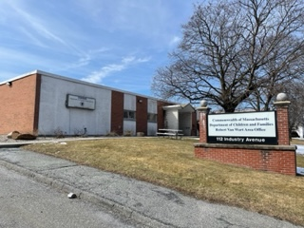

Prepared by:

Massachusetts Department of Public Health

Bureau of Environmental Health

Indoor Air Quality Program

April 2022

# BACKGROUND

|  |  |
| --- | --- |
| Building: | Department of Children and Families (DCF) |
| Address: | 112 Industry Avenue, Springfield, Massachusetts |
| Assessment Requested by: | Pedro Batista, Project Coordinator, Executive Office of Health and Human Services (EOHHS) |
| Reason for Request: | Reports of odors associated with natural gas, general IAQ issues, and rodents |
| Date of Assessment: | March 10, 2022 |
| Massachusetts Department of Public Health/Bureau of Environmental Health (MDPH/BEH) Staff Conducting Assessment: | Mike Feeney, Director, Indoor Air Quality (IAQ) Program and Stefanie Santora, Environmental Analyst, IAQ Program |
| Building Description: | The DCF Center is located in a one-story building that was completely remodeled into offices. The DCF occupies space in the front of the building, including offices, workstations, storage, and meeting rooms. |
| Windows: | Not openable |

**METHODS**

Please refer to the IAQ Manual for methods, sampling procedures, and interpretation of results (MDPH, 2015).

**RESULTS AND DISCUSSION**

The following is a summary of indoor air testing results (Table 1).

* ***Carbon dioxide levels*** were below 800 parts per million (ppm) in all areas indicating adequate fresh air in the space for the occupancy at the time of assessment.
* ***Temperature*** was within the recommended range of 70°F to 78°F in almost all areas assessed.
* ***Relative humidity*** was below the MDPH recommended range of 40 to 60% in all occupied areas. A sensation of dryness and irritation is common in a low relative humidity environment. Low relative humidity is a very common problem during the heating season in the northeast part of the United States.
* ***Carbon monoxide*** levels were equal to or less than 1 ppm in the areas surveyed, with the exception of two areas. Outdoor measurements upwind from the DCF Center were 2 ppm in the afternoon. It is likely the products of combustion from adjacent buildings and vehicle traffic were held in place low to the ground by temperature inversion (EB, unknown), which was drawn into the building by the rooftop air handling units. This unusual condition would only be present during temperature inversion events and certain wind conditions.
* ***Fine particulate matter (PM2.5)*** concentrations measured were below the National Ambient Air Quality Standard (NAAQS) level of 35 μg/m3 in all areas assessed.

## Ventilation

Fresh air is provided by rooftop air-handling units (AHUs). Fresh air is drawn into the AHUs through a bank of filters, heated or cooled, and delivered to occupied areas via ducted supply diffusers. Return air is drawn into ceiling-mounted vents and ducted back to the rooftop AHUs. Some offices are designed to have supply vents and passive exhaust vents; the positive pressure created by supply ventilation aids in the removal of stale air from these areas.

AHUs are controlled by thermostats, which have fan settings of “on” and “auto”. The automatic setting on the thermostat activates the system at a preset temperature. Once that temperature is measured by the thermostat, the HVAC system is deactivated. Therefore, no mechanical ventilation is provided until the thermostat reactivates the system. The BEH/IAQ program recommends that thermostats be set to “on” rather than “auto” to provide continuous ventilation during occupied periods.

One of the reasons for this visit was reports of a gas odor. At the time of this assessment, a rooftop AHU believed to be the source of the gas odor was deactivated. No gas odor was noted by IAQ staff. Although one AHU was off at the time of the assessment, due to reduced occupancy of the building at the time of this assessment, provision of fresh air by the working HVAC system would be considered adequate.

In order to have proper ventilation with a mechanical supply and exhaust system, the system must be balanced to provide an adequate amount of fresh air to the interior of a room while removing stale air from the room. It is recommended that HVAC systems be rebalanced every five years to ensure adequate air systems function (SMACNA, 1994). It was reported that the system was balanced prior to occupancy in 2011.

## Microbial/Moisture Concerns

Water-stained ceiling tiles were noted in several areas (Table 1). No other signs of water damage or water infiltration were noted during the visit. Water-stained ceiling tiles indicate a leak from the plumbing system, HVAC system, or building envelope. They should be replaced, and the area cleaned, once the leak has been repaired.

## Gas Odor

IAQ staff examined the area where a gas odor was reported and did not detect any gas. Natural gas delivered to homes and businesses has an odorant, a material with a strong and distinctive odor, added to it to make it easy to detect leaks. The additive has a low odor threshold, meaning that the material can be detected by most individuals in extremely small amounts. DCF and IAQ, staff as well as the EOHHS representative, could not detect any gas odor on the day of the assessment, including in the areas where odors had been reported previously. DCF staff reported that the gas odor had not been detected since the AHU identified as the possible source was deactivated.

## Other Issues

Signs of rodents were noted in the kitchen area. In the experience of the IAQ Program, rodents and other pests tend to increase in spaces due to:

* an abundance of unsecured food,
* locations for rodents to hide and nest (harborages),
* occupant traffic/occupancy is reduced for extended periods of time.

IAQ staff noted a number of attractants for rodents, including:

* poorly cleaned microwaves and toaster ovens in the kitchen,
* food residue on and near workstations from occupants eating at their desks,
* presence of materials that may use glues containing fatty material, such as cardboard boxes and bound books,
* the likely presence of food stored inside desks in non-airtight containers

Rodent harborages were noted throughout the occupied spaces (Picture 1). Harborages can include paper piles, cardboard boxes, and other materials. In order to reduce rodents in a building, the elimination of harborages including materials stored on floors and on other flat surfaces is necessary.

Rodent infestation can result in IAQ-related symptoms due to materials in their wastes. Mouse urine contains a protein that is a known sensitizer (US EPA, 1992). A sensitizer is a material that can produce symptoms (e.g., running nose or skin rashes) in sensitive individuals after repeated exposure. To eliminate exposure to allergens, rodents must be removed from the building. Please note that removal, even after cleaning, may not provide immediate relief since allergens can exist in the interior for several months after rodents are eliminated (Burge, 1995). Once the infestation is eliminated, a combination of cleaning and increased ventilation and filtration should serve to reduce allergens associated with rodents.

# CONCLUSIONS AND RECOMMENDATIONS

As reported by EOHHS staff, the landlord of this building deactivated the AHU that was identified as the source of the gas odor, and this appeared to have eliminated the odor. The landlord has reportedly ordered a replacement for the deactivated unit. Based on air testing, the building appears to provide adequate fresh air supply with the current building occupancy at the time of this assessment. If building occupancy were to increase, it is expected that carbon dioxide levels will increase and temperature control may become more difficult.

In view of the findings at the time of the visit, the following recommendations are provided:

## Ventilation recommendations

1. Monitor the temperature in the area serviced the deactivated AHU.
2. If necessary, use fans to direct air from the areas with activated AHUs into the area with the disabled AHU temporarily and as needed. Particular attention should be given to this location when outdoor air temperatures exceed 80°F. Discontinue fan use once repairs/replacement are completed.
3. Ensure thermostats are set to have the fan on continuously during occupancy.
4. Consider adopting a balancing schedule of every 5 years for all mechanical ventilation systems, as recommended by ventilation industrial standards (SMACNA, 1994).
5. Change filters for AHUs in accordance with the manufacturer’s instructions or more frequently if needed.
6. For buildings in New England, periods of low relative humidity during the winter are often unavoidable. Therefore, scrupulous cleaning practices should be adopted to minimize common indoor air contaminants whose irritant effects can be enhanced when the relative humidity is low. To control for dusts, a high efficiency particulate arrestance (HEPA) filter equipped vacuum cleaner in conjunction with wet wiping of all surfaces is recommended. Avoid the use of feather dusters. Drinking water during the day can help ease symptoms associated with a dry environment (throat and sinus irritations).

## Water damage recommendations

1. Repair water leaks causing stained ceiling tiles. Once the water source is repaired, replace stained ceiling tiles.

## Other recommendations

1. Remove materials stored on walls and in cubicles.
2. Do not store boxes on the floor.
3. Obtain storage shelves, cabinets, or pest-proof totes that are configured to reduce rodent hiding spaces/harborages.
4. Routinely clean the kitchens including food residues from toasters, microwave ovens, coffee makers, or any other appliances used to prepare or heat food.
5. Eliminate any unwashed food dishes and utensils.
6. Do not store food in or on employee desks, cubicles, or other work surfaces apart from the kitchen, and only in pest-proof air-tight containers made of hard plastic, glass, or metal.
7. Consumption of food should occur in the kitchen area to limit the locations of food residues.
8. Remove all empty food containers daily. Do not reuse food containers for other uses.
9. Install door sweeps on all hallway doors.
10. For additional recommendations, please use methods of integrated pest management IPM in this workplace described in the IPM guide: <https://www.mass.gov/doc/ipm-integrated-pest-management-kit-for-building-managers/download>
11. Refer to resource manual and other related IAQ documents located on the MDPH’s website for further building-wide evaluations and advice on maintaining public buildings. These documents are available at: <http://mass.gov/dph/iaq>.

# REFERENCES

Burge, H.A. 1995. Bioaerosols. CRC Publishing, Boca Raton, FL. p. 110.

EB. Unknown. Temperature Inversion. <https://www.britannica.com/science/temperature-inversion> Encyclopedia Britannica.

MDPH. 2015. Massachusetts Department of Public Health. Indoor Air Quality Manual: Chapters I-III. Available at: <https://www.mass.gov/lists/indoor-air-quality-manual-and-appendices>

SMACNA. 1994. HVAC Systems Commissioning Manual. 1st ed. Sheet Metal and Air Conditioning Contractors’ National Association, Inc., Chantilly, VA.

US EPA. 1992. Indoor Biological Pollutants. US Environmental Protection Agency, Environmental Criteria and Assessment Office, Office of Health and Environmental Assessment, research Triangle Park, NC. EPA 600/8-91/202. January 1992.

**Picture 1**

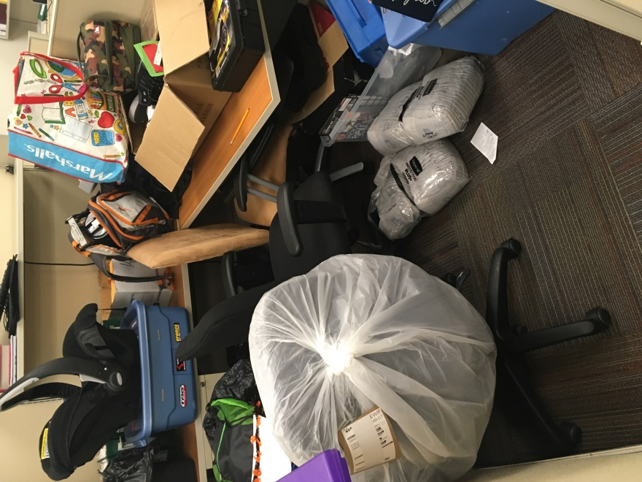

**Boxed materials forming a rodent harborage**

| Location | **Carbon**  **Dioxide**  **(ppm)** | **Carbon Monoxide**  **(ppm)** | **Temp**  **(°F)** | **Relative**  **Humidity**  **(%)** | **PM2.5**  **(µg/m3)** | **Occupants**  **in Room** | **Windows**  **Openable** | **Ventilation** | | **Remarks** |
| --- | --- | --- | --- | --- | --- | --- | --- | --- | --- | --- |
| **Supply** | **Exhaust** |
| Background  (outdoors) | 355 | 2 | 54 | 41 |  |  |  |  |  |  |
| Meeting room | 634 | 2 | 53 | 49 | 4 | 0 | N | Y | Y |  |
| Copy Room | 778 | ND | 77 | 24 | 2 | 0 | NA | N | Y | Stained ceiling tile |
| 005 | 740 | 1 | 72 | 26 | 1 | 0 | N | Y | Y | Stained ceiling tile |
| 022 | 723 | ND | 73 | 26 | ND | 0 | N | Y | Y |  |
| 028 | 798 | ND | 73 | 27 | 2 | 1 | N | Y | Y |  |
| 044 | 633 | 1 | 71 | 26 | 2 | 0 | N | Y | Y |  |
| 047 | 649 | 1 | 71 | 26 | 2 | 0 | N | Y | Y |  |
| 049 | 626 | ND | 73 | 25 | 2 | 0 | N | Y | Y |  |
| 058 | 681 | ND | 74 | 24 | 3 | 0 | NA | Y | Y |  |
| 059 | 639 | ND | 73 | 25 | 1 | 0 | N | Y | Y |  |
| 066 | 665 | ND | 74 | 24 | 2 | 0 | NA | N | Y |  |
| 070 | 476 | 2 | 64 | 30 | 4 | 0 | N | Y | Y |  |
| Open cubicle area adjacent to 070 | 680 | ND | 75 | 24 | 3 | 0 | NA | Y | Y |  |
| 077 | 698 | ND | 74 | 24 | 1 | 0 | NA | Y | Y |  |
| Open cubicle area adjacent to 077 | 680 | ND | 74 | 24 | 1 | 1 | NA | Y | Y |  |
| 080 | 729 | ND | 73 | 25 | 1 | 0 | NA | Y | Y |  |
| 081 | 709 | ND | 73 | 24 | 3 | 0 | NA | Y | Y |  |
| Open cubicle area adjacent to 081 | 725 | ND | 72 | 25 | 2 | 1 | NA | Y | Y |  |
| 082 | 715 | ND | 73 | 25 | 2 | 0 | NA | Y | Y |  |
| 084 | 734 | ND | 72 | 25 | 1 | 0 | N | Y | Y |  |
| Cubicle area adjacent to 084 | 725 | ND | 72 | 25 | 2 | 1 | NA | Y | Y |  |
| 086 | 683 | ND | 73 | 25 | 2 | 0 | NA | Y | Y |  |
| Open cubicle area adjacent to 086 | 697 | ND | 73 | 25 | 2 | 0 | NA | Y | Y |  |
| 087 | 706 | ND | 73 | 25 | 1 | 0 | NA | Y | Y |  |
| Open cubicle area adjacent to 089 | 689 | ND | 73 | 25 | 2 | 0 | NA | Y | Y |  |
| 089 | 694 | ND | 72 | 25 | 2 | 0 | NA | N | Y |  |
| 095 | 715 | ND | 72 | 25 | 2 | 0 | NA | Y | Y |  |
| 095 | 715 | ND | 72 | 25 | 2 | 0 | NA | Y | Y |  |
| 096 | 739 | ND | 73 | 25 | 3 | 0 | N | Y | Y |  |
| Open cubicle area adjacent to 096 | 726 | ND | 73 | 24 | 2 | 0 | NA | Y | Y |  |
| 101 | 668 | 1 | 73 | 25 | 2 | 1 | N | Y | Y |  |
| 101 hallway | NA | NA | NA | NA | NA | NA | NA | Y | Y | Food debris on floor |
| 102 | 651 | 1 | 73 | 24 | 1 | 0 | N | Y | Y |  |
| 107 | 643 | 1 | 73 | 24 | 2 | 0 | N | Y | Y |  |
| 201 | 711 | 1 | 73 | 24 | 2 | 1 | N | Y | Y | Supply off |
| 204 | 661 | 1 | 72 | 26 | 2 | 0 | N | Y | Y |  |
| 222 | 650 | ND | 73 | 25 | 1 | 0 | N | Y | Y |  |
| 235 | 653 | ND | 73 | 25 | 1 | 0 | N | Y | Y |  |
| 250 | 658 | 1 | 71 | 26 | 2 | 2 | N | Y | Y |  |
| 255 | 635 | 1 | 72 | 26 | 2 | 4 | N | Y | Y |  |
| 260 | 651 | ND | 73 | 25 | 2 | 2 | N | Y | Y |  |
| 261 | 639 | ND | 73 | 24 | 1 | 0 | N | Y | Y |  |
| 265 | 627 | ND | 73 | 25 | 2 | 0 | N | Y | Y |  |
| 273 | 632 | ND | 73 | 25 | 2 | 1 | N | Y | Y |  |
| 278 | 649 | ND | 73 | 25 | 1 | 2 | N | Y | Y |  |
| 284 | 642 | ND | 73 | 25 | 2 | 2 | N | Y | Y |  |
| 289 | 692 | ND | 73 | 25 | 3 | 3 | N | Y | Y |  |
| 293 | 734 | ND | 73 | 26 | 2 | 2 | N | Y | Y |  |
| 303 | 694 | 1 | 73 | 21 | ND | 3 | N | Y | Y | Supply off |
| 312 | 676 | 1 | 73 | 21 | 2 | 0 | N | Y | Y | Supply off |
| 321 | 708 | 1 | 73 | 25 | ND | 0 | N | Y | Y | Stained ceiling tile |
| 331 | 692 | 1 | 73 | 24 | ND | 3 | N | Y | Y | Supply off |