**INDOOR AIR QUALITY ASSESSMENT**

**Department of Conservation and Recreation**

**State Transportation Building**

**6th floor**

**10 Park Plaza**

**Boston, MA**

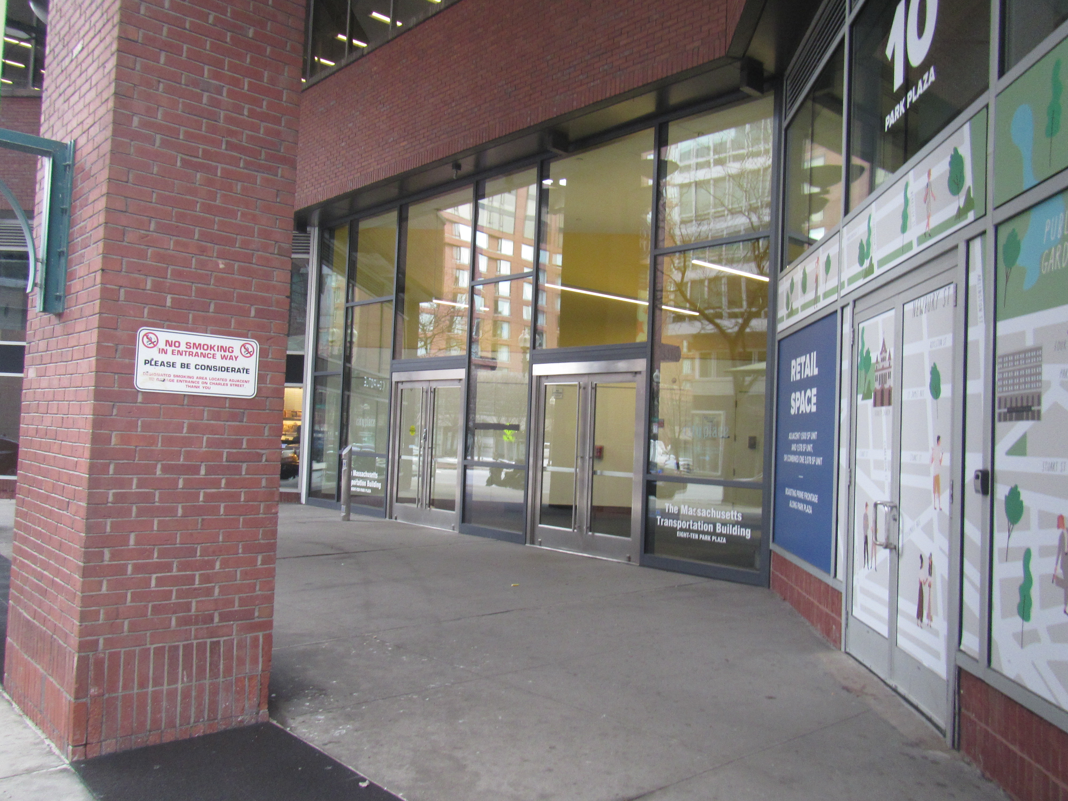

Prepared by:

Massachusetts Department of Public Health

Bureau of Climate and Environmental Health

Division of Health Regulations and Standards

January 2025

# BACKGROUND

|  |  |
| --- | --- |
| Building: | Department of Conservation and Recreation (DCR) offices |
| Address: | State Transportation Building, 10 Park Plaza, Boston. 6th floor suites. |
| Assessment Requested by: | Robert Northrup, Director of Property Management, Department of Transportation (DOT) |
| Reason for Request: | Concerns about indoor air quality (IAQ) following pest control activities |
| Date of Assessment: | January 13, 2025 |
| Massachusetts Department of Public Health, Bureau of Climate and Environmental Health, **Division of Environmental Health, Regulations and Standards (MDPH/BCEH/EHRS)** Staff Conducting Assessment: | Ruth Alfasso, Environmental  Engineer, EHRS |
| Building Description: | The State Transportation Building is a high-rise located in downtown Boston built in the 1980s and operated by the DOT. Sixth floor offices were remodeled within the last two years. The space has offices, open workstation areas, meeting/conference rooms, a break room and mail/copy areas. |
| Windows: | Openable, slightly, but opening is discouraged |

Other floors and offices in this building have been visited by BCEH staff in the past. Reports from previous assessments are available by request.

# METHODS

Please refer to the IAQ Manual for methods, sampling procedures, and interpretation of results (MDPH, 2015).

# RESULTS AND DISCUSSION

Measurements for IAQ parameters are shown in Table 1 and summarized below:

* ***Carbon dioxide*** measurements were below the MDPH guideline of 800 parts per million (ppm) in most areas, and slightly above in a few, indicating mostly adequate fresh air in the space. Note that many areas were lightly occupied or vacant. Carbon dioxide levels would be expected to increase with higher occupancy.
* ***Temperature*** was within or close to the lower end of the recommended range of 70°F to 78°F in all areas tested.
* ***Relative humidity*** was below the recommended range of 40% to 60% in all areas tested, which is common during the heating season.
* ***Carbon monoxide*** levels were non-detectable (ND) in all areas tested.
* ***Fine particulate matter (PM2.5)*** concentrations were below the National Ambient Air Quality Standard (NAAQS) level of 35 μg/m3 in all areas tested.
* ***Total volatile organic compounds (TVOC)*** were non-detect in all areas assessed.

## Ventilation

A heating, ventilating, and air conditioning (HVAC) system has several functions. First, it provides heating and, if equipped, cooling. Second, it is a source of fresh air. Finally, an HVAC system will dilute and remove normally occurring indoor environmental pollutants by not only introducing fresh air but also filtering the airstream and ejecting stale air to the outdoors via exhaust ventilation. Even if an HVAC system is operating as designed, point sources of respiratory irritation may exist and affect symptoms in sensitive individuals. The following analysis examines and identifies components of the HVAC system and likely sources of respiratory irritant/allergen exposure due to water damage, aerosolized dust, and/or chemicals found in the indoor environment.

Fresh air is provided by air handling units (AHUs) and ducted to fresh air supply vents located in the ceilings (Picture 1). Air is drawn through return grills (Picture 1) to return to the AHU or be exhausted from the building. Induction units along the exterior walls of the building provide supplemental heating and air circulation (Picture 2). Note that a few induction units had items on them, which will block airflow (Picture 3). If items on induction units carry dust or can emit odors when heated (e.g. plants), this can also be circulated by the airflow of the unit.

The ventilation system should be on and operating to supply fresh air continuously during occupied periods. Without adequate fresh air supply and removal of stale air, common indoor air pollutants can build up and cause irritation. It is recommended that HVAC systems be re-balanced every five years to ensure adequate air systems function (SMACNA, 1994). It is not known when the last time these systems were balanced.

Thermostats are present at intervals along each floor (Picture 4). These feed into a centralized management system. The systems should be set to have the fan on during occupied periods regardless of temperature settings. No indication of fan status could be seen on the thermostats viewed. Some conference rooms had sensors for carbon dioxide, which can be helpful to increase ventilation during heavy occupancy. Carbon dioxide sensors have a limited lifespan and need to be calibrated or replaced in accordance with the manufacturer’s recommendations.

## Microbial/Moisture Concerns

A water-damaged ceiling tile was noted in the mailroom (Picture 5; Table 1). Given the location of the stain, the source is likely from condensation on sprinkler or HVAC components. This ceiling tile should be changed, and the area above it examined for additional water damage and anything needing repair, cleaning, or additional insulation to prevent condensation.

Plants were observed in a few areas (Picture 3 and 6; Table 1). Plants can be a source of pollen and mold, which can be respiratory irritants to some individuals. Plants should be properly maintained and equipped with drip pans to prevent water damage to porous materials.

Water dispensers and water fountains were observed in carpeted areas (Pictures 7 and 8). Appliances may spill or leak and lead to carpet damage and microbial growth. One of the water fountains (Picture 8) was found covered. Note that water fixtures such as fountains can develop dry drain traps if they are not used for a period of time, and a dry trap can allow sewer gases into occupied spaces providing a source of irritation.

Refrigerators were noted in a few areas, including a break room; they need to be kept clean to prevent microbial growth and odors. All food should be enclosed in pest-proof containers. Refrigerators were noted to be clean during the site visit, and the breakroom flooring was water and spill resistant material.

## Other IAQ Concerns

Note the main reason for this assessment was staff concerns following detection of and treatment for bedbugs in the office. A licensed pest control contractor was used to confirm and treat for bedbugs, and staff were not in the office for over a month until follow-up pest assessments were conducted and no additional treatment deemed needed. The principles and procedures outlined in the Bedbug Protocol (<https://www.mass.gov/info-details/bed-bug-protocol>) were followed. No specific testing relating to bedbugs or bedbug treatment were conducted by BCEH staff during this visit, however no odors or other conditions were noted that could be related to bedbug treatment.

However, note that one key principle when dealing with pests in an office, and bedbugs in particular, is the reduction of clutter on floors and surfaces to reduce places where pests can hide. While most desks and other surfaces were clear of items, boxes and other materials were noted stored on floors in many areas (Picture 9 and 10). If files in cardboard boxes need to be saved, space should be made available in a room with shelving or cabinets to store them neatly and off the floor. Clutter can also make routine cleaning such as vacuuming less effective and more time consuming.

An examination was conducted for products that may be a source of VOCs in indoor air. While no VOCs were detected, products such as dry erase markers, hand sanitizers, and cleaners were found in many areas (Table 1). In the absence of adequate fresh air and exhaust ventilation, VOCs from these products can build up and lead to irritation of the mucous membranes or irritating odors. In addition, this office has several large format printers. These can produce odors, VOCs, and particulates in use, particularly in heavy use. Direct-vented exhaust would be ideal if these printers are used often.

Most areas of the office suite were carpeted. Carpets should be cleaned regularly in accordance with Institute of Inspection, Cleaning and Restoration Certification (IICRC) recommendations (IICRC, 2012). A vacuum cleaner was noted in the space (Picture 11) with a label indicating that it has high efficiency particulate arrestance (HEPA) filtration capabilities. This, and other, vacuum cleaners should be maintained to ensure that HEPA filtration is working.

# CONCLUSIONS/RECOMMENDATIONS

The following are recommendations made to improve IAQ:

## Ventilation recommendations

1. Operate supply and exhaust ventilation in all areas during occupied periods. Ensure that all control systems allow for the fan to be on when the office is occupied.
2. Calibrate or replace carbon dioxide sensors in accordance with manufacturer’s instructions.
3. Have the HVAC system balanced every 5 years in accordance with SMACNA recommendations (SMACNA, 1994).
4. Ensure filters are replaced on HVAC units at least twice a year. If feasible, use filters with a minimum efficiency rating value (MERV) of 8 or better.
5. Remove blockages from induction units and avoid placing items such as plants in the airstream.

## Water damage recommendations

1. Replace water-damaged ceiling tile(s) and check above the ceiling tile grid for any ongoing source of moisture such as leaks or uninsulated pipes.
2. Keep indoor plants in good condition and avoid overwatering. Ensure any plants are placed on water-resistant drip pans to prevent water damage to materials like windowsills.
3. Consider moving refrigerators and water dispensers to areas without carpeting or use a waterproof mat underneath.
4. Until water fountains can be either repaired or permanently removed, ensure drains are not allowed to dry out by wetting the fixture once a week.
5. Keep refrigerators and other food-preparation appliances clean and in good condition.

## Other recommendations

1. Continue to work with a licensed pest control contractor to monitor for bedbugs or other pests.
2. Reduce clutter, including finding more permanent storage for file boxes.
3. Periodically clean dust from supply and return vents and fans.
4. Use VOC-containing products in areas with good ventilation and keep tightly closed when not in use.
5. If direct vented exhaust is not available for large-format printers, consider using them when the office is not heavily occupied.
6. Clean carpeting in accordance with IICRC recommendations (IICRC, 2012).
7. Ensure vacuum cleaners are properly equipped with HEPA filters.
8. For buildings in New England, periods of low relative humidity during the winter are often unavoidable. Therefore, scrupulous cleaning practices should be adopted to minimize common indoor air contaminants whose irritant effects can be enhanced when the relative humidity is low. To control for dusts, a high efficiency particulate arrestance (HEPA) filter equipped vacuum cleaner in conjunction with wet wiping of all surfaces is recommended. Avoid the use of feather dusters. Drinking water during the day can help ease some symptoms associated with a dry environment (throat and sinus irritations).
9. Refer to resource manual and other related IAQ documents located on the MDPH’s website for further building-wide evaluations and advice on maintaining public buildings. These documents are available at: <http://mass.gov/dph/iaq>.

# REFERENCES

IICRC. 2012. Institute of Inspection, Cleaning and Restoration Certification. Carpet Cleaning: FAQ.

MDPH. 2015. Massachusetts Department of Public Health. Indoor Air Quality Manual: Chapters I-III. Available at: <https://www.mass.gov/lists/indoor-air-quality-manual-and-appendices>.

SMACNA. 1994. HVAC Systems Commissioning Manual. 1st ed. Sheet Metal and Air Conditioning Contractors’ National Association, Inc., Chantilly, VA.

**Picture 1**

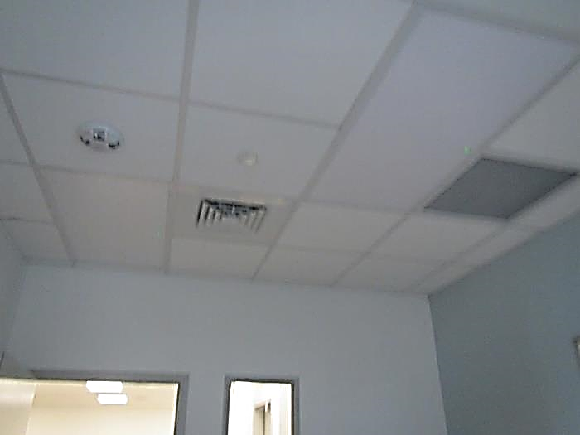

**Supply and return vent in an office**

**Picture 2**

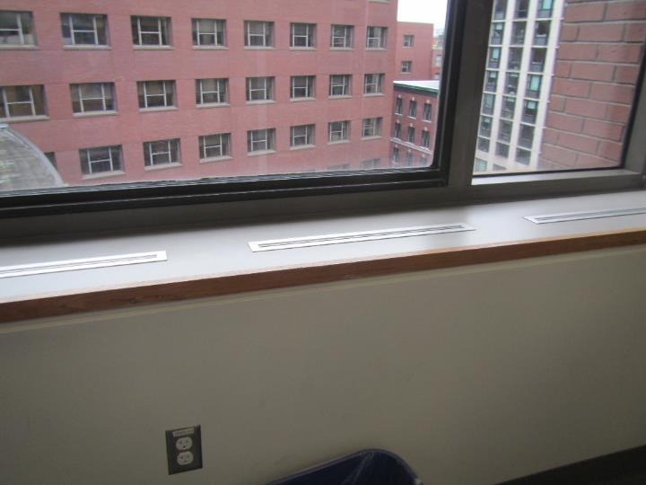

**Induction unit along exterior wall**

**Picture 3**

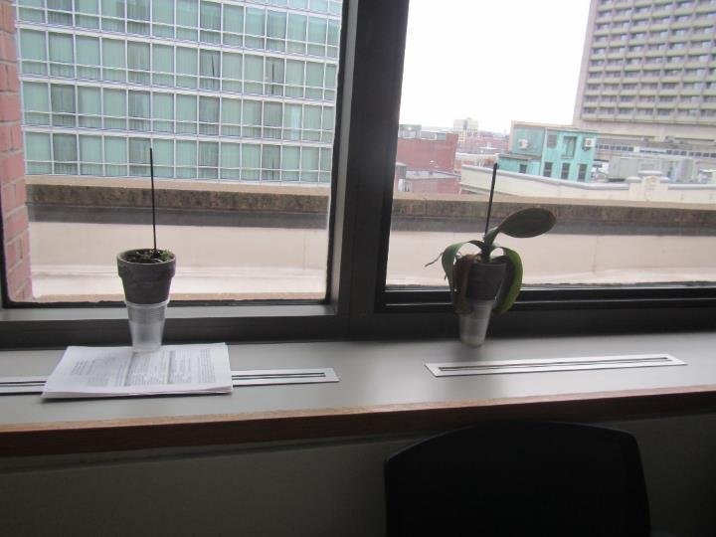

**Items blocking induction unit air outlet, and plants on induction unit**

**Picture 4**

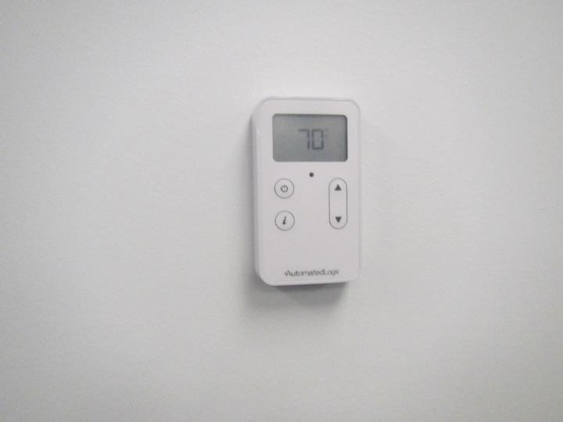

**Typical thermostat**

**Picture 5**

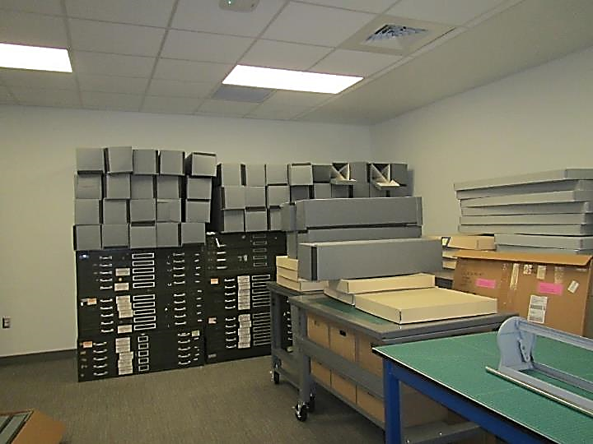

**Water-damaged ceiling tile (arrow)**

**Picture 6**

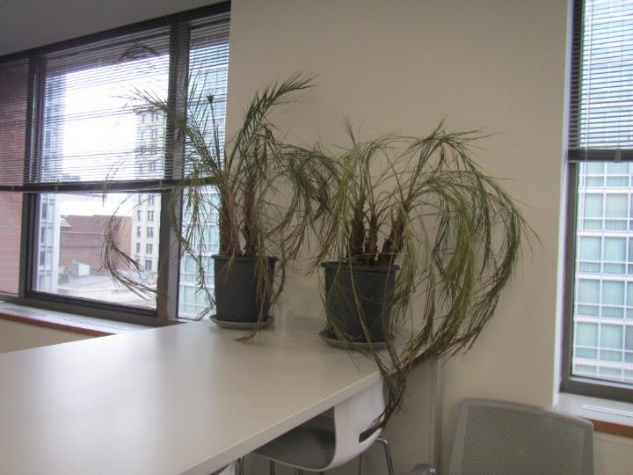

**Plant in an office**

**Picture 7**

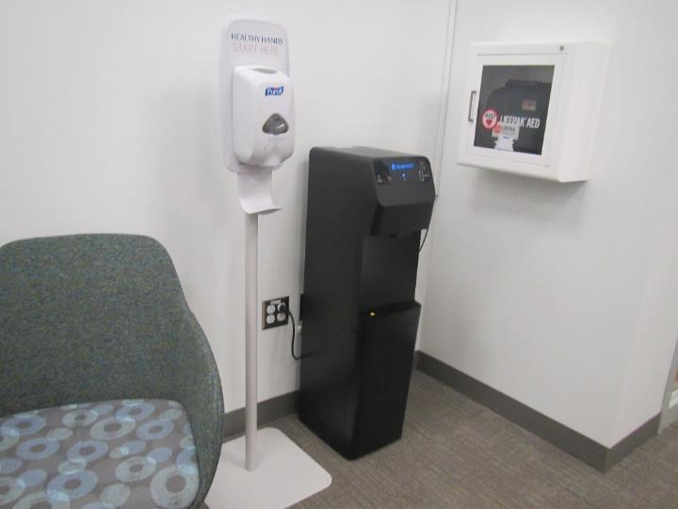

**Water dispenser over carpet, also note hand sanitizer station**

**Picture 8**

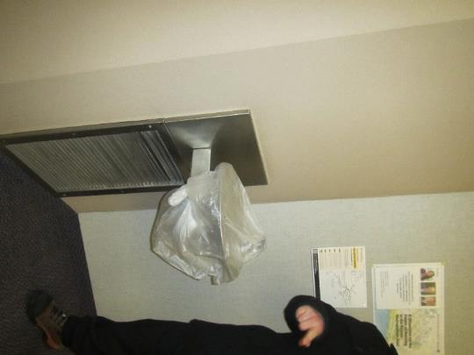

**Covered water fountain in a carpeted area**

**Picture 9**

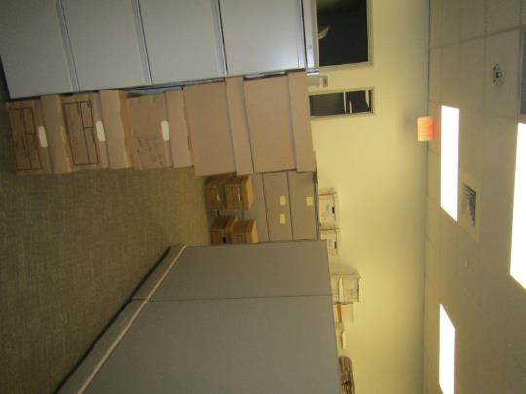

**Boxes on floors and on top of cabinets**

**Picture 10**

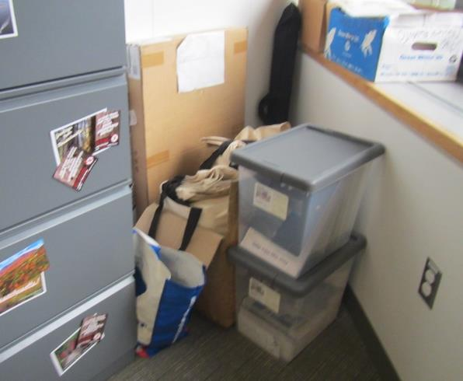

**Items on the floor in an office**

**Picture 11**

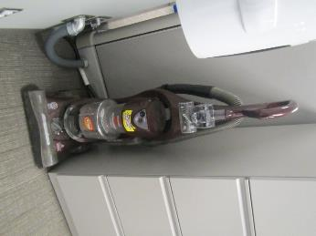

**HEPA-equipped vacuum cleaner**

| **Location** | **Carbon**  **Dioxide**  **(ppm)** | **Carbon Monoxide**  **(ppm)** | **Temp**  **(°F)** | **Relative**  **Humidity**  **(%)** | **PM2.5**  **(µg/m3)** | **TVOC (ppm)** | **Occupants**  **in Room** | **Windows**  **Openable** | **Ventilation** | | **Remarks** |
| --- | --- | --- | --- | --- | --- | --- | --- | --- | --- | --- | --- |
| **Supply** | **Exhaust** |
| Background | 507 | ND | 41 | 43 | 32 |  |  |  |  |  | Busy street |
| 6169 huddle | 729 | ND | 71 | 21 | ND | ND | 0 | N | Y | Y | DEM |
| 6170 | 718 | ND | 71 | 21 | ND | ND | 1 | N | Y | Y |  |
| 6171 | 733 | ND | 70 | 21 | ND | ND | 0 | N | Y | Y | DEM |
| 6172 huddle | 715 | ND | 70 | 21 | ND | ND | 0 | N | Y | Y | DEM |
| W6179.9 | 714 | ND | 70 | 21 | ND | ND | 0 | Y | Y | Y |  |
| W6173.6 | 734 | ND | 70 | 21 | ND | ND | 0 | N | Y | Y |  |
| W6173.3 | 731 | ND | 70 | 21 | ND | ND | 00 | Y | Y | Y |  |
| 6174 huddle | 734 | ND | 71 | 21 | ND | ND | 0 | Y | Y | Y |  |
| 6175 | 732 | ND | 70 | 21 | ND | ND | 0 | N | Y | Y | DEM |
| 6177 documents |  |  |  |  |  |  |  | N | Y | Y | Supplies |
| 6176 | 743 | ND | 70 | 21 | ND | ND | 1 | N | Y | Y |  |
| 6660 mailing area | 791 | ND | 70 | 22 | ND | ND | 1 | N | Y | Y | 1 WD CT, mail machines, NC, HS |
| 6121 | 758 | ND | 70 | 21 | ND | ND | 0 | N | Y | Y | DEM, CO2 monitor |
| Mail/copy | 765 | ND | 69 | 22 | ND | ND | 0 | N | Y | Y | NC, copy and mail equipment |
| 6122 | 788 | ND | 80 | 22 | ND | ND | 1 | N | Y | Y | DEM |
| 6123 | 868 | ND | 80 | 23 | ND | ND | 1 | N | Y | Y | DEM |
| 6124 | 845 | ND | 70 | 22 | ND | ND | 0 | N | Y | Y | DEM, food |
| W6126.2 | 795 | ND | 71 | 22 | ND | ND | 3 | N | Y | Y |  |
| 6127 huddle | 506 | ND | 71 | 21 | ND | ND | 0 | N | Y | Y | DEM |
| 6128 huddle | 773 | ND | 71 | 21 | ND | ND | 0 | N | Y | Y | DEM |
| 6129 | 918 | ND | 71 | 23 | ND | ND | 1 | N | Y |  |  |
| 6130 | 834 | ND | 71 | 21 | ND | ND | 0 | N | Y | Y | DEM, occupant reported odor |
| 6131 phone | 769 | ND | 71 | 21 | ND | ND | 0 | N | Y | Y | DEM |
| 6132 phone | 758 | ND | 71 | 21 | ND | ND | 0 | Y | N | Y | DEM |
| W6133.1 | 803 | ND | 72 | 21 | ND | ND | 0 | Y | Y | Y | DEM |
| W6132 | 777 | ND | 72 | 21 | ND | ND | 1 | Y | Y | Y | Boxes |
| W6133.5 | 768 | ND | 71 | 21 | ND | ND | 1 | Y | Y | Y |  |
| W6134.1 | 766 | ND | 71 | 21 | ND | ND | 1 | Y | Y | Y | Plants |
| W6199.8 | 794 | ND | 71 | 21 | ND | ND | 2 | N | Y | Y |  |
| W6155.6 | 765 | ND | 71 | 21 | ND | ND | 0 | N | Y | Y |  |
| W6138.5 | 769 | ND | 70 | 22 | ND | ND | 0 | Y | Y | Y |  |
| W6139 | 762 | ND | 69 | 22 | ND | ND | 0 | Y | N | Y | DEM |
| 6140 conference | 773 | ND | 70 | 22 | ND | ND | 0 | Y | Y | Y | DEM |
| 6141 | 765 | ND | 70 | 22 | ND | ND | 1 | N | Y | Y | DEM |
| 6143 break room | 786 | ND | 71 | 22 | ND | ND | 0 | Y | Y | Y | 3 refrigerators (clean) microwaves, other equipment, sink, NC |
| 6101 reception for parking, staff side | 783 | ND | 73 | 21 | ND | ND | 0 | N | Y | Y | Shredder |
| W6148.2 | 768 | ND | 73 | 20 | ND | ND | 2 | Y | Y | Y |  |
| W6149.8 | 730 | ND | 71 | 20 | ND | ND | 0 | Y | Y | Y |  |
| W6149.3 | 707 | ND | 71 | 20 | ND | ND | 0 | Y | Y | Y |  |
| 6150 huddle | 703 | ND | 71 | 21 | ND | ND | 0 | Y | Y | Y | DEM |
| 6151 huddle | 710 | ND | 71 | 20 | ND | ND | 0 | N | Y | Y |  |
| 6153 huddle | 718 | ND | 71 | 20 | ND | ND | 0 | N | Y | Y | Many boxes, DEM |
| 6157 conference | 720 | ND | 71 | 21 | ND | ND | 0 | N | Y | Y | DEM |
| 6158 huddle | 750 | ND | 71 | 21 | ND | ND | 0 | N | Y | Y | DEM |
| 6159 | 751 | ND | 71 | 22 | ND | ND | 0 | N | Y | Y | DEM |
| 6147 conference | 752 | ND | 72 | 21 | ND | ND | 0 | Y | Y | Y | DEM, plant |
| Waiting area (public side) | 759 | ND | 73 | 20 | ND | ND | 0 | N | Y | Y | Plant, water cooler on carpet |
| Women’s restroom |  |  |  |  |  |  |  |  |  |  | Air freshener odor |