INDOOR AIR QUALITY ASSESSMENT

Massachusetts Department of Developmental Services
Fernald Center Wallace Building
200 Trapelo Road
Waltham, Massachusetts 02452



Prepared by:
Massachusetts Department of Public Health
Bureau of Environmental Health
Indoor Air Quality Program
July 2009

Background/Introduction
At the request of Kevin Buckley, Business Manager, Massachusetts Department of Developmental Services (DDS), the Massachusetts Department of Public Health (DPH), Bureau of Environmental Health (BEH) provided assistance and consultation regarding indoor air quality concerns at the DDS, Wallace Building (WB). The WB is part of the Fernald Center campus located at 200 Trapelo Road, Waltham, Massachusetts.
On May 8, 2009, a visit to conduct an assessment was made to this building by Cory Holmes, Environmental Analyst/Inspector for BEH’s Indoor Air Quality (IAQ) Program. The assessment was prompted by a recommendation from the DDS Office of Quality Enhancement to clean the mechanical ventilation system ductwork. BEH staff were accompanied by David Dunton, Program Manager and Mr. Buckley during the assessment; and, John Robbilard, HVAC Technician for portions of the assessment.
The WB is a single-story, red brick building with a basement, originally constructed in 1936 as a residential facility. For approximately five years the building has served as a residence for DDS clients. Over the years, it has undergone interior renovations and consists of dorm rooms, common areas and office space. The basement is currently unoccupied and is not used. Windows are openable throughout the building; however, several were damaged or found inoperable. At the time of the IAQ assessment, Mr. Dunton reported that replacement windows were on work order.
Methods
Air tests for carbon monoxide, carbon dioxide, temperature and relative humidity were conducted with the TSI, Q-Trak, IAQ Monitor, Model 8554. Air tests for airborne particle matter with a diameter less than 2.5 micrometers were taken with the TSI, DUSTTRAK™ Aerosol Monitor Model 8520. BEH staff also performed visual inspection of building materials for water damage and/or microbial growth.
Results
The WB has an employee population of approximately 18 and currently houses 5 residents. Mr. Dunton reported that several dorm rooms are being prepared to receive 3 more residents bringing the residential population to 8. Test results appear in Table 1.
Discussion
Duct Cleaning/Ventilation
It can be seen from Table 1 that carbon dioxide levels were below 800 parts per million (ppm) in all areas surveyed, indicating adequate air exchange in the building at the time of the assessment. The WB was originally designed with a heating, ventilating and air conditioning (HVAC) system consisting of a large air handling unit (AHU) located in the basement (Picture 1) supplemented by openable windows and perimeter fan coil units (FCUs) in the rooms (Picture 2). A FCU does not introduce outside air; rather, it draws air from the room then filters, heats and re-circulates the air back to the room.
The AHU was designed to draw fresh air through an air intake on the exterior wall, then heat/filter and distribute it to occupied areas via ducted ceiling diffusers (Pictures 3 and 4). Air is ducted back to the AHU through ceiling-mounted return vents and exhausted out of the building from a vent on the exterior wall (Picture 5).
As previously mentioned, the assessment was prompted by a recommendation to clean the AHU ductwork. However, at the time of the assessment, the HVAC system did not appear to be operating. According to Mr. Robbilard, the system is unused and has not been activated in the five years that the WB has been used as a client residence. The building has been heated by FCUs and ventilated via openable windows during that time. Mr. Dunton and WB staff reported that the FCUs have been sufficient to maintain heat in the building.
Based on the lack of use of the original AHU, cleaning the ductwork would not be recommended. Sealing the various openings for this unused system to properly abandon the ductwork would be the most appropriate action. Duct cleaning of an unused system may result in increased indoor air quality problems. According to the United States Environmental Protection Agency (US EPA), knowledge about potential benefits and problems with duct cleaning is limited. Since conditions in every building are different, it is difficult to generalize whether or not duct cleaning will be beneficial. If occupants are not experiencing symptoms (e.g., allergies, exacerbation of asthma); detecting strange odors; or observing particulate/debris coming from vents/diffusers, it may be unnecessary to have ducts cleaned. It is also normal for supply diffusers and exhaust/return vents to accumulate dust, which does not indicate that the air ducts are contaminated. Supply, exhaust and return vents should be cleaned/vacuumed as needed. In addition, duct cleaning can damage ducts, fans, coils and other HVAC equipment if not done properly (US EPA, 2006a). Therefore, the most efficient manner to prevent pollutants from impacting the building population is to seal the openings of the unused HVAC system.
Restrooms are equipped with exhaust vents that operate via rooftop motors (Pictures 6 and 7). The vents were not drawing air at the time of the assessment. Mr. Dunton reported that the repair/replacement of exhaust motors was on work order. Exhaust ventilation is necessary in restrooms to remove excess moisture and to prevent odors from penetrating into adjacent areas.
Window mounted air conditioners (ACs) provide cooling throughout the building (Picture 8). ACs examined were equipped with a “fan only” or “exhaust open” setting (Picture 9). In this mode of operation, ACs can provide air circulation by delivering outside air into space without cooling (i.e., air provided by unit equals that of outside temperature).
The Massachusetts Building Code requires that each room have a minimum ventilation rate of 20 cubic feet per minute (cfm) per occupant of fresh outside air or openable windows (SBBRS, 1997; BOCA, 1993). The ventilation must be on at all times that the room is occupied. Providing adequate fresh air ventilation with open windows and maintaining the temperature in the comfort range during the cold weather season is impractical. Mechanical ventilation is usually required to provide adequate fresh air ventilation.
Carbon dioxide is not a problem in and of itself. It is used as an indicator of the adequacy of the fresh air ventilation. As carbon dioxide levels rise, it indicates that the ventilating system is malfunctioning or the design occupancy of the room is being exceeded. When this happens, a buildup of common indoor air pollutants can occur, leading to discomfort or health complaints. The Occupational Safety and Health Administration (OSHA) standard for carbon dioxide is 5,000 parts per million parts of air (ppm). Workers may be exposed to this level for 40 hours/week, based on a time-weighted average (OSHA, 1997).
The MDPH uses a guideline of 800 ppm for publicly occupied buildings. A guideline of 600 ppm or less is preferred in schools due to the fact that the majority of occupants are young and considered to be a more sensitive population in the evaluation of environmental health status. Inadequate ventilation and/or elevated temperatures are major causes of complaints such as respiratory, eye, nose and throat irritation, lethargy and headaches. For more information concerning carbon dioxide, please see Appendix A.
Temperature readings in the building ranged from 66º F to 73 º F, most of which were within or close to the lower end of the MDPH recommended comfort guidelines (Table 1). The MDPH recommends that indoor air temperatures be maintained in a range of 70 º F to 78 º F in order to provide for the comfort of building occupants. In many cases concerning indoor air quality, fluctuations of temperature in occupied spaces are typically experienced, even in a building with an adequate fresh air supply.
The relative humidity measurements in the building ranged from 51 to 57 percent, which were within the MDPH recommended comfort range (Table 1). The MDPH recommends a comfort range of 40 to 60 percent for indoor air relative humidity. Relative humidity levels in the building would be expected to drop during the winter months due to heating. The sensation of dryness and irritation is common in a low relative humidity environment. Low relative humidity is a very common problem during the heating season in the northeast part of the United States.
Microbial/Moisture Concerns
Water damaged ceiling tiles were noted in a few areas (Pictures 10 and 11). Water-damaged ceiling tiles can indicate sources of water penetration and provide a source of mold growth. Ceiling tiles should be replaced after a water leak is discovered and repaired. At the time of the assessment, Mr. Dunton reported that an active roof leak was being investigated for repairs by a roofing contractor.
BEH staff examined the perimeter of the building to identify breaches in the building envelope or other conditions that could provide a source for water penetration. A number of exterior sources for moisture penetration were identified:
- Tree branches overhanging the roof (Picture 12);
- Plant growth against the building (Picture 13);
- A broken window in the rear of the building (Pictures 14); and
- Damage/breaches in wooden eaves along the roof’s edge (Picture 15).
These conditions can undermine the integrity of the building envelope and provide a means of water entry by capillary action into the building through exterior walls, foundation concrete and masonry (Lstiburek & Brennan, 2001). In addition, breaches in exterior areas can provide a means of drafts and pest entry into the building.
The US Environmental Protection Agency and the American Conference of Governmental Industrial Hygienists (ACGIH) recommends that porous materials (carpeting, ceiling tiles, etc.) be dried with fans and heating within 24 to 48 hours of becoming wet (US EPA, 2001; ACGIH, 1989). If porous materials are not dried within this time frame, mold growth may occur. Water-damaged porous materials cannot be adequately cleaned to remove mold growth. The application of a mildewcide to moldy porous materials is not recommended.

Other IAQ Evaluations
Indoor air quality can be negatively influenced by the presence of respiratory irritants, such as products of combustion. The process of combustion produces a number of pollutants. Common combustion emissions include carbon monoxide, carbon dioxide, water vapor and smoke (fine airborne particle material). Of these materials, exposure to carbon monoxide and particulate matter with a diameter of 2.5 micrometers (μm) or less (PM2.5) can produce immediate, acute health effects upon exposure. To determine whether combustion products were present in the building, BEH staff obtained measurements for carbon monoxide and PM2.5.

Carbon Monoxide
Carbon monoxide is a by-product of incomplete combustion of organic matter (e.g., gasoline, wood and tobacco). Exposure to carbon monoxide can produce immediate and acute health affects. Several air quality standards have been established to address carbon monoxide and prevent symptoms from exposure to these substances. The MDPH established a corrective action level concerning carbon monoxide in ice skating rinks that use fossil-fueled ice resurfacing equipment. If an operator of an indoor ice rink measures a carbon monoxide level over 30 ppm, taken 20 minutes after resurfacing within a rink, that operator must take actions to reduce carbon monoxide levels (MDPH, 1997).
The American Society of Heating Refrigeration and Air-Conditioning Engineers (ASHRAE) has adopted the National Ambient Air Quality Standards (NAAQS) as one set of criteria for assessing indoor air quality and monitoring of fresh air introduced by HVAC systems (ASHRAE, 1989). The NAAQS are standards established by the US EPA to protect the public health from six criteria pollutants, including carbon monoxide and particulate matter (US EPA, 2006b). As recommended by ASHRAE, pollutant levels of fresh air introduced to a building should not exceed the NAAQS levels (ASHRAE, 1989). The NAAQS were adopted by reference in the Building Officials & Code Administrators (BOCA) National Mechanical Code of 1993 (BOCA, 1993), which is now an HVAC standard included in the Massachusetts State Building Code (SBBRS, 1997). According to the NAAQS, carbon monoxide levels in outdoor air should not exceed 9 ppm in an eight-hour average (US EPA, 2006b).
Carbon monoxide should not be present in a typical, indoor environment. If it is present, indoor carbon monoxide levels should be less than or equal to outdoor levels. On the day of assessment, outdoor carbon monoxide concentrations were non-detect (ND) (Table 1). No measurable levels of carbon monoxide were detected inside the building at the time of the assessment (Table 1).

Particulate Matter (PM2.5)
The US EPA has established NAAQS limits for exposure to particulate matter. Particulate matter is airborne solids that can be irritating to the eyes, nose and throat. The NAAQS originally established exposure limits to particulate matter with a diameter of 10 μm or less (PM10). According to the NAAQS, PM10 levels should not exceed 150 microgram per cubic meter (μg/m³) in a 24-hour average (US EPA, 2006b). These standards were adopted by both ASHRAE and BOCA. Since the issuance of the ASHRAE standard and BOCA Code, US EPA established a more protective standard for fine airborne particles. This more stringent PM2.5 standard requires outdoor air particle levels be maintained below 35 μg/m³ over a 24-hour average (US EPA, 2006b). Although both the ASHRAE standard and BOCA Code adopted the PM10 standard for evaluating air quality, MDPH uses the more protective PM2.5 standard for evaluating airborne particulate matter concentrations in the indoor environment.
Outdoor PM2.5 concentrations were measured at 12 μg/m³ (Table 1). PM2.5 levels measured indoors ranged from 16 to 26 μg/m³ (Table 1), which were below the NAAQS PM2.5 level of 35 μg/m³. Frequently, indoor air levels of particulates (including PM2.5) can be at higher levels than those measured outdoors. A number of mechanical devices and/or activities that occur in buildings can generate particulate during normal operations. Sources of indoor airborne particulates may include but are not limited to particles generated during the operation of fan belts in the HVAC system, cooking in stoves and microwave ovens; use of photocopiers, fax machines and computer printing devices; operation of an ordinary vacuum cleaner and heavy foot traffic indoors.

Other Conditions
Other conditions that can affect indoor air quality were observed during the assessment. FCUs are normally equipped with filters that provide filtration to strain particulates from airflow. The FCU filters appeared to be ill-fitting and occluded with dust (Picture 16). In order to decrease aerosolized particulates, disposable filters with an increased dust spot efficiency can be installed. The dust spot efficiency is the ability of a filter to remove particulates of a certain diameter from air passing through the filter. Filters that have been determined by ASHRAE to meet its standard for a dust spot efficiency of a minimum of 40 percent (Minimum Efficiency Reporting Value equal to 9) would be sufficient to reduce many airborne particulates (Thornburg, 2000; MEHRC, 1997; ASHRAE, 1992). Note that increasing filtration can reduce airflow, a condition known as pressure drop, which can reduce the efficiency of the FCU due to increased resistance. Prior to any increase of filtration, a HVAC engineer should be consulted as to whether FCUs can maintain function with more efficient filters.
Finally, personal fans and AC filters had dirt, dust and debris accumulation (Pictures 17 and 18). In order to prevent equipment from serving as a source of aerosolized particulates, the fans and filters should be regularly cleaned (or changed) as needed.
Conclusions/Recommendations
The assessment was prompted by the recommendation that the mechanical ventilation ductwork be cleaned. As discovered during the assessment, the ventilation system had not been used for 5 years of occupation by staff/residents at the WB; therefore, cleaning the ductwork does not seem prudent. However, several other IAQ issues typical of many buildings were identified. In view of findings at the time of the visit, the following recommendations are made:
- Seal the fresh air supply and exhaust vents with an appropriate material to abandon the non-operating HVAC system in place.
- Continue with plans to make window repairs. Provide air exchange by using openable windows to control for comfort. Care should be taken to ensure windows are properly closed as needed to avoid the freezing of pipes and potential flooding.
- Supplement fresh air by operating window-mounted air conditioners in the "fan only" “fresh air” mode, which introduces outside air by mechanical means.
- Restore exhaust ventilation in restrooms to remove odors and moisture, make repairs as necessary.
- Work with DDS staff/officials to develop a preventative maintenance program for all HVAC equipment department-wide.
- Operate FCUs continuously to facilitate airflow.
- Clean FCU air handling chambers, return vents and air diffusers periodically of accumulated dust.
- Change filters for FCUs and ACs as per the manufacturers’ instructions or more frequently if needed. Consider increasing the dust-spot efficiency of FCU filters. Ensure filters fit flush in their racks to prevent filter bypass.
- For more information on duct cleaning consult the US EPA website at http://www.epa.gov/iaq/pubs/airduct.html#deciding%20to%20have%20your%20air%20ducts%20cleaned, or The National Air Duct Cleaners Association (NADCA) website at http://www.nadca.com/consumerinformation/residentialconsumer.aspx.
- For buildings in New England, periods of low relative humidity during the winter are often unavoidable. Therefore, scrupulous cleaning practices should be adopted to minimize common indoor air contaminants whose irritant effects can be enhanced when the relative humidity is low. To control for dusts, a high efficiency particulate arrestance (HEPA) filter equipped vacuum cleaner in conjunction with wet wiping of all surfaces is recommended. Drinking water during the day can help ease some symptoms associated with a dry environment (e.g., throat and sinus irritations).
- Remove/replace water damaged ceiling tiles. Examine the areas above and around for mold growth. Disinfect areas of water leaks with an appropriate antimicrobial.
- Remove clinging plants, trim overhanging branches or remove trees from close proximity to exterior walls.
- Repair/replace damaged windows.
- Refer to resource manuals and other related indoor air quality documents for further building-wide evaluations and advice on maintaining public buildings. Copies of these materials are located on the MDPH’s website: http://mass.gov/dph/iaq.
References
ACGIH. 1989. Guidelines for the Assessment of Bioaerosols in the Indoor Environment. American Conference of Governmental Industrial Hygienists, Cincinnati, OH.
ASHRAE. 1989. Ventilation for Acceptable Indoor Air Quality. American Society of Heating, Refrigeration and Air Conditioning Engineers. ANSI/ASHRAE 62-1989
ASHRAE. 1992. Gravimetric and Dust-Spot Procedures for Testing Air-Cleaning Devices Used in General Ventilation for Removing Particulate Matter. American Society of Heating, Refrigeration and Air Conditioning Engineers. ANSI/ASHRAE 52.1-1992.
BOCA. 1993. The BOCA National Mechanical Code-1993. 8th ed. Building Officials & Code Administrators International, Inc., Country Club Hills, IL.
Lstiburek, J. & Brennan, T. 2001. Read This Before You Design, Build or Renovate. Building Science Corporation, Westford, MA. U.S. Department of Housing and Urban Development, Region I, Boston, MA
MDPH. 1997. Requirements to Maintain Air Quality in Indoor Skating Rinks (State Sanitary Code, Chapter XI). 105 CMR 675.000. Massachusetts Department of Public Health, Boston, MA.
MEHRC. 1997. Indoor Air Quality for HVAC Operators & Contractors Workbook. MidAtlantic Environmental Hygiene Resource Center, Philadelphia, PA.
OSHA. 1997. Limits for Air Contaminants. Occupational Safety and Health Administration. Code of Federal Regulations. 29 C.F.R 1910.1000 Table Z-1-A.
SBBRS. 1997. Mechanical Ventilation. State Board of Building Regulations and Standards. Code of Massachusetts Regulations. 780 CMR 1209.0
Thornburg, D. 2000. Filter Selection: a Standard Solution. Engineering Systems 17:6 pp. 74-80.
US EPA. 2001. “Mold Remediation in Schools and Commercial Buildings”. Office of Air and Radiation, Indoor Environments Division, Washington, DC. EPA 402-K-01-001. March 2001. Available at: http://www.epa.gov/iaq/molds/mold_remediation.html
US EPA. 2006a. US Environmental Protection Agency, Indoor Environments Division, Office of Air and Radiation, Washington, DC. Should You Have the Air Ducts in Your Home Cleaned? http://www.epa.gov/iaq/pubs/airduct.html#deciding%20to%20have%20your%20air%20ducts%20cleaned
US EPA. 2006b. National Ambient Air Quality Standards (NAAQS). US Environmental Protection Agency, Office of Air Quality Planning and Standards, Washington, DC. http://www.epa.gov/air/criteria.html
Picture 1

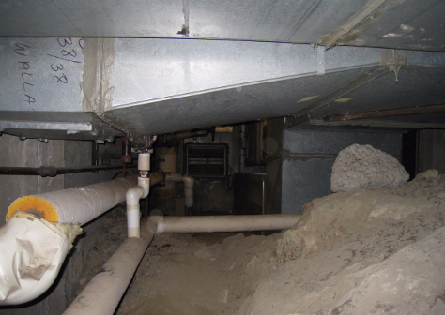

AHU and Ductwork Located in Basement Crawlspace

Picture 2

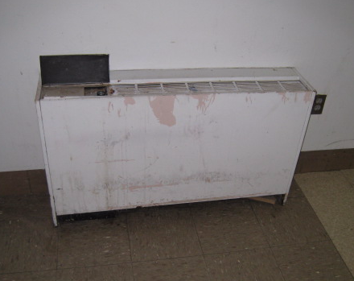

Fan Coil Unit

Picture 3

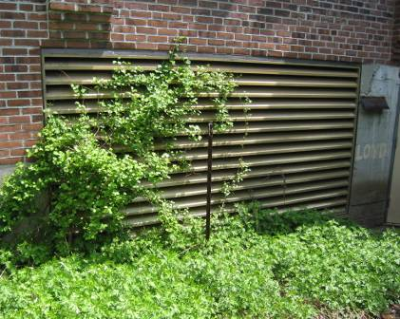

Fresh Air Intake for Abandoned Mechanical Ventilation System

Picture 4

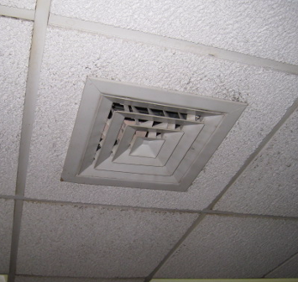

Ceiling-Mounted Supply Diffuser

Picture 5

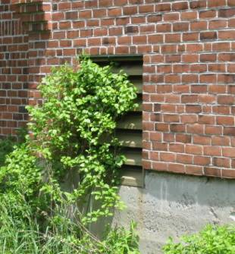

Exhaust Vent for Abandoned Mechanical Ventilation System

Picture 6

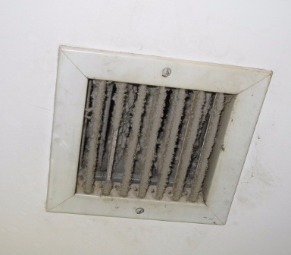

Restroom Exhaust Vent

Picture 7

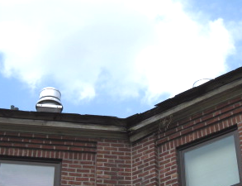

Rooftop Exhaust Motors

Picture 8

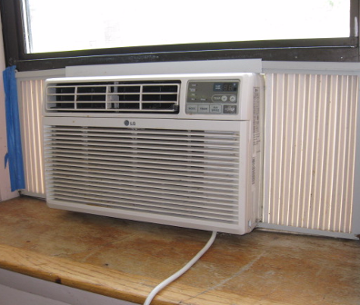

Window Mounted Air Conditioner

Picture 9

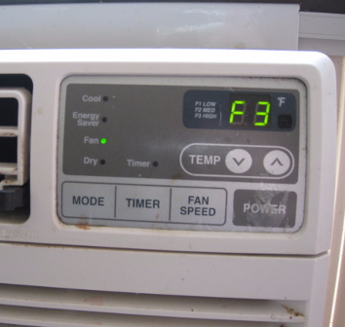

Close Up of Window Mounted Air Conditioner, Note Fan Function

Picture 10

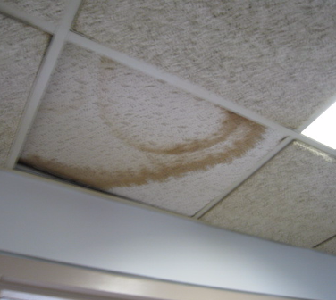

Water-Damaged Ceiling Tiles

Picture 11

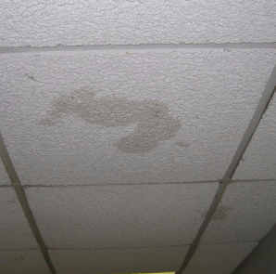

Water-Damaged Ceiling Tiles

Picture 12

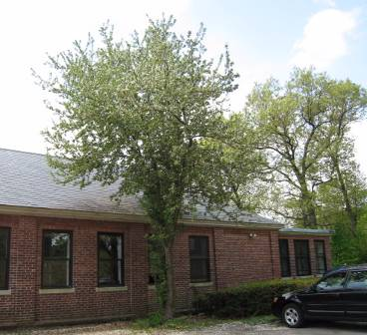

Tree Branches Overhanging Roof

Picture 13

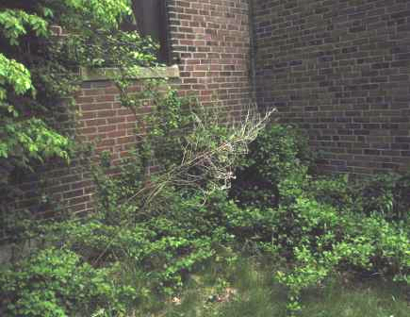

Plant Growth against the Exterior Brickwork

Picture 14



Broken Window at the Rear of Building

Picture 15

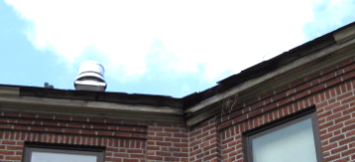

Missing/Damaged Wooden Roof Eaves at Rear of Building

Picture 16

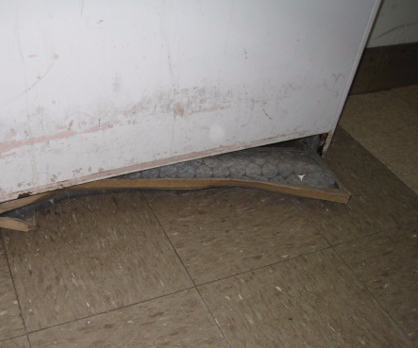

FCU Filter Protruding from Filter Rack

Picture 17

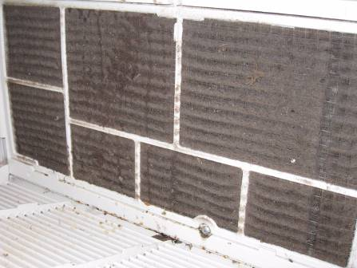

AC Filter Occluded With Dust/Debris

Picture 18

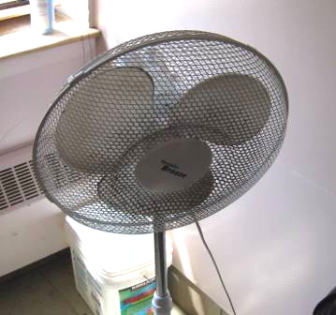

Dust/Debris Accumulation on Portable Fan
Location/ Room | Occupants  in Room | Temp  (°F) | Relative  Humidity  (%) | Carbon  Dioxide  (ppm) | Carbon Monoxide  (ppm) | PM2.5  (µg/m³) | Windows  Openable | Ventilation |  | Remarks
 |  |  |  |  |  |  |  | Supply | Exhaust | Remarks
background |  | 72 | 57 | 364 | ND | 12 |  |  |  | Cool, scattered clouds, winds 5-15 mph, gusts up to 25
145 Dining Room | 3 | 69 | 55 | 413 | ND | 16 | Y | N | N | AC-dusty filter, DO
130 | 0 | 69 | 55 | 369 | ND | 17 | Y | N | N | DO
150 | 0 | 67 | 57 | 396 | ND | 18 | Y | N | N | DO
147 | 0 | 67 | 54 | 373 | ND | 17 | Y | N | N | DO
148 | 0 | 66 | 54 | 371 | ND | 16 | Y | N | N | DO
Bathroom Left Wing |  |  |  |  |  |  | N | N | Y | Exhaust inoperable-on repair, dusty
201 | 0 | 68 | 57 | 718 | ND | 18 | Y | N | N | PF-dusty, DO
134 Dining Room | 0 | 71 | 54 | 401 | ND | 22 | Y | N | N | DO
127 | 1 | 72 | 53 | 433 | ND | 21 | Y | N | N | Window open, DO
129 | 0 | 72 | 53 | 418 | ND | 16 | Y | N | N | Window open, DO
144 | 0 | 71 | 52 | 396 | ND | 18 | Y | N | N | DO
133 | 2 | 72 | 51 | 509 | ND | 19 | Y | N | N | DO
Living Room | 0 | 73 | 51 | 409 | ND | 22 | Y | N | N | DO
161 | 0 | 73 | 51 | 385 | ND | 24 | Y | N | N | DO
Time Out  Room | 0 | 73 | 52 | 425 | ND | 26 | Y | N | N
122 | 0 | 72 | 52 | 408 | ND | 23 | Y | N | N | DO

