INDOOR AIR QUALITY ASSESSMENT

Massachusetts Department of Mental Retardation
The Fernald Center
North Nurses Building
200 Trapelo Road
Waltham, Massachusetts 02452

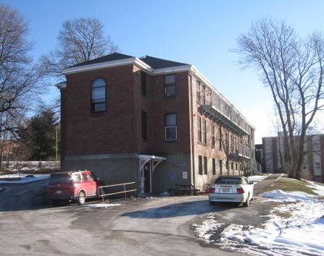

Prepared by:
Massachusetts Department of Public Health
Bureau of Environmental Health
Indoor Air Quality Program
February 2009

Background/Introduction
At the request of Roger Tremblay, Human Resources Director, Office of Disabilities & Community Services, Executive Office of Health and Human Resources (EOHHS), the Massachusetts Department of Public Health (MDPH), Bureau of Environmental Health (BEH) provided assistance and consultation regarding indoor air quality concerns at the Massachusetts Department of Retardation (DMR), North Nurses Building (NNB). The NNB is part of the Fernald Center campus located at 200 Trapelo Road, Waltham Massachusetts.
On January 5, 2009, a visit to conduct an assessment was made to this building by Cory Holmes, Environmental Analyst/Inspector for BEH’s Indoor Air Quality (IAQ) Program. The assessment was prompted by concerns of possible mold growth and water-damaged building materials due to a substantial and prolonged steam leak in the basement. A preliminary report detailing conditions observed at the time of the assessment with recommendations for mold remediation was previously issued (MDPH, 2009). This report focuses on general IAQ conditions throughout the building.
The NNB is a two-story, red brick building originally constructed in the early 1900s as a dormitory. The building has undergone renovations over the years including an addition. The building consists of offices, common work areas and office space. Windows are openable throughout the building; however, in some cases usage is prohibited by the installation of window-mounted air conditioners.

Methods
Air tests for carbon monoxide, carbon dioxide, temperature and relative humidity were conducted with the TSI, Q-Trak, IAQ Monitor, Model 8554. Air tests for airborne particle matter with a diameter less than 2.5 micrometers were taken with the TSI, DUSTTRAK™ Aerosol Monitor Model 8520. BEH staff also performed visual inspection of building materials for water damage and/or microbial growth. Moisture content of porous building materials were measured with Delmhorst, BD-2000 Model, Moisture Detector with a Delmhorst Standard Probe.

Results
The NNB has an employee population of approximately 35 to 40 and can be visited by several members of the public daily. At the time of the assessment, the majority of DMR staff typically housed on the first floor were working at alternate work locations. Test results appear in Table 1.

Discussion
Ventilation
It can be seen from Table 1 that carbon dioxide levels were below 800 parts per million (ppm) in all areas surveyed, indicating adequate air exchange in the building at the time of the assessment. It is important to note, however, that a number of areas were unoccupied or sparsely populated at the time of the assessment, which can contribute to reduced carbon dioxide levels.
The NNB is not equipped with a modern mechanical ventilation system; rather, it relies on openable windows for air circulation. In a number of cases, openable windows in offices have been eliminated with the permanent installation of window-mounted air conditioners. Without a means for air exchange via windows or a mechanical supply and exhaust system, normally occurring indoor environmental pollutants can build up and lead to indoor air quality/comfort complaints. Air conditioners examined were equipped with a “fan only” or “exhaust open” setting. In this mode of operation air conditioning units can provide air circulation by delivering outside air into space without cooling (i.e. air provided by unit equals that of outside temperature).
Restrooms, custodial closets and storage areas appear to be equipped with local exhaust ventilation (Picture 1). None of the exhaust vents were functioning during the assessment however, which can indicate they were either deactivated or inoperable. Exhaust ventilation is necessary in restrooms/custodial closets to remove excess moisture and to prevent restroom odors from penetrating into adjacent areas.
The Massachusetts Building Code requires that each room have a minimum ventilation rate of 20 cubic feet per minute (cfm) per occupant of fresh outside air or openable windows (SBBRS, 1997; BOCA, 1993). The ventilation must be on at all times that the room is occupied. Providing adequate fresh air ventilation with open windows and maintaining the temperature in the comfort range during the cold weather season is impractical. Mechanical ventilation is usually required to provide adequate fresh air ventilation.
Carbon dioxide is not a problem in and of itself. It is used as an indicator of the adequacy of the fresh air ventilation. As carbon dioxide levels rise, it indicates that the ventilating system is malfunctioning or the design occupancy of the room is being exceeded. When this happens, a buildup of common indoor air pollutants can occur, leading to discomfort or health complaints. The Occupational Safety and Health Administration (OSHA) standard for carbon dioxide is 5,000 parts per million parts of air (ppm). Workers may be exposed to this level for 40 hours/week, based on a time-weighted average (OSHA, 1997).
The MDPH uses a guideline of 800 ppm for publicly occupied buildings. A guideline of 600 ppm or less is preferred in schools due to the fact that the majority of occupants are young and considered to be a more sensitive population in the evaluation of environmental health status. Inadequate ventilation and/or elevated temperatures are major causes of complaints such as respiratory, eye, nose and throat irritation, lethargy and headaches. For more information concerning carbon dioxide, please see Appendix A.
Temperature readings in the building ranged from 69º F to 77 º F, which were within the MDPH recommended comfort guidelines in the majority of areas on the day of the assessment. The MDPH recommends that indoor air temperatures be maintained in a range of 70 º F to 78 º F in order to provide for the comfort of building occupants. In many cases concerning indoor air quality, fluctuations of temperature in occupied spaces are typically experienced, even in a building with an adequate fresh air supply. Occupants reported temperature control difficulties in a number of areas of the building. Since the building was built in the early 1900s, it was not designed for the use of modern office equipment. The combination of a lack of mechanical ventilation, waste heat producing equipment and antiquated heating components can make temperature control difficult.
The relative humidity measured in the building ranged from 18 to 23 percent, which was below the MDPH recommended comfort range in all areas surveyed. The MDPH recommends a comfort range of 40 to 60 percent for indoor air relative humidity. Relative humidity levels in the building would be expected to drop during the winter months due to heating. The sensation of dryness and irritation is common in a low relative humidity environment. Low relative humidity is a very common problem during the heating season in the northeast part of the United States.

Microbial/Moisture Concerns
As discussed in detail in a previous MDPH report, visible mold growth was observed in the 1st floor hallway and conference room, which appeared to be a result of the steam leak. The earlier report provided information and supplied guidelines for remediation (MDPH, 2009). Several other potential sources of water damage and/or mold growth unrelated to the steam leak were observed. Several areas on the second floor had water-damaged ceiling plaster and stains on walls, which likely indicate leaks from either the roof or building envelope (Pictures 2 through 4/Table 1). Active roof leaks were reported in office 201 and in the environmental closet on the 1st floor (Pictures 2 and 4).
Efflorescence was observed on ceiling and wall plaster in a number of areas (Table 1/Picture 5). Efflorescence is a characteristic sign of water damage to brick and mortar, but it is not mold growth. As moisture penetrates and works its way through mortar and brick, water-soluble compounds in mortar and brick dissolve, creating a solution. As the solution moves to the surface of the mortar or brick, the water evaporates, leaving behind white, powdery mineral deposits.
Water damaged/missing ceiling tiles were noted in the first floor hallway near room 105 (Picture 6). Water-damaged ceiling tiles can indicate sources of water penetration and provide a source of mold. Ceiling tiles should be replaced after a water leak is discovered and repaired. Water damaged wooden windowsills were also observed around window-mounted air conditioners is several areas (Picture 7/Table 1).
BEH staff examined the perimeter of the building to identify breaches in the building envelope that could provide a source for water penetration. A number of exterior sources for moisture penetration were identified:
- Damaged/dislodged gutters and downspouts (Pictures 8 through 10);
- Gutters clogged with leaves and plant debris (Picture 11);
- Missing/damaged mortar and cracks/holes in exterior brick (Pictures 12 and 13);
- Missing/damaged basement windows sealed with plywood (Pictures 14 and 15); and
- Damage/breaches in wooden eaves along the roof edge (Pictures 16 and 17).
These conditions can undermine the integrity of the building envelope and provide a means of water entry by capillary action into the building through exterior walls, foundation concrete and masonry (Lstiburek & Brennan, 2001). In addition, these breaches in exterior areas can provide a means of drafts and pest entry into the building.
The US Environmental Protection Agency and the American Conference of Governmental Industrial Hygienists (ACGIH) recommends that porous materials (carpeting, ceiling tiles, etc.) be dried with fans and heating within 24 to 48 hours of becoming wet (US EPA, 2001; ACGIH, 1989). If porous materials are not dried within this time frame, mold growth may occur. Water-damaged porous materials cannot be adequately cleaned to remove mold growth. The application of a mildewcide to moldy porous materials is not recommended.
Visible mold growth was observed along the seam of the sink countertop and backsplash in the 1st floor kitchen (Picture 18). If not watertight, moisture can penetrate through the seam, causing water damage. Improper drainage or sink overflow can lead to water penetration into the countertop, cabinet interior and areas behind cabinets. Water penetration and chronic exposure of porous and wood-based materials can cause these materials to swell and show signs of water damage.

Other Concerns
Indoor air quality can be negatively influenced by the presence of respiratory irritants, such as products of combustion. The process of combustion produces a number of pollutants. Common combustion emissions include carbon monoxide, carbon dioxide, water vapor and smoke (fine airborne particle material). Of these materials, exposure to carbon monoxide and particulate matter with a diameter of 2.5 micrometers (μm) or less (PM2.5) can produce immediate, acute health effects upon exposure. To determine whether combustion products were present in the building, BEH staff obtained measurements for carbon monoxide and PM2.5.
Carbon Monoxide
Carbon monoxide is a by-product of incomplete combustion of organic matter (e.g., gasoline, wood and tobacco). Exposure to carbon monoxide can produce immediate and acute health affects. Several air quality standards have been established to address carbon monoxide and prevent symptoms from exposure to these substances. The MDPH established a corrective action level concerning carbon monoxide in ice skating rinks that use fossil-fueled ice resurfacing equipment. If an operator of an indoor ice rink measures a carbon monoxide level over 30 ppm, taken 20 minutes after resurfacing within a rink, that operator must take actions to reduce carbon monoxide levels (MDPH, 1997).
The American Society of Heating Refrigeration and Air-Conditioning Engineers (ASHRAE) has adopted the National Ambient Air Quality Standards (NAAQS) as one set of criteria for assessing indoor air quality and monitoring of fresh air introduced by HVAC systems (ASHRAE, 1989). The NAAQS are standards established by the US EPA to protect the public health from six criteria pollutants, including carbon monoxide and particulate matter (US EPA, 2006). As recommended by ASHRAE, pollutant levels of fresh air introduced to a building should not exceed the NAAQS levels (ASHRAE, 1989). The NAAQS were adopted by reference in the Building Officials & Code Administrators (BOCA) National Mechanical Code of 1993 (BOCA, 1993), which is now an HVAC standard included in the Massachusetts State Building Code (SBBRS, 1997). According to the NAAQS, carbon monoxide levels in outdoor air should not exceed 9 ppm in an eight-hour average (US EPA, 2006).
Carbon monoxide should not be present in a typical, indoor environment. If it is present, indoor carbon monoxide levels should be less than or equal to outdoor levels. On the day of assessment, outdoor carbon monoxide concentrations were non-detect (ND) (Table 1). Similarly, carbon monoxide measurements inside the building at the time of the assessment were ND (Table 1).
Particulate Matter (PM2.5)
The US EPA has established NAAQS limits for exposure to particulate matter. Particulate matter is airborne solids that can be irritating to the eyes, nose and throat. The NAAQS originally established exposure limits to particulate matter with a diameter of 10 μm or less (PM10). According to the NAAQS, PM10 levels should not exceed 150 microgram per cubic meter (μg/m³) in a 24-hour average (US EPA, 2006). These standards were adopted by both ASHRAE and BOCA. Since the issuance of the ASHRAE standard and BOCA Code, US EPA established a more protective standard for fine airborne particles. This more stringent PM2.5 standard requires outdoor air particle levels be maintained below 35 μg/m³ over a 24-hour average (US EPA, 2006). Although both the ASHRAE standard and BOCA Code adopted the PM10 standard for evaluating air quality, MDPH uses the more protective PM2.5 standard for evaluating airborne particulate matter concentrations in the indoor environment.
Outdoor PM2.5 concentrations were measured at 11 μg/m³ (Table 1). PM2.5 levels measured indoors ranged from 5 to 9 μg/m³ (Table 1). Both indoor and outdoor PM2.5 levels were below the NAAQS PM2.5 level of 35 μg/m³. Frequently, indoor air levels of particulates (including PM2.5) can be at higher levels than those measured outdoors. A number of mechanical devices and/or activities that occur in buildings can generate particulate during normal operations. Sources of indoor airborne particulates may include but are not limited to particles generated during the operation of fan belts in the HVAC system, cooking in stoves and microwave ovens; use of photocopiers, fax machines and computer printing devices; operation of an ordinary vacuum cleaner and heavy foot traffic indoors.

Other Conditions
Other conditions that can affect indoor air quality were observed during the assessment. Occupants pointed out a coating of white dust on surfaces in the 1st floor men’s restroom (Pictures 19 and 20). The dust appears to be sloughing off ceiling plaster and becoming aerosolized when disturbed by air currents (as observed by BEH staff), such as when the restroom door is opened/closed. Dust can be irritating to eyes, nose and respiratory tract.
In some areas in the building, items were observed on windowsills, tabletops, counters, bookcases and desks. The large number of items stored provides a source for dusts to accumulate. These items (e.g., papers, folders, boxes) make it difficult for custodial staff to clean. Items should be relocated and/or be cleaned periodically to avoid excessive dust build up. Exposed fiberglass pipe insulation was observed in the 1st floor conference room. Fiberglass insulation can provide a source of skin, eye and respiratory irritation (Picture 21).
Finally, sewer gas-type odors were reported from the custodial sink/floor drain in the 1st floor environmental closet (Picture 22). Drains are usually designed with traps in order to prevent sewer odors/gases from penetrating into occupied spaces. When water enters a drain, the trap fills and forms a watertight seal. Without a periodic input of water (e.g., every other day), traps can dry, breaking the watertight seal. Without a watertight seal, odors or other material can travel up the drain and enter the occupied space.

Conclusions/Recommendations
To improve indoor environmental conditions in the building, a two-phase approach is recommended. This approach consists of short-term measures to improve air quality and long-term recommendations that will require planning and resources to adequately address the overall indoor air quality concerns.
- Continue to implement corrective actions listed in the previous DPH report (MDPH, 2009).
- Work with building occupants, management and engineering department to identify and improve areas of temperature/comfort complaints.
- Open windows (weather permitting) to temper rooms and provide fresh. As discussed, this building was designed to use windows (in combination with radiators) to provide fresh air and heat. Care should be taken to ensure windows are properly closed at night and weekends to avoid the freezing of pipes and potential flooding.
- Supplement fresh air by operating window-mounted air conditioners in the "fan only" “fresh air” mode, which introduces outside air by mechanical means.
- Restore exhaust ventilation in restrooms and custodial closets to remove odors and moisture, make repairs as necessary.
- For buildings in New England, periods of low relative humidity during the winter are often unavoidable. Therefore, scrupulous cleaning practices should be adopted to minimize common indoor air contaminants whose irritant effects can be enhanced when the relative humidity is low. To control for dusts, a high efficiency particulate arrestance (HEPA) filter equipped vacuum cleaner in conjunction with wet wiping of all surfaces is recommended. Drinking water during the day can help ease some symptoms associated with a dry environment (e.g., throat and sinus irritations).
- Make temporary repairs to seal breaches in building envelope (Pictures 12 through 17) to prevent drafts, access by pests/rodents and further water penetration and damage to building materials.
- Remove/replace water damaged ceiling tiles. Examine the areas above and around for mold growth. Disinfect areas of water leaks with an appropriate antimicrobial.
- Remove leaves and debris from gutters, examine for proper drainage.
- Seal areas around sinks to prevent water-damage to the interior of cabinets and adjacent wallboard. Clean mold and disinfect countertop in 1st floor kitchen. Make repairs or replace if needed.
- Seal basement windows to prevent water penetration and rodent/pest entry.
- Ensure leaks are repaired. Scrape off efflorescence, repair/repaint water damaged plaster.
- Relocate or consider reducing the amount of materials stored in offices and common areas to allow for more thorough cleaning. Clean items regularly with a wet cloth or sponge to prevent excessive dust build-up.
- Seal and repaint ceiling plaster in 1st floor men’s restroom to prevent flaking.
- Wrap/replace exposed fiberglass pipe insulation in conference room.
- If not in use consider sealing the floor drain in the 1st floor environmental closet, if not feasible, ensure water is poured into the drains every other day (or as needed) to maintain the integrity of the traps.
- Refer to resource manuals and other related indoor air quality documents for further building-wide evaluations and advice on maintaining public buildings. Copies of these materials are located on the MDPH’s website: http://mass.gov/dph/iaq.
The following long-term recommendations should be considered:
- Consider consulting with an architect, masonry firm or general contractor regarding the integrity of the building envelope, primarily concerning water penetration through the roof/exterior walls.
- Repair/replace missing/damaged sections of gutter/downspout system to direct water away from the building.
References
ACGIH. 1989. Guidelines for the Assessment of Bioaerosols in the Indoor Environment. American Conference of Governmental Industrial Hygienists, Cincinnati, OH.
ASHRAE. 1989. Ventilation for Acceptable Indoor Air Quality. American Society of Heating, Refrigeration and Air Conditioning Engineers. ANSI/ASHRAE 62-1989
BOCA. 1993. The BOCA National Mechanical Code-1993. 8th ed. Building Officials & Code Administrators International, Inc., Country Club Hills, IL.
Lstiburek, J. & Brennan, T. 2001. Read This Before You Design, Build or Renovate. Building Science Corporation, Westford, MA. U.S. Department of Housing and Urban Development, Region I, Boston, MA
MDPH. 1997. Requirements to Maintain Air Quality in Indoor Skating Rinks (State Sanitary Code, Chapter XI). 105 CMR 675.000. Massachusetts Department of Public Health, Boston, MA.
MDPH. 2009. Preliminary Indoor Air Quality Assessment. North Nurses Building, The Fernald Center, Waltham, MA. Massachusetts Department of Public Health, Bureau of Environmental Health, Boston, MA.

OSHA. 1997. Limits for Air Contaminants. Occupational Safety and Health Administration. Code of Federal Regulations. 29 C.F.R 1910.1000 Table Z-1-A.

SBBRS. 1997. Mechanical Ventilation. State Board of Building Regulations and Standards. Code of Massachusetts Regulations. 780 CMR 1209.0
US EPA. 2001. “Mold Remediation in Schools and Commercial Buildings”. Office of Air and Radiation, Indoor Environments Division, Washington, DC. EPA 402-K-01-001. March 2001. Available at: http://www.epa.gov/iaq/molds/mold_remediation.html
US EPA. 20006. National Ambient Air Quality Standards (NAAQS). . US Environmental Protection Agency, Office of Air Quality Planning and Standards, Washington, DC. http://www.epa.gov/air/criteria.html
Picture 1

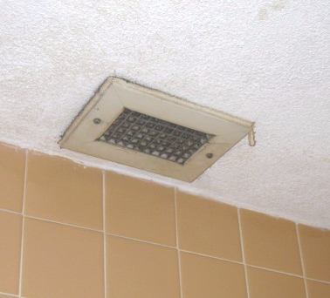

Local Exhaust Vent in Restroom

Picture 2

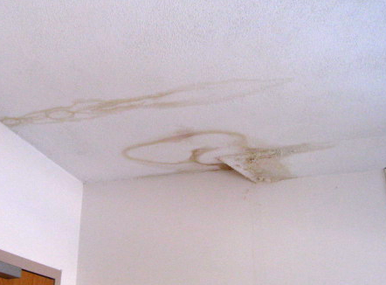

Water Damaged Ceiling Plaster, Stains on Wall/Paint Office 201

Picture 3

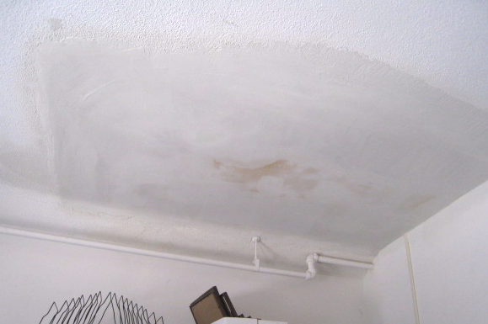

Repaired Section of Ceiling Plaster in 2nd Floor Office, Note new Staining in Center

Picture 4

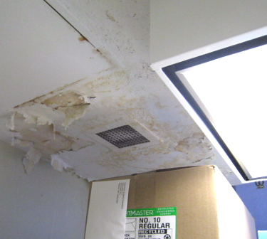

Water Damaged Ceiling Plaster/Peeling Paint in Environmental Closet 1st Floor

Picture 5

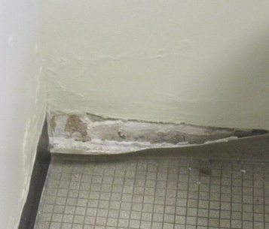

Efflorescence on Wall Plaster in Women’s Restroom

Picture 6

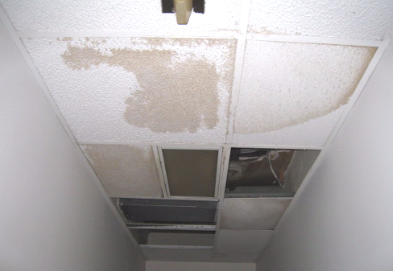

Missing/Water Damaged Ceiling Tiles 1st Floor Hallway (near Room 105)

Picture 7

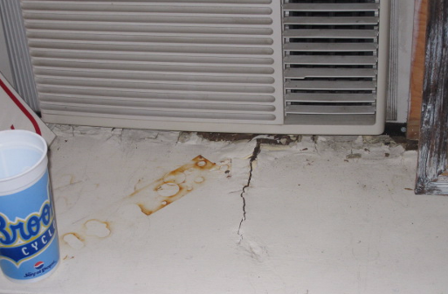

Water Damaged Wooden Windowsill in Office 110

Picture 8

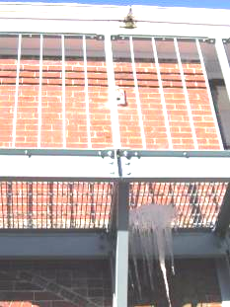

Hole in Gutter, Note Ice Formation Due to Leak

Picture 9

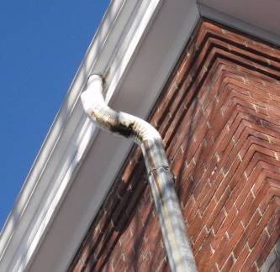

Hole in Downspout/Elbow

Picture 10

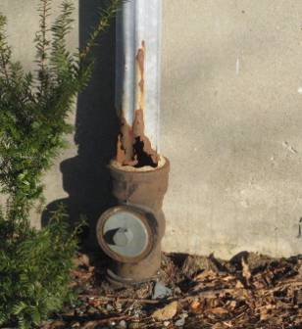

Hole in Downspout

Picture 11

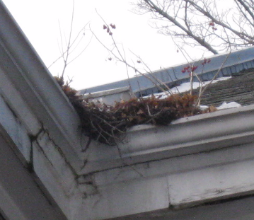

Gutters Clogged with Leaves and Plant Debris

Picture 12

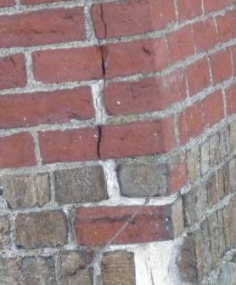

Damaged Brick, Missing/Damaged Mortar, Note Lighter Mortar Indicating
Previous Repairs/Re-pointing

Picture 13

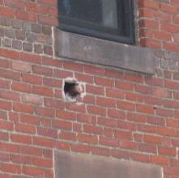

Hole in Building Exterior

Picture 14

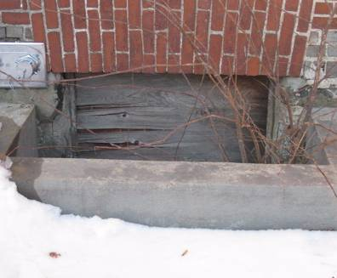

Basement Window Sealed With Plywood

Picture 15

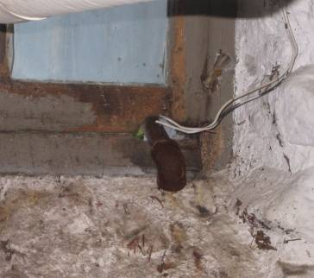

Hole in Window Frame for Utilities

Picture 16

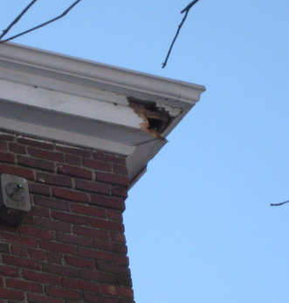

Damaged Wooden Cornice

Picture 17

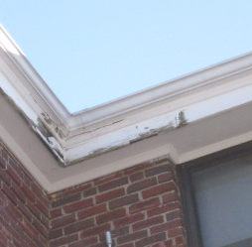

Damaged Wooden Cornice

Picture 18

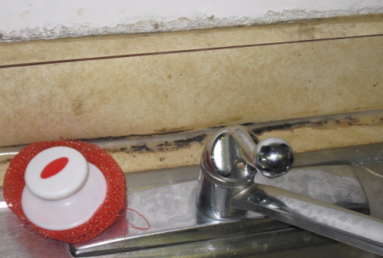

Mold (Dark Staining) along Backsplash of 1st Floor Kitchen Sink

Picture 19

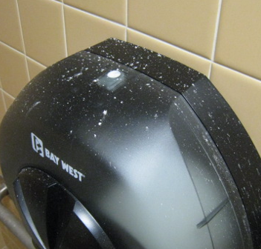

White Dust/Debris on Surfaces 1st Floor Men’s Restroom

Picture 20

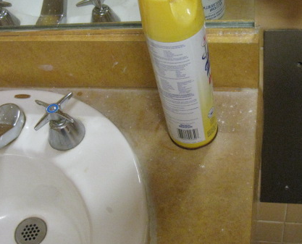

White Dust/Debris on Surfaces 1st Floor Men’s Restroom

Picture 21

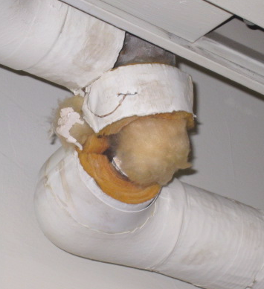

Exposed Fiberglass Insulation in 1st Floor Conference Room

Picture 22

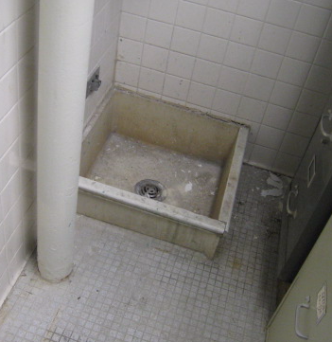

Custodial Sink/Floor Drain 1st Floor Environmental Closet
Location/ Room | Occupants  in Room | Temp  (°F) | Relative  Humidity  (%) | Carbon  Dioxide  (ppm) | Carbon Monoxide  (ppm) | PM2.5  (µg/m³) | Windows  Openable | Ventilation |  | Remarks
 |  |  |  |  |  |  |  | Supply | Exhaust | Remarks
background |  | <32 | 35 | 380 | ND | 11 |  |  |  | Overcast, cold, winds: WSW 5-10 mph
Main Hallway | 0 | 75 | 19 | 480 | ND | 8 | N | N | N | WD CT, visible surface mold on GW ceiling, low moisture measurement
Conference Room | 0 | 75 | 23 | 558 | ND | 7 | Y | N | N | Visible mold on base of wall beneath vinyl coving, carpet/walls-low moisture measurements, exposed fiberglass on pipes
111 | 0 | 75 | 19 | 554 | ND | 7 | Y | N | N | carpet/walls-low moisture measurements
110 | 0 | 75 | 18 | 461 | ND | 6 | Y | N | N | WD wooden windowsill around AC-elevated moisture, carpet/walls-low moisture measurements
Ladies RR  119 | 0 | 75 | 22 | 523 | ND | 7 | Y | N | Y | Exhaust not operating
Environmental Closet 118 | 0 | 75 | 23 | 483 | ND | 7 | Y | N | Y | Exhaust not operating, occasional odors from custodial sink/floor drain, WD ceiling plaster-low moisture, WD boxes
Men’s RR  C 113 | 0 | 75 | 22 | 481 | ND | 7 | N | N | Y | Exhaust not operating, flaking dust/debris from ceiling plaster/stucco
113 | 0 | 74 | 21 | 488 | ND | 8 | N | N | Y | Carpet/walls-low moisture measurements
115 | 0 | 76 | 21 | 573 | ND | 7 | Y | N | N | Carpet/walls-low moisture measurements
117 | 1 | 76 | 19 | 529 | ND | 7 | N | N | N | AC-no openable windows, carpet/walls-low moisture measurements
112 | 0 | 77 | 21 | 489 | ND | 7 | N | N | N | PC
Stairway |  |  |  |  |  |  |  |  |  | Carpet/walls-low moisture measurements
216 | 0 | 72 | 20 | 625 | ND | 7 | Y | N | N | DO, carpet/walls-low moisture measurements
215 | 1 | 72 | 21 | 563 | ND | 9 | Y | N | N | DO, carpet/walls-low moisture measurements
214 | 0 | 71 | 21 | 581 | ND | 7 | Y | N | N | DO, carpet/walls-low moisture measurements
213 | 0 | 71 | 21 | 530 | ND | 6 | Y | N | N | DO, carpet/walls-low moisture measurements
212 | 2 | 71 | 21 | 560 | ND | 6 | Y | N | N | DO, carpet/walls-low moisture measurements
211 | 0 | 69 | 22 | 540 | ND | 6 | Y | N | N | DO, carpet/walls-low moisture measurements
219 | 0 | 69 | 22 | 543 | ND | 7 | Y | N | N | DO, carpet/walls-low moisture measurements, WD ceiling plaster-low moisture
Storage Rooms |  |  |  |  |  |  |  |  |  | Former shower areas-no odors reported from drains
Ladies RR |  |  |  |  |  |  | Y | N | Y | Exhaust not operating, WD ceiling plaster
200 | 0 | 69 | 21 | 512 | ND | 7 | Y | N | N | DO, carpet/walls-low moisture measurements
2nd Floor Hallway |  |  |  |  |  |  |  |  |  | Carpet/walls-low moisture measurements
205 | 0 | 70 | 24 | 511 | ND | 6 | Y | N | N | DO, carpet/walls-low moisture measurements
206 | 0 | 73 | 25 | 532 | ND | 5 | Y | N | N | Walls-low moisture measurements
207 | 0 | 74 | 25 | 509 | ND | 7 | Y | N | N | WD wooden windowsill-low moisture, walls-low moisture
208 | 0 | 75 | 27 | 701 | ND | 5 | Y | N | N | Carpet/walls-low moisture measurements, WD wooden windowsill-low moisture
209 | 2 | 75 | 24 | 650 | ND | 8 | Y | N | N | Carpet/walls-low moisture measurements
210 | 1 | 75 | 21 | 659 | ND | 6 | Y | N | N | WD ceiling plaster-low moisture measurements, DO
201 | 1 | 72 | 23 | 581 | ND | 8 | Y | N | N | WD ceiling plaster-low moisture, wall plaster-elevated moisture beneath ceiling leak
1st Floor Hallway (near 105) |  |  |  |  |  |  |  |  |  | WD/missing CTs, carpet/walls-low moisture measurements
109 | 1 | 70 | 24 | 600 | ND | 7 | Y | N | N | DO, heat complaints, walls-low moisture measurements
101 | 0 | 70 | 23 | 707 | ND | 7 | Y | N | N
107 | 0 | 72 | 21 | 605 | ND | 6 | Y | N | N
106 | 1 | 75 | 21 | 618 | ND | 6 | Y | N | N | Carpet/walls low moisture measurements
103 | 0 | 75 | 20 | 673 | ND | 7 | Y | N | N
105 | 0 | 76 | 18 | 561 | ND | 6 | Y | N | N | Carpet/walls low moisture measurements
Kitchen |  |  |  |  |  |  |  |  |  | Water damaged sink/backsplash-mold

