INDOOR AIR QUALITY ASSESSMENT

Massachusetts Department of Developmental Services
21 Spring Street
Taunton, Massachusetts

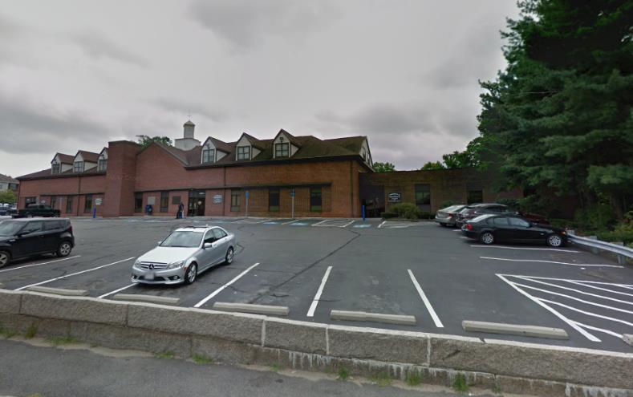

Prepared by:
Massachusetts Department of Public Health
Bureau of Environmental Health
Indoor Air Quality Program
March 2019

Executive Summary
The main complaint was in regards to water damage/mold concerns, which have been resolved due to recent replacement of the roof and subsequently, affected ceiling tiles/insulation. Carpeting is old/worn and past its service life and should be replaced. A HAZMAT incident occurred during the assessment, involving a kerosene-containing thermometer/device in a private office, which was isolated/contained upon discovery by MDPH/IAQ staff and remediated over the weekend following the Friday site visit.

Background
Building: | Massachusetts Department of Developmental Services (DDS)
Address: | 21 Spring Street, Taunton, MA
Assessment Requested by: | Executive Office of Health and Human Services (EOHHS)
Reason for Request: | General indoor air quality (IAQ) assessment and mold concerns
Date of Assessment: | March 8, 2019
Massachusetts Department of Public Health/Bureau of Environmental Health (MDPH/BEH) Staff Conducting Assessment: | Cory Holmes, Environmental Analyst/Inspector, IAQ Program
Building Description: | The DDS occupies a one-story red brick section of a building occupied by several other EOHHS offices. The space contains wall to wall carpet and suspended ceiling tiles. The DDS has occupied the space for over 25 years.
Windows: | There are no openable windows in the space.

Methods
Please refer to the IAQ Manual and appendices for methods, sampling procedures, and interpretation of results (MDPH, 2015).

Background
During the site visit, it was brought to the attention of BEH/IAQ staff that a kerosene-containing device called a Galileo Thermometer (H-B Instrument, 2014; Picture 1) had broken in an office (Garrett Office). A limited area of the carpet was wet with kerosene and odors were present (Picture 2). To prevent the migration of odors into adjacent areas, BEH/IAQ staff cleared the room, shut the louvers on the supply vent (Picture 3), sealed both the supply and return vents with plastic and duct tape and sealed the door (Picture 4). In addition, the carpet was recommended to be removed, which was confirmed to have occurred over the weekend following the Friday site visit.

Results and Discussion
The following is a summary of indoor air testing results (Table 1).
- Carbon dioxide measurements were below the MDPH recommended level of 800 parts per million (ppm) in all areas surveyed.
- Temperature was within the MDPH recommended range of 70°F to 78°F at the time of assessment.
- Relative humidity was below the MDPH recommended range of 40 to 60% in all areas tested, which is typical of New England during the heating season.
- Carbon monoxide levels were non-detectable (ND) in all areas tested.
- Particulate matter (PM2.5) concentrations measured were below the National Ambient Air Quality (NAAQS) level of 35 μg/m³ in all areas tested.
- Moisture Measurements of porous building materials (i.e., carpet, ceiling tiles) were all dry (i.e., within normal parameters) at the time of assessment.
- Total Volatile Organic Compounds (TVOCs) were measured at low levels (5-6 ppm) in the breathing zone in Garrett Office (35 ppm directly over the spill). All other areas tested ND.

Ventilation
A heating, ventilating and air-conditioning (HVAC) system has several functions. First it provides heating and, if equipped, cooling. Second, it is a source of fresh air. Finally, an HVAC system will dilute and remove normally occurring indoor environmental pollutants by not only introducing fresh air, but also filtering the airstream and ejecting stale air to the outdoors via exhaust ventilation.
Testing results suggest that sufficient fresh air was being introduced into the space for the current occupancy at the time of assessment. Operating the system in the fan “on” mode for continuous circulation/filtration is recommended.
It is important to note that relative humidity levels in the building would be expected to be low during the winter months due to atmospheric conditions and heating. Low relative humidity can lead to common symptoms such as: dry skin, lips, and scalp; dry/scratchy throats and noses (nose bleeds); exacerbation of asthma, eczema, or allergies; dry/irritated eyes; and irritation of respiratory tract.
In order to have proper ventilation with a mechanical HVAC system, the system must be balanced to provide an adequate amount of fresh air to the interior of a room while removing stale air from the room. It is recommended that existing ventilation systems be re-balanced every five years to ensure adequate air systems function (SMACNA, 1994).
The rooftop air handling units (AHUs) were not accessible at the time of assessment. It is recommended that AHUs should be outfitted with pleated filters of a Minimum Efficiency Reporting Value (MERV) of 8, if they are not already, which are adequate in filtering out pollen and mold spores (ASHRAE, 2012). In addition, filters should be changed 2-4 times a year or in accordance with the manufacture’s recommendations.
Also noted was a lack of draw from restroom exhaust vents. Exhaust ventilation is important in restrooms to remove excess moisture and odors.

Microbial/Moisture Concerns
In order for building materials to support mold growth, a source of water exposure is necessary. Water-damaged ceiling tiles were seen some areas (Pictures 5 through 7; Table 1), reportedly due to roof leaks. Water-damaged ceiling tiles indicate leaks from either the roof or plumbing system and can provide a source for mold growth. All ceiling tiles were tested for moisture content and found dry (as well as carpeting below them) at the time of assessment. These tiles should be replaced after a water leak is discovered and repaired. It was reported that the rubber membrane roof was replaced several months prior to the assessment. Stained ceiling tiles (and insulation material above them) were confirmed replaced over the weekend after the Friday site visit.
The US Environmental Protection Agency (US EPA) and the American Conference of Governmental Industrial Hygienists (ACGIH) recommends that porous materials (e.g., wallboard, carpeting, ceiling tiles) be dried with fans and heating within 24 to 48 hours of becoming wet (US EPA, 2008; ACGIH, 1989). If porous materials are not dried within this time frame, mold growth may occur. Once mold has colonized porous materials, they are difficult to clean and should be removed.

Other IAQ Evaluations
Other conditions that can affect IAQ were observed during the assessment. Carpets should be cleaned annually (or semi-annually in soiled/high traffic areas) in accordance with Institute of Inspection, Cleaning and Restoration Certification (IICRC) recommendations, (IICRC, 2012). The service life of carpeting is approximately 10-11 years (IICRC, 2002). In many areas, carpeting was observed to be worn and stained (Pictures 8 through 10). Carpeting of this age and condition becomes increasingly difficult to clean and maintain and may be a source of particulate matter to the indoor environment. Regular cleaning with a high efficiency particulate air (HEPA) filtered vacuum in combination with an annual cleaning will help to reduce accumulation and potential aerosolization of materials from carpeting.
In a number of areas, items were observed on the floor, windowsills, tabletops, counters, bookcases and desks. The large number of items stored provides a source for dusts to accumulate. These items (e.g., papers, folders, boxes) make it difficult for custodial staff to clean. Items should be relocated and/or be cleaned periodically to avoid excessive dust build up. In addition, dusty materials can accumulate on flat surfaces (e.g., desktops, windowsills and carpets) in occupied areas and subsequently be re-aerosolized causing further irritation.
Exposure to low levels of TVOCs may produce eye, nose, throat, and/or respiratory irritation in some sensitive individuals. In addition to testing, BEH/IAQ staff examined spaces for products containing VOCs. BEH/IAQ staff noted air fresheners/deodorizers, hand sanitizers and cleaning products in a number of areas. All of these products have the potential to be irritants to the eyes, nose, throat, and respiratory system of sensitive individuals.

Conclusions and Recommendations
In view of the findings at the time of the visit, the following recommendations are made:
- Operate HVAC system in fan “on” mode to provide continuous circulation/filtration during occupied hours.
- Have the HVAC system re-balanced, as recommended (every 5 years) in accordance with SMACNA recommendations (SMACNA, 1994).
- Restore exhaust vents/motors to working order. Examine all restroom exhaust vents/motors/belts for proper function, make repairs as needed.
- For buildings in New England, periods of low relative humidity during the winter are often unavoidable. Therefore, scrupulous cleaning practices should be adopted to minimize common indoor air contaminants whose irritant effects can be enhanced when the relative humidity is low. To control for dusts, a high efficiency particulate arrestance (HEPA) filter-equipped vacuum cleaner in conjunction with wet wiping of all surfaces is recommended. Avoid the use of feather dusters. Drinking water during the day can help ease some symptoms associated with a dry environment (throat and sinus irritation).
- Monitor the new roof for watertight integrity and report any water-stained ceiling tiles for prompt replacement/remediation as well as any remaining damaged tiles from previous leaks.
- Reduce clutter building-wide and increase dust control.
- Ensure HVAC filters are of a pleated variety, MERV dust-spot efficiency 8 or higher, which are adequate in filtering out pollen and mold spores (ASHRAE, 2012). Filters should be changed 2-4 times a year or in accordance with the manufacture’s recommendations.
- Reduce the use of cleaning products, sanitizers and other items that contain VOCs.
- Consider replacing any worn carpeting with new carpet tiles. Regularly HEPA vacuum any remaining carpeting and clean annually according to IICRC recommendations (IICRC, 2012).
- For more information about mold, consult the US EPA’s “Mold Remediation in Schools and Commercial Buildings” (US EPA, 2008).
- Refer to resource manual and other related IAQ documents located on the MDPH’s website for further building-wide evaluations and advice on maintaining public buildings. These documents are available at http://mass.gov/dph/iaq.

REFERENCES
ACGIH. 1989. Guidelines for the Assessment of Bioaerosols in the Indoor Environment. American Conference of Governmental Industrial Hygienists, Cincinnati, OH.
ASHRAE. 2012. American Society of Heating, Refrigeration and Air Conditioning Engineers (ASHRAE) Standard 52.2-2012 -- Method of Testing General Ventilation Air-Cleaning Devices for Removal Efficiency by Particle Size (ANSI Approved).
H-B Instrument. 2014. Safety Data Sheet. Oil of Galileo Thermometer. Bel-Art Products. Revision 6/26/2014.
IICRC. 2002. Institute of Inspection, Cleaning and Restoration Certification. A Life-Cycle Cost Analysis for Floor Coverings in School Facilities.
IICRC. 2012. Institute of Inspection Cleaning and Restoration Certification. Institute of Inspection, Cleaning and Restoration Certification. Carpet Cleaning: FAQ.
MDPH. 2015. Massachusetts Department of Public Health. Indoor Air Quality Manual: Chapters I-III. Available at: http://www.mass.gov/eohhs/gov/departments/dph/programs/environmental-health/exposure-topics/iaq/iaq-manual/.
SMACNA. 1994. HVAC Systems Commissioning Manual. 1st ed. Sheet Metal and Air Conditioning Contractors’ National Association, Inc., Chantilly, VA.
US EPA. 2008. “Mold Remediation in Schools and Commercial Buildings”. Office of Air and Radiation, Indoor Environments Division, Washington, DC. EPA 402-K-01-001. September 2008. Available at: http://www.epa.gov/mold/mold-remediation-schools-and-commercial-buildings-guide.
Picture 1
Examples of Galileo Thermometers
Picture 2
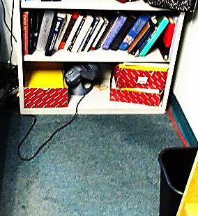
Carpet wet/stained with kerosene (corner/arrow)
Picture 3
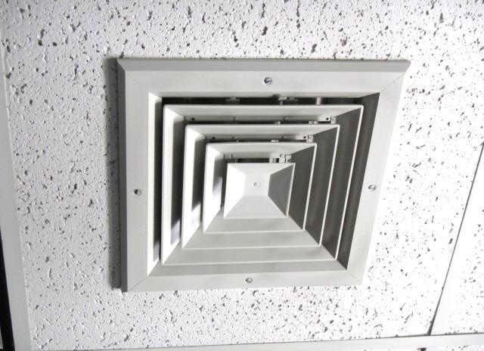
Louvers shut on ceiling-mounted supply vent in Garrett Office, note this vent was also sealed with plastic and duct tape
Picture 4
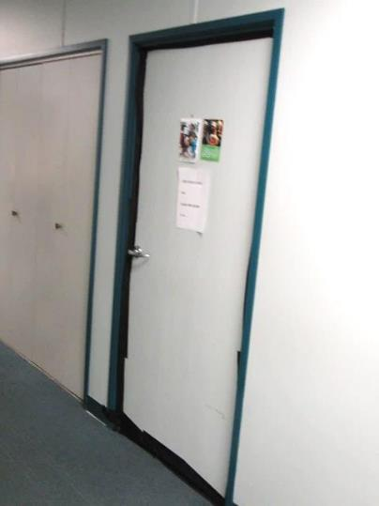
Sealed door of Garrett Office
Picture 5
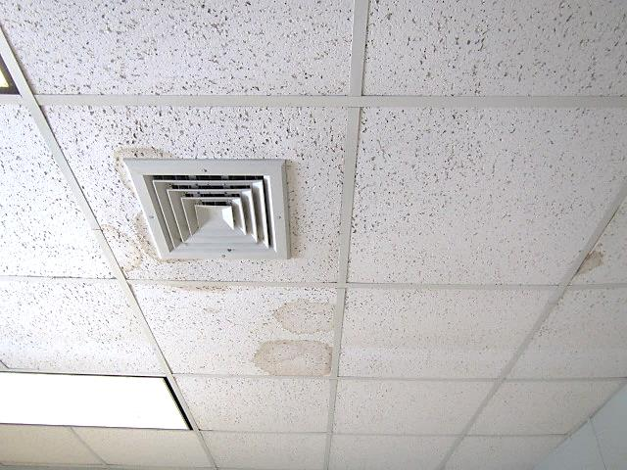
Water-damaged ceiling tiles in Tracy Office
Picture 6
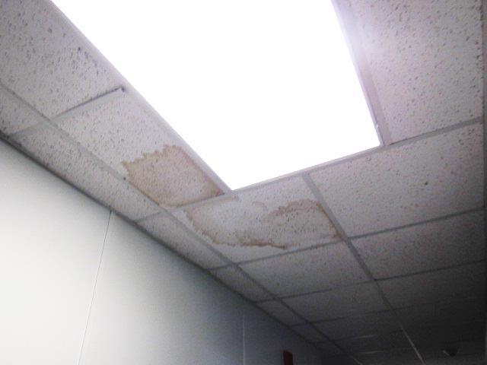
Water-damaged ceiling tiles in main hallway
Picture 7
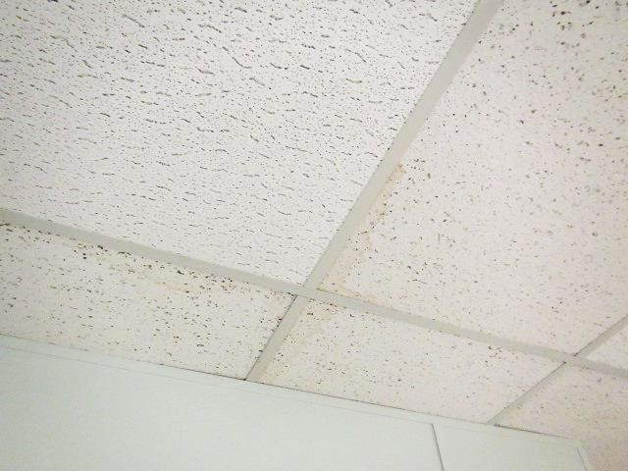
Water-damaged ceiling tiles in Reception hallway
Picture 8
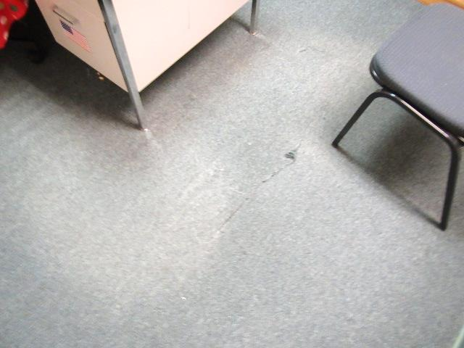
Worn/damaged carpeting
Picture 9
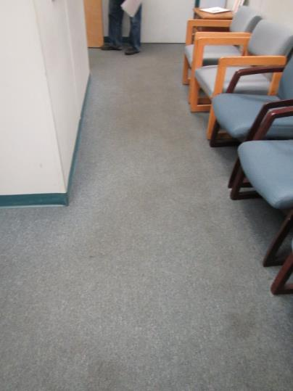
Worn/stained carpeting
Picture 10
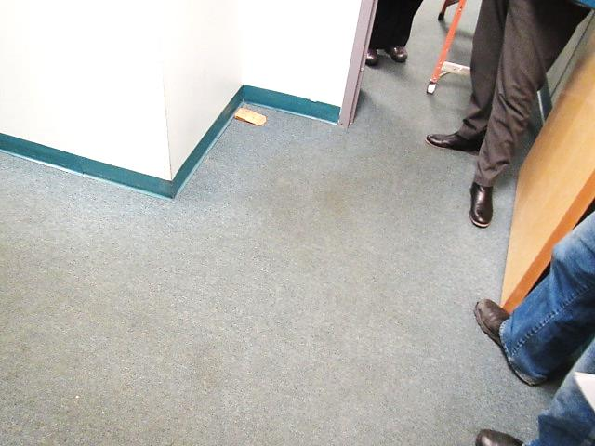
Worn/stained carpeting
Location | Carbon  Dioxide  (ppm) | Carbon Monoxide  (ppm) | Temp  (°F) | Relative  Humidity  (%) | TVOCs  (ppm) | PM2.5  (µg/m³) | Occupants  in Room | Windows  Openable | Ventilation |  |  | Remarks
 |  |  |  |  |  |  |  |  | Intake | Exhaust
Background (outside) | 416 | ND | 38 | 23 | ND | 7 |  |  |  |  |  | Cold, clear/sunny
Area Director Office | 726 | ND | 70 | 18 | ND | 5 | 5 | N | Y |  | Y | Carpet
Reception | 666 | ND | 72 | 15 | ND | 5 | 1 | N | Y |  | Y | Carpet-worn/stained, HS/wipes, carpet dry
Waiting Area | 655 | ND | 73 | 12 | ND | 9 | 0 | N | Y |  | Y | Carpet-soiled/stained-dry
Garrett Office | 779 | ND | 74 | 15 | 4-5* | 5 | 2 | N | Y |  | Y | *TVOC 4-5 in breathing zone, 35 ppm directly over spill, odors-detected
Main Hallway (outside Garrett Office) | 661 | ND | 74 | 12 | ND | 5 | 0 | N | Y |  | Y | Garrett office sealed by MDPH/IAQ staff, WD CTs-historic leaks-dry
Tracy Office | 774 | ND | 73 | 16 | ND | 5 | 0 | N | Y |  | Y | WD CTs-historic leaks-dry, sloughing wallpaper-corner

