INDOOR AIR QUALITY ASSESSMENT

Department of Developmental Services
194 West Street, Unit 9
Milford, MA

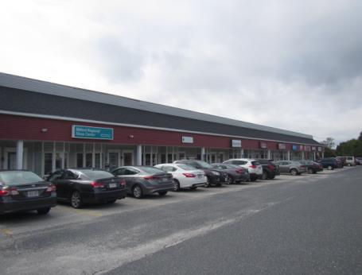

Prepared by:
Massachusetts Department of Public Health
Bureau of Environmental Health
Indoor Air Quality Program
October 2018

Background
Building: | Department of Developmental Services (DDS)
Address: | 194 West Street, Unit 9, Milford, MA
Assessment Requested by: | Deborah Coleman, Facilities Director,  Executive Office of Health and Human Services (EOHHS)
Reason for Request: | General indoor air quality (IAQ) and follow-up to water damage remediation
Date of Assessment: | October 4, 2018
Massachusetts Department of Public Health/Bureau of Environmental Health (MDPH/BEH) Staff Conducting Assessment: | Cory Holmes, Environmental Analyst/Inspector, IAQ Program
Building Description: | The DDS office is on located in a one-story mixed use building built in 1988. The DDS has occupied the space for approximately 20 years and is flanked by a private office and exercise facility. The office contains wall-to-wall carpeting, gypsum wallboard (GW) and suspended ceiling tiles.
Building Population: | Approximately 20-25 employees meeting with a number of clients each day
Windows: | Not openable

Methods
Please refer to the IAQ Manual for methods, sampling procedures, and interpretation of results (MDPH, 2015).

IAQ Testing Results
The following is a summary of indoor air testing results (Table 1).
- Carbon dioxide levels were below or very close to the MDPH guidance level of 800 parts per million (ppm) in all areas assessed, indicating adequate fresh air in the space.
- Temperature was within the recommended range of 70°F to 78°F in all areas assessed.
- Relative humidity was within or very close to the recommended range of 40% to 60%.
- Carbon monoxide levels were non-detectable (ND).
- Fine particulate matter (PM2.5) concentrations measured were below the National Ambient Air Quality Standard (NAAQS) level of 35 μg/m³.

Ventilation
A heating, ventilating, and air conditioning (HVAC) system has several functions. First, it provides heating and, if equipped, cooling. Second, it is a source of fresh air. Finally, an HVAC system will dilute and remove normally-occurring indoor environmental pollutants by not only introducing fresh air, but also filtering the airstream and ejecting stale air to the outdoors via exhaust ventilation. Even if an HVAC system is operating as designed, point sources of respiratory irritation may exist and affect symptoms in sensitive individuals.
Fresh air is provided by rooftop air handling units (AHUs). Air from the AHUs is filtered, heated/cooled, and delivered to rooms via ducted supply vents (Picture 1). Air is returned/exhausted through exhaust grills (Picture 2). It is recommended that during occupied periods, the HVAC system be operated with the fan “on” vs. “auto” mode. It could not be discerned from Picture 3 what the thermostat was set to. The fan “on” mode provides continuous air circulation and filtration. AHUs were not accessible at the time of assessment. It is recommended that AHUs be outfitted with pleated filters of a Minimum Efficiency Reporting Value (MERV) of 8 or higher, which are adequate in filtering out pollen and mold spores (ASHRAE, 2012). In addition, filters should be changed 2-4 times a year or in accordance with the manufacture’s recommendations.
Occupants expressed concern regarding the effectiveness of restroom exhaust vents. The exhaust fans are activated by a light switch. BEH/IAQ staff examined the vent motors above the ceiling and found that the units were not vented to the outside (Pictures 4 and 5). Vents should be exhausted to the outside of the building to remove excess moisture and odors. In addition, venting above the ceiling can pressurize the plenum and force dust/debris into occupied areas providing a source of irritation.

Microbial/Moisture Concerns
As mentioned, this assessment was conducted as a follow up to a previous MDPH water damage investigation conducted in July 2018 in response to roof leaks. At the time of this assessment, all materials moistened during the July roof leak event were dried and ceiling tiles had been changed.
BEH/IAQ staff noted a white/wet stain on the carpet in the main reception area that was reportedly spilt milk. The carpet was recommended to be cleaned/dried. In addition, moist carpeting was detected directly inside the exterior doors (Pictures 6 and 7). If not properly sealed, moisture/drafts can enter underneath/around exterior doors and wet carpeting, which could lead to mold growth/associated odors. Spaces around exterior doors were observed in the form of light penetrating around doors (to the rear of the MRC) and accumulated debris on doors (Pictures 8 through 10).
Water dispensers were observed in carpeted areas (Table 1; Picture 11). These appliances may spill or leak and lead to carpet damage and microbial growth. It is recommended that these appliances be located in areas without carpeting or on waterproof mats. Carpet could also be replaced with tile in areas in front of exterior doors and where water dispensers are located.
Plants were observed in some office areas (Table 1). Plants can be a source of pollen and mold, which can be respiratory irritants to some individuals. Plants should be properly maintained and equipped with drip pans to prevent water damage to porous materials. Plants should also be located away from air diffusers to prevent the aerosolization of dirt, pollen, and mold.

Other IAQ Evaluations
Exposure to low levels of total volatile organic compounds (TVOCs) may produce eye, nose, throat, and/or respiratory irritation in some sensitive individuals. To determine if VOCs were present, BEH/IAQ staff examined rooms for products containing VOCs. BEH/IAQ staff noted air fresheners, hand sanitizers, dry erase materials and other products in use within the building (Table 1). All of these products have the potential to be irritants to the eyes, nose, throat, and respiratory system of sensitive individuals.
The offices were mostly carpeted. Carpets should be cleaned annually (or semi-annually in soiled/high traffic areas) in accordance with Institute of Inspection, Cleaning and Restoration Certification (IICRC) recommendations, (IICRC, 2012).
In some areas, stored materials and accumulated items make it more difficult for custodial staff to clean. Items should be stored neatly and moved periodically to allow for wet wiping and vacuuming of surfaces.
Personal fans were observed in a number of areas. Fan blades to some of these units had settled dust (Picture 12), which can be reaerosolized when the fan is activated. Some supply/exhaust vents also had accumulated dust/debris (Picture 13).

Conclusions/Recommendations
Based on observations at the time of assessment, the following is recommended:
- Operate supply and exhaust ventilation in all areas during occupied periods.
- Duct restroom exhaust vents to the outdoors and operate during occupied periods to remove moisture and odors.
- Have the HVAC system balanced every 5 years in accordance with SMACNA recommendations (SMACNA, 1994).
- Use pleated MERV 8 filters in AHUs, which are adequate in filtering out pollen and mold spores (ASHRAE, 2012). Change 2-4 times a year or in accordance with the manufacture’s recommendations.
- Ensure exterior doors are weathertight, examine around doors for light penetration and drafts.
- Consider installing floor tile directly inside exterior doors to prevent wetting of carpeting, mold growth and/or associated odors (see Picture 14 for example).
- Install plastic/rubber mats beneath water dispensers.
- For buildings in New England, periods of low relative humidity during the winter are often unavoidable. Therefore, scrupulous cleaning practices should be adopted to minimize common indoor air contaminants whose irritant effects can be enhanced when the relative humidity is low. To control for dusts, a high efficiency particulate arrestance (HEPA) filter equipped vacuum cleaner in conjunction with wet wiping of all surfaces is recommended. Avoid the use of feather dusters. Drinking water during the day can help ease some symptoms associated with a dry environment (throat and sinus irritations).
- Keep indoor plants in good condition, avoid overwatering, and avoid placing them on porous items such as carpets or paper. Also, keep plants out of the air stream of supply vents.
- Reduce use of products containing VOCs including eliminating air freshening products.
- Clean carpeting in accordance with IICRC recommendations (IICRC, 2012).
- Reduce accumulated materials on flat surfaces and store in an organized manner to allow for thorough cleaning.
- Clean the blades of personal fans, supply, and exhaust vents periodically to avoid aerosolizing dusts.
- Refer to resource manual and other related IAQ documents located on the MDPH’s website for further building-wide evaluations and advice on maintaining public buildings. These documents are available at: http://mass.gov/dph/iaq.

References
ASHRAE. 2012. American Society of Heating, Refrigeration and Air Conditioning Engineers (ASHRAE) Standard 52.2-2012 -- Method of Testing General Ventilation Air-Cleaning Devices for Removal Efficiency by Particle Size (ANSI Approved).
IICRC. 2012. Institute of Inspection, Cleaning and Restoration Certification. Carpet Cleaning: FAQ.
MDPH. 2015. Massachusetts Department of Public Health. Indoor Air Quality Manual: Chapters I-III. Available at: http://www.mass.gov/eohhs/gov/departments/dph/programs/environmental-health/exposure-topics/iaq/iaq-manual/.
SMACNA. 1994. HVAC Systems Commissioning Manual. 1st ed. Sheet Metal and Air Conditioning Contractors’ National Association, Inc., Chantilly, VA.
Picture 1
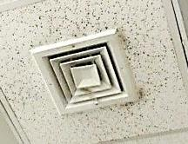
Supply diffuser, note accumulated dust/debris on vent and ceiling tiles
Picture 2
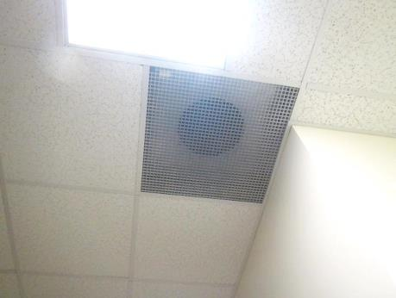
Return vent/grill
Picture 3
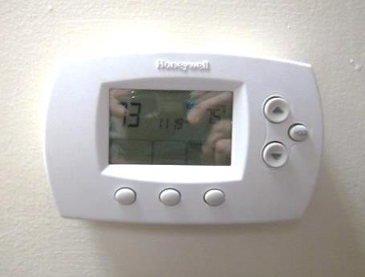
Digital thermostat
Picture 4
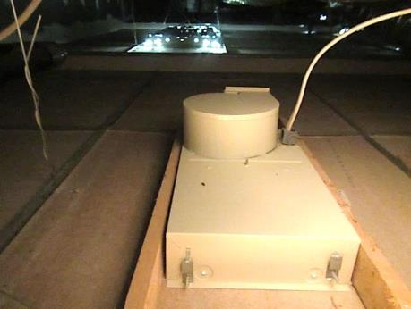
Restroom exhaust vent above ceiling, note lack of ductwork to outside
Picture 5
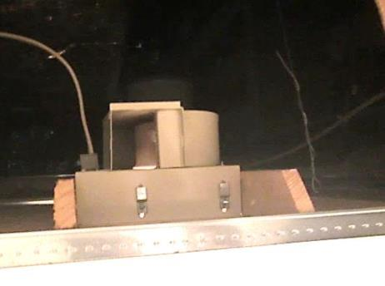
Restroom exhaust vent above ceiling, note lack of ductwork to outside
Picture 6
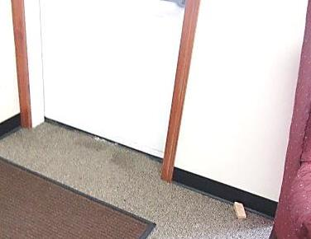
Moist carpeting in front of exterior door, note stains
Picture 7
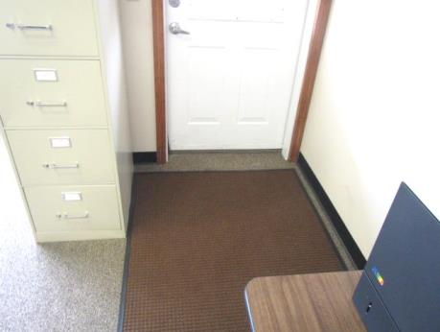
Moist carpeting in front of exterior door
Picture 8
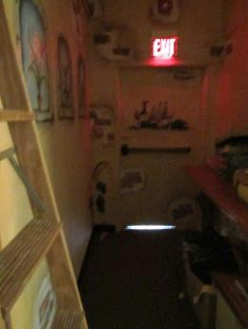
Light penetrating beneath exterior door
Picture 9
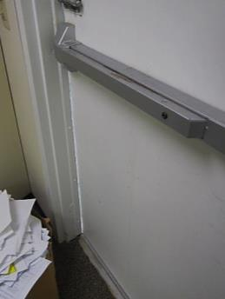
Light penetrating around exterior door
Picture 10
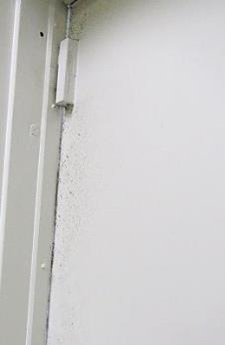
Accumulated debris on interior of exterior door from drafts/air penetration
Picture 11
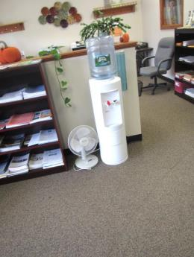
Water dispenser on carpet
Picture 12
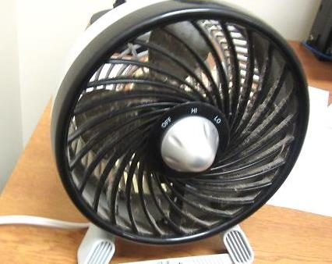
Accumulated dust/debris on personal fan
Picture 13
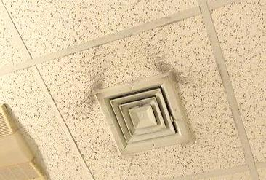
Accumulated dust/debris on supply vent/ceiling tiles
Picture 14
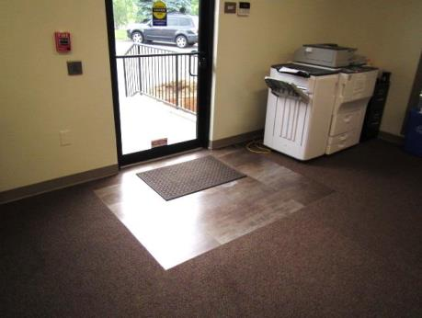
Tile installed in front of exterior door (Middleborough DDS)
Location | Carbon  Dioxide  (ppm) | Carbon Monoxide  (ppm) | Temp  (°F) | Relative  Humidity  (%) | PM2.5  (µg/m³) | Occupants  in Room | Windows  Openable | Ventilation |  | Remarks
 |  |  |  |  |  |  |  | Supply | Exhaust
Background | 406 | ND | 69 | 79 | 10 |  |  |  |  | Mostly cloudy, humid
Main Reception | 742 | ND | 73 | 61 | 2 | 2 | N | Y | N | Carpet stain (spilt milk), plants, water cooler on carpet, dust debris on vents, HS, PF
Germaine Office | 746 | ND | 75 | 60 | 1 | 0 | N | Y | N | DO, PF-dusty, AF-spray bottle (flammable/alcohol)
Enegren Office | 788 | ND | 75 | 59 | 1 | 0 | N | Y | N
Boone Office | 798 | ND | 75 | 58 | 1 | 0 | N | Y | N | DO
Moore Office | 757 | ND | 75 | 58 | 1 | 0 | N | Y | N | DO, DEM
Barrett Office | 779 | ND | 76 | 59 | 1 | 1 | N | Y | N | DO
Margolin Office | 782 | ND | 76 | 59 | 2 | 1 | N | Y | N | DO
Hooley Office (open) | 790 | ND | 75 | 59 | 2 | 1 | N | Y | N | AF oil/reeds
Work Cubicles/Storage Area | 749 | ND | 75 | 58 | 2 | 0 | N | Y | Y
Mercer | 775 | ND | 75 | 59 | 3 | 0 | N | Y | Y | Items on flat surfaces, dust/debris on vents
Eldridge Office | 790 | ND | 75 | 58 | 2 | 0 | N | Y | N
O’Neill Office | 763 | ND | 75 | 58 | 2 | 1 | N | Y | Y
Cooper | 752 | ND | 75 | 59 | 2 | 1 | N | Y | N
Break Room | 756 | ND | 76 | 59 | 3 | 0 | N | Y | N
Coenen Office | 726 | ND | 75 | 58 | 2 | 0 | N | Y | N
Lee Office | 756 | ND | 76 | 59 | 3 | 0 | N | Y | N
Restrooms |  |  |  |  |  |  | N | Y | Y | Exhaust vents not vented outdoors, dust/debris on vents/CTs
Breakroom Dining Area | 752 | ND | 75 | 60 | 7 | 0 | N | Y | N | DO
Losardo Office | 773 | ND | 75 | 60 | 4 | 1 | N | Y | N | DO, plants
Tracy Office | 745 | ND | 76 | 60 | 4 | 0 | N | Y | N | DO
Roberts/Clifford Office | 805 | ND | 76 | 60 | 6 | 2 | N | Y | N | DO
Salera Office | 739 | ND | 76 | 58 | 5 | 0 | N | Y | N | DO

