INDOOR AIR QUALITY ASSESSMENT

Department of Developmental Services
1221 Main Street
Weymouth, Massachusetts

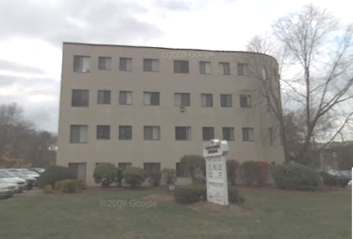

Prepared by:
Massachusetts Department of Public Health
Bureau of Environmental Health
Indoor Air Quality Program
May 2011

Background/Introduction
At the request of Roger Tremblay, Human Resources Director for the Executive Office of Health and Human Resources’ (EOHHS) Office of Disabilities and Community Services, the Massachusetts Department of Public Health (MDPH), Bureau of Environmental Health (BEH) provided assistance and consultation regarding indoor air quality (IAQ) concerns at the Massachusetts Department of Developmental Services’ (DDS) South Coastal Area Office located at 1221 Main Street, Weymouth, Massachusetts. The request was prompted by employee concerns of poor indoor air quality conditions in the building. On December 17, 2010, a visit was made to the DDS by Sharon Lee, Environmental Analyst/IAQ Inspector within BEH’s IAQ Program.
The DDS is located on the third floor of a four-story brick building constructed in 1987. The remainder of the building is occupied primarily by a medical practice. The DDS space, which consists of small offices and common work areas, has wall-to-wall carpeting, gypsum wallboard (GW), and dropped ceilings. Windows are openable throughout the DDS.

Methods
Air tests for carbon monoxide, carbon dioxide, temperature and relative humidity were conducted with the TSI, Q-Trak, IAQ Monitor, Model 7565. Air tests for airborne particle matter with a diameter less than 2.5 micrometers were taken with the TSI, DUSTTRAK™ Aerosol Monitor Model 8520. Moisture content of porous building materials was measured with a Delmhorst, BD-2100 Model, Moisture Detector equipped with a Delmhorst Standard Probe BEH staff also performed visual inspection of building materials for water damage and/or microbial growth.

Results
The DDS has an employee population of approximately 33 and can be visited by up to 20 members of the public daily. The tests were taken during normal operations and results appear in Table 1. Locations where tests were taken are listed by letter designation listed on the floor plan provided in Figure 1.

Discussion

Ventilation
It can be seen from Table 1 that carbon dioxide levels were above 800 parts per million (ppm) in all areas surveyed, indicating a lack of air exchange at the time of the assessment. Ventilation is provided by two air-handling units (AHUs) located in mechanical closets on the third floor (Picture 1). Ductwork located above the ceiling connects the AHUs to ceiling-mounted air diffusers (Picture 2), which provide conditioned air to occupied areas. At the time of assessment, MDPH/BEH staff could not identify a source of fresh air for the AHUs. Subsequent correspondence with the building’s property manager revealed that 2 roof-mounted fans introduce fresh air to the AHUs servicing the DDS. These fans are currently set to provide 20% fresh air mixed with 80% recycled air.
Two return vents were observed in the office suite, one in conference room A (Picture 3) and another in office ZZ (Picture 4; Figure 1). These vents are designed to return air back to the AHUs. The system is designed to use hallways to draw return air from office areas. To facilitate airflow, office doors are undercut approximately one-inch to provide a space through which air can be drawn into the hallways.
Digital wall-mounted thermostats control each of the AHUs. Thermostats have fan settings of on and automatic. Both thermostats were set to the automatic setting during the assessment (Picture 5). The automatic setting on the thermostat activates the HVAC system at a preset temperature. Once a preset temperature is measured by the thermostat, the HVAC system is deactivated. Therefore, no mechanical ventilation is provided until the thermostat re-activates the system. MDPH recommends that the fan setting of thermostats be set to the on position during occupied periods, as this setting provides a continuous source of air circulation.
Please note, while examining the AHU in the closet of office G, BEH staff observed rust color debris on the post-filtration side of the filter (Picture 6). The deposition of this material is an indication that the AHUs are aging/becoming damaged through routine use and nearing the end of their useful service life. These AHUs are likely original equipment, approximately 24 years old. According to the American Society of Heating, Refrigeration and Air-Conditioning Engineers (ASHRAE), the service life for a unit heater (hot water or steam) is 20 years, assuming routine maintenance of the equipment (ASHRAE, 1991).
A dedicated exhaust system for the office space could not be identified at the time of the assessment. Without adequate fresh air supply and/or dedicated exhaust ventilation, pollutants existing in the building interior will remain inside the building and be continuously recirculated.
To maximize air exchange, the MDPH recommends that both supply and exhaust ventilation operate continuously during periods of occupancy. In order to have proper ventilation with a mechanical supply and exhaust system, the systems must be balanced to provide an adequate amount of fresh air to the interior of a room while removing stale air from the room. It is recommended that HVAC systems be re-balanced every five years to ensure adequate air systems function (SMACNA, 1994). The date of the last system balancing was unknown at the time of the assessment.
The Massachusetts Building Code requires that each area have a minimum ventilation rate of 20 cubic feet per minute (cfm) per occupant of fresh outside air or openable windows (SBBRS, 1997; BOCA, 1993). The ventilation must be on at all times that the room is occupied. Providing adequate fresh air ventilation with open windows and maintaining the temperature in the comfort range during the cold weather season is impractical. Mechanical ventilation is usually required to provide adequate fresh air ventilation.
Carbon dioxide is not a problem in and of itself. It is used as an indicator of the adequacy of the fresh air ventilation. As carbon dioxide levels rise, it indicates that the ventilating system is malfunctioning or the design occupancy of the room is being exceeded. When this happens a buildup of common indoor air pollutants can occur, leading to discomfort or health complaints. The Occupational Safety and Health Administration (OSHA) standard for carbon dioxide is 5,000 parts per million parts of air (ppm). Workers may be exposed to this level for 40 hours/week, based on a time-weighted average (OSHA, 1997).
The Department of Public Health uses a guideline of 800 ppm for publicly occupied buildings. A guideline of 600 ppm or less is preferred in schools due to the fact that the majority of occupants are young and considered to be a more sensitive population in the evaluation of environmental health status. Inadequate ventilation and/or elevated temperatures are major causes of complaints such as respiratory, eye, nose and throat irritation, lethargy and headaches. For more information concerning carbon dioxide, please see Appendix A.
Temperature readings were measured in a range of 67º F to 78º F, which were within or slightly below the MDPH recommended comfort range in several areas. The MDPH recommends that indoor air temperatures be maintained in a range of 70º F to 78º F in order to provide for the comfort of building occupants. In many cases concerning indoor air quality, fluctuations of temperature in occupied spaces are typically experienced, even in a building with an adequate fresh air supply. DDS staff expressed concerns regarding uneven temperature control. Staff reportedly activate the cooling system during the heating season due to excessive temperatures in the building. At the time of the assessment, BEH staff observed that the thermostat was set to cool (air-conditioning mode) (Picture 5). Running the thermostat with the fan on rather than in the auto position and lowering the set point on the thermostat could help to improve comfort.
Relative humidity measurements ranged from 23 to 34 percent, which were below the MDPH recommended comfort guidelines. The MDPH recommends that indoor air relative humidity is comfortable in a range of 40 to 60 percent. Relative humidity levels in the building would be expected to drop during the winter months due to heating. The sensation of dryness and irritation is common in a low relative humidity environment. Low relative humidity is a very common problem during the heating season in the northeast part of the United States.

Microbial/Moisture Concerns
DDS staff reported that flooding occurred over the summer of 2010. The flooding resulted when a frozen coiling coil for the AHU thawed, reportedly causing water damage to GW walls and carpeting in the Telcom room and office G. DDS staff reported that, at the time of flooding, water was vacuumed/mopped, but no measures were taken to dry moistened materials (i.e., use of industrial fans).
As mentioned previously, staff typically override the thermostat system due to excessive heat in the building throughout the year. Repeated actions to override the thermostat’s current preset parameters to increase provision of cool air may have paled a role in the coil freezing.
At the time of assessment, no excessive moisture was measured in any affected materials. DPH staff removed portions of the vinyl wall coving on GW in the Telcom room for moisture testing and visual observation. While no moisture was detected, visible mold growth was observed on GW behind the vinyl coving (Picture 7). No microbial growth was observed beneath carpeting in this area. Damaged GW should be removed and replaced. Remediation of water-damaged/mold contaminated materials should be done in a manner consistent with recommendations in “Mold Remediation in Schools and Commercial Buildings” published by the US Environmental Protection Agency (US EPA, 2001).
Water-damaged ceiling tiles were observed in a several areas, a few of which appeared to have microbial growth (Pictures 8 and 9; Table 1). Water-damaged ceiling tiles indicate leaks from either the roof or plumbing system and can be a medium on which mold can grow. Water stains were also observed on the wall of an office, but no other signs of water damage (i.e. damaged ceiling tiles) were observed (Table 1). DDS staff reported that water periodically leaks from flooding from in washrooms from the medical facility on the floor above. No materials were wet at the time of the assessment. Measures should be taken to disinfect affected surfaces (i.e., walls) and tiles should be replaced after a water leak is discovered and repaired.
The US Environmental Protection Agency (US EPA) and the American Conference of Governmental Industrial Hygienists (ACGIH) recommend that porous materials be dried with fans and heating within 24 to 48 hours of becoming wet (US EPA, 2001; ACGIH, 1989). If not dried within this time frame, mold growth may occur. Once mold has colonized porous materials, they are difficult to clean and should be removed/discarded.
Plants were observed in several areas, including directly on carpeting. In one case, over-watering was observed as evidenced by damage to furnishing (Picture 10). Plants, soil and drip pans can serve as sources of mold/bacterial growth. Plants should be properly maintained, over-watering of plants should be avoided and drip pans should be inspected periodically for mold growth. Plants should also be placed away from ventilation sources to prevent the aerosolization of related materials.

Other IAQ Evaluations
Indoor air quality can be negatively influenced by the presence of respiratory irritants, such as products of combustion. The process of combustion produces a number of pollutants. Common combustion emissions include carbon monoxide, carbon dioxide, water vapor, and smoke (fine airborne particle material). Of these materials, exposure to carbon monoxide and particulate matter with a diameter of 2.5 micrometers (μm) or less (PM2.5) can produce immediate, acute health effects upon exposure. To determine whether combustion products were present in the indoor environment, BEH staff obtained measurements for carbon monoxide and PM2.5.

Carbon Monoxide
Carbon monoxide is a by-product of incomplete combustion of organic matter (e.g., gasoline, wood and tobacco). Exposure to carbon monoxide can produce immediate and acute health effects. Several air quality standards have been established to address carbon monoxide and prevent symptoms from exposure to these substances. The MDPH established a corrective action level concerning carbon monoxide in ice skating rinks that use fossil-fueled ice resurfacing equipment. If an operator of an indoor ice rink measures a carbon monoxide level over 30 ppm, taken 20 minutes after resurfacing within a rink, that operator must take actions to reduce carbon monoxide levels (MDPH, 1997).
The American Society of Heating Refrigeration and Air-Conditioning Engineers (ASHRAE) has adopted the National Ambient Air Quality Standards (NAAQS) as one set of criteria for assessing indoor air quality and monitoring of fresh air introduced by HVAC systems (ASHRAE, 1989). The NAAQS are standards established by the US EPA to protect the public health from six criteria pollutants, including carbon monoxide and particulate matter (US EPA, 2006). As recommended by ASHRAE, pollutant levels of fresh air introduced to a building should not exceed the NAAQS levels (ASHRAE, 1989). The NAAQS were adopted by reference in the Building Officials & Code Administrators (BOCA) National Mechanical Code of 1993 (BOCA, 1993), which is now an HVAC standard included in the Massachusetts State Building Code (SBBRS, 1997). According to the NAAQS, carbon monoxide levels in outdoor air should not exceed 9 ppm in an eight-hour average (US EPA, 2006).
Carbon monoxide should not be present in a typical, indoor environment. If it is present, indoor carbon monoxide levels should be less than or equal to outdoor levels. Outdoor carbon monoxide concentrations were non-detect (ND) at the time of the assessment (Table 1). No measureable levels of carbon monoxide were detected in the building during the assessment (Table 1).

Particulate Matter
The US EPA has established NAAQS limits for exposure to particulate matter. Particulate matter is airborne solids that can be irritating to the eyes, nose and throat. The NAAQS originally established exposure limits to particulate matter with a diameter of 10 μm or less (PM10). According to the NAAQS, PM10 levels should not exceed 150 micrograms per cubic meter (μg/m³) in a 24-hour average (US EPA, 2006). These standards were adopted by both ASHRAE and BOCA. Since the issuance of the ASHRAE standard and BOCA Code, US EPA established a more protective standard for fine airborne particles. This more stringent PM2.5 standard requires outdoor air particle levels be maintained below 35 μg/m³ over a 24-hour average (US EPA, 2006). Although both the ASHRAE standard and BOCA Code adopted the PM10 standard for evaluating air quality, MDPH uses the more protective PM2.5 standard for evaluating airborne particulate matter concentrations in the indoor environment.
Outdoor PM2.5 concentrations were measured at 13 μg/m³ (Table 1). PM2.5 levels measured indoors ranged from 5 to 14 μg/m³ (Table 1), which were reflective of outside ambient conditions and below the NAAQS level. Frequently, indoor air levels of particulates (including PM2.5) can be at higher levels than those measured outdoors. A number of activities that occur indoors and/or mechanical devices can generate particulate during normal operations. Sources of indoor airborne particulates may include but are not limited to particles generated during the operation of fan belts in the HVAC system, use of stoves and/or microwave ovens in kitchen areas; use of photocopiers, fax machines and computer printing devices; operation of an ordinary vacuum cleaner and heavy foot traffic indoors.

Other Conditions
Other conditions that can affect indoor air quality were observed during the assessment. AHUs are typically fitted with filters to remove particles from the air stream before air is distributed to occupant areas. As discussed, two AHUs provide fresh air to the DDS space. Building management reported that filters are changed every 3 months. At the time of the assessment, BEH staff observed that a filter was installed in one AHU but not the other (Pictures 10 and 11). Without filtration, normally occurring pollutants/particulates will continue to cycle through the space. As discussed, no exhaust system was observed, which can result in an accumulation of particulates in this building.
An air purifier was observed on the floor of one office (Picture 12; Table 1). Air purifiers should be placed within the breathing zone rather than at floor level to ensure filtered air is being provided to the occupant and to prevent aerosolization of materials that may be trapped in carpeting. In addition, this equipment is normally equipped with filters that should be cleaned or changed as per manufacturer’s instructions to prevent build up and re-aerosolization of dirt, dust and particulate matter.
In several areas, items were observed on windowsills, tabletops, counters, bookcases and desks. The large number of items stored provides a source for dusts to accumulate. These items (e.g., papers, folders, boxes) make cleaning difficult. Items should be relocated and/or be cleaned periodically to avoid excessive dust build up. Dust accumulated on flat surfaces (e.g., desktops, shelving and carpets) in occupied areas can subsequently be re-aerosolized when ventilation/fans are activated, causing further irritation. Dust can be irritating to eyes, nose and respiratory tract.
The majority of floor surfaces are covered by wall-to-wall carpeting. It was not clear whether a carpet cleaning program in place at the DDS. The Institute of Inspection, Cleaning and Restoration Certification (IICRC), recommends that carpeting be cleaned annually (or semi-annually in soiled high traffic areas) (IICRC, 2005).

Conclusions/Recommendations
In view of the findings at the time of the assessment, the following recommendations are made to improve indoor air quality in the building:
- Remove and replace water-damaged/mold colonized GW in a manner consistent with US EPA guidance (US EPA, 2001).
- Program thermostats to operate AHUs with the fan in the on setting during occupied hours to increase air movement and comfort and prevent future occurrences of cooling coils from freezing.
- Increase the provision of fresh air to the DDS space to dilute/reduce airborne pollutants and increase comfort.
- Consider enlarging the closets that the AHUs are currently located. Reconfiguring to create more space to increase ventilation to the AHUs, which would prevent the equipment from overheating.
- Service/clean AHUs regularly to ensure function and integrity of equipment.
- Clean/change filters for AHUs and air purifiers as per the manufacturer’s instructions or more frequently if needed. Ensure filters are in place and that they fit properly.
- Open windows (weather permitting) to temper rooms and provide fresh outside air. Care should be taken to ensure windows are properly closed at night and weekends to avoid the freezing of pipes and potential flooding.
- Clean air diffusers, return vents and personal fans periodically of accumulated dust/debris.
- For buildings in New England, periods of low relative humidity during the winter are often unavoidable. Therefore, scrupulous cleaning practices should be adopted to minimize common indoor air contaminants whose irritant effects can be enhanced when the relative humidity is low. To control for dusts, a HEPA filter equipped vacuum cleaner in conjunction with wet wiping of all surfaces is recommended. Drinking water during the day can help ease some symptoms associated with a dry environment (throat and sinus irritations).
- Ensure leaks are repaired and replace water-damaged/mold-colonized ceiling tiles.
- Disinfect walls in areas where leaks have occurred with a mild detergent or bleach and water (one-to-ten) solution. Refrain from storing porous materials in areas where leaks are known to occur.
- Avoid over watering of plants. Examine drip pans periodically for mold growth and disinfect with an appropriate antimicrobial where necessary. Refrain from placing plants on porous materials (e.g., paper/cardboard, carpeting). Remove plants from the air stream of ventilation equipment. Consider reducing number of plants in some areas.
- Clean carpeting annually or semi-annually in soiled high traffic areas as per the recommendations of the Institute of Inspection, Cleaning and Restoration Certification (IICRC). Copies of the IICRC fact sheet can be downloaded at: http://www.cleancareseminars.com/carpet_cleaning_faq4.htm (IICRC, 2005).
- Refer to resource manuals and other related indoor air quality documents for further building-wide evaluations and advice on maintaining public buildings. Copies of these materials are located on the MDPH’s website: http://mass.gov/dph/iaq.

References
ACGIH. 1989. Guidelines for the Assessment of Bioaerosols in the Indoor Environment. American Conference of Governmental Industrial Hygienists, Cincinnati, OH.
ASHRAE. 1989. Ventilation for Acceptable Indoor Air Quality. American Society of Heating, Refrigeration and Air Conditioning Engineers. ANSI/ASHRAE 62-1989
ASHRAE. 1991. ASHRAE Applications Handbook, Chapter 33 “Owning and Operating Costs”. American Society of Heating, Refrigeration and Air Conditioning Engineers, Atlanta, GA.
BOCA. 1993. The BOCA National Mechanical Code/1993. 8th ed. Building Officials and Code Administrators International, Inc., Country Club Hill, IL.
IICRC. 2005. Carpet Cleaning FAQ 4 Institute of Inspection, Cleaning and Restoration Certification. Institute of Inspection Cleaning and Restoration, Vancouver, WA.
MDPH. 1997. Requirements to Maintain Air Quality in Indoor Skating Rinks (State Sanitary Code, Chapter XI). 105 CMR 675.000. Massachusetts Department of Public Health, Boston, MA.
OSHA. 1997. Limits for Air Contaminants. Occupational Safety and Health Administration. Code of Federal Regulations. 29 C.F.R 1910.1000 Table Z-1-A.
SBBRS. 1997. Mechanical Ventilation. State Board of Building Regulations and Standards. Code of Massachusetts Regulations. 780 CMR 1209.0
SMACNA. 1994. HVAC Systems Commissioning Manual. 1st ed. Sheet Metal and Air Conditioning Contractors’ National Association, Inc., Chantilly, VA.
US EPA. 2001. Mold Remediation in Schools and Commercial Buildings. US Environmental Protection Agency, Office of Air and Radiation, Indoor Environments Division, Washington, D.C. EPA 402-K-01-001. March 2001.
US EPA. 2006. National Ambient Air Quality Standards (NAAQS). US Environmental Protection Agency, Office of Air Quality Planning and Standards, Washington, DC. http://www.epa.gov/air/criteria.html.
Figure 1: Floor plan scheme with offices labeled

Picture 1

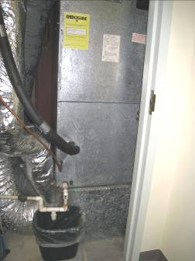

AHU in closet

Picture 2

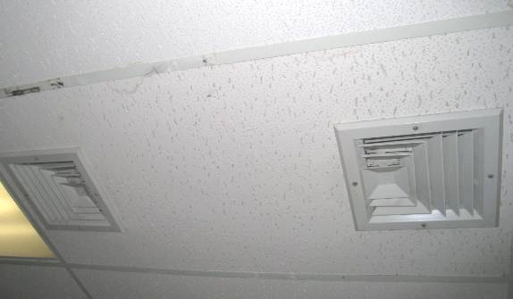

Ceiling-mounted air diffusers

Picture 3

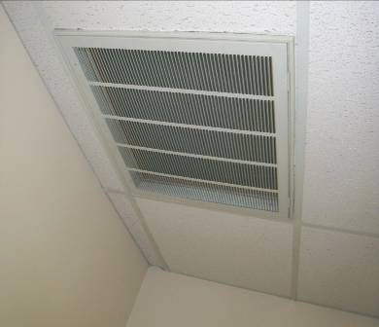

Ceiling-mounted return vent

Picture 4

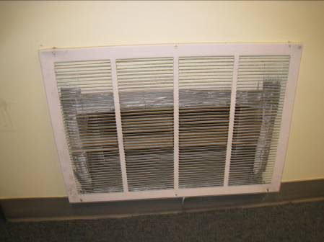

Wall-mounted return vent

Picture 5

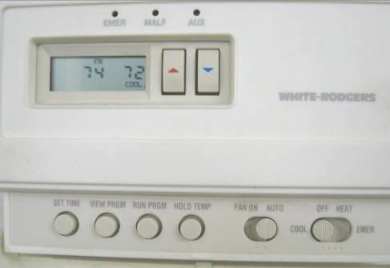

Digital wall-mounted thermostat set to cool (AC) with fan in auto setting (arrows)

Picture 6

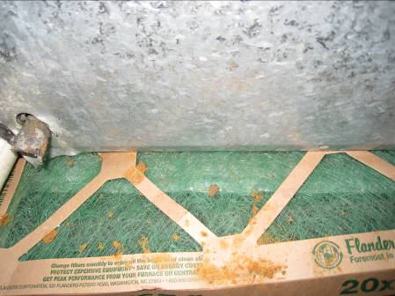

AHU with filter installed, note debris on top of filter

Picture 7

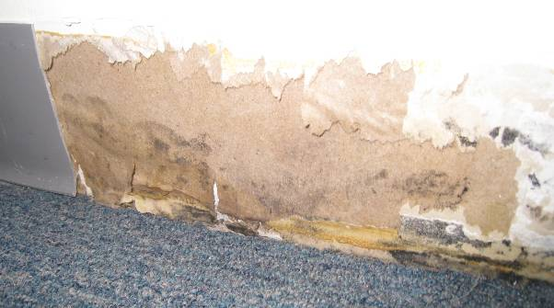

Mold growth on GW behind vinyl coving in Telcom room

Picture 8

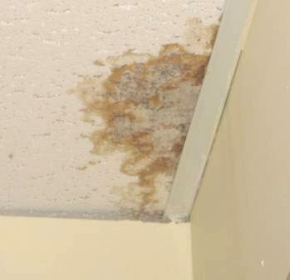

Mold growth on ceiling tile

Picture 9

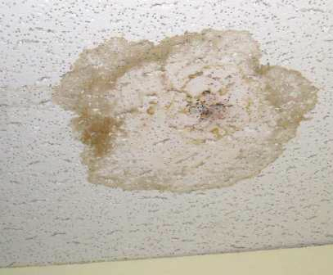

Mold growth on ceiling tile

Picture 10

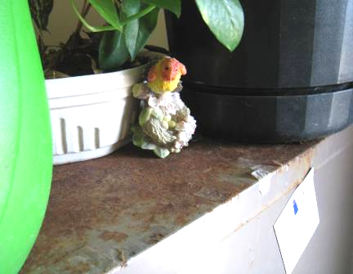

Rusting cabinet likely from overwatering of plants

Picture 11

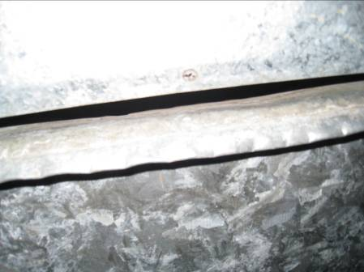

AHU lacking filter

Picture 12

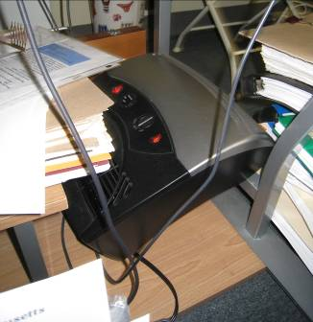

Air purifier
Location | Carbon  Dioxide  (ppm) | Carbon Monoxide  (ppm) | Temp  (°F) | Relative  Humidity  (%) | PM2.5  (µg/m3) | Occupants  in Room | Windows  Openable | Ventilation |  | Remarks
 |  |  |  |  |  |  |  | Supply | Exhaust | Remarks
Background | 368 | ND | 25 | 12 | 13
Conference A | 1541 | ND | 67 | 34 | 7 | 0 | N | Y | Y | Thermostat set to fan auto, AC, DO
Conference B | 1586 | ND | 68 | 33 | 5 | 0 | N | Y | N | DO, PC
A | 1243 | ND | 68 | 28 | 6 | 2 | Y | Y | N | DO, plants
B | 1388 | ND | 69 | 29 | 7 | 0 | Y | Y | N | DO
C | 1126 | ND | 68 | 28 | 7 | 0 | Y | Y | N | DO, plants, items, WD-file cabinet
D | 1114 | ND | 69 | 28 | 6 | 0 | Y | Y | N | DO, plants
E | 1099 | ND | 71 | 27 | 6 | 1 | Y | Y | N | Plants, PF, CPs
F | 1106 | ND | 71 | 25 | 7 | 0 | Y | Y | N | DO, plants, AD
G | 1117 | ND | 71 | 28 | 6 | 0 | N | Y | N | DO, WD-CT
H | 1102 | ND | 71 | 28 | 6 | 0 | N | Y | N
J | 1111 | ND | 71 | 24 | 7 | 0 | Y | Y | N | DO
K | 1134 | ND | 70 | 25 | 7 | 0 | N | Y | N | DO, items, plants
Kitchen | 1681 | ND | 73 | 25 | 14 | 0 | N | Y | N | 3 WD-CT
L | 1116 | ND | 70 | 24 | 8 | 1 | N | Y | N | DO, items
N | 1445 | ND | 73 | 25 | 8 | 2 | N | Y | N | DO, AP on floor, items
O (Telcom room) | 1236 | ND | 71 | 26 | 7 | 0 | N | Y | N | Slight mold growth behind wall coving, 2 WD-CT
P (file storage) | 1344 | ND | 70 | 29 | 7 | 0 | N | Y | N | DO
R/Q | 1355 | ND | 74 | 24 | 8 | 0 | N | Y | N | DO, plants
S | 1696 | ND | 75 | 26 | 6 | 1 | Y | Y | N | DO
T | 1154 | ND | 69 | 25 | 6 | 0 | N | Y | N | CPs
U (reception) | 1636 | ND | 74 | 25 | 8 | 1 | Y | Y | N
V | 1699 | ND | 78 | 25 | 9 | 2 | Y | Y | N | DO, PF, plants
W | 1753 | ND | 75 | 24 | 10 | 0 | Y | Y | N | Evidence of older water leak, DO, PF, plants, fridge on carpet
X | 1600 | ND | 75 | 23 | 10 | 0 | Y | Y | N | DO, plants
Y | 1512 | ND | 73 | 24 | 10 | 0 | Y | Y | N | Plants on floor,
Z | 1280 | ND | 69 | 28 | 14 | 3 | Y | Y | N
ZZ | 1685 | ND | 72 | 26 | 12 | 0 | Y | Y | Y | Plants, 5 WD-CT, moldy CT

