INDOOR AIR QUALITY ASSESSMENT

Department of Developmental Services Office
100 Cummings Center, Suite 419-E
Beverly, MA

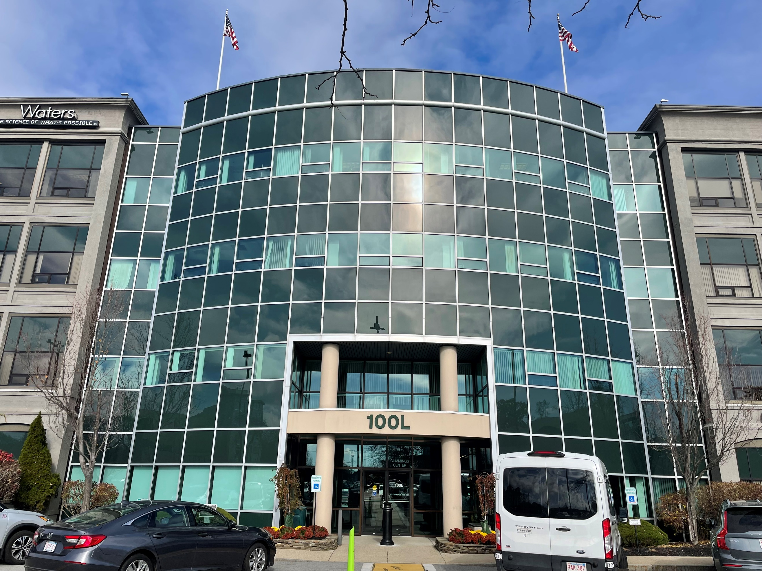

Prepared by:
Massachusetts Department of Public Health
Bureau of Climate and Environmental Health
Indoor Air Quality Program
November 2023

BACKGROUND
Building: | Massachusetts Department of Developmental Services (DDS) Office
Address: | 100 Cummings Center, Suite 419-E,  Beverly, MA
Assessment Requested by: | Pedro Batista, Project Coordinator, Executive Office of Health and Human Services (EOHHS)
Reason for Request: | General Indoor Air Quality (IAQ) Inspection
Date of Assessment: | November 13, 2023
Massachusetts Department of Public Health/Bureau of Climate and Environmental Health (MDPH/BCEH) Staff Conducting Assessment: | Jennifer Lajoie, Environmental  Analyst, IAQ Program
Building Description: | The DDS space is located in a building constructed in 1903 as the former United Shoe Machinery Corporation. The building has been completely renovated. The space is composed of private offices, open work areas, and conference rooms. Most areas have carpet tiles and dropped ceilings.
Windows: | This space has no windows

METHODS
Please refer to the IAQ Manual for methods, sampling procedures, and interpretation of results (MDPH, 2015).
This building has been visited previously by the IAQ program. Reports from those visits are available on the MDPH website at: https://www.mass.gov/info-details/indoor-air-quality-reports-cities-and-towns-b or on request.

RESULTS AND DISCUSSION
The following is a summary of indoor air testing results (Table 1).
- Carbon dioxide measurements were below or close to the MDPH guideline of 800 parts per million (ppm) in most areas. Several areas above the guideline indicates a need for increased fresh air in these areas.
- Temperature was within or just below the recommended range of 70°F to 78°F.
- Relative humidity was within or just below the recommended range of 40% to 60% in all areas tested. Low relative humidity is common during the heating season in the Northeast.
- Carbon monoxide levels were non-detectable (ND) in all areas tested.
- Fine particulate matter (PM2.5) concentrations were below the National Ambient Air Quality Standard (NAAQS) level of 35 μg/m³ in all areas tested.

Ventilation
A heating, ventilating, and air conditioning (HVAC) system has several functions. First it provides heating and, if equipped, cooling. Second, it is a source of fresh air. Finally, an HVAC system will dilute and remove normally occurring indoor environmental pollutants by not only introducing fresh air, but by filtering the airstream and ejecting stale air to the outdoors via exhaust ventilation. Even if an HVAC system is operating as designed, point sources of respiratory irritation may exist and cause symptoms in sensitive individuals.
The HVAC system in this space consists of large rooftop air handling units (AHUs) that draw in fresh air from intakes on the roof. Supply air is ducted to ceiling-mounted supply diffusers throughout the space (Picture 1). Air is brought back to the AHUs through return vents (Picture 2). Some offices were noted to have supply vents only. The landlord reports that the fresh air pre-filters are reusable metal mesh cleaned twice a year in the spring and fall and that the pleated Minimum Efficiency Reporting Value (MERV) 10 filters are changed quarterly. It should be noted that the MDPH recommends pleated filters with a MERV of 8 or higher, which are adequate in filtering out pollen and mold spores (ASHRAE, 2012).
The MDPH recommends that ventilation system should be on and operating to supply fresh air continuously during occupied periods. Without adequate fresh air supply and removal of stale air, common indoor air pollutants can build up and cause irritation. The landlord of the Cummings Center has indicated that fresh air and exhaust are on a timeclock that runs from 7am until 7pm.
Thermostats for temperature control are local (Picture 3). For better energy savings, thermostat settings should be centrally coordinated to save energy.
A few areas had levels of carbon dioxide above 800 (Table 1). These areas contain closely spaced workstations and offices, some of which were occupied by employees actively on the phone or speaking in meetings via computer. High density and activity can increase carbon dioxide levels. If it is possible, supply more fresh air to areas with frequent high-density occupancy.
A return vent was found to be blocked with items of clothing in one office. (Pictures 4 and 5; Table 1). Blocking vents can affect the balancing of the system overall, and the blocked vent will not properly supply fresh air to the area. Porous materials blocking vents can also become moistened by condensation and become mold colonized. Occupants should work with facility staff if vents are noisy or causing uncomfortable drafts.

Microbial/Moisture Concerns
A few water-damaged ceiling tiles were found throughout the set of offices (Picture 6; Table 1). Based on the location and pattern of the damage, these appear to stem from the sprinkler or HVAC system. The DDS office is located on the top floor of the building so roof leaks should also be investigated as the source of leaks. Office staff reported ceiling leaks in the past which were reported to the Cummings Center landlord. Staff also reported that the carpet tiles below the leaks became saturated during those leaks. Wet carpeting was not observed at the time of inspection. During the inspection, EOHHS staff recommended that water leakage or other issues also be reported directly to EOHHS. Water-damaged ceiling tiles should be removed and replaced after the leak is fixed. Note that porous materials such as carpeting, or ceiling tiles should be dried with fans and heating within 24 to 48 hours of becoming wet (US EPA, 2008). If porous materials are not dried within this time frame, mold growth may occur. Water-damaged porous materials cannot be adequately cleaned to remove mold growth and should be discarded.
Water dispensers were located on mats on carpet in several of the locations assessed (Picture 7). The dispensers should be fully on the mats as these appliances can be a source of leaks that can moisten carpeting and lead to mold growth. A personal refrigerator was also found on carpet and contained food spills (Picture 8). If refrigerators are not kept clean, they can be a source of odors and/or pests.
Low humidity indoors is a common problem during the heating season in the Northeast, which may lead to discomfort from dry skin and mucous membranes, and may enhance the ability of dust to become airborne. The MDPH/IAQ program recommends drinking water during the day to mitigate issues associated with dry air, and to enhance cleaning/dust removal when the humidity is low.

Other Issues
Hand sanitizers, scented cleaning products, and odor eliminators were noted in some areas of the office space and bathrooms. (Pictures 9 and 10; Table 1). These products can cause irritation of the eyes, nose, and respiratory system of some people and should be used with adequate ventilation and in accordance with package instructions to avoid excess VOCs. Scented products such as air fresheners should not be used.
Cooking equipment (toaster, microwave) is located in the kitchen area. Some crumbs were observed in the toaster. This equipment and the surrounding area can become attractive to pests if not kept clean.
Most flooring is covered with carpet tile. Carpets should be cleaned regularly in accordance with Institute of Inspection, Cleaning and Restoration Certification (IICRC) recommendations (IICRC, 2012).
Air purifiers were in use in some areas (Table 1). These units should be well maintained and cleaned, including filter changes, in accordance with manufacturers’ instructions. Air purifiers that may produce ozone should not be used in occupied areas (US EPA 2008).
Plants were also noted in some areas (Table 1). Indoor plants should be well maintained and not overwatered to prevent water damage and pests.
Bathroom vents have accumulated dust and debris. These should be cleaned on a regular basis.

CONCLUSIONS AND RECOMMENDATIONS
Based on observations at the time of assessment, the following is recommended:

Ventilation Recommendations
- Operate supply and exhaust ventilation continuously in all areas during occupied periods. Ensure all HVAC equipment is cleaned/maintained in accordance with manufacturer’s instructions.
- Continue to change filters for HVAC equipment 2-4 times a year. Continue to use pleated filters of MERV 8 (or higher), which are adequate in filtering out pollen and mold spores (ASHRAE, 2012).
- Deliver additional fresh air to the highly occupied areas of the floor.
- Do not block supply vents with items.
- Clean bathroom vents regularly.

Water Damage Recommendations
- Investigate any sources of leaks including sprinklers and the roof and make repairs as needed.
- Replace water-damaged ceiling tiles and monitor for further damage.
- Maintain indoor plants and place them on waterproof drip pans that are cleaned periodically.
- Keep refrigerators clean. Consider placing a waterproof mat underneath refrigerators and water dispensers to prevent water damage to carpeting.
- For buildings in New England, periods of low relative humidity during the winter are often unavoidable. Therefore, scrupulous cleaning practices should be adopted to minimize common indoor air contaminants whose irritant effects can be enhanced when the relative humidity is low. To control dust, a high efficiency particulate arrestance (HEPA) filter equipped vacuum cleaner in conjunction with wet wiping of all surfaces is recommended. Avoid the use of feather dusters. Drinking water during the day can help ease some symptoms associated with a dry environment (throat and sinus irritations).

Other Recommendations
- Avoid bringing in scented products (e.g., air fresheners, candles). Use VOC-containing cleaning products in accordance with package instructions and do not overuse or mix incompatible products.
- Keep food preparation equipment clean to prevent smoke, odors, and pests.
- Regularly vacuum carpeting with a HEPA-filtered vacuum cleaner. Clean carpeting at least once per year according to IICRC recommendations (IICRC, 2012).
- Clean and maintain air purifiers in accordance with manufacturer’s instructions including filter changes.
- Occupants should contact both EOHHS and the landlord’s representative when any water damage occurs.
- Refer to resource manual and other related IAQ documents located on the MDPH’s website for further building-wide evaluations and advice on maintaining public buildings. These documents are available at: http://mass.gov/dph/iaq.

REFERENCES
ASHRAE. 2012. American Society of Heating, Refrigeration and Air Conditioning Engineers (ASHRAE) Standard 52.2-2012 -- Method of Testing General Ventilation Air-Cleaning Devices for Removal Efficiency by Particle Size (ANSI Approved).
IICRC. 2012. Carpet Cleaning FAQ 4 Institute of Inspection, Cleaning and Restoration Certification. Institute of Inspection Cleaning and Restoration, Vancouver, WA.
MDPH. 2015. Massachusetts Department of Public Health. Indoor Air Quality Manual: Chapters I-III. Available at: https://www.mass.gov/lists/indoor-air-quality-manual-and-appendices .
US EPA. 2008. “Mold Remediation in Schools and Commercial Buildings”. Office of Air and Radiation, Indoor Environments Division, Washington, DC. EPA 402-K-01-001. September 2008. Available at: http://www.epa.gov/mold/mold-remediation-schools-and-commercial-buildings-guide

Picture 1
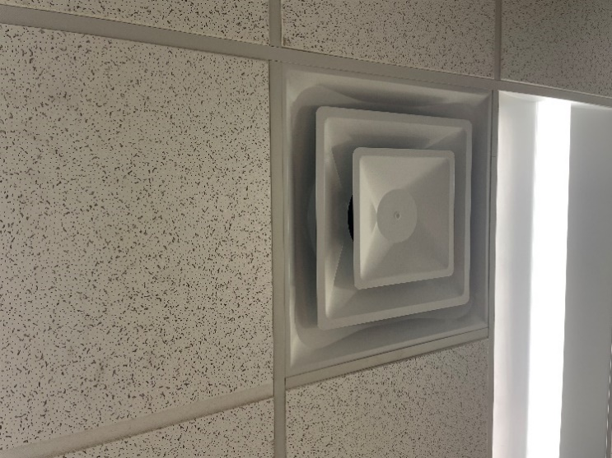
Supply vent
Picture 2
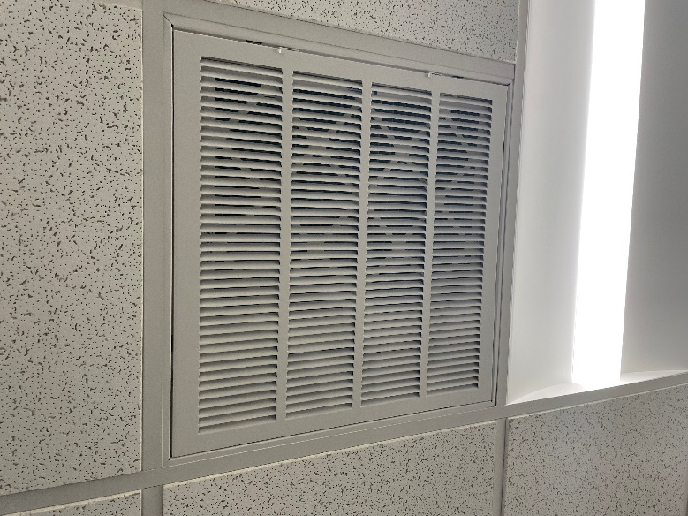
Return vent
Picture 3
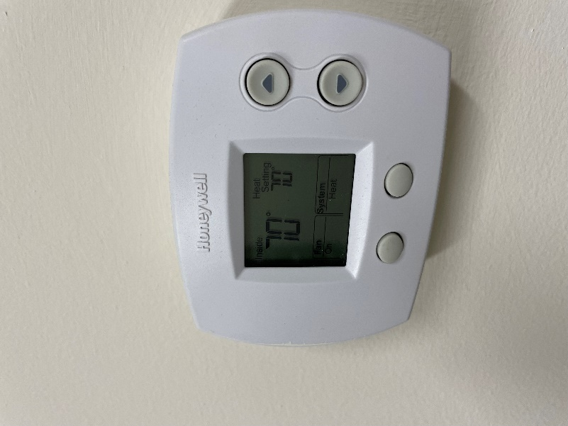
Thermostat in office
Picture 4
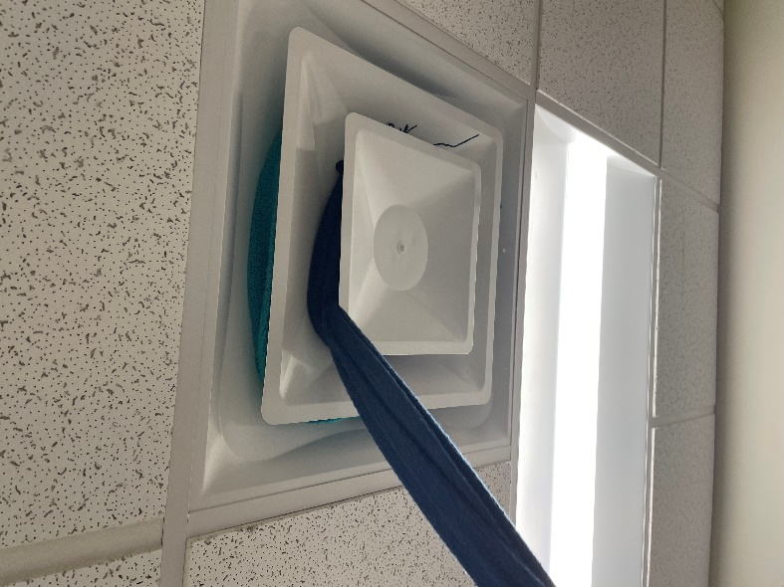
Blocked supply vent
Picture 5
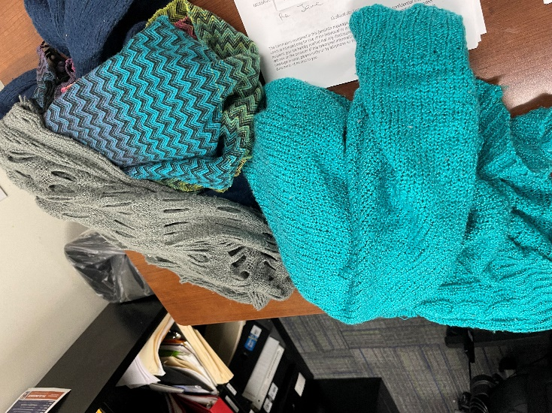
Items removed from the blocked supply vent

Picture 6
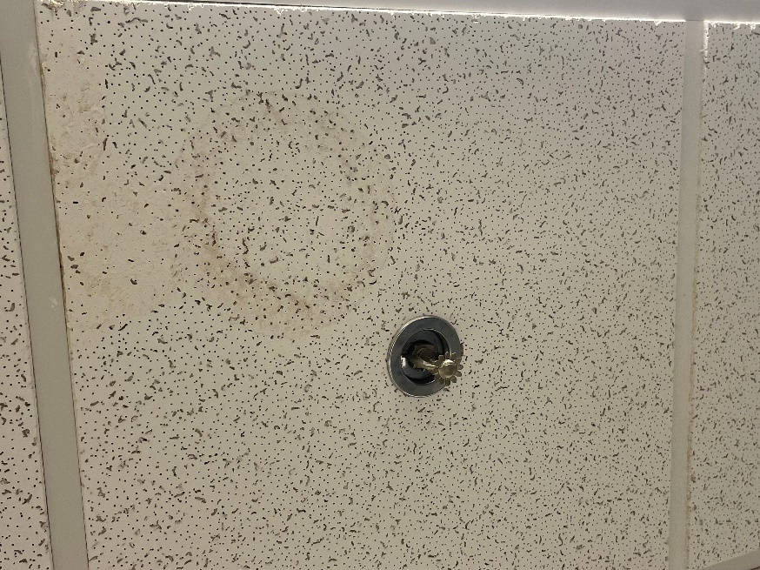
Water-damaged ceiling tiles

Picture 7
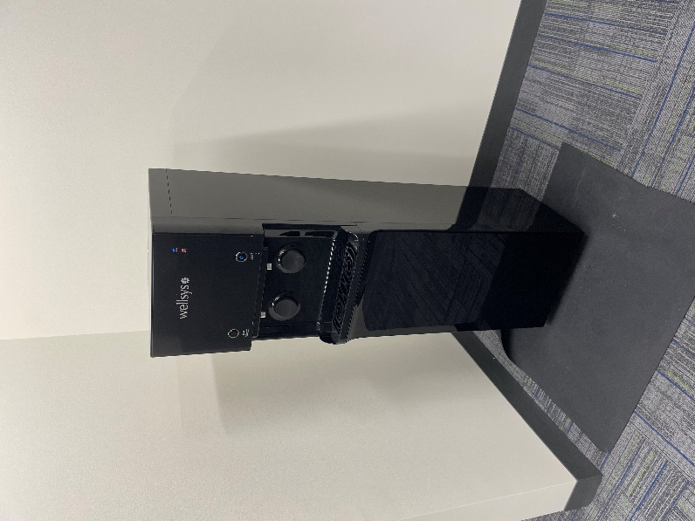
Water dispenser

Picture 8

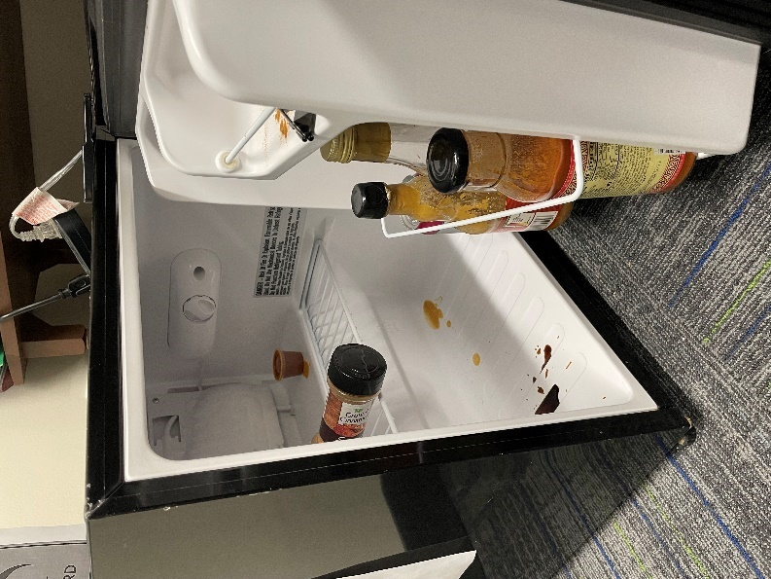
Refrigerator on carpet

Picture 9

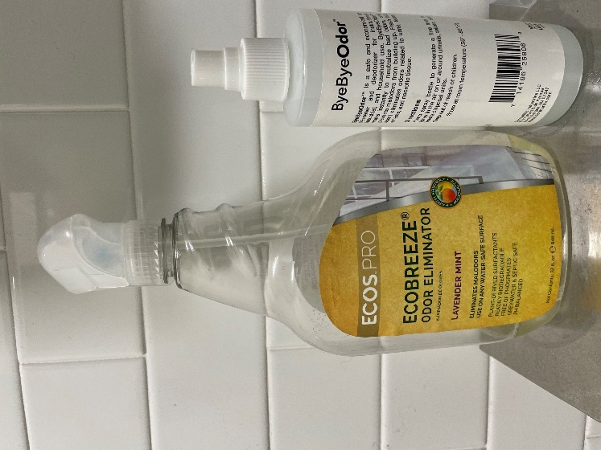
Odor eliminators

Picture 10

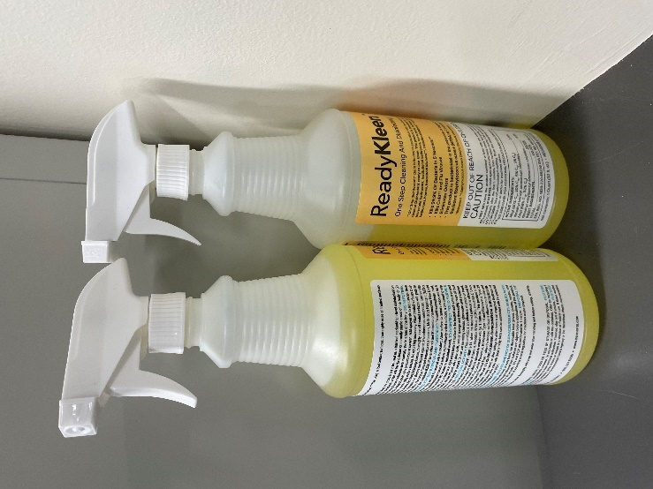
Disinfectants

Location | Carbon  Dioxide  (ppm) | Carbon Monoxide  (ppm) | Temp  (°F) | Relative  Humidity  (%) | PM2.5  (µg/m³) | Occupants  in Room | Windows  Openable | Ventilation |  | Remarks
 |  |  |  |  |  |  |  | Supply | Exhaust
Background (outside) | 488 | ND | 45 | 50 | ND
4103 | 585 | ND | 68 | 39 | ND | 0 | N/A | Y | N
4102 | 694 | ND | 70 | 39 | ND | 1 | N/A | Y | Y
4101 | 757 | ND | 72 | 38 | ND | 0 | N/A | Y | N
4126 | 595 | ND | 69 | 41 | ND | 0 | N/A | Y | N | File room, missing CT
4125 | 739 | ND | 68 | 41 | ND | 0 | N/A | Y | Y
4124 | 611 | ND | 62 | 41 | ND | 0 | N/A | - | - | Server room- ductless mini split
4123 | 692 | ND | 67 | 42 | ND | 0 | N/A | Y | Y | Crumbs in toaster
Outside cube 4135 | 862 | ND | 69 | 39 | ND | 0 | N/A | Y | Y
Outside cube 4140 | 767 | ND | 71 | 37 | ND | 0 | N/A | Y | Y
Outside cube 4142 | 809 | ND | 72 | 37 | ND | 0 | N/A | Y | Y
4115 | 705 | ND | 72 | 37 | ND | 0 | N/A | Y | N | Mini fridge on carpet, food spills in fridge, supply vent blocked by clothing
4114 | 746 | ND | 72 | 37 | ND | 0 | N/A | Y | N
Outside cube 4111 | 780 | ND | 72 | 38 | ND | 0 | N/A | Y | Y
4109 | 870 | ND | 72 | 38 | ND | 1 | N/A | Y | N | Air purifier
4108 | 765 | ND | 71 | 38 | ND | 0 | N/A | Y | N | Food, plants
4107 | 932 | ND | 72 | 39 | ND | 1 | N/A | Y | N | Stained CT
Outside cube 4110 | 799 | ND | 71 | 38 | ND | 0 | N/A | Y | Y | Water stain on wall, WD CT
4130 | 837 | ND | 72 | 38 | ND | 0 | N/A | Y | Y
4106- mailroom | 745 | ND | 72 | 37 | ND | 0 | N/A | Y | N
4122 | 827 | ND | 72 | 38 | ND | 0 | N/A | Y | Y | Stained CT around sprinkler
4120 | 727 | ND | 73 | 37 | ND | 0 | N/A | Y | Y
4121 | 668 | ND | 72 | 36 | ND | 0 | N/A | Y | Y
Outside cube 4151 | 718 | ND | 72 | 38 | ND | 0 | N/A | Y | Y
4119 | 972 | ND | 72 | 39 | ND | 1 | N/A | Y | Y
4118 | 854 | ND | 72 | 39 | ND | 1 | N/A | Y | N
4117 | 750 | ND | 73 | 38 | ND | 1 | N/A | Y | Y
Outside cube 4155 | 731 | ND | 72 | 38 | ND | 0 | N/A | Y | Y
Outside cube 4129 | 797 | ND | 72 | 37 | ND | 1 | N/A | Y | Y
4127- conference room | 784 | ND | 71 | 37 | ND | 6 | N/A | Y | Y | WD CTs around sprinkler
Outside cube 4128 | 768 | ND | 71 | 38 | ND | 0 | N/A | Y | Y

