INDOOR AIR QUALITY ASSESSMENT

Department of Developmental Services
100 Cummings Center
Beverly, Massachusetts

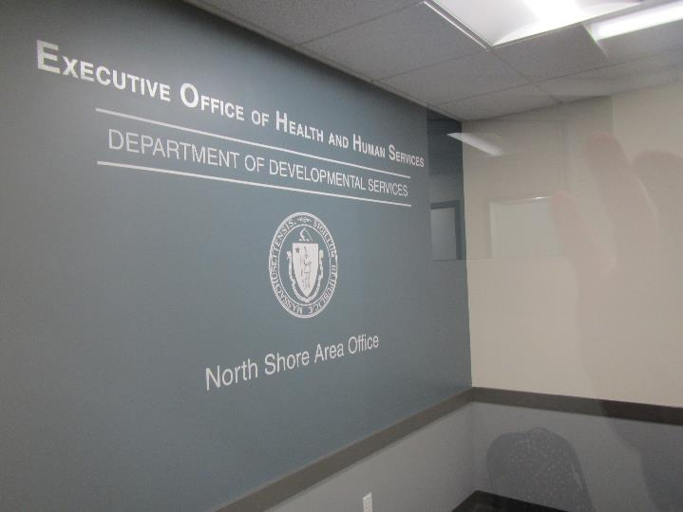

Prepared by:
Massachusetts Department of Public Health
Bureau of Environmental Health
Indoor Air Quality Program
January 2019

Background

Building: | Department of Developmental Services (DDS)
Address: | 100 Cummings Center, Beverly, MA
DCAMM Project Manager: | Paul Burke, Senior Project Manager, Division of Capital Asset Management and Maintenance (DCAMM)
Reason for Request: | Post-occupancy assessment
Date of Assessment: | December 20, 2018
Massachusetts Department of Public Health/Bureau of Environmental Health (MDPH/BEH) Staff Conducting Assessment: | Jason Dustin, Environmental Analyst/Inspector, Indoor Air Quality (IAQ) Program
Building Description: | The DDS space is located in a building constructed in 1903 as the former United Shoe Machinery Corporation and has been completely renovated. The space is composed of private offices, open work areas, and conference rooms. Most areas have carpet tiles and dropped ceilings.
Windows: | Windows are not openable.

Methods
Please refer to the IAQ Manual for methods, sampling procedures, and interpretation of results (MDPH, 2015).

Results
The following is a summary of indoor air testing results (Table 1).
- Carbon dioxide levels were below the MDPH guideline of 800 parts per million (ppm) in all areas assessed.
- Temperature was within or very close to the MDPH recommended range of 70°F to 78°F in all areas.
- Relative humidity was below the MDPH recommended range of 40% to 60% in all areas as is typical during the heating season in the Northeast.
- Carbon monoxide levels were non-detectable (ND) in all indoor areas assessed.
- Fine particulate matter (PM2.5) concentrations measured were below the National Ambient Air Quality Standard (NAAQS) level of 35 micrograms per cubic meter (μg/m³) in all occupied areas.
- TVOC (total volatile organic compound) levels were ND in all indoor areas assessed.

Discussion

Ventilation
A heating, ventilating, and air conditioning (HVAC) system has several functions. First it provides heating and, if equipped, cooling. Second, it is a source of fresh air. Finally, an HVAC system will dilute and remove normally occurring indoor environmental pollutants by not only introducing fresh air, but by filtering the airstream and ejecting stale air to the outdoors via exhaust ventilation. Even if an HVAC system is operating as designed, point sources of respiratory irritation may exist and cause symptoms in sensitive individuals.
The HVAC system in this space consists of large rooftop air handling units (AHUs) that draw in fresh air from intakes on the roof. Supply air is ducted to ceiling-mounted supply diffusers throughout the space. Return air is brought back to the AHUs through return vents. Some offices were noted to have supply vents only. Doors appeared to be slightly undercut to allow for some exhausting of stale air.
To maximize air exchange, the MDPH recommends that both supply and exhaust ventilation operate continuously during periods of occupancy. In order to have proper ventilation with a mechanical supply and exhaust system, the systems must be balanced to provide an adequate amount of fresh air to the interior of a room while removing stale air from the room. It is recommended that HVAC systems be re-balanced every five years to ensure adequate air systems function (SMACNA, 1994).
Some thermostats were set to “Fan Auto” (Picture 1). The thermostat fan settings for the AHUs should be inspected to ensure they are set to “Fan On” rather than “Auto”. This is especially important during temperate weather in spring and fall where heating or cooling may not be called for frequently. Intermittent fresh air supply will likely increase occupant complaints regarding IAQ.

Microbial/Moisture Concerns
No water-damaged building materials or musty odors were noted during this assessment. The active water leak in the hall and the historic water leak in the server room noted in the pre-occupancy report have been repaired and new ceiling tiles were installed as recommended.

Other Conditions
Hand sanitizers, scented cleaning products, and air fresheners were noted in some areas of the office space. These products can cause irritation of the eyes, nose, and respiratory system of some people (Picture 2).
Most flooring is covered with carpet tile. The Institute of Inspection, Cleaning and Restoration Certification (IICRC), recommends that carpeting be cleaned annually (or semi-annually in soiled high traffic areas) (IICRC, 2012).
DDS staff reported that a large number of occupants expressed complaints (e.g., eye strain, headaches) due to the new LED lighting fixtures. These occupants reported that the lights are too bright and some occupants have been disabling the lights or using shading techniques such as beach umbrellas to lessen the effects (Picture 3).
Some areas were noted to have large amounts of accumulated items on surfaces and floors. This interferes with the ability to thoroughly vacuum and wet-wipe surfaces allowing dust to accumulate and aerosolize in these areas.

Conclusions/Recommendations
Based on the observations made during the visit, the following is recommended:
- Operate the HVAC system to provide for continuous fresh air ventilation during occupied hours. Inspect all thermostats to ensure that they are set for “Fan On” instead of the “Auto” setting.
- Reduce or eliminate the use of scented cleaners, hand sanitizers, and personal air fresheners.
- Regularly vacuum carpeting with a HEPA-filtered vacuum cleaner. Clean carpeting at least once per year according to IICRC recommendations (IICRC, 2012).
- Reduce the amount of accumulated items on surfaces or floors to ensure regular wet-wiping of surfaces and access for custodial staff to HEPA vacuum daily.
- Continue to change filters for HVAC equipment 2-4 times a year. Continue to use pleated filters of MERV 8 (or higher), which are adequate in filtering out pollen and mold spores (ASHRAE, 2012), if these can be used with current equipment.
- Investigate methods to alleviate symptoms of those affected by the new lighting fixtures (e.g., the use of dimmers or blue light filters).
- If complaints arise from occupants in offices with supply only ventilation, consider installing passive vents in the door or wall until permanent return vents can be installed. Otherwise, encourage the use of open doors in these areas when privacy is not needed.
- Consider adopting a balancing schedule of every 5 years for all mechanical ventilation systems, as recommended by ventilation industrial standards (SMACNA, 1994).
- Refer to resource manuals and other related IAQ documents for further building-wide evaluations and advice on maintaining public buildings. Copies of these materials are located on the MDPH’s website: http://mass.gov/dph/iaq.

References
ASHRAE. 2012. American Society of Heating, Refrigeration and Air Conditioning Engineers (ASHRAE) Standard 52.2-2012 -- Method of Testing General Ventilation Air-Cleaning Devices for Removal Efficiency by Particle Size (ANSI Approved).
IICRC. 2012. Institute of Inspection Cleaning and Restoration Certification. Institute of Inspection, Cleaning and Restoration Certification. Carpet Cleaning: FAQ. Retrieved from https://www.iicrc.org/general/custom.asp?page=SANSIIICRCS100.
MDPH. 2015. Massachusetts Department of Public Health. “Indoor Air Quality Manual: Chapters I-III”. Available at: http://www.mass.gov/eohhs/gov/departments/dph/programs/environmental-health/exposure-topics/iaq/iaq-manual/.
SMACNA. 1994. HVAC Systems Commissioning Manual. 1st ed. Sheet Metal and Air Conditioning Contractors’ National Association, Inc., Chantilly, VA.
Picture 1
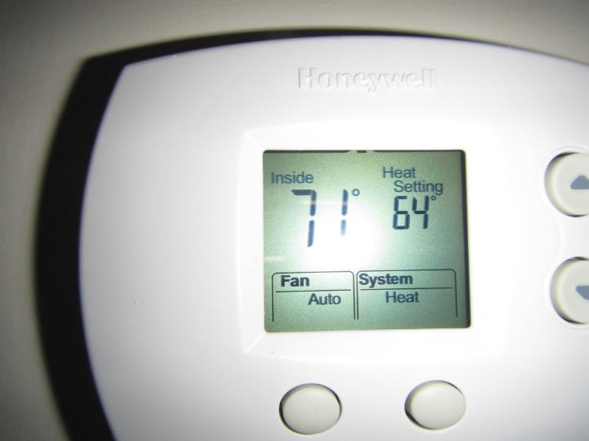
Thermostat showing Fan setting of “Auto” rather than recommended “On”
Picture 2
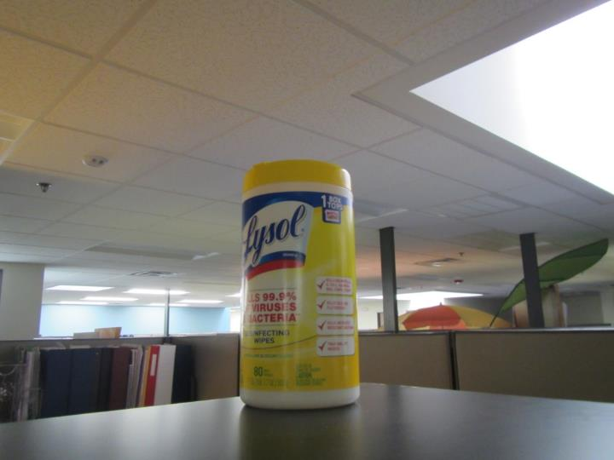
VOC containing cleaners used in occupied areas
Picture 3
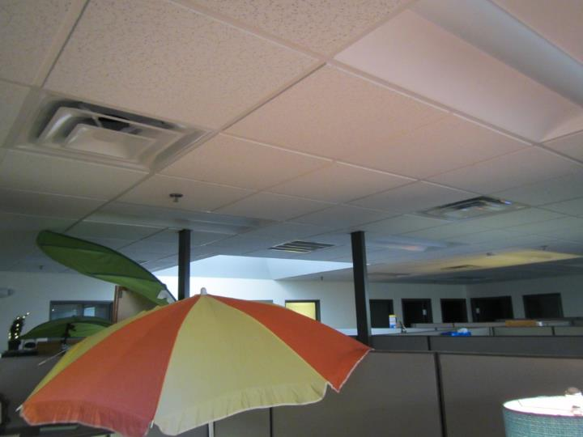
LED lights deactivated with umbrellas/various shades in use

Location | Carbon  Dioxide  (ppm) | Carbon Monoxide  (ppm) | Temp  (°F) | Relative  Humidity  (%) | PM2.5  (µg/m³) | TVOC  (ppm) | Occupants  in Room | Windows  Openable | Ventilation |  | Remarks
 |  |  |  |  |  |  |  |  | Supply | Exhaust
Background | 498 | ND | 46 | 43 | 43* | ND | - | - | - | - | *Heavy vehicle traffic nearby
Reception | 703 | ND | 68 | 32 | 14 | ND | 1 | N | Y | Y | Vinyl floor tiles
4103 | 661 | ND | 70 | 28 | 10 | ND | 1 | N | Y | N | Carpet tiles, no return vent
4102 | 641 | ND | 70 | 24 | 11 | ND | 0 | N | Y | N
4101 | 626 | ND | 72 | 22 | 12 | ND | 1 | N | Y | Y
4127 | 612 | ND | 70 | 22 | 14 | ND | 1 | N | Y | Y
4105 | 577 | ND | 70 | 22 | 25 | ND | 1 | N | Y | Y | Ongoing paper shredding
Open cubes near 4128 | 570 | ND | 70 | 23 | 16 | ND | 1 | N | Y | Y
4106 | 598 | ND | 70 | 24 | 15 | ND | 1 | N | Y | Y
4130 | 590 | ND | 71 | 22 | 17 | ND | 0 | N | Y | N | AI
4107 | 584 | ND | 71 | 22 | 16 | ND | 0 | N | Y | N
4108 | 588 | ND | 71 | 21 | 17 | ND | 0 | N | Y | N | Plant
4109 | 606 | ND | 71 | 22 | 18 | ND | 0 | N | Y | N
Open cubes near 4111 | 625 | ND | 71 | 21 | 17 | ND | 2 | N | Y | Y
Open cubes near 4144 | 641 | ND | 71 | 22 | 15 | ND | 4 | N | Y | Y | Carpet tile, AI, CPs
Open cubes near 4146 | 624 | ND | 72 | 22 | 14 | ND | 2 | N | Y | Y | AI
Open cubes near 4149 | 598 | ND | 72 | 21 | 14 | ND | 1 | N | Y | Y | Plant in water
4122 | 603 | ND | 72 | 21 | 14 | ND | 0 | N | Y | Y | Personal fan
4121 | 560 | ND | 73 | 20 | 11 | ND | 0 | N | Y | Y
4120 | 575 | ND | 74 | 20 | 12 | ND | 0 | N | Y | Y | AI, hand sanitizer
4119 | 585 | ND | 74 | 20 | 14 | ND | 0 | N | Y | Y
Open cubes near 4151 | 598 | ND | 73 | 20 | 15 | ND | 1 | N | Y | Y
4118 | 610 | ND | 73 | 20 | 15 | ND | 0 | N | Y | N | DO, CPs, AI
4117 | 624 | ND | 73 | 20 | 15 | ND | 0 | N | Y | Y
4116 | 627 | ND | 73 | 20 | 17 | ND | 0 | N | Y | N | AI, boxes on floor
4114 | 631 | ND | 72 | 20 | 16 | ND | 0 | N | Y | N
4115 | 749 | ND | 72 | 23 | 16 | ND | 2 | N | Y | N | AI, hand sanitizer
Open cubes near 4112 | 659 | ND | 73 | 21 | 14 | ND | 2 | N | Y | Y
4123 Break Room | 696 | ND | 73 | 24 | 11 | ND | 5 | N | Y | Y
4124 Servers | - | - | - | - | - | - | - | - | - | - | New CT replaced historic WD CT
4126 | 530 | ND | 70 | 21 | 12 | ND | 0 | N | Y | Y | File room

