INDOOR AIR QUALITY ASSESSMENT

Department of Developmental Services
324R Clark Street
Worcester, Massachusetts

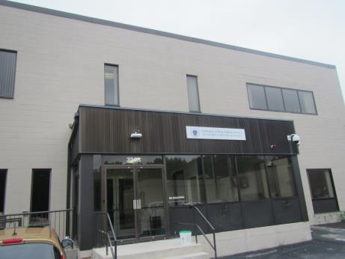

Prepared by:
Massachusetts Department of Public Health
Bureau of Environmental Health
Indoor Air Quality Program
October 2018

Background
Building: | Department of Developmental Services (DDS)
Address: | 324R Clark St. Worcester, MA
DCAMM Project Manager: | Jamie Merrill Blood, Project Manager, Division of Capital Asset Management and Maintenance (DCAMM)
Reason for Request: | Post-occupancy assessment
Date of Assessment: | September 20, 2018
Massachusetts Department of Public Health/Bureau of Environmental Health (MDPH/BEH) Staff Conducting Assessment: | Jason Dustin, Environmental Analyst/Inspector, Indoor Air Quality (IAQ) Program
Building Description: | The DDS space is located on the 1st floor of a two-story office building that was constructed in 1980. The space is composed of private offices, open work areas and conference rooms. Most areas have carpet tile and dropped ceiling tiles.
Windows: | Windows are not openable.

Methods
Please refer to the IAQ Manual for methods, sampling procedures, and interpretation of results (MDPH, 2015).

Results
The following is a summary of indoor air testing results (Table 1).
- Carbon dioxide levels were below the MDPH guideline of 800 parts per million (ppm) in most areas assessed. About one third of the areas were slightly elevated as explained the “Ventilation” section of this report.
- Temperature was within the MDPH recommended range of 70°F to 78°F in all areas.
- Relative humidity was slightly above the MDPH recommended range of 40% to 60% in the majority of areas. This is discussed further under the “Ventilation” section.
- Carbon monoxide levels were non-detectable (ND) in all indoor areas assessed.
- Fine particulate matter (PM2.5) concentrations measured were below the National Ambient Air Quality Standard (NAAQS) level of 35 micrograms per cubic meter (μg/m³) in all occupied areas.

Discussion

Ventilation
A heating, ventilating, and air conditioning (HVAC) system has several functions. First it provides heating and, if equipped, cooling. Second, it is a source of fresh air. Finally, an HVAC system will dilute and remove normally occurring indoor environmental pollutants by not only introducing fresh air, but by filtering the airstream and ejecting stale air to the outdoors via exhaust ventilation. Even if an HVAC system is operating as designed, point sources of respiratory irritation may exist and cause symptoms in sensitive individuals.
The HVAC system in this space consists of large rooftop air handling units (AHUs) that draw in fresh air from intakes on the roof. Supply air is ducted to ceiling-mounted supply diffusers throughout the space (Picture 1). Return air is brought back to the AHUs through return vents (Picture 2).
To maximize air exchange, the MDPH recommends that both supply and exhaust ventilation operate continuously during periods of occupancy. In order to have proper ventilation with a mechanical supply and exhaust system, the systems must be balanced to provide an adequate amount of fresh air to the interior of a room while removing stale air from the room. It +is recommended that HVAC systems be re-balanced every five years to ensure adequate air systems function (SMACNA, 1994).
BEH staff noted that some areas had slightly elevated carbon dioxide readings (168 to 202, Table 1). It is likely this is the result of some thermostats being set to “Fan Auto” (Picture 3). The thermostat fan settings for the AHUs should be inspected to ensure they are all set to “Fan On” rather than “Auto”. This is especially important in spring and fall seasons where fresh air supply and exhaust will be intermittent rather than continuous when the thermostat is not calling for heat or cooling. Intermittent fresh air supply will likely increase occupant complaints regarding IAQ due to inadequate air exchange and buildup of common indoor air pollutants.
The majority of the DDS space was just above the MDPH guideline for relative humidity (Table 1). Higher humidity can further increase the perception of poor IAQ. The HVAC settings should be reviewed to ensure that the units are adequately removing moisture from the air especially during humid weather events.

Microbial/Moisture Concerns
Water-damaged ceiling tiles were noted in conference rooms 153 and 154 (Picture 4). The leaks were reported to be active. Porous items such as ceiling tiles can be the source of microbial growth if exposed to chronic moisture. The ceiling tiles should be discarded and replaced. DDS staff reported that the roof is scheduled to be replaced in the coming weeks.

Other Conditions
Hand sanitizers and scented cleaning products were noted in some areas of the office space. These products can cause irritation of the eyes, nose and respiratory system of some people.
Most flooring is covered with carpet tile. The Institute of Inspection, Cleaning and Restoration Certification (IICRC), recommends that carpeting be cleaned annually (or semi-annually in soiled high traffic areas) (IICRC, 2012).

Conclusions/Recommendations
Based on the observations made during the visit, the following is recommended:
- Operate the HVAC system to provide for continuous fresh air ventilation during occupied hours. Inspect all thermostats to ensure that they are set for “fan on” instead of the “auto” setting.
- Inspect humidity set points for the HVAC system to adequately remove moisture from the air especially during high dew point weather events.
- Remove any water-damaged ceiling tiles and replace. Monitor the area for any new leaks and make any necessary repairs.
- Continue with plans to have the roof replaced. Ensure that property managers/contractors and DDS staff have a system to quickly communicate IAQ complaints during these renovation activities. Any work involving solvents/adhesives and high dust generating activities should be performed during unoccupied hours whenever possible. Consult the MDPH guideline: https://www.mass.gov/service-details/constructionrenovation-generated-pollutants-in-occupied-buildings.
- Reduce or eliminate the use of scented cleaners, hand sanitizers, and personal air fresheners.
- Regularly vacuum carpeting with a high efficiency particulate arrestance (HEPA)-filtered vacuum cleaner. Clean carpeting at least once per year according to IICRC recommendations (IICRC 2012).
- Continue to change filters for HVAC equipment 2-4 times a year. Continue to use pleated filters of Minimum Efficiency Reporting Value (MERV) 8 (or higher), which are adequate in filtering out pollen and mold spores (ASHRAE, 2012), if these can be used with current equipment.
- Consider adopting a balancing schedule of every 5 years for all mechanical ventilation systems, as recommended by ventilation industrial standards (SMACNA, 1994).
- Refer to resource manuals and other related IAQ documents for further building-wide evaluations and advice on maintaining public buildings. Copies of these materials are located on the MDPH’s website: http://mass.gov/dph/iaq.

References
ASHRAE. 2012. American Society of Heating, Refrigeration and Air Conditioning Engineers (ASHRAE) Standard 52.2-2012 -- Method of Testing General Ventilation Air-Cleaning Devices for Removal Efficiency by Particle Size (ANSI Approved).
IICRC. 2012. Institute of Inspection Cleaning and Restoration Certification. Institute of Inspection, Cleaning and Restoration Certification. Carpet Cleaning: FAQ. Retrieved from https://www.iicrc.org/general/custom.asp?page=SANSIIICRCS100.
MDPH. 2015. Massachusetts Department of Public Health. “Indoor Air Quality Manual: Chapters I-III”. Available at: http://www.mass.gov/eohhs/gov/departments/dph/programs/environmental-health/exposure-topics/iaq/iaq-manual/.
SMACNA. 1994. HVAC Systems Commissioning Manual. 1st ed. Sheet Metal and Air Conditioning Contractors’ National Association, Inc., Chantilly, VA.
Picture 1
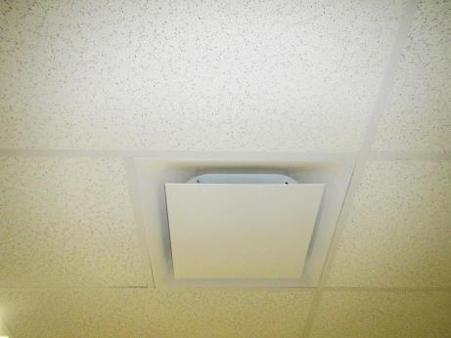
Ceiling-mounted supply air diffuser
Picture 2
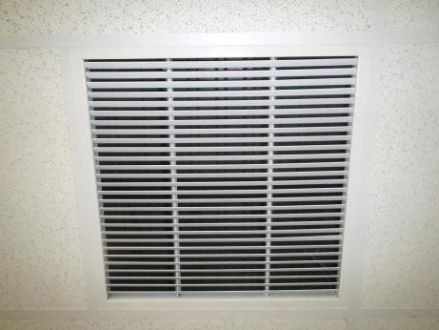
Return air vent
Picture 3
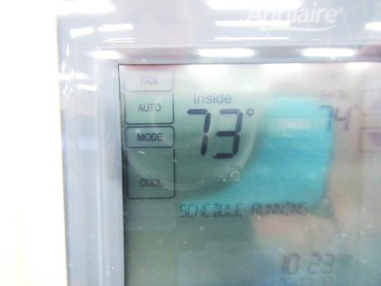
Thermostat showing fan set to “auto” instead of “on”
Picture 4
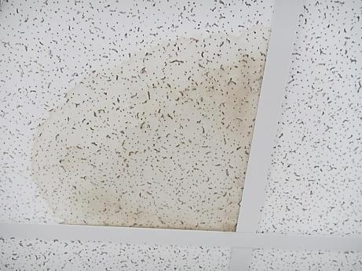
Water-damaged ceiling tile
Location | Carbon  Dioxide  (ppm) | Carbon Monoxide  (ppm) | Temp  (°F) | Relative  Humidity  (%) | PM2.5  (µg/m³) | Occupants  in Room | Windows  Openable | Ventilation |  |  | Remarks
 |  |  |  |  |  |  |  | Intake | Exhaust
Background (outside) | 433 | ND | 68 | 57 | 14 | - | - | - |  | - | Overcast
Reception-public | 790 | ND | 72 | 69 | 30 | 1 | N | Y |  | Y
Conference 153 | 717 | ND | 72 | 67 | 28 | 1 | N | Y |  | Y | WD CT
Conference 154 | 744 | ND | 73 | 62 | 21 | 0 | N | Y |  | Y | Large WD CT
Reception- inner | 721 | ND | 74 | 64 | 30 | 2 | N | Y |  | Y | CPs
Break room | 712 | ND | 73 | 65 | 12 | 0 | N | Y |  | Y | NC
Open cubicles-front | 733 | ND | 73 | 64 | 13 | 4 | N | Y |  | Y | HS
156 | 945 | ND | 75 | 63 | 22 | 0 | N | Y |  | Y
157 | 944 | ND | 75 | 62 | 24 | 1 | N | Y |  | Y
158 | 1012 | ND | 75 | 63 | 22 | 7 | N | Y |  | Y | Plants
Server 168 | 942 | ND | 75 | 59 | 10 | 1 | N | Y |  | Y
169 Conference | 706 | ND | 73 | 63 | 14 | 0 | N | Y |  | Y | Carpet tile
184 | 798 | ND | 74 | 62 | 12 | 0 | N | Y |  | Y
Open cubicles-Mid near 190 | 761 | ND | 73 | 64 | 14 | 2 | N | Y |  | Y
192 | 858 | ND | 74 | 64 | 14 | 1 | N | Y |  | Y | AI
193 | 863 | ND | 73 | 64 | 12 | 1 | N | Y |  | Y | Carpet
Open cubicles rear- near 195 | 779 | ND | 73 | 64 | 12 | 3 | N | Y |  | Y
200 | 831 | ND | 73 | 64 | 12 | 0 | N | Y |  | Y
202 | 827 | ND | 73 | 64 | 12 | 0 | N | Y |  | Y | AI
208 | 780 | ND | 73 | 63 | 13 | 0 | N | Y |  | Y
209 | 798 | ND | 73 | 64 | 12 | 1 | N | Y |  | Y
210 | 786 | ND | 73 | 64 | 12 | 0 | N | Y |  | Y | AI
211 | 792 | ND | 73 | 64 | 12 | 3 | N | Y |  | Y

