# Background/Introduction

**INDOOR AIR QUALITY ASSESSMENT**

**Commonwealth of Massachusetts**

**Department of Developmental Services**

**151 Campanelli Drive**

**Middleborough, MA**

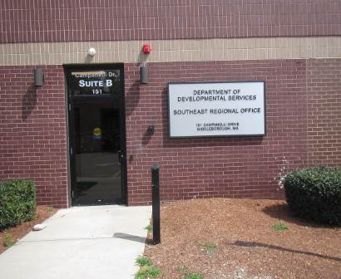

Prepared by:

Massachusetts Department of Public Health

Bureau of Environmental Health

Indoor Air Quality Program

October 2015

**Building:** Department of Developmental Services (DDS)

**Address:** 151 Campanelli Drive, Massachusetts

**Assessment Requested by:** Gerry Covino, Project Manager, Division of Capital Asset

Management and Maintenance (DCAMM)

**Date of Assessment:** June 24, 2015

**BEH/IAQ Staff**

**Conducting Assessment:** Michael Feeney, Director

Cory Holmes, Environmental Analyst/Inspector

**Date of Building**

**Construction:**  1990s

**Reason for Request:** This evaluation was conducted as part of enhanced efforts to assess the air quality of office space leased by Massachusetts state agencies pre and post-occupancy.

# Building Description

The building is a one-story red brick, flat-roofed structure that was built as a bank headquarters. The office space assessed has undergone a complete renovation including interior walls/paint ceilings, floors, appliances, carpeting and heating, ventilating and air conditioning (HVAC) systems. Most areas of the DDS have drop ceilings and carpet tiles. Windows in the building are unopenable. Also located in the building is a bank and law office.

# Methods

Air tests for carbon dioxide, carbon monoxide, temperature and relative humidity were taken with the TSI, Q-Trak, IAQ Monitor 7565. Tests for airborne particle matter with a diameter less than 2.5 micrometers were taken with the TSI, DUSTTRAK™ Aerosol Monitor Model 8520. Screening for volatile organic compounds was conducted using a RAE Systems Mini-RAE Lite, Photo Ionization Detector. BEH/IAQ staff also performed a visual inspection of building materials for water damage and/or microbial growth.

# Results

The DDS houses approximately 75 employees. Members of the public/clients also visit the space daily. Test results are presented in Table 1. Indoor air related sampling information can be found in the IAQ Manual and Appendices for IAQ Reports that can be found at:

<http://www.mass.gov/eohhs/gov/departments/dph/programs/environmental-health/exposure-topics/iaq/iaq-rpts/general-appendices-for-iaq-reports.html>

# Discussion

## Ventilation

It can be seen from Table 1 that carbon dioxide levels were below 800 parts per million (ppm) in all areas tested, indicating optimal air exchange at the time of the assessment (Table 1). Fresh air is provided by rooftop air-handling units (AHUs, Picture 1). Once air is filtered, it is heated or cooled and delivered to occupied areas via ducted supply diffusers (Picture 2). Return air is drawn into a combination of plenum and ducted ceiling-mounted vents (Picture 3) and returned back to rooftop AHUs.

The HVAC system for the DDS office is controlled by digital touch screen thermostats (Picture 4). Thermostats examined had a fan switch with two settings, *on* and *auto*. When the fan is set to *on,* the system provides a continuous source of air circulation and filtration. The *automatic* setting on the thermostat activates the HVAC system at a pre-set temperature. Once the pre-set temperature is reached, the HVAC system is deactivated. Therefore, no mechanical ventilation is provided until the thermostat re-activates the system. At the time of the assessment, the thermostat fan settings appeared to be in the “on” position, as recommended by MDPH for continuous airflow and filtration.

To maximize air exchange, the MDPH recommends that both supply and exhaust ventilation operate continuously during periods of occupancy. In order to have proper ventilation with a mechanical supply and exhaust system, the systems must be balanced to provide an adequate amount of fresh air to the interior of a room while removing stale air from the room. It is recommended that HVAC systems be re-balanced every five years to ensure adequate air systems function (SMACNA, 1994). Balancing should have been completed upon occupancy, however now that the building is under normal operation adjustments may be needed.

## Temperature and Relative Humidity

Indoor temperature measurements at the time of the assessment ranged from 70°F to 78°F (Table 1), which were equal to the MDPH recommended comfort range. The MDPH recommends that indoor air temperatures be maintained in a range of 70°F to 78°F in order to provide for the comfort of building occupants. Some areas of the DDS are affected by solar gain from poorly insulated window frames and panes, particular along the southeastportion of the building, which can lead to increased temperatures. In addition, small appliances (i.e., refrigerators, air purifiers), can also generate excess heat, further increasing temperatures as well as reducing relative humidity, which can lead to comfort complaints.

Indoor relative humidity measurements at the time of the assessment ranged from 60 to 74 percent (Table 1), which were at the upper level or above the MDPH recommended comfort range in all areas tested. The MDPH recommends a comfort range of 40 to 60 percent for indoor air relative humidity. The elevated relative humidity measurements were reflective of outdoor conditions and the result of the volume of outside air being introduced to the space.

The relationship between temperature and relative humidity is known as the heat index. As indoor temperature rises, the addition of humid air increases occupant discomfort and generates heat complaints. If moisture levels are decreased, the comfort of the individuals increases. It is important to note that the operation of AC systems provide cooling as well as remove moisture from the air. Elevated humidity for extended periods of time also increases the likelihood of mold colonization.

## Microbial/Moisture Concerns

In order for building materials to support mold growth, a source of water exposure is necessary. A recent roof leak was reported in area 1047-1049, which was reportedly repaired. No current evidence of further water penetration, water damage or mold growth on building materials was observed or reported.

Plants were noted in a few areas. Plants can be a source of pollen and mold, which can be respiratory irritants to some individuals. Plants should be properly maintained and equipped with drip pans and should be located away from air diffusers to prevent the aerosolization of dirt, pollen and mold.

## Other IAQ Evaluations

Indoor air quality can be negatively influenced by the presence of respiratory irritants, such as products of combustion. The process of combustion produces a number of pollutants. Common combustion emissions include carbon monoxide, carbon dioxide, water vapor, and smoke (fine airborne particle material). Of these materials, exposure to carbon monoxide and particulate matter with a diameter of 2.5 micrometers (μm) or less (PM2.5) can produce immediate, acute health effects upon exposure. To determine whether combustion products were present in the indoor environment, BEH/IAQ staff obtained measurements for carbon monoxide and PM2.5.

### Carbon Monoxide

*Carbon monoxide should not be present in a typical, indoor environment*. If it *is* present, indoor carbon monoxide levels should be less than or equal to outdoor levels. On the day of the assessment, outdoor carbon monoxide concentrations were non-detect (ND) (Table 1). No measurable levels of carbon monoxide were detected inside the building (Table 1).

### Particulate Matter

Outdoor PM2.5 was measured at 22 μg/m3 (Table 1). PM2.5 levels measured indoors ranged from 9 to 15 μg/m3 (Table 1), which were below the NAAQS PM2.5 level of 35 μg/m3.

### Volatile Organic Compounds

Outdoor TVOC concentrations were ND on the day of the assessment (Table 1). Although slight odors from new furnishings (e.g., carpet tiles, office furniture) were detected, no measureable levels of TVOCs were detected during the assessment (Table 1).

A few areas contained dry erase boards and related materials. Materials such as dry erase markers and dry erase board cleaners may contain VOCs, such as methyl isobutyl ketone, n-butyl acetate and butyl-cellusolve (Sanford, 1999), which can be irritating to the eyes, nose and throat.

## Other Conditions

Other conditions that can affect indoor air quality were observed during the assessment. Most areas in the DDS space are covered with new carpet tiles. The Institute of Inspection, Cleaning and Restoration Certification (IICRC), recommends that carpeting be cleaned annually (or semi-annually in soiled high traffic areas) (IICRC, 2012).

# Conclusions/Recommendations

In view of the findings at the time of the visit, the following recommendations are made:

1. Work with HVAC engineer to adjust temp/AC controls to achieve optimal temp/relative humidity conditions as well as continuous air circulation/filtration and adequate fresh air supply during business hours.
2. Consider adopting a balancing schedule of every 5 years for all mechanical ventilation systems, as recommended by ventilation industrial standards (SMACNA, 1994).
3. Consider reducing/removing small appliances generating waste heat in offices to improve comfort.
4. Consider applying tinted film to windows as needed to reduce solar gain as well as solar glare.
5. For buildings in New England, periods of low relative humidity during the winter are often unavoidable. Therefore, scrupulous cleaning practices should be adopted to minimize common indoor air contaminants whose irritant effects can be enhanced when the relative humidity is low. To control for dusts, a high efficiency particulate arrestance (HEPA) filter equipped vacuum cleaner in conjunction with wet wiping of all surfaces is recommended. Avoid the use of feather dusters. Drinking water during the day can help ease some symptoms associated with a dry environment (throat and sinus irritations).
6. Continue to monitor area 1047-1049 to ensure roof leaks have been properly repaired, report and further leaks/water damage to building management for prompt remediation.
7. Plants should be properly maintained and equipped with drip pans and should be located away from air diffusers to prevent the aerosolization of dirt, pollen and mold.
8. The Institute of Inspection, Cleaning and Restoration Certification (IICRC), recommends that carpeting be cleaned annually (or semi-annually in soiled high traffic areas) (IICRC, 2012).
9. Refer to resource manual and other related indoor air quality documents located on the MDPH’s website for further building-wide evaluations and advice on maintaining public buildings. These documents are available at <http://mass.gov/dph/iaq>.

# References

IICRC. 2012. Carpet Cleaning FAQ 4 Institute of Inspection, Cleaning and Restoration Certification. Institute of Inspection Cleaning and Restoration, Vancouver, WA.

Sanford. 1999. Material Safety Data Sheet (MSDS No: 198-17). Expo® Dry Erase Markers Bullet, Chisel, and Ultra Fine Tip. Sanford Corporation. Bellwood, IL.

SMACNA. 1994. HVAC Systems Commissioning Manual. 1st ed. Sheet Metal and Air Conditioning Contractors’ National Association, Inc., Chantilly, VA.

**Picture 1**

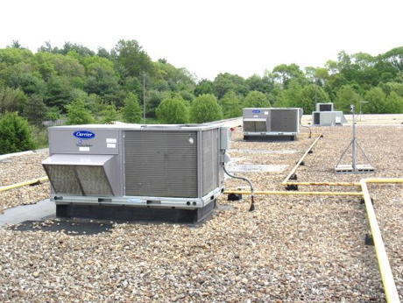

**Rooftop air handling units**

**Picture 2**

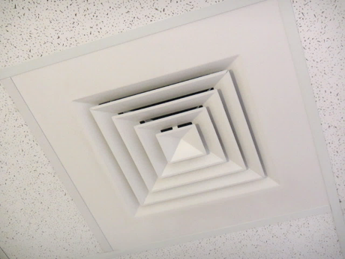

**Supply diffuser**

**Picture 3**

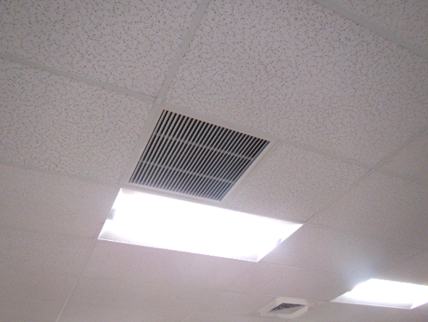

**Return vent**

**Picture 4**

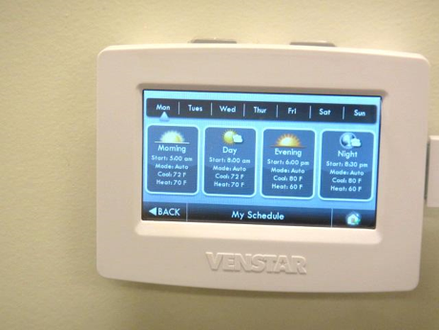

**Digital touchscreen thermostat**

| **Location** | **Carbon**  **Dioxide**  **(ppm)** | **Carbon Monoxide**  **(ppm)** | **Temp**  **(°F)** | **Relative**  **Humidity**  **(%)** | **PM2.5**  **(µg/m**3**)** | **TVOCs**  **(ppm)** | **Occupants**  **in Room** | **Windows**  **Openable** | **Ventilation** | | | **Remarks** |
| --- | --- | --- | --- | --- | --- | --- | --- | --- | --- | --- | --- | --- |
| **Intake** | **Exhaust** | |
| Background | 451 | ND | 82 | 73-82 | 22 | ND |  |  |  | |  | Hot, humid, South winds 3-13 mph, gusts up to 23 mph |
| Lobby | 554 | ND | 73 | 72 | 14 | ND | 0 | N | Y | | Y |  |
| Reception | 580 | ND | 70 | 74 | 14 | ND | 1 | N | Y | | Y |  |
| 0100 Conference Room | 562 | ND | 74 | 68 | 14 | ND | 0 | N | Y | | Y |  |
| 0103 | 652 | ND | 74 | 74 | 13 | ND | 3 | N | Y | | Y |  |
| 0104 | 542 | ND | 72 | 69 | 14 | ND | 0 | N | Y | | Y |  |
| 0105 | 548 | ND | 73 | 68 | 15 | ND | 0 | N | Y | | Y |  |
| 0106 Conference Room | 585 | ND | 74 | 65 | 13 | ND | 0 | N | Y | | Y |  |
| 0107 | 601 | ND | 75 | 65 | 15 | ND | 0 | N | Y | | Y |  |
| 0110 | 596 | ND | 75 | 66 | 13 | ND | 0 | N | Y | | Y |  |
| 0111 | 564 | ND | 78 | 68 | 9 | ND | 0 | N | Y | | Y | AP |
| 0117 | 601 | ND | 75 | 64 | 14 | ND | 0 | N | Y | | Y |  |
| 0118 | 613 | ND | 75 | 66 | 13 | ND | 0 | N | Y | | Y |  |
| 0131 | 602 | ND | 74 | 71 | 13 | ND | 0 | N | Y | | Y | Plant |
| 0132 | 586 | ND | 75 | 68 | 14 | ND | 1 | N | Y | | Y |  |
| 0133 | 678 | ND | 75 | 68 | 13 | ND | 2 | N | Y | | Y |  |
| 0134 | 600 | ND | 75 | 67 | 13 | ND | 0 | N | Y | | Y |  |
| 0137 | 630 | ND | 78 | 60 | 9 | ND | 0 | N | Y | | Y | Small refrigerator, AP, solar glare |
| 0138 | 586 | ND | 75 | 64 | 13 | ND | 0 | N | Y | | Y |  |
| 0140 | 608 | ND | 74 | 64 | 12 | ND | 1 | N | Y | | Y |  |
| 0142 | 617 | ND | 74 | 65 | 12 | ND | 1 | N | Y | | Y |  |
| 0143 | 562 | ND | 74 | 65 | 13 | ND | 0 | N | y | | Y |  |
| 0144 | 575 | ND | 73 | 66 | 13 | ND | 0 | N | Y | | Y |  |
| 0145 | 563 | ND | 73 | 67 | 13 | ND | 0 | N | Y | | Y |  |
| 0146 | 624 | ND | 74 | 68 | 12 | ND | 0 | N | Y | | Y |  |
| 0147 | 587 | ND | 74 | 69 | 13 | ND | 0 | N | Y | | Y |  |
| 0148 | 610 | ND | 75 | 71 | 12 | ND | 1 | N | Y | | Y |  |
| 0149 | 609 | ND | 77 | 70 | 13 | ND | 1 | N | Y | | Y | Dry erase materials |
| 0156 | 574 | ND | 77 | 65 | 14 | ND | 0 | N | Y | | Y |  |
| 0157 | 600 | ND | 77 | 65 | 14 | ND | 0 | N | Y | | Y |  |
| 0158 | 586 | ND | 76 | 66 | 13 | ND | 0 | N | Y | | Y |  |
| 0159 | 623 | ND | 75 | 64 | 13 | ND | 0 | N | Y | | Y |  |
| 1010-1019 | 620 | ND | 75 | 68 | 14 | ND | 4 | N | Y | | Y |  |
| 1011-1018 | 638 | ND | 76 | 63 | 12 | ND | 4 | N | Y | | Y |  |
| 1020-1026 | 602 | ND | 75 | 64 | 12 | ND | 2 | N | Y | | Y |  |
| 1021-1025 | 639 | ND | 74 | 67 | 13 | ND | 2 | N | Y | | Y |  |
| 1027-1037 | 662 | ND | 75 | 66 | 13 | ND | 2 | N | Y | | Y |  |
| 1028-1038 | 580 | ND | 74 | 66 | 11 | ND | 4 | N | Y | | Y |  |
| 1040-1046 | 673 | ND | 75 | 67 | 13 | ND | 5 | N | Y | | Y |  |
| 1047-1049 | 617 | ND | 77 | 65 | 11 | ND | 0 | N | Y | | Y | Area of recent roof leaks; Dried and roof repaired-no further leaks observed/reported, printer near thermostat |
| 1054-1066 | 607 | ND | 77 | 65 | 12 | ND | 3 | N | Y | | Y |  |
| 1058-1069 | 667 | ND | 77 | 66 | 12 | ND | 4 | N | Y | | Y |  |
| 1071-1076 | 559 | ND | 78 | 67 | 15 | ND | 0 | N | Y | | Y | Heat complaints |
| 1077 | 579 | ND | 74 | 68 | 13 | ND | 0 | N | N | | N | Partial office, vents nearby |