**ODORS/WATER DAMAGE REASSESSMENT**

**Massachusetts Rehabilitation Commission**

**340 Main Street**

**Worcester, Massachusetts**


Aerial view of 
Massachusetts E
340 Main Street
Worcester, Massachusetts


Prepared by:

Massachusetts Department of Public Health

Bureau of Environmental Health

Indoor Air Quality Program

August 2019

# Background

|  |  |
| --- | --- |
| Building: | Massachusetts Rehabilitation Commission (MRC) |
| Address: | 340 Main Street, Worcester |
| Assessment Requested by: | Pedro Batista, Facilities Resource Coordinator  Executive Office of Health and Human Services (EOHHS) |
| Reason for Request: | Concerns regarding odors/water damage |
| Date of Assessment: | July 19, 2019 |
| Massachusetts Department of Public Health/Bureau of Environmental Health (MDPH/BEH) Staff Conducting Assessment: | Michael Feeney, Director, Indoor Air Quality (IAQ) Program |
| Building Description: | Multi-story building in downtown Worcester |
| Building Population: | Approximately 130 employees and visitors from the public |
| Windows: | Openable in some areas |
|  |  |

# Discussion

The area of concern consists of office space in the southwest corner/rear of the 5th floor around a vault and rear stairwell of the building that continued to have periodic odors since a flood that occurred in over the summer of 2018. Mr. Feeney was accompanied during this visit by Pedro Batista, EOHHS; Lori Stevens, Director, MRC-Disability Determination Services; and Felicia A. Wood, Project Manager, Commerce Associates.

## Microbial/Moisture Concerns

A musty odor was detected entering the 5th floor area during this visit. Both Ms. Stevens and Ms. Wood reported that the odor detected during this visit was the same as previously reported. The odor was traced to an air handling unit (AHU). Several conditions within this AHU appear to contribute to the musty odor that is being distributed by the HVAC system in this area:

* The lower access panel of the AHU was ajar.
* Heavy corrosion and water droplets were observed outside the drip pan (Picture 1) indicating either a leak through the pan or water dripping on the outside from air passing through the coil assembly.
* The floor of the AHU cabinet was covered with a dust/oil film which can be mold growth media (Picture 2).
* A white, powder-like accumulation was found in the AHU below the drip pan. This material had a musty odor (Picture 3).
* The drip pan drain that empties into an open pipe in the adjacent restroom is connected to building’s plumbing system (Picture 4).
* The AHU is located in a closet with a door with slats to allow air to be returned to the AHU. An examination for the restroom door found that air from the restroom is drawn by the AHU, which in turn, can draw air from the open drain in Picture 4.

These conditions related to the AHU have contributed to the development of mold colonization within the AHU. The musty odor from the mold colonization can then be drawn into the airstream and distributed to hallways and offices served by this AHU via air diffusers. Additional distribution of the odors would occur due to flow of air back to the AHU return. The AHU may also be distributing odors from the nearby restroom as well as from the open pipe shown in Picture 4.

# Conclusions/Recommendations

Based on the observations made during this assessment, the likely sources of musty odor in the MRC office is likely mold growth observed inside the AHU. Repairs to, and cleaning of, the interior of the AHU should alleviate the musty odor. The following recommendations are made:

1. Have an HVAC company examine the interior of the AHU regarding the following issues:
   1. the best methods of cleaning mold from the AHU drip pan and other surfaces;
   2. repairing drainage of water into the drain pan;
   3. repairing leaks from the drain pan;
   4. improving condensation drainage;
   5. repairing pipe corrosion; and
   6. repairing eroded insulation.
2. Given conditions, it is likely mold spores were captured and distributed by the fresh air supplies. Consideration should be given to cleaning ductwork connected to this AHU using methods outlined in “Introduction to HAVC System Cleaning Services” published by the National Air Duct Cleaners Association (NADCA, 2005).
3. Consideration should be given to replacing the condensation drain piped into the existing drain in the restroom (shown in Picture 4), with a condensation pump to reduce possible draw of air from this drain into the AHU. The drain opening should be plumbed in a manner to seal the drain system away from, contact with air.
4. Continue with any other recommendations from previous reports on this building as needed.
5. Refer to resource manuals and other related IAQ documents for further building-wide evaluations and advice on maintaining public buildings. Copies of these materials are located on the MDPH’s website: <http://mass.gov/dph/iaq>.

**REFERENCES**

MDPH. 2015. Massachusetts Department of Public Health. “Indoor Air Quality Manual: Chapters I-III”. Available at: <http://www.mass.gov/eohhs/gov/departments/dph/programs/environmental-health/exposure-topics/iaq/iaq-manual/>.

NADCA. 2005. “Introduction to HVAC System Cleaning Services: A Guideline for Commercial Consumers”. NADCA National Air Duct Cleaners Association. Mt. Laurel, NJ.

**Picture 1**

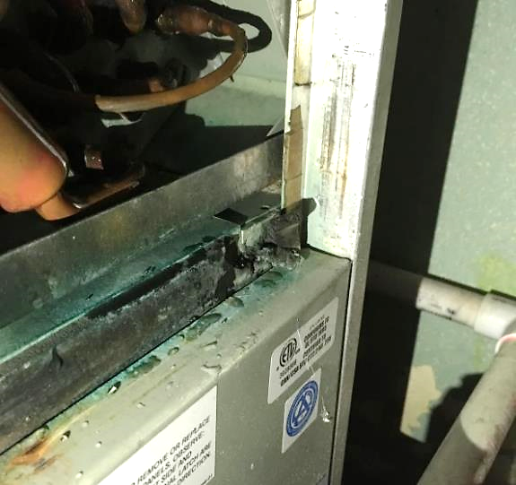

**Corrosion to AHU outside of drip pan**

**Picture 2**

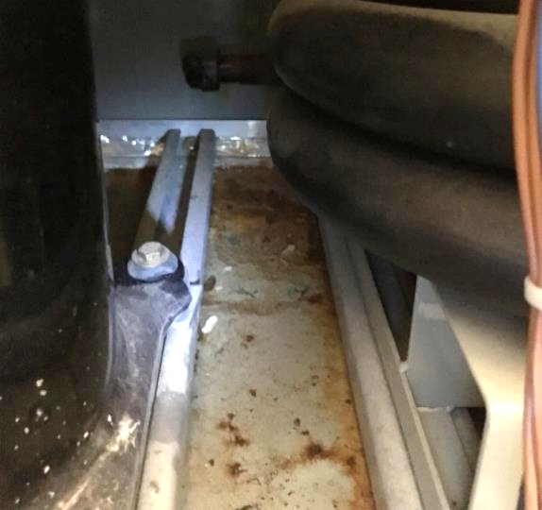

**Oily film and debris inside AHU drip pan and cabinet**

**Picture 3**

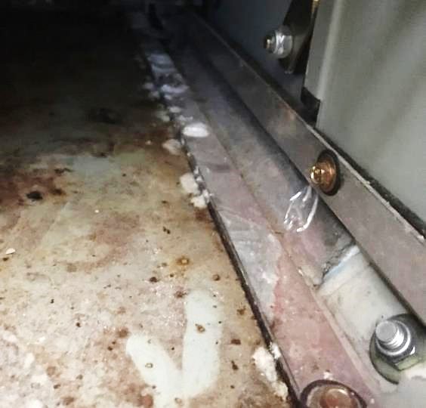

**White spots on drip pan, likely to be mold colonies**

**Picture 4**

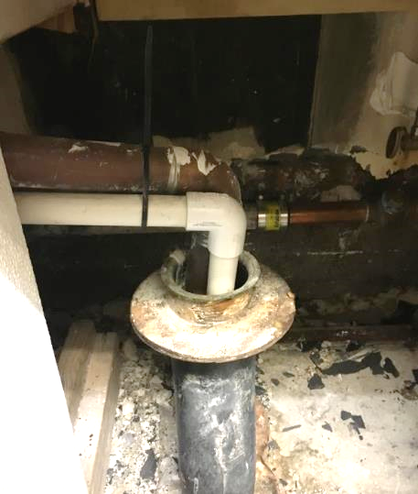

**Open drain pipe in restroom with drain from condensation pan in it**