INDOOR AIR QUALITY ASSESSMENT

Department of Developmental Services
24 Southbridge Street
Worcester, Massachusetts

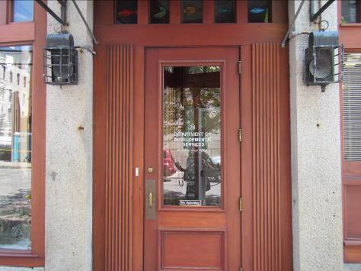

Prepared by:
Massachusetts Department of Public Health
Bureau of Environmental Health
Indoor Air Quality Program
September 2015

Background
Building: | Department of Developmental Services (DDS)
Address: | 24 Southbridge Street, Worcester, MA
Assessment Requested by: | Erin R. McCabe  EHS Facilities Deputy Director for Finance and Operations
Date of Assessment: | August 17, 2015
BEH/IAQ Staff Conducting Assessment: | Michael Feeney, Director  Ruth Alfasso, Inspector
Date of Building Construction: | Pre 1900s
Reason for Request: | Mold concerns and odors

Building Description
The DDS Area Office occupies two floors in a building in downtown Worcester. The space has open areas, offices, meeting rooms and storage areas. Some windows are openable.

Methods/Results
Air tests for carbon dioxide, carbon monoxide, temperature and relative humidity were taken with the TSI, Q-Trak, IAQ Monitor 7565. Tests for airborne particle matter with a diameter less than 2.5 micrometers were taken with the TSI, DUSTTRAK™ Aerosol Monitor Model 8520. BEH/IAQ staff also performed a visual inspection of building materials for water damage and/or microbial growth. Results appear in Table 1.

Discussion

Ventilation
It can be seen from Table 1 that carbon dioxide levels were below 800 parts per million (ppm) in all areas surveyed during the assessment. Note that many areas were empty or sparsely populated and one window was open on the second floor. Closed windows and higher occupancy would be expected to result in higher carbon dioxide levels.
An air handling unit (AHU) was found on the second floor inside the kitchen (Picture 1). This unit appears to draw air from the kitchen (Picture 2). If this is the only AHU for the DDS offices, no supply of fresh outside air exists for this office. Ducts carry air from this AHU to offices on both the first and second floor (Pictures 3 and 4). Passive vents are present in many walls and doors which appear to be for exhaust/return (Picture 5), but apart from the vent to the AHU in the kitchen, there is no source of return air. Exhaust vents are present in the restrooms on the first floor, but these were not operating at the time of the visit. As a result, this building has no means of systematically introducing fresh air into the building or removing stale air and related pollutants. Any fresh air is introduced through openable windows, the front door and incidental air leakage.
To maximize air exchange, the MDPH recommends that both supply and exhaust ventilation operate continuously during periods of occupancy. In order to have proper ventilation with a mechanical supply and exhaust system, the systems must be balanced to provide an adequate amount of fresh air to the interior of a room while removing stale air from the room. It is recommended that HVAC systems be re-balanced every five years to ensure adequate air systems function (SMACNA, 1994). The date of the last balancing of this system was not available at the time of the assessment and it is unclear whether the system can be balanced in its current configuration.
The MDPH uses a guideline of 800 ppm for publicly occupied buildings. Inadequate ventilation and/or elevated temperatures are major causes of complaints such as respiratory, eye, nose and throat irritation, lethargy and headaches. For more information concerning carbon dioxide, please see Appendix A.

Temperature
Indoor temperature measurements at the time of the assessment ranged from 82°F to 85°F (Table 1), which were above the MDPH recommended comfort range. The MDPH recommends that indoor air temperatures be maintained in a range of 70°F to 78°F in order to provide for the comfort of building occupants. In many cases concerning indoor air quality, fluctuations of temperature in occupied spaces are typically experienced, even in a building with an adequate fresh air supply. Note that the day of the assessment was preceded by a weekend during which power was off for this and other nearby buildings due to a lightning storm. The HVAC system was not turned back on until the building was occupied the morning of the assessment; due to the high temperatures over the weekend, the interior of the building had not yet been cooled back down to normal indoor temperature.
Note that the data room had a higher temperature than any other space. This room was equipped with a very small wall-mounted air conditioning unit (Picture 6). The wall in which it was inserted was not an exterior wall, and the air conditioner appeared to discharge waste heat into an empty space behind the wall which could not be accessed. This is not an effective means of providing cooling to this space. In addition, a wall-mounted air conditioner creates condensate, which can moisten building materials if not drained properly away from the building.

Relative Humidity
Indoor relative humidity at the time of the assessment ranged from 47 to 63 percent (Table 1). All measurements on the first floor were above the MDPH comfort range while all those on the second floor were within it. The MDPH recommends a comfort range of 40 to 60 percent for indoor air relative humidity. The elevated relative humidity measurements were reflective of outdoor conditions and the fact that air conditioning had not been operational over the weekend. Relative humidity levels in the building would be expected to drop during winter months due to heating. The sensation of dryness and irritation is common in a low relative humidity environment. Low relative humidity is a very common problem during the heating season in the northeast part of the United States.

Microbial/Moisture Concerns
The concerns initiating the request for assessment were regarding mold and odors. Reportedly, flooding/leaks had occurred in the basement at various times, including the week before the assessment. No access to the basement was possible during the assessment; additionally the basement is not available to the DDS office staff and no storage of DDS materials takes place there. Prompt cleanup of water and removal of any water-damaged porous materials should occur any time there are leaks in basement areas. In addition, any pathways between the basement and occupied areas should be kept tightly sealed/closed.
BEH/IAQ staff detected a basement /musty odor that was present in the stairwell that connects the front of the first floor to the second floor. It is likely that air is being drawn through spaces in the stairs between the treads, risers and stringers into the occupied space by a combination of rising heat air and draw of air by the operation of the second floor AHU.
Leaks were also reported in occupied areas previously. Areas impacted had reportedly been dried with fans. Carpeting and coving was examined in the large conference room which had reportedly been subject to leaks, and this material appeared dry and free from microbial growth. Ceiling tiles in the large conference room that had been impacted had reportedly been replaced. Water-damaged ceiling tiles were observed in the kitchen (Picture 7) next to the closet with the AHU. These stained tiles may be from roof or plumbing leaks and should be replaced once the source of water is discovered and repaired.
Plants were observed in some offices and open areas (Table 1). Plants can be a source of pollen and mold, which can be respiratory irritants to some individuals. Plants should be properly maintained, over-watering of plants should be avoided and drip pans should be inspected periodically for mold growth and cleaned or replaced as necessary. An aquarium was observed in one office, which can be a source of odors if not properly maintained.
Water dispensers were observed on carpeted areas. Spills or leaks from these appliances can moisten carpeting and lead to mold growth. They should be located in a non-carpeted area or on waterproof mats.

Other IAQ Evaluations
Indoor air quality can be negatively influenced by the presence of respiratory irritants, such as products of combustion. The process of combustion produces a number of pollutants. Common combustion emissions include carbon monoxide, carbon dioxide, water vapor, and smoke (fine airborne particle material). Of these materials, exposure to carbon monoxide and particulate matter with a diameter of 2.5 micrometers (μm) or less (PM2.5) can produce immediate, acute health effects upon exposure. To determine whether combustion products were present in the indoor environment, BEH/IAQ staff obtained measurements for carbon monoxide and PM2.5

Carbon Monoxide
Carbon monoxide is a by-product of incomplete combustion of organic matter (e.g., gasoline, wood and tobacco). Exposure to carbon monoxide can produce immediate and acute health effects. Several air quality standards have been established to address carbon monoxide and prevent symptoms from exposure to these substances. The MDPH established a corrective action level concerning carbon monoxide in ice skating rinks that use fossil-fueled ice resurfacing equipment. If an operator of an indoor ice rink measures a carbon monoxide level over 30 ppm, taken 20 minutes after resurfacing within a rink, that operator must take actions to reduce carbon monoxide levels (MDPH, 1997).
The American Society of Heating Refrigeration and Air-Conditioning Engineers (ASHRAE) has adopted the National Ambient Air Quality Standards (NAAQS) as one set of criteria for assessing indoor air quality and monitoring of fresh air introduced by HVAC systems (ASHRAE, 1989). The NAAQS are standards established by the US EPA to protect the public health from six criteria pollutants, including carbon monoxide and particulate matter (US EPA, 2006). As recommended by ASHRAE, pollutant levels of fresh air introduced to a building should not exceed the NAAQS levels (ASHRAE, 1989). The NAAQS were adopted by reference in the Building Officials & Code Administrators (BOCA) National Mechanical Code of 1993 (BOCA, 1993), which is now an HVAC standard included in the Massachusetts State Building Code (SBBRS, 2011). According to the NAAQS, carbon monoxide levels in outdoor air should not exceed 9 ppm in an eight-hour average (US EPA, 2006).
Carbon monoxide should not be present in a typical, indoor environment. If it is present, indoor carbon monoxide levels should be less than or equal to outdoor levels. No carbon monoxide was detected (ND) in any indoor or outdoor measurements (Table 1).

Particulate Matter
Particulate matter is airborne solids that can be irritating to the eyes, nose and throat. The NAAQS originally established exposure limits to particulate matter with a diameter of 10 μm or less (PM10). According to the NAAQS, PM10 levels should not exceed 150 microgram per cubic meter (μg/m³) in a 24-hour average (US EPA, 2006). These standards were adopted by both ASHRAE and BOCA. Since the issuance of the ASHRAE standard and BOCA Code, US EPA established a more protective standard for fine airborne particles. This more stringent PM2.5 standard requires outdoor air particle levels be maintained below 35 μg/m³ over a 24-hour average (US EPA, 2006). Although both the ASHRAE standard and BOCA Code adopted the PM10 standard for evaluating air quality, MDPH uses the more protective PM2.5 standard for evaluating airborne particulate matter concentrations in the indoor environment.
Outdoor PM2.5 concentrations were 35 μg/m³ (Table 1), which was at the NAAQS limit, likely due to traffic outside the building. Indoor PM2.5 levels ranged from 9 to 29 μg/m³ (Table 1), which were below the NAAQS PM2.5 level of 35 μg/m³. Frequently, indoor air levels of particulate matter (including PM2.5) can be at higher levels than those measured outdoors.

Volatile Organic Compounds (VOCs)
VOCs are carbon-containing substances that have the ability to evaporate at room temperature. Frequently, exposure to low levels of total VOCs (TVOCs) may produce eye, nose, throat and/or respiratory irritation in some sensitive individuals.
Hand sanitizer was observed in office areas (Table 1). These products may contain ethyl alcohol and/or isopropyl alcohol, which are highly volatile and may be irritating to the eyes and nose. Sanitizing products may also contain fragrances to which some people may be sensitive.
Cleaning products were also observed. Cleaning products, air fresheners and other air deodorizers contain chemicals that can be irritating to the eyes, nose and throat of sensitive individuals. Many air fresheners contain 1,4-dichlorobenzene, a VOC which can reduce lung function (NIH, 2006). Furthermore, deodorizing agents do not remove materials causing odors, but rather mask odors that may be present in the area. Cleaning products should be properly labeled and stored in an appropriate area. In addition, a Material Safety Data Sheet (MSDS) should be available at a central location for each product in the event of an emergency.
Several areas had dry erase boards and related materials (Table 1). Materials such as dry erase markers and dry erase board cleaners may contain VOCs, such as methyl isobutyl ketone, n-butyl acetate and butyl-cellusolve (Sanford, 1999), which can be irritating to the eyes, nose and throat.

Other Concerns
The location of the AHU in the kitchen may be a source of degraded indoor air in the DDS space. The air intake vent is located directly adjacent to the refrigerator, which puts out heat during operation. This will force the AHU to work harder to cool down the space during the cooling season. In addition, any odors from the kitchen, including food, smoke or trash, would be distributed into the rest of the occupied space through the operation of the AHU.
Note that the filter in the AHU was not the correct size (Picture 1) and was of a type that provides minimal filtration. The dust spot efficiency is the ability of a filter to remove particulate matter of a certain diameter from air passing through the filter. Filters that have been determined by ASHRAE to meet its standard for a dust spot efficiency of a minimum of 40 percent would be sufficient to reduce many airborne particulates (Thornburg, 2000; MEHRC, 1997; ASHRAE, 1992). Pleated filters with a Minimum Efficiency Reporting Value (MERV) dust-spot efficiency of 9 or higher are recommended. Note that increasing filtration may require evaluation and adjustments to the AHU systems to deal with the increased resistance to flow of higher MERV value filters.
Other conditions that can affect IAQ were observed during the assessment. Personal fans, air purifiers and heaters were observed in some offices. Some of these appliances were dusty (Picture 8). Dust on these items can be reaerosolized and cause irritation or odors. In addition, air purifiers may have filters or other components that need to be cleaned and maintained so that they do not become a source of air pollution.
In some areas, accumulation of items, including papers, boxes and personal items were stored on floors desks, tables and counters (Pictures 9 and 10). Large numbers of items provide a source for dusts to accumulate. These items make it difficult for custodial staff to clean. Items should be relocated and/or cleaned periodically to avoid excessive dust build up.
Fluorescent bulbs were observed stored loosely (Picture 11). New and spent bulbs can release mercury and create shards of glass if broken.

Conclusions/Recommendations
In view of the findings at the time of the visit, the following recommendations are made:
- Ensure that basement areas are dried, cleaned and any water-damaged materials removed following any leaks.
- Seal any openings between basement areas and occupied areas to prevent the transport of odors from the basement, particularly in the stairwell leading from the first to second floor. Ensuring the basement door fits tightly and remains closed.
- Replace the wall-mounted air conditioner in the data room with a correctly-sized portable or ductless unit with appropriate drainage of condensate. Inspect the space behind the wall-mounted air conditioner for water damage and make repairs as needed.
- Investigate whether there is a supply of fresh air for the building. Consider building modifications to supply fresh outside air to the AHU. Use openable windows during temperate times of the year to supply additional fresh air. Ensure windows are closed tightly at the end of each day.
- Consider moving the air supply to the AHU to a location other than adjacent to the refrigerator/in the kitchen to avoid entrained odors and excess heat. Until that can be done, take special care with use and cleanliness of the kitchen to avoid creating odors that can be transported to the rest of the occupied spaces.
- Make repairs to restroom exhaust vents to remove bathroom odors and moisture from the building. Note that draw of air through the exhaust vents may depressurize the rest of the occupied spaces and create conditions that may draw odors from unoccupied areas such as the basement unless a supply of fresh outside air is obtained.
- For buildings in New England, periods of low relative humidity during the winter are often unavoidable. Therefore, scrupulous cleaning practices should be adopted to minimize common indoor air contaminants whose irritant effects can be enhanced when the relative humidity is low. To control for dusts, a high efficiency particulate arrestance (HEPA) filter equipped vacuum cleaner in conjunction with wet wiping of all surfaces is recommended. Avoid the use of feather dusters. Drinking water during the day can help ease some symptoms associated with a dry environment (throat and sinus irritations).
- Replace the water-damaged ceiling tiles in the kitchen once the source of water has been discovered and repaired.
- Consider placing water dispensers on non-carpeted areas or place a waterproof mat underneath them.
- Maintain indoor plants, use non-porous drips pans and prevent overwatering.
- Reduce the use of dry erase materials, hand sanitizer and cleaning/scented products to avoid exposure to TVOCs in a building with no fresh air supply.
- Replace the filter in the AHU with one of correct size. Consider upgrading to a MERV value of 9; change filters regularly.
- Clean vents and personal fans to avoid reaerosolizing dusts.
- Store items in an organized manner and move them to clean periodically to prevent a buildup of dust.
- Store new and spent fluorescent bulbs in sturdy closed containers to prevent breakage and dispose of in accordance with relevant environmental regulations.
- Refer to resource manuals and other related indoor air quality documents for further building-wide evaluations and advice on maintaining public buildings. These materials are located on the MDPH’s website: http://mass.gov/dph/iaq.

References
ASHRAE. 1989. Ventilation for Acceptable Indoor Air Quality. American Society of Heating, Refrigeration and Air Conditioning Engineers. ANSI/ASHRAE 62-1989.
ASHRAE. 1992. Gravimetric and Dust-Spot Procedures for Testing Air-Cleaning Devices Used in General Ventilation for Removing Particulate Matter. American Society of Heating, Refrigeration and Air Conditioning Engineers. ANSI/ASHRAE 52.1-1992.
BOCA. 1993. The BOCA National Mechanical Code/1993. 8th ed. Building Officials and Code Administrators International, Inc., Country Club Hill, IL.
MDPH. 1997. Requirements to Maintain Air Quality in Indoor Skating Rinks (State Sanitary Code, Chapter XI). 105 CMR 675.000. Massachusetts Department of Public Health, Boston, MA.
MEHRC. 1997. Indoor Air Quality for HVAC Operators & Contractors Workbook. MidAtlantic Environmental Hygiene Resource Center, Philadelphia, PA.
NIH. 2006. Chemical in Many Air Fresheners May Reduce Lung Function. NIH News. National Institute of Health. July 27, 2006. http://www.nih.gov/news/pr/jul2006/niehs-27.htm
Sanford. 1999. Material Safety Data Sheet (MSDS No: 198-17). Expo® Dry Erase Markers Bullet, Chisel, and Ultra Fine Tip. Sanford Corporation. Bellwood, IL.
SBBRS. 2011. Mechanical Ventilation. State Board of Building Regulations and Standards. Code of Massachusetts Regulations. 780 CMR 1209.0.
SMACNA. 1994. HVAC Systems Commissioning Manual. 1st ed. Sheet Metal and Air Conditioning Contractors’ National Association, Inc., Chantilly, VA.
Thornburg, D. 2000. Filter Selection: a Standard Solution. Engineering Systems 17:6 pp. 74-80.
US EPA. 2006. National Ambient Air Quality Standards (NAAQS). US Environmental Protection Agency, Office of Air Quality Planning and Standards, Washington, DC. http://www.epa.gov/air/criteria.html
Picture 1
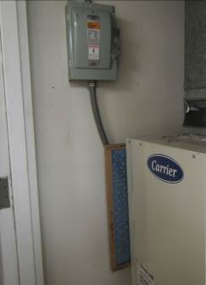
Air handling unit (AHU) in kitchen closet, note poorly fitted filter (arrow)
Picture 2
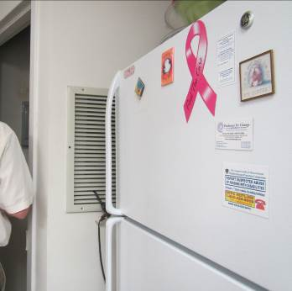
Air intake for AHU next to refrigerator
Picture 3
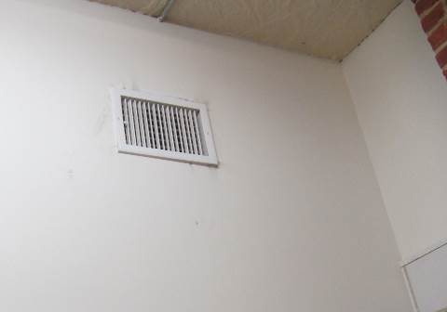
Supply vent in room, note dust
Picture 4
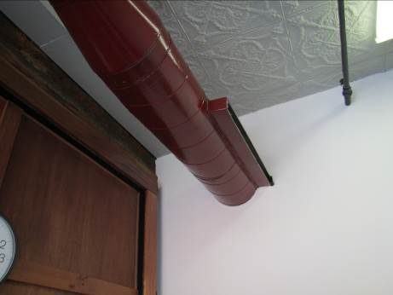
Supply vent off ductwork
Picture 5
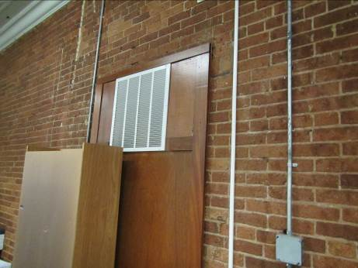
Passive vent in hallway
Picture 6
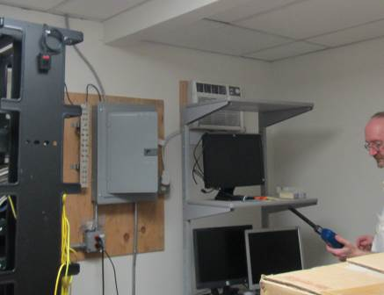
Data room, note small wall-mounted air conditioner (arrow)
Picture 7
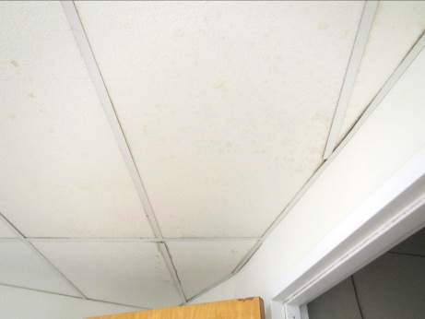
Water-damaged ceiling tiles in the kitchen above the door to the AHU closet
Picture 8
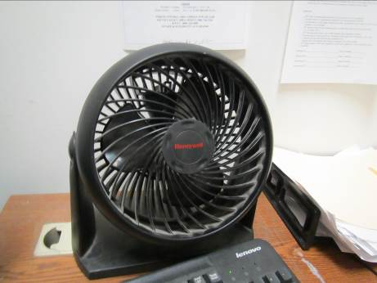
Dusty personal fan
Picture 9
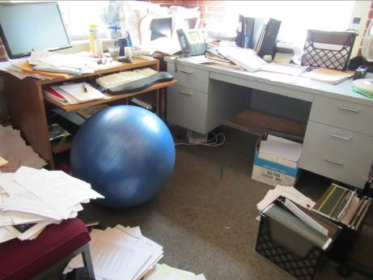
Items in an office
Picture 10
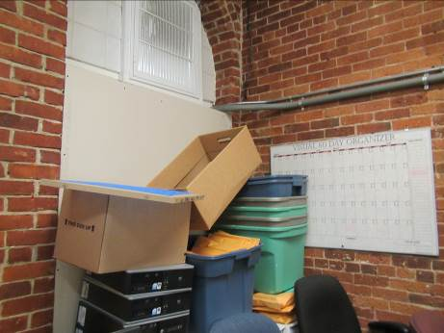
Items in a storeroom
Picture 11
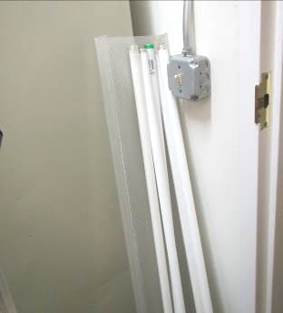
Poorly stored fluorescent bulbs
Location | Carbon  Dioxide  (ppm) | Carbon Monoxide  (ppm) | Temp  (°F) | Relative  Humidity  (%) | PM2.5  (µg/m³) | Occupants  in Room | Windows  Openable | Ventilation |  | Remarks
 |  |  |  |  |  |  |  | Supply | Exhaust | Remarks
Background | 592 | ND | 84 | 58 | 35 |  |  |  |  | Busy street
1st floor
Waiting room | 581 | ND | 83 | 62 | 10 | 0 | N | Y |  | Many plants in window, DEM in hallway
Storage area | 626 | ND | 83 | 62 | 17 | 0 | N | Y |  | Boxes on floor, DO
Storage area end of hallway | 623 | ND | 83 | 62 | 27 | 0 | N |  |  | Many items, fluorescent bulbs stored out of boxes, vents dirty, DO
Large Conference room | 728 | ND | 83 | 63 | 12-22 | 4 | N | Y | N | PF on
Men’s restroom |  |  |  |  |  |  |  | N | Y | Exhaust off
Women’s restroom |  |  |  |  |  |  |  | N | Y | Exhaust off, DO
Data room |  |  | 85 |  |  |  | N | N | N | Wall-mounted air conditioner which does not go outside, NC
Rear hallway | 646 | ND | 83 | 61 | 11 | 0 | N | Y |  | Boxes on floor, PF, CF, PC
End of hall office (1) | 590 | ND | 83 | 61 | 14 | 0 | N | Y | N | DO
Office (2) | 598 | ND | 83 | 62 | 13 | 0 | N | Y
Office (3) | 585 | ND | 82 | 62 | 11 | 0 | N | Y | N
Office (4) | 626 | ND | 83 | 62 | 14 | 1 | N | Y | N | Plants
Office (5) | 617 | ND | 83 | 62 | 13 | 1 | N | Y | N | Couch, PF dusty, DO
Storage (6) | 610 | ND | 83 | 62 | 10 | 0 | N | Y |  | Open area on top of walls, CF, boxes on floor
Office behind reception | 669 | ND | 83 | 63 | 9 | 0 | N | Y |  | Plant, PF/AP, AI
Reception | 599 | ND | 83 | 62 | 11 | 1 | N | Y |  | CP
2nd floor
Executive Office | 653 | ND | 83 | 53 | 16 | 0 | N | Y |  | DO, balloons
Lunchroom | 584 | ND | 83 | 54 | 17 | 0 | N | Y |  | NC, WD-CT, fridge next to air handling unit closet vent, refrigerator, toaster, food
Storage off of lunchroom | 674 | ND | 83 | 55 | 16 | 0 | N |  |  | Boxes and items
Open office near lunchroom | 644 | ND | 83 | 51 | 12 | 0 | N | Y | N | PF – on, food
205 | 641 | ND | 83 | 50 | 27 | 0 | N | Y | N | DO
Open hallway | 650 | ND | 83 | 51 | 11 | 0 | N | Y | N
Mail | 763 | ND | 83 | 52 | 29 | 0 | N | Y | N | PC, NC, HS, no door
Conference room | 660 | ND | 82 | 51 | 14 | 0 | N | Y |  | DO
File room |  |  |  |  |  |  |  |  |  | NC, PF, boxes on floor
End of hallway office | 665 | ND | 82 | 52 | 13 | 1 | N | Y | N | Plants, no door, PF on
Office next to end of hallway | 721 | ND | 83 | 52 | 19 | 0 | N | Y | N | Plant
Office | 607 | ND | 83 | 56 | 16 | 0 | Y open | Y | N | DO
Inner office | 599 | ND | 82 | 54 | 12 | 0 | N | Y | N | HS, CP, PF
Outer office | 593 | ND | 83 | 54 | 12 | 0 | N | Y | N | DO, PF dusty
Open work area | 627 | ND | 82 | 47 | 13 | 1 | N | Y | N | PF on, DEM
Small corner office | 610 | ND | 83 | 56 | 11 | 0 | Y | Y | N | PF, AI, CP
Office | 616 | ND | 83 | 54 | 20 | 0 | Y | Y | N | AI, PF
Office | 674 | ND | 82 | 56 | 13 | 2 | Y | Y | N | Fish tank, plants

The stack effect is the movement of air into and out of buildings, chimneys, flue gas stacks, or other containers, resulting from air buoyancy created by heat.

