INDOOR AIR QUALITY ASSESSMENT

Department of Developmental Services
Berkshire Regional Office
333 East Street, 5th Floor
Pittsfield, MA

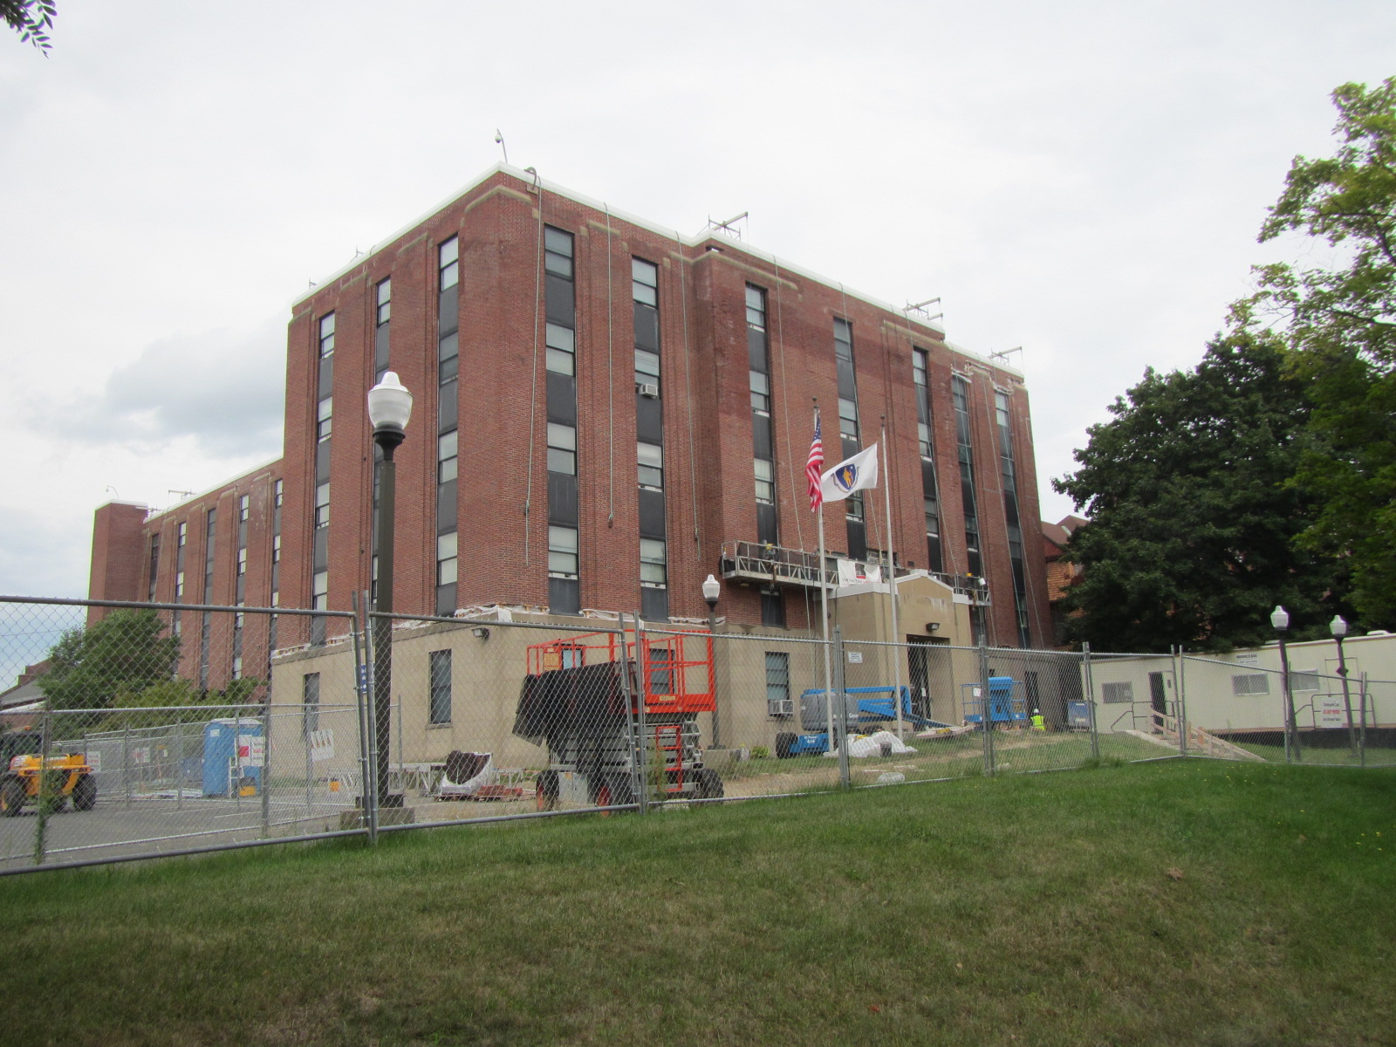

Prepared by:
Massachusetts Department of Public Health
Bureau of Environmental Health
Indoor Air Quality Program
September 2016
BACKGROUND
Building: | Department of Developmental Services
Address: | 333 East Street, Pittsfield, MA
Assessment Requested by: | Kelly Flaherty, Division of Capital Asset Management and Maintenance (DCAMM)
Reason for Request: | Odors on the 5th floor during brick repointing
Date of Assessment: | August 31, 2016
Massachusetts Department of Public Health/Bureau of Environmental Health (MDPH/BEH) Staff Conducting Assessment: | Mike Feeney, Director, Indoor Air Quality (IAQ) Program
Date Building Constructed: | 1950s
Building Description: | Constructed as a brick building that served as a nunnery for nursing trainees.
Building Population: | Approximately 20 employees

METHODS
Please refer to the IAQ Manual for methods, sampling procedures, and interpretation of results (MDPH, 2015).

RESULTS and DISCUSSION
The following is a summary of indoor air testing results (Table 1).
- Carbon dioxide levels were below the MDPH recommended level of 800 parts per million (ppm) in all but 2 areas surveyed, indicating adequate air exchange in most of the building.
- Temperature was within the MDPH recommended range of 70°F to 78°F in most occupied areas surveyed.
- Relative humidity was within the MDPH recommended range of 40 to 60% in most areas tested.
- Carbon monoxide levels were non-detectable (ND) in all areas tested.
- Particulate matter (PM2.5) concentrations measured were below the National Ambient Air Quality (NAAQS) level of 35 μg/m³ in all areas tested.
- Volatile Organic Compounds concentrations were ND in all areas tested.

Ventilation
It is important to note that the building is not equipped with a functioning ventilation system. The sole source of ventilation in the building is openable windows. Air-conditioning (AC) is provided by window-mounted units. In an effort to reduce the impact of odors from the brick repointing, the window-mounted AC units were removed from the windows frames, which were then sealed with plastic. A number of offices were equipped with portable AC units (Picture 1) to provide temperature relief while windows were sealed.

Other IAQ Evaluations
The installation of the portable AC units coincided with the reports of odors inside the building. BEH IAQ staff noted that odors in the hallways seemed to originate from offices that did not have operating AC units. It appears the use of the portable AC units is causing depressurization (e.g., negative pressure), which draws odors from offices, storage space and the elevator shafts into the hallways and into offices with operating equipment. A number of different sources of odors were noted throughout the 5th floor:
- Household cleaners;
- Plants;
- Personal care products;
- Desk cleaners;
- Hand sanitizers;
- Cooking odors from the microwave oven in the breakroom;
- Office supplies; and
- Hydraulic fluid from the elevator shaft.
All of these materials can produce odors that can be irritating to the eyes, nose and respiratory system.

CONCLUSIONS/RECOMMENDATIONS
A number of building conditions, described in this report, may contribute to odors. These conditions/issues combined with a lack of a mechanical ventilation system to filter air can play a role in causing odors described by building occupants. In order to reduce the migration of odors into DDS offices, a combination of providing a source of fresh air with a reduction/elimination of odor producing materials in offices/at the base of elevator shafts should be employed. Based on conditions observed at the time of assessment, the following recommendations are provided.
- Install a fan with a filter in the hallway window at near the north elevator to direct fresh air indoors to pressurize the hallway.
- Use a fan to direct air towards the north elevator to contain hydraulic fluid odor.
- Ascertain if a second fan with filters can be installed in another exterior window on the 5th floor to provide additional pressurization.
- Reduce/eliminate odorous products in office space.
- Use methods outlined in the MA DPH document “Methods Used to Reduce/Prevent Exposure to Construction/Renovation Generated Pollutants in Occupied Buildings” which is included as Appendix A.
- For buildings in New England, periods of low relative humidity during the winter are often unavoidable. Therefore, scrupulous cleaning practices should be adopted to minimize common indoor air contaminants whose irritant effects can be enhanced when the relative humidity is low.
- Use a vacuum cleaner equipped with a high efficiency particulate arrestance (HEPA) filter in conjunction with wet wiping to remove dust from all surfaces. Avoid the use of feather dusters.
- Consider reducing the number of plants. Indoor plants should be properly maintained and equipped with drip pans to prevent water damage to porous building materials and be located away from ventilation sources to prevent the aerosolization of dirt, pollen or mold.
- Drinking water during the day can help ease some symptoms associated with a dry environment (throat and sinus irritations).
- Refer to resource manual and other related indoor air quality documents located on the MDPH’s website for further building-wide evaluations and advice on maintaining public buildings. These documents are available at http://mass.gov/dph/iaq.

REFERENCES
MDPH. 2015. Massachusetts Department of Public Health. “Indoor Air Quality Manual: Chapters I-III”. Available from http://www.mass.gov/eohhs/gov/departments/dph/programs/environmental-health/exposure-topics/iaq/iaq-manual/
Picture 1
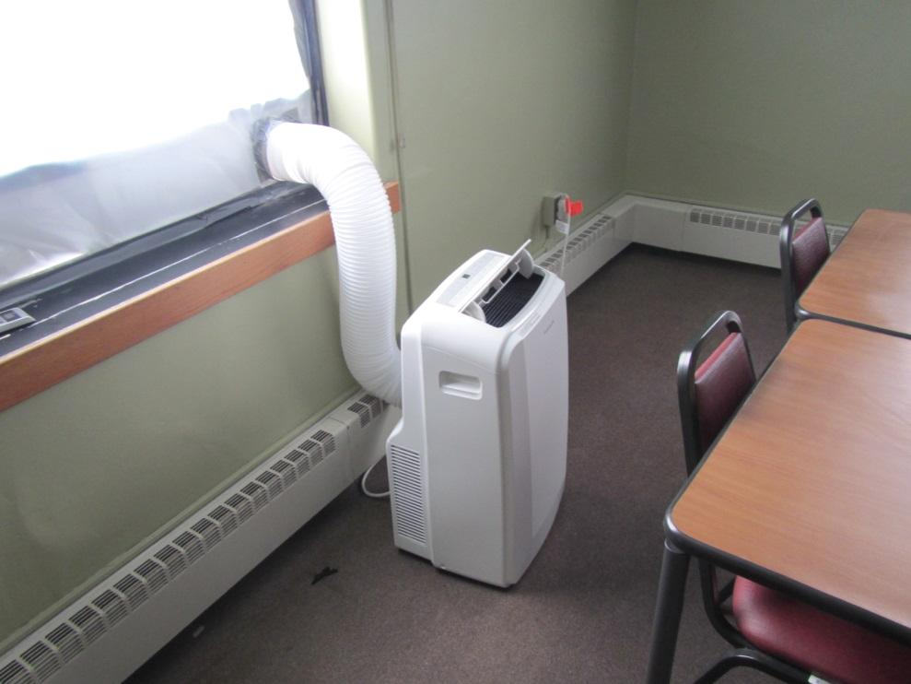
Example of portable AC unit

Location | Carbon  Dioxide  (ppm) | Carbon Monoxide  (ppm) | Temp  (°F) | Relative  Humidity  (%) | PM2.5  (µg/m³) | TVOCs  (ppm) | Occupants  in Room | Windows  Openable | Ventilation |  |  | Remarks
 |  |  |  |  |  |  |  |  | Intake | Exhaust
Background | 398 | ND | 74 | 68 | 16 | ND | 0
505 | 646 | ND | 78 | 47 | 8 | ND | 0 | N | N |  | N
506 | 619 | ND | 78 | 48 | 11 | ND | 0 | N | N |  | N
502 | 588 | ND | 77 | 47 | 5 | ND | 0 | N | N |  | N
504 | 580 | ND | 78 | 57 | 9 | ND | 0 | N | N |  | N
510 | 609 | ND | 79 | 52 | 10 | ND | 0 | N | N |  | N
507 | 541 | ND | 80 | 54 | 7 | ND | 0 | N | N |  | N
508 | 633 | ND | 79 | 51 | 18 | ND | 1 | N | N |  | N
509 | 620 | ND | 79 | 50 | 9 | ND | 0 | N | N |  | N
511 | 617 | ND | 77 | 54 | 7 | ND | 0 | N | N |  | N
512 | 570 | ND | 78 | 58 | 16 | ND | 0 | N | N |  | N
513 | 559 | ND | 78 | 53 | 12 | ND | 1 | N | N |  | N
514 | 1018 | ND | 77 | 44 | 11 | ND | 0 | N | N |  | N
515 | 676 | ND | 74 | 69 | 16 | ND | 0 | N | N |  | N
517 | 673 | ND | 71 | 55 | 10 | ND | 0 | N | N |  | N
519 | 730 | ND | 74 | 58 | 14 | ND | 3 | N | N |  | N
520 | 607 | ND | 76 | 58 | 14 | ND | 0 | N | N |  | N
538 | 670 | ND | 75 | 57 | 11 | ND | 1 | N | N |  | N
521 | 671 | ND | 75 | 51 | 12 | ND | 2 | N | N |  | N
537 | 738 | ND | 76 | 54 | 12 | ND | 1 | N | N |  | N
522 | 685 | ND | 77 | 51 | 14 | ND | 1 | N | N |  | N
536 | 728 | ND | 76 | 48 | 23 | ND | 1 | N | N |  | N
523 | 722 | ND | 78 | 57 | 23 | ND | 0 | N | N |  | N
535 | 685 | ND | 76 | 47 | 13 | ND | 0 | N | N |  | N
524 | 636 | ND | 78 | 57 | 26 | ND | 0 | N | N |  | N
534 | 637 | ND | 77 | 46 | 13 | ND | 0 | N | N |  | N
525 | 822 | ND | 74 | 44 | 13 | ND | 1 | N | N |  | N
520 | 747 | ND | 76 | 56 | 14 | ND | 1 | N | N |  | N
532 | 754 | ND | 75 | 46 | 9 | ND | 0 | N | N |  | N
530 | 704 | ND | 74 | 47 | 16 | ND | 0 | N | N |  | N
Reception | 697 | ND | 75 | 52 | 12 | ND | 1 | N | N |  | N
Elevator | 664 | ND | 77 | 60 | 14 | ND | 0 | N | N |  | N
Main hallway | 689 | ND | 74 | 52 | 14 | ND | 0 | N | N |  | N

