WATER DAMAGE/MOLD INVESTIGATION

Department of Developmental Services
194 West Street, Unit 9
Milford, Massachusetts

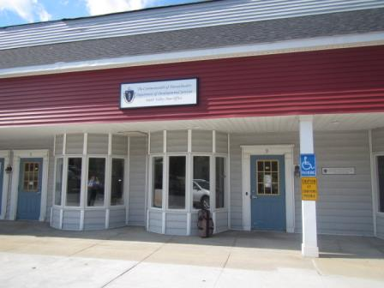

Prepared by:
Massachusetts Department of Public Health
Bureau of Environmental Health
Indoor Air Quality Program
July 2018

BACKGROUND
Building: | Department of Developmental Services (DDS)
Address: | 194 West Street, Unit 9, Milford, MA
Assessment Requested by: | Erin McCabe, EHS Facilities Deputy Director for Finance and Operations, EOHHS
Reason for Request: | Mold/water damage concerns
Date of Assessment: | July 18, 2018
Massachusetts Department of Public Health/Bureau of Environmental Health (MDPH/BEH) Staff Conducting Assessment: | Cory Holmes, Environmental Analyst/Inspector, Indoor Air Quality (IAQ) Program
Building Description: | The DDS office is on located in a one-story mixed use building built in 1988. The DDS has occupied the space for approximately 20 years and is flanked by a private office and exercise facility. The office contains wall-to-wall carpeting (~6 years old), gypsum wallboard (GW) and suspended ceiling tiles.
Windows: | Windows are not openable.

IAQ Testing Results
Please refer to the IAQ Manual for methods, sampling procedures, and interpretation of results (MDPH, 2015). The following is a summary of testing results (Table 1).
- Moisture Measurements were all dry (i.e., within normal parameters) at the time of assessment.
- Temperature was within the recommended range of 70°F to 78°F at the time of assessment.
- Relative humidity was within the recommended range of 40 to 60% in areas tested at the time of the assessment and lower than outside measurements.

Background and Discussion
The BEH/IAQ Program was asked to examine the DDS office for the presence of water damage/mold growth, with a focus on areas that were damaged by a roof leak that reportedly occurred on Tuesday July 10, 2018. The leak reportedly resulted in wet carpeting in the right hallway and ceiling tiles in a number of areas throughout the space (Pictures 1 through 5). One ceiling tile in an office appeared to have mold growth (Table 1; Picture 5). It was also reported that a flooding restoration/carpet cleaning firm (Stanley Steemer), had been contacted to perform moisture testing of wet materials, primarily GW.
At the time of assessment, all porous materials tested (i.e., carpet, ceiling tiles and GW) were dry and no visible mold/associated odor was observed/detected apart from the single ceiling tile (Table 1). It is important to note that relative humidity levels were within the recommended range of 40 to 60% in all areas tested, suggesting that no sources of lingering moisture were present at the time of assessment.
In general, the US Environmental Protection Agency (US EPA) and the American Conference of Governmental Industrial Hygienists (ACGIH) recommends that porous materials (e.g., wallboard, carpeting) be dried with fans and heating within 24 to 48 hours of becoming wet (US EPA, 2008; ACGIH, 1989). If porous materials are not dried within this time frame, mold growth may occur. However, it is important to note that in the DDS office the carpet is a thin, commercial grade with no padding/backing (unlike in homes), which allows it to dry relatively quickly.
As mentioned, the DDS office contains wall-to-wall carpeting. DDS staff reported that a regular carpet cleaning program was not in place. Carpets should be vacuumed regularly with a high efficiency particulate arrestance (HEPA) filter equipped vacuum cleaner and cleaned annually (or semi-annually in soiled/high traffic areas) in accordance with Institute of Inspection, Cleaning and Restoration Certification (IICRC) recommendations, (IICRC, 2012).

Conclusions/Recommendations
Based on the observations made during the visit, the following recommendations are made:
- Continue with plans to work with building management to replace all water-damaged ceiling tiles.
- Clean carpeting in accordance with IICRC recommendations (IICRC, 2012).
- Operate HVAC system/set thermostat to fan “on” (continuous) mode vs “auto” to facilitate air exchange and assist drying prior to occupants returning to space.
- For more information on mold refer to the US EPA’s “Mold Remediation in Schools and Commercial Buildings”. Available at: http://www.epa.gov/mold/mold-remediation-schools-and-commercial-buildings-guide.
- Refer to resource manuals and other related IAQ documents for further building-wide evaluations and advice on maintaining public buildings. Copies of these materials are located on the MDPH’s website: http://mass.gov/dph/iaq.

REFERENCES
ACGIH. 1989. Guidelines for the Assessment of Bioaerosols in the Indoor Environment. American Conference of Governmental Industrial Hygienists, Cincinnati, OH.
IICRC. 2012. Institute of Inspection, Cleaning and Restoration Certification. Carpet Cleaning: FAQ.
MDPH. 2015. Massachusetts Department of Public Health. “Indoor Air Quality Manual: Chapters I-III”. Available at: http://www.mass.gov/eohhs/gov/departments/dph/programs/environmental-health/exposure-topics/iaq/iaq-manual/.
US EPA. 2008. Mold Remediation in Schools and Commercial Buildings. US Environmental Protection Agency, Office of Air and Radiation, Indoor Environments Division, Washington, D.C. EPA 402-K-01-001. http://www.epa.gov/mold/mold-remediation-schools-and-commercial-buildings-guide.
Picture 1
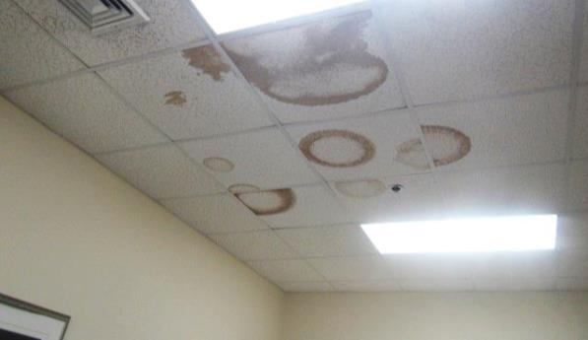
Water-damaged ceiling tiles
Picture 2
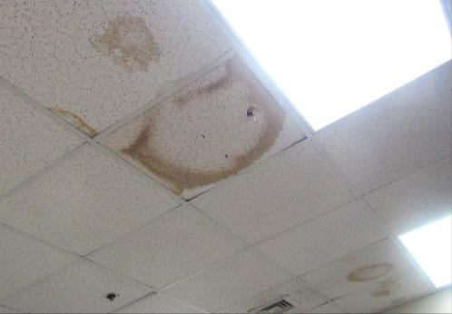
Water-damaged ceiling tiles
Picture 3
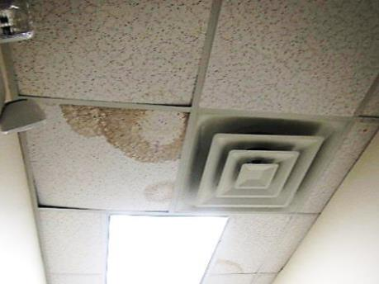
Water-damaged ceiling tiles
Picture 4
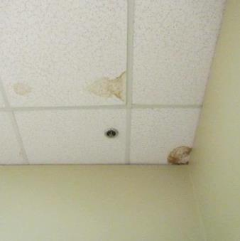
Water-damaged ceiling tiles
Picture 5
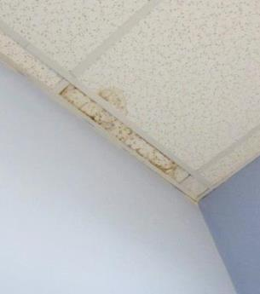
Water-damaged ceiling tile with possible mold growth
Location |  | Temp  (°F) | Relative  Humidity  (%) | Moisture Testing/Remarks
 | Background (outside) | 71 | 67 | Cool, mostly sunny
 | Reception | 73 | 53 | Carpet – dry  Gypsum wallboard - dry
 | Work Cubicle | 73 | 53 | Carpet – dry  Gypsum wallboard – dry  Water-damaged ceiling tiles
 | Left Hallway | 71 | 54 | Carpet – dry  Gypsum wallboard - dry
 | Right Hallway - Rear | 72 | 54 | Carpet – dry  Gypsum wallboard – dry  Water-damaged ceiling tile
 | Right Hallway - Mid | 72 | 53 | Carpet – dry  Gypsum wallboard – dry  Water-damaged ceiling tiles
 | Right Hallway – Front | 72 | 53 | Carpet – dry  Gypsum wallboard - dry
 | Small Conference Room | 72 | 56 | Carpet – dry  Gypsum wallboard – dry  Water-damaged ceiling tiles - dry
 | Large Conference Room | 71 | 52 | Carpet – dry  Gypsum wallboard – dry  Water-damaged ceiling tiles
 | Enegren Office | 73 | 56 | Carpet – dry  Gypsum wallboard – dry  Water-damaged ceiling tile possible mold growth (light grey staining)
 | Germaine Office | 73 | 55 | Carpet – dry  Gypsum wallboard – dry
 | Rear restroom |  |  | Water-damaged ceiling tile

