WATER DAMAGE REASSESSMENT

Massachusetts Department of Developmental Services
340 Main Street
Worcester, Massachusetts

Prepared by:
Massachusetts Department of Public Health
Bureau of Environmental Health
Indoor Air Quality Program
May 2019

Background

Building: | Department of Developmental Services (DDS)
Address: | 340 Main Street, Worcester
Assessment Requested by: | Erin McCabe, Executive Office of Health and Human Services
Reason for Request: | Concerns regarding odors/water damage
Date of Assessment: | May 3, 2019
Massachusetts Department of Public Health/Bureau of Environmental Health (MDPH/BEH) Staff Conducting Assessment: | Michael Feeney, Director, Indoor Air Quality (IAQ) Program
Building Description: | Multi-story building in downtown Worcester
Building Population: | Approximately 130 employees and visitors from the public
Windows: | Openable in some areas
An area of office space in the southwest corner of the rear of the 5th floor around a vault and rear stairwell of the building (the flooded area) was inundated with water from a heating, ventilating and air-conditioning (HVAC) coil leak that occurred in July of 2018. DDS staff had reported an odor in this location on an intermittent basis since the flooding incident. DDS staff reported that the floor was dried to address the moistened carpet and walls. The BEH/IAQ Program was asked to examine the DDS floor in the area of water damage. DPH previously visited this DDS office on April 19, 2019 to examine the area and conduct moisture sampling of floors and walls. DPH/IAQ staff returned on May 3, 2019 to reexamine the flooded area and conduct further moisture sampling. This examination, with the participation of 340 Main Street building staff, revealed that carpet tile was adhered directly to a cement floor without any plywood or padding that could support mold growth, as suggested in the previous report. Without chronically moistened plywood or padding, no materials that could support mold growth are present under the floor tiles.

Methods/IAQ Testing Results
Please refer to the IAQ Manual for methods, sampling procedures, and interpretation of results (MDPH, 2015). The following is a summary of testing results.
- Moisture Measurements in all carpeting in the areas around the vault had comparable levels of moisture in comparison to non-flooded (control) areas at the time of this assessment.

Discussion

Microbial/Moisture Concerns
As part of the assessment, the exterior walls at the rear of the building were examined. The fifth floor has a number of vents of unknown purpose beneath windows (Picture 1). None of these vents appear to be connected to the fresh air intake for the current HVAC system. No other floor above the fifth has these vents. Each opening has a bug screen installed beneath the exterior grate, which indicates that each opening was likely design to be a fresh air intake. A close-up of one vent reveals that a material was used to seal behind the bug screen, however it appears that this material has degraded creating a hole (Picture 2). If other vents are in similar condition, unconditioned air may enter the building wall cavity, which may result in water vapor penetration as well as other odors that exist outside the building under certain wind directions (west to southwesterly) and speed. This condition may also pose a condensation problem during summer months since the HVAC system provides chilled air in the summer. If hot, moist air enters the wall cavity, condensation may develop within the wall cavity that can produce mold growth, resulting in musty/mold odors in this area.
In general, the US Environmental Protection Agency (US EPA) and the American Conference of Governmental Industrial Hygienists (ACGIH) recommends that porous materials (e.g., GW, carpeting) be dried with fans and heating within 24 to 48 hours of becoming wet (US EPA, 2008; ACGIH, 1989). If porous materials are not dried within this time frame, mold growth may occur.

Conclusions/Recommendations
Based on the observations made during this assessment, without plywood and/or padding beneath the carpet tile, it is possible that moisture/precipitation from the west to southwest may be entering the wall cavity to be a contributing source of odor in this space. Odor from restroom plumbing and dampness from moistened materials have each been considered and eliminated. The next step would be to eliminate other moisture sources, such as stream leaks from radiators and/or uncontrolled moist air from the vents identified in this report. In order to address this situation, carpet tile and flooring needs to be examined, and removed if it is the source of the odor:
- The IAQ Program suggests identifying the purpose of the outdoor vents in Pictures 1 and 2. If not part of an active HVAC system, consider permanently sealing these vents with an appropriate material that can withstand wind directions and speed experienced in the greater Worcester area. If feasible, clean debris within these vent prior to sealing.
- Examine the radiators for leaks and repair as needed.
- If odor continues, please feel free to contact the DPH IAQ Program.
- Refer to resource manuals and other related IAQ documents for further building-wide evaluations and advice on maintaining public buildings. Copies of these materials are located on the MDPH’s website: http://mass.gov/dph/iaq.

REFERENCES
ACGIH. 1989. Guidelines for the Assessment of Bioaerosols in the Indoor Environment. American Conference of Governmental Industrial Hygienists, Cincinnati, OH.
MDPH. 2015. Massachusetts Department of Public Health. “Indoor Air Quality Manual: Chapters I-III”. Available at: http://www.mass.gov/eohhs/gov/departments/dph/programs/environmental-health/exposure-topics/iaq/iaq-manual/.
US EPA. 2008. Mold Remediation in Schools and Commercial Buildings. US Environmental Protection Agency, Office of Air and Radiation, Indoor Environments Division, Washington, D.C. EPA 402-K-01-001. http://www.epa.gov/mold/mold-remediation-schools-and-commercial-buildings-guide.
Picture 1
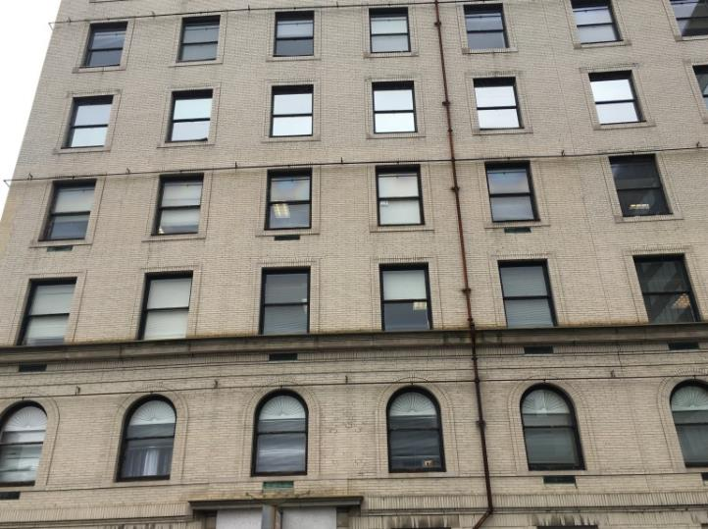
Vent beneath windows on 5th floor (arrow)
Picture 2
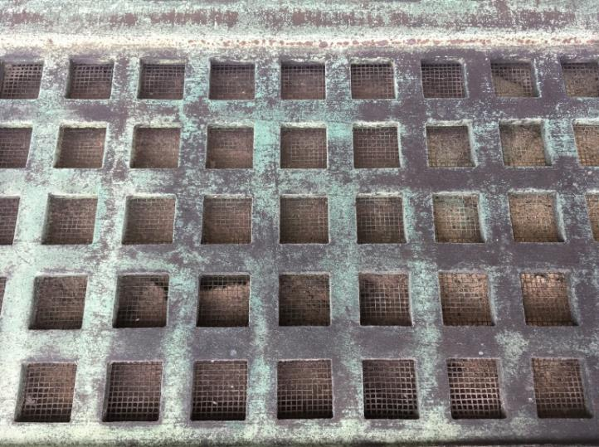
Close up of vent, note bug screen and hole (arrow) in sealing material

