WATER DAMAGE/MOLD INVESTIGATION

Massachusetts Department of Developmental Services
68 North Main Street
Carver, Massachusetts

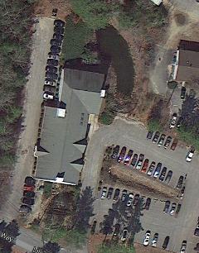

Prepared by:
Massachusetts Department of Public Health
Bureau of Environmental Health
Indoor Air Quality Program
November 2013

Background/Introduction
At the request of Lisa Gallup, Director of Human Resources, Disabilities and Community Services, Executive Office of Health and Human Services, a water damage/mold investigation was conducted at the Massachusetts Department of Developmental Services (DDS), Regional Office, 68 North Main Street, Carver, Massachusetts. The Massachusetts Department of Public Health (MDPH), Bureau of Environmental Health (BEH) conducted the assessment in response to lingering concerns related to the water damage and potential mold growth following a flooding incident experienced on the first floor over the weekend of August 23-26, 2013.
On October 21, 2013, a site assessment was made by Cory Holmes, Environmental Analyst/Regional Inspector in BEH’s Indoor Air Quality (IAQ) Program. During the assessment, Mr. Holmes was accompanied by Ms. Carol Slaiding, Regional Operations Manager, Southeast Region, DDS. The first floor where the flooding event occurred is located on a cement slab covered with vinyl floor tiles; the space consists of offices and open workstations. Walls are painted gypsum wallboard (GW) with vinyl base coving. At the request of DDS, BEH/IAQ staff also examined several other areas where staff had concerns regarding water damage/mold.

Methods
BEH/IAQ staff performed a visual inspection of building materials for water damage and/or microbial growth. Moisture content of porous building materials (i.e., GW and carpeting) was measured using a Delmhorst, BD-2000 Model Moisture Detector. Moisture testing results are included as Table 1.

Results and Discussion
The flooding occurred after hours in a first floor restroom, reportedly the result of a water backup from blocked drainage. Ms. Slaiding reported that approximately two inches of standing water had accumulated in the adjacent work area (Picture 1). Water also seeped out in to the main foyer, moistening the wall-to-wall carpeting (Picture 2). Upon discovering the flood, building management contacted Kennedy Carpet Restoration/Cleaners to conduct remediation work (e.g., water extraction, drying the area with fans, cleaning, and disinfection of surfaces with an antimicrobial agent).
In order for building materials to support mold growth, a source of water exposure is necessary. Identification of the location of materials with increased moisture levels can indicate an existing or potential location of mold colonization. To determine if GW and carpeting had elevated moisture content that would be conducive to or indicative of mold growth, BEH/IAQ staff conducted moisture testing of these materials. The majority of building materials affected by the flooding event were dry at the time of the assessment due to the remediation activities that were conducted coupled with the time that had passed since the flood. A few areas, however, were found damp (Table 1). It was recommended that the affected materials be removed.
The US Environmental Protection Agency (US EPA) and the American Conference of Governmental Industrial Hygienists (ACGIH) recommends that porous materials be dried with fans and heating within 24 to 48 hours of becoming wet (US EPA, 2001; ACGIH, 1989). If porous materials are not dried within this time frame, mold growth may occur.
At the time of assessment, BEH/IAQ staff were asked to examine several other areas unrelated to the recent flooding event. Water-damaged/mold-colonized GW was found in two first floor mechanical rooms, one adjacent to the elevator known as the “water room” (Pictures 3 through 5) and another off the Personnel File Room (Pictures 6 and 7). Moldy/stained rolled-up carpeting was also observed in the water room (Picture 8).
The air-handling unit (AHU) in the water room was missing a filter panel (Picture 9). Missing access panels will render the AHU casing non-airtight, allowing the draw of air from the mechanical room into the unit. As air bypasses filters, the opportunity exists for airborne dirt, dust, odors, and particulates and, in this case, fiberglass insulation (Picture 10) to be drawn into the HVAC system and distributed to occupied areas. Aerosolized dust, particulates, and odors can provide a source of eye, skin, and respiratory irritation to certain individuals. In addition, these materials can accumulate on flat surfaces in occupied areas and subsequently be re-aerosolized causing further irritation. A hole was observed in ductwork for the AHU in the mechanical room by the Personnel File room (Picture 11); breaches can allow infiltration of odors/particulates and also result in the loss of heated/cooled air.
Remnants of mold-colonized boxes were present on the floor of the Personnel File room (Picture 12). Other cardboard boxes were observed on the floor (Picture 13). Cardboard boxes or other porous materials should not be stored directly on floors in areas where condensation can accumulate or other water exposure can occur. During summer months, the cool surface of floors can generate condensation due to elevated humidity. Condensation can moisten cardboard, which provide a medium for mold growth.
DDS staff reported concerns regarding the floor of the Personnel File Room, where deposits/stains were attributed to possible mold growth (Picture 14). In the experience of BEH/IAQ staff, the deposited material is most likely the mastic/glue from beneath the tiles that had softened due to condensation/moistening and is being pushed up between the tiles.
BEH/IAQ staff also examined failing base coving and water-damaged GW in Ms. Baker’s office (Pictures 15 and 16), which is directly inside the main entrance. GW in this area was moist at the time of assessment (Table 1). This area appears to experience chronic water infiltration due to poor drainage. The exterior corner directly outside this portion of the building is not properly graded (Picture 17).
Finally, BEH/IAQ staff examined the second floor in the Investigation area, where water damage occurred previously but has been since repaired. At the time of assessment, the window trim had been removed; no visible mold growth, elevated moisture, or current water infiltration was observed (Table 1).

Conclusions/Recommendations
While remediation efforts to remove water from the first floor appeared to have prevented widespread impacts, BEH/IAQ staff identified several areas with damp materials (e.g., GW and carpeting) that should be removed. Several other recommendations not related to the flooding event are also made to improve IAQ conditions:
- Remove remaining water-damaged materials (e.g. carpeting and GW) in a manner consistent with recommendations found in “Mold Remediation in Schools and Commercial Buildings” published by the US Environmental Protection Agency (US EPA, 2001).
- Cover employee workstations in areas of remediation to protect items and facilitate cleanup.
- Place water-damaged/mold-colonized materials in plastic bags for transport.
- Consider replacing carpeting in main foyer with a non-porous surface (e.g., tile, rubber matting).
- Consider using a water/mold-resistant material such as green board instead of GW in areas of chronic water leaks (e.g., mechanical rooms).
- Ensure AHUs are deactivated during removal/remediation of GW.
- Ensure areas are thoroughly cleaned and vacuumed using a high efficiency particulate arrestance (HEPA) filter equipped vacuum cleaner after remediation is complete.
- If possible, relocate susceptible persons and those with pre-existing medical conditions (e.g., hypersensitivity, asthma) away from the general areas of remediation until activities are complete.
- Install/replace missing filter panels on AHU(s). In the interim, seal with foil/duct tape to prevent entrainment of unwanted particulates and odors.
- Seal hole in ductwork, shown in Picture 11. Inspect remaining ductwork for additional breaches and repair as needed.
- Seal/cover fiberglass insulation in mechanical rooms (e.g., with plastic sheeting, green board).
- Avoid storage of porous materials, such as cardboard boxes, directly on floors in areas subject to condensation or water infiltration. Use shelving or pallets to raise stored items up from the floor and allow air to circulate beneath.
- Consult with building engineer/drainage specialist to improve drainage outside of main entrance to prevent further water infiltration.
- Reinstall window trim in Investigation area; continue to monitor to ensure water penetration does not reoccur.

References
ACGIH. 1989. Guidelines for the Assessment of Bioaerosols in the Indoor Environment. American Conference of Governmental Industrial Hygienists, Cincinnati, OH.
US EPA. 2001. Mold Remediation in Schools and Commercial Buildings. US Environmental Protection Agency, Office of Air and Radiation, Indoor Environments Division, Washington, D.C. EPA 402-K-01-001. http://www.epa.gov/iaq/molds/mold_remediation.html
Picture 1
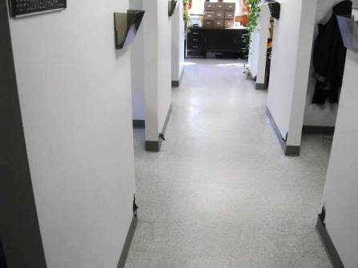
Work area outside of previously flooded restroom

Picture 2
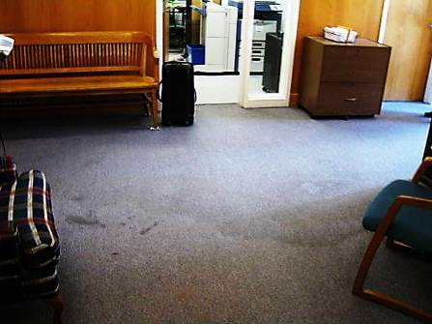
Water-damaged carpeting in main foyer
Picture 3
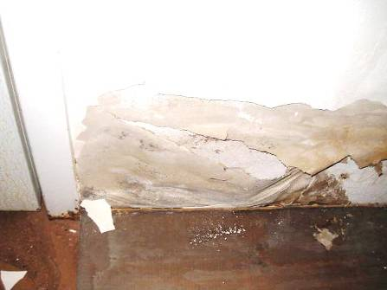
Water-damaged/mold-colonized GW in water/mechanical room
Picture 4
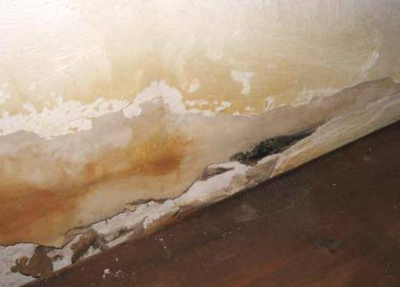
Water-damaged/mold-colonized GW in water/mechanical room

Picture 5
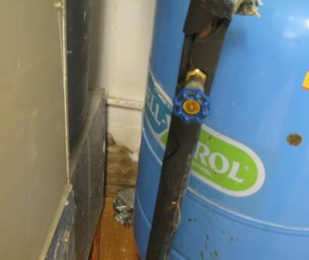
Water-damaged/mold-colonized GW in water/mechanical room
Picture 6
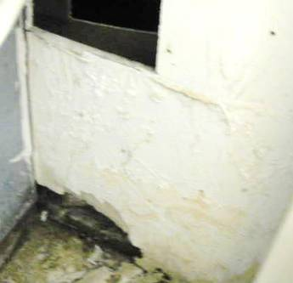
Water-damaged/mold-colonized GW in mechanical room off Personnel File room

Picture 7
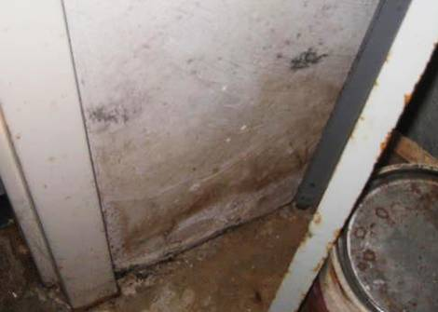
Water-damaged/mold-colonized GW in mechanical room off Personnel File room

Picture 8
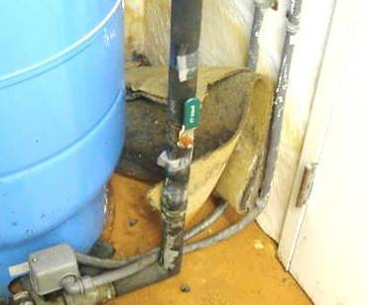
Stained/moldy carpeting in water/mechanical room (arrow)
Picture 9
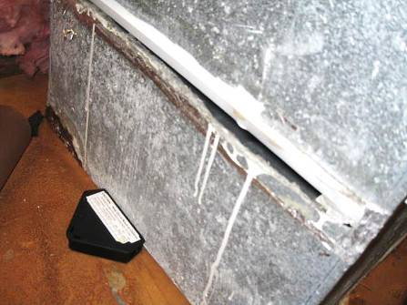
Missing filter access panel, note spaces around filter
Picture 10
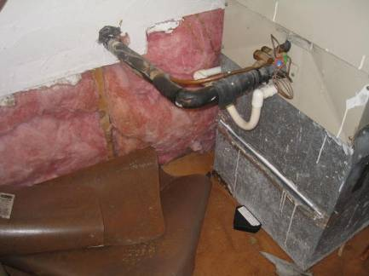
Missing filter access panel, note spaces around filter and proximity to exposed fiberglass insulation
Picture 11
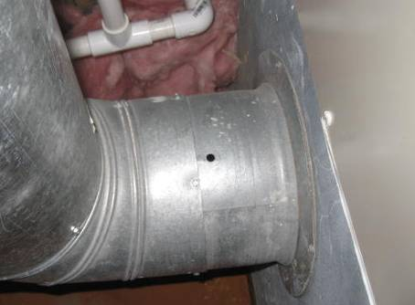
Hole in ductwork, note proximity to exposed fiberglass insulation
Picture 12
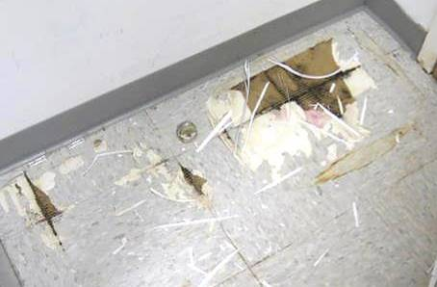
Remnants of water-damaged/mold-colonized boxes on Personnel File Room floor

Picture 13
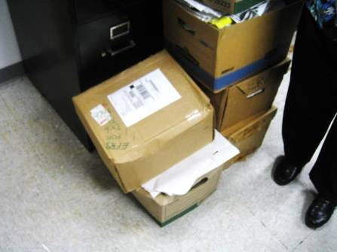
Cardboard boxes stored directly on Personnel File Room floor
Picture 14
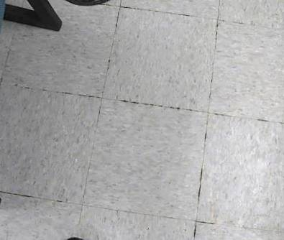
Glue/mastic between floor tiles in Personnel File Room

Picture 15
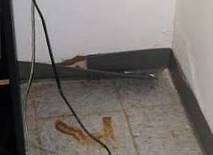
Water-damaged GW, failing base coving and efflorescence (corner/walls) in Ms. Baker’s office
Picture 16
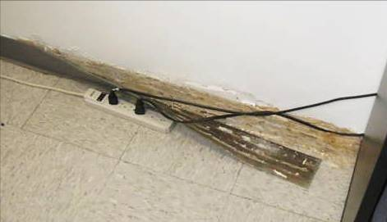
Water-damaged GW and failing base coving in Ms. Baker’s office
Picture 17
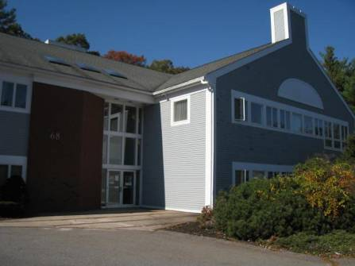
Exterior corner of building/main entrance outside of Ms. Baker’s office

Location | Moisture Testing | Comments
Mechanical/Water Room | GW-moist | WD/visible mold growth on GW north/west walls, WD carpeting (rolled up), exposed fiberglass insulation in close proximity to AHU missing filter access cover
Personnel File Room |  | Glue/mastic visible between tiles, moldy/remnants of cardboard boxes on floor, cardboard boxes piled/stored directly on tile floor
Mechanical Room (off Personnel File Room) | GW-moist | WD/visible mold growth on GW, hole in duct
Main Foyer | Carpeting-mostly dry, moist near mech room door | Soiled/water stained, repeated WD
Doherty Work Station | GW-dry | Slight surface mold under coving
Personnel Payroll Area | GW-dry | Directly outside restroom/flooding area
Pirozzi/Hayward | GW-dry
Famiglietti/Netto | GW-dry
Cabin/Waldron | GW-dry
Legal Suite | GW-dry
McCurtin Office | GW-moist northwest wall
Wolfgang | GW-moist northwest wall
Baker Office | GW-moist northwest wall | Historic/current WD, efflorescence on wall from leaks (main entrance area), water infiltration from exterior/drainage issue

GW = gypsum wallboard WD = water-damaged AHU = air handling unit

