INDOOR AIR QUALITY ASSESSMENT

Department of Developmental Services
Hogan Regional Center, Maintenance Building
7 Hathorne Circle
Danvers, MA

Prepared by:
Massachusetts Department of Public Health
Bureau of Environmental Health
Indoor Air Quality Program
December 2016

Background
Building: | Department of Developmental Services (DDS), Hogan Regional Center Maintenance Building
Address: | 7 Hathorne Circle, Danvers, MA
Assessment Requested by: | James Millins, DDS
Reason for Request: | Indoor air quality (IAQ) concerns
Date of Assessment: | November 10, 2016
Massachusetts Department of Public Health/Bureau of Environmental Health (MDPH/BEH) Staff Conducting Assessment: | Ruth Alfasso, Environmental Engineer, IAQ Program
Building Description: | Ground floor and part of the second floor of a multi-story brick building on the campus of the Hogan Regional Center
Building Population: | Five to eight employees
Windows: | Some openable

Methods
Please refer to the IAQ Manual for methods, sampling procedures, and interpretation of results (MDPH, 2015).

IAQ Testing Results
The following is a summary of indoor air testing results (Table 1).
- Carbon dioxide levels were below 800 parts per million (ppm) in all areas assessed, indicating adequate fresh air in the space.
- Temperature was within or close to the lower end of the recommended range of 70°F to 78°F.
- Relative humidity was below the recommended range of 40% to 60% in all areas assessed.
- Carbon monoxide levels were non-detectable (ND) in all indoor areas assessed.
- Total volatile organic compounds (TVOCs) were ND in the building at the time of the assessment.
- Fine particulate matter (PM2.5) concentrations measured were below the National Ambient Air Quality Standard (NAAQS) level of 35 micrograms per cubic meter (μg/m³) in all areas assessed.

Ventilation
The maintenance area consists of a large space on the ground floor and a small space directly upstairs with an office and files. The rest of the building is offices and residences for other DDS functions and was not assessed during this visit. The upstairs room is served by a small air handling unit (AHU). Air is supplied to the space through ceiling-mounted vents (Picture 1). Supply and exhaust ventilation should be on at all times.
The lower floor has no source of supply ventilation. During warmer months, doors to the outside are kept open when the building is occupied, providing fresh air. Two exhaust fans are installed in windows by the saw table (Picture 2), one is installed in the restroom (Picture 3) and one is in the room with the fuel tank for the generator (Picture 4). All are activated by way of a switch.
Due to the age of the building, it is likely that some fresh air is drawn into the building through cracks and seams when the exhaust fans are activated, even when the doors are closed; however a source of make-up air will make the exhaust work better at removing odors and pollutants. The exhaust fans near the saw table should be turned on whenever the shop is occupied even with the exterior door closed.
Note that heating on the lower floor is provided by source heaters hanging from the ceiling. The ones in the main floor are operated by way of heated water (from a rooftop solar system) and are self-contained (Picture 5). The one in the restroom (Picture 3) is operated by propane and should only be used when the exhaust fan is on.
There is also a mechanical room adjacent to the shop space (Picture 6). The mechanical room contains the heating and hot water equipment for the building; these units are reportedly new in the last five years and appeared to be clean and in good condition. Doors between mechanical spaces and occupied areas should be kept tightly closed when not in use.
There is currently no source of cooled air for the summer in the workshop area, which is reportedly a concern for some of the occupants. The installation of air conditioning for a space of this size can be expensive, as the large open spaces and high ceilings make cooling the entire space difficult. In addition, caution must be used to avoid over-chilling some areas which may lead to condensation on chilled surfaces and water damage of materials. Most of the workshop area is one connected open space. If the occupants wish to install a portable or ductless air conditioning system in a single room to serve as a rest area, the area should be fully enclosed with a tight-fitting door to allow for efficient cooling and prevent condensation from the entry of humid air. An area currently used as a lounge has divider walls that do not stretch all the way to the ceiling (Picture 7), requiring modification if this room were to be fitted with air-conditioning.

Microbial/Moisture Concerns
Water-damaged, likely mold-colonized materials were found in the stairwell from the offices on the upper level around a portion of an AHU (Picture 8). This indicates that this material has been moistened, possibly from humid air rising along the stairwell, or by AHU leaks. This material should be removed and replaced.
Boxes and numerous other items were found on the floor in the workshop area. Floors may be subject to condensation when they are cooler than the surrounding air and this may moisten materials stored on them.
A refrigerator in one of the open areas had evidence of spills/stains (Picture 9) which can cause odors. Refrigerators should be regularly cleaned.

Other IAQ Evaluations

TVOCs
Exposure to low levels of total volatile organic compounds (TVOCs) may produce eye, nose, throat, and/or respiratory irritation in some sensitive individuals. Measurements of TVOCs in the space at the time of the visit were ND. Many items and products in the space contain VOCs, including cleaning products, paints, lubricants, and dry erase materials in a number of places (Pictures 10 through 12). All of these products have the potential to be irritants to the eyes, nose, throat, and respiratory system of sensitive individuals. As shown in pictures 10 through 12, many of these materials were found stored in a disorganized manner, missing caps and improperly labeled. Based on appearance, some of the materials are old and may have undergone container degradation or chemical changes that may increase the chances of release and potential exposure. A flammable materials cabinet was observed in one alcove (Picture 13) with signs of corrosion. The cabinet was stuck closed (Picture 14), so it is not known what, if anything, is currently stored inside.
Materials that are outdated or no longer useful should be properly discarded and the remaining materials stored in an organized manner, with clear labels and intact containers. Materials that are incompatible with one another should not be stored together.

Other Concerns
Although the wood cutting area had exhaust ventilation, there is currently no system for containing/collecting wood shavings. It was reported that a new system was going to be installed as soon as funding becomes available. Wood shavings can be an irritating dust when airborne as well as a slipping hazard. Until such time as a proper collecting system can be installed, prompt thorough cleaning to remove shavings and other debris should be conducted each time the woodworking area is used.
Storage of other materials, as shown in Pictures 15 and 16, are also disorganized. These conditions can lead to safety concerns as well as the build-up of dust and debris which may be reaerosolized and cause irritation. Items should be sorted and organized, with unneeded items discarded appropriately and other items neatly stored to allow for easy access and cleaning.
Spent fluorescent light bulbs were observed to be stored without proper containment (Picture 17); accidental breakage of these bulbs can release glass and powders which may contain mercury.
Upholstered furniture was observed in the workshop area. These items need to be regularly cleaned to remove dust and debris that can cause irritation.

Conclusions/Recommendations
Based on observations at the time of assessment, the following is recommended:
- Operate the exhaust fans near the woodworking area when woodworking and other pollutant-generating activities are taking place.
- During the cold season, when the doors are kept closed, consider operating these exhaust vents continuously during occupied periods to provide some air exchange. Consider installing a make-up vent in or next to the door to allow for fresh air during the heating season.
- Operate the exhaust vent in the restroom whenever the heater is in use and as needed at other times.
- Operate the exhaust vent next to the generator fuel tank whenever the tank is being filled or used.
- If cooling is desired to be installed to serve the break area, ensure the area is fully enclosed with a tight-fitting door.
- If cooling of the entire space is desired, consider consulting with an HVAC engineer regarding the type and size of units that would be needed in a space of this size and configuration.
- Repair/replace water-damaged materials around the AHU shown in Picture 8.
- Avoid storing porous items on the floor to prevent condensation from moistening them.
- Clean refrigerators out regularly.
- Sort products and items such as paint and lubricants and properly dispose of any that are outdated, not needed, or in damaged/unlabeled containers. Open the flammable cabinet and ensure that no hazardous products are stored inside.
- Store remaining VOC-containing items neatly and appropriately, including proper labelling. Ensure that incompatible products are not stored together.
- Sort items stored in the workshop to remove anything no longer needed and store the remaining items in an organized manner that is easy to access and clean.
- Depending on the types and amounts of materials to be disposed of in the recommendations described above, the services of a hazardous waste disposal company may be needed. Ensure all applicable laws and regulations are followed.
- As soon as possible, install a wood-dust-collection system. Until this can be done, promptly clean up all shavings, including the use of wet wiping or high-efficiency particulate (HEPA)-vacuuming to avoid creating airborne dust.
- Store fluorescent light bulbs in boxes or other containers to avoid breakage, and have the spent bulbs removed as soon as practical.
- Clean upholstered items regularly to remove dust and debris that can be reaerosolized.
- Refer to resource manual and other related IAQ documents located on the MDPH’s website for further building-wide evaluations and advice on maintaining public buildings. These documents are available at: http://mass.gov/dph/iaq.

References
Massachusetts Department of Public Health (MDPH). 2015. Massachusetts Department of Public Health. Indoor Air Quality Manual: Chapters I-III. Available at: http://www.mass.gov/eohhs/gov/departments/dph/programs/environmental-health/exposure-topics/iaq/iaq-manual/.
Picture 1
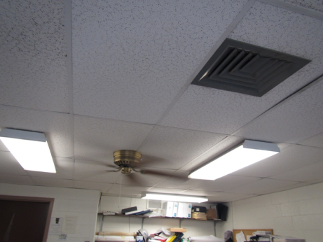
Supply vent in upstairs office
Picture 2
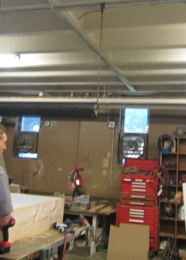
Exhaust vents in windows in the woodworking area
Picture 3
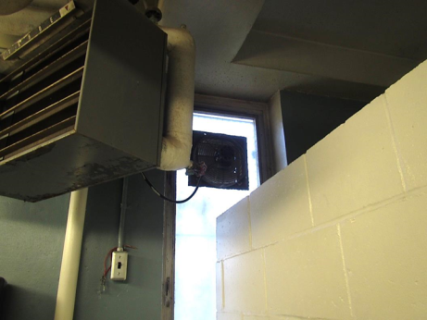
Exhaust vent, vent switch, and heater in the restroom
Picture 4
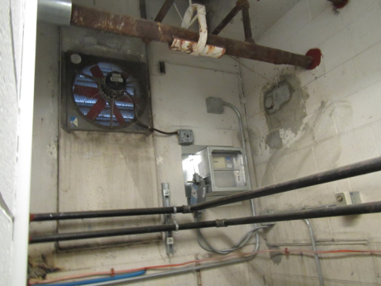
Exhaust vent in diesel tank room
Picture 5
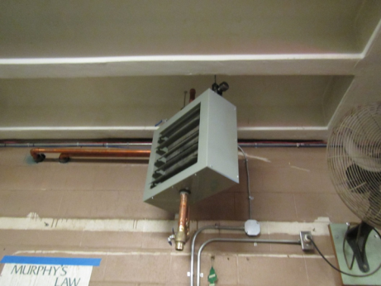
Hot-water-based room heater
Picture 6
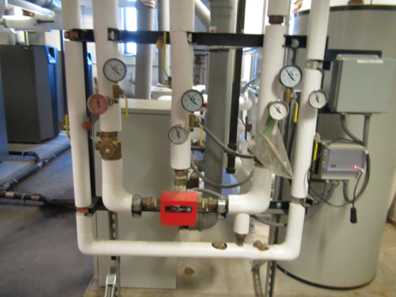
Inside mechanical room showing new equipment
Picture 7
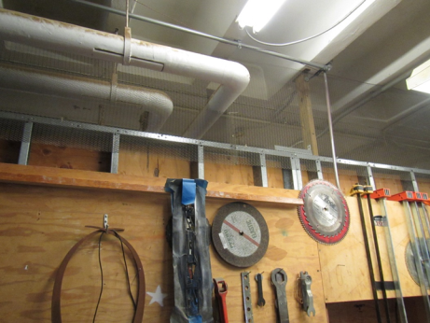
Incomplete wall (with mesh) between woodworking area and room used as a lounge
Picture 8
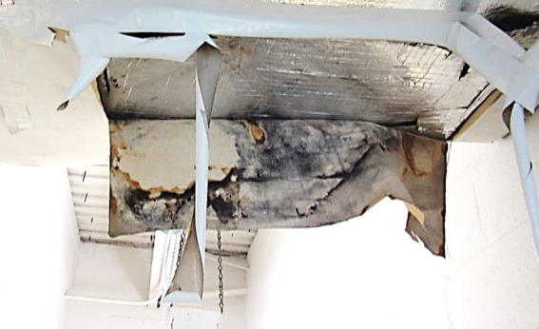
Water-damaged, mold-colonized wrapper on AHU in the upper part of the stairwell
Picture 9
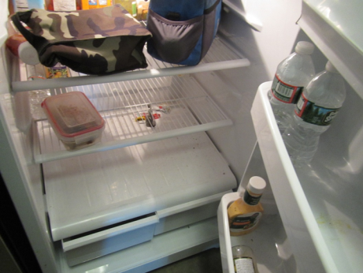
Stains from spills in bottom and door shelf of fridge
Picture 10
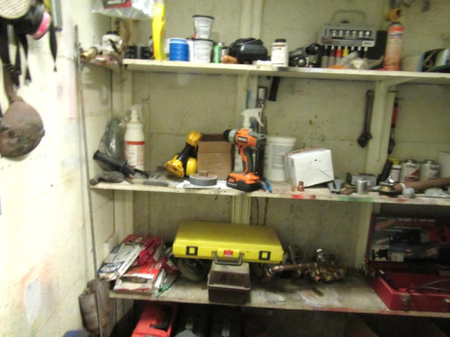
Cleaners and other VOC-containing items on a disorganized shelf
Picture 11
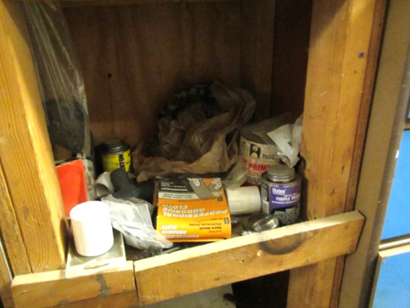
VOC-containing items stored in a disorganized manner
Picture 12
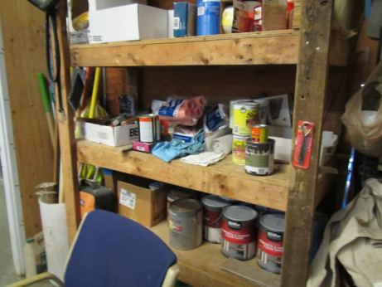
Stored paints
Picture 13
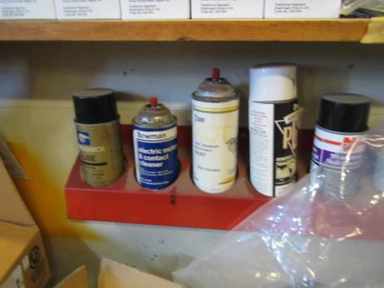
Cleaners and spray paints, some without caps
Picture 14
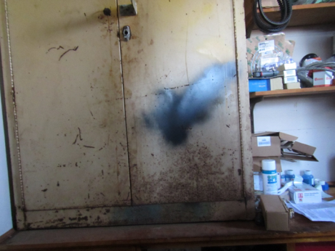
Cabinet for flammable materials, could not be opened
Picture 15
\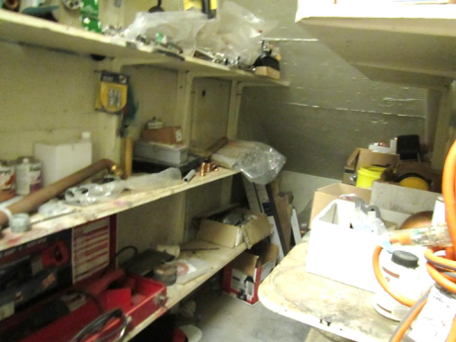
Storage shelves in need of cleaning and organization
Picture 16
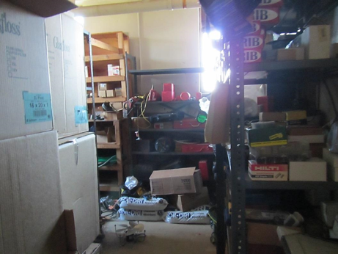
Storage of items, note items on the floor where they may be moistened by condensation
Picture 17
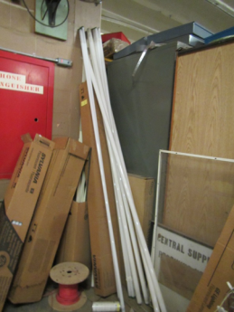
Fluorescent bulbs stored in an insecure manner

Location | Carbon  Dioxide  (ppm) | Carbon Monoxide  (ppm) | Temp  (°F) | Relative  Humidity  (%) | PM2.5  (µg/m³) | Occupants  in Room | Windows  Openable | Ventilation |  | Remarks
 |  |  |  |  |  |  |  | Supply | Exhaust
Background | 362 | ND | 53 | 30 | 9 |  |  |  |  | Sunny, near greenhouse area
Upstairs office area | 606 | ND | 74 | 25 | 7 | 2 | N | Y | Y | CF (on), PC, NC
Mechanical room |  | ND |  |  |  |  |  |  |  | Fairly new boilers, clean
Table saw area | 470 | ND | 66 | 31 | 10 | 3 | Y | N | Y on | Table saw in operation, no current dust collector but exhaust fans were on
Open area 1 | 397 | ND | 71 | 25 | 11 | 0 | N | N | N | Fridge, stove, etc.
Office off of open area | 435 | ND | 70 | 28 | 10 | 0 | N | N | N | DEM
Bathroom |  | ND |  |  |  |  | N | N | Y | Propane heater (off) and switch operated exhaust fan (operable)
Open area 2 | 523 | ND | 69 | 28 | 13 | 0 | Y | N | N | Fridge, clothes dryer (vented)
Office with couch/breakroom | 399 | ND | 69 | 29 | 12 | 0 | Y | N | N | Upholstered furniture, open to shop area above walls
Shop area | 366 | ND | 67 | 27 | 11 | 3 | Y | N | Y on | Storage
Pipe, cable storage area | 388 | ND | 71 | 29 | 10 | 0 | N | N | N

