Massachusetts Department of Early Education and Care

2014 Annual Legislative Report

Submitted March 19, 2015

 | 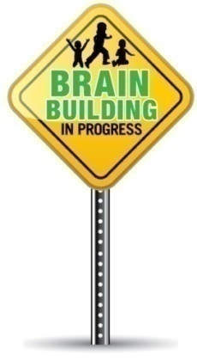

Table of Contents

Glossary of Acronyms...............................................................................................Page 3
Submission of Annual Report....................................................................................Page 5
Executive Summary..................................................................................................Page 6
Mission of Department.............................................................................................Page 9
Governance............................................................................................................Page 10
Board of Early Education and Care..........................................................................Page 10
Strategic Directions and Statutory Responsibilities.................................................Page 13
Improvements to the System in 2014......................................................................Page 14
- Providing Access.......................................................................................Page 14
- Quality Investments.................................................................................Page 16
- Health and Safety.....................................................................................Page 21
- Workforce Development..........................................................................Page 24
- Alignment of Services...............................................................................Page 28
- Streamlining the System...........................................................................Page 33
Race to the Top-Early Learning Challenge Grant......................................................Page 39
Communications.....................................................................................................Page 42

List of Appendices

Appendix A: Legislative Reporting Requirements……………………………..…………………..Page 47
Appendix B: Licensing Activity by Calendar Year 2010 through 2014……………………..Page 49
Appendix C: 2014 Caseload Detail…………………………..…………………………………………….Page 52
Appendix D: Income Eligible Waitlist Demographic Breakdowns…………………….…….Page 55
Appendix E : Budget Overview…………………….…...................................................….Page 57
Appendix F: Mental Health Consultation Services Grant Information…………...…..….Page 64

Glossary of Acronyms

ACF | Administration for Children and Families
ASOST | After–school and out-of-school time
ASQ | Ages and Stages Questionnaire
BCM | Boston Children’s Museum
CCDF | Child Care Development Fund
CCR&R | Child Care Resource and Referral Agency
CCSSO | Council of Chief State School Officers
CTF | Children’s Trust Fund
CEU | Continuing Education Unit
CFCE | Coordinated Family and Community Engagement
CLASS | Classroom Assessment Scoring System
CMHCC | Comprehensive Mental Health in Child Care Program
CSEFEL | Center on the Social and Emotional Foundations for Early Learning
DCF | Department of Children and Families
DHCD | Department of Housing and Community Development
DHE | Department of Higher Education
DLL | Dual Language Learners
DMH | Department of Mental Health
DPH | Department of Public Health
DTA | Department of Transitional Assistance
DYS | Department of Youth Services
ECERS | Early Childhood Environment Rating Scales
ECE | Early Childhood Educators
ECIS | Early Childhood Information System
ECMH | Early Childhood Mental Health
ECRC | Early Childhood Resource Center
EEC | Massachusetts Department of Early Education and Care
EEFI | Early Educators Fellowship Institute
EI | Early Intervention
ELL | English Language Learners
EOE | Executive Office of Education
EOHHS | Executive Office of Health and Human Services
EPS | Educator and Provider Support
ERS | Environmental Rating Scales
ESE | Department of Elementary and Secondary Education
FAQ | Frequently Asked Questions
FCC | Family Child Care
FCCERS | Family Child Care Environment Rating Scales
HSSCO | Head Start State Collaboration Office
IDEA | Individuals with Disabilities Education Act
IEP | Individual Education Plan
IHE | Institute of Higher Education
ISA | Interagency Service Agreement
ITERS | Infant Toddler Environment Rating Scales
LEA | Lead Education Agency
LEP | Limited English Proficiency
LRE | Least Restrictive Environment
MELD | Massachusetts Early Learning and Development Assessment System
MFLC | Massachusetts Family Literacy Consortium
MHVI | Massachusetts Home Visiting Initiative
MIECHV | Maternal, Infant and Early Childhood Home Visiting Initiative
MKEA | Massachusetts Kindergarten Entry Assessment
MOU | Memorandum of Understanding
MRS | Market Rate Study
NIEER | National Institute for Early Education Research
ORI | Office of Refugees and Immigrants
OSFA | Office of Student Financial Assistance
PAC | Peer Assistance and Coaching
PCG | Public Consulting Group
PCHP | Parent Child Home Program
PQR | Professional Qualifications Registry
QRIS | Quality Rating and Improvement System
RFR | Request for Responses
ROR | Reach Out and Read
RTTT- ELC | Race to the Top – Early Learning Challenge Grant
SAC | State Advisory Council
SACCRS | School Age Child Care Rating Scales
SASID | State Assigned Student Identification
SPP | State Performance Plan
STEM | Science, Technology, Engineering and Math
TANF | Temporary Assistance for Needy Families
UDL | Universal Design for Learning
UPK | Universal Pre-Kindergarten Program

Submission of Annual Report:

This reports satisfies the Board of Early Education and Care’s legislative reporting mandates, as codified in M.G.L. c. 15D, §§ 3(g), 10 and 13(d), to submit an annual report describing its progress in achieving the goals and implementing the programs authorized under Chapter 15D of the General Laws of the Commonwealth. Specifically, EEC is required to submit an annual report, which includes, at a minimum, the following topics:

- Progress in achieving goals and implementing programs authorized by statute;
- Progress towards universal early education and care for pre-school aged children;
- Rules and regulations promulgated by the Board related to civil fines and sanctions, including the types of sanctions and the amount of the fines;
- Progress in reducing expulsion rates through developmentally appropriate prevention and intervention services;
- Behavioral health indicators:
  - Estimates of annual rates of preschool suspensions and expulsions;
  - Types and prevalence of behavioral health needs of children served by the Department;
  - Racial and ethnic background of children with identified behavioral health needs;
  - Existing capacity to provide behavioral health services; and
  - Analysis of best intervention and prevention practices, including strategies to improve delivery of services and to improve collaboration of services.
- Findings and recommendations related to the study on the programmatic financing and phase-in options for the development and implementation of the Massachusetts universal pre-kindergarten program.

In addition, this report satisfies the Board’s mandate to develop and annually update an implementation plan for a workforce development system, which is designed to support the education, training, and compensation of the early education and care workforce, including all center, FCC, infant, toddler, preschool, and school-age providers. See M.G.L. c. 15D, § 5

(See Appendix A for the Legislative reporting language).

Executive Summary

“The Massachusetts Department of Early Education and Care provides the foundation that supports all children in their development as lifelong learners and contributing members of the community, and supports families in their essential work as parents and caregivers.”

Pursuant to M.G.L. c. 15D, it is our privilege to submit the Annual Report of the Department of Early Education and Care (EEC or the Department) for 2014. On behalf of the Board of Early Education and Care (Board) and employees of the Department, thank you for the opportunity to discuss the improvements we have implemented and the successes we have achieved in the past year as well as highlighting the ongoing work and future goals of the Department.

In 2005, EEC was established as the first state agency of its kind in the nation, solely-focused on early education and care. The Department works to ensure all children enter school ready to succeed and to close the achievement gap between low-income or other at-risk children and their more advantaged peers. Compelling evidence shows that one effective solution to this issue is high-quality early education and care. As the entry point of Massachusetts' birth to 20 education pipeline, EEC aims to deliver the most effective high-quality, comprehensive early learning and development system in the nation.

In 2014 The Department of Early Education and Care continued to build on past investments to make further improvements in both operations and in improving access to high quality early education and care in the Commonwealth. The Department, in conjunction with the Board, embarked on an effort to engage in a conversation with our field and those we serve, to develop a multi-year plan for operational improvements and changes as well as investments in our programs and infrastructure. The EEC Board discussed the state of early education and care in Massachusetts during both regular and special meetings in October and December, and at the EEC Advisory Council meeting in November. These conversations with the public, policymakers, advocates and our field led to a framework of priorities for the Department to help guide our development and implementation plans for the immediate future.

This Framework is as follows:

(1) Access
(2) Quality
(3) Health and Safety
(4) Workforce
(5) Alignment
(6) Simplify and Streamline
(7) Supporting Families in Child Development and Other Informal Settings

The year 2014 saw continued investment in our system, not the least of which was in access. There are currently over 54,000 children receiving subsidized child care and early education services in the Commonwealth today in settings that are licensed to serve up to 230,000 children. The Legislature supported the children of the Commonwealth with an additional $15 M in new funding in FY15 to allow us to remove more children from the waitlist and to connect them with services and programs. But direct care is only one of the areas where the Department has been able to make great strides in access to services. The successful application for the Federal Preschool Expansion Grant represents another opportunity to serve a population of children that otherwise would not have access to a high-quality early education experience.

Just as important as increasing access is improving the quality of the programs children are entering. To support this work the Department has continued to develop and invest in quality measures and tools, especially the Quality Rating and Improvement System (QRIS). Today QRIS touches each program we license and the Department and Board have set a goal of eventually using QRIS ratings in developing a multi-year plan to more closely align EEC resources with program quality.

For the first time this year, the Department was also able to provide capital funding for physical improvements at programs. An Act Financing the Production and Preservation of Housing for Low and Moderate Income Residents from 2013 established a capital fund for grants to support facilities development and improvement of large group and school age early education programs licensed by the Department of Early Education and Care. In January 2014, EEC announced $7.5 million in grant awards statewide to support facilities development and improvements in large group and school age early education and care programs that lead to higher program quality settings for over 1,300 children and increased capacity to serve an additional 231 children.

The Department also took time in 2014 to focus on our health and welfare efforts in a number of areas. The implementation of the Background Records Check Law continues to be a priority and EEC staff have collaborated with Executive Office of Education (EOE) information technology staff as well as their counterparts in other public safety and child-serving agencies to develop methods that are efficient, accurate and responsible to our field. EEC utilizes two legacy systems for its Criminal Offender Record Information (CORI) and Department of Children and Families (DCF) check and has developed a number of patches and workarounds to allow our existing database to accept and store Sex Offender Registry Information (SORI) and fingerprint suitability results, these existing system are insufficient to meet our needs. We are currently working on reducing the wait time for approval of a potential hire for a child care or residential program to limit negative impacts on our field's ability to properly staff their programs.

Over the past year the Department also worked to develop a new system of risk assessment in our Field Operations Unit called differential monitoring. This system utilizes a limited number of regulatory indicators and common factors which have been proven to be statistically significant in determining compliance with the larger set of regulations. This system would also allow us to more effectively assign our licensors in the field given the large number of programs we license. The Department conducted a successful initial pilot and is working to institute this system of regulatory compliance in all three types of licensing in Massachusetts, Family Child Care, Large Group and School Age Child Care and Residential and Placement.

Improving EEC's workforce is also a priority with programs designed to develop educator and provider skills across a number of disciplines such as business development, licensing technical assistance and providing continuing educational opportunities and scholarships for educational advancement. An important focus of the Department's Framework is in making progress towards increased compensation through rate increases, incentives for educator and program improvement and increasing the access of benefits associated with the Universal Pre-K grant.

The Department continued implementing the more than 50 projects funded through Massachusetts' $50M federal Race to the Top Early Learning Challenge (RTTT-ELC) grant award. The goal of the RTTT-ELC is to support quality improvements in early education and care that ensure young children have a strong foundation for learning. We are partnering with the Boston Children’s Museum (BCM) to engage with over one hundred libraries and museums across the Commonwealth to provide family engagement activities and early learning opportunities. In addition, we expanded our Brain Building in Progress campaign to include partnerships with the Massachusetts Bay Transportation Authority (MBTA) and Registry of Motor Vehicles (RMV) to reach children and parents in new settings. Brain Building in Progress is a public/private partnership with United Way of Massachusetts Bay and Merrimack Valley and a growing community of early education and child care providers, academic researchers, business leaders and individuals. The campaign's mission is to raise awareness of the critical importance of fostering the cognitive, social and emotional development of young children by emphasizing its future impact on the economic prosperity of everyone in Massachusetts.

The Department also has found innovative ways to reach families in non-traditional settings such as through the Coordinated Family and Community Engagement (CFCE) Program. In 2014, the Department re-bid this grant to ensure statewide coverage of this program and as a result of this and other efforts, more than 100,000 families have been touched by the work of CFCEs, through referrals to comprehensive services, such as early childhood special education, early intervention, and Women, Infants, and Children (WIC) as well as participation in literacy-based parent/child educational playgroups and\or child development education opportunities offered in various settings across communities, including homeless shelters, libraries and correctional facilities.

Partnering with EOE IT, The Department worked to finish our Child Care Financial Assistance (CCFA) application which will support the agency's primary role of providing subsidies to eligible families seeking care at early education and care or out of school time programs. CCFA will modernize EEC's subsidy management system by merging the functionality provided by the two existing legacy systems (Child Care Information Management System (CCIMS) and electronic. This system will improve the process for placing children off of our waitlist, managing billing with our provides and ensuring that each dollar spent by the Department can be tracked. CCFA is scheduled to launch in Spring 2015.

In continuing our work to update our regulations, the Department worked to update our restraint and seclusion regulations pursuant to the utilization of restraint and seclusion in residential and educational programs for children. The re-drafting of the regulations resulted in the banning of prone, mechanical and medical restraints for children in these facilities. This work was carried out in coordination with the Department of Elementary and Secondary Education (DESE) to ensure a level of consistency among agencies in the Commonwealth.

As the Department looks back at its successes in 2014 and forward to 2015, there are a number of items that will require continued focus. Like all of state government, resources remain a challenge, but we are committed to utilizing the tools we have available to support our first in the nation education system. The Department and the Board will continue to develop our multi-year plan to more closely align EEC resources with program quality, implementing preschool partnerships between LEAs and community-based providers supported by federal grant, and engaging partner agencies including DESE, the Department of Higher Education (DHE), The Department of Public Health (DPH), The Department of Developmental Services (DDS), The Department of Housing and Community Development (DHCD) and DCF to better serve children and families.

Mission of Department:

The Department of Early Education and Care remains focused on increasing access to a high-quality education for every child in the Commonwealth.. This commitment has been realized through the implementation of a wide array of initiatives in early education, K-12, and postsecondary education to build a 21st Century public education system in Massachusetts. This system is one that creates seamless educational pathways from birth through postsecondary education and prepares the Commonwealth's residents for college, career, and lifelong beyond.

Massachusetts is still challenged by the persistence of achievement gaps among students, and they are evident early. Currently, only 57% of all 3rd graders, 38% of African-American 3rd graders and 34% of Hispanic 3rd graders scored at the proficient level on the MCAS in English Language Arts. However recent research suggests that deficiencies form earlier. A 2013 study by researchers at Stanford University found a gap in vocabulary levels in children from low income families as early as 18 months of age. These data are noteworthy for several reasons:
- Nearly a third of the children birth to age five in Massachusetts are living in poverty.
- Large numbers of children so not have access to early education and care programs and thus enter kindergarten with no prior formal experiences in group settings where early literacy and early math games can prepare them for the K-12 requirements
- Statistics show that three-quarters of children who struggle with reading in 3rd grade will continue to struggle academically throughout their educational careers, greatly reducing their chances of graduating from high school, going to college or successfully participating in a 21st Century high-skill economy.

Strong evidence from brain development research has shown the positive long-term impact of high-quality early education and care, and its potential return on investment in terms of high-performing, successful students and citizens. Leading economists agree that high-quality early learning programs and supports to families can help level the playing field for children from lower-income families on vocabulary, social and emotional development, while helping students to stay on track and stay engaged in the early elementary grades and progress to higher education. Children and families who attend or participate in these programs are more likely to do well in school, find good jobs, and succeed in their careers.

This Department is committed to leading the way and forging ahead by continuing to build a comprehensive early learning system that provides all our youngest residents with the best chance for a prosperous future.

Governance:

The Department of Early Education and Care (EEC) is part of the Governor's Executive Branch, specifically the Executive Office of Education under the direction of Secretary of Education James A. Peyser. Working with the Department of Elementary and Secondary Education and the Department of Higher Education, EEC is part of a system to develop lifelong learning for students in the Commonwealth.

EEC is governed by an eleven member Board, chaired by Jay Gonzalez which meets at least ten times per year. The Department's day to day operations are managed by Commissioner Thomas L. Weber.

There is also an Advisory Council on early education and care, in accordance with M.G.L. c. 15D, §3A. EEC's Advisory Council members represent a geographic balance and reflect the diversity of the Commonwealth in race, ethnicity, gender and sexual orientation. All appointees have a special expertise or interest in high-quality early childhood education and care and are a mix of representatives of the early childhood community, civic, labor, and business communities, academics, parents, teachers, social service providers, and health care providers. The Advisory Council may review and offer comments on any rules or regulations before promulgation by EEC's Board, and may, from time to time, make recommendations to the Board that it considers appropriate for changes and improvements in early education and care programs and services.

Board of Early Education and Care

The Department is governed by a Board of Early Education and Care. The Board consists of 11 members, including the secretary of education (ex-officio), the secretary of health and human services (ex-officio); and nine members appointed by the Governor. Commissioner Weber acts as the Secretary to the Board.

EEC’s Board members are as follows:

Jay Gonzalez, Chairperson
President and Chief Executive Officer, CeltiCare Health Plan of Massachusetts, Inc.
At-large Representative
James A. Peyser
Secretary, Executive Office of Education

Marylou Sudders
Secretary, Executive Office of Health and Human Services
Mary Walachy, Vice Chairperson
Executive Director of the Irene E. & George A. Davis Foundation
At-large Representative

Elizabeth Childs, M.D., M.P.A.
Appointed as psychologist recognized for research in field of educational psychology

Joni Block
Grant Specialist, Brockton Public Schools
Appointed as an early education and care teacher

Sharon Scott-Chandler, Esq.
Executive Vice President, Action for Boston Community Development
Appointed as early education and care provider with management and administrative experience

Jondavid “J.D.” Chesloff
Executive Director, Massachusetts Business Roundtable
Appointed as business representative with demonstrated commitment in education

Joan Wasser Gish, Esq.
Principal at Policy Progress
At-large Representative

Eleonora Villegas-Reimers, Ed.D.
Associate Professor at Wheelock College
Appointed as an expert in evaluation and assessment of pre-schools

Kathleen C. Joyce
Vice President for Policy and Domestic and International Government Relations at Massachusetts Life Sciences Center
Appointed as a parent of a child receiving early education and care services

On June 6, 2014, Governor Patrick appointed Kathleen Joyce as the parent representative to the Board of Early Education and Care replacing former Board Member and Vice Chairperson Chi-Cheng Huang, M.D..

On June 6, 2014, Governor Patrick appointed Jay Gonzalez as an At-large Representative to the Board of Early Education and Care replacing former Board Member, Cheryl Stanley, Ed.D. whose board term ended on May 11, 2014. On July 17, 2014 Governor Patrick appointed Board Member Gonzalez as the Chairperson of the Board of Early Education and Care.

On September 9, 2014, Mary Walachy was elected as the Vice Chairperson of the Board of Early Education and Care.

The EEC Board meets monthly, except in the summer months (July and August). The meetings are open to the public and 30 minutes are made available at the beginning of every meeting for public testimony. The Board holds most meetings in the EEC Boston office, however, this past year the Board also held meetings in Methuen (March 11, 2014), Barre (May 13, 2014), and Easthampton (November 12, 2014), to allow for greater participation of stakeholders across the state. The Board held two Special Meetings in Worcester (October 28, 2014) and Medford (December 15, 2014) to receive feedback and priorities from the early childhood field. The Board participated in a Joint Board Meeting with the Department of Elementary and Secondary Education on December 15, 2014.

Board members also participate as members on three committees; descriptions of the committees’ missions, membership and staffing are listed below:
Strategic Initiatives Committee
The Strategic Initiatives Committee (formerly known as the Planning and Evaluation Committee) of the Board of Early Education and Care provides strategic direction to the Department and an organized structure that facilitates greater Board engagement and input into relevant EEC strategic initiatives that are brought to the full Board for discussion and decision making. The Strategic Initiatives Committee meets monthly to periodically review the metrics related to the implementation of the strategic plan.
Membership:
Committee Chair: Eleonora Villegas-Reimers
EEC Board Members: Joni Block (In 2014, Designees of the Secretaries of the Executive Office of Education and The Executive Office of Health and Human Services were also appointed to this committee
Ex-Officio Members: EEC Board Chair (Jay Gonzalez)

Policy, Research and Communications Committee
The Policy, Research and Communications Committee reviews and monitors both internal and external research to inform the Board's decision making, policy development and communications. The Committee's work aligns and intersects with that of the Oversight (formerly Fiscal) and Strategic Initiatives (formerly Planning and Evaluation) Committees of the Board as they work to implement a system to improve and support quality statewide and to offer an array of high quality, comprehensive, and affordable programs designed to meet the diverse, individual needs of children and families.
Membership:
Chair: Joan Wasser Gish, Esq.
Members: Sharon Scott-Chandler, Esq. and Katie Joyce
Ex- Officio Members: EEC Commissioner (Tom Weber)

Oversight Committee
The Oversight Committee (formerly known as the Fiscal Committee) reviews EEC budget related activities that are brought to the full Board for discussion and decision making, and supports EEC’s efforts to implement a system to improve and support quality statewide and to offer an array of high quality, comprehensive, and affordable programs designed to meet the diverse, individual needs of children and families.

Membership:
Chair: Elizabeth Childs, M.D.
Members: Mary Walachy and J.D. Chesloff
Ex- Officio Members: EEC Board Chair (Jay Gonzalez) and EEC Commissioner (Tom Weber)

2014 EEC Board Retreat

The EEC Board held its yearly retreat on July 31, 2014 and focused the discussion on the strategic direction for the Department and refining the EEC Strategic Plan. The Board also discussed governance methods of checks and balances for the Commissioner and EEC Board.

Strategic Directions and Statutory Responsibilities:

In June 2014, the EEC Board voted on an updated Strategic Plan for the Department. The 2014-2019 Strategic Plan focuses on four key areas:

- All young children in the Commonwealth will be ready to enter the K-12 education system and be successful, and their families will be provided with opportunities to support their children’s cognitive, socio-emotional, language, and physical development.
- Programs offered in early childhood, out of school time settings licensed or license exempt by the EEC will promote and support the high quality education and healthy development of children that enables all children to be successful as school members and citizens.
- The early childhood and out-of-school time workforce who works with children and families in the Commonwealth is professionally prepared, adequately compensated, and diverse.
- The Department and Board of Early Education and Care will provide leadership, direction and resources to meet the mission of the agency with utmost integrity, transparency and accountability to the people of the Commonwealth

To ensure that the work of the Department is carried out in a measurable manner that creates accountability to those we serve, each of these strategic directions will have supporting objectives organized into four groups:

- Commitment to Quality
- Increasing Access
- Continuing Communication and advocacy
- Sustainable Infra-structure and finance

The full Strategic Plan can be found on our website at:

http://www.mass.gov/edu/government/departments-and-boards/board-of-early-education-and-care/

In concert with the strategic goals outlined above, the Department has a wide range of statutory obligations for which is it responsible (some of which are listed below), which it carries out in addition to being the lead agency for all early education and care services and funding in the Commonwealth:

- Licensing or approval of early education and care programs, group care facilities, adoption and placement agencies, school-aged child care programs, and temporary shelter facilities;
- Establishment of provider rates and participant fees for EEC licensed programs;
- Implementation of a number of programs and administration of any related grant awards;
- Providing ongoing program monitoring to ensure quality as well as adherence to regulations and standards;
- Providing Technical Assistance to providers and potential providers;
- Facilitating development of the EEC workforce and, when appropriate, provides training and Professional Development;
- Maintaining an educator database and comprehensive waitlist of children expressing interest in services;
- Providing family education in English and other, commonly spoken languages when available and;
- Addressing infant and toddler needs, including parental education, early literacy services, and informal developmental opportunities.

Improvements to the System in 2014:

Building upon the work and accomplishments of 2013, the Department has continued to make improvements and identify areas of operation that are in need of focus. 2014 saw this work continue across the Department with a particular focus made on Health and Safety improvements and policy updates. The Department has also worked hard to support a diverse workforce with 82% of the workforce women, 30% minorities, and 4% persons identifying themselves as having a disability.

The EEC Board has discussed the state of early education and care in Massachusetts in both our regular Board meetings this past fall as well as within special Board meetings in October and December as well at the EEC Advisory Council meetings this past year. These conversations with the public, policymakers, advocates and our field has led to the development of a framework of priorities for the Department that when considered in conjunction with the Department's Strategic Plan help guide our development and implementation plans for the immediate future.

The following are a number of ways that the Department has implemented or is implementing new improvements to provide quality and operational improvements as well as greater alignment across the system and to prepare for :

  - Provide access to affordable early education and care for every child;
  - Provide quality early education and care services that prepare children for life and academic success;
  - Ensure the health and safety of all children in early education and care programs;
  - Develop and retain the workforce needed to provide early ed and care services;
  - Align early education and care services across the life of a child's education; and
  - Simplify and streamline the system for families and providers.

Providing Access:

Aligning both with the Department's current strategic plan and long term goals, the Department and Board seek to ensure that all young children in the Commonwealth are provided with opportunities to learn and develop equally with their peers across the state. In the past year, the Department has worked in a number of different ways to provide new opportunities for entry into a variety of early education and care settings as well as supporting families to be able to access new opportunities on their own.

Waitlist Remediation

2014 saw an additional $15 M investment in waitlist remediation for FY15. This funding dedicated to reduce the waitlist for income-eligible early education and care programs is similar to the funding we received in FY14 through the 3000-4070 account. The Department placed nearly 5,000 vouchers in FY14 through the waitlist remediation account and the Income Eligible account. This year in FY15, we have released 2,500 vouchers in the waitlist remediation account.

Preschool Expansion Grant Award
In Late September and early October of 2014, EEC staff with help and support from partners such as the Department of Elementary and Secondary Education developed and submitted an application for the federal Preschool Development Grant: Expansion Grant competition. On December 10, 2014, President Obama announced that Massachusetts was a winner and would receive significant funding over the next four years to expand high quality preschool programs in five high-needs communities across the state. Massachusetts is eligible for up to $60 million under the Preschool Development Grant.

The federal Preschool Development Grants competition supports states in building and expanding the delivery of high-quality voluntary preschool programs. The Expansion Grant funds are focused on increasing the availability of high-quality preschool programs in targeted communities within a state that will serve as models for expanding preschool to all 4-year-olds from low-income families in that state.

Five Commonwealth high-need communities will partner with the Massachusetts Department of Early Education and Care to develop public school district and community-based provider partnerships for expanded preschool programming: Boston, Holyoke, Lawrence, Lowell and Springfield. Together these partnerships will provide a year of high-quality preschool programming for approximately 3,000 4-year-olds in the participating communities over the span of the grant. The funding will also support quality improvements in outreach and coordination of comprehensive services, assuring that young children's development is supported and advanced in their home environments as well as in preschool settings.
Museums/Libraries
One of the most successful programs to be supported by the RTTT grant has been our partnership with the Boston Children’s Museum (BCM) to engage with over one hundred libraries and museums across the Commonwealth to provide family engagement activities and early learning opportunities. We have developed and provided a shared framework and set of resources that will increase their capacity to support the development of all children. The partnership is focused on four key areas in supporting family and community engagement in child development. They are early literacy, Kindergarten readiness, STEM, and child development, leveraging the research behind the state’s Brain Building in Progress communications initiative. This is another program that allows children and their families to engage in activities that are not limited by where they live. EEC funded CFCE grantees work in partnership with museums and libraries to ensure that families are aware of these learning opportunities in their communities.

In 2014, this initiative reached 155 museum and library educators and CFCE staff with training to increasing awareness and promote the use of resources that are part of the Brain Building in Progress initiative that encourages parents to use informal opportunities to support their children's development. Boston Children's Museum also held six sessions of the STEM Family Activities Kit training for the CFCEs that reached 182 CFCE coordinators and playgroup or parent group facilitators in addition to distributing 182 STEM Family Activity Kits.

Resources for training and implementation of the four core areas of this project are available on the BCM website in a variety of languages: http://www.bostonchildrensmuseum.org/learning-resources/race-to-the-top

Early English Language Learners (E-ELD) Standards: Massachusetts Guidelines to support Young Dual Language Learners
In the Commonwealth of Massachusetts, more than 1 in 4 children under age 6 live in households that speak a language other than English. In order to prepare children for school success, a focus on early learning for Dual Language Learners (DLLs) and meaningful engagement of their parents and communities is essential. In FY12, EEC engaged with the World-Class Instructional Design and Assessment (WIDA) group from the University of Wisconsin to develop Early English Language Development Standards (E-ELDS). The E-ELDS are designed for early education programs that serve Dual Language Learners ages 2.5 to 5.5 years. The standards include social emotional and physical development, and cover the domains of early literacy, math, social studies, and science.

The E-ELDS are aligned with the State's Early Learning Standards, including the Head Start Child Development and Early Learning Framework, and WIDA's K-12 English Language Development Standards (ELDS) implemented by the Department of Elementary and Secondary (ESE).

The EEC Board approved the E-ELDS to be used in the state's early education and care system in November 2013. In 2014, EEC will collaborate with WIDA to provide a variety of professional development opportunities for educators to:

- help guide lesson planning to ensure that the different linguistic needs of dual language learners are being met through their program day;
- support dual language learners to reach their next level of English Language Development;
- make programmatic decisions about class composition, staffing, curriculum, and assessment in programs that serve dual language learners; and
- advance within the Massachusetts Quality Rating and Improvement System (QRIS)

Parent Child Home Program

As described by the national center, the Parent-Child Home program is an "early literacy, parenting and school readiness model committed to closing the achievement gap by giving low-income families the skills and the materials they need to prepare their children with school and life success." The model is implemented through twice weekly visits to families with children between the ages of 16 months and 4 year olds. PCHP is embedded in thirty-one Coordinated Family and Community Engagement grants.

In June 2014, in partnership with the National Parent-Child Home program, EEC funded a joint training of Parent-Child Home programs and CFCE grantees. The intent of the training was to bolster the capacity of our network of programs by sharing best practices, offering evidence-based literacy content, strengthening community partnerships, and enhancing program alignment between PCHP and CFCE programs. There were several components to the training, including offering the PCHP model in homeless shelters.

In FY15, the Commonwealth increased its investment in the Parent-Child Home program by nearly 20%. As a result, 120 additional families will be served by the program. These additional dollars were allocated across PCHP lead agencies, ensuring that all PCHP lead agencies supporting families through EEC's CFCE network serve a minimum of 20 families. It is anticipated that approximately 750 families will be served with this model in FY2015.

Quality Investments:

In the past several years, the Department has been extremely fortunate to receive increases in funding for access to programs for children across the Commonwealth. To ensure that the programs these children are attending are of the highest quality, the Department has made concerted efforts to increase the system-side quality of the programs that we license, no matter the setting. We have carried out this work in a number of ways, primarily with our flagship Quality Rating and Improvement System (QRIS) and a number of other initiatives, many of which are detailed below.

Quality Rating and Improvement System (QRIS)

Scientists and practitioners have been drawing on lessons learned to define the specific characteristics of a "quality" program, one that is attuned to the developmental needs of all children. They have been able to measure what they call the "effectiveness factors" that often make the difference between programs that work and those that do not effectively support children's healthy development.

The Commonwealth's Quality Rating and Improvement System (QRIS) is a key tool, among many, that Massachusetts is developing to help families, communities, and policymakers understand what constitutes quality. Building on a strong foundation of licensing, the QRIS is designed to support to all children and youth (birth to 13) served in settings across the Commonwealths' mixed delivery System.

The MA QRIS offers guidance to professionals in early education and care and out of school time settings on a path towards quality, recognizing that higher expectations of programs must be matched with increased supports that include a better-articulated career ladder, financial incentives, and professional development and technical assistance, which are grounded in the science of child development.

To foster the integration and use of child development principles and practices, linked to quality, a set of QRIS Standards were adopted by Board of Early Education and Care on December 14, 2010. The QRIS Standards incorporate learning standards, curriculum, assessment, educator preparation, and family and community engagement to ensure the strongest outcomes for children. These standards are a central component to the MA QRIS.

Through the creation of the MA Quality Rating and Improvement System that engages programs, educators, families and communities in the quest for what is best for our children, we can ensure that, over time, our vision becomes a reality.

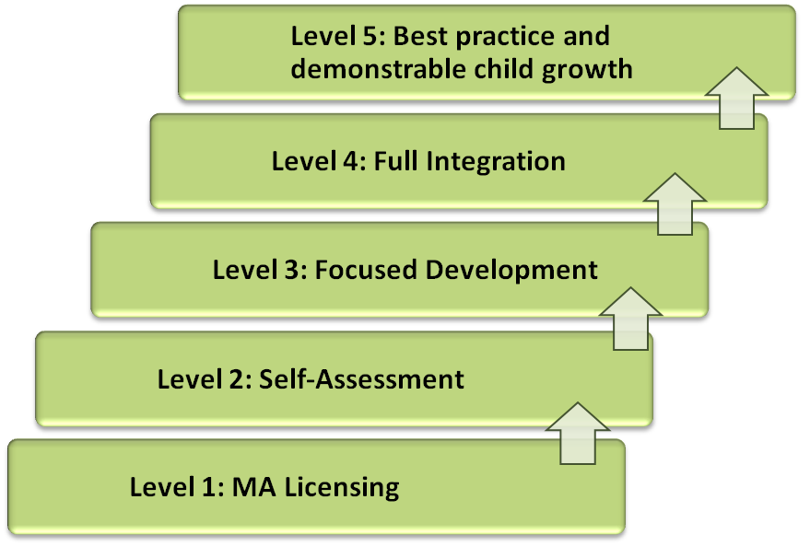

QRIS Standard 1: Curriculum and Learning
QRIS Standard 2: Safe, Healthy Indoor and Outdoor Environments
QRIS Standard 3: Workforce Qualifications and Professional Development
QRIS Standard 4: Family and Community Engagement
QRIS Standard 5: Leadership, Management and Administration

Benefits of QRIS Include:
- Parents have easily accessible information about the quality of early care and education programs.
- Programs and providers use one streamlined set of standards that are connected to supports and fiscal incentives to help them meet and maintain the standards.
- Policymakers understand where and how to invest additional resources.
2014 QRIS Updates:
QRIS Participation by Type:

QRIS Participation by Region – 2012 through 2015:

QRIS Validation Study

A revised QRIS Validation Study design has been drafted and vetted with the QRIS Validation Study Advisory. Changes have been made to the Child Assessment Battery, the study sample, and the director and teacher interviews. These changes are in greater alignment with national trends and best practice. The revised design will be presented to the Policy and Research Committee in March for input and feedback
NAYEC/QRIS Pilot Project

This project was designed to explore the intersections and possible integration of NAEYC Program Accreditation Standards and Criteria with the MA-Quality Rating and Improvement System (QRIS) Center- and School-Based Standards and Criteria. The overall goal was to make progress toward integrating QRIS requirements with NAEYC Accreditation, thus making participation in both systems less challenging for child care programs.

There are currently 841 NAEYC-accredited programs in Massachusetts, with 565 of these programs also participating in QRIS. This high participation, particularly in proportion to other states, makes EEC well-positioned to explore intersections between QRIS and NAEYC. Massachusetts recognizes the influence NAEYC accreditation can have as a method of improving and assessing quality child care programs, and for this reason EEC requires contracted community block grant programs to be accredited by NAEYC. EEC has also invested funding to support programs with attaining NAEYC accreditation, including offering grants to pay for program accreditation fees and the provision of coaching/mentoring for accreditation. As a result of achieving NAEYC accreditation, program participation in QRIS is complimentary, as high program quality is acknowledged through both systems.

EEC collaborated with NAEYC on a pilot project with 20 Massachusetts Center or School Based programs participating in QRIS, that were also awaiting NAEYC accreditation site visits (initial or renewal). This pilot project was conducted between May 20, 2013 and October 24, 2013, and allowed for the collection of valuable data to inform decisions about how programs participating in both the Massachusetts QRIS and NAEYC Accreditation processes may be able to reduce redundancies in documentary evidence. As a result of this joint effort, valuable lessons were learned by both EEC and NAEYC, and EEC is committed to refining the process so that documentary evidence that programs produce for one system, can be used to rate criteria in the other.

As we continue to evaluate and revise the Massachusetts QRIS, EEC looks forward to a continuing collaboration with NAEYC and working to align content, documentary evidence and monitoring processes. Our commitment to increasing program quality through QRIS and also through attainment of NAEYC accreditation remains solid, and EEC will continue to support program efforts through funding and other resources. We look forward to working with NAEYC in the future as both systems continue to evolve.

Universal Pre-Kindergarten (UPK) Grant

One of the many grant programs the department uses to improve the quality of programming for children in the Commonwealth is the UPK Grant. It is a grant that is awarded to programs across the mixed-delivery system and aids in our efforts to improve the quality of child care programs regardless of zip code. This annual grant is awarded to pre-school programs who continue to:

- Promote the early learning guidelines to support school readiness and positive outcomes for children participating in UPK classrooms and homes;
- Support and enhance the quality of services for children in UPK classrooms and family child care homes, especially for high needs children and/or children living in underperforming school districts;
- Maximize parent choice by ensuring participation from all program types within a mixed public and private service delivery system;
- Use child evidence-based formative assessment systems/tools to ensure that programs are effectively measuring children’s progress across all developmental domains and using this information to inform practice through individualized teaching; and
- Inform the longer-term implementation of a program of universally accessible, high-quality early childhood education.

For FY15, the renewal grant was posted on April 9, 2014 and approximately $6.3 million was allocated to fund the 224 existing UPK programs. There are 468 UPK classrooms that educate a total of 7,540 children, of which 4,248 have been identified as "high needs" children.

As of November 18, 2014, there are 11 UPK programs that are at level 4 in QRIS (1 "Granted" status and 10 "Final-Submitted" status) and 213 UPK programs that are at level 3 (41 "Granted" status and 172 "Final-Submitted" status) in QRIS.

Preschool Science, Technology, and Engineering (STE) Learning Standards and Guidelines

EEC developed Pre-Kindergarten Science, Technology, and Engineering*(STE) Learning Standards to inform the development of STEM curricula in early education programs for preschool children from 2 years and 9 months through 5 years old. The standards are developmentally appropriate for children in this age range and align to the Science and Technology/Engineering Standards for preschool through grade 2 being revised by the Department of Elementary and Secondary Education (ESE). Furthermore, these standards align with EEC’s existing regulations, early learning standards and guidelines, as well as the Head Start outcomes frameworks.

License Plate Quality Grant

EEC conducted a competitive grant funded through the Child Care Quality Fund, established in Massachusetts General Law, Chapter 29, section_2JJ (http://www.mass.gov/legis/laws/mgl/29-2jj.htm). The Child Care Quality Fund was established in 1997, and is supported by revenues received from the sale of the “Invest in Children” Massachusetts license plates.

The purpose of the Child Care Quality Grant is to promote school readiness, school success, and positive outcomes for children by supporting and enhancing the quality of services being delivered to children in early education and out of school time settings across the Commonwealth. The RFR was posted on October 31, 2013 and award notices issued to child care programs starting on January 29, 2014. EEC received 124 grant applications representing 64 different entities from across the state. EEC funded 39 grant applications with the total amount of funding given out approximately $1,079,624.00. These funds supported the following types of grant approved uses from among the various grantees. Support to programs involved in EEC's QRIS initiative, UPK, NAEYC Accreditation coaching and fee support. Funds helped support playground improvement projects, Curriculum kits, Kid Smart computers, IPAD's, CEU Training on STEM learning Integration in the classroom, Math & Science materials for classrooms, Whiteboards, behavioral training for educators, Bilingual Curriculum kits, Health specific equipment for children needing specific supports. These were the main types of requests.

2013 Housing Bond Bill

A 2011 study on the condition of the facilities in which early childhood and out-of-school time centers in Massachusetts operate found that deficiencies in the buildings impacted the quality of teaching and learning, and recommended the development of a sustainable source of public capital to help non-profit providers serving children living in low income communities improve their facilities. In 2013, An Act Financing the Production and Preservation of Housing for Low and Moderate Income Residents established a capital fund for grants to support facilities development and improvement of large group and school age early education programs licensed by the Department of Early Education and Care. The legislation that established the capital fund provided $45 million in general obligation bond funding over five years.

The Community Economic Development Assistance Corporation (CEDAC) was selected to administer the funds. In January 2015, EEC and CEDAC announced $7.5 million in grant awards statewide to support facilities development and improvements in large group and school age early education and care programs that lead to higher program quality settings for over 1,300 children, increased capacity to serve an additional 231 children, and the creation of 160 jobs during the grant period. All of the programs selected to receive a grant award serve publicly subsidized families, have demonstrated financial need, and have secured additional funding to pay for a portion of their project costs. The applicants selected for a grant award demonstrated sound feasibility of project, readiness for implementation, and likely potential for long-term sustainability and success. The grantees and their award amounts are listed below:

Lead Agency | Service Area | Award
Beverly Children's Learning Center | Beverly | $1,000,000
Catholic Charitable Bureau of the Archdiocese | Lynn | $750,000
Community Teamwork, Inc | Lowell | $500,000
Ellis Memorial & Eldredge House Inc | Boston | $800,000
For Kids Only | Revere | $400,000
Markman Children's Programs Inc | Attleboro | $1,000,000
Merrimack Valley YMCA | Lawrence | $800,000
Tri-Community YMCA | Southbridge | $800,000
United Teen Equality Center Inc | Lowell | $400,000
Valley Opportunity Council | Chicopee | $1,000,000

All grantees are tax-exempt non-profit corporations or organizations in which a non-profit corporation has a controlling interest.

Health and Safety:

Our fourth Strategic Direction commits the Department to providing leadership, direction and resources to meet the mission of the agency and we undertook several initiatives in the past year to improve our health and safety efforts. EEC already has some of the most respected regulations in the country and we are continuing to work to find ways to develop new methods for enforcing them and providing safe environments for our youngest learners. Staff at the Department have worked with a number of outside partners including our providers, our educators, our Board and the public to review aspects of our licensing work and implement changes to improve

Health and Safety Improvements

During the past year on a monthly basis the Department has conducted an analysis of the 10,000 addresses of licensed child care facilities with the addresses of registered sex offenders maintained by the Sex Offender Registry Board. When the analysis of the databases results in a match the Department investigates the address to ensure that registered sex offenders are not residing at an address where early education services are being provided. Over the past year there have not been any instances where the matches led to the discovery of registered sex offenders residing at the addresses of child care facilities.

Over the past year the Department conducted an analysis of the conditions on the licenses of EEC licensed family child care providers. This analysis found that there were over 5,400 conditions on licenses. The Department conducted a review of those licensed family child care providers with conditions. That review resulted in the reduction of conditions on licenses by fifty percent. The Department will continue that review over the next year and anticipates that there will be a further reduction in conditions on licenses. The Department has also instituted a new process for the review of proposed conditions to be placed on family child care licenses.

The Department at the request of the Executive Office of Education conducted an analysis of the restraint sections of the Standards for the Licensure or Approval of Residential Programs Serving Children and Teen Parents. As a result of this process the Department in conjunction with the Department of Elementary and Secondary Education developed new regulations pursuant to the utilization of restraint and seclusion in residential and educational programs for children. The re-drafting of the regulations resulted in the banning of prone, mechanical and medical restraints for children in these facilities. The new regulations also placed restrictions on the use of seclusion in residential programs for children. Other changes included new definitions for types of restraint, requirements for data analysis by program administrators, goals for reducing or eliminating the use of all physical restraints and new requirements regarding consent. After approval by the Board of Early Education and Care in December of 2014 the new requirements are to become effective in January of 2016.

Over the past twenty four months the Department has reviewed and redrafted the regulations regarding the child placement and adoption. The review of the regulations consisted of numerous meetings with external placement stakeholders. The Department also reviewed the regulations of other states, the requirements of the Hague Commission and consultation by the Evan P. Donaldson Institute for Adoption. These regulations are currently in draft form and the agency is waiting for the moratorium on new regulation to be lifted before bringing the regulations to the Board of early Education and Care for review. If approved by the Board the agency will conduct public hearings on the proposed regulations.

The Department initiated new requirements for the monitoring of infant safe sleep requirements in Large Group and School Age and Family Child Care programs over the past year. The new policies require licensed providers who are found to be non-compliant with the agency's regulations pursuant to safe sleep must participate in mandatory in person trainings conducted in the agency's regional offices. These trainings are conducted once per month and are provided in multiple languages, as necessary. The policies also require notification to the parents of the infant who was not placed in a safe sleep environment. Further violations of the safe sleep regulations require notification of the parents of all infants in the program and could result in a ban on caring for infants. Pursuant to safe sleep the Department also was a key participant in the EOHHS Safe Sleep Initiative which took place in the fall of 2014.

Comprehensive Review of Licensing Policies and Practices

Over the past year the Department has been working to develop a system of differential licensing in the Field Operations Unit. This is a system of utilizing a limited number of regulatory indicators which have been proven to be statistically significant in determining compliance with the larger set of regulations. The Department is working to institute this system of regulatory compliance in all three types of licensing in Massachusetts, Family Child Care, Large Group and School Age Child Care and Residential and Placement. The Department has formulated three sub-committees for each type of care type. These sub-committees are comprised of licensors and other interested staff members. The total number of involved staff is thirty five individuals across the three sub-committees which constitute over thirty percent of the field operations unit.

The goals of the differential licensing project is to increase the number of visits to licensed programs by decreasing the amount of time spent on each visit. The caseloads of the licensing staff are significantly higher than the national average and those recommended by national accrediting bodies. By decreasing the amount of time spent on visits utilizing the differential licensing model, the Department, even with high caseloads, anticipates the ability to make annual licensing visits to programs as required by the new Child Care Development Block Grant Legislation.

The Department continued to be the recipient of intensive technical assistance from the Federal Administration for Children and Families National Center for Child Care Quality. This technical assistance has been utilized to participate in peer to peer telephone calls with other states that have similar licensing infrastructure and have instituted differential licensing models. Currently twenty seven other states have instituted differential licensing models. The Department is also utilizing the technical assistance to identify new ways to utilize scarce staff resources and make changes to the current licensing processes to utilize less desk time and spend more time in the field conducting visits to programs. The technical assistance has included an examination of the entire licensing process including the application process, paperwork processes, and utilization of technology resources as a means to increase efficiency. This technical assistance has been an extremely valuable resource for the Department and has resulted in changes in practices that are already yielding results.

Commencing in January of 2014 the Department contracted with Public Consulting Group (PCG) to develop the EEC Differential Licensing Process. PCG has worked with the three sub-committees described above to develop licensing indicators for each type of licensed child care. From January to June of 2014 the Department and PCG worked to develop a differential licensing system on a macro perspective. PCG through conference calls, webinars and in person meetings with each subcommittee developed a mission statement and Guiding Principles for the initiative as follows.

Mission Statement:

To ensure the health and safety of children and quality of early education and care programs through a differential licensing model that increases monitoring frequency and tailors visits based on program needs while supporting an effective allocation of EEC resources and technical assistance.

Guiding Principles:

Conduct at least one visit to all programs annually
Strengthen collaboration between EEC and stakeholder agencies with the goal of clear and consistent communication to share program data
Serve as a resource for programs to encourage the sharing and reinforcement of best practices
Tailor interventions through improved licensing practices and processes resulting in increased program compliance, efficiency, effectiveness and quality
Promote compliance through program visits and an informed use of data to assess the program's compliance and determine an individualized approach
Increase efficiency through improved licensing administration and management
Increase effectiveness through development of an integrated IT system that allows for mobility, real time data and visibility into EEC and other collateral agencies core functions
Promote quality through the use of a monitoring tool based on key indicators of risk to children

Commencing in August and continuing through December of 2014, the Department and PCG engaged in the process of finalizing the key indicators for differential licensing and field test them through pilot visits to licensing programs. The Department set four objectives for the pilot.
Conduct visits using key indicators and core rules
Conduct visits within 45 minutes to 1 hour
Conduct unannounced visits
Conduct visits using tablets, mobile technology and a survey tool that would automatically create the visit outcome report to reduce licensor desk time

The Department conducted pilot visits to 117 randomly selected programs in all three licensing types over an eight week period from September 15 to November 7, 2014. The pilot tested newly developed abbreviated monitoring tools which included a shortened version of state licensing regulations that predict the most severe and imminent danger to the safety of young children.

The pilot successfully met the four objectives and PCG was able to use the feedback and data collected from the pilot to identify strengths and weaknesses that inform next steps. Overall the licensing staff that participated in the pilot provided positive outcomes on the process and visit protocols. Data collected from the pilot also found that participating providers had very positive comments as well.

EEC and PCG will utilize the data and feedback from the pilot conducted in the Fall of 2014 to revise the abbreviated monitoring tools along with developing clearly defined business processes. EEC will conduct a second round of pilot monitoring visits in the Spring of 2015 with the anticipation of implementing a differential licensing model commencing in July of 2015.

Workforce Development:

The thousands of individuals that are licensed by EEC to care for and educate tens of thousands children each day represent some of our most important resources. Supporting Strategic Direction number three, the Department has a number of initiatives funded by state and federal sources that are designed to support and enhance our workforce across a number of different disciplines. EEC supports educator and provider growth in all areas of operations from business planning to technical assistance in licensing to educational opportunities. The following are examples of workforce supports EEC provides.

Educator and Provider Support (EPS) Grantees

The five regional EPS grantees continue to support EEC's efforts in building a comprehensive system of workforce and professional development. The EPS grantees are required to function as a partnership and are included in many other EEC initiatives as a required collaborator. The EPS grantees work to balance the professional development needs of educators and providers at the local, regional, and statewide level. The EPS grantees are continually assessing the needs of their service area and meet monthly with EEC to address needs at a statewide level. In FY2014 the EPS grantees provided the following services:
- 3,030 educators supported in creating or updating an Individualized Professional Development Plan; 34% of those educators' professional development goal was to earn a degree.
- 3,950 educators working in the field participated in 262 continuing education courses.
- 1,733 educators working in the field participated in 101 cohort college courses.
- 344 information session were held throughout the year and throughout the state on topics related to the EPS grant, QRIS, EEC's Professional Qualifications Registry, and the new PreK Science, Technology, and Engineering standards .

Early Childhood Educator Scholarships

The ECE Scholarship Program was established to increase the quality of the early education and care workforce. The Scholarship program provides financial assistance to early education and care out-of-school time providers working in EEC-licensed or licensed-exempt programs who are pursuing associate's or bachelor's degrees in early childhood education or a related field at a Massachusetts college or university. The ECE Scholarship is available annually and is a joint initiative with EEC and the Department of Higher Education Office of Student Financial Assistance (OSFA).

ECE Scholarship Program Accomplishments:

The 2014-1015 ECE Scholarship Program successfully launched on April 1, 2014. 1042 educators were approved for the EEC Scholarship. Scholarship recipients received funding for 6 credits for the 2014 fall term and 3 credits during the spring 2015 semester in 46 colleges/universities across the state.

Goals Described in FY 2014-2015 CCDF Plan | Describe Progress – Include Examples and Numeric Targets where Possible
Early Childhood Educators (ECE) Scholarship Program -- a collaboration with the Department of Higher Education’s Office of Student Financial Assistance (OSFA). EEC supports an annual scholarship to early education and out-of-school-time providers working in an EEC-licensed or license-exempt program that are also earning an associate’s or bachelor’s degree in early childhood education or a related field at a Massachusetts college or university. | - EEC and OFSA revised the "Questions and Answers" document to assist applicants with the Scholarship application process.  - EEC and OFSA held monthly conference calls in preparation for the Scholarship application and held calls throughout the Scholarship approval process to ensure accurate and prompt completion.  - The Scholarship application was successfully launched on April 1, 2014.  - 1042 Scholarship applicants received funding for 6 credits for the fall 2014 terms and 3 credits during the spring 2015 semester.  - ECE Scholarship students are working on degrees at 46 institutions across the state. (783 educators attending 4-year colleges/universities; 259 educators attending 2-year colleges).  - Since its inception in 2006, the demand for the Early Childhood Educators (ECE) Scholarship has grown each year. For the past few years, approximately $3.2 million in state funds has been allocated for the Scholarship program.

Business Planning

EEC supported programs specifically to increase their business planning skills, as programs that are able to implement sound business practices are better positioned to retain talented staff that can provide high- quality early education for young children. EEC partnered with Inspirational Ones with the goal of developing a business planning course to assist early educators in both center-based and family child care.
The business planning course is focused specifically on helping programs to receive higher scores on the Program Administration Scale (PAS) and Business Administration (BAS), so that they can meet higher level criteria on the QRIS to demonstrate improved program quality. A team of local and national experts developed the business planning curriculum, including the United Way of MassBay, a lawyer specializing in ECE issues and experts in ECE business practices. The course awards 1.5 CEUs and participants of the course had a sound business plan in place once they complete the course.

In 2014, additional RTT-ELC funds allowed for EEC to partner with Little Sprouts to provide additional trainings to qualified trainers within the Educator and Provider Support system, Readiness Centers, Family Child Care systems, and independent consultants to build state capacity on business planning. The first training of trainers was in June 2014, and additional trainings have been held in September and October.

Peer Assistance and Coaching

The goal of the Peer Assistance and Coaching (PAC) project is to combine the promise of coaching as an effective strategy and the reality that the existing early childhood teachers and directors may be well-equipped to support one another’s practices. Massachusetts PAC is promoting the use of training and coaching methods, including the use of video capture, that give teachers opportunities to see and try out effective practices, and receive feedback about these efforts to improve those educator competencies. This initiative aims to promote career advancement, professionalization, and accessible professional development opportunities in the field of early education. Additionally they are intended to improve the education, training, and compensation of early childhood educators to promote effective practice and alignment with EEC's workforce core competencies, increase workforce retention, and strengthen adult-child interactions, especially among high-needs children.

Research has shown the importance of teacher- or caregiver-child interactions that are emotionally supportive, responsive to children’s individual and developmental needs, and rich in their provision of support for children’s exploration and understanding of new concepts. Evaluation results from first-year participants using the CLASS Assessment as a measure, which is a rating scale of instructional practices focused specifically on measuring the educational and interactional strategies that teachers use, showed improvement as a result of project participation.

- All three CLASS domains showed improvement:

  - Total Emotional Support from 5.5 to 6.0
  - Total Classroom Organization from 4.5 to 5.5
  - Total Instructional Support from 2.4 to 3.2

(Scores of 1 and 2 are characteristic of “Low-Range” where little or no indicators of good practice are present; 3, 4 & 5 Middle Range; and 6 & 7 the High Range, where most or all indicators of good practice are present.)

Post Master's Certificate Program

In Spring 2012, EEC partnered with an institution of higher education (IHE) to develop a Post Master’s Certificate in Early Education Research, Policy, and Leadership (PMC) to launch a new generation of early childhood leaders in Massachusetts. The purpose of the PMC is to improve the knowledge, skills, and abilities of early childhood educators from public and private programs, specifically in the areas of data, research, policy, and leadership. The courses provide advanced study in early education research methods, policy, leadership, organizational change, and the science of child development and early learning. The intention of the PMC is to support early childhood educators with Master’s degrees currently working in EEC-licensed or license-exempt programs with the means to further their own knowledge, skills, and abilities while working to inform policy at the local, regional, and state level. The coursework designed for the PMC is in alignment with EEC’s Core Competency Areas, QRIS Standards, the National Association for the Education of Young Children (NAEYC) Advanced Standards (AS) within NAEYC’s Six Professional Preparation Standards, and Division of Early Childhood Advanced Personnel Preparation Standards.

The following describes progress made with the PMC program in 2014:

- The Leadership Forum commemorating the PMC cohort 2 graduates took place on September 27, 2014 at the University of Massachusetts Boston campus. Valora Washington, President of the Council for Professional Recognition, was this year's keynote speaker for this year's event.
- Cohort 2 participants will officially graduate in December 2014.
- Participants from Cohorts 1 and 2 continue to participate in EEC working groups.
- UMass Boston is working on a survey to cohort 1 participants to identify the impact of the PMC program one year later.
- Cohort 3 participants began coursework in September 2014.
- UMass Boston has submitted an application to the Massachusetts Department of Higher Education for a PhD in early childhood education and care. The new PhD program will accept all 12 credits from the post master’s program, ensuring a pathway from the PMC program into the doctoral program. The anticipated approval for this program is December 2014
- The PMC program will exist post the RTT-ELC grant through the UMass system however one challenge is expanding the program to other campuses in Massachusetts as well as finding more PhD or CAGs programs that will accept the 12 credits from the PMC program.
- One challenge has been that the program is very intensive; 4 post masters/doctoral level courses in one year, for educators working full time is a lot to manage. Students struggle to balance. The grant has been able to provide a very high level of both academic and other supports that have proven sufficient to enable educators to successfully complete the program and to report high levels of satisfaction with the program and its impact.
- A second challenge has been in establishing articulation and transfer agreements with other institutions of higher education. There are currently agreements with 3 MA IHEs. The main barrier to additional partner agreements is that there are almost no doctoral/advanced graduate programs in early education and care in the state for which this coursework would be relevant. This speaks to a gap, and the importance of developing advanced graduate/doctoral study in our field, especially to meet the huge need for higher education faculty with doctoral degrees in early education and care.

Technical Assistance Guide:

In 2013-2014 EEC developed Guiding Change, Impacting Quality: A Guide to Technical Assistance in Setting Serving Infants & Toddlers, Preschoolers, and Children in Out-of-School Time Programs and Their Families. This comparable guide to effective consultation for consultants, mentors and faculty serving settings for three to five year olds and out-of-school time providers was developed to ensure quality services are provided to these age groups and consistent foundational practices are occurring in the early childhood field. The purpose of the Guide is to describe and articulate the dispositions, knowledge, and skills needed by TA providers who work in one or more of the following settings: I/T, Pre-K, and OST programs. Core dispositions, knowledge, and skills (e.g. competencies) are essential for TA providers in order to support program quality, good outcomes for children and families, and to sustain effective TA.

TA providers offer a variety of supports and should have specific competencies, which are garnered through a combination of education, training, and experience. The Guide identifies what TA providers should demonstrate in order to work effectively with educators that work with children and families in settings serving I/T, Pre-K, and/or OST programs. The Guide establishes a baseline of knowledge, competencies and dispositions for TA providers to ensure that high quality TA practices apply across all three of these settings, in every corner of the State, and for children and families of diverse cultures, racial, socio-economic and developmental backgrounds. Consequently, the Guide aims to unify TA practice by identifying what good TA providers across early childhood disciplines and settings have in common. The Guide will help TA providers who specialize in one age group understand TA providers in other age groups, and to look more closely at children as they move across settings.

- While the Guide is designed to support TA providers in Massachusetts, it is also intended to strengthen and inform similar efforts to identify a coordinated set of competencies and expand opportunities for TA providers and Institutes of Higher Education (IHE) faculty and staff who work with these settings across the nation.

Early Educators Fellowship Initiative (EEFI)

The Early Educators Fellowship Initiative (EEFI), which started in 2010, is a community-based leadership series for early education and care providers in public and private programs from birth to grade three. The purpose of EEFI is to organize, equip and empower Massachusetts educators who will then build high-quality learning environments for our earliest school-ready children, in partnership with families and communities. This Fellowship facilitates:
- System building among early educators for the benefit of all young children;
- Working relationships among early educators;
- A shared knowledge base among early educators;
- Bridges that deepen our understanding of the needs of young learners; and
- Action in local communities.

Alignment of Services

In the past few years the Department has made a concerted effort to engage our sister agencies and other connected Department's across the administration in our efforts to improve our quality and services. Starting within the Executive Office of Education, there are a number of joint efforts we have engaged with the DESE staff on such as standards development, the Preschool Expansion Grant as well as the K-1 Expansion Grant. We collaborate with DHE on teacher education and training as well as the early educator Scholarship program. The Department also works closely with Health and Human Services agencies to align our services with theirs due to our often shared population of clients and we also work closely with public safety agencies in carrying out our background records check duties to provide safe learning spaces for our students.

Standards Development in the Domains of Social-Emotional Development and Approaches to Learning

EEC, in partnership with ESE, has contracted with the University of Massachusetts/Boston to create a comprehensive set of preschool and kindergarten standards in the domains of Social-Emotional Development and Approaches to Play and Learning. Due to be completed by the spring of 2015, these standards are being informed by and vetted with local, regional and state early childhood practitioners, researchers including Sharon Lynn Kagan (Teachers College, Columbia University) and Stephanie Jones (Graduate School of Education, Harvard University) as well as the National Governor’s Association (NGA) and the Collaborative for Academic, Social and Emotional Learning (CASEL). It is anticipated that, if approved, these standards would provide a much needed resource for the field as it relates to curriculum, instruction, and assessment practices of young children and on-going professional development related to early childhood education as well as make the critical link for administrators, educators and families to the acquisition of academic competencies.
RTTT-ELC - Interagency Partnerships
EEC has built partnerships with many of the Commonwealth’s health and human services and economic development agencies that share in our mission to support young children and their families. As we enter the final year of this grant cycle we are working with our partners to develop sustainability plans to ensure that the work and investments that we have all worked so hard to build will survive past the life of this funding source.
The following is a summary of 2014 accomplishments in EEC's Interagency Partnerships with the Department of Children and Families (DCF), Department of Housing and Community Development (DHCD), Department of Mental Health (DMH), Department of Public Health (DPH) and the Office of Refugees and Immigrants (ORI).
Department of Children and Families (DCF)
An interagency partnership with the DCF was established to promote early childhood and child development within the child welfare system. We worked with DCF to hire staff focused on embedding child development into the policies and practices of the agency through professional development, the revision of policies as needed, and by offering technical assistance to the field. To build the relationship between the work our Departments, we helped to establish a new full day in-service training day that is required for all new DCF Social Workers on the Foundations of Health and Well-Being in Child Welfare. This training includes information on early childhood education, brain development, school readiness and success, and trauma informed care. EEC and DCF departments also established a new Early Childhood Mental Health Certificate Program for social workers that will increase their expertise in meeting the social and emotional needs of young children and their families.
To further support the effective use of EEC funded Supportive Child Care, in 2014 DCF used RTT-ELC funds to develop a training on a new Data Management Tool that reached each of the 29 DCF Area Offices as well as a training for Child Care Coordinators on the policies and procedures of the Supportive Child Care program and the importance of high quality child care for children in the child welfare system.
Department of Housing and Community Development (DHCD)
The interagency partnership between EEC and DHCD is in a unique position to help some of the most vulnerable children and families in the state. Due to the transient nature of their client population, it is important to make sure that these children receive quality supports no matter where they are staying. Our approach with DHCD ranges from the dispersal of bilingual information on local early education resources, staff trainings for homelessness agencies on the Ages and Stages Questionnaire developmental screening tool as well as distribution of over 2,000 donated books for children living in hotels, motels, and shelters.
Starting in 2014, DHCD collaborated with EEC, the DPH and Horizons for the Homeless to develop an intensive training and mentoring program for direct care providers and supervisors in shelters that uses evidence based training from the Center on the Social Emotional Foundations for Early Learning, which targets children at the most risk of emotional problems.
Department of Mental Health (DMH)
Our work with the DMH has been designed to strengthen the comprehensive statewide system of mental health supports for children and families that are available throughout the Commonwealth. By working together, we have implemented new professional development opportunities that model teamwork between the early childhood mental health consultation service providers and early childhood educators in addressing prevention and intervention with emotional and behavioral challenges. Through DMH, we have also developed an Interagency Service Agreement (ISA) with EOHHS and its Medicaid office to expand the capacity of a major mental health state system for children to address the unique needs of the early childhood population.
To increase the capacity of pediatricians to help parents prevent and reduce the behavioral and emotional challenges of their pre-school children, DMH introduced an evidenced-based family intervention, Triple-P Program, into pediatric practices throughout the Commonwealth. DMH worked collaboratively with the Massachusetts Child Psychiatry Access Project (MCPAP), a system of regional children’s mental health teams designed to help primary care providers meet the behavioral health needs of children, to address the needs of pre-school children, and expand capacity with pediatric practices to diagnose, treat, and manage behavioral and emotional challenges.
Department of Public Health (DPH)
The interagency partnership between EEC and the DPH is focused on building a system of health supports for young children and their families through professional development training, technical assistance, and policy development to promote healthy social-emotional development of children. Through this ISA, DPH supervises Registered Nurse Health Advisors placed within EEC regional offices. These Health Advisors support programs in meeting the health related program quality standards in QRIS including the development of an online training that will be required for all programs to meet level 2 QRIS requirements. Health Advisors also work with programs to reduce health related expulsions.
Through their Regional Consultation Programs, DPH used RTT-ELC funds to provide 228 individual Medication Administration in Child Care (MACC) module trainings to 116 child care programs, reaching 1691 educators. The MACC modules include asthma, allergies and anaphylaxis, seizure disorders and diabetes.
Office of Refugees and Immigrants (ORI)
EEC has partnered with the ORI to support early learning and school readiness for immigrant and refugee children and their families. In collaboration with the Massachusetts Immigrant and Refugee Advocacy Coalition and the Multilingual Action Council at Wheelock College, ORI sponsored a series of trainings on “New Start: Supporting Multilingual Young Children and Immigrant and Refugee Families” for the Coordinated Family and Community Engagement Grantees (CFCE), Child Care Resources and Referral Agencies (CCR&Rs), MASS 2-1-1, Family Child Care (FCC) System Providers, Head Start and ORI’s service providers. The trainings offered knowledge on immigration policy as it impacts children and families, cultural competency, and child development and educational principles in the context of multilingual homes and multicultural environments. Approximately 270 people participated in four regional trainings over the course of calendar year 2014.
Financial Education Literacy for Parents of Young Children

- EEC and the Head Start State Collaboration Office partnered with the Massachusetts Community Action Programs (MASSCAP) to develop a Financial Literacy Education online course (with a training module) to support families in gaining long-term economic independence and self-sufficiency skills, so that they can provide stable and healthy learning environments for young children. Since the launch of this project in 2012, over 394 community agencies participated in the financial education initiative and have provided financial literacy education to over 1,200 families.

- In FY2014, The Promising Practices in Financial Education for Parents of Young Children Symposium was held on Friday, October 24, 2014. Over 196 participants across multiple national, state, and local agencies that work with parents of young children in supporting financial education attended this successful event. The Advisory members included representatives from the Administration of Children and Families, the Office of Head Start, Cambridge Economic Opportunity Council (CEOC), Community Teamwork, Inc., the Department of Housing and Community Development, the Department of Early Education and Care, the Department of Elementary and Secondary, the Head Start Association, the EEC/Head Start State Collaboration Office, the MA State Treasury, and MASSCAP.

- Massachusetts was invited by the Office of Head Start and the Office of Community Services to present at a national convening of Stakeholder "Building the Financial Security of Families with Young Children" in October 2014. Jeannie Chaffin, Office of Community Services, and Ann Linehan, Office of Head Start, welcomed all participants from national, state, and local agencies working with parents of young children. Topics included: barriers to financial capability of families with young children, research on strategies and solutions to build financial security , initiatives and programs that support financial stability, and research and policy change or program actions needed to move financial capability strategies forward. The Massachusetts Head Start State Collaboration Office Director was invited to be part of a national panel and share information on MA Statewide Financial Education Literacy to support parents of young children.

- The Office of Community Services and the Office of Head Start are in the process of releasing three specific practice briefs developed to support financial education for parents of young children. In November 2014, as a panelist on the convening conducted in October in Washington DC, the MA Head Start Collaboration Office provided input and feedback on these documents developed to help HS/EHS programs increase parent participation in financial education activities, build the capacity of HS/EHS staff to engage families on financial topics, and demonstrate the connection between asset building and the Parent, Family, and Community Engagement Framework.

Birth to Grade Three Strategy Development

Massachusetts has embraced birth to third grade alignment as a comprehensive strategy that seeks to improve young children’s access to high quality birth to grade three programs and strengthens the capacity of elementary schools to sustain student learning gains in the early elementary school years. EEC has invested RTT-ELC funds to help support communities with the goal of improving child outcomes through building alignment among systems serving infants, young children and their families.

In 2012, EEC awarded the Birth to Grade Three Community Implementation/Planning grant to five communities: Lowell, Boston, Springfield, Somerville, and Pittsfield. In the spring of 2014, EEC awarded additional funding to these 5 communities to support their alignment building work through the conclusion of the Race to the Top- Early Learning Challenge grant. EEC also awarded 7 new communities funding: Cape Cod, Holyoke, Lawrence, New Bedford, North Adams/Northern Berkshires, and Worcester. The Birth to Grade Three Alignment Grants focus on strengthening the existing birth to third grade infrastructure within targeted local communities (i.e., low-performing school districts, Gateway cities, and Home Visiting communities).

As part of the application process, all applicants used the "Framework for Planning, Implementing, and Evaluating PreK-3rd Grade Approaches" created by Kristie Kauerz and Julia Hoffman to evaluate alignment in their community in the areas of: Cross-Sector Work, Administrator Effectiveness, Teacher Effectiveness, Instructional Tools, Learning Environment, Data-Driven Improvement, Family Engagement, and Continuity and Pathways. While each grantee designed goals and projects to support the needs of their specific community, many of the communities chose to focus on common themes including: family engagement, improving alignment and transitions between/among early learning environments and public schools, improving 3rd grade literacy scores, professional development for educators and administrators, and school readiness. Developing strong partnerships and increasing collaboration among partners serving young children and their families is core to the work in all of the communities.

For the communities who received initial funding, EEC partnered with a private non-profit organization to document and analyze the early learning partnerships between public and private organizations that support children birth to grade three, such as public schools, private early education and care programs, and business leaders within a community who are interested in the early education. This non-profit has documented the work done in the communities who received the initial funding and created a website called the Learning Hub. This website shares information about the alignment work being done locally and nationally, shares promising practices, and highlights relevant research. This organization has also provided guiding support to new grantees as they began to implement their projects.

Massachusetts Kindergarten Entry Assessment (MKEA)

To promote alignment among early learning environments, RTTT-ELC and state funding has been used to hire a vendor to train and support the mixed delivery system and public pre-K and K educators in using formative assessment tools. This vendor provides training, technical assistance and formative assessment and screening training and materials state wide.

As of December, 2014 173 school districts participating in MKEA. This is more than double the number of districts that participated in Cohorts 1 & 2 combined. Many are using formative assessment in pre-K classrooms as well. More than 2,000 teachers were trained in using a formative assessment tool between April-October 2014. More than 36,000 kindergarten children in kindergarten were assessed in the Fall of 2014.

There is a comprehensive support system in place to support districts in successfully implementing MKEA. This support system includes state-wide conferences, district level training, technical assistance, regional meetings and PLCs, and webinars. Additionally, using RTTT-ELC funding, districts have been awarded roughly $1.2 million of funding to provide teachers time to attend professional development and spend time learning to use a formative assessment tool. In April 2014 over 400 teachers and administrators participated in a statewide MKEA conference on collecting high quality observational data. In October of 2014 more than 300 teachers and administrators participated in a statewide MKEA conference on using formative assessment data at the student classroom and district level. More than 2,000 K and pre-K teachers participated in 2 days of formative assessment training between April-October, 2014.

Ages and Stages Questionnaire

In support of finding new ways to identify children and families who could benefit from additional resources to succeed, the Coordinated Family and Community Engagement (CFCE) grantees have been deploying the Ages and Stages Questionnaire (ASQ) developmental screening tool. These 89 grantees, located throughout the Commonwealth, use this tool as a way to have a meaningful conversation with parents and families about their child's progress across five developmental domains. If the child's ASQ scores are below the cutoff, CFCE staff provide the family with information and referrals to other supports, such as developmental assessment and evaluation, Early Intervention, public preschool special education, and any other resources to support the parent and child. Additionally, the ASQ kit includes activities that parents and families can do to support their child's progress in any of the developmental domains.

Streamlining the System

The last focus of the Department's work is crucial to the spirit of our Strategic Plan and represents a commitment to our children, our field and the Commonwealth to continue to review and improve on the services we provide. Much like the Health and Welfare improvements detailed above, these changes are each designed to not only allow the Department to become more efficient and serve more children by better utilizing the resources we have been given. These changes, especially in our information technology infrastructure will allow us to more transparently provide information about EEC's activities.
Waitlist Clean-up
Over the past year, EEC has continued to take steps to improve the quality of the EEC waitlist. A waitlist working group was convened in Fall 2014 to review waitlist policies and procedures in order to identify any improvements and address existing waitlist issues. In May 2014, EEC implemented two key policy changes to improve the quality of the waitlist: (1) Families must respond to funding availability letters. Failure to respond will result in the removal from the EEC Waiting List; and (2) Reducing the time period for reinstating Waiting List records with the original waitlist position from six (6) months to thirty (30) days. These policy changes were made after stakeholders conveyed that the same families receive multiple funding availability letters while other families with an immediate need for child care financial assistance were not receiving any communication because: (1) families were not required to respond to available funding letters; and (2) non-compliant families were allowed to return to the "top of the list" provided that the family contacts EEC, or its designee, within 6 months of removal. Not only did this dilute the quality of Waiting List data, but it also raised concerns about the fairness of child care financial assistance policies applied in Massachusetts.

In coordination with the timing of the policy changes, EEC contracted with the Child Care Resource and Referral Agencies (CCRRs) in May 2014 to complete an outreach to all 30,589 families on the waitlist in order to review waitlist records for accuracy, assess continued family interest, determine potential eligibility, and communicate fees and other EEC policies. Contact with each family was attempted three times, including a final notice by mail. Families who did not respond to the outreach were terminated from the waitlist. The results of this outreach were astonishing with approximately 47% of families being removed from the waitlist through either the parent’s choice, children no longer needing care, duplicate household records, or lack of response to the outreach. Another 10% of families who had been listed as active were found to be already enrolled in an EEC program. The waitlist, which totaled 41,028 children at the end of April, stood at 27,593 at the end of August after the cleanup project was completed.

The EEC waitlist working group continues to evaluate all aspects of waitlist policies and procedures to ensure continued accuracy of the waitlist while ensuring that those still seeking services will not be adversely affected. In September, EEC determined that the overall numbers of users in the waitlist system should be reduced to improve the quality of data and adherence to EEC policies. As a result, the Coordinated Family and Community Engagement networks are no longer EEC waitlist agents. Additionally, EEC provided detailed waitlist policy and procedure training for remaining waitlist agents as a part of our Fall Subsidy Management training sessions.
EEC continues to monitor the waitlist data on a weekly basis in conjunction with a weekly CCRR touch base call. Upcoming priorities for the Subsidy Management Working Group includes further analysis into the number of waitlist agents and revision of waitlist letters. Waitlist data, funding available letter counts and caseload reports are reviewed monthly to determine additional improvements.
Internal Control Plan - Review and Update

The annual review of EEC's Internal Control Plan took place in Summer 2014 and included the following activities:

- A review of the suggested edits and comments submitted by the Comptroller’s Quality Assurance Bureau from the 2013 Internal Control Plan.
- Hosting a Risk Management training at EEC's Central office. This training was conducted by personnel from within the Comptroller's Quality Assurance Bureau. All EEC Unit Directors and Senior Leadership were required to attend.
- Dissemination of the 2013 Internal Control Plans to Unit Directors for review and revision;
- A directive to all Unit Directors to review or develop Policies and Procedures while reviewing for potential risk; and
- Internal audit and risk assessment on the Accounting Unit.

Urban Institute Study:

Pursuant to Chapter 38 of the Acts of 2013, the Department of Early Education and Care has contracted with the Urban Institute to complete a two-year assessment of the childcare supports funded through items 3000-3050 (Supporting Childcare), 3000-4050 (DTA Related Childcare), 3000-4060 (Income Eligible Childcare), and 3000-4070 (Waitlist Remediation). This assessment has been designed to have five distinct components: (1) Assessment of Subsidy Eligibility Policies and Practices; (2) Assessment of Budgetary Policies and Practices; (3) Assessment of Current Business Practices and Service Delivery; (4) Review of the Child Care Needs of Families; and (5) Analysis Relative to the Balance of Providing Quality Early Childhood Education with Providing Workforce Support. The Urban Institute is currently finishing the final components of the project and compiling the final report. The Assessment of Budgetary Policies and Practices was submitted to the House and Senate Committees on Ways and Means at the beginning of December and the Urban Institute is on target to submit all assessment components no later than March 1, 2015 as required by legislative language.

Grants Administration:

Grants Administration completed development on a new standard Online Application for the following FY15 grants: Head Start, Coordinated Family and Community Engagement, Inclusive Preschool, Mental Health Consultation Services, Educator and Provider Support, Universal Pre-Kindergarten, and Special Education. Currently, Grants Administration is working with the Information Technology Department, the Policy Analysts, and Grants Management to add budget amendments and final financial reports to the existing online system. The feedback from the field regarding the Online Application has continued to be positive. Grants Administration will be using COMMBUYS, the new state procurement system, for the posting of competitive grants in FY 2016.

Grants Administration also released two additional competitive grants in FY 2014: Preschool Innovative STEM Curriculum and Child Care Quality. The funding for the STEM grant initiative totaled $250,000.00 and 5 grantees were awarded.

The Child Care Quality Grant Fund is supported by revenues received from the sale of the Massachusetts “Invest in Children” license plates. For this grant period, $1M was available and proposals requesting up to $50,000 were submitted. EEC awarded 39 grantees out of the 177 applications submitted.

Early Childhood Information System (ECIS)

An initiative funded by the Race to the Top - Early Learning Challenge (RTTT-ELC) grant, the Early Childhood Information System (ECIS) is EEC's new enterprise data warehouse designed to serve as a single source of truth for EEC business reporting. ECIS provides better insight into EEC data, particularly operational and program quality data. It also provides the business with a more agile, centralized platform for data, reducing the time required to generate complex, multi-dimensional reports. Integration with the Child Care Financial Assistance CCFA system, it allows the Department to forecast with improved accuracy, reduced effort. As a part of the Longitudinal Data System (LDS), ECIS child and program level data is shared across agencies to improve child outcomes and support school readiness initiatives.

Child Care Financial Assistance System (CCFA)

The Department's Child Care Financial Assistance (CCFA) application will support the agency's primary role of providing subsidies to eligible families seeking care at early education and care or out of school time programs. Families must generally meet income and activity requirements to be eligible for EEC financial assistance. Due to limited funding, eligible families may be placed on the EEC waiting list for financial assistance until funding becomes available. CCFA will modernize EEC's subsidy management system by merging the functionality provided by the two existing legacy systems (Child Care Information Management System (CCIMS) and electronic Child Care Information Management System (eCCIMS)) into one platform and is scheduled to launch in Spring 2015.

The project objectives included:
- Present a single platform for managing Children and Families receiving subsidies, as well as their service Providers;
- Provide a billing system for accounting to track invoicing and payments for subsidized services;
- Give users of the system - EEC central office, Contract Providers and CCR&Rs an easier, more efficient platform in which to manage their day-to-day activities;
- Provide better data management and reduced duplicate and dirty data; and
- Eliminate waste and fraud.

Child Care Resource and Referral Improved Services to Families and Providers in Massachusetts

During FY14 CCR&Rs completed an intensive and comprehensive two-year training program conducted by Child Care Aware of America, formerly known by its legal name -- NACCRRA, the National Association of Child Care Resource and Referral Agencies. As a result of this training CCR&R agencies in Massachusetts have enhanced their supports to families and child providers by developing consistent and improved procedures and producing timely and accurate regional and statewide data.

These improvements have led to CCR&R agencies serving families by educating parents and placing their children in appropriate child care quickly and efficiently.

The Department of Early Education and Care continued its partnership with Child Care Resource and Referral Agencies (CCR&R) by renewing its contracts with seven CCR&Rs across the state to provide services to families searching for child care and the providers that deliver these services.

This past year, CCR&R agencies embarked on a huge and successful effort to clean the EEC Centralized Waitlist and open access to child care by providing vouchers to 2500 families that were waiting for care. In addition CCR&R agencies issued vouchers for 776 siblings of children currently in care and 22 eligible military families. CCR&R agencies have mirrored EEC’s efforts by administering rate increases for Family Child Care providers and Center based providers. In addition, the CCR&R agencies have worked in tandem with EEC to administer structural changes to EEC’s reimbursement rates by unblending the School age and Infant/Toddler rates resulting in more accurate reimbursement data according to the age of the child. CCR&R agencies additionally have formed subcommittees to provide EEC with information concerning data analysis, parent engagement, provider engagement, and subsidy management in order to enhance consistency statewide. Each CCR&R agency has updated their Client and Provider data entry Guide for NaccrraWare (standardized system used by CCR&Rs) in order to standardize informational resources for clients. The CCR&R marketing efforts were highlighted by the creation of a video through You Tube for the Department of Transitional (DTA) that was accompanied by a flyer to enhance the child care services provided to DTA clients.

Audit Compliance and Resolution Unit (ACR) – Revisions to Policy and Procedures

In response the SAO review of EEC's oversight of transportation compliance, EEC was able to create an additional FTE within the Audit Compliance and Resolution Unit. A Transportation Compliance Monitor was hired in December 2013 with the goal of conducting monitoring visits and compliance reviews on those Contract Providers, specifically Family Child Care Systems, who conduct transportation services through their organization and/or through a subcontract. Transportation Monitoring Compliance policies and procedures were developed and include a risk assessment process, monitoring checklist, monitoring visit scheduling, reporting, and corrective action measures.

Additionally, in April 2014, the ACR Unit was able to increase its fiscal monitoring staff from two to three. This additional fiscal monitor has helped to add extra monitoring visits to the FY2014 schedule, increase the number of files reviewed, support the supplementary reviews of excessive absences, and monitor Family Child Care Systems.

Single State Audit

KPMG conducted a Single State Audit on the Child Care Development Fund (CCDF) granted to EEC utilizing the OMB A-133 CCDF Audit Supplement for the review of State Fiscal Year 2014. This audit began in May 2014 and concluded in August 2014. The areas of review consisted of Allowable Costs/Cost Principles, Eligibility, Matching, Period of Availability of Federal Funds, Reporting, Sub recipient Monitoring, Cash Management, Health and Safety, and Fraud Detection and Repayment. Sample requests consisted of selected documentation and EEC's internal controls related to each review area. EEC's Administration and Finance Unit was very responsive to KPMG's request for additional information and further explanations, where necessary. This Audit resulted in one finding within the Subrecipient Monitoring review area related to report approvals. ECC immediately put the necessary controls in place to mitigate risk in future non compliances. It was noted by KPMG that EEC staff were very professional and very helpful in completing the audit.

Response to Office of the State Auditor (OSA) Report

On November 25, 2014, the Office of the State Auditor (OSA) issued a performance audit of certain activities related to the department’s oversight of waitlist, transportation, and payments to Child Care providers. The audit contained findings in each of these performance areas, all of which have been addressed by the Department with the oversight of its Board. OSA provided recommendations to EEC's oversight of the waitlist, transportation compliance, and excessive absences. EEC implemented the following control mechanisms to ensure it addresses all of the findings and recommendations detailed in the audit:

Waitlist
- Reactivation of Auto-archive feature and removal of 20,287 children's entries.
- In May 2014, EEC instituted a waitlist remediation project in conjunction with the Child Care Resource and Referral Agencies. Project resulted in 40% of children removed from the waitlist and was completed in August 2014.

Excessive Absences
- In 2015, EEC will roll out a new web based application, Child Care Financial Assistance (CCFA). This application will handle all of the financial assistance cases and will proactively manage the existing EEC absence polices for subsidized care. Providers will no longer be able to bill for excessive absences or more than 3 unexcused consecutive absences.

- EEC incorporated a review of excessive absences during the FY2014 scheduled monitoring visits. This review function is now a part of all monitoring visits. We also conducted desk reviews on providers not scheduled for the FY2014 monitoring visits. Thus far the Audit Unit has identified over $200,000 in excessive absence recoupment.

Transportation
- EEC hired a Transportation Compliance Monitoring, created policies and procedures to address transportation compliance issues, and instituted a monitoring process.

Policies and procedures in within the respective IT and Audit Units have been updated to reflect all administrative functions related to the audit findings and recommendations. Five Subsidy Management Trainings were held all across the state between the months of September to November to reinforce the waitlist and excessive absence policies.

Fingerprinting

Chapter 459 of the Acts of 2012 (as amended by Chapter 77 of the Acts of 2013) requires the Department to conduct fingerprint-based checks of the national and state criminal history databases. The Department has continued to work with EOE IT to enhance EEC's existing background record check database so that it captures the disposition of all four background record checks (CORI, DCF, SORI and fingerprint-based checks of national and state criminal history databases).

The biggest challenge the Department has encountered during implementation is common to state government, a lack of adequate IT resources and infrastructure. EEC utilizes two legacy systems for its CORI and DCF check and has developed a number of patches and workarounds to allow our existing database to accept and store SORI and fingerprint suitability results, these existing system are insufficient to meet our needs.

The current wait time for approval of a potential hire for a child care or residential program is 4-6 weeks which impacts negatively our field's ability to properly staff their programs. The current wait time was decreased from 8 weeks during the summer of 2014 due to EEC Background Record Check staff reverting to a number of manual processes to process results, which are neither time or cost effective.

This plan can hopefully provide a model for the entire administration as the Adam Walsh Act and "An Act to require national background checks" (Chapter 234 of 2014) shows a movement towards this type of check for health and human services agencies, specifically the Department of Children and Families and the Department of Developmental Services.

The BRC Unit processed the following background record checks in 2014:
- 78,897 CORI Checks;
- 77,750 DCF checks;
- 104,275 SORI checks; and
- 25,244 fingerprint check appointments have been completed.

Legal Orders

In 2014, the Department has received and processed more licensing actions than in prior years, a total of 107 separate requests for legal orders and consults. (See Appendix B.)

Subsidy Financial Assistance

In 2014, the Department received and processed 846 of 1,073 requests for review and received 83 requests for hearing. The Department continues to work to improve accountability and transparency in the status of final agency decisions relative to subsidized child care financial assistance. We will continue to revise and improve processes for responding to requests for reviews and hearings. We will also offer opportunities for providers and systems on subsidy management through regular trainings and technical assistance.

Race To The Top - Early Learning Challenge Grant

In late Summer 2011, the Obama Administration released the application for the Race to the Top Early Learning Challenge (RTTT-ELC) to provide $500 million in state-level competitive grants to improve early learning and development programs. The goal of the RTTT-ELC is to better prepare children with high needs for kindergarten because children from birth to age 5, including those from low-income families, need a strong foundation for success in school and beyond. RTT-ELC focuses on five key areas:
- Successful State Systems
- High-Quality, Accountable Programs (Quality Rating and Improvement Systems or QRIS)
- Promoting Early Learning and Development Outcomes for Children
- A Great Early Childhood Education Workforce
- Measuring Outcomes and Progress.
In their applications, states had to demonstrate a commitment to building a coordinated system, aligning resources and policies, and increasing access to high-quality early learning and development programs for children who need them most.

Massachusetts submitted an application which received the fifth-highest score in the nation and was awarded $50M for four years beginning January 1, 2012. We have successfully created twelve projects with approximately $24.1M devoted to statewide infrastructure investment programs and $25.8M directed toward direct community investment programs. These funds are managed by a network of sister state agencies, institutions of higher education, non-profit agencies, and training and research firms. In 2014 EEC distributed over $2.7M from the RTTT-ELC to over 300 early education and care programs participating in the Commonwealth's Quality Rating and Improvement System (QRIS) to improve program quality. Each program received personalized guidance from a one of EEC's Program Quality Specialists to ensure that the use of funds resulted in the improvement of program quality as defined within the QRIS program standards.

The following is a brief summary of the projects funded through the RTTT-ELC initiative.

- Project 1 -Systems Infrastructure: These funds support the administration of the grant (EEC payroll, travel, computer and database, fringe and indirect) and RTTT-ELC mandated technical assistance facilitated by US DOE or HHS.

- Project 2 - Tiered Quality, Rating, and Improvement System (QRIS): Universal participation and Quality Improvement: Massachusetts is using our QRIS to ensure that all children with high needs are enrolled in high quality early learning and development programs. To support this goal, this project is designed to increase the number of programs participating in the Commonwealth's tiered QRIS and the number of programs rated in the top tiers. These activities provide programs and educators with resources needed to meet QRIS standards. While each activity within Project 2 is directly related to concrete improvements in program quality, several other projects including Project 8 that aims to enhance Early Childhood Educators and Project 6 that focuses on enhancing and expanding the state's Early Learning and Development Standards, directly relate to the program quality standards defined within our QRIS.

- Project 3 - Measuring Growth Through the Massachusetts Early Learning and Development Assessment System (MELD) from Birth to Grade Three: The design and implementation of the MELD Assessment System to measure the growth and development of young children to ensure they are on track for school success. Massachusetts' Coordinated Family and Community Engagement (CFCE) grantees, early education programs, and public school classrooms will support the alignment of a seamless assessment system that promotes the healthy development of children and their families. This project includes the use of evidence based screening and assessment tools in early education and care programs and the use of formative assessment in the implementation of the Massachusetts Kindergarten Entry Assessment (MKEA) in full-day kindergarten classrooms.

- Project 4 - Family Engagement Evidence Based Practice: EEC seeks to increase school readiness by providing concrete supports to families and strengthening partnerships with families and communities. Families are their children's first teachers and the single most influential individuals in a child‘s development. EEC recognizes that school readiness goals are more successful when families and communities are fully engaged and supported. With a focus on reaching families of children with high needs, this project seeks to provide resources and tools to families and communities with the aim of preparing all children for success in school and beyond.

- Project 5 - Sustaining Program Effects in the Early Elementary Grades: Activities in Project 5 aim to support communities in promoting children’s third grade reading and math proficiency as well as their social and emotional development through the alignment of birth to grade 3 instruction, assessment and implementation opportunities. Informed by evidenced based research, EEC has embraced birth to third grade alignment as a comprehensive strategy that seeks to sustain student learning gains throughout the early elementary school years.

- Project 6 - Standards: Validation and Alignment: This project is intended to establish a seamless system of developmentally appropriate early learning and development standards for all children from birth to kindergarten. Through the adoption of the nation's first Early English Language Development Standards, enhancement and increased alignment of preschool and kindergarten standards, and a validation study of the QRIS program quality standards, EEC is ensuring that Massachusetts has comprehensive program and child development standards that directly promote positive child outcomes.

- Project 7 - Interagency Partnerships: Through the development of Interagency Service Agreements with our sister state agencies that serve young children and their families, EEC has used RTTT-ELC funds to increase alignment of policies, develop and deliver shared professional development and training resources, and promote access to services for children with high needs, including access to high quality early education and care services. Activities that EEC and its' partners are implementing through this Project include the promotion of early childhood mental health, increased alignment and information sharing between local service systems, and providing health and wellness supports to early education and care programs.

- Project 8 - Ensuring Competency through Workforce Knowledge, Skills, and Practice-Based Support: EEC has long recognized that high quality interactions between providers and children are critical to successful child outcomes. Through Project 8, EEC has implemented several activities to support the Commonwealth's early education and care workforce. These activities include the validation of core workforce competencies, developing a model for increasing access to higher education for ELL educators, the development of a post-masters certificate program and an innovative model of expanding access to quality coaching and mentoring for educators. These strategies aim to support all early educators, from paraprofessionals whose home language is not English to those with post-graduate degrees, in achieving benchmarks aligned with the state’s newly developed career ladder for education, training and credentialing.

- Project 9 - Measuring Growth by Developing a Common Measure for Kindergarten Entry Assessment: EEC used RTT funds to research the development of a common metric to align several tools used in the Massachusetts Kindergarten Entry Assessment (MKEA) initiative, which utilizes evidence based formative assessment to measure growth and learning, individual teaching and curriculum design, and communicate with parents on the child's progress. Through this research EEC learned that the development of a common metric would not be feasible, and shifted our focus to the use of one formative assessment tool in the implementation of the MKEA initiative.

- Project 10 - Implementing the Early Childhood Information System: Using RTT-ELC funds, EEC has worked over the past three years to develop a robust early childhood information system to collect and report on children, family, and program level data. This development of a comprehensive early childhood information system (ECIS) incorporates essential data elements for programs and providers that are involved in EEC funded programs and all children receiving subsidies. The system is fully inter-operable with the Statewide Longitudinal Data System (SLDS), which allows for the Commonwealth to assess the effects of successful outcomes of early education and care programs on children's third grade reading and math proficiencies.

- Project 11 - Pre-K to Grade Three Alignment for Educational Success - Communications: The Brain Building in Progress campaign is a public/private partnership between EEC, United Way of Massachusetts Bay and Merrimack Valley and a growing community of early education and child care providers, academic researchers, business leaders and individuals. The goal of the campaign is to raise awareness of the critical importance of fostering the cognitive, social, and emotional development of young children by emphasizing future impact on economic development and prosperity for everyone in Massachusetts. We have engaged the business, education, and policy-making communities, as well as members of the media in this crucial venture to promote a strong start to our youngest citizens, creating a stronger, more prosperous future for all.

- Project 12 - Pre-K to Grade Three Alignment for Educational Success - Content Based Media Partnership: EEC recognizes the importance of providing early childhood educators and families with the skills, training, and knowledge needed to help young children grow and learn. In order to support adults who teach, nurture, and care for children ages birth to five , EEC, in partnership with the WGBH Educational Foundation, has created an online interactive resource, Resources for Early Learning. This new, comprehensive digital hub featuring a media-based English Language Arts (ELA) and Science, Technology, Engineering and Mathematics (STEM) preschool curriculum, professional development modules, online educational games, and other digital tools for educators and parents.

As detailed above, the RTTT-ELC Grant has allowed the Department to engage in a wide variety of projects, all with the goal of improving the quality of early education and care for children in the Commonwealth. These projects have allowed us to enter into partnerships with local institutions of higher education, media outlets, private and public organizations, and our fellow state agencies with the shared goal of expanding and enhancing quality early education and care resources for the Commonwealth's youngest children and their families. The grant has helped to bring together this wide variety of sectors around a common goal of investing in our future.

RTTT-ELC Project Deliverable Benchmarking for Expenditures
As we approach the last year of the grant, the fiscal unit worked with the RTTT-ELC Project Manager and individual program managers on developing a reasonable timeline for each activity for project deliverables and budgeted expenditures providing additional insight to the project status and associated spending. Each month the benchmarking worksheets are updated for payment information and approved deliverable modifications for budget amendments. The Project Manager and Activity Program Managers provide updates on the status of projects that are not on target. The information is summarized for the EEC Commissioner and is used as a monitoring tool for spending associated with specified deliverables. Going forward this tool should prove beneficial in realigning available resources and uncommitted funds which will ensure we meet all deliverables as outlined in the grant proposal.

Communications

Understanding that strong internal and external communications are key tools used in a successful organizations, both the Department and the Commissioner have worked on bolstering interactions between the main office in Boston and the five regional offices across the state. The Commissioner holds regular calls with all Regional Directors to discuss what is happening in the field and he attends monthly meetings at each of the five regional EEC offices on a rotating basis to ensure that the work the Department does is integrated at all locations. We have now also added a monthly EEC staff meeting at the main office that is used as an opportunity to not only report out significant news or policy changes but also to allow staff to present their work and accomplishments to their colleagues.

The Commissioner regularly engages State Legislators regarding the department’s work. He meets regularly with Senate and House leadership as well as Education Chairs Senator Sonia Chang-Diaz and Representative Alice Peisch. These have proven invaluable in updating policymakers on the important work the Department does, discussing what the direction of the Department is and the resources needed to realize that vision.

Public Awareness: "Brain Building in Progress"

"Brain Building in Progress" is a public awareness campaign that promotes the importance of children's brain development to their learning and academic success. In 2014 the Department and the United Way of Massachusetts Bay and Merrimack Valley (UWMBMV) expanded the reach of the "Brain Building in Progress" campaign through several creative new partnerships and initiatives, focusing on two major themes: that everyone can be a brain builder and that brain building can happen anywhere. Nearly 100 Coordinated Family and Community Engagement (CFCE) networks across the state are partners in the Brain Building in Progress campaign. The CFCEs help carry the Brain Building messages locally to providers, educators, families, businesses, legislators and other key stakeholders. EEC and United Way provide resources to the CFCEs such as brain building tips for parents to use with their children at home, brain building activity books for children, an online calendar of brain building activities, and a searchable database of brain building zones (such as museums, libraries, and early childhood resource centers). These resources are publicly available through the website, www.brainbuildinginprogress.org.
EEC kicked off its "Brain Building Zones" campaign with the MBTA during the summer of 2014. EEC and the MBTA ran a "Build your child's brain on the train!" ad on the red and orange lines and buses from July to September. EEC and the MBTA held a successful event at the Harvard Square T station that turned the station into a "Brain Building Zone" for a day by providing free books and bookmarks for children and a "Brain Building is Fun" guide for parents on learning activities they can do together with their children. |  | 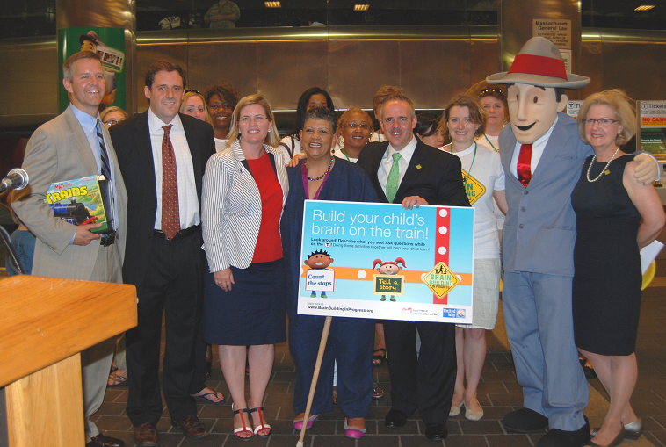
In addition, EEC developed a webpage of "Brain Building" tips for riding the T (brainbuildinginprogress.org/OnTheT) and further pushed out the message through Twitter and Facebook through a photo series of parents and children engaged in brain building activities on the T, with the hashtag #IAmABrainBuilder. The partnership was featured on WCVB-TV's EyeOpener. | 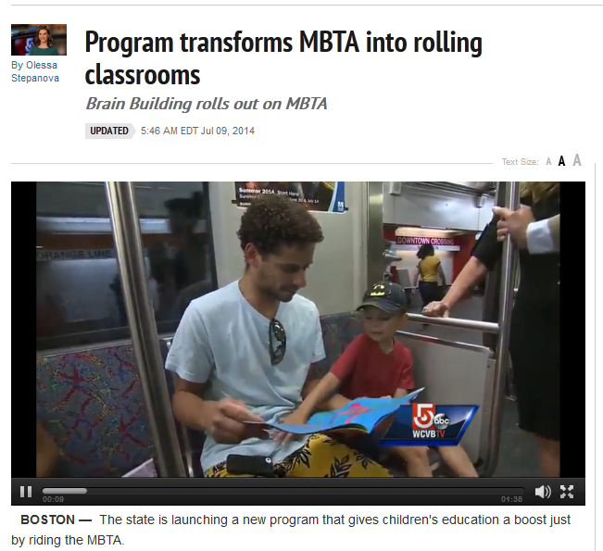

EEC participated in Fox25 News' ZipTrip in Jamaica Plain to further promote awareness of the EEC/United Way collaborative Brain Building in Progress campaign and partnership with the MBTA. EEC licensing and family/community engagement staff spoke about the importance of brain building
 |  | and provided families and children in attendance with educational resources. Staff and children from the nearby Nazarene program also attended and provided Boston Mayor Marty Walsh with a Brain Building t-shirt.
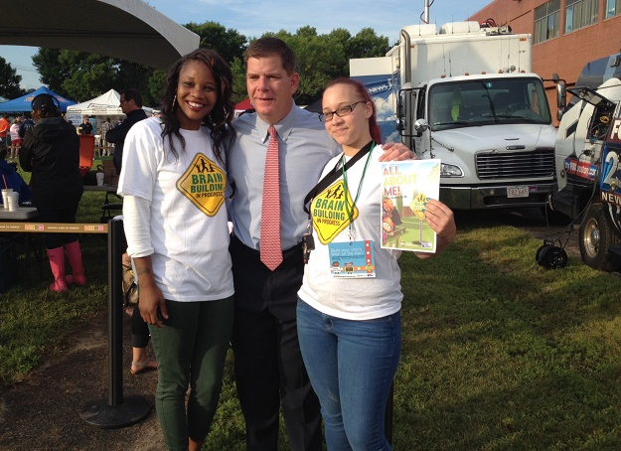 | 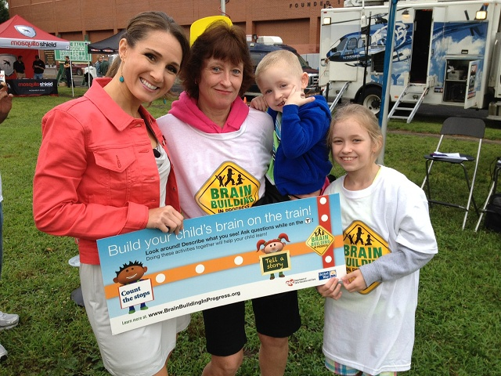

In the fall of 2014, EEC and United Way partnered with the Massachusetts Department of Transportation's (MassDOT) Registry of Motor Vehicles (RMV) and launched the "License to Learn" initiative at RMV branches across the state. Continuing the theme of promoting learning opportunities for young children in all environments and settings, "License to Learn" highlighted the RMV stations as a "Brain Building Zones" for young children. "License to Learn" promotes the message that parents are "brain builders" and suggests that parents and caregivers can use the time while at the RMV to share a "brain building moment" with their child(ren) and discuss important transportation safety related topics such as wearing your seatbelt, wearing a helmet when riding a bike, and using crosswalks to cross the street, etc. "License to Learn" was officially celebrated at the RMV's new location in Boston (Haymarket) in December 2014 during a special event with Registrar Celia Blue, Early Education and Care Commissioner Tom Weber, EEC Board Chair Jay Gonzalez, and UWMBMV President and CEO Mike Durkin. | 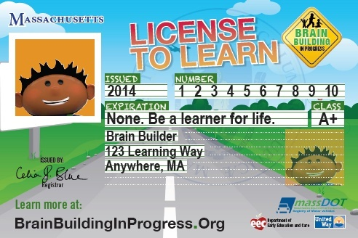
 | 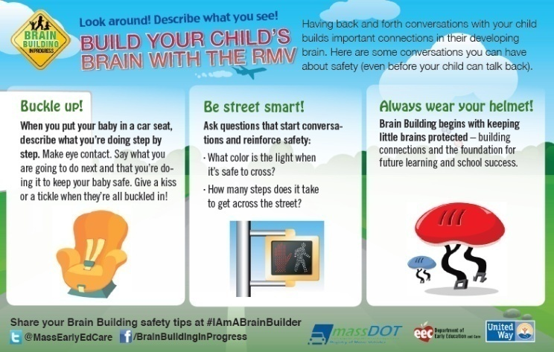

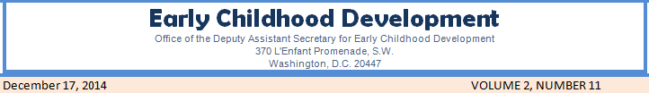  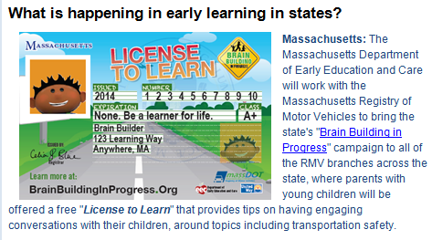 |  | The federal Office for Early Childhood Development featured "License to Learn" in the December issue of their monthly newsletter, as a highlighted activity of what is happening in early learning in states across the country.

#IAmABrainBuilder and Social Media

In 2014, EEC and United Way used social media to increase awareness of these resources and to help the public understand how they can engage in and support the Brain Building in Progress effort.  EEC followed its successful launch of the "Build Your Child's Brain on the Train" ad with a push on Twitter and Facebook asking followers to share "brain building moment" photos using the hashtag #IAmABrainBuilder. | 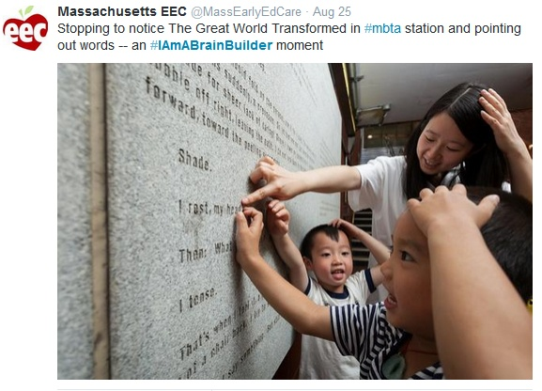
The #IAmABrainBuilder hashtag was quickly picked up by the CFCEs and other early education organizations in their social media postings.  EEC continued to use it with the "License to Learn" RMV initiative, and now regularly associates it with brain building related tweets.  EEC continued to use Twitter as the primary social media tool for interacting with external audiences and communicating resources and other information to key constituencies including providers and families. In 2014, the number of followers of EEC's Twitter account more than doubled, from 918 to 1,902. | 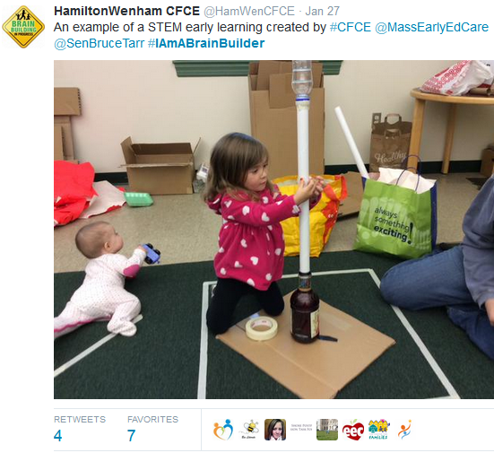

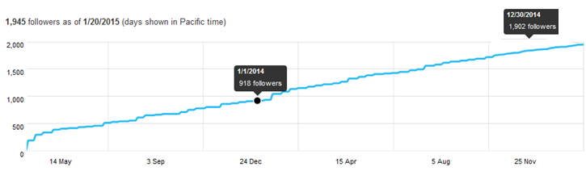
EEC leveraged its partnerships with the RMV and MBTA through the Brain Building in Progress campaign to gain higher visibility on Twitter, and to help build our following. For example, on several occasions during the month of December EEC tagged @MassDOT in its tweets about RMV/"License to Learn", and @MassDOT retweeted the posts to their over 40,000 followers (count as of December 2014). Twitter analytics showed a significant spike in the number of impressions that EEC's tweets received in the month of December -- nearly 45,000, almost a tenfold increase over the previous month. The tweets that tagged @MassDOT had the highest number of impressions. (An "impression" is a measure of how many times a tweet is viewed by a Twitter user.)

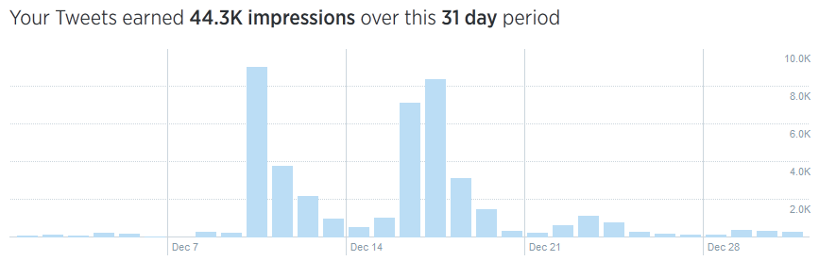

The @MassEarlyEdCare tweets with the highest number of impressions in December 2014 were ones about "License to Learn" and tagged @MassDOT. The dates, impressions and tweets are shown below:

December 10th (8,787) | December 17th (7,362) | December 16th (7,063)
 | 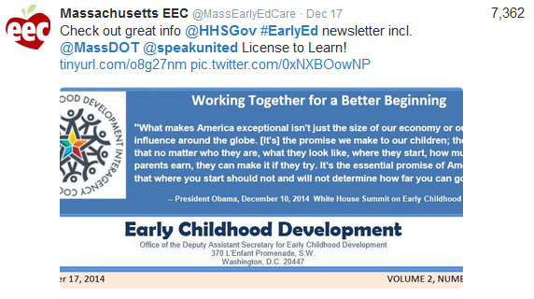 | 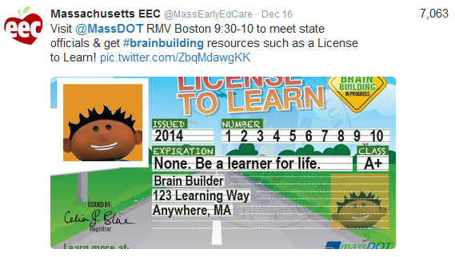

In contrast, there were roughly 5,000 impressions during the month of November.
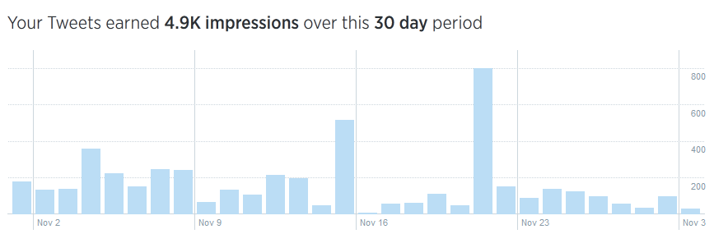

@MassEarlyEdCare's next goal is to pass the 2,000 mark of Twitter followers.

APPENDICES

Appendix A: Legislative Reporting Requirements
Annual Legislative Report Language:
- (g) The board shall submit an annual report to the secretary of education, the secretary of administration and finance, and the clerks of the House of Representatives and senate, who shall forward the same to the joint committee on education, describing its progress in achieving the goals and implementing the programs authorized in this chapter. The report shall evaluate the progress made toward universal early education and care for preschool-aged children and toward reducing expulsion rates through developmentally appropriate prevention and intervention services.
- The department shall include an annual report on behavioral health indicators that includes estimates of the annual rates of preschool suspensions and expulsions, the types and prevalence of behavioral health needs of children served by the department, the racial and ethnic background of the children with identified behavioral health needs, the existing capacity to provide behavioral health services, and an analysis of the best intervention and prevention practices, including strategies to improve the delivery of comprehensive services and to improve collaboration between and among early education and care and human services providers. The report and any recommendations for legislative or regulatory changes shall be submitted by February 15th to the secretary of health and human services, the secretary of administration and finance, the children's behavioral health advisory council, the child advocate, and the general court by filing it with the house committee on ways and means, the senate committee on ways and means, the joint committee on education, the joint committee on mental health and substance abuse, the joint committee on children, families and persons with disabilities, the clerk of the house and the clerk of the senate.
G.L.c. 15D, Sec. 10:
- The board shall include in its annual report rules and regulations promulgated by the board relative to the use of civil fines and sanctions, the types of sanctions, and the amount of those fines.
G.L.c. 15D, Sec. 13(d):
- The department of early education and care, with the approval of the board and in consultation with the state advisory committee on early education and care established in section 3A, shall study and present any additional recommendations on the programmatic, financing, and phase-in options for the development and universal implementation of the Massachusetts universal pre-kindergarten program. This study shall include an estimate of the need for full-day, full-year care that meets the needs of parents who work full-time and shall include the number of pre-school aged children in the commonwealth who may be at risk due to family poverty, TAFDC status, special needs, or other risk factors.
- The department shall include its findings and recommendations, and any updates of its findings, in the annual report required under section 3.

Effective: November 18, 2008
Massachusetts General Laws Annotated Currentness
Part I. Administration of the Government (Ch. 1-182)
Title II. Executive and Administrative Officers of the Commonwealth (Ch. 6-28A)
Chapter 15D. Department of Early Education and Care (Refs & Annos)
Workforce System Update Legislative Report Language:

§ 5. Workforce development system; implementation plan
The board shall develop and annually update an implementation plan for a workforce development system designed to support the education, training and compensation of the early education and care workforce, including all center, FCC, infant, toddler, preschool and school-age providers. The board shall solicit input from organizations and agencies that represent a diverse spectrum of expertise, knowledge and understanding of broader workforce development issues and of the professional development needs of the early childhood and care workforce. In order to inform the plan, the board shall conduct:
(1) an inventory and assessment of the current resources and strategies available for workforce and professional development in the commonwealth, including but not limited to Head Start trainings, community-based trainings, higher education programs, child care resource and referral agency trainings, state and federally funded workforce development trainings/programs, public school system trainings/credentialing, and other trainings that address the needs of those who work with children and make recommendations for coordinating the use of those existing resources and strategies;
(2) analyses using current data on the status of the early education and care workforce, including work experience, certifications, education, training opportunities, salaries, benefits and workplace standards; and
(3) an assessment of the workforce capacity necessary to meet the state's early education and care needs in the future.

In the development of the plan, the board shall consider:
(1) core competencies, a common and shared body of knowledge, for all those working in the early education and care fields;
(2) streamlined and coordinated state certification, credentialing, and licensing within the early education and care fields including teacher and provider certification and licensing, the child development associate, public school teacher certification, and other program standards as appropriate for director, teacher and provider credentialing requirements;
(3) a mandatory and regularly updated professional development and qualification registry;
(4) agreements among IHEs for an articulated system of education, training, and professional development in early education and care;
(5) approval of early education and care training programs and academic coursework, incentives for associates and bachelors programs to meet best practices and to modify curricula to reflect current child development research, and certification of trainers and teachers;
(6) coordination of existing workforce resources among public agencies, including establishing regional workforce support resources in coordination with child care resource and referral agencies;
(7) a range of professional development and educational opportunities that provide appropriate coursework and degree pathways for FCC as well as center-based providers at all levels of the career ladder that are available in locations, days, and times that are accessible;
(8) credit for prior learning experiences, development of equivalencies to 2 and 4 year degrees, and the inclusion of strategies for multiple pathways for entry into the field of early education and care;
(9) recruitment and retention of individuals into the early education and care workforce who reflect the ethnic, racial, linguistic, and cultural diversity of Massachusetts families based on the current census data;
(10) incentives and supports for early education and care professionals to seek additional training and education, such as scholarships, stipends, loan forgiveness connected to a term of service in the field, career counseling and mentoring, release time and substitutes;
(11) guidelines for a career ladder or career lattice representing salaries and benefits that suitably compensate professionals for increases in educational attainment and with incentives for advancement, including a salary enhancement program;
(12) public and private resources to support the workforce development system;
(13) a data collection and evaluation system to determine whether the workforce and professional development activities established pursuant to this chapter are achieving recruitment, retention and quality of the workforce goals;
(14) ways to recognize and honor advancement in educational attainment among early educational and care professionals;
(15) professional development opportunities that are provided in languages other than English, and incorporation of these opportunities into any broader, articulated system that is developed; and
(16) alignment of the core competencies, course offerings and other professional development opportunities, where appropriate, with the program quality standards established under section 11.
(17) training to identify and address infant toddler and early childhood behavioral health needs.

CREDIT(S)
Added by St.2004, c. 205, § 1, eff. Mar. 1, 2005. Amended by St.2008, c. 215, § 35, eff. July 31, 2008; St.2008, c. 321, § 5, eff. Nov. 18, 2008.
HISTORICAL AND STATUTORY NOTES
2009 Electronic Update; 2004 Legislation; St.2004, c. 205, § 1, an emergency act, was approved July 23, 2004, and by § 2 made effective Mar. 1, 2005.; 2008 Legislation; St.2008, c. 215, § 35, an emergency act, approved July 31, 2008, effective July 31, 2008, in the second paragraph, in cl. (13), deleted “and” from the end; in cl. (14), substituted “advancement” for “advancements” and added “; and” to the end; and added cls. (15) and (16).
St.2008, c. 321, § 5, approved Aug. 20, 2008, effective Nov. 18, 2008, added cl. (17).
(c) 2009 Thomson Reuters.
Link to last year’s report: http://www.mass.gov/edu/docs/eec/2013/fy13eec.pdf

Appendix B: Licensing Activity by Calendar Year 2010 through 2014
New Licensing Enforcement Actions | # in 2010 | # in 2011 | # in 2012 | # in 2013 | # in 2014
Sanctions | 6 | 10 | 5 | 17 | 22
Acknowledgment of Vol. Surrender | 3 | 1 | 13 | 31 | 17
Revocation (license and TQ) | 5 | 9 | 17 | 6 | 17
Cease and Desist | 8 | 12 | 9 | 24 | 28
C&D w/ Civ. Injunc. | 1 | 2 | 0 | 1 | 0
C&D w/ Crim. Pen. | 0 | 0 | 0 | 0 | 0
Refusal to Renew/Issue | 1 | 5 | 3 | 4 | 6
Emergency Suspension | 3 | 7 | 8 | 4 | 10
Legal Agreement | 2 | 3 | 4 | 1 | 8
Legal Consult | 2 | 1 | 2 | 4 | 2
Appeal of CORI/DCF denial | 1 | 2 | 0 | 4 | 11
Enforcement Mtg. | 0 | 1 | 3 | 0 | 1
Fine | 0 | 1 | 1 | 1 | 0
Correction Order | 0 | 2 | 0 | 0 | 0
TOTAL: | 32 | 56 | 65 | 97 | 107
*NOTE: Many licensing legal referrals require multiple actions (i.e. emergency suspension/revocation, sanctions and fine, etc.)

Subsidy Appeals | 2010 Total | 2011 Total | 2012 Total | 2013 Total | 2014 Total
Requests for Review | 847 | 1,226 | 928 | 974 | 1,073
Reviews Completed | 840* | 900* | 864 | 888 | 846
Requests for Hearing | 37 | 60 | 41 | 94 | 83
30A Appeals | 1 | 0 | 0 | 0 | 1

PROGRAMS | Jul  (FY 2015) | Aug  (FY 2015) | Sep  (FY 2015) | Oct  (FY 2015) | Nov  (FY 2015) | Dec  (FY 2015)
Central MA | 1,903 | 1,903 | 1,897 | 2,010 | 2,005 | 1,998
Metro Boston | 2,287 | 2,270 | 2,269 | 2,202 | 2,200 | 2,188
Northeast MA | 2,346 | 2,342 | 2,329 | 2,204 | 2,201 | 2,194
Southeast and Cape MA | 1,718 | 1,734 | 1,713 | 1,878 | 1,873 | 1,870
Western MA | 1,824 | 1,825 | 1,816 | 1,703 | 1,695 | 1,691
Total Number of Programs | 10,078 | 10,074 | 10,024 | 9,997 | 9,974 | 9,941

CAPACITY | Jul  (FY 2015) | Aug  (FY 2015) | Sep  (FY 2015) | Oct  (FY 2015) | Nov  (FY 2015) | Dec  (FY 2015)
Family Child Care | 51,357 | 51,182 | 50,789 | 50,677 | 50,573 | 50,364
Small Group and School Age | 246 | 236 | 224 | 225 | 249 | 269
Large Group and School Age | 171,255 | 172,747 | 173,512 | 173,325 | 173,419 | 173,647
Residential and Placement Child Care | 6,754 | 6,800 | 6,841 | 6,854 | 6,814 | 6,799
Total Licensed Capacity | 229,612 | 230,965 | 231,366 | 231,081 | 231,055 | 231,079

Licensing | Jul  (FY 2015) | Aug  (FY 2015) | Sep  (FY 2015) | Oct  (FY 2015) | Nov  (FY 2015) | Dec  (FY 2015)
New | 49 | 81 | 78 | 54 | 38 | 48
Renewal | 278 | 286 | 267 | 330 | 235 | 243
Reopen | 10 | 10 | 13 | 11 | 7 | 10
Moves | 20 | 35 | 31 | 25 | 20 | 24
Closed Programs | 101 | 95 | 144 | 94 | 64 | 91
New Applications Received | 96 | 121 | 81 | 69 | 57 | 55
Total Licenses Issued | 357 | 412 | 389 | 420 | 300 | 325

COMPLAINTS | Jul  (FY 2015) | Aug  (FY 2015) | Sep  (FY 2015) | Oct  (FY 2015) | Nov  (FY 2015) | Dec  (FY 2015)
Number of closed complaints during the month | 278 | 196 | 203 | 348 | 227 | 244
Number of new complaints received during the month | 226 | 245 | 248 | 314 | 193 | 215
Total number of open complaints on the 1st day of the month | 492 | 437 | 477 | 519 | 479 | 444
Number of open complaints on the 1st day of the month with interim report done | 38 | 35 | 35 | 30 | 17 | 33

VISITS | Jul  (FY 2015) | Aug  (FY 2015) | Sep  (FY 2015) | Oct  (FY 2015) | Nov  (FY 2015) | Dec  (FY 2015)
Central MA | 59 | 73 | 52 | 82 | 78 | 66
Metro Boston | 73 | 106 | 83 | 97 | 65 | 90
Northeast MA | 134 | 87 | 108 | 113 | 101 | 107
Southeast and Cape MA | 50 | 66 | 69 | 87 | 54 | 51
Western MA | 75 | 73 | 43 | 65 | 46 | 59
Total Number of Visits | 391 | 405 | 355 | 444 | 344 | 373

Note(s):
1. Licensing information includes data for open and currently active FCC, GCC, SACC and R&P programs, but excludes FCC Assistants. Delegated and Exempt programs are included. Number of programs and total capacity are calculated on the first day of the following month. If GCC has Limited SACC, they counted as one program. Limited SACC capacity is included in Group Child Care capacity.

2. For Monthly Activities: if transaction is done for limSACC, and not for corresponding GCC, it's counted. If the transaction is done for GCC and limSACC, it's counted only for GCC.

3. Complaint information includes data for all types of intakes: Complaint, Voluntary Incident, Mandatory Incidents, Injury/Illness Review and Internal Investigation. Number of open complaints on the last day of the month is the same as on the first day of the following month.

4. Visit information includes data entered via Licensing Manager, EECRS and FCC Mobile applications.

5. Close progams include code id 1 - 4, 9 - 16, 500.

Data Source(s): ECIS Monthly reporting database with sources out of Licensing,

Appendix C: 2014 Caseload Detail

2014 Caseload by Child Care Account

FY2014-2015 Children Actively Enrolled by Child Care Account (Service Month)

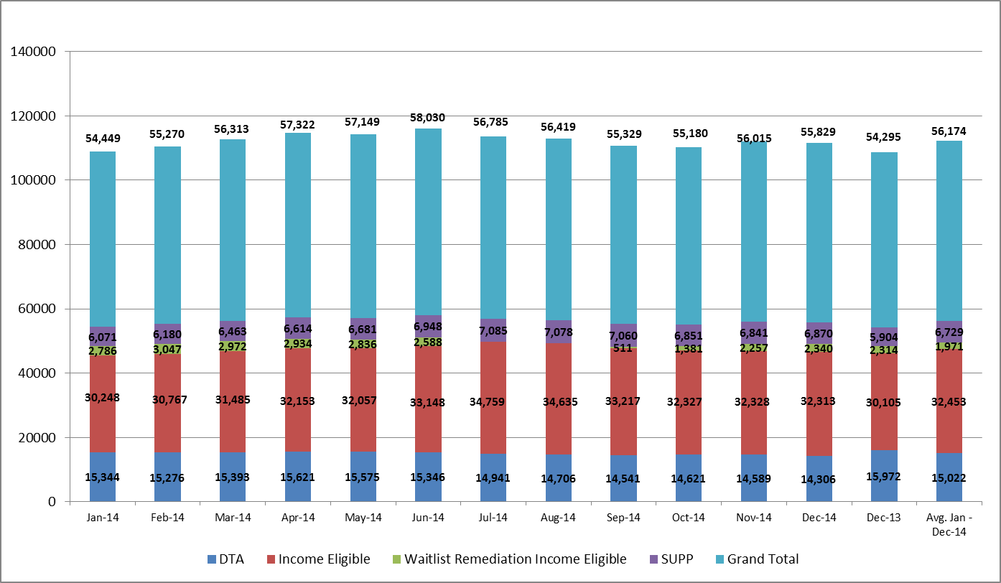

Appendix C: 2014 Caseload Detail

FY2014-2015 Children Actively Enrolled by Age Group (Service Month)

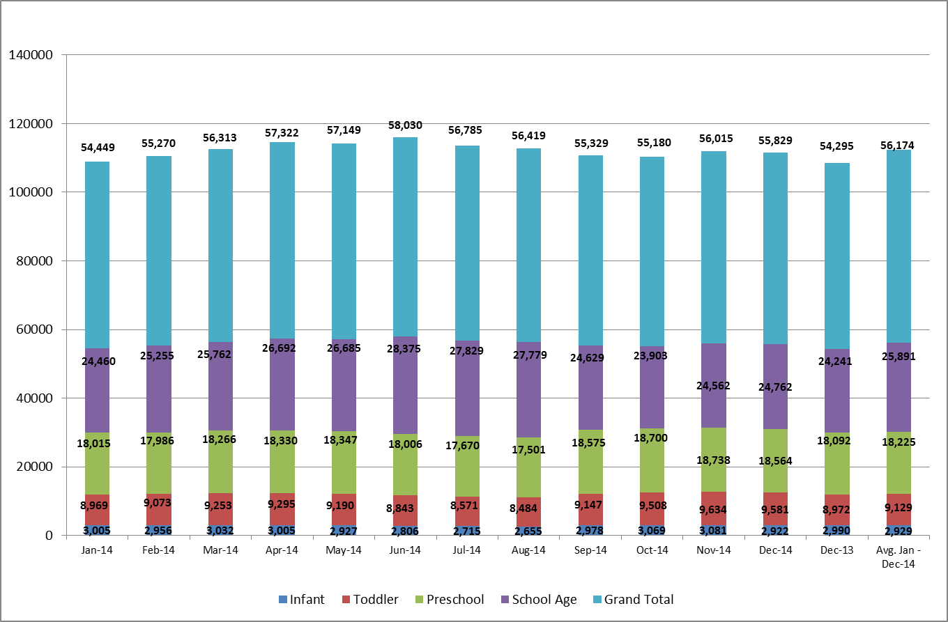

Appendix C: 2014 Caseload Detail

FY2014-2015 Children Actively Enrolled by Program Setting (Service Month)

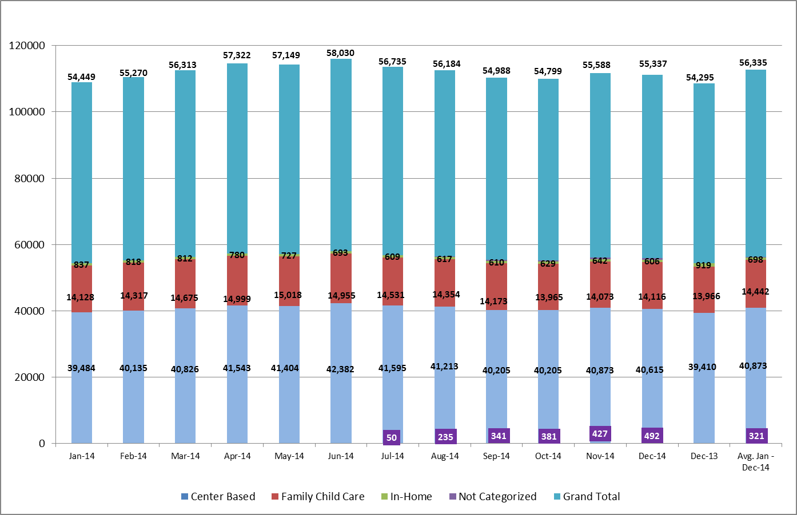

Appendix D: Income Eligible Waitlist Demographic Breakdowns

EEC maintains a waitlist of Income Eligible families who are seeking child care financial assistance.

Waitlist by Age Group (over time):
Waiting List | Jan-14 | Feb-14 | Mar-14 | Apr-14 | May-14 | Jun-14 | Jul-14 | Aug-14 | Sep-14 | Oct-14 | Nov-14 | Dec-14
Infants | 5,080 | 4,954 | 4,988 | 4,983 | 5,013 | 4,615 | 4,116 | 3,940 | 4,199 | 4,034 | 3,678 | 3,677
Toddlers | 7,963 | 7,799 | 7,801 | 7,900 | 7,868 | 7,110 | 6,001 | 5,521 | 5,627 | 5,179 | 4,600 | 4,604
Preschool | 11,206 | 11,002 | 11,098 | 11,257 | 11,357 | 10,266 | 7,818 | 6,707 | 6,790 | 6,093 | 5,305 | 5,455
School Age | 16,269 | 16,292 | 16,423 | 16,888 | 17,343 | 15,921 | 12,367 | 11,425 | 11,841 | 10,308 | 9,039 | 9,382
Total I/T/P | 24,249 | 23,755 | 23,887 | 24,140 | 24,238 | 21,991 | 17,935 | 16,168 | 16,616 | 15,306 | 13,583 | 13,736
Total | 40,518 | 40,047 | 40,310 | 41,028 | 41,581 | 37,912 | 30,302 | 27,593 | 28,457 | 25,614 | 22,622 | 23,118

Waitlist by Department of Elementary and Secondary Education (ESE) Commissioner Districts:

ESE Commissioner's District | General Priority | Child Of Foster Care | Child Of Homeless Family | Child Of Military Personnel | Child Of Teen Parent | Child with Special Needs | Continuity of Care: Prior Year Summer Only | Continuity Of Care: Aging Out | Continuity Of Care: Approved Break in Service | Continuity of Care: ARRA | Continuity Of Care: Geographic Relocation | Continuity Of Care: Homeless Contract | Continuity Of Care: Supportive Referral | Continuity Of Care: Teen Parent Contract | Grandparent/Guardian Families | Head Start Wrap Around - HS Enrolled Only | N/A | No Priority - Other Family Member | Parent with Special Needs | Sibling: Contract | Sibling: Voucher | Summer Only Care
Holyoke | 126 | 3 | 8 |  | 4 | 11 |  | 4 | 1 |  |  |  |  |  | 4 |  |  |  | 1 |  | 10 | 12
Springfield | 1016 | 10 | 8 | 5 | 12 | 46 | 2 | 2 | 17 |  |  | 1 | 1 |  | 9 |  |  | 1 | 9 | 5 | 8 | 35
Worcester | 673 | 2 | 16 | 1 | 5 | 34 | 5 | 3 | 15 |  | 2 | 1 | 3 | 1 | 2 |  | 1 | 15 | 6 | 21 | 9 | 22
Lawrence | 1603 | 2 |  | 1 | 52 | 43 | 25 | 16 | 18 | 1 | 2 |  | 10 | 1 | 1 |  | 2 | 12 | 8 | 24 | 25 | 44
Lowell | 930 |  | 9 |  | 8 | 51 | 8 | 2 | 8 | 1 | 3 | 4 | 5 |  | 5 |  |  | 14 | 8 | 9 | 6 | 9
Lynn | 967 | 4 | 6 |  | 18 | 45 | 8 | 9 | 9 |  | 4 | 1 | 1 |  | 3 |  |  | 4 | 10 | 18 | 18 | 27
Brockton | 826 | 6 | 8 | 6 | 2 | 23 |  | 4 | 4 |  | 8 | 1 | 6 |  | 4 |  |  | 12 | 3 | 5 | 9 | 10
Fall River | 369 | 7 | 5 |  | 1 | 10 | 1 | 5 | 3 | 6 |  |  |  |  | 3 |  | 1 | 5 | 2 | 6 | 2 | 5
New Bedford | 438 | 1 |  | 1 | 3 | 17 |  | 5 | 5 | 1 | 3 | 3 | 7 |  | 9 |  |  | 5 | 1 | 2 | 8 | 5
Boston | 3000 | 11 | 78 | 3 | 18 | 104 | 99 | 7 | 12 |  | 9 | 4 | 32 | 2 | 19 | 7 |  | 8 | 13 | 51 | 119 | 204
 | 9948 | 46 | 138 | 17 | 123 | 384 | 148 | 57 | 92 | 9 | 31 | 15 | 65 | 4 | 59 | 7 | 4 | 76 | 61 | 141 | 214 | 373

Waitlist by Priority Code:

Priority | Infant | Toddler | Preschool |  | School Age | Total Nov. 30, 2014 | Total Dec. 31, 2014
Child Of Foster Care | 12 | 16 | 24 | 56 |  | 104 | 108
Child Of Homeless Family | 35 | 73 | 82 | 103 |  | 279 | 293
Child Of Military Personnel | 7 | 8 | 18 | 15 |  | 49 | 48
Child Of Teen Parent | 81 | 79 | 30 | 14 |  | 168 | 204
Child with Special Needs | 33 | 138 | 252 | 542 |  | 951 | 965
Continuity of Care: Prior Year Summer Only | 1 | 7 | 7 | 233 |  | 245 | 248
Continuity Of Care: Aging Out | 0 | 5 | 7 | 104 |  | 113 | 116
Continuity Of Care: Approved Break in Service | 3 | 6 | 36 | 146 |  | 193 | 191
Continuity of Care: ARRA | 1 | 1 | 2 | 11 |  | 13 | 15
Continuity Of Care: Geographic Relocation | 2 | 4 | 30 | 58 |  | 100 | 94
Continuity Of Care: Homeless Contract | 0 | 4 | 15 | 6 |  | 23 | 25
Continuity Of Care: Supportive Referral | 10 | 26 | 52 | 51 |  | 144 | 139
Continuity Of Care: Teen Parent Contract | 2 | 3 | 1 | 3 |  | 9 | 9
General Priority | 3263 | 4091 | 4728 | 6784 |  | 18408 | 18866
Grandparent/Guardian Families | 9 | 29 | 43 | 98 |  | 170 | 179
Head Start Wrap Around - HS Enrolled Only | 0 | 1 | 8 | 2 |  | 11 | 11
N/A | 1 | 2 | 0 | 7 |  | 11 | 10
No Priority - Other Family Member | 4 | 9 | 15 | 132 |  | 167 | 160
Parent with Special Needs | 12 | 30 | 32 | 65 |  | 143 | 139
Sibling: Contract | 66 | 36 | 29 | 132 |  | 270 | 263
Sibling: Voucher | 134 | 27 | 26 | 160 |  | 348 | 347
Summer Only Care | 1 | 9 | 18 | 660 |  | 703 | 688
Grand Total | 3677 | 4604 | 5455 | 9382 |  | 22622 | 23118

Appendix E: Budget Information

Budget Overview

The Fiscal Year 2015 General Appropriation Act (GAA) is a reflection of the continued strong commitment of the Legislature to early education and care. The FY15 GAA includes an FY15 budget for EEC of $543.4M, which is $30.8M more than the total amount available in FY14. The GAA includes significant investments in quality child care access and care which is highlighted by $15M to remediate the Income Eligible waitlist, $6.5M in a reserve fund to provide a modest rate increase for center-based providers, and allows EEC to carry forward (PAC) over $8.7M of remaining FY14 Income Eligible funds to support FY15 caseload. In addition to the GAA authorized funds and Income Eligible PAC, there is another $662.2K available to EEC through smaller reserves and PACs for the continuation of certain FY14 projects. Overall, the department has $544M in total funding to support FY15 activities.

This total was reduced over the past 3 months through two 9C reduction exercises. Both Governors Patrick and Baker have moved to reduce appropriations throughout the executive branch to address underperforming FY15 revenue collections in a process informally referred to as "9Cs". The "9C' cuts reduced EEC's appropriations by a total of $6.48 M.

FY15 EEC State-Funded Budget: A Continuation of FY14 Programs

3000-1000 Administration

The administration account provides funding for the agency’s administrative and operational expenses including payroll and office leases. This account was funded at $12.9M in FY14 (after $85K was PAC'd from FY13 into FY14 for the Region 1 move in the early half of FY14), and increased to $13.4M in FY15. The increase primarily supports the annualization of additional Background Check (BRC) unit staff hired in FY14. An additional $339K is available through a reserve account to support the cost associated with the recent collective bargaining agreement with our NAGE and SEIU employees.

3000-2000 Access Management

This account is for the regional administration and coordination of services provided by Child Care Resource and Referral (CCRR) agencies. The FY15 appropriation of $6.5M is a $630K increase from FY14 level. This increase is due to the annualization of funds that were provided through the 3000-4070 Waitlist Remediation account in FY14 to increase the management fee to ensure that CCRRs were staffed appropriately to handle the increased volume for placements and to monitor the backfilling and reassessment process.

3000-3000 Innovative Curriculum in Pre School Programs

The goal of the grant was to develop innovative preschool Science, Technology, Engineering, and Mathematics curricula to be used by early education programs for preschool-aged children. EEC recognizes that quality STEM Curricula includes: project based learning, hands-on experimentation, and providing experiences that support natural inquiry. After eight months of research, testing, training and written development work, our five selected grantees concluded their projects for EEC with five new in-depth Innovation Preschool STEM focused Curricula. EEC released the final products of this line item to the public on October 22, 2014. These curricula are in multiple languages and can be found at the following web link: http://www.mass.edu/stem/initiatives/otherstateearlycurricula.asp. The five curricula are:

- The Heritage Museums and Garden's Hundred Acre School: Collections: A STEM Focused Curriculum, Implementation guide, Lab Report template & MASS STE. Standards Crosswalk. The Collections Curriculum encourages children to be curious, to wonder, think, play, question, and connect with the world around them, so they will become innovators able to make great contributions to society. Every Investigation begins with provocations designed to get children and families talking and asking questions about STEM concepts related to the specific Investigation. As children’s questions emerge, teachers will design activities to help children test their hypotheses and further their learning. Teachers expand the investigation based on children’s interests and experiments using lab reports that document their hypotheses. Investigations culminate in the creation of an Exhibition where children share what they have learned with others.

- SHED Children's Campus: Pumpkin Patch Project- Exploring the Life-Cycle Process. This STEM curriculum involves an array of activities that appropriately teaches children to explore and comprehend complex life-­cycle processes through active involvement in each of the stages from researching local species of pumpkins to identifying nutrients for soil fertility.

- Mass Audubon: Four curriculum units- Our Furthered Friends, Digging into Soil, Tree-mendous Trees and Wicked Cool Weather. This set of curricula focus on the world that is all around young children. By using your five senses and by observing one can begin to learn about the natural world in classroom learning stations, outside in the school yard setting, and in their local communities, children can acquire an increased understanding about natural science and the world.
- Clarendon Early Education Services, Inc.: Four STEM focused curriculum units specifically designed for family child care educators and the children in their care. The four unit topics are- Building Things, Light And Shadows, Simple Machines and Building Brains with Boxes.

- YWCA of Central Massachusetts: Live Learn Grow- A Gardening Curriculum. Gardening is an easy hands on approach to incorporating STEM concepts into a program's daily life. This curriculum supports children' s natural curiosity about the world around them and provides a prolonged opportunity to make inquiry-based investigations, to help define nature and substance, to ask questions (science), explore using microscopes (technology), solve problems (engineering) and use mathematics and computational thinking all while having fun.

3000-3050 Supportive Childcare

Provides early education and care and afterschool services for children referred by the Department of Children and Families (DCF). This account is funded at $79.7M in FY15, a decrease of $874K when compared to the FY14 expenditures. Funds from this appropriation contribute $600,000 to a statewide mental health program which, in total, is funded at $1.25 million (The other portion comes from 3000-6075). The statewide Mental Health Program offers a statewide consultation system of mental health supports for children and families to foster the healthy social-emotional development of all children.

3000-4040 Waitlist Remediation

This is a new appropriation funded at $15M to reduce the waitlist for income-eligible early education and care programs, similar to the funding we received in FY14 through the 3000-4070 account. This funding has enabled the department to provide Income Eligible care for 2,500 children in FY15.

3000-4050 DTA Related Childcare

This line item provides early education and care and after school services for children referred by the Department of Transitional Assistance (DTA). This account is funded at $133.7 million in FY15 which is an increase of roughly $5.2 million when compared to the amount expended FY14.

3000-4060 Income Eligible Childcare

Provides child care, early education, and afterschool financial assistance for children from low income and at-risk families through vouchers and contracts. The FY15 GAA appropriates $241.9M, but the GAA also includes language that allows up to $8.8M of any surplus remaining at the end of FY14 in IE to carry over into FY15. With the PAC, this account has $250.6M available in FY15, which is an increase of $30.9M over the amount expended in FY14. Much of the increase is to annualize the SEIU CBA increases in FY14, fund the FY15 portion of the SEIU CBA increase, and support the cost of child care.

Funds from 3000-4060 are also used to fund Inclusive Preschool Learning Environments programs. These funds, valued at $9 million, (formerly known as Chapter 188/Phase I of CPC) are designed to support inclusive preschool learning environments serving preschool-age children with disabilities in early education and care settings with their same-aged peers without disabilities. Through this grant funded program, in FY14 EEC funded ninety-four grantees that delivered inclusive preschool learning environments within 136 programs through the Commonwealth, and in FY15 ninety-two grantees are funded to serve children within 135 programs.

3000-5000 Grants to Head Start Programs

Provides state supplemental salary grants for twenty-nine federally funded Head Start agencies to support their programs. This account was funded at $8.1 million in FY14 and increased to $9.1 million in FY15. Grantees must provide services that support the development of a state-wide system of early education and care for children (birth to age eight) and families served by Head Start and Early Head Start in the Commonwealth. The purpose of the Head Start State Supplemental grant is to:

- Enhance program capacity to serve state-funded children and offer them Head Start services;
- Increase the professional development opportunities available to staff;
- Use Head Start State Supplemental funds to support staff salaries;
- Enhance program quality by continuing to require Head Start (HS) and Early Head Start (EHS) center-based and family child care programs to participate in QRIS;
- Provide non-federal matching funds for programs. Note: these are the only EEC funds which can be used for matching federal funds; and
- Support HS and EHS approaches to school readiness to ensure that children are ready for school, families are ready to support their children's learning, and schools are ready for children.

3000-5075 Universal Pre-Kindergarten

This account was funded at $7.5 million in the FY15 GAA, but was reduced through the "9C" process by $100K. The funds support three primary activities: (1) the Universal Pre-Kindergarten (UPK) Grant, (2) the Assessment Grant and (3) the QRIS Measurement Tools Grant.

The Universal Pre-Kindergarten (UPK) Grant Program funds preschool programs to:
- Promote the early learning guidelines to support school readiness and positive outcomes for children participating in UPK classrooms and homes;
- Support and enhance the quality of services for children in UPK classrooms and family child care homes, especially for high needs children and/or children living in underperforming school districts;
- Maximize parent choice by ensuring participation from all program types within a mixed public and private service delivery system;
- Use child evidence-based formative assessment systems/tools to ensure that programs are effectively measuring children’s progress across all developmental domains and using this information to inform practice through individualized teaching; and
- Inform the longer-term implementation of a program of universally accessible, high-quality early childhood education.

The purpose of the Assessment Grant is to design, deliver and coordinate screening and assessment system training. Through this grant, EEC endeavors to build infrastructure that supports the state professional development system to provide the training, consultation, materials, and supports that programs need to become skilled in child assessment and screening and in measuring program quality. The grant will also support efforts by the Readiness Center Grantees to ensure that programs engaged in the Massachusetts Kindergarten Entry Assessment (MKEA) project have access to and are trained to integrate screening and assessment into their programs.

The purpose of the QRIS Measurement Tools Grant is to provide training on the QRIS measurement tools and provide access to those tools to support program improvement in settings serving children birth to 13 across the Commonwealth.

3000-6075 Early Childhood Mental Health Consultation Services

This account mainly funds grants for mental health consultation services to empower programs to manage children’s mental health issues in order to reduce the number of expulsions and is funded at $750,000 in FY15 which is the same level as FY14. Aside from $100,000 dedicated to payroll and fringe, all other funds in this appropriation support the Mental Health Consultation Grant which also receives nearly half its support ($600,000) from the 3000-3050 Supportive line items. As part of a broader comprehensive statewide system of mental health supports for children and families, EEC, in collaboration with the Department of Mental Health (DMH), aims to provide a statewide system of mental health consultation services.

3000-7050 Services for Infants and Parents/ Quality

This appropriation is funded at $18,464,890 in FY15, an increase from FY14 amount. The appropriation primarily funds grants for a statewide system that provides families with access to comprehensive services and supports that strengthen families and promote optimal child development. The Services for Infants and Parents account is used to fund two grant programs: Coordinated Family and Community Engagement (CFCE) and Educator and Provider Support (EPS).

Coordinated Family and Community Engagement (CFCE)

The CFCE grantees act as a community-based information and resource hub for all families in order to increase knowledge of and accessibility to high-quality early education and care programs and services for families with children birth through age 8. In addition, the CFCE grant supports program quality by providing early education and out-of -school time programs with referrals to a range of locally available resources that meet the needs of children and families. CFCE grantees create linkages between educators and providers on the local level to professional development supports and opportunities available through EEC’s statewide system of educator and provider support. The key goals of CFCE include strengthening families to build their capacity to support and promote their child’s development. This is accomplished multiple ways including linking to comprehensive supports.

In 2014, more than 100,000 families have been touched by the work of CFCEs, through referrals to comprehensive services, such as early childhood special education, early intervention, and WIC; participation in literacy-based parent/child educational playgroups and\or child development education opportunities offered in various settings across communities, including homeless shelters, libraries and correctional facilities; and, in partnership with community-based agencies, as EEC works on the local level to strengthen families in order to promote their child’s development through a system of early education and care.

Educator and Provider Support (EPS)

Through an FY14 competitive grant application, EEC awarded grants to five vendors who provide professional development opportunities and services for working adults in early education and out of school time field to increase their knowledge and skills, which can then be applied to practice. The EPS grant was a renewal grant for FY2015. The five regional EPS grantees continued to provide professional development and coaching and mentoring support services to increase early educator's knowledge, skills, and abilities. The EPS grant provides for credit professional development opportunities and technical assistance to early education and out of school time providers working in EEC's mixed delivery system across the Commonwealth. The continuing education (CEU) and college coursework provided through the grant are aligned with EEC's Core Competencies and Quality Rating and Improvement System standards. There are five EPS providers across the Commonwealth funded at a total of $3,167,999.

3000-7070 Reach Out and Read

Funded at $700,000, Reach Out and Read is a research-proven, pediatric literacy intervention program which trains doctors and nurse practitioners to provide advice to parents on reading aloud to children and books for children living in poverty and in underperforming school districts through programs established in community health centers, medical practices, and hospitals. The funds distributed through Reach Out and Read shall be contingent upon a match of not less than $1 in private or corporate contributions for every $1 in state grant funding.

FY15 EEC State Funded Budget: New Programs and Initiatives

1599-0042 CBC Reimbursement Rate Reserve

The FY15 GAA includes $6.6M to increase reimbursement rates for center-based subsidized early education and care providers and for salaries, benefits, and stipends for professional development of early educators or programmatic quality improvement. These funds have been transferred to the caseload accounts and, like the rate increase provided in FY14 through the consolidated net surplus, it is assumed that this rate increase will be annualized in FY16 into the individual caseload accounts.

3000-1050: EEC Assessment

The FY15 budget set aside $385K for “supplemental research and assessment related to item 1599-0500 in section 2 of chapter 38 of the acts of 2013; provided, that the supplemental research shall be directed by a nonprofit research organization with demonstrated experience assessing the business practices, service delivery and financial systems of state-subsidized childcare programs…” The 1599-0500 account provided $500K for a 2-year assessment of childcare supports funded in items 3000-3050, 3000-4050, 3000-4060, and 3000-4070. EEC contracted with the Urban Institute in November 2013 to complete this assessment, which has a final deadline of June 30, 2015. There is still $224,070 remaining from the FY14 appropriation (which is an ISA with ANF), which has been PAC'd into FY15.

The $385K provided for in this account was eliminated as a part of the 9C process. Work and funding continues under the original 1599-0500 account and is on target to be completed by the end of FY15.

3000-5025 K1 Classroom Grant Program

A new initiative introduced in the FY15 GAA at $1M, but reduced through "9Cs" to $750K, that will provide grants to cities and towns to provide educational opportunities on a voluntary basis to 4-year-olds in the district through the creation of high quality pre-kindergarten classrooms and the support of quality initiatives in existing programs, regardless of the setting in which the children are served. This funding will be used to develop partnerships between districts, community based providers and other local entities, with priority given to communities with Level 5 elementary schools and school districts, to improve the quality and accessibility of early education in each grantee district. The goal of this grant program is to demonstrate sustainable, scalable approaches to quality improvements that meet the diverse needs of families and children in the target communities and that result in improved outcomes for young children. These initiatives may include but will not be limited to: shared professional development opportunities; data sharing between districts and community providers; enhanced curriculum, instruction, and assessment practices; initiatives to strengthen family engagement, and; the development of financing mechanisms that incent and sustain quality programming across a mixed delivery system over time.

The FY15 GAA includes $1M for a new K1 Classroom grant program to provide educational opportunities to 4-year olds. The GAA states that preference for this program may be given to level 5 schools and districts.

This item was completely eliminated by the two rounds of 9C reductions, prior to the grant being solicited and awarded.

3000-7040 EEC Contingency Contract Retained Revenue

The FY15 GAA includes this new account, originally proposed by the Governor and included by the House and Senate, which allows EEC to retain up to $200K in Title IVE revenue to streamline payments to PCG for their work on collecting Title IVE funds. This is a cost neutral item.

Federal Funds

In addition to the Race to the Top and Preschool Expansion Grant Awards, EEC has been fortunate to enjoy the support of other federally funded programs.

Head Start State Collaboration Project

This is a five-year grant awarded by the Department of Health and Human Services' Administration for Children and Families (ACF) that is renewed annually during the grant period. We are now in the four year of a five-year grant cycle. The total grant amount varies State to State and is based on the number of federally funded Head Start children in the State; Massachusetts receives $175,000 annually. The work of the Head Start Collaboration project highlights the importance of the work and commitment to all children and families in the Commonwealth. The HSSCO’s goals, key priority areas, and activities are aligned with EEC’s enabling legislation and include school transitions, professional development with higher education, and early childhood systems development and coordination and the Office of Head Start Region 1 Priorities such as Dual Language Learners, Financial Education, Serving Children with Disabilities, Parent, Family, and Community Engagement, etc.

Appendix F: Mental Health Consultation Services Grant Information

Overview and Grant Purpose

As part of a broader comprehensive statewide system of mental health supports for children and families, EEC, in collaboration with the Department of Mental Health (DMH), aims to provide a statewide system of early childhood mental health consultation services (ECMHC). The consultation services offered through the FY 2014 Mental Health Consultation Grant & FY 2015 include mental health supports, strategies, and services that address the developmental, emotional, and behavioral challenges of infants and young children and their families to promote school success, ensure healthy social-emotional development, and reduce the suspension and expulsion rate in early education and care settings. To meet the needs of the programs, providers, educators, children, families, and communities throughout the Commonwealth, early childhood mental health consultation services are aligned with the EEC's Strategic Direction, Goals and Objectives, and are designed to support the Department in meeting its legislative charge.
The information outlined below was gathered through the FY14 and FY15 Mental Health Consultation Grantee Performance Reports as submitted by the following six FY2015 Mental Health Consultation Grantees:
- Western MA: Behavior Health Network, Inc.; Early Childhood Mental Health Consultation Program,
- Central MA: Community Healthlink, Inc.; Together For Kids (TFK) Program,
- North East MA: MSPCC; Mental Health Consultation Services for Children,
- North East, Metro west, South East:, Enable, Inc.; Consultation Services for Children,
- Metro Boston: The Home for Little Wanderers; Preschool Outreach Program, and
- South East/ Cape and Islands: Justice Resource Institute, Inc; Early Childhood Training and Consultation

EEC currently gathers information from the Mental Health Consultation grantees on the types and prevalence of behavioral health needs of children who receive child-family focused consultation services through this state funded program. Table D1. outlines the six most frequently identified emotional concerns or behavioral issues in children who received such services.

Funding
Fiscal Year | Grant Funds | Number of Grantees | Coverage Area
FY2014 | 1,250,000 | 6 | Statewide (regional grantees)
FY2015 | 1,250,000 | 6 | Statewide (regional grantees)

FY 2014 - 2015 Grantees | Amount Awarded | Number of Cities and Towns Served
Behavioral Health Network | $280,241.00 | 102
Community Healthlink | $175,596.00 | 65
Enable, Inc. | $155,315.00 | 60
Justice Resource Institute, Inc. | $225,843.00 | 69
MSPCC | $267,685.00 | 50
The Home for Little Wanderers | $145,320.00 | 5
Total | $1,250,000.00 | 351

Early Childhood Mental Health Consultation Services Provided - Mid Year Comparison
Measures: The number of programs, classrooms, educators which received ECMH consultation services; hour of consultation services delivered, and children that benefitted from consultation services delivered.
Performance Period | # of Programs / FCC Homes  Receiving Consultation | # of Classrooms/FCC Homes  Receiving Consultation | # of Educators  Receiving Consultation | # of Consultation Hours Delivered | Estimated # of Children Benefiting from Consultation
January - June 2014 (FY 14) | 345 | 621 | 1,465 | 5,016 | 6,468
July - Dec 2014 (FY 15) | 320 | 531 | 1,236 | 7,337 | 5,770

Child and Family-Focused Childhood Mental Health Consultation Services Delivered
Measures: The number of children who received child-family focused ECMH consultation services; hours of consultation services delivered, and the integration other systems of support.
Performance Period | # of Children who received Child -Family Focused Consultation | Number hours of child-family focused consultation services | % of children / Families who also received intensive therapeutic intervention service | % of Children/ Families who also received Early Intervention (EI) or Special Education Services
FY 2014  Full Year  7/1/14 -6/30/14 | 1,179 | Data not available | 25% | 9%
FY 2015  Mid Year  7/1/14-12/31/14 | 585 | 4,390 | 20% | 18%

Behavioral Issues Identified in Children who Received Child- family Focused Consultation Services
FY 2014 Full Year | FY 2015 Mid Year
- Aggression (biting, hitting, etc.--peers and adults) | - History of trauma
- Oppositional (defiant, disobedient) | - Aggression (biting, hitting, etc.--peers and adults)
- Peer relations/social skills (difficulty taking turns, sharing, negotiating, social bullying) | - Anxiety (nervous, fearful, extreme shyness)
- Over activity/Impulsivity (restless, uncontrolled) | - Attachment (separation distress, neediness)
- Attention (inability to focus, follow directions) | - Attention (inability to focus, follow directions)
- History of trauma | - Depression (withdrawal, sadness)

Frequency of behavioral concerns identified for the children who received child -family focused consultation services by age-groups.

(Children with more than one behavioral concern were counted for each concern.)

EEC currently monitors suspensions and expulsions for children in programs that receive mental health consultation services. Preliminary data for FY 2015 indicates low rates of expulsions amongst the programs receiving mental health consultation services for children who were identified as "at risk” for suspension or expulsion and who received child and family focused consultation services between July and December 2014.
- 85% of the children served who were identified as "at risk” for suspension or expulsion were "retained successfully" or "retained, but still “at risk for suspension/ expulsion".
- 5% of the children transitioned to a program that could better meet their needs.
- FY15 mid-year reporting also indicates that one (1) suspension and ten (10) expulsions occurred during the first half of FY 2015.

The most frequent strategies used to ameliorate these behaviors are consultation to staff, consultation to parent, modeling of strategies, individual behavior plans and referrals to therapy and other supports. Consultation involves on-site child focused and general classroom/program observations which includes the use of an evidenced based observation tool which screen and assess children’s social-emotional and behavioral skills. Consultants speak with educators and families about the strengths and needs of the classroom or the child and collaborate around the development of individualized behavior plans, classroom management plans and/or to review behavioral guidance policies. Consultants provide on-site modeling/coaching of appropriate responses to challenging behavior. If the child presents with behaviors that may require more intensive services that go beyond the scope of consultation, the consultants will assist programs/families in locating and accessing the appropriate resource and referral information for these additional services, specifically community-based mental health services.

Early Childhood Mental Health Consultation (ECMHC) is effective in increasing children’s social skills, reducing children’s challenging behavior, preventing preschool suspensions and expulsions, improving child-adult relationships, and identifying child concerns early, so that children get the supports they need as soon as possible.

See M.G.L. c. 15D, § 3(g)
See M.G.L. c. 15D, § 3(g)
See M.G.L. c. 15D, § 10
See M.G.L. c. 15D, § 3(g)
See M.G.L. c. 15D, § 3(g)
See M.G.L. c. 15D, § 3(d)
The accomplishments and activities described in this report are from the time period February 2014 – February 2015. This report satisfies the legislative mandates codified in M.G.L. c. 15D, §§ 3(g), 5, 10 and 13(d):
http://www.doe.mass.edu/mcas/results.html?yr=2014
"Language gap between rich and poor children begins in infancy, Stanford psychologists find". September 25, 2013 http://news.stanford.edu/news/2013/september/toddler-language-gap-091213.html
2010 census data
228 received child- and family focused consultation services in FY2014 and FY2015.

