INDOOR AIR QUALITY ASSESSMENT

Department of Early Education and Care
Central Regional Office
10 Austin Street
Worcester, Massachusetts



Prepared by:
Massachusetts Department of Public Health
Bureau of Environmental Health
Indoor Air Quality Program
December 2012

Background/Introduction
At the request of Virginia Platt, Project Manager for the Massachusetts Division of Capital Asset Management (DCAM), the Massachusetts Department of Public Health (MDPH), Bureau of Environmental Health (BEH), provided assistance and consultation regarding indoor air quality (IAQ) at the Department of Early Education and Care (DEEC), Central Regional Office, located at 10 Austin Street, Worcester, Massachusetts. The request was prompted by concerns related to odors, water damage and general IAQ issues. On August 10, 2012, a visit to conduct an IAQ assessment was made to the DEEC by Michael Feeney, Director of BEH’s Indoor Air Quality Program and Kathleen Gilmore, Inspector/Analyst within BEH’s IAQ Program. Mr. Feeney and Ms. Gilmore were accompanied by Donna Cohen-Avery, DEEC Director, and Ms. Platt.
The DEEC occupies the second and third floors of a three story building constructed in the early 1900’s. The building was renovated in the 1990’s and retrofitted for DEEC office space prior to occupancy in 2008. The space consists of private offices, open work areas (cubicles), conference rooms, kitchen/dining space and storage areas. Floors are carpeted in most areas. Windows are openable throughout the building.

Methods
Air tests for carbon dioxide, temperature, relative humidity and carbon monoxide were conducted with the TSI, Q-Trak, IAQ Monitor, Model 7565. Air tests for airborne particle matter with a diameter less than 2.5 micrometers were taken with the TSI, DUSTTRAK™ Aerosol Monitor Model 8520. BEH/IAQ staff performed a visual inspection of building materials for water damage and/or microbial growth, as well as the exterior of the building.

Results
The DEEC has an employee population of approximately 16. The DEEC utilizes conference room space for meetings and training sessions with 25 to 75 attendees once or twice per week. The tests were taken during normal operations and results appear in Table 1.

Discussion

Ventilation
It can be seen from Table 1 that carbon dioxide levels were below 800 parts per million (ppm) in all areas surveyed at the time of the assessment, indicating adequate air exchange in the areas surveyed. It is important to note that some areas were empty/sparsely populated, which can greatly reduce carbon dioxide levels. Carbon dioxide levels would be expected to increase with higher room occupancy.
The heating, ventilation and air-conditioning (HVAC) system consists of air handling units (AHUs) located in the ceiling plenum above the offices. The ceiling plenum is the space located between a roof/floor decking and a suspended ceiling system. The AHUs draw outside air through a fresh air intake located on the roof of the building (Picture 1) and distribute it to occupied areas via ceiling-mounted air diffusers (Picture 2) connected via ductwork. Return air is drawn through grates and ducted back to the AHUs.
Digital wall-mounted thermostats control the heating, ventilation and air-conditioning (HVAC) system (Picture 3). These thermostats have fan settings of on and automatic. All thermostats examined were set to the automatic setting. The automatic setting on the thermostat activates the heating, ventilation and air-conditioning (HVAC) system for a preset temperature. Once a preset temperature is reached by the thermostat, the HVAC system is deactivated. Therefore, no mechanical ventilation is provided until the thermostat re-activates the system. MDPH recommends that thermostats be set to the on position during occupied periods, as this setting provides a continuous source of air circulation.
Exhaust vents in the in the building were not drawing air, with the exception of the local exhaust vents in restrooms. Exhaust ventilation is necessary to remove environmental pollutants from classrooms. Without exhaust ventilation, environmental pollutants that exist in a building can accumulate and cause irritant symptoms. Ceiling-mounted exhaust vents in the restrooms (Picture 4) are activated via light switches. It is recommended that exhaust ventilation in bathrooms be continuous during occupied hours rather than in response to a light switch.
BEH/IAQ staff also noted a filter protruding from the AHU (Picture 5). Air filters are configured to remove particulates from the system’s air stream. These filters should be sized to fit flush inside the system. When filters do not fit properly, dust and smoke particles can be drawn into the AHU and distributed around the occupied areas of the building.
To maximize air exchange, the MDPH recommends that both supply and exhaust ventilation operate continuously during periods of occupancy. In order to have proper ventilation with a mechanical supply and exhaust system, the systems must be balanced to provide an adequate amount of fresh air to the interior of a room while removing stale air from the room. It is recommended that HVAC systems be re-balanced every five years to ensure adequate air systems function (SMACNA, 1994). The date of balancing was not available at the time of the assessment but should have occurred prior to occupancy by the DEEC in 2008.
Minimum design ventilation rates are mandated by the Massachusetts State Building Code (MSBC). Until 2011, the minimum ventilation rate in Massachusetts was higher for both occupied office spaces and general classrooms, with similar requirements for other occupied spaces (BOCA, 1993). The current version of the MSBC, promulgated in 2011 by the State Board of Building Regulations and Standards (SBBRS), adopted the 2009 International Mechanical Code (IMC) to set minimum ventilation rates. Please note that the MSBC is a minimum standard that is not health-based. At lower rates of cubic feet per minute (cfm) per occupant of fresh air, carbon dioxide levels would be expected to rise significantly. A ventilation rate of 20 cfm per occupant of fresh air provides optimal air exchange resulting in carbon dioxide levels at or below 800 ppm in the indoor environment in each area measured. MDPH recommends that carbon dioxide levels be maintained at 800 ppm or below. This is because most environmental and occupational health scientists involved with research on IAQ and health effects have documented significant increases in indoor air quality complaints and/or health effects when carbon dioxide levels rise above the MDPH guidelines of 800 ppm for schools, office buildings and other occupied spaces (Sundell et. al., 2011). The ventilation must be on at all times that the room is occupied. Providing adequate fresh air ventilation with open windows and maintaining the temperature in the comfort range during the cold weather season is impractical. Mechanical ventilation is usually required to provide adequate fresh air ventilation.
Carbon dioxide is not a problem in and of itself. It is used as an indicator of the adequacy of the fresh air ventilation. As carbon dioxide levels rise, it indicates that the ventilating system is malfunctioning or the design occupancy of the room is being exceeded. When this happens a buildup of common indoor air pollutants can occur, leading to discomfort or health complaints. The Occupational Safety and Health Administration (OSHA) standard for carbon dioxide is 5,000 parts per million parts of air (ppm). Workers may be exposed to this level for 40 hours/week, based on a time-weighted average (OSHA, 1997).
The MDPH uses a guideline of 800 ppm for publicly occupied buildings. A guideline of 600 ppm or less is preferred in schools due to the fact that the majority of occupants are young and considered to be a more sensitive population in the evaluation of environmental health status. Inadequate ventilation and/or elevated temperatures are major causes of complaints such as respiratory, eye, nose and throat irritation, lethargy and headaches. For more information concerning carbon dioxide, please see Appendix A.
Temperature readings ranged from 74ºF to 76ºF, which were within the MDPH recommended comfort range (Table 1). The MDPH recommends that indoor air temperatures be maintained in a range of 70ºF to 78ºF in order to provide for the comfort of building occupants. In many cases concerning indoor air quality, fluctuations of temperature in occupied spaces are typically experienced, even in a building with an adequate fresh air supply.
Relative humidity measurements ranged from 48 to 57 percent, which were within the MDPH recommended comfort guidelines (Table 1). The MDPH recommends that indoor air relative humidity is comfortable in a range of 40 to 60 percent. Relative humidity levels in the building would be expected to drop during the winter months due to heating. The sensation of dryness and irritation is common in a low relative humidity environment. Low relative humidity is a very common problem during the heating season in the northeast part of the United States.

Microbial/Moisture Concerns
Water-damaged ceiling tiles were observed in some areas, such as the training rooms and cubicle spaces on the second floor (Picture 6). Water-damaged ceiling tiles can stem from roof leaks, leaks in the plumbing system and/or leaks and condensation from air-conditioning systems and can provide a source of mold. These tiles should be replaced after a water leak is discovered and repaired.
Caulking/sealant around the toilet in the restroom appeared to be failing at the time of assessment (Picture 7). Water/condensation can result in moistening of materials beneath the tiled floor. Over time, this can undermine the integrity of the grout and mastic adhering tiles to the floor. Measures should be taken to ensure the spaces around the toilet are watertight to prevent damage to flooring.
The US Environmental Protection Agency (US EPA) and the American Conference of Governmental Industrial Hygienists (ACGIH) recommend that porous materials be dried with fans and heating within 24 to 48 hours of becoming wet (US EPA, 2001; ACGIH, 1989). If not dried within this time frame, mold growth may occur. Once mold has colonized porous materials, they are difficult to clean and should be removed/discarded.
BEH/IAQ staff observed damaged chimney brick, mortar and flashing (Picture 8). The purpose of flashing is to create a surface that allows water to roll down and away from the building. Where mortar and/or flashing are damaged, these breaches can allow water to collect and penetrate into the building. In addition, efflorescence was observed on brick and pipes in the basement (Picture 9). Efflorescence is a characteristic sign of water damage to brick and mortar, but it is not mold growth. As moisture penetrates and works its way through mortar, brick or plaster, water-soluble compounds dissolve, creating a solution. As the solution moves to the surface of the material, the water evaporates, leaving behind white, powdery mineral deposits.
Plants were observed in some cubicles/offices (Picture 10). Plants can be a source of pollen and mold, which can serve as respiratory irritants for some sensitive individuals. Plants should be properly maintained and equipped with drip pans to prevent water damage to porous building materials. Plants should also be located away from ventilation sources (e.g., air diffusers, portable fans) to prevent the aerosolization of dirt, pollen or mold.

Other IAQ Evaluations
Indoor air quality can be negatively influenced by the presence of respiratory irritants, such as products of combustion. The process of combustion produces a number of pollutants. Common combustion emissions include carbon monoxide, carbon dioxide, water vapor, and smoke (fine airborne particle material). Of these materials, exposure to carbon monoxide and particulate matter with a diameter of 2.5 micrometers (μm) or less (PM2.5) can produce immediate, acute health effects upon exposure. To determine whether combustion products were present in the indoor environment, BEH/IAQ staff obtained measurements for carbon monoxide and PM2.5.

Carbon Monoxide
Carbon monoxide is a by-product of incomplete combustion of organic matter (e.g., gasoline, wood and tobacco). Exposure to carbon monoxide can produce immediate and acute health effects. Several air quality standards have been established to address carbon monoxide and prevent symptoms from exposure to these substances. The MDPH established a corrective action level concerning carbon monoxide in ice skating rinks that use fossil-fueled ice resurfacing equipment. If an operator of an indoor ice rink measures a carbon monoxide level over 30 ppm, taken 20 minutes after resurfacing within a rink, that operator must take actions to reduce carbon monoxide levels (MDPH, 1997).
The American Society of Heating Refrigeration and Air-Conditioning Engineers (ASHRAE) has adopted the National Ambient Air Quality Standards (NAAQS) as one set of criteria for assessing indoor air quality and monitoring of fresh air introduced by HVAC systems (ASHRAE, 1989). The NAAQS are standards established by the US EPA to protect the public health from six criteria pollutants, including carbon monoxide and particulate matter (US EPA, 2006). As recommended by ASHRAE, pollutant levels of fresh air introduced to a building should not exceed the NAAQS levels (ASHRAE, 1989). The NAAQS were adopted by reference in the Building Officials & Code Administrators (BOCA) National Mechanical Code of 1993 (BOCA, 1993), which is now an HVAC standard included in the Massachusetts State Building Code (SBBRS, 2011). According to the NAAQS, carbon monoxide levels in outdoor air should not exceed 9 ppm in an eight-hour average (US EPA, 2006).
Carbon monoxide should not be present in a typical, indoor environment. If it is present, indoor carbon monoxide levels should be less than or equal to outdoor levels. On the day of assessment, outdoor carbon monoxide concentrations were non-detect (ND) (Table 1). No measurable levels of carbon monoxide were detected in the building during the assessment (Table 1).

Particulate Matter
The American Society of Heating Refrigeration and Air-Conditioning Engineers (ASHRAE) has adopted the National Ambient Air Quality Standards (NAAQS) as one set of criteria for assessing indoor air quality and monitoring of fresh air introduced by HVAC systems (ASHRAE, 1989). The NAAQS are standards established by the US EPA to protect the public health from six criteria pollutants, including carbon monoxide and particulate matter (US EPA, 2006). As recommended by ASHRAE, pollutant levels of fresh air introduced to a building should not exceed the NAAQS levels (ASHRAE, 1989). The NAAQS were adopted by reference in the Building Officials & Code Administrators (BOCA) National Mechanical Code of 1993 (BOCA, 1993), which is now an HVAC standard included in the Massachusetts State Building Code (SBBRS, 2011). According to the NAAQS, carbon monoxide levels in outdoor air should not exceed 9 ppm in an eight-hour average (US EPA, 2006).
Outdoor PM2.5 concentrations were measured at 9 μg/m³ which is below the NAAQS PM2.5 level of 35 μg/m³ (Table 1). PM2.5 levels measured indoors ranged from 1 to 11 μg/m³ (Table 1), which were also below the NAAQS level of 35 μg/m³. Frequently, indoor air levels of particulates (including PM2.5) can be at higher levels than those measured outdoors. A number of activities that occur indoors and/or mechanical devices can generate particulate during normal operations. Sources of indoor airborne particulates may include but are not limited to particles generated during the operation of fan belts in the HVAC system; use of stoves and/or microwave ovens in kitchen areas; use of photocopiers, fax machines and computer printing devices; and the operation of an ordinary vacuum cleaner and heavy foot traffic indoors.

Volatile Organic Compounds
Indoor air concentrations can be greatly impacted by the use of products containing volatile organic compounds (VOCs) within the building. VOCs are carbon-containing substances that have the ability to evaporate at room temperature. Frequently, exposure to low levels of total volatile organic compounds (TVOCs) may produce eye, nose, throat and/or respiratory irritation in some sensitive individuals. For example, chemicals evaporating from a paint can stored at room temperature would most likely contain VOCs. In an effort to identify materials that can potentially increase VOC concentrations, BEH/IAQ staff examined areas for products that may contain these respiratory irritants.
Scented incense candles and deodorizing materials were found in the second and third floor restrooms (Picture 11, Table 1). Of note, air-fresheners and deodorizes released very strong odors which migrated into the hallway and adjacent office spaces when the when the exhaust fan was activated. Cleaning products and air deodorizers contain chemicals that can be irritating to the eyes, nose and throat of sensitive individuals. Many air fresheners contain 1,4-dichlorobenzene, a VOC which may cause reductions in lung function (NIH, 2006). Furthermore, deodorizing agents do not remove materials causing odors, but rather mask odors that may be present in the area.
Hand sanitizer was also found in the office (Picture 12). Hand sanitizer products may contain ethyl alcohol and/or isopropyl alcohol which are highly volatile and may be irritating to the eyes and nose, and may also contain fragrances to which some people may be sensitive.
Photocopiers were observed at the DEEC. VOCs and ozone can be produced by photocopiers, particularly if the equipment is older and in frequent use. Ozone is a respiratory irritant (Schmidt Etkin, 1992).

Other Conditions
Occupants reported periodic odors in and around the Supervisor 1 office and restroom hallways after the heating system is activated (Table 1). Since activating the heating system appears to trigger reports of odor, components of the ventilation system servicing the office and surrounding areas were examined. In addition to providing fresh air, each AHU has its coils internally heated by combustion of natural gas. The combustion products are removed from the AHU by a power vent (Picture 13), which is connected to a series of horizontal PVC pipes that terminate through exterior of the building (Pictures 14 and 15). As natural gas is combusted, products of combustion (carbon monoxide, carbon dioxide, particulates, etc.) are generated. Another by-product of combustion is water. The horizontal configuration would make the PVC pipe prone to accumulation of condensed water, which requires drainage. In an effort to provide such drainage, a plastic hose was installed (Picture 16). The plastic hose is connected to the AHU drip pan condensation pipe in close proximity to the AHU (Picture 17). During the heating season, when the drainage hose is dry, products of combustion are likely to be drawn into the AHU from the drip pan condensation drain when the power vent is activated, leading to the reported periodic odors in the DEEC offices. In general, it is not good practice to connect a furnace exhaust vent condensation drain to the plumbing of the AHU condensation drain pipes.
A number of vents, personal fans and windowsills were observed to have accumulated dust/debris (Picture 4). Diffusers, vents and fans should be cleaned in order to prevent dust/debris from being aerosolized and redistributed throughout the room.
Most of the floor surfaces are covered by wall-to-wall carpeting. The Institute of Inspection, Cleaning and Restoration Certification (IICRC), recommends that carpeting be cleaned annually (or semi-annually in soiled high traffic areas) (IICRC, 2005).

Conclusions/Recommendations
In view of the findings at the time of the assessment, the following recommendations are made to improve indoor air quality in the building:
- Identify the means by which the general ventilation system exhausts air from the building and operate the system during business hours. If no means to provide general exhaust ventilation exists, consult a ventilation engineer on the most appropriate method to install a general exhaust ventilation system and move forward with installing this equipment.
- Ensure filters are in place and that they fit properly. Change filters regularly to ensure proper filtration.
- To increase the circulation of air and increase comfort, operate the thermostats with the fan in the on setting during occupied hours. If possible, restroom exhaust vents should also be on at all times the building is occupied.
- Consider adopting a balancing schedule of every 5 years for all mechanical ventilation systems, as recommended by ventilation industrial standards (SMACNA, 1994).
- For buildings in New England, periods of low relative humidity during the winter are often unavoidable. Therefore, scrupulous cleaning practices should be adopted to minimize common indoor air contaminants whose irritant effects can be enhanced when the relative humidity is low. To control for dusts, a high efficiency particle arrestance (HEPA) filter-equipped vacuum cleaner in conjunction with wet wiping of all surfaces is recommended. Drinking water during the day can help ease some symptoms associated with a dry environment (throat and sinus irritations).
- Remove water-damaged ceiling tiles and examine for source of water. Replace all missing and ajar ceiling tiles and monitor for future leaks. Ensure all ceiling tiles are flush to prevent movement of materials from the plenum.
- Reseal around toilet to prevent water damage below tiled floor.
- Ensure all plants are equipped with drip pans. Examine drip pans for mold growth and disinfect areas of water leaks with an appropriate antimicrobial where necessary.
- Refrain from having scented candles or using air fresheners/deodorizers to prevent exposure to VOCs.
- The configuration of the AHU furnace exhaust drainage system should be changed to reduce/eliminate pathways for combustion entrainment. MDPH recommends that the flexible hose be extended to empty at the terminus of the condensation drains at the exterior wall of the building.
- Clean air diffusers, return vents and personal fans periodically of accumulated dust/debris.
- Clean carpeting annually (or semi-annually in soiled high traffic areas) as per the recommendations of the Institute of Inspection, Cleaning and Restoration Certification (IICRC). Consider a schedule for replacing worn carpeting that is beyond its service life.
- Refer to resource manuals and other related indoor air quality documents for further building-wide evaluations and advice on maintaining public buildings. Copies of these materials are located on the MDPH’s website: http://mass.gov/dph/iaq.

References
ACGIH. 1989. Guidelines for the Assessment of Bioaerosols in the Indoor Environment. American Conference of Governmental Industrial Hygienists, Cincinnati, OH.
ASHRAE. 1989. Ventilation for Acceptable Indoor Air Quality. American Society of Heating, Refrigeration and Air Conditioning Engineers. ANSI/ASHRAE 62-1989.
BOCA. 1993. The BOCA National Mechanical Code/1993. 8th ed. Building Officials and Code Administrators International, Inc., Country Club Hill, IL.
IICRC. 2005. Carpet Cleaning FAQ 4 Institute of Inspection, Cleaning and Restoration Certification. Institute of Inspection Cleaning and Restoration, Vancouver, WA.
IMC, 2009. 2009 International Mechanical Code. International Code Council Inc., Country Club Hills, IL.
MDPH. 1997. Requirements to Maintain Air Quality in Indoor Skating Rinks (State Sanitary Code, Chapter XI). 105 CMR 675.000. Massachusetts Department of Public Health, Boston, MA.
NIH. 2006. Chemical in Many Air Fresheners May Reduce Lung Function. NIH News. National Institute of Health. July 27, 2006. http://www.nih.gov/news/pr/jul2006/niehs-27.htm
OSHA. 1997. Limits for Air Contaminants. Occupational Safety and Health Administration. Code of Federal Regulations. 29 C.F.R 1910.1000 Table Z-1-A.
SBBRS. 2011. Mechanical Ventilation. State Board of Building Regulations and Standards. Code of Massachusetts Regulations, 8th edition. 780 CMR 1209.0.
Schmidt Etkin, D. 1992. Office Furnishings/Equipment & IAQ Health Impacts, Prevention & Mitigation. Cutter Information Corporation, Indoor Air Quality Update, Arlington, MA.
SMACNA. 1994. HVAC Systems Commissioning Manual. 1st ed. Sheet Metal and Air Conditioning Contractors’ National Association, Inc., Chantilly, VA.
Sundell, J., H. Levin, W. W. Nazaroff, W. S. Cain, W. J. Fisk, D. T. Grimsrud, F. Gyntelberg, Y. Li, A. K. Persily, A. C. Pickering, J. M. Samet, J. D. Spengler, S. T. Taylor, and C. J. Weschler. 2011. Ventilation rates and health: multidisciplinary review of the scientific literature. Indoor Air, Volume 21: pp 191–204.

US EPA. 2001. Mold Remediation in Schools and Commercial Buildings. US Environmental Protection Agency, Office of Air and Radiation, Indoor Environments Division, Washington, D.C. EPA 402-K-01-001. March 2001.
US EPA. 2006. National Ambient Air Quality Standards (NAAQS). US Environmental Protection Agency, Office of Air Quality Planning and Standards, Washington, DC.
Picture 1

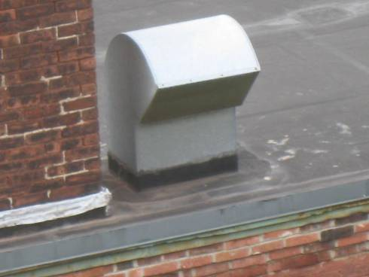

HVAC Fresh Air Intake

Picture 2
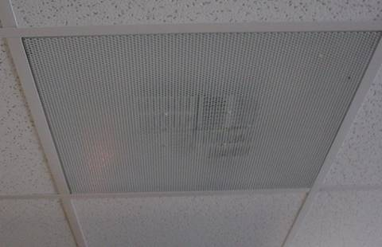

Fresh Air Supply Diffuser
Picture 3

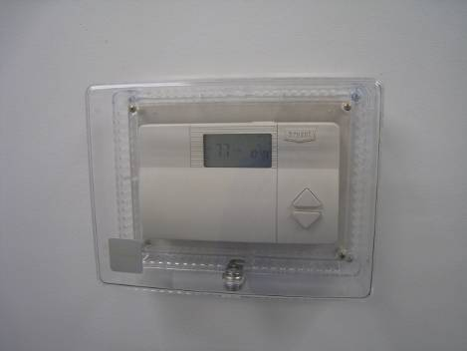

Digital Thermostat

Picture 4

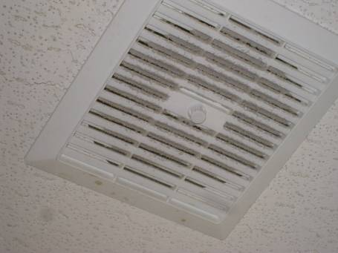

Restroom Exhaust Vent: Note Dirt and Debris
Picture 5

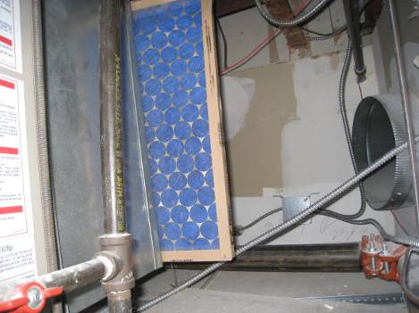

Ill-fitting, Protruding AHU Filter

Picture 6

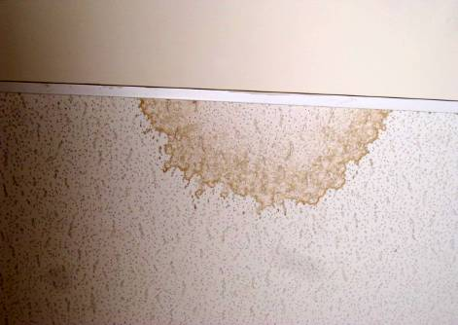

Water-damaged Ceiling Tile
Picture 7

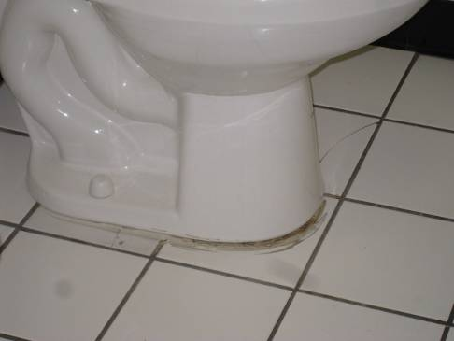

Deteriorated Sealant Around Toilet

Picture 8

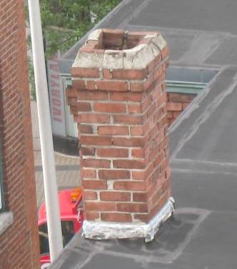
Chimney with Damaged Brick, Mortar and Flashing

Picture 9

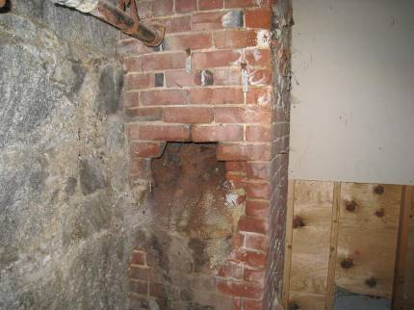

Efflorescence in Basement (Note Arrows)

Picture 10

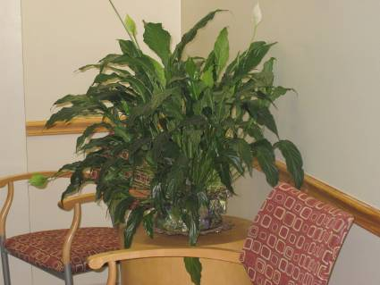

Plant in Reception Area
Picture 11

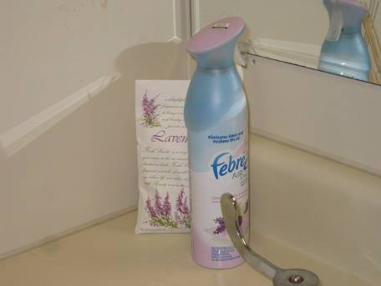

Air Freshener and Deodorizers in Restroom

Picture 12

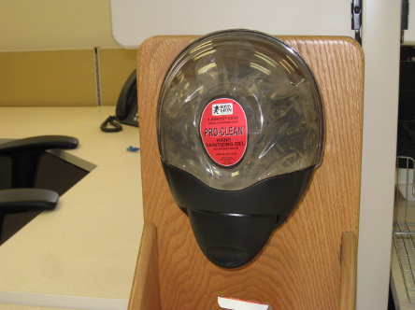

Hand Sanitizer in Cubicle Office Space

Picture 13

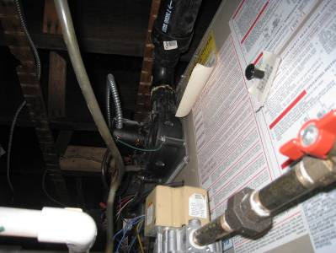

Power Vent Installed on Furnace Portion of AHU

Picture 14

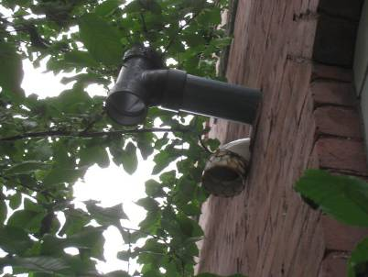

HVAC System PVC Vent Pipes
White for Fresh Air Intake
Black for Exhaust of Furnace Products of Combustion

Picture 15

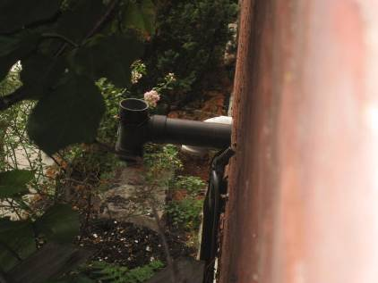

HVAC System PVC Vent Pipes
White for Fresh Air Intake
Black for Exhaust of Furnace Products of Combustion

Picture 16

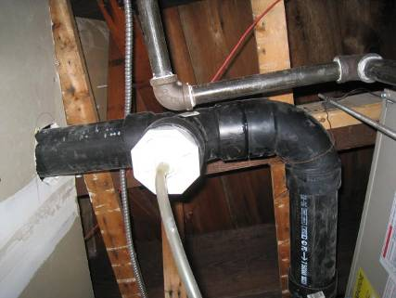

Plastic Drainage Hose for AHU Furnace Exhaust Vent

Picture 17

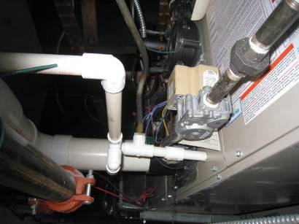

Plastic Hose Connected to the PVC Condensation
Drain Pipe in Close Proximity to the AHU Cabinet (arrow)

Location | Carbon  Dioxide  (ppm) | Carbon Monoxide  (ppm) | Temp  (°F) | Relative  Humidity  (%) | PM2.5  (µg/m³) | Occupants  in Room | Windows  Openable | Ventilation |  | Remarks
 |  |  |  |  |  |  |  | Supply | Exhaust | Remarks
Background | 789 | ND | 84 | 86 | 9 |  |  |  |  | Cloudy, humid, rain
Second Floor
Cubicle Space  East Wall | 733 | ND | 76 | 50 | 4 | 3 | Y | Y | Y | 2 WD CT, PF, PC, plants, hand sanitizers
Cubicle Space West Wall | 745 | ND | 76 | 48 | 4 | 1 | Y | Y | Y | PF, PC, plants, hand sanitizers
Cubicle Space South Wall | 754 | ND | 76 | 51 | 4 | 2 | Y | Y | Y
Cubicle Space North Wall | 788 | ND | 76 | 49 | 3 | 1 | Y | Y | Y | Plants
Director’s office | 748 | ND | 76 | 57 | 2 | 0 | Y | Y | N | DO
Supervisor 1 | 794 | ND | 76 | 57 | 3 | 1 | Y | Y | N | DO, odors
Supervisor 2 | 781 | ND | 75 | 56 | 3 | 1 | Y | Y | Y | DO, PF, plants, clutter
Supervisor 3 | 788 | ND | 76 | 48 | 4 | 1 | Y | Y | N
Men’s Restroom | 742 | ND | 76 | 50 | 11 | 0 | N | N | Y | DO, exhaust vent activated by light switch, AD, incense  candles in scented oil
Women’s Restroom | 750 | ND | 75 | 52 | 11 | 0 | N | N | Y | DO, exhaust vent activated by light switch, AD, incense candles in scented oil
Third Floor
Cubicle Space | 598 | ND | 75 | 48 | 4 | 2 | Y | Y | Y | PC, plants. hand sanitizers, PFs
Mail Room | 612 | ND | 75 | 48 | 3 | 0 | N | N | N | DO, PC, fax/scanner
MDF | 688 | ND | 76 | 48 | 2 | 0 | Y | Y | N
Reception Area | 696 | ND | 75 | 49 | 1 | 0 | N | N | N
Records and Storage | 701 | ND | 76 | 52 | 4 | 0 | N | N | N
Seating | 696 | ND | 75 | 49 | 3 | 0 | Y | N | N
Staff Support/  Kitchen | 698 | ND | 76 | 50 | 2 | 6 | Y | Y | Y | Refrigerator, microwave, toaster
Storage Room | 611 | ND | 74 | 50 | 3 | 0 | Y | Y | N | DO
Training Room 1 | 612 | ND | 76 | 49 | 1 | 0 | Y | Y | Y | 2 WD CTs
Training Room 2 | 652 | ND | 76 | 49 | 1 | 0 | Y | Y | Y | DO, 2 WD CTs
Training Room 3 | 612 | ND | 76 | 49 | 1 | 0 | Y | Y | Y | DO, 4 WD CTs
Men’s Restroom | 698 | ND | 76 | 50 | 10 | 0 | N | N | Y | DO, exhaust vent activated by light switch, AD, incense candles in scented oil
Women’s Restroom | 612 | ND | 76 | 49 | 11 | 0 | N | N | Y | DO, exhaust vent activated by light switch, AD, incense candles in scented oil

