INDOOR AIR QUALITY ASSESSMENT

Department of Early Education & Care
326 Clark Street
Worcester, Massachusetts

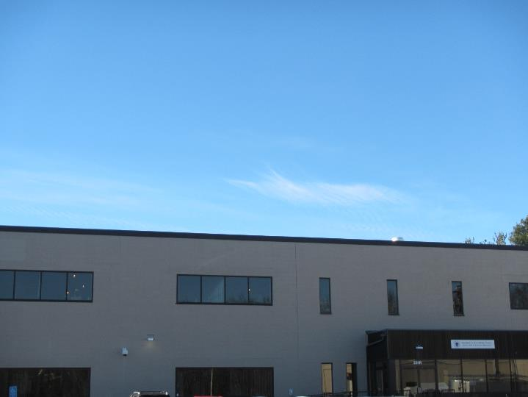

Prepared by:
Massachusetts Department of Public Health
Bureau of Environmental Health
Indoor Air Quality Program
January 2019

Background

Building: | Department of Early Education & Care (EEC)
Address: | 326 Clark Street Worcester, MA
DCAMM Project Manager: | Paul Burke, Senior Project Manager, Division of Capital Asset Management and Maintenance (DCAMM)
Reason for Request: | Post-occupancy assessment
Date of Assessment: | December 27, 2018
Massachusetts Department of Public Health/Bureau of Environmental Health (MDPH/BEH) Staff Conducting Assessment: | Jason Dustin, Environmental Analyst/Inspector, Indoor Air Quality (IAQ) Program
Building Description: | The EEC space is located on the first floor of a two-story building and has been completely renovated. The space is composed of private offices, open work areas, and conference rooms. Most areas have carpet tiles and dropped ceilings.
Windows: | Windows are not openable.

Methods
Please refer to the IAQ Manual for methods, sampling procedures, and interpretation of results (MDPH, 2015).

Results
The following is a summary of indoor air testing results (Table 1).
- Carbon dioxide levels were below the MDPH guideline of 800 parts per million (ppm) in all areas assessed.
- Temperature was within the MDPH recommended range of 70°F to 78°F in most areas.
- Relative humidity was below the MDPH recommended range of 40% to 60% in all areas as is typical during the heating season in the Northeast.
- Carbon monoxide levels were non-detectable (ND) in all indoor areas assessed.
- Fine particulate matter (PM2.5) concentrations measured were below the National Ambient Air Quality Standard (NAAQS) level of 35 micrograms per cubic meter (μg/m³) in all occupied areas.

Discussion

Ventilation
A heating, ventilating, and air conditioning (HVAC) system has several functions. First it provides heating and, if equipped, cooling. Second, it is a source of fresh air. Finally, an HVAC system will dilute and remove normally occurring indoor environmental pollutants by not only introducing fresh air, but by filtering the airstream and ejecting stale air to the outdoors via exhaust ventilation. Even if an HVAC system is operating as designed, point sources of respiratory irritation may exist and cause symptoms in sensitive individuals.
The HVAC system in this space consists of large rooftop air handling units (AHUs) that draw in fresh air from intakes on the roof. Supply air is ducted to ceiling-mounted supply diffusers throughout the space. Return air is brought back to the AHUs through return vents.
To maximize air exchange, the MDPH recommends that both supply and exhaust ventilation operate continuously during periods of occupancy. In order to have proper ventilation with a mechanical supply and exhaust system, the systems must be balanced to provide an adequate amount of fresh air to the interior of a room while removing stale air from the room. It is recommended that HVAC systems be re-balanced every five years to ensure adequate air systems function (SMACNA, 1994).

Microbial/Moisture Concerns
Two water-damaged ceiling tiles were noted in the men’s bathroom during this assessment (Picture 1). Porous building materials (e.g., carpeting, gypsum wallboard, ceiling tiles) that are not dried within 24 to 48 hours of being wet may support mold growth and should be discarded. Repairs should be made to stop any active leaks.
There were a large number of plants in occupied areas (Table 1). Some of these plants were on porous items, lacking waterproof drip pans, or growing against porous building materials (Pictures 2 and 3). Plants can be a source of odors, pollen and mold. Plants should be kept in good condition, not overwatered, and not placed on porous materials.

Other Conditions
The second floor (above the EEC space) was being actively renovated at the time of this assessment. Some gaps between the EEC-occupied space and the area under construction were observed (Pictures 4 and 5). These pathways may allow construction odors and particulates into the space if they are not properly sealed.
BEH staff noted one missing ceiling tile in the public reception area (Picture 6). All ceiling tiles should be replaced and seated properly in the ceiling grid to avoid the migration of odors and particulates from unconditioned spaces.
Hand sanitizers, scented cleaning products, and air fresheners were noted in some areas of the office space. These products can cause irritation of the eyes, nose, and respiratory system of some people.
Most flooring is covered with carpet tile. The Institute of Inspection, Cleaning and Restoration Certification (IICRC), recommends that carpeting be cleaned annually (or semi-annually in soiled high traffic areas) (IICRC, 2012).
Some occupants in the open cubicle area reported complaints regarding solar glare from south-facing windows. Solar glare can affect occupant comfort and IAQ perception. Blinds or window tinting should be considered to reduce these complaints.

Conclusions/Recommendations
Based on the observations made during the visit, the following is recommended:
- Operate the HVAC system to provide for continuous fresh air ventilation during occupied hours. Inspect all thermostats to ensure that they are set for “fan on” instead of the “auto” setting.
- Discard water-damaged ceiling tiles in men’s bathroom and replace. Make repairs as necessary if there is an active water leak in this area.
- Replace any missing ceiling tiles (e.g., reception area) and ensure they are all seated properly in the ceiling tile grid.
- Reduce or eliminate the use of scented cleaners, hand sanitizers, and personal air fresheners.
- Property management/contractors should consult the MDPH guideline: “Construction and renovation generated pollutants in occupied buildings”. Implement the recommended isolation/depressurization strategies during active renovation projects. Any pathways that lead from the construction area to the EEC space should be sealed. This would include pathways that lead to the ceiling plenum.
- Regularly vacuum carpeting with a HEPA-filtered vacuum cleaner. Clean carpeting at least once per year according to IICRC recommendations (IICRC 2012).
- Properly maintain plants, including drip pans, to prevent water damage to porous materials. Plants should also be located away from air diffusers to prevent the aerosolization of dirt, pollen, and mold. Consult the MDPH guideline “Indoor Plants and Indoor Air Quality” to avoid problems associated with improper plant maintenance.
- Continue to change filters for HVAC equipment 2-4 times a year. Continue to use pleated filters of MERV 8 (or higher), which are adequate in filtering out pollen and mold spores (ASHRAE, 2012), if these can be used with current equipment.
- Consider adopting a balancing schedule of every 5 years for all mechanical ventilation systems, as recommended by ventilation industrial standards (SMACNA, 1994).
- Consider installing window tinting or blinds on south-facing windows to reduce comfort complaints related to solar glare.
- Refer to resource manuals and other related IAQ documents for further building-wide evaluations and advice on maintaining public buildings. Copies of these materials are located on the MDPH’s website: http://mass.gov/dph/iaq.

References
ASHRAE. 2012. American Society of Heating, Refrigeration and Air Conditioning Engineers (ASHRAE) Standard 52.2-2012 -- Method of Testing General Ventilation Air-Cleaning Devices for Removal Efficiency by Particle Size (ANSI Approved).
IICRC. 2012. Institute of Inspection Cleaning and Restoration Certification. Institute of Inspection, Cleaning and Restoration Certification. Carpet Cleaning: FAQ. Retrieved from https://www.iicrc.org/general/custom.asp?page=SANSIIICRCS100.
MDPH. 2015. Massachusetts Department of Public Health. “Indoor Air Quality Manual: Chapters I-III”. Available at: http://www.mass.gov/eohhs/gov/departments/dph/programs/environmental-health/exposure-topics/iaq/iaq-manual/.
SMACNA. 1994. HVAC Systems Commissioning Manual. 1st ed. Sheet Metal and Air Conditioning Contractors’ National Association, Inc., Chantilly, VA.
Picture 1
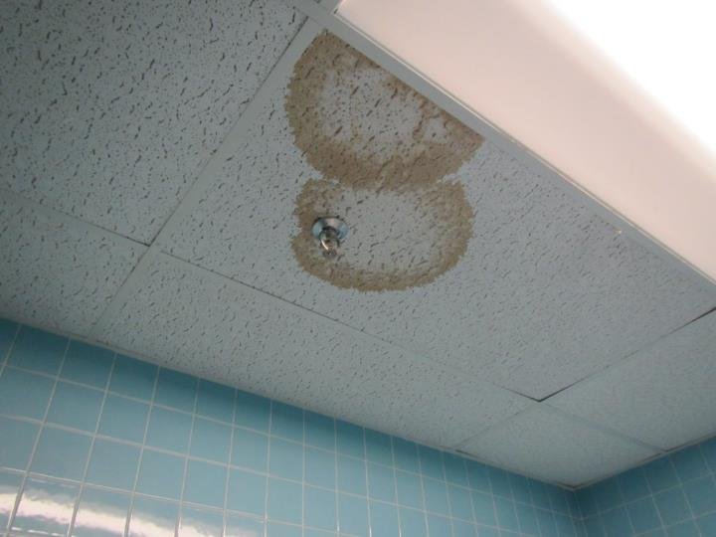
One of two water-damaged ceiling tiles found in the men’s room
Picture 2
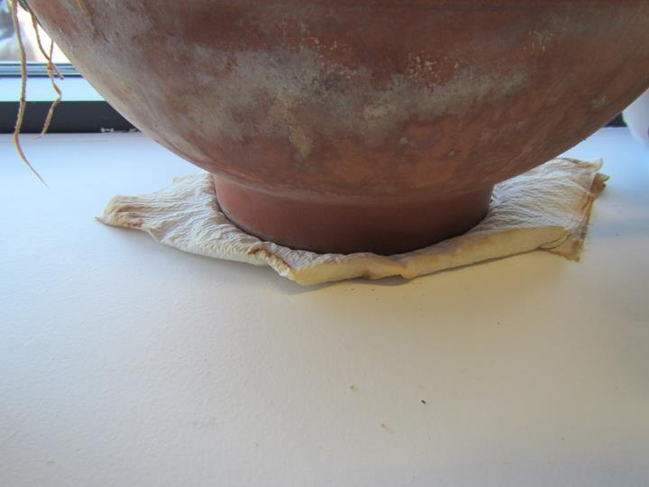
Plant placed on water-damaged/porous material
Picture 3
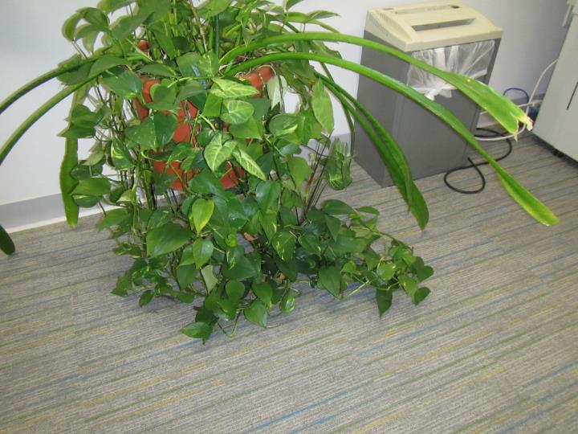
Overgrown plant over porous carpeting
Picture 4
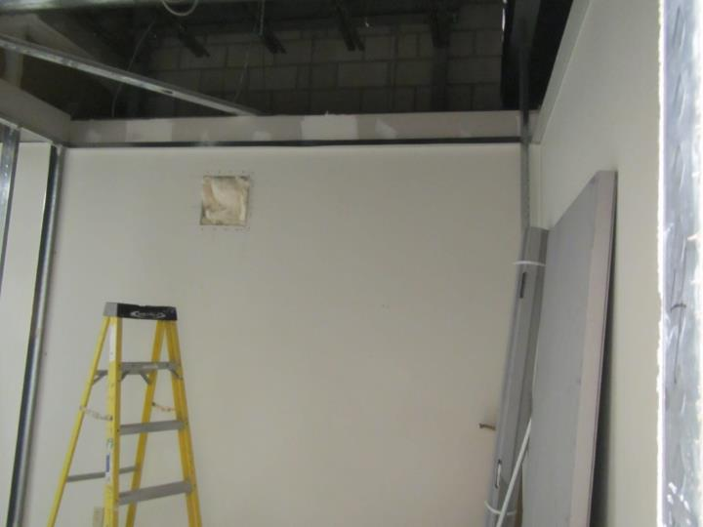
Active renovations in room off of EEC hall and 2nd floor above
Picture 5
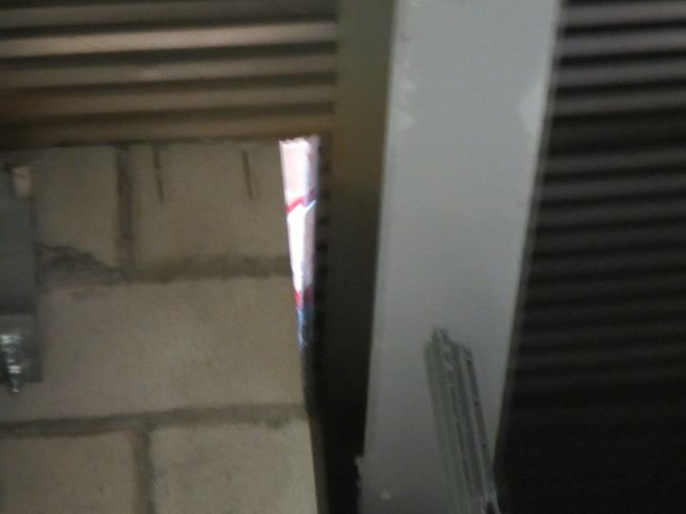
Pathways leading to 2nd floor active renovations
Picture 6
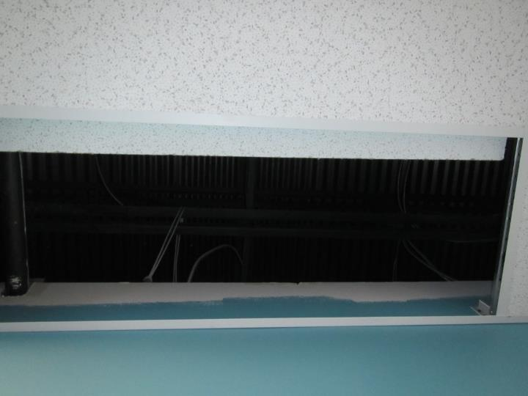
Ceiling tile not in place within ceiling grid of reception area
Location | Carbon  Dioxide  (ppm) | Carbon Monoxide  (ppm) | Temp  (°F) | Relative  Humidity  (%) | PM2.5  (µg/m³) | TVOC  (ppm) | Occupants  in Room | Windows  Openable | Ventilation |  | Remarks
 |  |  |  |  |  |  |  |  | Supply | Exhaust
Background | 427 | ND | 38 | 15 | 14 | ND | - | - | - | - | Clear, light wind
Mail room | 647 | ND | 68 | 24 | 8 | ND | 2 | N | Y | Y | Plants, NC
104 | 611 | ND | 68 | 22 | 8 | ND | 0 | N | Y | Y | Carpet tiles
Hotel space | 635 | ND | 68 | 21 | 6 | ND | 0 | N | Y | Y | Plants, 1 on porous paper towels
Open cubes near 206 | 703 | ND | 68 | 20 | 11 | ND | 1 | N | Y | Y | Plants, CPs
Open cubes near 214 | 652 | ND | 70 | 20 | 12 | ND | 1 | N | Y | Y | HS, CPs
Open cubes near 223 | 595 | ND | 71 | 18 | 7 | ND | 0 | N | Y | Y
112 | 641 | ND | 71 | 17 | 13 | ND | 0 | N | Y | Y | Plants
111 | 564 | ND | 71 | 17 | 15 | ND | 1 | N | Y | Y
Open cubes near 215 | 654 | ND | 72 | 17 | 15 | ND | 0 | N | Y | Y | Plants
110 | 577 | ND | 71 | 16 | 12 | ND | 0 | N | Y | Y | HS
Ginnetti | 572 | ND | 72 | 16 | 11 | ND | 0 | N | Y | Y | ½ wall office, plant
120 | 588 | ND | 72 | 16 | 12 | ND | 0 | N | Y | Y | Plants
Open 211 | 598 | ND | 72 | 16 | 13 | ND | 2 | N | Y | Y
119 | 587 | ND | 72 | 17 | 10 | ND | 0 | N | Y | Y | ½ wall office
105 | 590 | ND | 72 | 15 | 13 | ND | 1 | N | Y | Y | Carpet tile
108 | 537 | ND | 72 | 15 | 10 | ND | 0 | N | Y | Y
113 | 552 | ND | 73 | 14 | 10 | ND | 1 | N | Y | Y
114 | 551 | ND | 72 | 15 | 9 | ND | 1 | N | Y | Y
Large conference | 591 | ND | 73 | 15 | 5 | ND | 1 | N | Y | Y
File room | 516 | ND | 71 | 15 | 4 | ND | 0 | N | Y | Y

