WATER DAMAGE ASSESSMENT

Massachusetts Department of Environmental Protection
Central Regional Office
8 New Bond Street
Worcester, Massachusetts

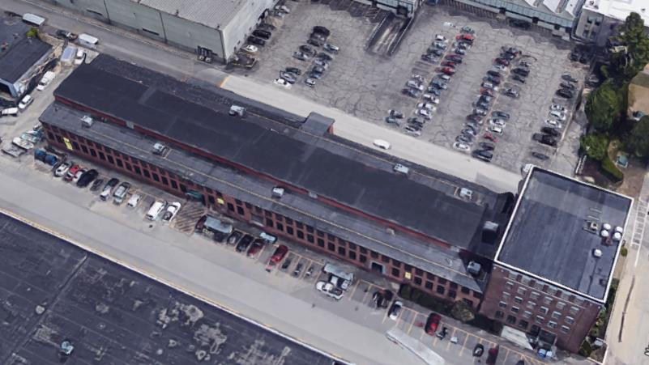

Prepared by:
Massachusetts Department of Public Health
Bureau of Environmental Health
Indoor Air Quality Program
March 2019

Background
Building: | Massachusetts Department of Environmental Protection (DEP), Central Regional Office (CERO)
Address: | 8 New Bond Street, Worcester MA
Reason for Request: | Post-remediation water damage assessment
Date of Assessment: | December 7 and 28, 2018
Massachusetts Department of Public Health/Bureau of Environmental Health (MDPH/BEH) Staff Conducting Assessment: | Mike Feeney, Director, Indoor Air Quality (IAQ) Program
Building Description: | The office complex consists of a five- story office building connected to a two-story former warehouse. The CERO occupies the first floor of the office building (office wing) as well as the first floor of the renovated warehouse floor (main offices). The first floor of the warehouse was converted into office space by installing gypsum wallboard (GW) walls, a heating, ventilating and air-conditioning (HVAC) system, windows, and a suspended ceiling. The second floor of the main offices is unfinished with the only heating capacity via radiators.
Windows: | Not openable

METHODS
Please refer to the IAQ Manual for methods, sampling procedures, and interpretation of results (MDPH, 2015). DPH staff conducted a series of visual assessments, temperature measurements and use of an infrared camera to identify likely areas that could be prone to condensation in hot, humid weather. A FLIR infrared camera was used to visualize temperature ranges between floors, walls and other building materials.

RESULTS and DISCUSSION
The following is a summary of indoor air testing results (Table 1).
- Air Temperature was within the MDPH recommended comfort range of 70°F to 78°F in all areas tested.
- Relative humidity was below the MDPH recommended comfort range of 40 to 60% in all areas, which is typical for New England during the heating season.

Ventilation
The HVAC system that provides heating and cooling for the CERO first floor space is located on the unfinished second floor above main offices (the balcony space) (Picture 1). The balcony space would be considered to have unconditioned air during summer weather, since it does not have means to cool or dehumidify air above the suspended ceiling of the main offices.
If hot, humid conditions exist outdoors, moistened air can readily enter the balcony space through openings in/around roof rafters and brick support walls (Picture 2). Once inside the balcony space, the hot, moist air can pass through the suspended ceiling to increase relative humidity, which in turn may lead to condensation on surfaces that have a temperature below the dew point and may wet building materials in the main offices. To prevent this occurrence, unconditioned spaces are usually separated from air-conditioned areas. Some of the methods of separation may include: physical separation (solid walls/ceilings), installation of sufficient R-Value insulation on top of the suspended ceiling, or installation of ceiling tiles that provide sufficient R-Value insulation.
There appears to be no solid ceiling/flooring above the suspended ceiling. No insulation was installed on top of the suspended ceiling system (e.g., fiberglass batting) (Picture 3). Note that the ceiling tiles currently in use do not appear to made of an insulating material.

Microbial Concerns
During the summer of 2018, the Boston area experienced an unprecedented period of extended hot, humid weather. According to the Washington Post, “[d]ata…show[s]…cities in the Northeast have witnessed such humidity levels for record-challenging duration...[i]ncluding Albany, Boston, Burlington Portland and Providence” during the summer of 2018 (WP, 2018). “Boston and nearby locations… [saw]…historic numbers of those warm nights with low temperatures at or above 70 degrees…Providence and Blue Hill Observatory have already broken their annual records” (WP, 2018).
If a building does not have adequate exhaust ventilation and air chilling capacity to remove/reduce relative humidity from outside air, then hot, moist air introduced into a building can linger to increase occupant discomfort as well as possibly moisten materials that may lead to mold growth.
As noted previously, the building is configured in a manner where significant hot, moist air can readily pass into the main offices from the balcony space. Other sources of hot, humid air impacting the main offices include spaces around the basement door (Picture 4), as well as outdoor exterior doors. Note that both liquid water and water vapor can create conditions conducive to fungal colonization of vulnerable materials. Leaks through the building envelope (e.g., roof, exterior wall components, and foundation) or plumbing issues are obvious water sources. High relative humidity combined with hot weather can also cause damage. Under certain conditions, condensation can accumulate and moisten materials. If these materials are porous, carbon-containing items (e.g., gypsum wallboard, carpeting, cloth, paper, and cardboard), mold can grow.
The key to managing condensation in hot, humid weather indoors is understanding dew point. When warm, moist air passes over a cooler surface, condensation can form. Condensation is the collection of moisture on a surface at or below the dew point. The dew point is the temperature that air must reach for saturation to occur. If a building material/component has a temperature below the dew point, condensation will accumulate on that material. Over time, condensation can collect and form water droplets.
According to American Society of Heating, Refrigerating and Air-Conditioning Engineers (ASHRAE), if relative humidity exceeds 70%, mold growth may occur due to wetting of building materials (ASHRAE, 1989). It is recommended that porous material be dried with fans and heating within 24 to 48 hours of becoming wet (US EPA, 2008, ACGIH, 1989). If porous materials are not dried within this time frame, mold growth may occur. Water-damaged porous materials cannot be adequately cleaned to remove mold growth.

Building Materials Prone to Condensation
A method to locate areas in a building prone to condensation would be to measure air and building material temperatures. If a wide temperature range exists between measurements, the building materials at the colder end of the range may be prone to becoming moistened with condensation in hot, humid weather.
Using a laser thermometer, the surface temperature of the following locations were measured: interior walls, window frames, GW in close proximity to the floor, and floor temperature approximately five feet (5’) from exterior walls (Table 1). Air temperature and relative humidity were also measured. Several conditions were noted:
- Measurement of the temperature of window frames was done during a rainstorm with no solar heating. Window frame temperatures measured in a range from 43-58°F, while the indoor temperature was in a range of 70- 73°F. The difference in temperature indicates that the windows/frames are not energy efficient and can serve as thermal bridges. Where a thermal bridge exists, condensation is likely to form on the warm side of the cold object which can moisten materials, such as GW.
- Floor temperatures 5′ from exterior walls was measured in a range from 52- 88°F, while the indoor temperature was in a range of 70- 73°F. The warmest floor locations were in the office building, while the coldest measurements were on the warehouse floor. The floor slab in the warehouse is likely not insulated and can serve as thermal bridge, leading to potential condensation on the floor which can moisten carpeting and items placed on the floor.
- GW temperatures at the floor/wall junction (Picture 5) measured in a range from 42-64°F, while the indoor temperature was in a range of 70-73°F. This condition indicates that the walls are not effectively insulated and that the steel studs holding the GW can also serve as a thermal bridge. Confirming this phenomenon are photos from the infrared camera, which showed significant differences between floor and wall temperatures (Picture 6). Windowsills and upper portions appear to be heated by HVAC fresh air diffusers. If walls are properly insulated, there should be little temperature difference between the GW with spaces behind it and locations attached to steel studs. The temperature and moisture content of the GW would be expected to increase in hot, humid weather if in the airstream of the HVAC system.
In each of these instances, the lower temperature of the slab floors and walls combined with presence of thermal bridges make the GW vulnerable to subsequent moistening and mold growth under the weather conditions experienced in Massachusetts in the summer of 2018.

Window Leaks
Some locations of the exterior wall appear to have increased water exposure from splashing due to exterior structures, such as an exterior fire escape (Picture 7), and piping above windowsills (Picture 8). Water may penetrate through the underneath side of brick windowsills where they are missing mortar, which in turn may moisten GW around and beneath window frames (Picture 9). In addition a trough for rainwater drainage exists (Pictures 10 and 11). A gap exists between the trough and exterior wall, which can allow water to moisten the brick and slab.

CONCLUSIONS AND RECOMMENDATIONS
The conditions related to IAQ at the CERO raise a number of complex issues. Work to remove and replace water-damaged/mold-colonized GW occurred prior to the DPH assessment. Because of this, the wall cavities along exterior walls could not be examined to identify the likely source of the water damage. Without being able to examine the wall cavities, a number of possible water sources could have produced sufficient moisture conditions to cause GW to become mold-colonized. A combination of the following conditions likely caused the mold colonization of the GW prior to it being removed:
- The unusually hot, humid weather experienced in New England during the summer of 2018 caused hot humid air to accumulate in the balcony and pass through the suspended ceiling and/or into open tops of wall cavities along exteriors walls.
- The cement slab floor lacks insulation and had a temperature below the dew point, which lowered the steel wall stud temperatures below the dew point, which in turn accumulated condensation to chronically wet GW.
- Air from fresh air supplies had high relative humidity (> 70%) which moistened GW to cause mold growth.
- Air from fresh air supplies had a temperature that was cooling GW below the dew point of the hot, moist air in the wall cavities, which caused GW to become wet.
In each of these scenarios, the existence of hot, humid air inside the building envelope that is not adequately separated from air-conditioned/chilled space likely resulted in condensation on surfaces. Without changes to structures and operations, similar conditions are likely to reoccur and create additional water damage.
A number of solutions exist to prevent a reoccurrence. These may include but are not limited to the following actions:
- Prevent the balcony space from accumulating hot, moist air during summer months;
- Separating the balcony space from the office space by installing insulation on top of the suspended ceiling and openings at the top of wall cavities;
- Eliminate temperature bridges in the wall cavity and/or;
- Install a wall material that will not be a mold growth medium (e.g., cement board).

In general, eliminating/limiting the source of water damage is the preferred method for preventing mold growth inside of buildings. In view of the findings at the time of the visit, the following recommendations are made:
- All water-damaged material should be removed in a manner consistent with recommendations listed in the US EPAs’ “Mold Remediation in Schools and Commercial Buildings” (US EPA, 2008). This work should be performed when the building is unoccupied. In addition, due to the age of the building and the presence of asbestos-containing floor tiles, all work should be done in accordance with state and federal regulations.
- Seal all spaces between roof joists and exterior walls such as shown in Picture 2 with an appropriate sealant.
- Install a door sweep and weatherstripping around the basement access door to prevent moist air from entering occupied space.
- Seal the seam between the trough and exterior with an appropriate sealant.
- Repoint brickwork under window sills as well as window frames as needed where GW has been moistened by window water leaks, particularly where structures outside the building envelope chronically wet the exterior walls (e.g., fire escape and pipes).
- Consult a building engineer to ascertain the best method(s) to separate the balcony space from the warehouse office space. Such remedies that could be consider may include but are not limited to:
  - Replacing existing cellulose ceiling tiles with fiberglass insulation ceiling tiles with a sufficient R-value to reduce temperature transfer and air movement.
  - Install fiberglass batting on top of ceiling tiles to reduce temperature transfer and air movement.
  - Examine the tops of GW wall cavities for openings that exist above the suspended ceiling that are open to the balcony space. If openings exist, seal with an appropriate insulation material to prevent hot, moist air accumulation in the wall cavity during hot, humid weather.
- Consider using the methods described in the methods described in the document “Preventing Mold Growth in Massachusetts Schools During Hot, Humid Weather” to help reduce impact of hot, humid weather in the balcony space during hot, humid weather. This guideline is attached as Appendix A and can be found online at: https://www.mass.gov/service-details/preventing-mold-growth-in-massachusetts-schools-during-hot-humid-weather
  - As noted in this document, according to American Society of Heating, Refrigerating and Air-Conditioning Engineers (ASHRAE), if relative humidity exceeds 70%, mold growth may occur due to wetting of building materials (ASHRAE, 1989). Monitoring weather for predicted outdoor relative humidity over 70% for over 2 consecutive days is recommended to implement the guidelines is highly recommended. This condition is mostly likely to occur during summer heatwave in New England.
- Refer to resource manual and other related indoor air quality documents located on the MDPH’s website for further building-wide evaluations and advice on maintaining public buildings. These documents are available at http://mass.gov/dph/iaq.

REFERENCES
ACGIH. 1989. Guidelines for the Assessment of Bioaerosols in the Indoor Environment. American Conference of Governmental Industrial Hygienists, Cincinnati, OH.
ASHRAE. 1989. Ventilation for Acceptable Indoor Air Quality. American Society of Heating, Refrigeration and Air Conditioning Engineers. ANSI/ASHRAE 62-1989.
MDPH. 2015. Massachusetts Department of Public Health. Indoor Air Quality Manual: Chapters I-III. Available at: http://www.mass.gov/eohhs/gov/departments/dph/programs/environmental-health/exposure-topics/iaq/iaq-manual/.
US EPA. 2008. “Mold Remediation in Schools and Commercial Buildings”. Office of Air and Radiation, Indoor Environments Division, Washington, DC. EPA 402-K-01-001. September 2008. Available at: http://www.epa.gov/mold/mold-remediation-schools-and-commercial-buildings-guide.
WP. 2018. ‘It’s been relentless’: Smothering summer humidity in the Northeast has crushed records. Washington Post, Washington, DC. https://www.washingtonpost.com/news/capital-weather-gang/wp/2018/08/30/its-been-relentless-smothering-summer-humidity-in-the-northeast-has-crushed-records/
Picture 1
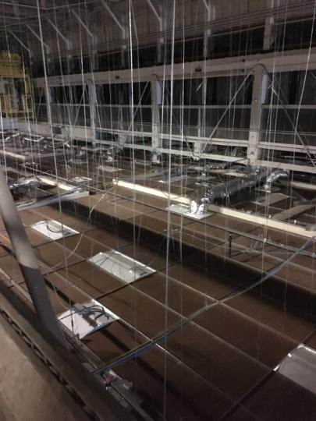
Unfinished, non-conditioned balcony space
Picture 2
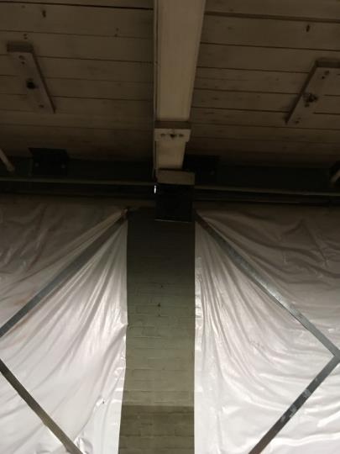
Spaces between roof rafters and brick support walls (Note light next to rafter)
Picture 3
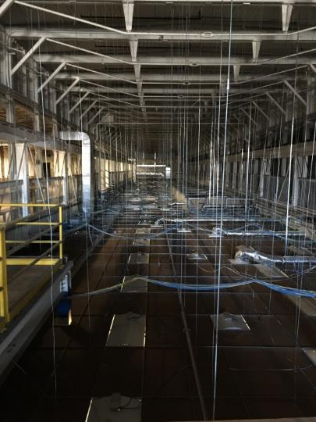
Ceiling tile system with no insulation
Picture 4
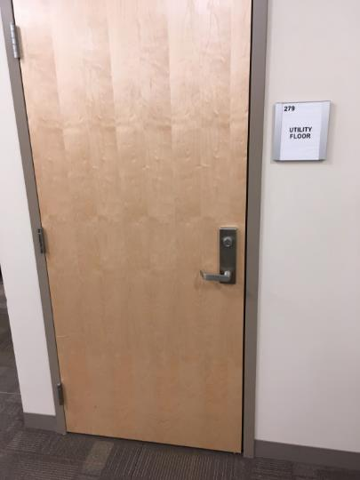
The office side of the basement door
Picture 5
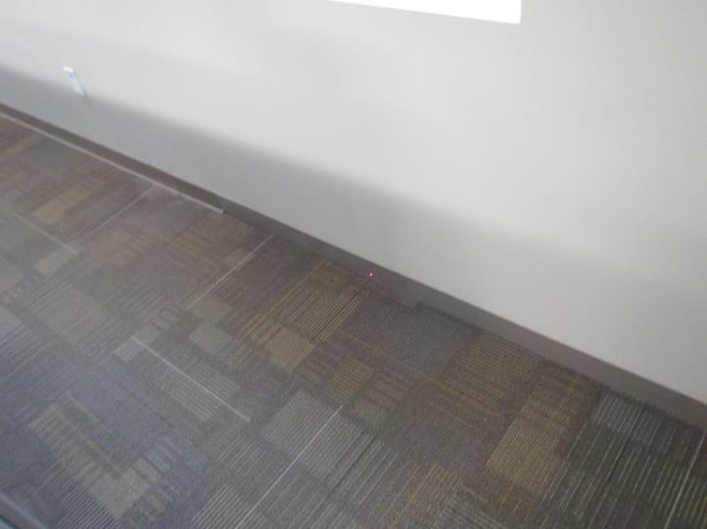
Floor/wall junction
Picture 6
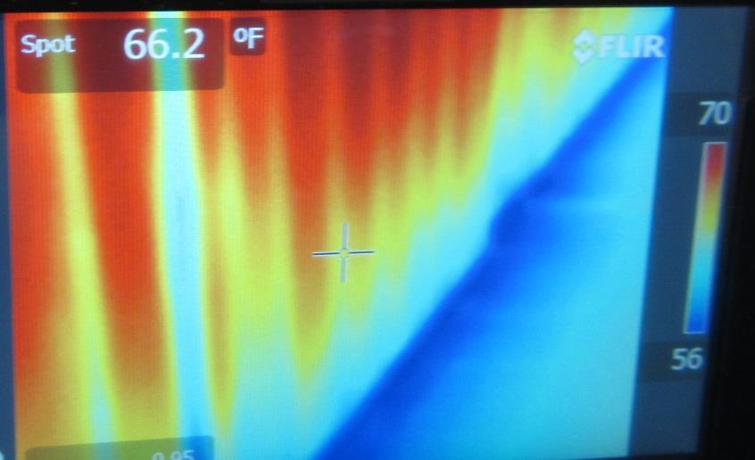
Significant thermal difference in floor and wall temperatures
(Wall studs would be expected to be same color/shade as GW if no temperature bridge existed)
Picture 7
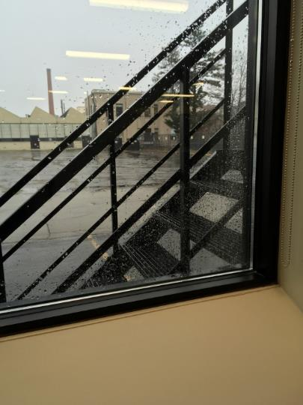

Windows splashed from fire escape
Picture 8

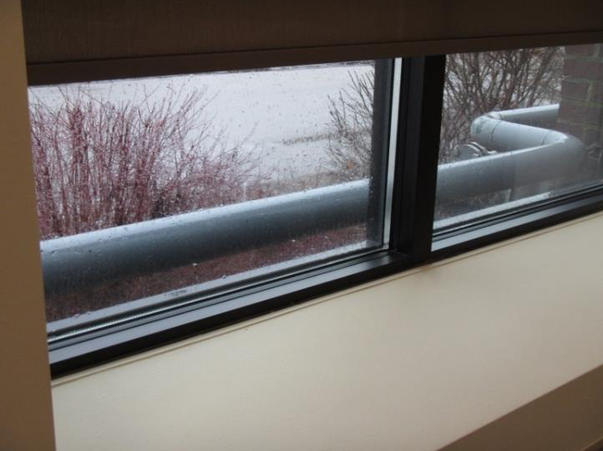

Windows splashed by pipe

Picture 9

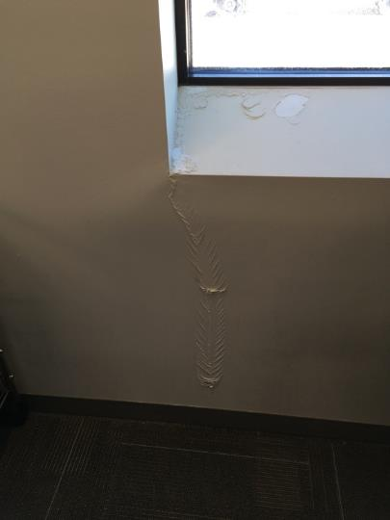

Water-damaged GW from window frame leak

Picture 10

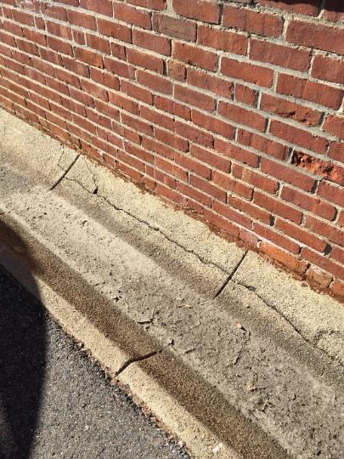

Trough against exterior wall and crack in cement

Picture 11

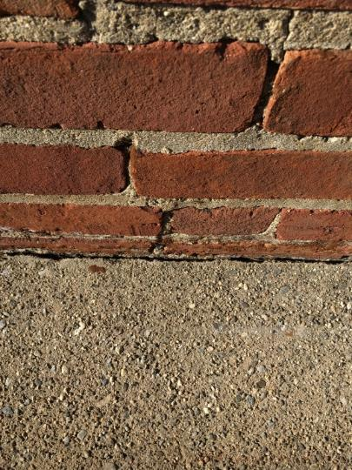

Gap between brick and trough

Location | Air Temperature  (ºF) | Relative Humidity  (%) | Temperature Interior Wall  (ºF) | Temperature Window Frame  (ºF) | Temperature of Floor 5’ from Exterior Wall  (ºF) | Temperature at Floor/Wall Junction  (ºF) | Difference in Temperature of Air v. Floor/Wall Junction  (ºF)
183 | 73 | 22 | 73
181 | 73 | 23 | 65 | 53 | 69 | 59 | -14
180 | 73 | 23 | 67 | 54 | 59 | 54 | -19
178 | 73 | 27 | 68 | 56 | 64 | 57 | -16
175 | 73 | 25 | 66 | 53 | 65 | 58 | -15
171 | 73 | 30 | 67 | 51 | 63 | 55 | -18
172 | 73 | 26 | 64 | 51 | 64 | 56 | -17
Hallway near 122 | 71 | 23 | 57 | 45 | 61 | 51 | -20
119 | 71 | 24 | 71 |  | 52 | 46 | -25
119 Lockers | 71 | 23 | 67 | 52 | 63 | 49 | -22
111 | 72 | 25 | 66 | 51 | 57 | 44 | -26
128 | 72 | 25 | 70 | 54 | 64 | 52 | -20
136 | 74 | 24 | 68 | 53 | 64 | 53 | -21
145 | 74 | 22 | 68 | 48 | 62 | 51 | -23
109 | 74 | 23 | 67 | 49 | 63 | 49 | -25
Reception | 73 | 24 | 65 | 45 | 63 | 47 | -26
103 | 73 | 24 | 65 | 51 | 62 | 42 | -31
326 | 73 | 26 | 67 | 53 | 65 | 53 | -20
319 | 73 | 25 | 66 | 50 | 63 | 47 | -26
295 | 72 | 26 | 65 | 52 | 59 | 49 | -23
290 | 72 | 26 | 61 | 51 | 60 | 49 | -23
231 | 73 | 33 | 66 |  | 63 | 64 | -9
273 | 73 | 34 | 63 | 52 | 62 | 58 | -15
275 | 73 | 35 | 64 | 50 | 62 | 56 | -17
258 | 73 | 37 | 66 | 55 | 66 | 61 | -12
246 | 73 | 35 | 66 | 55 | 64 | 58 | -15
240 | 73 | 36 | 64 | 53 | 62 | 61 | -12
249 | 73 | 36 | 66 | 55 | 66 | 63 | -10
Outside 238 | 70 | 36 | 57 | 54 | 65 | 63 | -17
238 | 73 | 37 | 64 | 48 | 62 | 60 | -13
236 | 73 | 31 |  | 57 | 64 | 60 | -13
233 | 73 | 32 | 64 | 53 | 88 | 54 | -19
222 | 73 | 32 | 68 | 55 | 64 | 55 | -18
214 | 73 | 33 | 68 | 55 | 62 | 56 | -17
207 | 73 | 33 | 66 | 56 | 62 | 56 | -17
198 | 73 | 34 | 62 | 53 | 59 | 52 | -21
189 | 73 | 32 | 70 | 58 | 66 | 60 | -13

Condensation is the collection of moisture on a surface with a temperature below the dew point. The dew point is a temperature determined by air temperature and relative humidity. For example, at a temperature of 73°F and relative humidity of 57 percent indoors, the dew point for water to collect on a surface is approximately 57°F.
A thermal bridge is an object (usually metallic) in a wall space through which heat is transferred at a greater rate than materials surrounding it. During the heating season, the window comes in contact with heated air from the interior and chilled air from the outdoors, resulting in condensation formation if the window frame temperatures are below the dew point.

