INDOOR AIR QUALITY ASSESSMENT

Massachusetts Department of Environmental Protection
Central Regional Office, 627 Main Street
Worcester, Massachusetts



Prepared by:
Massachusetts Department of Public Health
Bureau of Environmental Health
Indoor Air Quality Program
June 2010

Background/Introduction
In response to a request from the Massachusetts Department of Environmental Protection (MDEP), the Massachusetts Department of Public Health (MDPH), Bureau of Environmental Health (BEH) conducted an evaluation of the indoor air quality at the MDEP Central Regional Office (CERO) located at 627 Main Street, Worcester, Massachusetts. On February 18, 2010, Cory Holmes and Lisa Hébert, Environmental Analysts/Regional Inspectors in BEH’s Indoor Air Quality (IAQ) Program visited the CERO to conduct an assessment. The assessment was prompted by occupant complaints of eye/respiratory irritation and a conspicuous maple-like odor that occupants believed to be related to the heating/ventilation system. BEH staff were accompanied during the assessment by Virginia Platt, Division of Capital Asset Management (DCAM) and Andrea Briggs, Deputy Regional Director for Administration, MDEP.
The CERO is located in a two-story yellow brick building located in downtown Worcester. The building was constructed in 1914 as the Worcester Market and underwent complete renovations to provide office space in 1989. The CERO has occupied the building for approximately 10 years. The roof is made of rubber membrane, the majority of floor surfaces are wall to wall carpeting, with floor tile in remaining areas. Windows are not openable.

Methods
Air tests for carbon monoxide, carbon dioxide, temperature and relative humidity were conducted with the TSI, Q-Trak, IAQ Monitor, Model 7565. Air tests for airborne particle matter with a diameter less than 2.5 micrometers were taken with the TSI, DUSTTRAK™ Aerosol Monitor Model 8520. Screening for total volatile organic compounds (TVOCs) was conducted using a RAE Systems, MiniRae 2000™ Portable VOC Monitor PGM-7600 Photo-Ionization Detector (PID). BEH staff also performed visual inspection of building materials for water damage and/or microbial growth.

Results
The CERO office house approximately 100 employees with approximately 15 to 25 visitors on a daily basis. Tests were taken during normal operations; results appear in Table 1.

Discussion

Ventilation
It can be seen from Table 1 that carbon dioxide levels were below 800 parts per million (ppm) in all areas surveyed, indicating adequate air exchange throughout the building at the time of the assessment. The heating, ventilation and air conditioning (HVAC) system, is a computer controlled system consisting of a two large rooftop air handling units (AHUs) (Picture 1). Rooftop units draw fresh outside air in through a bank of pleated filters (Picture 2), which are reportedly changed 3 times a year. AHU filters appeared clean at the time of the assessment. The air is heated/cooled and ducted to a series of variable air volume (VAV) boxes, which control temperature/airflow at remote locations throughout the building. Fresh air is distributed via ceiling or wall-mounted air diffusers (Pictures 3 and 4). Exhaust air is drawn into the ceiling plenum via grates and returned back to the AHUs via ductwork (Picture 5).
To maximize air exchange, the MDPH recommends that both supply and exhaust ventilation operate continuously during periods of occupancy. In order to have proper ventilation with a mechanical supply and exhaust system, the systems must be balanced to provide an adequate amount of fresh air to the interior of a room while removing stale air from the room. It is recommended that HVAC systems be re-balanced every five years to ensure adequate air systems function (SMACNA, 1994). The date of the last balancing of these systems was not available at the time of the assessment.
The Massachusetts Building Code requires a minimum ventilation rate of 20 cubic feet per minute (cfm) per occupant of fresh outside air or have openable windows in each room (SBBRS, 1997; BOCA, 1993). The ventilation must be on at all times that the room is occupied. Providing adequate fresh air ventilation with open windows and maintaining the temperature in the comfort range during the cold weather season is impractical. Mechanical ventilation is usually required to provide adequate fresh air ventilation.
Carbon dioxide is not a problem in and of itself. It is used as an indicator of the adequacy of the fresh air ventilation. As carbon dioxide levels rise, it indicates that the ventilating system is malfunctioning or the design occupancy of the room is being exceeded. When this happens, a buildup of common indoor air pollutants can occur, leading to discomfort or health complaints. The Occupational Safety and Health Administration (OSHA) standard for carbon dioxide is 5,000 parts per million parts of air (ppm). Workers may be exposed to this level for 40 hours/week, based on a time-weighted average (OSHA, 1997).
The MDPH uses a guideline of 800 ppm for publicly occupied buildings. A guideline of 600 ppm or less is preferred in schools due to the fact that the majority of occupants are young and considered to be a more sensitive population in the evaluation of environmental health status. Inadequate ventilation and/or elevated temperatures are major causes of complaints such as respiratory, eye, nose and throat irritation, lethargy and headaches. For more information concerning carbon dioxide, consult Appendix A.
Temperature measurements ranged from 70° F to 79° F, which were within or close to the upper end of the MDPH recommended range (Table 1). The MDPH recommends that indoor air temperatures be maintained in a range of 70° F to 78° F in order to provide for the comfort of building occupants. In many cases concerning indoor air quality, fluctuations of temperature in occupied spaces are typically experienced, even in a building with an adequate fresh air supply.
The relative humidity measured in the building ranged from 13 to 23 percent, which was below the MDPH recommended comfort range (Table 1). The MDPH recommends a comfort range of 40 to 60 percent for indoor air relative humidity. Relative humidity levels in the building would be expected to drop during the winter months due to heating. The sensation of dryness and irritation is common in a low relative humidity environment. Low relative humidity is a very common problem during the heating season in the northeast part of the United States.

Microbial/Moisture Concerns
In order for building materials to support mold growth, a source of water exposure is necessary. Water-damaged ceiling tiles were observed in several areas (Pictures 6 and 7/Table 1). Water damaged tiles in the 1st floor men’s room, reportedly resulted from a flooding event in the 2nd floor kitchen. Water damaged ceiling tiles can provide a source of mold and should be replaced after a leak is discovered and repaired.
An open seam between the sink backsplash and wall was observed in the 2nd floor kitchen (Picture 8). If not watertight, water can penetrate through the seam, causing damage. Improper drainage or sink overflow can lead to water penetration into the countertop, cabinet interiors and areas behind cabinets. Water penetration and chronic exposure of porous and wood-based materials can cause these materials to swell and show signs of water damage. Repeated moistening of porous materials can result in mold growth.
The US Environmental Protection Agency (US EPA) and the American Conference of Governmental Industrial Hygienists (ACGIH) recommend that porous materials be dried with fans and heating within 24 to 48 hours of becoming wet (US EPA, 2001; ACGIH, 1989). If not dried within this time frame, mold growth may occur. Once mold has colonized porous materials, they are difficult to clean and should be removed/discarded.
Plants were noted in several areas (Picture 9/Table 1). Plants should be properly maintained and equipped with drip pans. Plants should be located away from ventilation sources to prevent aerosolization of dirt, pollen or mold. Plants should also not be placed on porous materials (Picture 10), since water damage to porous materials may lead to microbial growth.

Other IAQ Evaluations
Indoor air quality can be negatively influenced by the presence of respiratory irritants, such as products of combustion. The process of combustion produces a number of pollutants. Common combustion emissions include carbon monoxide, carbon dioxide, water vapor and smoke (fine airborne particle material). Of these materials, exposure to carbon monoxide and particulate matter with a diameter of 2.5 micrometers (μm) or less (PM2.5) can produce immediate, acute health effects upon exposure. To determine whether combustion products were present in the indoor environment, BEH staff obtained measurements for carbon monoxide and PM2.5.

Carbon Monoxide
Carbon monoxide is a by-product of incomplete combustion of organic matter (e.g., gasoline, wood and tobacco). Exposure to carbon monoxide can produce immediate and acute health affects. Several air quality standards have been established to address carbon monoxide and prevent symptoms from exposure to these substances. The MDPH established a corrective action level concerning carbon monoxide in ice skating rinks that use fossil-fueled ice resurfacing equipment. If an operator of an indoor ice rink measures a carbon monoxide level over 30 ppm, taken 20 minutes after resurfacing within a rink, that operator must take actions to reduce carbon monoxide levels (MDPH, 1997).
The American Society of Heating Refrigeration and Air-Conditioning Engineers (ASHRAE) has adopted the National Ambient Air Quality Standards (NAAQS) as one set of criteria for assessing indoor air quality and monitoring of fresh air introduced by HVAC systems (ASHRAE, 1989). The NAAQS are standards established by the US EPA to protect the public health from six criteria pollutants, including carbon monoxide and particulate matter (US EPA, 2006). As recommended by ASHRAE, pollutant levels of fresh air introduced to a building should not exceed the NAAQS levels (ASHRAE, 1989). The NAAQS were adopted by reference in the Building Officials & Code Administrators (BOCA) National Mechanical Code of 1993 (BOCA, 1993), which is now an HVAC standard included in the Massachusetts State Building Code (SBBRS, 1997). According to the NAAQS, carbon monoxide levels in outdoor air should not exceed 9 ppm in an eight-hour average (US EPA, 2006).
Carbon monoxide should not be present in a typical, indoor environment. If it is present, indoor carbon monoxide levels should be less than or equal to outdoor levels. Outdoor carbon monoxide concentrations ranged from non-detect (ND) to 2.5 ppm at the time of the assessment (Table 1), likely due to moderate to heavy traffic in the area at the time of testing. No measureable levels of carbon monoxide were detected inside the building during the assessment (Table 1).

Particulate Matter (PM2.5)
The US EPA has established NAAQS limits for exposure to particulate matter. Particulate matter is airborne solids that can be irritating to the eyes, nose and throat. The NAAQS originally established exposure limits to particulate matter with a diameter of 10 μm or less (PM10). According to the NAAQS, PM10 levels should not exceed 150 micrograms per cubic meter (μg/m³) in a 24-hour average (US EPA, 2006). These standards were adopted by both ASHRAE and BOCA. Since the issuance of the ASHRAE standard and BOCA Code, US EPA established a more protective standard for fine airborne particles. This more stringent PM2.5 standard requires outdoor air particle levels be maintained below 35 μg/m³ over a 24-hour average (US EPA, 2006). Although both the ASHRAE standard and BOCA Code adopted the PM10 standard for evaluating air quality, MDPH uses the more protective PM2.5 standard for evaluating airborne particulate matter concentrations in the indoor environment.
Outdoor PM2.5 concentrations the day of the assessment ranged from 4 to 23 μg/m³. PM2.5 levels measured inside the building ranged from 2 to 5 μg/m³ (Table 1), which were below the NAAQS PM2.5 level of 35 μg/m³. Frequently, indoor air levels of particulates (including PM2.5) can be at higher levels than those measured outdoors. A number of mechanical devices and/or activities that occur indoors can generate particulate during normal operations. Sources of indoor airborne particulates may include but are not limited to: particles generated during the operation of fan belts in the HVAC system; use of stoves and microwave ovens; use of photocopiers, fax machines and computer printing devices; operation of an ordinary vacuum cleaner; and, heavy foot traffic indoors.

Volatile Organic Compounds
Indoor air concentrations can be greatly impacted by the use of products containing volatile organic compounds (VOCs). VOCs are carbon-containing substances that have the ability to evaporate at room temperature. Frequently, exposure to low levels of total VOCs (TVOCs) may produce eye, nose, throat and/or respiratory irritation in some sensitive individuals. For example, chemicals evaporating from a paint can stored at room temperature would most likely contain VOCs. In an effort to determine whether VOCs were present in the building, air monitoring for TVOCs was conducted. An outdoor air sample was taken for comparison. Outdoor TVOC concentrations were ND. No measureable levels of TVOCs were detected inside the building during the assessment (Table 1).

Odors
As discussed, the assessment was prompted by occupant reports of a sweet, maple-like odor that is periodically detected in several areas of the CERO, most notably on the 2nd floor in office 262 and in work areas 257-260. In general, maple-like odors have been associated with antifreeze/coolant leaks in HVAC systems. In order to determine whether or not the HVAC system was the source of the odor, BEH staff examined the interior of rooftop units to determine if any antifreeze/coolant leaks had occurred. The interior of both units were dry with no evidence of antifreeze/coolant spills, overflows or odors present at the time of the assessment.
During the course of the assessment a CERO employee reported that the suspect odor was detectable along the baseboard of the exterior wall of work area 200. Although no obvious source of leaks was observed, a distinguishable sweet, maple-like odor was identified along the floor/baseboard in this area. Immediately above the baseboard is a large radiator style heating unit (Pictures 11 and 12), that appears to operate separate from the HVAC system. It is likely that this radiator system predates the installation of the HVAC system in the building. Historically these types of radiators were part of a boiler style furnace system that would deliver hot water to radiators along exterior walls to provide radiant heat during cold weather. It is likely that these radiators have a steam vent that will open and close while the heating system is operating/deactivated. It is when the heating system is not operating that air from the radiators can enter the occupied space through a steam vent. This vent will close when the boiler is providing steam to the radiators.
If the steam valve is worn out or the system is frequently activated/deactivated this may allow for steam, air and other materials inside the pipes to enter occupied space. If an anti-freeze material (e.g., propylene glycol) is added to the system to prevent freezing of pipes in cold weather, steam and odors may enter the indoor environment through steam valves. It could not be determined whether or not these radiators have steam valves due to the way the heating coils were contained inside of metal cabinets. During the assessment, BEH staff detected a maple-like odor in and around the radiators in area 200, which would indicate that anti-freeze had been added to the heating system and that steam was venting through steam valves.
Propylene glycol is used as an additive to prevent pipes from freezing. It would not be an inhalation hazard in this instance because its boiling point is 315°F (Houghton Chemical Corporation, 2004). A standard boiler works with a water temperature between 180°F and 200°F, depending on the fuel used (Hornung, W.J., 1982). Heated water in the radiator would not exceed this temperature therefore propylene glycol would not form a vapor under these conditions. If propylene glycol is ingested it can be aspirated into the lungs to cause damage, but in this instance, due to the temperature of the heated water and its toxicological properties, propylene glycol would not pose a chronic health hazard, but would rather be a source of nuisance odors. In order to understand how airborne fumes/odors may be impacting above/adjacent areas, the following concepts concerning heated air and air movement must be considered:
- Heated air will create upward air movement.
- Steam and other heated materials inside the radiator will likely rise to create an odor which would then be distributed via the airstream created by radiators.
- Cold air moves to hot air, which creates drafts.
- As heated air rises, negative pressure is created, which draws cold air to the base of the radiator.
- The operation of the HVAC systems can draw air and odors and distribute them to other areas of the building.
Each of these concepts has influence on the movement of odors from radiators into adjacent areas. In subsequent correspondence with building management, it was reported that a propylene glycol-based antifreeze/coolant had been added to the boiler system most recently in December, 2009, which roughly coincides with reports of maple odor in the office space (MDEP, 2010).

Other Conditions
Other conditions that can affect indoor air quality were observed during the assessment. In several areas, items were observed on windowsills, tabletops, counters, bookcases and desks (Picture 13). The large number of items stored provides a source for dusts to accumulate. These items (e.g., papers, folders, boxes) make it difficult for maintenance staff to clean. Items should be relocated and/or be cleaned periodically to avoid excessive dust build up.
Finally, fluorescent light fixtures were missing covers in stairwells (Picture 14). Fixtures should be equipped with access covers installed with bulbs fully secured in their sockets. Breakage of glass can cause injuries and may release mercury and/or other hazardous compounds.

Conclusions/Recommendations
In view of the findings at the time of the assessment, the following recommendations are made to improve indoor air quality in the building:
- Examine the necessity of adding propylene glycol to a heating system that has likely operated without such an additive during its operational lifespan. If necessary, have propylene glycol drained from the system.
- Remove covers to baseboard heating units in areas where odors typically occur (e.g., 200) and thoroughly examine pipes/fixtures for leakage and/or evidence of leakage in the form of residual fluid or staining. Make repairs and conduct cleaning as necessary. Consider contacting a licensed plumber or HVAC technician to inspect/test for leaks throughout the building.
- Consider adopting a balancing schedule of every 5 years for all mechanical ventilation systems, as recommended by ventilation industrial standards (SMACNA, 1994).
- For buildings in New England, periods of low relative humidity during the winter are often unavoidable. Therefore, scrupulous cleaning practices should be adopted to minimize common indoor air contaminants whose irritant effects can be enhanced when the relative humidity is low. To control for dusts, a high efficiency particulate arrestance (HEPA) filter equipped vacuum cleaner in conjunction with wet wiping of all surfaces is recommended. Avoid the use of feather dusters. Drinking water during the day can help ease some symptoms associated with a dry environment (throat and sinus irritations).
- Ensure (roof/plumbing) leaks are repaired and replace water damaged ceiling tiles. Examine the area above and around these areas for mold growth. Disinfect areas of water leaks with an appropriate antimicrobial.
- Ensure plants have drip pans and avoid over-watering. Examine drip pans periodically for mold growth. Disinfect with an appropriate antimicrobial where necessary. Remove plants from porous materials, discard if moldy.
- Seal areas around sink in kitchen to prevent water damage to the interior of cabinets and adjacent wallboard.
- Relocate or consider reducing the amount of materials stored in offices, work stations and common areas to allow for more thorough cleaning. Clean items regularly with a wet cloth or sponge to prevent excessive dust build-up.
- Clean supply, exhaust and return vents periodically of accumulated dust.
- Replace all covers for fluorescent light fixtures.
- Refer to resource manuals and other related indoor air quality documents for further building-wide evaluations and advice on maintaining public buildings. Copies of these materials are located on the MDPH’s website: http://mass.gov/dph/iaq.

References
ACGIH. 1989. Guidelines for the Assessment of Bioaerosols in the Indoor Environment. American Conference of Governmental Industrial Hygienists, Cincinnati, OH.
ASHRAE. 1989. Ventilation for Acceptable Indoor Air Quality. American Society of Heating, Refrigeration and Air Conditioning Engineers. ANSI/ASHRAE 62-1989
BOCA. 1993. The BOCA National Mechanical Code/1993. 8th ed. Building Officials and Code Administrators International, Inc., Country Club Hill, IL.
Hornung, W. J. 1982. Plumbing and Heating. Prentice-Hall, Inc., Englewood Cliffs, N.J.
Houghton Chemical Corporation. 2004. Material Safety Data Sheet “Safe-T–Therm® HD”. Houghton Chemical Corporation, Allston, Massachusetts.
MDEP. 2010. E-mail to Cory Holmes, DPH IAQ Program from Andrea Briggs, DEP, Concerning IAQ Follow-up Questions for Site Assessment DEP CERO, dated April 7, 2010. Massachusetts Department of Environmental Protection, Boston, MA.
MDPH. 1997. Requirements to Maintain Air Quality in Indoor Skating Rinks (State Sanitary Code, Chapter XI). 105 CMR 675.000. Massachusetts Department of Public Health, Boston, MA.
OSHA. 1997. Limits for Air Contaminants. Occupational Safety and Health Administration. Code of Federal Regulations. 29 C.F.R 1910.1000 Table Z-1-A.
SBBRS. 1997. Mechanical Ventilation. State Board of Building Regulations and Standards. Code of Massachusetts Regulations. 780 CMR 1209.0
SMACNA. 1994. HVAC Systems Commissioning Manual. 1st ed. Sheet Metal and Air Conditioning Contractors’ National Association, Inc., Chantilly, VA.
US EPA. 2001. “Mold Remediation in Schools and Commercial Buildings”. Office of Air and Radiation, Indoor Environments Division, Washington, DC. EPA 402-K-01-001. March 2001. Available at: http://www.epa.gov/iaq/molds/mold_remediation.html
US EPA. 2006. National Ambient Air Quality Standards (NAAQS). US Environmental Protection Agency, Office of Air Quality Planning and Standards, Washington, DC. http://www.epa.gov/air/criteria.html.
Picture 1

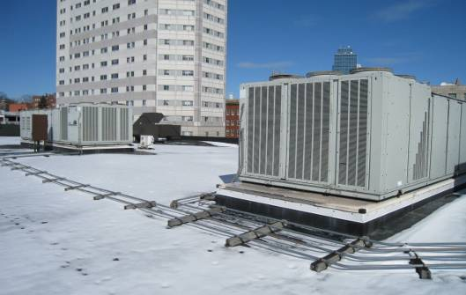

Rooftop Air Handling Units

Picture 2

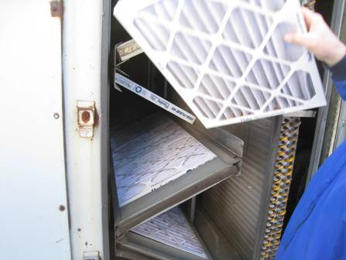

Pleated Filters Installed in Rooftop Air Handling Units

Picture 3

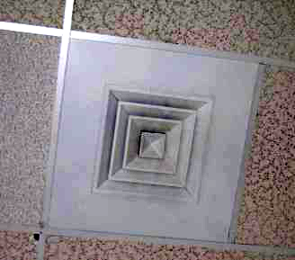

Ceiling-Mounted Supply Diffuser

Picture 4

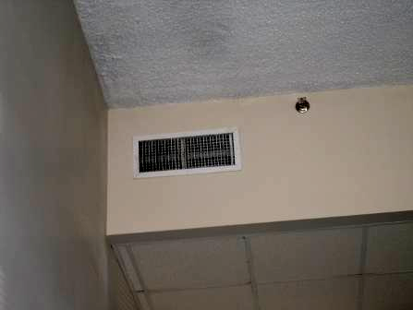

Wall-Mounted Supply Diffuser

Picture 5

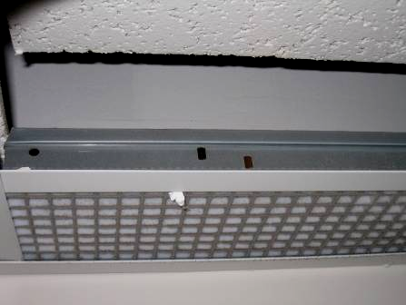

Ceiling-Mounted Return Grill

Picture 6

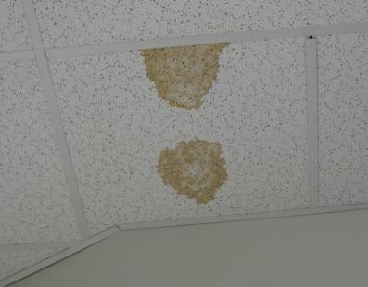

Water Damaged Ceiling Tiles

Picture 7

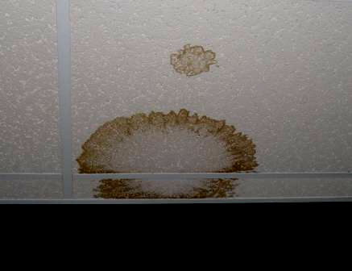

Water Damaged Ceiling Tiles in 1st Floor Men’s Room

Picture 8

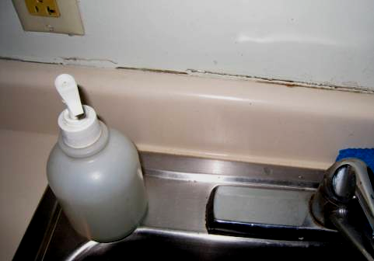

Space between Sink Backsplash and Wall in 2nd Floor Kitchen

Picture 9

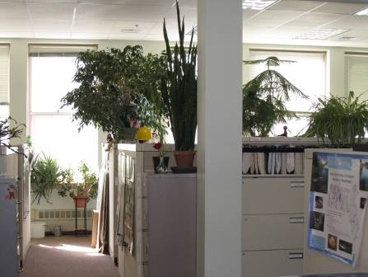

Plants in Cubicle Areas

Picture 10

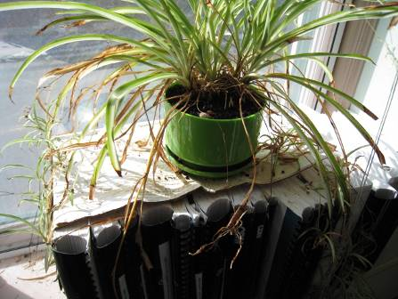

Plants on Porous Materials

Picture 11

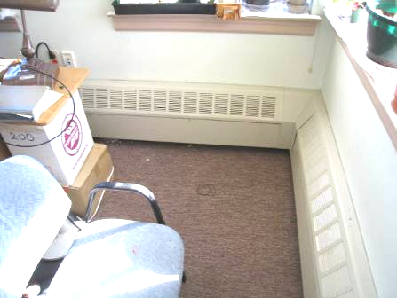

Baseboard Heating Elements in Work Area 200

Picture 12

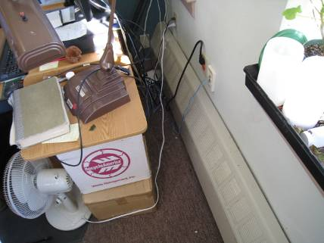

Baseboard Heating Elements in Work Area 200, From Which the Maple Smell
Originated

Picture 13

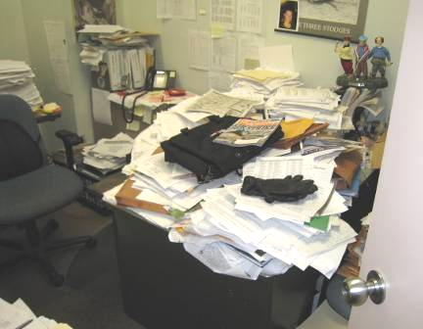

Accumulated Items on Flat Surfaces in Office

Picture 14

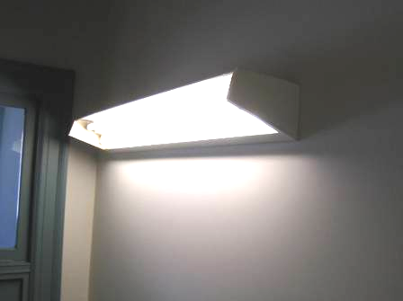

Fluorescent Light Fixture Missing Cover in Stairwell
Location |  | Occupants  in Room |  | Temp  (°F) |  | Relative  Humidity  (%) |  | Carbon  Dioxide  (ppm) |  | Carbon Monoxide  (ppm) |  | PM2.5 |  | TVOCs  (ppm) |  | Windows  Openable |  | Ventilation |  |  |  | Remarks
 |  |  |  |  |  |  |  |  |  |  |  | (µg/m3) |  |  |  |  |  | Supply |  | Exhaust |  | Remarks
Outside/  Background |  |  | 42 |  | 30 |  | 374 |  | ND-2.5 |  | 4-23 |  | ND |  |  |  |  |  |  |  | Cloudy, winds WNW 20-32 mph, gusts up to 43 mph, moderate to busy traffic
2nd Floor
262 | 1 |  | 72 |  | 22 |  | 701 |  | ND |  | 2 |  | ND |  | N |  | Y |  | Y |  | Personal fan
267/266 | 1 |  | 73 |  | 23 |  | 706 |  | ND |  | 3 |  | ND |  | N |  | Y |  | Y |  | 1 WD CT, discolored CTs
259/260 | 0 |  | 73 |  | 22 |  | 780 |  | ND |  | 3 |  | ND |  | N |  | Y |  | Y |  | Plants
280 | 0 |  | 74 |  | 21 |  | 691 |  | ND |  | 3 |  | ND |  | N |  | Y |  | Y |  | Dusty return vent
251/253 | 0 |  | 73 |  | 20 |  | 682 |  | ND |  | 3 |  | ND |  | N |  | Y |  | Y
248/249 | 1 |  | 74 |  | 20 |  | 668 |  | ND |  | 3 |  | ND |  | N |  | Y |  | Y
Chicopee Conf Room | 0 |  | 74 |  | 20 |  | 720 |  | ND |  | 3 |  | ND |  | N |  | Y |  | Y
246/294 | 0 |  | 77 |  | 20 |  | 699 |  | ND |  | 3 |  | ND |  | N |  | Y |  | Y |  | Plants on porous materials
GIS | 0 |  | 75 |  | 19 |  | 663 |  | ND |  | 3 |  | ND |  | N |  | Y |  | Y
Westview Mtg Room | 0 |  | 76 |  | 20 |  | 708 |  | ND |  | 3 |  | ND |  | N |  | Y |  | Y
234.1 | 1 |  | 75 |  | 19 |  | 681 |  | ND |  | 4 |  | ND |  | N |  | Y |  | Y
232/233 | 0 |  | 74 |  | 20 |  | 667 |  | ND |  | 5 |  | ND |  | N |  | Y |  | Y
228 Lab | 0 |  | 73 |  | 20 |  | 645 |  | ND |  | 4 |  | ND |  | N |  | Y |  | Y
226 Lab | 0 |  | 73 |  | 20 |  | 644 |  | ND |  | 4 |  | ND |  | N |  | Y |  | Y |  | 1 WD CT
229 Fish | 0 |  | 72 |  | 20 |  | 661 |  | ND |  | 3 |  | ND |  | N |  | Y |  | Y |  | 2 WD CT
Nuzzo Lab | 0 |  | 72 |  | 20 |  | 631 |  | ND |  | 3 |  | ND |  | N |  | Y |  | Y
200 | 1 |  | 75 |  | 21 |  | 789 |  | ND |  | 3 |  | ND |  | N |  | Y |  | Y |  | Plants, “Maple” odors detected along baseboard heating unit
207 | 0 |  | 78 |  | 13 |  | 713 |  | ND |  | 3 |  | ND |  | N |  | Y |  | Y |  | 1 WD CT
213/214 | 0 |  | 79 |  | 15 |  | 570 |  | ND |  | 3 |  | ND |  | N |  | Y |  | Y
224 | 0 |  | 77 |  | 16 |  | 570 |  | ND |  | 3 |  | ND |  | N |  | Y |  | Y
216/217 | 1 |  | 77 |  | 17 |  | 563 |  | ND |  | 3 |  | ND |  | N |  | Y |  | Y
218 | 6 |  | 76 |  | 16 |  | 570 |  | ND |  | 3 |  | ND |  | N |  | Y |  | Y
316/319 | 5 |  | 76 |  | 18 |  | 600 |  | ND |  | 3 |  | ND |  | N |  | Y |  | Y |  | 1 WD CT
225 | 1 |  | 74 |  | 19 |  | 606 |  | ND |  | 3 |  | ND |  | N |  | Y |  | Y
Kitchen | 4 |  | 75 |  | 21 |  | 720 |  | ND |  | 4 |  | ND |  | N |  | Y |  | Y |  | Missing/damaged caulking around sink, crumbs/food debris countertops, corners of floor near vending machine-needs cleaning
301-303 | 0 |  | 74 |  | 19 |  | 628 |  | ND |  | 3 |  | ND |  | N |  | Y |  | Y
300 | 0 |  | 75 |  | 20 |  | 643 |  | ND |  | 3 |  | ND |  | N |  | Y |  | Y |  | Plants
Fuller Room | 0 |  | 74 |  | 19 |  | 614 |  | ND |  | 3 |  | ND |  | N |  | Y |  | Y |  | Plants
296 | 0 |  | 73 |  | 20 |  | 624 |  | ND |  | 4 |  | ND |  | N |  | Y |  | Y |  | 1 WD CT
1st Floor
103/105 | 1 |  | 70 |  | 22 |  | 763 |  | ND |  | 3 |  | ND |  | N |  | Y |  | Y
100/102 | 1 |  | 75 |  | 22 |  | 760 |  | ND |  | 3 |  | ND |  | N |  | Y |  | Y
37/41 | 2 |  | 73 |  | 21 |  | 630 |  | ND |  | 3 |  | ND |  | N |  | Y |  | Y
97 | 0 |  | 73 |  | 20 |  | 661 |  | ND |  | 3 |  | ND |  | N |  | Y |  | Y
45 | 0 |  | 73 |  | 20 |  | 675 |  | ND |  | 3 |  | ND |  | N |  | Y |  | Y
98 | 0 |  | 73 |  | 20 |  | 692 |  | ND |  | 3 |  | ND |  | N |  | Y |  | Y
109 | 0 |  | 73 |  | 20 |  | 644 |  | ND |  | 3 |  | ND |  | N |  | Y |  | Y
Stairwell |  |  |  |  |  |  |  |  |  |  |  |  |  |  |  |  |  |  |  |  | Missing fluorescent light covers
115 | 0 |  | 73 |  | 20 |  | 680 |  | ND |  | 3 |  | ND |  | N |  | Y |  | Y
118 | 0 |  | 73 |  | 20 |  | 680 |  | ND |  | 3 |  | ND |  | N |  | Y |  | Y
110 | 1 |  | 74 |  | 20 |  | 655 |  | ND |  | 3 |  | ND |  | N |  | Y |  | Y
79/81 | 0 |  | 73 |  | 22 |  | 731 |  | ND |  | 3 |  | ND |  | N |  | Y |  | Y |  | Water fountain inoperable
Restrooms |  |  |  |  |  |  |  |  |  |  |  |  |  |  | N |  |  |  | Y |  | Exhaust vent not operating
68 | 0 |  | 73 |  | 21 |  | 661 |  | ND |  | 3 |  | ND |  | N |  | Y |  | Y
Service Center | 0 |  | 73 |  | 20 |  | 651 |  | ND |  | 3 |  | ND |  | N |  | Y |  | Y
File Area | 0 |  | 74 |  | 20 |  | 616 |  | ND |  | 3 |  | ND |  | N |  | Y |  | Y
8 | 1 |  | 75 |  | 20 |  | 647 |  | ND |  | 4 |  | ND |  | N |  | Y |  | Y
57/59 | 4 |  | 75 |  | 19 |  | 653 |  | ND |  | 3 |  | ND |  | N |  | Y |  | Y
80/82 | 1 |  | 74 |  | 20 |  | 636 |  | ND |  | 3 |  | ND |  | N |  | Y |  | Y

