INDOOR AIR QUALITY ASSESSMENT

Department of Environmental Protection
436 Dwight Street
Springfield, Massachusetts

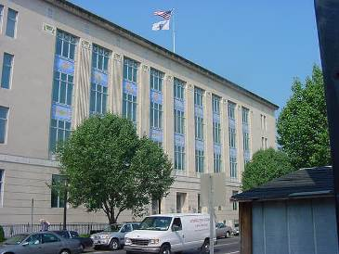

Prepared by:
Massachusetts Department of Public Health
Bureau of Environmental Health
Indoor Air Quality Program
May 2016

BACKGROUND
Building: | Department of Environmental Protection (DEP)-4th & 5th floors
Address: | Springfield State Office Building (SSOB)  436 Dwight St., Springfield, MA
Assessment Requested by: | Kelly Flaherty Division of Capital Asset Management and Maintenance (DCAMM)
Reason for Request: | Employee concerns re: odors
Date of Assessment: | March 25, 2016
Massachusetts Department of Public Health/Bureau of Environmental Health (MDPH/BEH) Staff Conducting Assessment: | Michael Feeney, Director, Indoor Air Quality (IAQ) Program  Jason Dustin, Environmental Analyst/Inspector IAQ Program
Date of Building Construction: | 1937
Building/Site Description: | The building is a five-story stone and cement building formerly used as a post office
Windows: | Non-openable

Executive Summary:
No significant public health concerns were identified during this visit. Some occupants expressed concern over a “sheet rock” or “burnt paper” odor on the fifth floor. This issue is discussed in detail under the “Other IAQ Evaluations” section of the report. The general IAQ assessment for the building revealed no major concerns. Any active leaks should be repaired and water-damaged porous materials such as stained ceiling tiles should be replaced. It is recommended that more storage solutions are implemented to improve cleaning access and products containing fragrances be reduced/eliminated within the office area.

METHODS
Please refer to the IAQ Manual for methods, sampling procedures, and interpretation of results (MDPH, 2015).

RESULTS and DISCUSSION
The following is a summary of indoor air testing results (Table 1).
- Carbon dioxide levels were below 800 parts per million (ppm) in all areas surveyed. It should be noted that the building was scarcely occupied at the time of assessment which can reduce carbon dioxide levels.
- Temperature was within the MDPH recommended range of 70°F to 78°F in all areas.
- Relative humidity was below the MDPH recommended range of 40 to 60% in all areas as is typical during the heating season in the Northeast.
- Carbon monoxide levels were non-detect (ND) throughout all areas surveyed.
- Particulate matter (PM2.5) concentrations ranged from 3 to 19 μg/m³. All of the readings were below the National Ambient Air Quality (NAAQS) guideline of 35.
- Total Volatile Organic Compounds (TVOCs) levels were ND throughout the building.

Ventilation
It can be seen from Table 1 that carbon dioxide levels were below 800 ppm in all areas surveyed. Fresh air is provided by air-handling units (AHUs) located on the roof. Fresh air is ducted to supply air diffusers located throughout the space (Picture 1). Air is returned to the AHUs via ceiling plenum exhaust vents (Picture 2).
Some DEP staff on the 4th floor reported that when coming into the office at approximately 6:45am, the air quality is “stale”. AHUs are regulated by a centrally controlled system which is programmed to begin preheating at this time before most of the staff arrives later in the morning. The AHU system controls could be reprogrammed to allow for preheating or cooling at least one hour prior to staff occupying the office space. If not feasible, the hours of early staff arrival could be delayed until the system has adequately conditioned and exchanged the air within the office.
The BEH/IAQ program recommends that thermostats/central controls be set to the fan “on” setting during occupied periods to provide continuous air circulation and filtration. This setting typically reduces the incidence of IAQ complaints due to the dilution and removal of common indoor air pollutants.

Microbial/Moisture Concerns
In order for building materials to support mold growth, a source of water exposure is necessary.
- Water-damaged ceiling tiles were observed in several areas throughout the DEP office space (Pictures 3 and 4, Table 1). DEP staff reported that most water damage was historic except for the leak in the entry hall of the DEP space on the fifth floor just after the Reception area (Picture 5). The source of this leak should be investigated and repaired.
- Any porous materials (e.g., ceiling tiles) not dried within 48 hours should be discarded and replaced.
- Plants were noted in several areas (Pictures 6 to 8). Plants can be a source of pollen and mold, which can be respiratory irritants to some individuals. Plants should be properly maintained and equipped with drip pans and should be located away from air diffusers to prevent the aerosolization of dirt, pollen and mold.

Other IAQ Evaluations
As mentioned previously, DEP staff expressed concerns regarding an odor that was described as a “sheetrock” or “burnt paper” smell. BEH/IAQ staff examined samples of the gypsum wallboard (GW) that was recently replaced in a small area on the 5th floor. Extra sheets of this GW located in the basement did not have any odor. BEH/IAQ staff also used a moisture meter to determine if the GW installed in the “File Room” was wet from water in and around the area where odor complaints were reported. No elevated moisture readings were detected in any of the GW in this area.
BEH staff examined the suspended ceiling, which contain a radiant heating loop near the perimeter walls of the entire 5th floor space (Picture 9). BEH staff noted the heating loop was installed in the beams of the suspended ceiling without any separation or insulation between the heating loop housing and the suspended ceiling beams. BEH staff found that the heating loop had a temperature range of 135°F to 147°F in several areas (Table 2). The metal beams adjacent to the heating loop housing had a temperature range of 115°F to 128°F, which then heated the adjacent ceiling tiles to a temperature within a range of 92°F to 103°F. Ceiling tiles have an operational temperature range set by the manufacturer. If the operational temperature range is exceeded, it is likely to accelerate off-gassing of odor and breakdown of the ceiling tiles. DEP staff reported that these ceiling tiles had a strong odor when they arrived for installation. According to the manufacturer, the temperature range recommendation for use is 60 °F to 85 °F (Armstrong, 2016). It is likely that the odors reported are starches and other compounds in the ceiling tiles which are being off-gassed due to the high heat in close proximity to the new ceiling tiles. In addition, the exhaust vent was not operating in this area, which would result in off-gassing odors to accumulate in this location. Other locations in the DEP offices had similar ceiling temperature measurements; however each area had a functioning exhaust vent.
DCAMM staff reported that electrostatic filters are used in the roof top AHUs and that they are investigating ways to further improve filtering. The building is in close proximity to a working railway which presents a challenge in terms of excess particulate matter clogging typical AHU filters. Consideration should be given to utilizing pre-filters and performing more frequent filter changes.
The 4th floor men’s bathroom was noted to have several missing ceiling tiles (Picture 10). These tiles should be replaced as soon as possible to avoid the entrainment of bathroom odors and moisture into the ceiling return plenum.
BEH/IAQ staff noted air fresheners, scented hand sanitizers, cleaners, and dry erase materials in use. All of these products have the potential to be irritants to the eyes, nose, throat, and respiratory system of sensitive individuals and their use should be minimized.
Supply and exhaust vents were noted to be dusty in several areas throughout the DEP space (Pictures 11 and 12). Some of this debris may be the result of filter bypass. These vents should be cleaned regularly to avoid aerosolizing accumulated particulate matter.
In several areas, items were observed on the floor, windowsills, tabletops, counters, bookcases, and desks (Pictures 13 and 14). The large number of stored items provides a source for dusts to accumulate. These items (e.g., papers, folders, boxes) make it difficult for custodial staff to clean. Once aerosolized, they can act as irritants to eyes and respiratory system. Items should be relocated and/or be cleaned periodically to avoid excessive dust build up. In addition, further storage solutions should be implemented.
DEP has a number of field personnel who often work in contaminated environments. Upon returning to the office from these field sites, it is likely that field personnel track mud, dust and debris into the office. This debris has the potential to contain chemicals/irritants. Consideration should be given to providing a locker room or decontamination area for field personnel to change clothing/boots to avoid tracking contaminated debris into the office space.
DEP staff reported that they were not aware of a regular cleaning program utilizing wet-wiping and high efficiency particulate arrestence (HEPA) vacuuming of the office space. Wet-wiping flat surfaces and using a HEPA vacuum on carpeting greatly reduces common indoor irritants and small particulate matter.
Some supply diffusers were noted to be covered with duct tape (Picture 15). Any obstructions to the supply or return vents will interfere with the HVAC system balance and should be removed. Dedicated local exhaust vents should be installed in kitchen/breakrooms to remove food odors/smoke. Also, consider sealing pathways (Picture 16) in these areas to avoid entraining food odors/smoke into the return plenum system.

CONCLUSION AND RECOMMENDATIONS
In view of the findings at the time of the visit, the following recommendations are made:
- Repair and activate the exhaust vent in the area where the odors was denoted.
- Investigate strategies to mitigate the probable ceiling tile odor in areas of elevated temperature surrounding the ceiling heating pipe loop. Some strategies may include improving insulation techniques near the ceiling tiles or replacing the ceiling tiles in those areas with a more heat resistant material.
- Investigate the source of the active leak on the fifth floor (through door past the Reception area) and repair as necessary.
- Remove any water-damaged porous materials (e.g., ceiling tiles) that were not dried within 24 to 48 hours and replace new.
- Ensure a regular program for wet-wiping of surfaces and HEPA vacuuming of carpet to minimize particulate matter which can have irritant effects.
- Consider providing a locker room or decontamination area for field staff to avoid tracking possible contaminated debris into the office space.
- Ensure thermostats/central controls are set to the fan “on” setting during occupied periods to provide continuous air circulation and filtration. This setting typically reduces the incidence of IAQ complaints due to the dilution and removal of common indoor air pollutants.
- Any obstructions (e.g., duct tape) to the supply or return vents will interfere with the HVAC system balancing and should be removed.
- Consider programming AHU controls to condition and exchange air an hour before early staff arrival times. Alternatively, staff arrival schedules could be delayed until the AHU system adequately conditions and exchanges the air in the space.
- Continue with plans to improve the AHU filter systems. Consider utilizing a bank of pre-filters in front of the typical higher efficiency AHU filters. More frequent changing will most likely be required due to the proximity to the railway.
- The missing ceiling tiles in the 4th floor men’s bathroom should be replaced as soon as possible to avoid the entrainment of bathroom odors and moisture into the ceiling return plenum.
- Supply and exhaust vents should be cleaned regularly to avoid aerosolizing accumulated particulate matter.
- The large number of stored items (e.g., papers, folders, boxes) makes it difficult for custodial staff to clean. Items should be relocated and/or be cleaned periodically to avoid excessive dust build up. Consider implementing further storage solutions.
- Minimize the use of air fresheners, scented hand sanitizers, cleaners, and dry erase materials within the building. These products have the potential to be irritants to the eyes, nose, throat, and respiratory system of sensitive individuals.
- Plants should be properly maintained and equipped with drip pans and should be located away from air diffusers to prevent the aerosolization of dirt, pollen and mold.
- Carpets should be regularly vacuumed with HEPA-filtered vacuum cleaners as well as cleaned annually to prevent them from becoming a source of suspended particulate matter.
- Regular wet wiping of all surfaces is recommended. Avoid the use of feather dusters. Drinking water during the day can help ease some symptoms associated with a dry environment (throat and sinus irritation).
- Dedicated local exhaust vents should be installed in kitchens/breakrooms to remove food odors/smoke and eject the exhaust to the outdoors. Also, consider sealing pathways in these areas to avoid entraining food odors/smoke into the return plenum system.
- Refer to resource manual and other related indoor air quality documents located on the MDPH’s website for further building-wide evaluations and advice on maintaining public buildings. These documents are available at http://mass.gov/dph/iaq.

REFERENCES

Armstrong. 2016. “How to Install Your Armstrong Ceiling Tiles”. Armstrong World Industries, Inc. Lancaster, PA. www.armstrong.com
Massachusetts Department of Public Health (MDPH). 2015. Indoor Air Quality Manual: Chapters I-III. Available at: http://www.mass.gov/eohhs/gov/departments/dph/programs/environmental-health/exposure-topics/iaq/iaq-manual/.
Picture

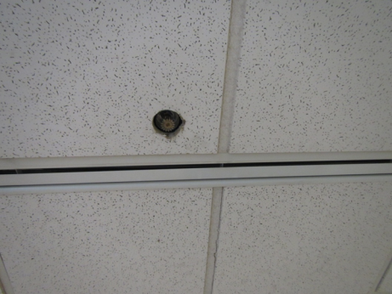

Ceiling-mounted, slotted supply diffuser

Picture

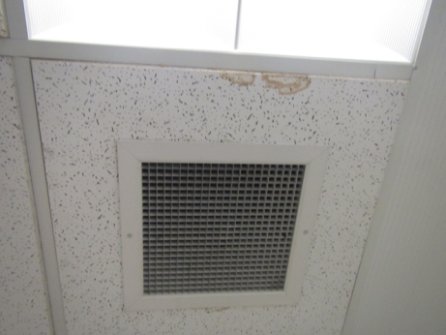

Ceiling plenum return vent
Picture

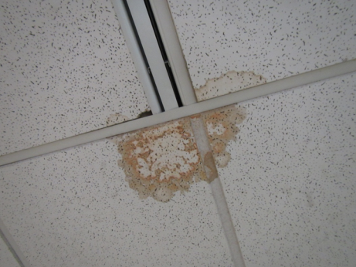

Water-damaged ceiling tiles

Picture

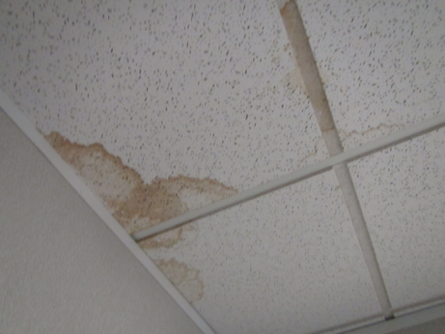

Water-damaged ceiling tiles
Picture

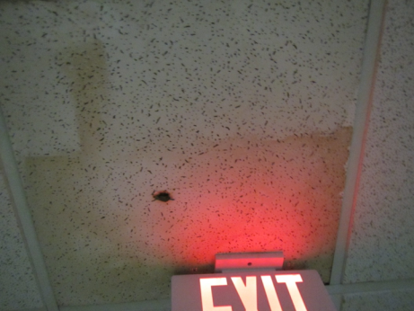

Area of reported active leak on 5th floor

Picture

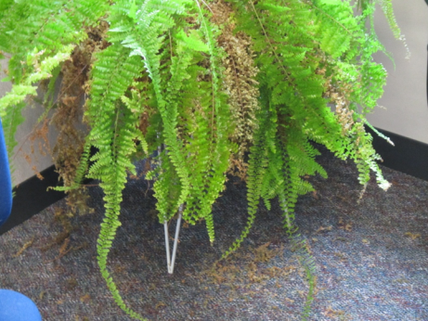

Plant and debris in office area
Picture
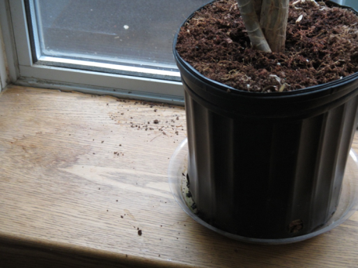

Plant with debris and water staining

Picture

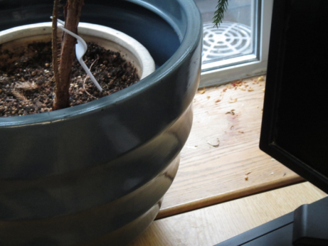

Plant with debris and water staining

Picture

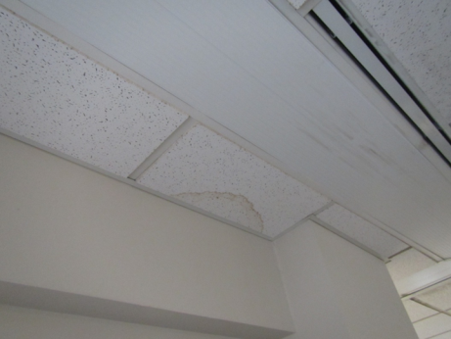

Section of perimeter heating loop pipe inspected (arrow)

Picture 10

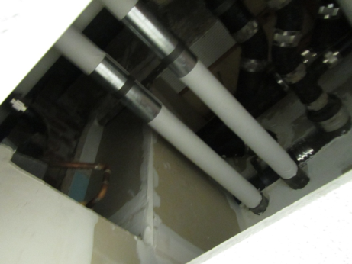

Missing ceiling tiles in 4th floor men’s bathroom

Picture 11

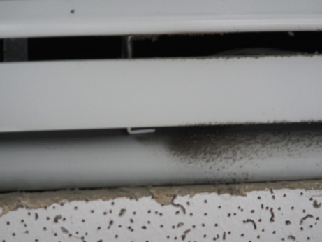

Dust/debris accumulated on supply vent
Picture 12

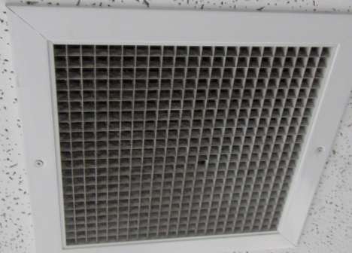

Dusty return vent

Picture 13

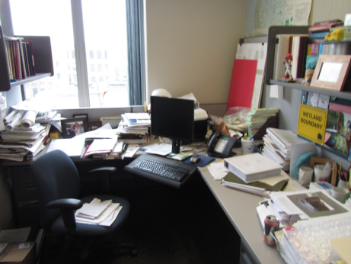

Accumulated items in office space

Picture 14

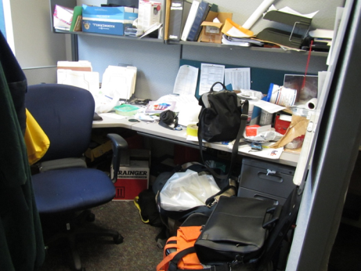

Accumulated items in office space
Picture 15

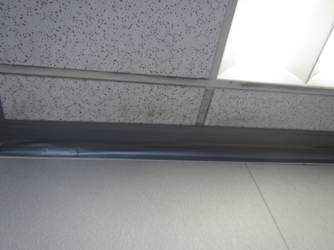

Supply diffuser blocked with duct tape

Picture 16

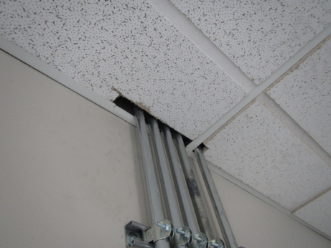

Pathways around utilities in kitchen area
Location | Carbon  Dioxide  (ppm) | Carbon Monoxide  (ppm) | Temp  (°F) | Relative  Humidity  (%) | TVOCs  (ppm) | PM2.5  (µg/m³) | Occupants  in Room | Windows  Openable | Ventilation |  |  | Remarks
 |  |  |  |  |  |  |  |  | Intake | Exhaust
Background (outside) | 407 | ND | 45 | 39 | ND | 12
5th Floor
5206 File Room | 634 | ND | 70 | 36 | ND | 3 | 0 | N | Y |  | Y | WD CTs, GW tested negative for moisture, slight odor
Reception | 563 | ND | 34 | ND | ND | 3 | 2 | N | Y |  | Y | WD CT, Lysol wipes, HS, mini fridge on carpet
519 | 509 | ND | 71 | 32 | ND | 5 | 0 | N | Y |  | Y | Plants
5203 | 504 | ND | 71 | 31 | ND | 3 | 1 | N | Y |  | Y | Plants
Reception/copy room | 517 | ND | 72 | 31 | ND | 3 | 0 | N | Y |  | Y | PC, WD CT
523 Break room | 531 | ND | 73 | 29 | ND | 4 | 0 | N | Y |  | Y | Gaps around utilities at ceiling
524 Conference | 523 | ND | 72 | 29 | ND | 3 | 0 | N | Y |  | Y | Paper odor
525 Conference | 573 | ND | 72 | 29 | ND | 3 | 0 | N | Y |  | Y | Slight paper odor, DEM
Foyer outside 526 | 533 | ND | 71 | 31 | ND | 3 | 0 | N | Y |  | Y | Large plant with standing water, HS
527 | 541 | ND | 71 | 30 | ND | 4 | 0 | N | Y |  | Y | Plants, WD CTs
528 | 507 | ND | 72 | 29 | ND | 3 | 1 | N | Y |  | Y | Bowed CT
5307 | 503 | ND | 72 | 30 | ND | 4 | 0 | N | Y |  | Y | HS, AI
5308 | 516 | ND | 72 | 30 | ND | 3 | 1 | N | Y |  | Y | Plants, AI
5311 | 511 | ND | 72 | 29 | ND | 3 | 1 | N | Y |  | Y | Plants
5312 | 501 | ND | 73 | 28 | ND | 4 | 1 | N | Y |  | Y | Plants, HS, AI
5401 | 502 | ND | 73 | 29 | ND | 3 | 1 | N | Y |  | Y | Plant, CP
5465 | 504 | ND | 73 | 28 | ND | 3 | 0 | N | Y |  | Y
5464 | 519 | ND | 73 | 28 | ND | 4 | 1 | N | Y |  | Y
5405 | 508 | ND | 73 | 28 | ND | 3 | 1 | N | Y |  | Y
5456 | 505 | ND | 73 | 27 | ND | 4 | 0 | N | Y |  | Y | Plants in adjacent cube & AI
5455 | 510 | ND | 73 | 27 | ND | 3 | 0 | N | Y |  | Y | AI
531 | 486 | ND | 73 | 28 | ND | 4 | 0 | N | Y |  | Y | WD CTs, plants
532 | 558 | ND | 71 | 30 | ND | 3 | 1 | N | Y |  | Y
5451 | 491 | ND | 71 | 29 | ND | 4 | 0 | N | Y |  | Y | Bowed CT
5415 | 583 | ND | 71 | 29 | ND | 5 | 0 | N | Y |  | Y | WD CT
5412 | 500 | ND | 71 | 29 | ND | 5 | 0 | N | Y |  | Y | AI
5409 | 514 | ND | 72 | 30 | ND | 4 | 0 | N | Y |  | Y
5407 | 524 | ND | 72 | 30 | ND | 4 | 0 | N | Y |  | Y
4th Floor
4201 Break room | 501 | ND | 72 | 31 | ND | 19 | 1 | N | Y |  | Y | Burning odor (toaster)
4220 | 479 | ND | 72 | 31 | ND | 5 | 1 | N | Y |  | Y
4212 | 484 | ND | 72 | 32 | ND | 5 | 0 | N | Y |  | Y | AI
4211 | 482 | ND | 72 | 30 | ND | 5 | 0 | N | Y |  | Y | Duct tape over supply vent
4214 | 472 | ND | 71 | 31 | ND | 7 | 1 | N | Y |  | Y | AI
4208 | 481 | ND | 71 | 31 | ND | 5 | 0 | N | Y |  | Y
4217 | 480 | ND | 71 | 31 | ND | 6 | 0 | N | Y |  | Y | AI
4303 | 464 | ND | 71 | 31 | ND | 6 | 0 | N | Y |  | Y
4311 | 459 | ND | 70 | 31 | ND | 6 | 0 | N | Y |  | Y | AI, Plants, WD CT
4312 | 487 | ND | 71 | 30 | ND | 5 | 1 | N | Y |  | Y
4316 | 484 | ND | 71 | 31 | ND | 5 | 0 | N | Y |  | Y | Plants, AI
4401 | 486 | ND | 71 | 30 | ND | 5 | 1 | N | Y |  | Y
4463 | 473 | ND | 71 | 32 | ND | 5 | 1 | N | Y |  | Y
4460 | 463 | ND | 71 | 31 | ND | 6 | 1 | N | Y |  | Y
4457 | 474 | ND | 71 | 32 | ND | 6 | 1 | N | Y |  | Y
4455 | 481 | ND | 71 | 32 | ND | 5 | 1 | N | Y |  | Y
4417 | 459 | ND | 70 | 31 | ND | 6 | 0 | N | Y |  | Y | Plants, AI
4414 | 495 | ND | 70 | 32 | ND | 6 | 1 | N | Y |  | Y | PF
4411 | 485 | ND | 70 | 32 | ND | 7 | 0 | N | Y |  | Y | AI
4409 | 511 | ND | 70 | 33 | ND | 6 | 1 | N | Y |  | Y | WD CT
4407 | 522 | ND | 70 | 33 | ND | 6 | 0 | N | Y |  | Y
4403 | 483 | ND | 70 | 33 | ND | 7 | 0 | N | Y |  | Y
4320 | 486 | ND | 70 | 33 | ND | 6 | 0 | N | Y |  | Y | AI, plant
4315 | 481 | ND | 70 | 32 | ND | 6 | 0 | N | Y |  | Y | AI
4313 | 541 | ND | 71 | 31 | ND | 7 | 0 | N | Y |  | Y

Location | Temperature Heat Loop Surface  (ºF) | Temperature Suspended Ceiling Metal Beam  (ºF) | Temperature Ceiling Tile Resting on Bean Adjacent to Heat Loop  (ºF)
5206 | 147 | 110 | 93
5200 | 137 | 128 | 94
5101 | 135 | 127 | 102
520 | 135 | 119 | 92
5209 | 71 | 70 | 72
5210 | 70 | 70 | 69
5212 | 69 | 69 | 68
5307 | 68 | 66 | 67
5309 | 69 | 68 | 68
5317 | 138 | 131 | 110
5405 | 142 | 129 | 111
5407 | 72 | 77 | 76
5453 | 66 | 65 | 69
5415 | 65 | 64 | 64
5454 | 136 | 106 | 93
5459 | 135 | 92 | 84
528 | 69 | 69 | 68
5208 | 69 | 69 | 69
502 | 142 | 134 | 94

