INDOOR AIR QUALITY ASSESSMENT

Department of Fish and Game
Division of Fisheries and Wildlife
Richard Cronin Building
1 Rabbit Hill Road
Westborough, MA

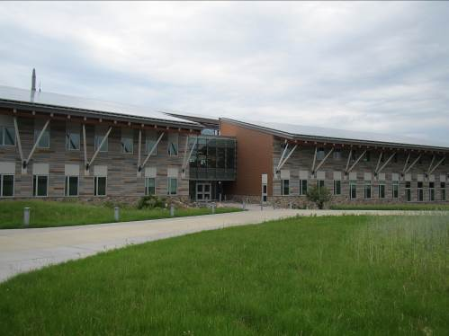

Prepared by:
Massachusetts Department of Public Health
Bureau of Environmental Health
Indoor Air Quality Program
September 2015

Background
Building: | Department of Fish and Game (DFG)  Division of Fisheries and Wildlife (DFW)  Richard Cronin Building
Address: | 1 Rabbit Hill Road  Westborough, MA
Assessment Requested by: | Johanna M. Zabriskie, Human Resources Office, DFG
Date of Assessment: | June 26, 2015
BEH/IAQ Staff Conducting Assessment: | Ruth Alfasso
Others Present:  Date of Building Construction: | Richard Donovan, Division of Capital Asset Management and Maintenance (DCAMM)  Completed in September 2014
Reason for Request: | Concerns regarding allergic/irritation symptoms and general IAQ

Building Description: The DFW building was completed in September of 2014 and is located in an office park in Westborough. This building was designed and built as a “zero net energy” building and has a number of innovative features. The space contains offices, open workstations, reception/atrium areas, conference rooms, storage areas, two small laboratories and kitchen/lounge areas. The central atrium contains a water feature (cold water trout pond). Ceilings consist of suspended ceiling tiles. Floors consist of wall to wall carpeting in the majority of areas. Windows are openable.

Methods
Air tests for carbon monoxide, carbon dioxide, temperature and relative humidity were conducted with the TSI, Q-Trak, IAQ Monitor, Model 7565. Air tests for airborne particle matter with a diameter less than 2.5 micrometers were taken with the TSI, DUSTTRAK™ Aerosol Monitor Model 8520. BEH/IAQ staff also performed a visual inspection of building materials for water damage and/or microbial growth.

Results
The employee population of the DFW office is approximately 40. Tests were taken during normal operations and results appear in Table 1.

Discussion

Ventilation
It can be seen from Table 1 that carbon dioxide levels were below 800 parts per million (ppm) in all areas tested, indicating adequate air exchange on the day of the assessment. Note that many areas were unoccupied at the time of the assessment, which would reduce carbon dioxide levels.
Fresh air for the space is provided by air handling units (AHUs) located on the roof and directed to fan coil units located in the ceiling. One hundred percent make-up air is supplied to the building, with exhaust air running through a heat-exchanger with a desiccant wheel in order to recover heat/cooling and transfer to the intake air stream. Air is distributed to offices through supply vent slots (Picture 1) and return/exhaust is drawn into vents (Picture 2). In laboratories, exhaust hoods (Picture 3) and task-exhaust direct air outside the building without heat recovery. Restroom exhausts also appear to be directly vented to the outside. Additional heating and cooling is reportedly provided by radiant floor coils in many areas.
The heating, ventilating and air conditioning (HVAC) system is computer controlled. Reportedly, multiple “seasonal” settings are available to help control inside temperature and humidity based on outdoor conditions. Windows are openable in many areas of the building and are part of the building’s climate control system. Windows may open as part of the building’s automation and may also be manually operated; indicator lights from the climate control systems provide visual information as to when the windows can be opened to provide ventilation and when they should remain closed as to not interfere with building-wide temperature and humidity controls (Picture 4). Building occupants have been instructed as to the use of these indictor lights. Open windows may provide additional fresh air as well as a feeling of connection to the outdoors, however air that comes in through windows is not provided with the same filtration that the intake air is, and should be avoided on days with high levels of pollen or other airborne pollutants.
Carbon dioxide sensors are present in the larger conference/meeting rooms. One of these sensors was suspected to be malfunctioning during the June 26, 2015 visit, and comparison with the Q-trak measurement showed that the sensor was inaccurate (Picture 5). Carbon dioxide sensors should be calibrated regularly/as per the manufacturer’s instructions and replaced/repaired when not functioning.
To maximize air exchange, the MDPH recommends that both supply and exhaust ventilation operate continuously during periods of occupancy. In order to have proper ventilation with a mechanical supply and exhaust system, the systems must be balanced to provide an adequate amount of fresh air to the interior of a room while removing stale air from the room. It is recommended that HVAC systems be re-balanced every five years to ensure adequate air systems function (SMACNA, 1994). It is likely balancing occurred prior to occupancy in February of 2014. It is also important to note that the building is still considered to be in the commissioning process, and adjustments to climate control and other systems are ongoing.
Minimum design ventilation rates are mandated by the Massachusetts State Building Code (MSBC). Until 2011, the minimum ventilation rate in Massachusetts was higher for both occupied office spaces and general classrooms, with similar requirements for other occupied spaces (BOCA, 1993). The current version of the MSBC, promulgated in 2011 by the State Board of Building Regulations and Standards (SBBRS), adopted the 2009 International Mechanical Code (IMC) to set minimum ventilation rates. Please note that the MSBC is a minimum standard that is not health-based. At lower rates of cubic feet per minute (cfm) per occupant of fresh air, carbon dioxide levels would be expected to rise significantly. A ventilation rate of 20 cfm per occupant of fresh air provides optimal air exchange resulting in carbon dioxide levels at or below 800 ppm in the indoor environment in each area measured. MDPH recommends that carbon dioxide levels be maintained at 800 ppm or below. This is because most environmental and occupational health scientists involved with research on IAQ and health effects have documented significant increases in indoor air quality complaints and/or health effects when carbon dioxide levels rise above the MDPH guidelines of 800 ppm for schools, office buildings and other occupied spaces (Sundell et al., 2011). The ventilation must be on at all times that the room is occupied. Providing adequate fresh air ventilation with open windows and maintaining the temperature in the comfort range during the cold weather season is impractical. Mechanical ventilation is usually required to provide adequate fresh air ventilation.
Carbon dioxide is not a problem in and of itself. It is used as an indicator of the adequacy of the fresh air ventilation. As carbon dioxide levels rise, it indicates that the ventilating system is malfunctioning or the design occupancy of the room is being exceeded. When this happens, a buildup of common indoor air pollutants can occur, leading to discomfort or health complaints. The Occupational Safety and Health Administration (OSHA) standard for carbon dioxide is 5,000 parts per million parts of air (ppm). Workers may be exposed to this level for 40 hours/week, based on a time-weighted average (OSHA, 1997).
The MDPH uses a guideline of 800 ppm for publicly occupied buildings. Inadequate ventilation and/or elevated temperatures are major causes of complaints such as respiratory, eye, nose and throat irritation, lethargy and headaches. For more information concerning carbon dioxide, please see Appendix A.

Temperature and Relative Humidity
Temperature readings ranged from 72ºF to 76ºF (Table 1), all within the MDPH recommended comfort guidelines. The MDPH recommends that indoor air temperatures be maintained in a range of 70ºF to 78ºF in order to provide for the comfort of building occupants. In many cases concerning indoor air quality, fluctuations of temperature in occupied spaces are typically experienced, even in a building with an adequate fresh air supply.
The relative humidity measured during the assessment ranged from 50 to 57 percent (Table 1), which were within the MDPH recommended comfort range. The MDPH recommends a comfort range of 40 to 60 percent for indoor air relative humidity. Relative humidity levels in the building would be expected to drop during the winter months due to heating. The sensation of dryness and irritation is common in a low relative humidity environment. Low relative humidity is a very common problem during the heating season in the northeast part of the United States.
Note that an additional visit was made to this office on July 31, 2015 to investigate the source of a persistent odor observed on the third floor. Findings from that visit traced the source of the odor to insulation material that was installed on top of the radiant heating/cooling coils in the third floor ceiling tile system, which had become moistened due to condensation and probable cooling leaks. A letter detailing this this visit with recommendations is attached as Appendix B. Note that humidity control issues in the building were identified contributing to the insulation to have become moist, and should be investigated as a part of the building’s ongoing commissioning process.

Microbial/Moisture Concerns
The following sources of potential water damage to building components were identified during the June 26, 2015 visit:
- Windows high up on the second floor along the south side of the building had been reported to leak during heavy rains. While repairs are underway windows are covered in plastic to prevent additional water infiltration (Pictures 6 and 7).
- Condensation from HVAC components were reported by building occupants to have occurred in the past, causing minor moistening of carpeting in a few areas; no moist building materials were observed during the visit.
- Piping for one of the ceiling AHUs on the first floor was wet with condensation. The AHU was equipped with a drip pan, which reportedly drains to the outside. Additional insulation may be needed for cooling pipes.
- A portable air conditioning unit was observed in the data/server room (Picture 8). These units create condensation that must be drained to the exterior. These units should be kept clean and in good repair to prevent spills, leaks, or odors from stagnant water.
- According to facilities management, the building has radiant floor cooling. Due to this feature, the potential exists for the floors to generate condensation when indoor conditions are humid. Carpeting could become moistened and if moistened for an extended period of time, be a medium for microbial growth. In many areas, cardboard boxes and other porous materials were stored on floors (Pictures 9 and 10), which may be moistened by condensation in humid conditions.
- Porous items on floors in below grade areas such as the basement storeroom (Picture 11) may become water-damaged.
The US EPA and the American Conference of Governmental Industrial Hygienists (ACGIH) recommend that porous materials be dried with fans and heating within 24 to 48 hours of becoming wet (US EPA, 2001; ACGIH, 1989). If porous materials are not dried within this time frame, mold growth may occur. Once mold has colonized porous materials, they are difficult to clean and should be removed and discarded.
The building atrium has a water feature in the form of a cold-water trout river/pool (Picture 12). This feature appeared to be in good condition during the visit, with clear water and no odors. In addition, it was reported that the fish were breeding and healthy, which indicates that good water quality is being maintained. If this water feature is not properly maintained, odors and microbial growth may occur. Due to the central placement of the water and the open atrium/office area, any unpleasant odors would be easily distributed to other occupied spaces.
Plants were observed in many open areas, cubicles and offices (Picture 13; Table 1). Plants can be a source of pollen and mold, which can be respiratory irritants to some individuals. Plants should be properly maintained, over-watering of plants should be avoided and drip pans should be inspected periodically for mold growth and cleaned or replaced as necessary.
Water dispensers were observed on carpeted areas. Spills or leaks from these appliances can moisten carpeting. They should be located in a non-carpeted area or on waterproof mats.
The laboratory area is equipped with men’s and women’s showers. It was reported that these are rarely if ever used. If drains inside the showers or shower rooms are not periodically filled with water, the seals on the drain traps can become dry and allow sewer gases to penetrate occupied spaces. These drains need to be filled with water periodically, either during cleaning or as a regular maintenance activity.
A refrigerator in one of the breakrooms had an odor from spoiled or spilled food items. Refrigerators should be cleaned regularly to avoid odors and microbial growth from spoiled food.
A slight musty odor was detected in the library (room 113), most likely from old books that had become water-damaged in the past. Books and other long-stored paper items can become musty or mold-colonized if they become and stay damp. To eliminate this odor, examine individual books for odors/water damage and discard them. If damaged items have significant value or are irreplaceable, a professional restoration company may be consulted.

Other IAQ Evaluations
Indoor air quality can be negatively influenced by the presence of respiratory irritants, such as products of combustion. The process of combustion produces a number of pollutants. Common combustion emissions include carbon monoxide, carbon dioxide, water vapor, and smoke (fine airborne particle material). Of these materials, exposure to carbon monoxide and particulate matter with a diameter of 2.5 micrometers (μm) or less (PM2.5) can produce immediate, acute health effects upon exposure. To determine whether combustion products were present in the indoor environment, BEH/IAQ staff obtained measurements for carbon monoxide and PM2.5.

Carbon Monoxide
Carbon monoxide is a by-product of incomplete combustion of organic matter (e.g., gasoline, wood and tobacco). Exposure to carbon monoxide can produce immediate and acute health effects. Several air quality standards have been established to address carbon monoxide and prevent symptoms from exposure to these substances. The MDPH established a corrective action level concerning carbon monoxide in ice skating rinks that use fossil-fueled ice resurfacing equipment. If an operator of an indoor ice rink measures a carbon monoxide level over 30 ppm, taken 20 minutes after resurfacing within a rink, that operator must take actions to reduce carbon monoxide levels (MDPH, 1997).
The American Society of Heating Refrigeration and Air-Conditioning Engineers (ASHRAE) has adopted the National Ambient Air Quality Standards (NAAQS) as one set of criteria for assessing indoor air quality and monitoring of fresh air introduced by HVAC systems (ASHRAE, 1989). The NAAQS are standards established by the US EPA to protect the public health from six criteria pollutants, including carbon monoxide and particulate matter (US EPA, 2006). As recommended by ASHRAE, pollutant levels of fresh air introduced to a building should not exceed the NAAQS levels (ASHRAE, 1989). The NAAQS were adopted by reference in the Building Officials & Code Administrators (BOCA) National Mechanical Code of 1993 (BOCA, 1993), which is now an HVAC standard included in the Massachusetts State Building Code (SBBRS, 2011). According to the NAAQS, carbon monoxide levels in outdoor air should not exceed 9 ppm in an eight-hour average (US EPA, 2006).
Carbon monoxide should not be present in a typical, indoor environment. If it is present, indoor carbon monoxide levels should be less than or equal to outdoor levels. Outdoor carbon monoxide concentrations were non-detect (ND) at the time of assessment (Table 1). No measureable levels of carbon monoxide were detected inside the building (Table 1).

Particulate Matter
The US EPA has established NAAQS limits for exposure to particulate matter. Particulate matter includes airborne solids that can be irritating to the eyes, nose and throat. The NAAQS originally established exposure limits to PM with a diameter of 10 μm or less (PM10). In 1997, US EPA established a more protective standard for fine airborne particulate matter with a diameter of 2.5 μm or less (PM2.5). This more stringent PM2.5 standard requires outdoor air particle levels be maintained below 35 μg/m³ over a 24-hour average (US EPA, 2006). Although both the ASHRAE standard and BOCA Code adopted the PM10 standard for evaluating air quality, MDPH uses the more protective PM2.5 standard for evaluating airborne PM concentrations in the indoor environment.
Outdoor PM2.5 concentrations were measured at 10 μg/m³ (Table 1). PM2.5 levels indoors during the visit ranged from 7 to 30 μg/m³, which were below the NAAQS PM2.5 level of 35 μg/m³. Frequently, indoor air levels of particulate matter (including PM2.5) can be at higher levels than those measured outdoors. A number of activities that occur indoors and/or mechanical devices can generate particulate matter during normal operations. Sources of indoor airborne particulate matter may include but are not limited to particles generated during the operation of fan belts in the HVAC system, use of stoves and/or microwave ovens in kitchen areas; use of photocopiers, fax machines and computer printing devices; operation of an ordinary vacuum cleaner and heavy foot traffic indoors.

Volatile Organic Compounds
Indoor air concentrations can be greatly impacted by the use of products containing volatile organic compounds (VOCs). VOCs are carbon-containing substances that have the ability to evaporate at room temperature. Indoor air concentrations can be greatly impacted by the use of products containing volatile organic compounds (VOCs). Frequently, exposure to low levels of total VOCs (TVOCs) may produce eye, nose, throat and/or respiratory irritation in some sensitive individuals.
No testing for TVOCs was conducted during the assessment, but several potential sources of VOCs were identified. In the laboratories, a shared hood contained a large vessel of formalin (Picture 3). Formalin is an aqueous solution of formaldehyde gas, often used as a tissue sample preservative or disinfectant. Formaldehyde gas can evaporate from the solution if not kept in a tightly closed container. Formaldehyde has a strong and irritating odor, and is toxic and carcinogenic. It can also cause an allergic reaction in sensitive people (ATSDR, 1999). Use of formaldehyde or other laboratory chemicals should take place in the laboratory hoods whenever possible and the containers should be kept tightly sealed. The laboratory hoods require calibration/certification annually to ensure safe performance.
Several areas had dry erase boards and related materials (Table 1). Materials such as dry erase markers and dry erase board cleaners may contain VOCs, such as methyl isobutyl ketone, n-butyl acetate and butyl-cellusolve (Sanford, 1999), which can be irritating to the eyes, nose and throat.
Hand sanitizer was also observed in office areas (Table 1). These products may contain ethyl alcohol and/or isopropyl alcohol, which are highly volatile and may be irritating to the eyes and nose. Sanitizing products may also contain fragrances to which some people may be sensitive.
Cleaning products were also observed. Cleaning products, air fresheners and other air deodorizers contain chemicals that can be irritating to the eyes, nose and throat of sensitive individuals. Many air fresheners contain 1,4-dichlorobenzene, a VOC which can reduce lung function (NIH, 2006). Furthermore, deodorizing agents do not remove materials causing odors, but rather mask odors that may be present in the area. Cleaning products should be properly labeled and stored in an appropriate area. In addition, a Material Safety Data Sheet (MSDS) should be available at a central location for each product in the event of an emergency.

Other Conditions
In some areas, accumulations of items were seen on floors, windowsills, tabletops, counters, bookcases and desks, which provide a source for dusts to accumulate. Some of these items included feathers, furs, taxidermy and other organic materials, which may contain allergens (Pictures 14 and 15). In addition, these items may make it difficult for custodial staff to clean. Items should be relocated and/or be cleaned periodically to avoid excessive dust build up.
In some areas, a space exists between the cube and building walls (Picture 16). If not cleaned regularly, accumulations of dust and debris in this space can provide food and harborage for pests.
Most areas of the office space had wall to wall carpeting. The Institute of Inspection, Cleaning and Restoration Certification (IICRC) recommends that carpeting be cleaned annually (or semi-annually in soiled high traffic areas) (IICRC, 2012). Regular cleaning with a high efficiency particulate arrestance (HEPA) filtered vacuum in combination with an annual cleaning will help to reduce accumulation and potential aerosolization of materials from the carpeting.

Conclusions/Recommendations
In view of the findings at the time of the visit, the following recommendations are made:
- Continue commissioning of the buildings climate control systems. Monitor operation of the building and ensure that instructions on operation and maintenance are followed and documented. Appropriate preventative maintenance and adjustment are critical to ensuring the innovative features of this building continue to provide adequate air quality and climatic comfort.
- Humidity control in particular appears to be an ongoing issue in this building; ceiling tiles should not be collecting condensation under normal operation. Continue to adjust building controls and monitor for condensation issues.
- Repair leaking windows and remove and discard any water-damaged porous building materials (gypsum wallboard, carpeting, paper-backed insulation, etc.) as necessary in a manner consistent with recommendations found in “Mold Remediation in Schools and Commercial Buildings” published by the US Environmental Protection Agency (US EPA, 2001).
- Ensure occupants are aware of the use of special features of the building, such as the window indicator lights.
- Ensure proper operation of carbon dioxide sensors in meeting room; calibrate and/or make repairs/replace as necessary. Maintain these systems in accordance with manufacturer’s instructions.
- Consider adopting a balancing schedule of every 5 years for all mechanical ventilation systems, as recommended by ventilation industrial standards (SMACNA, 1994).
- For buildings in New England, periods of low relative humidity during the winter are often unavoidable. Therefore, scrupulous cleaning practices should be adopted to minimize common indoor air contaminants whose irritant effects can be enhanced when the relative humidity is low. To control for dusts, a high efficiency particulate arrestance (HEPA) filter equipped vacuum cleaner in conjunction with wet wiping of all surfaces is recommended. Avoid the use of feather dusters. Drinking water during the day can help ease some symptoms associated with a dry environment (throat and sinus irritations).
- Monitor and maintain condensation drip pans in the HVAC system. Consider additional insulation of cooling coils to prevent condensation. Maintain the portable air conditioner in accordance with manufacturer’s instructions and monitor for spills/leaks of condensate.
- Avoid storing porous items on floors where there is radiant floor cooling and in below-grade/basement areas.
- Maintain the water feature in the atrium and monitor for water quality, fish health and any odors/other issues.
- Indoor plants should be properly maintained and equipped with drip pans to prevent water damage to porous building materials and be located away from ventilation sources to prevent the aerosolization of dirt, pollen or mold.
- Place water coolers/dispensers in areas without carpeting or place on a waterproof mat.
- Ensure that drain traps in shower rooms have water added to them periodically to maintain the trap seal.
- Clean refrigerators regularly.
- Consider examining items in the library to determine the source of musty odors and discard/replace/restore any water-damaged materials.
- Reduce the use of hand sanitizing products especially those containing fragrances.
- Clean items including feathers, furs and taxidermy of accumulated dusts regularly and keep items out of airflow to prevent distributing dusts and allergens.
- Ensure areas between cube and building walls are cleaned regularly.
- Vacuum carpet with a high efficiency particulate arrestance (HEPA) filtered vacuum in combination with cleaning carpeting annually or semi-annually in soiled high traffic areas as per the recommendations of the Institute of Inspection, Cleaning and Restoration Certification (IICRC, 2012).
- Refer to resource manuals and other related indoor air quality documents for further building-wide evaluations and advice on maintaining public buildings. Copies of these materials are located on the MDPH’s website: http://mass.gov/dph/iaq.

References
ACGIH. 1989. Guidelines for the Assessment of Bioaerosols in the Indoor Environment. American Conference of Governmental Industrial Hygienists, Cincinnati, OH.
ASHRAE. 1989. Ventilation for Acceptable Indoor Air Quality. American Society of Heating, Refrigeration and Air Conditioning Engineers. ANSI/ASHRAE 62-1989.
ATSDR. 1999. Toxicological Profile For Formaldehyde. Agency for Toxic Substances and Disease Registry, Atlanta, Georgia.
BOCA. 1993. The BOCA National Mechanical Code/1993. 8th ed. Building Officials & Code Administrators International, Inc., Country Club Hills, IL.
IICRC. 2012. Carpet Cleaning FAQ 4 Institute of Inspection, Cleaning and Restoration Certification. Institute of Inspection Cleaning and Restoration, Vancouver, WA.
MDPH. 1997. Requirements to Maintain Air Quality in Indoor Skating Rinks (State Sanitary Code, Chapter XI). 105 CMR 675.000. Massachusetts Department of Public Health, Boston, MA.
NIH. 2006. Chemical in Many Air Fresheners May Reduce Lung Function. NIH News. National Institute of Health. July 27, 2006. http://www.nih.gov/news/pr/jul2006/niehs-27.htm
OSHA. 1997. Limits for Air Contaminants. Occupational Safety and Health Administration. Code of Federal Regulations. 29 C.F.R 1910.1000 Table Z-1-A.
Sanford. 1999. Material Safety Data Sheet (MSDS No: 198-17). Expo® Dry Erase Markers Bullet, Chisel, and Ultra Fine Tip. Sanford Corporation. Bellwood, IL.
SBBRS. 2011. Mechanical Ventilation. State Board of Building Regulations and Standards. Code of Massachusetts Regulations, 8th edition. 780 CMR 1209.0.
SMACNA. 1994. HVAC Systems Commissioning Manual. 1st ed. Sheet Metal and Air Conditioning Contractors’ National Association, Inc., Chantilly, VA.
Sundell. 2011. Sundell, J., H. Levin, W. W. Nazaroff, W. S. Cain, W. J. Fisk, D. T. Grimsrud, F. Gyntelberg, Y. Li, A. K. Persily, A. C. Pickering, J. M. Samet, J. D. Spengler, S. T. Taylor, and C. J. Weschler. Ventilation rates and health: multidisciplinary review of the scientific literature. Indoor Air, Volume 21: pp 191–204.
US EPA. 2001. Mold Remediation in Schools and Commercial Buildings. US Environmental Protection Agency, Office of Air and Radiation, Indoor Environments Division, Washington, D.C. EPA 402-K-01-001. http://www.epa.gov/mold/mold_remediation.html
US EPA. 2006. National Ambient Air Quality Standards (NAAQS). US Environmental Protection Agency, Office of Air Quality Planning and Standards, Washington, DC. http://www.epa.gov/air/criteria.html.
Picture 1

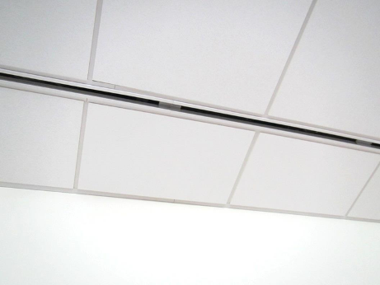

Supply air vent

Picture 2

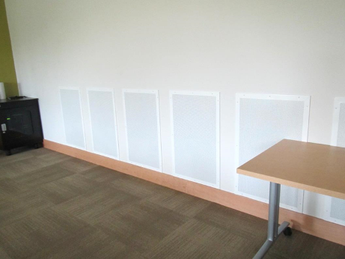

Exhaust vents in conference/meeting room
Picture 3

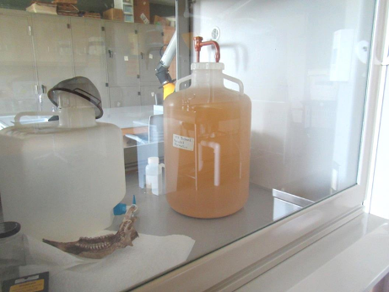

Exhaust hood in between laboratories

Picture 4

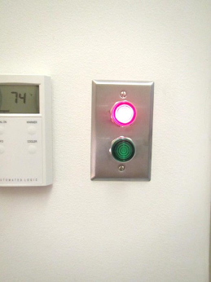

Indicator lights for window opening
Picture 5

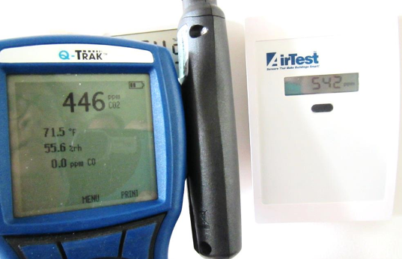

Comparison of carbon dioxide readings of Q-trak and building carbon dioxide sensor

Picture 6

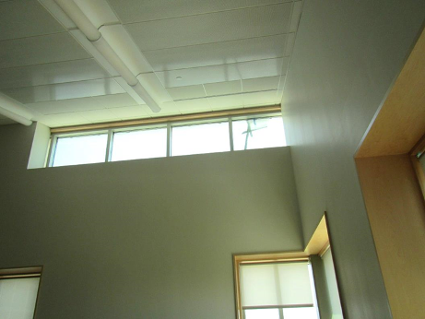

Inside room where upper windows leak
Picture 7

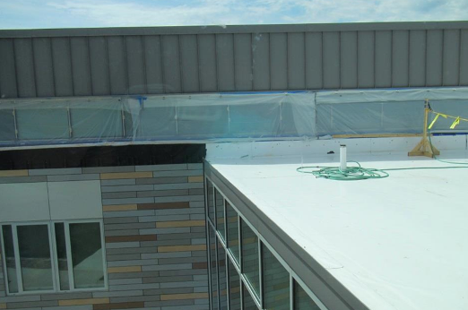

Plastic covering windows from outside

Picture 8

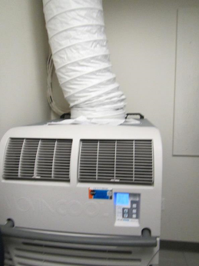

Portable air conditioner
Picture 9

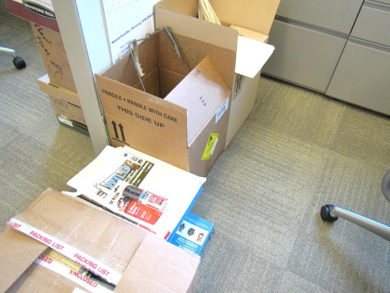

Cardboard and paper on the floor

Picture 10

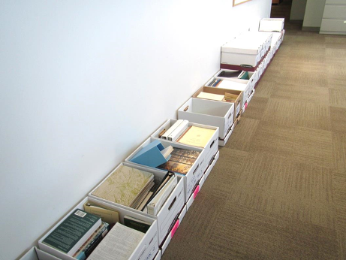

Boxes of books on the floor
Picture 11

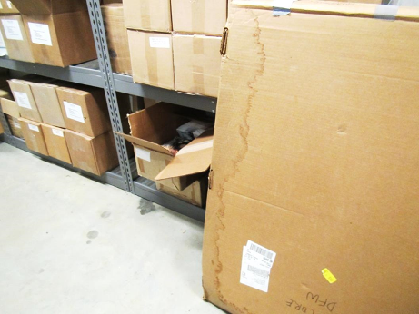

Water-damaged box on floor of basement storeroom

Picture 12

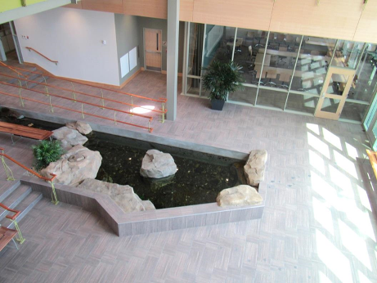

Trout pool in atrium view from upper level
Picture 13

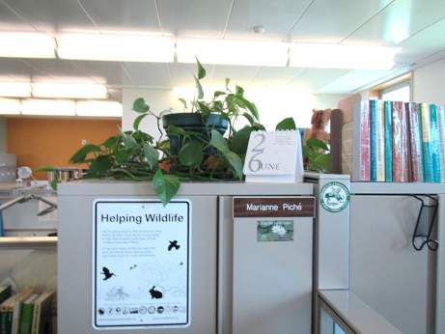

Plants in an office

Picture 14

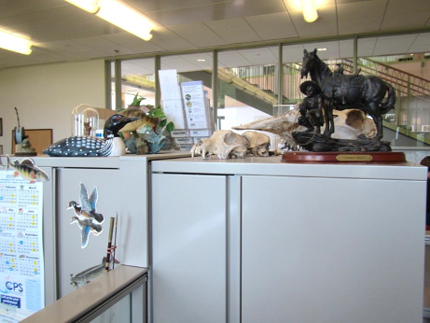

Items on a file cabinet
Picture 15

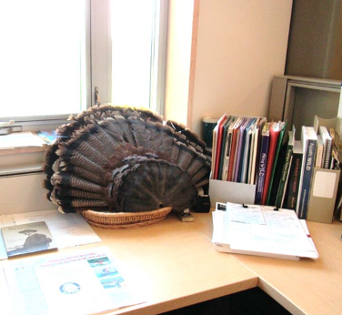

Feathers in an office

Picture 16

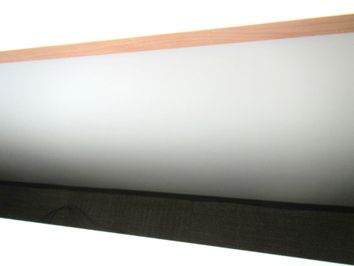

Area between cube and building walls
Location | Carbon  Dioxide  (ppm) | Carbon Monoxide  (ppm) | Temp  (°F) | Relative  Humidity  (%) | PM2.5  (µg/m³) | Occupants  in Room | Windows  Openable | Ventilation |  | Remarks
 |  |  |  |  |  |  |  | Intake | Exhaust | Remarks
Background | 424 | ND | 73 | 53 | 10 |  |  |  |  | Sunny
103 conference | 450 | ND | 72 | 55 | 8 | 3 | Y | Y | Y | DEM, CP, carpet stain
105 kitchen | 476 | ND | 72 | 56 | 16 | 0 | N | Y | Y | Kitchen equipment, no refrigerator
106 small conference | 482 | ND | 72 | 55 | 16 | 0 | Y | Y | Y | All radiant flooring
107 small conference | 498 | ND | 72 | 55 | 17 | 0 | Y | Y | Y | DEM
108 | 475 | ND | 72 | 55 | 13 | 0 | Y | Y | Y | Carbon dioxide sensor inaccurate/miscalibrated, door to outside
110 | 546 | ND | 73 | 56 | 15 | 0 | Y | Y | Y | CP, DEM
111 left | 580 | ND | 74 | 55 | 17 | 2 | Y | Y | Y | Feathers, boxes on floor
111 open area | 552 | ND | 74 | 54 | 19 | 1 | Y | Y | Y | Boxes on floor
111 right | 543 | ND | 74 | 55 | 15 | 3 | Y | Y | Y
111B office | 566 | ND | 74 | 54 | 11 | 0 | Y | Y | Y | Scented candle
113 library | 503 | ND | 75 | 52 | 8 | 0 | Y | Y | Y | Books, slight musty/book odor, NC
113 library support area | 495 | ND | 75 | 51 | 7 | 0 | Y | Y | Y | NC, books, boxes on floor
116 B office | 601 | ND | 75 | 53 | 15 | 1 | Y | Y | Y | Plant, furs, taxidermy
116 hunter education (cubes) | 532 | ND | 75 | 53 | 11 | 3 | Y | Y | Y | PF, AI, mail equipment, CP, HS
117 wildlife lab | 428 | ND | 75 | 57 | 7 | 0 | Y | Y | Y | Hood (certification up to date), formalin solution in hood, directable exhaust (on)
118 fish lab | 392 | ND | 72 | 53 | 7 | 0 | Y | Y | Y | Hood (certification up to date), directable exhaust (on), food in fridge
202 A office | 471 | ND | 75 | 51 | 18 | 0 | Y | Y | Y | DO, boxes on floor, AT
202 B office | 622 | ND | 75 | 52 | 14 | 1 | Y | Y | Y | Boxes on floor, paper, items
202 cubes center | 483 | ND | 74 | 51 | 9 | 0 | Y | Y | Y | Boxes on floor, plants
202 cubes far left | 511 | ND | 74 | 52 | 13 | 4 | Y | Y | Y | Plants
202 cubes left | 512 | ND | 74 | 52 | 12 | 3 | Y | Y | Y | Plants
202 cubes right | 506 | ND | 76 | 51 | 8-17 | 2 | Y | Y | Y | Plants, boxes on floor, AI
206 B office | 522 | ND | 74 | 52 | 10 | 1 | Y | Y | Y | Plants
206 C office | 492 | ND | 74 | 52 | 8 | 0 | Y | Y | Y | Reported window leaks
206 suite | 500 | ND | 74 | 52 | 9 | 0 | Y | Y | Y | Photocopier, slight odor
206A office | 519 | ND | 74 | 51 | 9 | 0 | Y | Y | Y | Plants
207 rear | 460 | ND | 74 | 53 | 6 | 0 | Y | Y | Y | Fridge, microwave, food, dishwasher, odor from fridge, NC
214 A office | 544 | ND | 73 | 57 | 16 | 2 | Y | Y | Y | Plant, DO
214 B office | 540 | ND | 73 | 55 | 10 | 0 | Y | Y | Y | DO, boxes on floor
214 cube area center | 488 | ND | 74 | 54 | 13 | 2 | Y | Y | Y | Plants
214 cube area left | 488 | ND | 75 | 53 | 30 | 2 | Y | Y | Y | Fan, plants
214 cube area right | 499 | ND | 73 | 55 | 12 | 0 | Y | Y | Y | Plants
217 A office | 495 | ND | 75 | 52 | 10 | 1 | Y | Y | Y | DO, boxes on floor, items
217 B office | 582 | ND | 75 | 52 | 9 | 0 | Y | Y | Y | DO, boxes on floor, items
218 A | 603 | ND | 74 | 52 | 20 | 3 | Y | Y | Y | Equipment
218 GIS |  | ND |  |  |  |  |  |  |  | Big printers, PF
219 | 504 | ND | 75 | 51 | 15 | 0 | Y | Y | Y | DO, boxes on floor, Photocopier
220 storage | 482 | ND | 75 | 50 | 7 | 0 | Y | Y | Y | DO, boxes on floor
222 | 496 | ND | 75 | 52 | 10 | 0 | Y | Y | Y | DO
222 office cube | 489 | ND | 75 | 51 | 10 | 0 | Y | Y | Y | Boxes on floor, stained carpet
223 office | 491 | ND | 74 | 52 | 20 | 0 | Y | Y | Y | DO, boxes on floor
224 meeting | 467 | ND | 75 | 51 | 9 | 0 | Y | Y | Y | DEM, DO, CP
2nd floor file storage |  |  |  |  |  |  |  |  |  | No boxes on floor
2nd floor open area | 467 | ND | 75 | 51 | 7 | 1 | Y | Y | Y
302 | 531 | ND | 74 | 53 | 9 | 0 | Y | Y | Y | NC, DO
302 B | 536 | ND | 74 | 52 | 9 | 0 | Y | Y | Y | NC, DO, items in closet
303 copier | 454 | ND | 74 | 52 | 11 | 0 | Y | Y | Y | Photocopier
304 | 468 | ND | 74 | 52 | 11 | 0 | Y | Y | Y
304 cube area front | 493 | ND | 73 | 53 | 11 | 4 | Y | Y | Y | Plants
304 cube area middle | 483 | ND | 74 | 53 | 9 | 1 | Y | Y | Y | Plants, boxes on floor, PF
304 cube area side | 419 | ND | 74 | 53 | 9 | 2 | Y | Y | Y | Boxes on floor, HS
305 | 483 | ND | 74 | 53 | 13 | 1 | Y | Y | Y | PF/AP
310 | 490 | ND | 74 | 53 | 10 | 0 | Y | Y | Y
311 | 491 | ND | 74 | 53 | 11 | 1 | Y | Y | Y
313 | 497 | ND | 74 | 53 | 9 | 0 | Y | Y | Y | DEM, opening in wall, CP
3rd floor elevator lobby | 496 | ND | 75 | 51 | 10 | 0 | N | Y | Y
3rd floor women's rest room |  |  |  |  |  |  |  | Y | Y | Musty odor
Area outside 202 | 496 | ND | 75 | 51 | 10 | 0 | Y | Y | Y | Plants
Atrium | 502 | ND | 73 | 55 | 27 | 0 | Y | Y | Y | Pond
Basement storage |  |  |  |  |  |  |  | Y | Y | Items
Copier/mail | 487 | ND | 75 | 51 | 9 | 0 | N | Y | Y | Mail and copy equipment, NC, boxes on floor
Laboratory area women's shower |  |  |  |  |  |  | N | Y | Y | Not used (potential dry drain)
Main reception | 488 | ND | 74 | 53 | 12 | 1 | Y | Y | Y | Plants
Server room |  |  |  |  |  |  |  |  |  | Portable air conditioner, DO
1st floor women’s restroom |  |  |  |  |  |  | N | Y | Y | Direct exhaust, cleaning/air freshener odor


Appendix B
The Commonwealth of Massachusetts
Executive Office of Health and Human Services
Department of Public Health
Bureau of Environmental Health
250 Washington Street, Boston, MA 02108-4619
Phone: 617-624-5757 Fax: 617-624-5777
TTY: 617-624-5286

CHARLES D. BAKER
Governor
KARYN E. POLITO
Lieutenant Governor

MARYLOU SUDDERS
Secretary
MONICA BHAREL, MD, MPH Commissioner

Tel: 617-624-6000
www.mass.gov/dph

August 25, 2015

Johanna M. Zabriskie
Human Resources Office
Department of Fish and Game
251 Causeway Street, 4th Floor
Boston, MA 02114

Dear Ms. Zabriskie:

As you know, the Massachusetts Department of Public Health (MDPH), Bureau of Environmental Health’s (BEH), Indoor Air Quality (IAQ) Program, was requested to conduct an odor assessment at the Department of Fish and Game, Division of Fisheries and Wildlife office located at One Rabbit Hill Road, Westborough MA. On July 31, 2015, the building was visited by Ruth Alfasso, Environmental Engineer/Inspector in BEH’s IAQ Program and myself. Concerns about a persistent odor in offices on the third floor prompted the request. During this visit, BEH/IAQ staff was accompanied by Richard Donovan, Division of Capital Asset Management and Maintenance (DCAMM), Edward Nicosia, Central Regional Director, DCAMM and Mark Tisa, Deputy Director, DFW.

According to Mr. Tisa, the odors were present for several months, but had become increasingly prominent during the summer months. On entering room 310, a slight odor that was variously described as “musty” and “like glue” could be detected. This odor was also present in room 311 and in the hallway and open area adjacent to these rooms.

The odors are believed to emanate from insulation batts that are placed on top of pipes installed on the metal ceiling above the offices. The pipes are connected to the building’s heating, ventilating and air-conditioning (HVAC) system and serve as radiant heating and cooling coils. It appears that this porous insulation is becoming moistened by the ceiling coils during hot, humid weather. In order to properly function as intended, in general, insulation must be kept free of moisture. When insulation gets wet, its glues and mastics may deteriorate, which may cause an odor and become a medium on which mold can grow. The following observations indicate that the moistened insulation is the source of the odor:

- The ceiling tile system has, from bottom to top, metal ceiling tiles, cooling coils and a layer of insulation (Picture 1).
- At the time of the July 31, 2015 visit, some of the ceiling tiles in the affected offices had visible condensation (Picture 2). Staining on other tiles indicate past condensation as well. In areas where the ceiling tiles were removed, condensation could also be seen on the coils themselves. This condensation can moisten the insulation.
- The use of the radiant ceiling in cooling mode would be more likely over the summer months, thus leading to an increase in problems associated with moistened insulation.
- Other leaks from the ceiling coils may have also occurred in these offices, as reported by Mr. Nicosia and Mr. Tisa.
- A sample of the insulation had been removed from the ceiling in room 310 and placed in a plastic bag for several days. The odor inside this bag matched the odor inside the offices, supporting the insulation as the source of the odor.
- Surface temperatures were measured on ceiling system in the affected offices and nearby areas. At the time of the visit, one of the surface temperature measurements (room 305) was below the dew point and the ceiling was visible wet. In other areas, the surface temperature of the tiles was only a few degrees above the dew point.

The conditions leading to the odor seem to be related to both the installation of the insulation (a porous material directly on cooling coils) and humidity control issues in the building during hot, humid weather. As a temporary measure to remove the source of the odor, it is recommended that all the insulation that is odorous or in direct contact with moisture above the third-floor ceiling tile system be removed and discarded.

In order to address the ceiling condensation issue, longer term measures should include an investigation of the design functioning of the ceiling tile system, particularly in cooling mode, to determine if another method of insulating the coils is appropriate. Additionally, continue to commission the building’s climate control systems with particular emphasis on humidity control.

If you have any questions regarding the report or if we can be of further assistance in this matter, please feel free to call us at (617) 624-5757.

Sincerely,

Michael A. Feeney, R.Ph., J.D., C.H.O.
Director, Indoor Air Quality Program

cc:
Jan Sullivan, Acting Director, BEH
Mark Tisa, Deputy Director of Fisheries and Wildlife
Doug Burdick, DCAMM
Ed Nicosia, Central Regional Director, DCAMM
John O’Donnell, DCAMM

Enclosure(s)

Picture 1

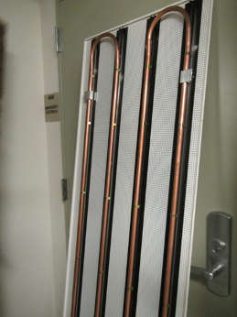

Construction of ceiling tile system with heating/cooling coils
Picture 2

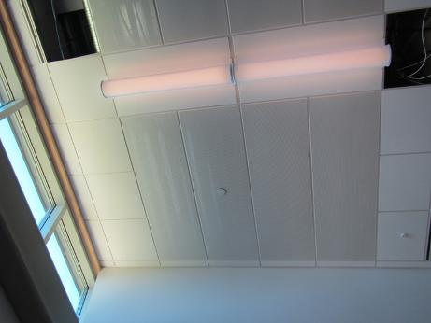

Condensation on ceiling tiles

