INDOOR AIR QUALITY ASSESSMENT

Department of Industrial Accidents,
Public Information Unit
1 Congress Street, 10th Floor
Boston MA 02114

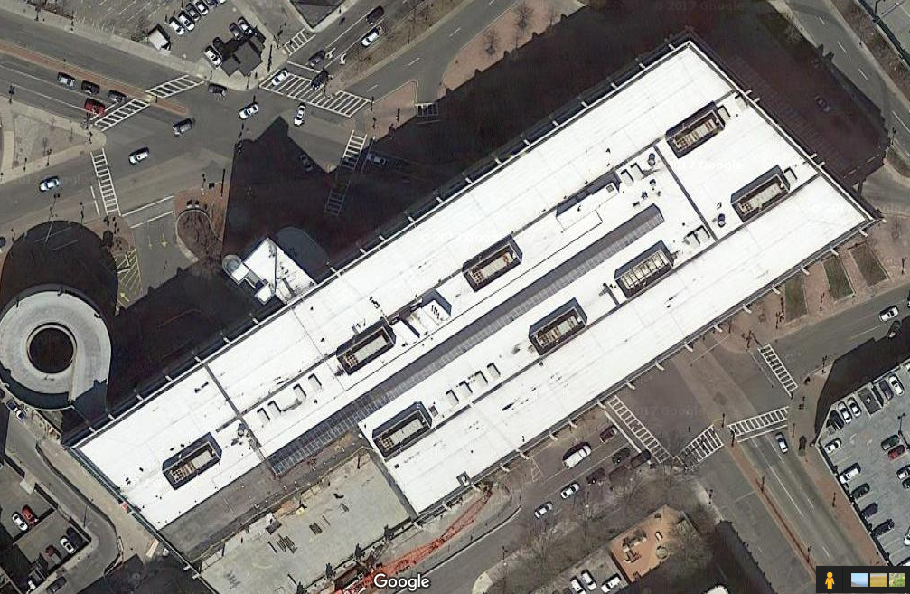

Prepared by:
Massachusetts Department of Public Health
Bureau of Environmental Health
Indoor Air Quality Program
December 2017

Background
Building: | Department of Industrial Accidents (DIA),  Public Information Unit (PIU)
Address: | 1 Congress Street, 10th Floor  Boston MA
Assessment Requested by: | Stephanie Ross  Director of Internal Control and Security & Interim Director of Labor Relations  Executive Office of Labor and Workforce Development (EOLWD)
Reason for Request: | Indoor Air Quality (IAQ) and health concerns relating to construction
Date of Assessment: | December 7, 2017
Massachusetts Department of Public Health/Bureau of Environmental Health (MDPH/BEH) Staff Conducting Assessment: | Ruth Alfasso, Environmental Engineer, indoor air quality (IAQ) Program
Building Description: | The area assessed is on the 10th floor of One Congress Street. Only one area of this suite was assessed at this time.
Windows: | Not openable

One Congress Street/the adjacent Government Center Garage are undergoing a large construction project called Bullfinch Crossing. Construction activities have included demolition of portions of the original garage, which was a source of noise and vibration. Demolition work was completed therefore limiting noise/vibration concerns for a few weeks prior to the assessment. However, other construction activities will be ongoing until 2019, including work in another part of the 10th floor of One Congress Street.

Methods
Please refer to the IAQ Manual for methods, sampling procedures, and interpretation of results (MDPH, 2015).

IAQ Testing Results
The following is a summary of indoor air testing results (Table 1).
- Carbon dioxide levels were below or very close to 800 parts per million (ppm) in all areas surveyed, indicating adequate air exchange.
- Temperature was within the recommended range of 70°F to 78°F in all areas tested.
- Relative humidity was below the recommended range of 40 to 60% in the areas tested which is typical during the heating season.
- Carbon monoxide levels were non-detectable (ND) in all areas tested.
- Fine particulate matter (PM2.5) concentrations measured were below the National Ambient Air Quality (NAAQS) limit of 35 μg/m³ in all areas tested.

Note that in addition to the Public Information Unit (PIU) suite, an adjacent area was tested (the Judges area, Table 1) for comparison. Results showed that the indoor air quality parameters between the two areas were very similar.

Ventilation
A heating, ventilating, and air conditioning (HVAC) system has several functions. First it provides heating and, if equipped, cooling. Second, it is a source of fresh air. Finally, an HVAC system will dilute and remove normally-occurring indoor environmental pollutants by not only introducing fresh air, but by filtering the airstream and ejecting stale air to the outdoors via exhaust ventilation. Even if an HVAC system is operating as designed, point sources of respiratory irritation may exist and cause symptoms in sensitive individuals.
Fresh air is provided by air handling units (AHUs). Ducts carry air from the AHUs to offices and distribute tempered air via supply vents (Picture 1). Return air is drawn into ceiling-mounted vents (Picture 2) and brought back to AHUs.
The assessment results indicate that the ventilation system is providing adequate fresh air for the current occupancy. It is recommended that HVAC systems be re-balanced every five years to ensure adequate air systems function (SMACNA, 1994). It is unknown when the last time this system was balanced.
It is reported that there are carbon dioxide sensors in the waiting area, which is adjacent to the PIU which were installed to allow additional fresh air into the waiting area when carbon dioxide levels rise. Note that these sensors need to be calibrated or replaced periodically to ensure proper function.

Microbial/Moisture Concerns
No water-damaged materials were found in the areas examined. Common sources of water damage and odors in offices include plants, especially if not properly maintained, and water coolers/refrigerators, which be a source of water spills and leaks that moisten the carpet.

Other IAQ Evaluations
Exposure to low levels of total volatile organic compounds (TVOCs) may produce eye, nose, throat, and/or respiratory irritation in some sensitive individuals. To determine if VOCs were present, BEH/IAQ staff examined rooms for products containing VOCs. Office occupants expressed concerns regarding printers and copy machines, which can be sources of TVOCs and particulates, especially if heavily used. These should be located away from occupants and, when possible, near an exhaust vent. Other common sources of TVOCs include cleaners, hand sanitizers, air fresheners, and other products which have the potential to be irritants to the eyes, nose, throat, and respiratory system of sensitive individuals.
As mentioned above, there construction in and adjacent to this office will be ongoing over the next two years. While specific impacts will vary depending on the activities being performed, construction can be a source of noise, dusts, odors, and other issues. Included as Appendix A is the BEH/IAQ document “Methods Used to Reduce/Prevent Exposure to Construction/Renovation Generated Pollutants in Occupied Buildings” which should be used to minimize disruption to occupants during the construction.
Some measures to prevent migration of construction-related dusts were in place in the office and surrounding area, including plastic coverings on carpets in the outside hallway (Picture 3). Part of the floor is sectioned off by walls between occupied and construction areas that are complete from floor-to-ceiling. Reportedly no HVAC system connections exist between occupied and unoccupied areas. A door between the occupied area and the vacant area had a walk-off mat to prevent dusts from migrating when this door is used (Picture 4). However, there was a visible gap underneath the door, which can allow unconditioned air and dusts to travel into the occupied area if the vacant area becomes pressurized.
Because of the timing of this visit, concerns regarding conditions a few weeks before the assessment could not be directly addressed. However it can be anticipated that future vibration/noise will occur as this project moves to completion. Occupants reported symptoms during a period where construction/demolition activities could be heard/felt strongly in the office. Noise can be annoying and distracting in itself. Loud, rhythmic noises and other vibrations can also dislodge debris from ceiling tiles or aerosolize dust from surfaces. Increased cleaning should be conducted to minimize these effects.
Most offices were carpeted. Carpets and area rugs should be vacuumed regularly with a HEPA-filter-equipped vacuum cleaner and cleaned annually (or semi-annually in soiled/high traffic areas) in accordance with Institute of Inspection, Cleaning and Restoration Certification (IICRC) recommendations, (IICRC, 2012).

Conclusions/Recommendations
Based on observations at the time of assessment, the following is recommended:
- Operate supply and exhaust ventilation continuously in all areas during occupied periods. Ensure all HVAC equipment is cleaned/maintained in accordance with manufacturer’s instructions including filter changes.
- Have the HVAC system balanced every 5 years in accordance with SMACNA recommendations (SMACNA, 1994).
- Calibrate and/or replace the carbon dioxide sensors in the waiting room in accordance with manufacturer’s instructions.
- For buildings in New England, periods of low relative humidity during the winter are often unavoidable. Therefore, scrupulous cleaning practices should be adopted to minimize common indoor air contaminants whose irritant effects can be enhanced when the relative humidity is low. To control for dusts a HEPA-filter-equipped vacuum cleaner in conjunction with wet wiping of all surfaces is recommended. Avoid the use of feather dusters. Drinking water during the day can help ease some symptoms associated with a dry environment (throat and sinus irritations).
- Minimize the use of cleaning products, sanitizers, and other items that contain VOCs, particularly scented products.
- Locate printers and copiers away from occupants and in areas with exhaust vents when possible.
- Consult Appendix A, “Methods Used to Reduce/Prevent Exposure to Construction/Renovation Generated Pollutants in Occupied Buildings” for information on how to avoid construction-related impacts.
- Apply weather-stripping to the door shown in Picture 4 to prevent any migration of dusts and odors.
- Clean dust and debris from ventilation equipment, including supply and exhaust vents, radiators and the blades of personal fans to prevent aerosolization of dust. Increase cleaning as needed due to vibration and other construction impacts.
- Clean carpeting annually or more frequently per the recommendations of the Institute of Inspection, Cleaning and Restoration Certification (IICRC).
- Refer to resource manual and other related IAQ documents located on the MDPH’s website for further building-wide evaluations and advice on maintaining public buildings. These documents are available at: http://mass.gov/dph/iaq.

References
IICRC. 2012. Institute of Inspection, Cleaning and Restoration Certification. Carpet Cleaning: FAQ. Retrieved from http://www.iicrc.org/consumers/care/carpet-cleaning.
MDPH. 2015. Massachusetts Department of Public Health. Indoor Air Quality Manual: Chapters I-III. Available at: http://www.mass.gov/eohhs/gov/departments/dph/programs/environmental-health/exposure-topics/iaq/iaq-manual/.
SMACNA. 1994. HVAC Systems Commissioning Manual. 1st ed. Sheet Metal and Air Conditioning Contractors’ National Association, Inc., Chantilly, VA.

Picture 1
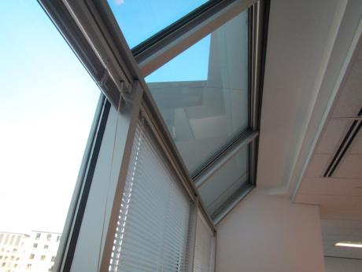
Supply vent near window area (arrow)
Picture 2
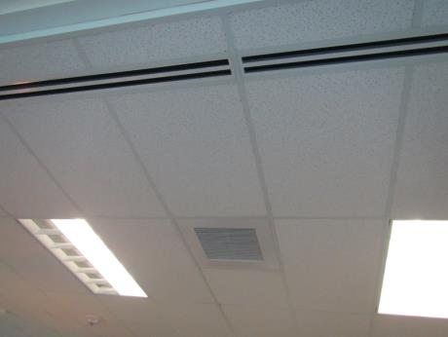
Return vent
Picture 3
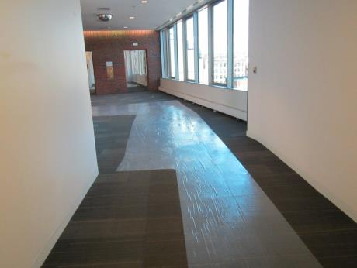
Plastic protecting carpeting
Picture 4
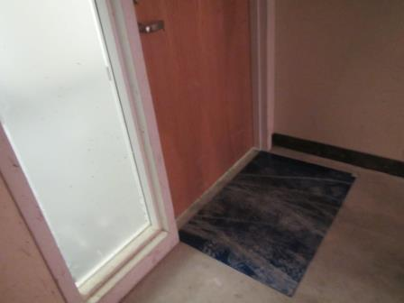
Walk-off mat between vacant area with construction activities and occupied-space hallway, note gap under door
Location | Carbon  Dioxide  (ppm) | Carbon Monoxide  (ppm) | Temp  (°F) | Relative  Humidity  (%) | PM2.5  (µg/m³) | Occupants  in Room | Windows  Openable | Ventilation |  | Remarks
 |  |  |  |  |  |  |  | Supply | Exhaust
Background | 395 | ND | 52 | 21 | 9 |  |  |  |  | Sunny, windy
Public information near waiting room | 809 | ND | 70 | 23 | 2 | 2 | N | Y | Y
Powers cube area | 620 | ND | 71 | 21 | 2 | 1 | N | Y | Y
Open area | 582 | ND | 71 | 20 | 2 | 1 | N | Y | Y
Control area
Judges’ area, other side of door | 621 | ND | 71 | 20 | 2 | 0 | N | Y | Y

