INDOOR AIR QUALITY ASSESSMENT

Department of Industrial Accidents
1 Father DeValles Boulevard
Fall River, Massachusetts

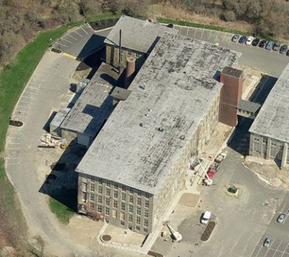

Prepared by:
Massachusetts Department of Public Health
Bureau of Environmental Health
Indoor Air Quality Program
August 2016

BACKGROUND
Building: | Department of Industrial Accidents (DIA)
Address: | 1 Father DeValles Boulevard
Assessment Requested by: | John O’Donnell, Division of Capital Asset Management & Maintenance (DCAMM)
Reason for Request: | Battery/chemical release, indoor air quality (IAQ) concerns
Date of Assessment: | August 8, 2016
Massachusetts Department of Public Health/Bureau of Environmental Health (MDPH/BEH) Staff Conducting Assessment: | Mike Feeney, Director and Cory Holmes, Environmental Analyst/Inspector IAQ Program
Date of Building Construction: | Early 1900s
Building Description: | Former stone mill building developed into an office park; DIA is located on the 3rd floor.
Building Population: | Approximately 15-20 staff, can have up to 100 visitors daily.
Windows: | Windows are designed to be opened but reportedly sealed shut by building management for thermal control reasons.

Occuhealth Recommendations
The IAQ program conducted a site visit on August 8, 2016. The bulk of this report summarizes that site visit. However, on August 8, 2016 the DIA was also visited by Mr. Tom Hamilton, Certified Industrial Hygienist, from OccuHealth, Inc. (OHI) an Environmental Consultant firm. Shortly after the visit by OccuHealth, Mr. Hamilton provided the following preliminary findings/recommendations:
- Replace ceiling tiles in the IT room that were exposed to chemicals during the battery release.
- Contact the manufacturers for proper instructions to have the interior of equipment in the IT room thoroughly cleaned.
- Seal the open duct found above the ceiling in the IT room and have it properly labeled in case of future use.
- Inspect the electrical panel on the wall behind the Eaton battery unit in the IT room.
- Evaluate the heating, ventilating and air-conditioning (HVAC) system for provision of fresh air introduction.
- Clean additional offices serviced by the fan coil unit (FCU) outside Regional Director’s office.
- Work with battery manufacturer to determine why meltdown occurred to prevent reoccurrence; and
- Perform a complete fresh air “Flush” of the building if possible, based on the evaluation of the HVAC system (OHI, 2016).

METHODS
Please refer to the IAQ Manual and appendices for methods, sampling procedures, and interpretation of results (MDPH, 2015).

BACKGROUND
It was reported by DIA staff that due to a malfunction of the air conditioning (AC) system, elevated temperatures were experienced in the IT/computer equipment room that reportedly caused lead acid batteries to expand, releasing gas/odors into the air (likely including sulfuric acid) (Picture 1). In the days following, DIA staff reportedly experienced symptoms including metallic taste in mouth and allergenic and respiratory irritation. As a result, a professional remediation company, Service Master, was contacted to conduct clean-up of the space. Service Master cleaned the flat surfaces in the office and used air scrubbers to remove contaminants from the air.

RESULTS and DISCUSSION
The following is a summary of MDPH indoor air testing results (Table 1):
- Carbon dioxide levels were above the MDPH recommended guideline of 800 parts per million (ppm) in all but two areas surveyed, which indicates a limited introduction of fresh air/air exchange at the time of assessment.
- Temperature was within the MDPH recommended range of 70°F to 78°F in all areas tested.
- Relative humidity was within the MDPH recommended range of 40 to 60% in all areas tested.
- Carbon monoxide levels were non-detectable in all areas tested.
- Particulate matter (PM2.5) concentrations measured were below the National Ambient Air Quality (NAAQS) level of 35 μg/m³ in all areas tested.
- Total Volatile Organic Compounds (TVOCs) were measured at very slight concentrations (< 1.0 ppm) in all areas tested.

Odors
At the time of the MDPH/BEH assessment, no sulfur-related odors were detected; however a few DIA staff members were reporting on-going symptoms of irritation. Sulfuric acid vapor will interact with copper to cause it to have a darkened stain (Picture 2). No darkened copper piping was noted in the ceiling plenum above the IT room (Picture 3). This finding indicates that sulfuric acid vapor was confined mostly to the IT room interior. As reported by Mr. Hamilton, surface pH samples of areas in the IT room were neutral, indicating that no acid residue was detected on sampled surfaces.
It is possible that these symptoms resulted from the presence of plastic residue that melted and became aerosolized during this incident. Burnt plastic odor can be irritating to the eyes, nose and respiratory system. Of note was a clear plastic tape that was wrapped around the batteries (Picture 1). It is possible the heat and/or sulfuric acid caused the clear plastic to degrade and release plastic residue into the air. In addition, insulation on piping within the air-conditioning (AC Unit) installed in the IT Room appears to have melted (Picture 4).
If melted plastic becomes airborne, any device that either directs air by convection (e.g., electrical panels) or by powered fans (e.g., computer equipment, return air ducts) can draw these materials in the air, which would readily coat surfaces within the air stream. Such equipment could serve as a reservoir for continuous odors. Of note was the existence of an open and operating return duct above the IT room in the ceiling plenum (Picture 5), which appeared to have been previously used for airflow. This duct appears to be connected to the general HVAC system, which can draw odors/particulates and distribute them to other areas of the floor.
During this assessment, BEH/IAQ staff identified the use of an operating air scrubber in the main hallway. This equipment emits hydroxylated oxygen to neutralize odors. This type of equipment is not recommended for use in occupied spaces since it can cause respiratory irritation in exposed individuals.
Finally, because the battery failure likely caused the release of plastic residue and a return vent exists in the ceiling plenum above the IT room, the ceiling tile system itself could serve as a lingering source of odors. Ceiling tiles are a porous material that can absorb odors and cannot be readily cleaned once exposed to plastic/chemical residue.

Ventilation
A heating, ventilating, and air conditioning (HVAC) system has several functions. First it provides heating and, if equipped, cooling. Second, it is a source of fresh air. Finally, an HVAC system will dilute and remove normally occurring indoor environmental pollutants by not only introducing fresh air, but by filtering the airstream and ejecting stale air to the outdoors via exhaust ventilation. Even if an HVAC system is operating as designed, point sources of respiratory irritation may exist and cause symptoms in sensitive individuals. Due to the elevated carbon dioxide readings, it would appear that the HVAC system was not bringing in adequate fresh/outside air and/or not providing adequate air exchange.
The HVAC system consists of a number of fan coil units (FCUs, Picture 6) located above ceiling tiles throughout the floor. It was not clear how or if these units provided fresh outside air to the space. Air is filtered, heated/cooled, and directed to occupied spaces via ducted ceiling vents (Picture 7). Return air is vented through ceiling-mounted vents back to the FCUs (Picture 8). The system is controlled by digital wall thermostats. IAQ staff examined the abandoned return vent (Picture 5) and traced it to a FCU unit in the ceiling of the hallway on the northwest corner of the building. Of note is that this same duct completely traverses the ceiling plenum above the adjacent courtroom ceiling, with no return/intake opening that would draw air from the occupied space.

Microbial/Moisture Concerns
In order for building materials to support mold growth, a source of water is necessary. Water-damaged ceiling tiles were found in Court Room 2. These represent areas of roof or plumbing leaks and should be replaced once the leaks are found and repaired.

Other Conditions
Other conditions that can affect IAQ were observed during the assessment. Some areas have wall to wall carpeting. The Institute of Inspection, Cleaning, and Restoration Certification (IICRC) recommends that carpeting be cleaned annually (or semi-annually in soiled high traffic areas) (IICRC, 2012). Regular cleaning with a high efficiency particulate air (HEPA) filtered vacuum in combination with an annual cleaning will help to reduce accumulation and potential aerosolization of materials from carpeting.
Several supply, exhaust, and return vents were observed to have accumulated dust/debris. If exhaust vents are not functioning, backdrafting can occur, which can re-aerosolize accumulated dust particles. Supply vents can aerosolize accumulated dust once activated.

CONCLUSIONS and RECOMMENDATIONS
In view of the findings at the time of the visit, the following recommendations are made:
- Implement the recommendations made by OHI, particularly those in relation to examining the HVAC system for adequate introduction of fresh/outside air.
- Examine whether the insulation in Picture 4 has melted and replace if needed.
- Consider relocating unused return duct found in the ceiling plenum above IT Equipment room to adjacent courtroom.
- Ensure roof/plumbing leaks are repaired and replace any water-damaged ceiling tiles.
- Consider adopting a balancing schedule of every 5 years for all mechanical ventilation systems, as recommended by ventilation industrial standards (SMACNA, 1994).
- For buildings in New England, periods of low relative humidity during the winter are often unavoidable. Therefore, scrupulous cleaning practices should be adopted to minimize common indoor air contaminants whose irritant effects can be enhanced when the relative humidity is low. To control for dusts, a high efficiency particulate arrestance (HEPA) filter equipped vacuum cleaner in conjunction with wet wiping of all surfaces is recommended. Avoid the use of feather dusters. Drinking water during the day can help ease some symptoms associated with a dry environment (throat and sinus irritation).
- Clean supply, exhaust and return vents periodically of accumulated dust.
- Clean carpeting annually or semi-annually in soiled high traffic areas as per the recommendations of the Institute of Inspection, Cleaning and Restoration Certification (IICRC, 2012).
- Refer to resource manual and other related indoor air quality documents located on the MDPH’s website for further building-wide evaluations and advice on maintaining public buildings. These documents are available at http://mass.gov/dph/iaq.

REFERENCES
IICRC. 2012. Institute of Inspection, Cleaning and Restoration Certification. Carpet Cleaning: FAQ. Retrieved from http://www.iicrc.org/consumers/care/carpet-cleaning/#faq.
MDPH. 2015. Massachusetts Department of Public Health. Indoor Air Quality Manual: Chapters I-III. Available at: http://www.mass.gov/eohhs/gov/departments/dph/programs/environmental-health/exposure-topics/iaq/iaq-manual/.
OHI. 2016. OccuHealth Inc. Email “Site visit preliminary initial findings, DIA offices Fall River” from Tom Hamilton to Paul Przystarz DTA. August 09, 2016.
SMACNA. 1994. HVAC Systems Commissioning Manual. 1st ed. Sheet Metal and Air Conditioning Contractors’ National Association, Inc., Chantilly, VA.
Picture 1
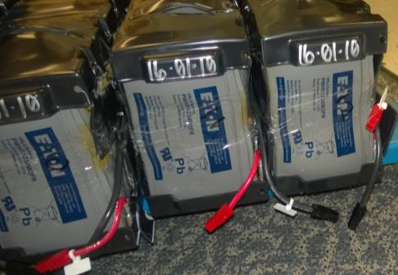
Computer room battery, note distended shape and clear plastic wrap/tape
(Photo provided by Paul A. Przystarz, Regional Manager, Department of Industrial Accidents)

Picture 2
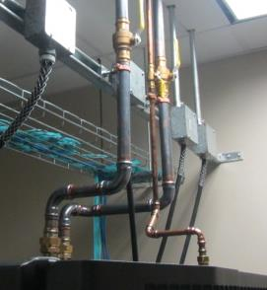
Darkened copper pipe in IT room
Picture 3
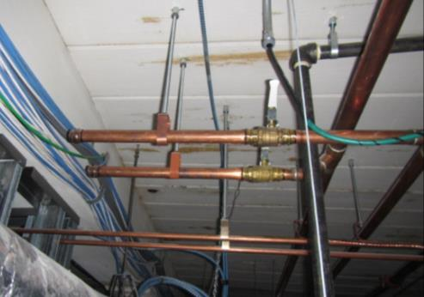
Non-discolored pipe in ceiling plenum above IT room
Picture 4
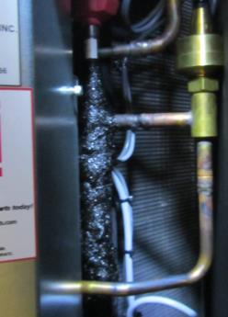
Possibly melted insulation, note copper pipe discoloration adjacent to insulation
Picture 5
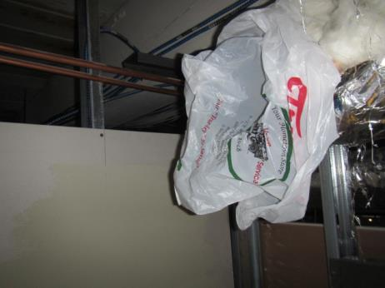
Open return vent above IT room (sealed with shopping bag by BEH/IAQ staff)
Picture 6
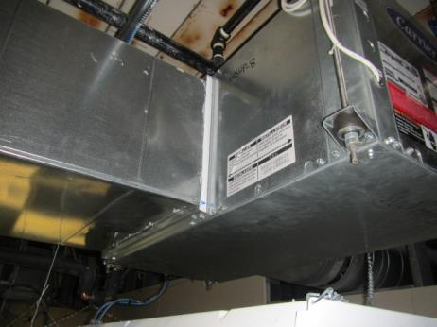
FCU in ceiling plenum
Picture 7
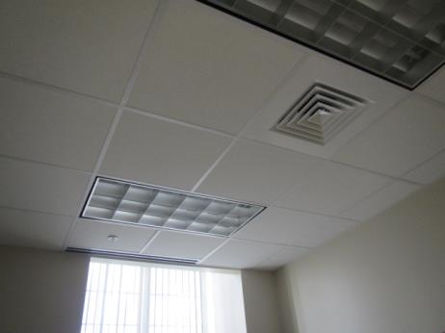
Fresh air supplies
Picture 8
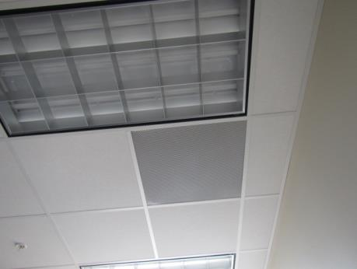
Return vent
Location | Carbon  Dioxide  (ppm) | Carbon Monoxide  (ppm) | Temp  (°F) | Relative  Humidity  (%) | TVOCs  (ppm) | PM2.5  (µg/m³) | Occupants  in Room | Windows  Openable | Ventilation |  |  | Remarks
 |  |  |  |  |  |  |  |  | Intake | Exhaust
Background (outside) | 385 | ND | 86 | 36 | ND | 6 |  |  |  |  |  | Partly cloudy, hot
Regional Manager | 946 | ND | 73 | 49 | 0.2 | ND | 4 | N | Y |  | Y
Admin Judge Vendetti | 908 | ND | 73 | 49 | 0.2 | ND | 0 | N | Y |  | Y
Admin Secretary (Vendetti) | 1005 | ND | 74 | 49 | 0.2 | ND | 0 | N | Y |  | Y
Hallway (Reg Mgr) | 908 | ND | 74 | 48 | 0.2 | 1 | 0 |  |  |  |  | Air Purifier (oxygen hydroxylator)
Admin Secretary (Sullivan) | 889 | ND | 74 | 45 | 0.2 | 1 | 0 | N | Y |  | Y
Equipment Room | 930 | ND | 74 | 45 | 0.3 | 1 | 3 | N | N |  | Y* | *Abandoned return duct found above ceiling tile system
Judge Sullivan | 929 | ND | 75 | 47 | 0.3 | ND | 1 | N | Y |  | Y
Judge Vierra | 841 | ND | 74 | 46 | 0.3 | 1 | 0 | N | Y |  | Y
Judge McManus | 825 | ND | 74 | 46 | 0.3 | 1 | 0 | N | Y |  | Y
Admin Secretary McElroy | 876 | ND | 74 | 46 | 0.3 | 5 | 0 | N | Y |  | Y
Admin Secretary Briggs | 873 | ND | 74 | 47 | 0.3 | 1 | 1 | N | Y |  | Y
Assigned Admin Judge | 855 | ND | 74 | 46 | 0.3 | 1 | 0 | N | Y |  | Y
Stenography | 955 | ND | 75 | 46 | 0.3 | ND | 2 | N | Y |  | y
Staff Room | 966 | ND | 75 | 48 | 0.4 | 1 | 1 | N | Y |  | Y
Conference Room | 815 | ND | 74 | 49 | 0.3 | 1 | 0 | N | Y |  | Y
Front Office | 874 | ND | 75 | 50 | 0.4 | 1 | 3 | N | Y |  | Y
Conciliator Cox | 866 | ND | 74 | 48 | 0.3 | 3 | 0 | N | Y |  | Y
Conciliator Townley | 827 | ND | 74 | 51 | 0.4 | 1 | 0 | N | Y |  | Y | Former window leak-drooping paint
VR Review OFC | 843 | ND | 75 | 51 | 0.4 | 1 | 0 | N | Y |  | Y
Conciliator Gonsalves | 906 | ND | 74 | 52 | 0.4 | 1 | 1 | N | Y |  | Y
Attorney Lounge | 935 | ND | 74 | 52 | 0.4 | 1 | 1 | N | Y |  | Y
Lobby | 904 | ND | 74 | 51 | 0.4 | 1 | 6 | N | Y |  | Y
Travelling Staff | 909 | ND | 74 | 51 | 0.4 | 1 | 0 | N | Y |  | Y | Dust/debris on vents
Court Room 1 | 743 | ND | 74 | 45 | 0.4 | 1 | 0 | N | Y |  | Y
Court Room 2 | 711 | ND | 74 | 44 | 0.3 | 2 | 0 | N | Y |  | Y | 6 WD CT
Court Room 3 | 840 | ND | 74 | 48 | 0.4 | 1 | 0 | N | Y |  | Y
Court Room 4 | 865 | ND | 73 | 48 | 0.3 | 1 | 0 | N | Y |  | Y

