**INDOOR AIR QUALITY ASSESSMENT**

**Department of Labor and Standards, Legal Office**

**19 Staniford St, 2nd floor**

**Boston, MA 02114**

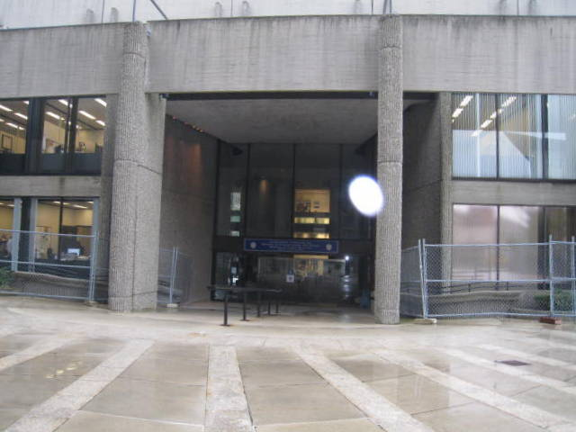

Prepared by:

Massachusetts Department of Public Health

Bureau of Environmental Health

Indoor Air Quality Program

May 2016

# Background

|  |  |
| --- | --- |
| Building: | Department of Labor and Standards (DLS), Legal Office |
| Address: | 19 Staniford St, 2nd floor, Boston, MA |
| Assessment Requested by: | Barbara Shultze, Administrative Assistant, Legal Office |
| Reason for Request: | Respiratory concerns/general assessment |
| Date of Assessment: | May 4, 2016 |
| Massachusetts Department of Public Health/Bureau of Environmental Health (MDPH/BEH) Staff Conducting Assessment: | Sharon Lee, Environmental Analyst, Indoor Air Quality (IAQ) Program |
| Building Description: | Multi-story concrete building |
| Office Population: | 10 staff members |
| Year of Construction: | 1960s |
| Windows: | Not openable |

# Methods

Please refer to the IAQ Manual for methods, sampling procedures, and interpretation of results (MDPH, 2015).

# Results and Discussion

The following is a summary of indoor air testing results (Table 1).

* ***Carbon dioxide levels*** were below 800 parts per million (ppm) in areas tested, indicating adequate fresh air. Some areas were not populated; carbon dioxide levels may increase with occupancy.
* ***Temperature*** was within the recommended range of 70°F to 78°F in test areas.
* ***Relative humidity*** was below the recommended range of 40% to 60% in all areas tested.
* ***Carbon monoxide*** was not detected in any areas tested.
* ***Fine particulate matter (PM2.5)*** concentrations measured were below the National Ambient Air Quality Standard (NAAQS) level of 35 μg/m3 in all areas tested.

## Ventilation

Mechanical ventilation is provided by air handling units (AHUs). Ducts carry air from the AHUs to offices and distribute tempered air via supply vents. Additional air circulation is provided by induction units located along the base of windows (Picture 1). Return air is drawn into ceiling-mounted vents and brought back to AHUs.

To maximize air exchange, the BEH recommends that mechanical ventilation systems operate continuously during periods of occupancy. Without the system operating as designed, normally occurring pollutants cannot be diluted or removed, allowing them to build up and lead to IAQ/comfort complaints. It is recommended that HVAC systems be re-balanced every five years to ensure adequate air systems function (SMACNA, 1994).

## Microbial/Moisture Concerns

Signs of water leakage were observed in a number of areas, particularly near windows indicating water penetration likely though the window systems. BEH/IAQ staff observed water staining and evidence of water dripping from the windows (Picture 2). Efflorescence was also observed where water had dripped. Efflorescence is a characteristic sign of water damage caused by salts and mineral deposits from water filtrating through materials such as brick and concrete. Water laden with salt and minerals likely drips onto the induction units. When the water evaporates, salts and minerals that remain can become aerosolized, causing eye and respiratory irritation.

Water-damaged ceiling tiles were observed in one office (Table 1). The source of water should be investigated and repaired. The stained tile should be replaced after appropriate repairs are made. Ceiling tiles should be monitored, and water stains should be reported.

Refrigerators were observed in some offices (Table 1). These small appliances were placed directly on carpet. Water dispensers were also placed directly on carpet. These appliances can be sources of water that can chronically moisten carpet.

The US Environmental Protection Agency (US EPA) and the American Conference of Governmental Industrial Hygienists (ACGIH) recommend that porous materials be dried with fans and heating within 24 to 48 hours of becoming wet (US EPA, 2008; ACGIH, 1989). If porous materials are not dried within this time frame, mold growth may occur. Once mold has colonized porous materials, they are difficult to clean and should be removed and discarded.

## Other IAQ Evaluations

### Particulate Matter

Dust was observed on flat surfaces (Picture 3), including induction units (Picture 1), in a number of locations. Accumulated debris was also observed along the base of induction units. Dust and debris settled on ventilation equipment can be re-aerosolized when the system is activated. Measures should be taken to clean these and other flat surfaces to prevent continued distribution of dust and particulate matter, which can cause eye and respiratory irritation.

### Other Concerns

Staff seated in office spaces within the Legal Office reported eye irritation, chronic coughing, and sneezing. These offices are configured such that occupants sit facing or are near the induction radiators. Air from the induction units passes across the face of a seated occupant can irritate the skin, eyes, and respiratory system, particularly in the winter time when the indoor relative humidity is low. Furthermore, as discussed prior, debris settled on the surfaces of these units can become aerosolized and cause irritation.

Carpet tiles are lifting from the floor (Picture 4). Mastics used to adhere carpet tiles to the cement floor can breakdown to small irritating particles. Cement dust from below carpet tiles can also be aerosolized, causing respiratory and eye irritation. In addition, carpet tiles that are not flush can be tripping hazards.

# Conclusions/Recommendations

A number of conditions contribute to the irritant symptoms reported by DLS legal staff. Staff in offices seated in close proximity to the induction units may experience irritation from aerosolization of dust/debris that may settle onto the surface of units or from air that is supplied by the units. Based on observations at the time of assessment, the following is recommended:

1. Clean flat surfaces on a regular basis using a high efficiency particulate arrestance (HEPA) filtered vacuum and damp cloth.
2. Install low cubicle walls or acrylic glass sheets to direct air upwards and away from seated occupants.
3. Increase water intake during periods of low humidity. The sensation of dryness and irritation is common in a low relative humidity environment. Low relative humidity conditions occur during the heating season in the northeast part of the United States.
4. Examine areas with signs of water damage and make appropriate repairs.
5. Place refrigerators and water dispensers in an area with non-porous flooring or on a waterproof mat.
6. Ensure carpet tiles are flush and adhered to the floor. Work requiring use of mastics and glues should be conducted during non-occupant hours.
7. Assess offices periodically to prevent water damage and microbial growth. Refer to US EPA’s *Mold Remediation in Schools and Commercial Buildings Guide* for assessing water-damaged materials. The guidance is available at <https://www.epa.gov/mold/mold-remediation-schools-and-commercial-buildings-guide>.
8. Refer to resource manual and other related IAQ documents located on the MDPH’s website for further building-wide evaluations and advice on maintaining public buildings. These documents are available at: <http://mass.gov/dph/iaq>.

# References

ACGIH. 1989. Guidelines for the Assessment of Bioaerosols in the Indoor Environment. American Conference of Governmental Industrial Hygienists, Cincinnati, OH.

MDPH. 2015. Massachusetts Department of Public Health. Indoor Air Quality Manual: Chapters I-III. Available at: <http://www.mass.gov/eohhs/gov/departments/dph/programs/environmental-health/exposure-topics/iaq/iaq-manual/>.

SMACNA. 1994. HVAC Systems Commissioning Manual. 1st ed. Sheet Metal and Air Conditioning Contractors’ National Association, Inc., Chantilly, VA.

US EPA. 2008. “Mold Remediation in Schools and Commercial Buildings”. Office of Air and Radiation, Indoor Environments Division, Washington, DC. EPA 402-K-01-001. September 2008. Available at: <http://www.epa.gov/mold/mold-remediation-schools-and-commercial-buildings-guide>.

**Picture 1**

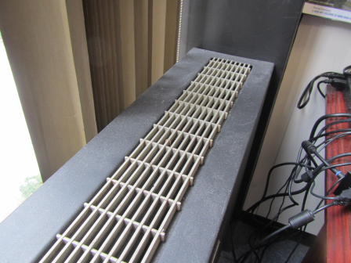

**Induction unit, note settled dust on unit surface**

**Picture 2**

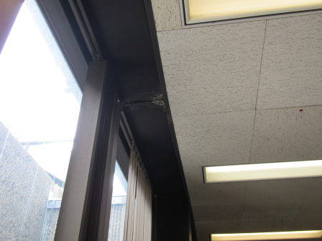

**Water damage and efflorescence from leak**

**Picture 3**

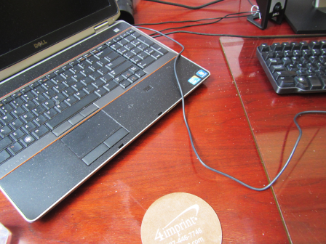

**Dust/debris on laptop and desk**

**Picture 4**

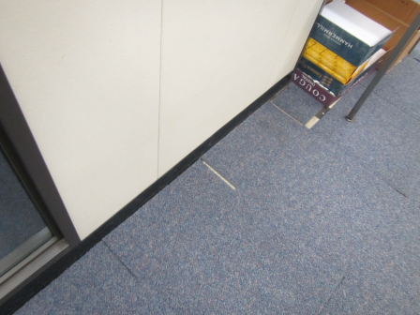

**Carpet tiles lifting/no longer adhered from floor**

| Location | **Carbon**  **Dioxide**  **(ppm)** | **Carbon Monoxide**  **(ppm)** | **Temp**  **(°F)** | **Relative**  **Humidity**  **(%)** | **PM2.5**  **(µg/m**3**)** | **Occupants**  **in Room** | **Windows**  **Openable** | **Ventilation** | | | **Remarks** |
| --- | --- | --- | --- | --- | --- | --- | --- | --- | --- | --- | --- |
| **Intake** | **Exhaust** | |
| Background | 403 | ND | 47 | 35 | 13 |  |  |  | |  | Hot, humid, hazy, measurements taken on roof next to air intakes |
| Wong office | 602 | ND | 72 | 38 | 15 | 0 | N | Y | | Y | DO, dust/debris on desk and induction unit, WD-CT, WD window casing |
| Bungcayao office | 620 | ND | 74 | 35 | 14 | 0 | N | Y | | Y | DO, refrigerator on carpet, debris on induction unit |
| Cubicle opposite Bungcayao office | 616 | ND | 74 | 35 | 14 | 0 | N | Y | | N |  |
| Copier area | 601 | ND | 73 | 35 | 14 | 0 | N | Y | | Y | Dust/debris on induction unit, WD window casing |
| Ronan office | 530 | ND | 73 | 35 | 15 | 0 | N | Y | | Y | DO, ajar CT, refrigerator on carpet |
| Falcon/Coyne cubicle area | 508 | ND | 73 | 35 | 14 | 1 | N | Y | | Y | Ajar CT |
| Shah/Risso/Shultze cubicle area | 556 | ND | 73 | 35 | 13 | 2 | N | Y | | Y |  |