INDOOR AIR QUALITY
WATER DAMAGE ASSESSMENT

Massachusetts Department of Mental Health
Cape Cod & Islands Community Mental Health Center
830 County Road
Pocasset, MA

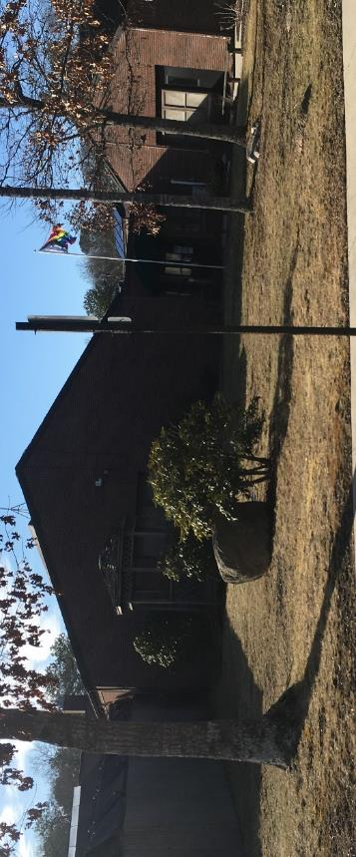

Prepared by:
Massachusetts Department of Public Health
Bureau of Environmental Health
Indoor Air Quality Program
April 2023

BACKGROUND
Building: | Department of Mental Health (DMH) Cape Cod & Islands Community Mental Health Center (CMHC)
Address: | 830 County Road, Pocasset, Bourne, MA
Assessment Requested by: | Travis Sheppard, Facilities Director,  Massachusetts Department of Mental Health
Reason for Request: | Mold odor in a physician bedroom and adjacent room
Date of Assessment: | February 10, 2023
Massachusetts Department of Public Health/Bureau of Environmental Health (MDPH/BEH) Staff Conducting Assessment: | Michael Feeney, Director, Indoor Air  Quality (IAQ) Program
Building Description: | CMHC is a one-story brick building constructed in the 1950’s.
Windows: | Windows are openable.

METHODS
The staff bedroom was examined for mold/odor sources and possible water damage sources. Please refer to the IAQ Manual for methods, sampling procedures, and interpretation of results (MDPH, 2015).

RESULTS AND DISCUSSION

Ventilation
The CMHC is equipped with unit ventilators (univents, Picture 1), installed when the building was originally constructed. Univents are designed to draw air from the outdoors through a fresh air intake located on the exterior wall of the building (Picture 2) and return air through an air intake located at the base of the unit. Fresh and return air are mixed, filtered, heated or cooled and provided to rooms through an air diffuser located in the top of the unit (Figure 1). For adequate ventilation, these units must remain on and be allowed to operate while rooms are occupied.
As reported by CMHC staff, univents are non-functional when the heat is shut off. Based on their condition and age, univents are at the end of their life cycle. Efficient function of equipment of this age (~ 20 years old) is difficult to maintain, since compatible replacement parts are often unavailable. According to the American Society of Heating, Refrigeration, and Air-Conditioning Engineering (ASHRAE), the service life of this type of unit is 15-20 years, assuming routine maintenance of the equipment (ASHRAE, 1991).
The radiator in the staff bedroom is covered with a heavy accumulation of dust and debris (Picture 3). Such materials, if exposed to moisture or high humidity, can become mold colonized and could become a source of odor.

Microbial/Moisture Concerns
A mold odor is reported to periodically exist in a bedroom used by overnight staff. The room contains a radiator that is connected to a heat supply pipe located in a trench in the cement floor slab. The heat supply pipe is designed to deliver heated water to univents and radiators. This trench is approximately a foot from the room’s exterior wall (Picture 4) and is covered with floor tile. The floor of the trench is covered with crumbled cement dust (Picture 5) which may indicate water penetration or chronically damp conditions. The following conditions exist in the bedroom that can draw odors from the trench.
- With the system deactivated, the trench is not dried by heat from the heating system.
- When the univent activated, air from the trench would be drawn to the univent fans.
- An exhaust fan in the ceiling depressurizes the bedroom which can draw air from the trench through spaces around radiator pipes (Picture 6).
- The ground outside the exterior wall shows signs of water accumulation along the exterior wall (Picture 7). A downspout empties at the base of the exterior wall (Picture 8), where its downspout diverter has sunken to direct water towards the exterior wall. Soil along the exterior wall has become compressed, which can lead to water pooling. Under conditions of heavy rain or pooling water, water can enter weepholes to both wet the cement slab and prevent exterior wall drying.
- Grass and soil appear to be of a height that buries the exterior wall/cement slab junction. This junction should be exposed above ground level to increase drainage and air drying of brick and cement.
- Accumulated water can also penetrate cement by capillary action to enter the heating pipe trench.
It is highly likely that odors associated with the heating pipe trench occur after rainstorms or during snow melt.

RECOMMENDATIONS
Issues that may increase odors in the staff bedroom are extreme relative humidity and rain during recent summers. Management of buildings in such weather particularly without air conditioning, can be challenging. The following documents can provide guidance that can be used to reduce the impact of hot, humid weather in buildings.
- Mold Growth Prevention During Hot, Humid Weather https://www.mass.gov/service-details/preventing-mold-growth-in-massachusetts-schools-during-hot-humid-weather.
- Remediation and Prevention of Mold Growth and Water Damage in Public Schools https://www.mass.gov/service-details/remediation-and-prevention-of-mold-growth-and-water-damage-in-public-schools-and-buildings-to-maintain-air-quality.
- Methods for Increasing Comfort in Non-air-conditioned Schools https://www.mass.gov/doc/methods-for-increasing-comfort-in-non-air-conditioned-schools/download.
To remedy building problems, two sets of recommendations are made: short-term measures that may be implemented as soon as practicable and long-term measures that will require planning and resources to address overall IAQ concerns. In view of the findings at the time of the visit, the following recommendations are provided:

Short-Term Recommendations

Ventilation
- Clean dust and accumulated debris from radiator in staff bedroom.

Water damage
- Consideration should be given to covering the floor of the bedroom with an airtight, fire-resistant approved floor covering. Openings for radiator pipes should be rendered airtight with an appropriate fire-rated sealing compound.
- Do not store any porous materials that may be subject to mold growth on lower-level floors such as the bedroom.
- Water-damaged material should be removed in a manner consistent with recommendations listed in the US EPA’s “Mold Remediation in Schools and Commercial Buildings” (US EPA, 2008). This work should be performed when the building is unoccupied. In addition, due to the age of the building and the presence of asbestos-containing floor tiles, all work should be done in accordance with state and federal regulations.
- Monitor weather for predicted outdoor relative humidity over 70% for over two consecutive days to implement the guidelines. This is mostly likely to occur during summer heatwave conditions in New England.
- Refer to the resource manual and other related indoor air quality documents located on the MDPH’s website for further building-wide evaluations and advice on maintaining public buildings. These documents are available at http://mass.gov/dph/iaq.

Long-Term Recommendations

Water damage
- Consider re-grading the ground outside the bedroom to prevent water accumulation along the exterior wall. In general, it is recommended that the ground be covered with a water-resistant material with a grade of 6 inches in height by 10 feet in width.
- Repair/redirect gutter downspout to empty water at a distance of at least 5 feet from the exterior wall (Lstiburek, J., 2006).

Ventilation
- The building’s univent system has been abandoned or is non-functional to introduce fresh air into rooms. Consult with a ventilation engineer to determine how best to provide heat and fresh air into the bedroom area as was originally designed.

REFERENCES
ASHRAE. 1991. ASHRAE Applications Handbook, Chapter 33 “Owning and Operating Costs”. American Society of Heating, Refrigeration and Air Conditioning Engineers, Atlanta, GA.

Lstiburek, Joseph, 2006. READ THIS: Before You Design, Build or Renovate. Building Science Corporation, Westford, MA . GM-0602: READ THIS: Before You Design, Build or Renovate | buildingscience.com

MDPH. 2015. Massachusetts Department of Public Health. Indoor Air Quality Manual: Chapters I-III. Available at: https://www.mass.gov/lists/indoor-air-quality-manual-and-appendices
US EPA. 2008. “Mold Remediation in Schools and Commercial Buildings”. EPA 402-K-01-001. United States Environmental Protection Agency, Office of Air and Radiation, Indoor Environments Division, Washington, DC. September 2008. http://www.epa.gov/mold/mold-remediation-schools-and-commercial-buildings-guide.

Figure 1

Unit Ventilator (Univent)

Mixed Air

Air Diffuser

Outdoors Indoors

Fan

Heating/Cooling Coil

Air Mixing Plenum

Filter

Outdoor Return
Air Air

Air
Flow
Control
Louvers

Air Flow

= Fresh Air/Return Air

= Mixed Air

Picture 1
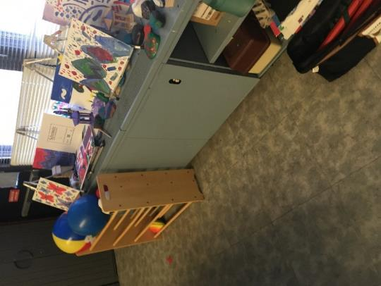
Univent

Picture 2
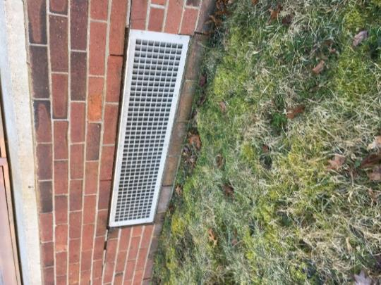
Univent fresh air intake

Picture 3
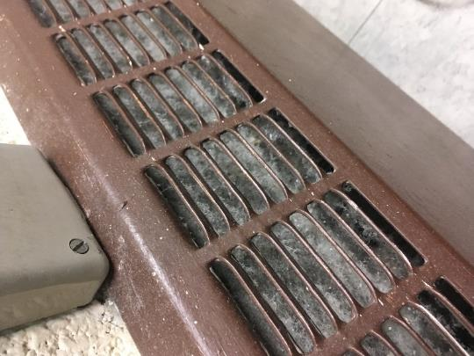
Dust and debris inside staff bedroom radiator

Picture 4
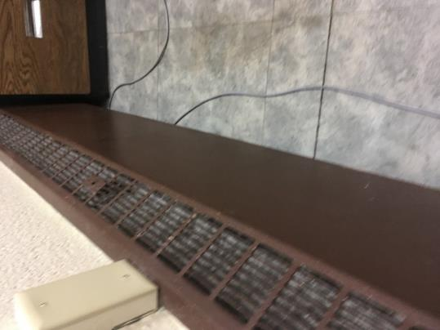
Heating pipe trench

Picture 5
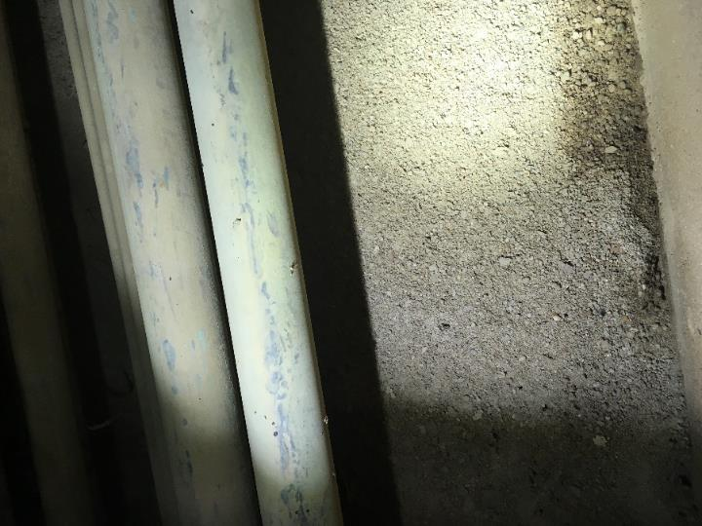
Crumbled cement in the bottom of the heating pipe trench

Picture 6
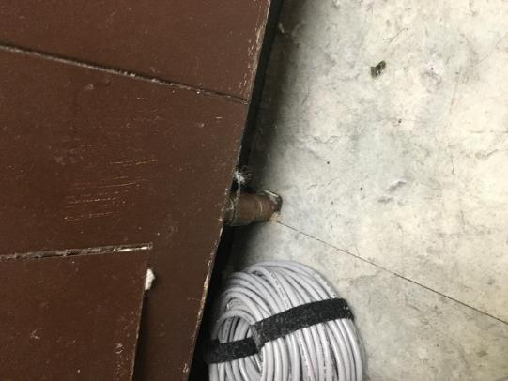
Spaces around radiator heat pipes in bedroom floor

Picture 7
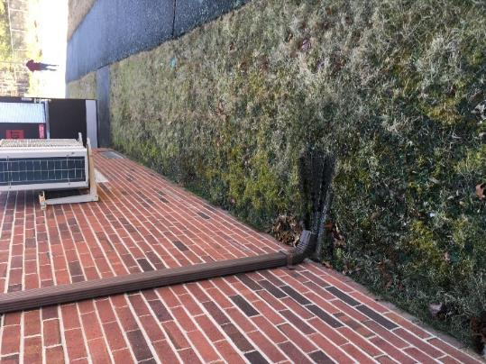
Soil depression next to exterior wall; note moss indicating chronic dampness

Picture 8
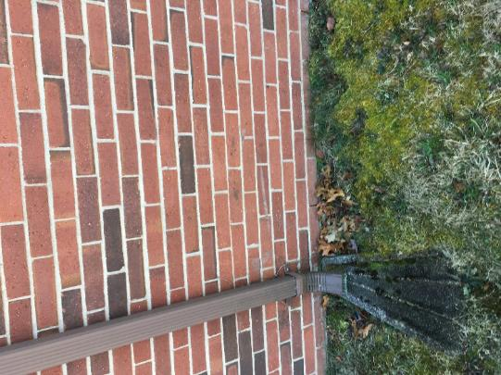
Downspout emptying at wall base

The service life is the median time during which a particular system or component of … [an HVAC]… system remains in its original service application and then is replaced. Replacement may occur for any reason, including, but not limited to, failure, general obsolescence, reduced reliability, excessive maintenance cost, and changed system requirements due to such influences as building characteristics or energy prices (ASHRAE, 1991).

