INDOOR AIR QUALITY ASSESSMENT

Massachusetts Department of Mental Health
Shetland Park Office Complex
35 Congress Street
Salem, Massachusetts

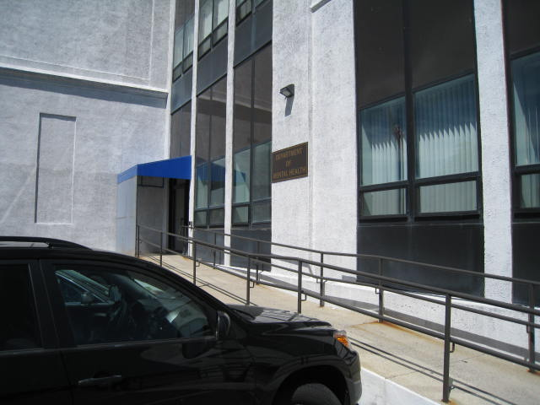

Prepared by:
Massachusetts Department of Public Health
Bureau of Environmental Health
Indoor Air Quality Program
June 2010

Background/Introduction
At the request of Lana Jerome, Director of Human Resources Office of Health for the Executive Office of Health and Human Services (EOHHS), the Massachusetts Department of Public Health (MDPH), Bureau of Environmental Health (BEH) provided assistance and consultation regarding indoor air quality concerns at the offices for the Massachusetts Department of Mental Health (DMH) located in the Shetland Park Office Complex at 35 Congress Street, Salem, Massachusetts. On May 28, 2010, a visit to conduct an indoor air quality assessment was made to the DMH offices by Michael Feeney, Director of BEH’s Indoor Air Quality (IAQ) Program.
The Shetland Park Complex at 35 Congress Street is a four-story office building, originally constructed as a cotton mill in the early 1930s. The building was renovated in the mid-1990s, prior to occupancy by state offices. The DMH occupies space on the ground floor. Windows are openable throughout the building.

Methods
Air tests for carbon monoxide, carbon dioxide, temperature and relative humidity were conducted with the TSI, Q-Trak, IAQ Monitor, Model 8551. Air tests for airborne particle matter with a diameter less than 2.5 micrometers were taken with the TSI, DUSTTRAK™ Aerosol Monitor Model 8520. Screening for total volatile organic compounds (TVOCs) was conducted using a RAE Systems, MiniRAE 2000 Photo Ionization Detector (PID). BEH staff also performed visual inspection of building materials for water damage and/or microbial growth.

Results
The DMH offices have an employee population of approximately 20 and can be visited by up to 10 individuals daily. Tests were taken during normal operations and appear in Table 1.

Discussion

Ventilation
It can be seen from Table 1 that carbon dioxide levels were below 800 parts per million (ppm) in all but one area surveyed during the assessment, indicating adequate air exchange. It is important to note that at the time of assessment a number of areas were unoccupied or sparsely populated, which can greatly reduce carbon dioxide levels. Carbon dioxide levels would be expected to increase with full occupancy. Fresh air is distributed by ceiling-mounted air diffusers. Return air is drawn into ceiling-mounted vents and ducted back to AHUs.
To maximize air exchange, the MDPH recommends that both supply and exhaust ventilation operate continuously during periods of occupancy. In order to have proper ventilation with a mechanical supply and exhaust system, the systems must be balanced to provide an adequate amount of fresh air to the interior of a room while removing stale air from the room. It is recommended that HVAC systems be re-balanced every five years to ensure adequate air systems function (SMACNA, 1994). The date of the last balancing was not available at the time of the assessment, but should have occurred prior to the DMH occupying the space in early 2010.
The Massachusetts Building Code requires that each room have a minimum ventilation rate of 20 cubic feet per minute (cfm) per occupant of fresh outside air or openable windows (SBBRS, 1997; BOCA, 1993). The ventilation must be on at all times that the room is occupied. Providing adequate fresh air ventilation with open windows and maintaining the temperature in the comfort range during the cold weather season is impractical. Mechanical ventilation is usually required to provide adequate fresh air ventilation.
Carbon dioxide is not a problem in and of itself. It is used as an indicator of the adequacy of the fresh air ventilation. As carbon dioxide levels rise, it indicates that the ventilating system is malfunctioning or the design occupancy of the room is being exceeded. When this happens, a buildup of common indoor air pollutants can occur, leading to discomfort or health complaints. The Occupational Safety and Health Administration (OSHA) standard for carbon dioxide is 5,000 parts per million parts of air (ppm). Workers may be exposed to this level for 40 hours/week, based on a time-weighted average (OSHA, 1997).
The MDPH uses a guideline of 800 ppm for publicly occupied buildings. A guideline of 600 ppm or less is preferred in schools due to the fact that the majority of occupants are young and considered to be a more sensitive population in the evaluation of environmental health status. Inadequate ventilation and/or elevated temperatures are major causes of complaints such as respiratory, eye, nose and throat irritation, lethargy and headaches. For more information concerning carbon dioxide, please see Appendix A.
Temperature readings during the assessment ranged from 71º F to 74 º F, which were within the MDPH recommended comfort guidelines in the majority of areas surveyed. The MDPH recommends that indoor air temperatures be maintained in a range of 70 º F to 78 º F in order to provide for the comfort of building occupants. In many cases concerning indoor air quality, fluctuations of temperature in occupied spaces are typically experienced, even in a building with an adequate fresh air supply.
The relative humidity measured in the building during the assessment ranged from 39 to 43 percent, which were within or very close to the lower end of the MDPH recommended comfort range. The MDPH recommends a comfort range of 40 to 60 percent for indoor air relative humidity. Relative humidity levels in the building would be expected to drop during the winter months due to heating. The sensation of dryness and irritation is common in a low relative humidity environment. Low relative humidity is a very common problem during the heating season in the northeast part of the United States.

Microbial/Moisture Concerns
BEH staff examined the ceiling, interior walls and floors for signs of water damage. No signs of water staining/damage and/or visible mold growth were noted within the DMH space.

Other IAQ Evaluations
Indoor air quality can be negatively influenced by the presence of respiratory irritants, such as products of combustion. The process of combustion produces a number of pollutants. Common combustion emissions include carbon monoxide, carbon dioxide, water vapor and smoke (fine airborne particle material). Of these materials, exposure to carbon monoxide and particulate matter with a diameter of 2.5 micrometers (μm) or less (PM2.5) can produce immediate and acute health effects upon exposure. To determine whether combustion products were present in the indoor environment, BEH staff obtained measurements for carbon monoxide and PM2.5.

Carbon Monoxide
Carbon monoxide is a by-product of incomplete combustion of organic matter (e.g., gasoline, wood and tobacco). Exposure to carbon monoxide can produce immediate and acute health affects. Several air quality standards have been established to address carbon monoxide and prevent symptoms from exposure to these substances. The MDPH established a corrective action level concerning carbon monoxide in ice skating rinks that use fossil-fueled ice resurfacing equipment. An operator of an indoor ice must take actions to reduce carbon monoxide levels, if those levels exceed 30 ppm, 20 minutes after resurfacing within a rink (MDPH, 1997).
The American Society of Heating Refrigeration and Air-Conditioning Engineers (ASHRAE) has adopted the National Ambient Air Quality Standards (NAAQS) as one set of criteria for assessing indoor air quality and monitoring of fresh air introduced by HVAC systems (ASHRAE, 1989). The NAAQS are standards established by the US EPA to protect the public health from six criteria pollutants, including carbon monoxide and particulate matter (US EPA, 2006). As recommended by ASHRAE, pollutant levels of fresh air introduced to a building should not exceed the NAAQS levels (ASHRAE, 1989). The NAAQS were adopted by reference in the Building Officials & Code Administrators (BOCA) National Mechanical Code of 1993 (BOCA, 1993), which is now an HVAC standard included in the Massachusetts State Building Code (SBBRS, 1997). According to the NAAQS, carbon monoxide levels in outdoor air should not exceed 9 ppm in an eight-hour average (US EPA, 2006).
Carbon monoxide should not be present in a typical, indoor environment. If it is present, indoor carbon monoxide levels should be less than or equal to outdoor levels. No measureable levels of carbon monoxide were detected inside the building during the assessment (Table 1). However, of note is the location of parking spaces immediately below the DMH windows. If vehicles are idling in the parking spaces, vehicle exhaust (including carbon monoxide) may enter the DMH space through windows under southerly/westerly wind conditions. Massachusetts law limits vehicle idling to 5 minutes (M.G.L. 1986).

Particulate Matter
The US EPA has established NAAQS limits for exposure to particulate matter. Particulate matter is airborne solids that can be irritating to the eyes, nose and throat. The NAAQS originally established exposure limits to particulate matter with a diameter of 10 μm or less (PM10). According to the NAAQS, PM10 levels should not exceed 150 micrograms per cubic meter (μg/m3) in a 24-hour average (US EPA, 2006). These standards were adopted by both ASHRAE and BOCA. Since the issuance of the ASHRAE standard and BOCA Code, US EPA established a more protective standard for fine airborne particles. This more stringent PM2.5 standard requires outdoor air particle levels be maintained below 35 μg/m3 over a 24-hour average (US EPA, 2006). Although both the ASHRAE standard and BOCA Code adopted the PM10 standard for evaluating air quality, MDPH uses the more protective PM2.5 standard for evaluating airborne particulate matter concentrations in the indoor environment.
PM2.5 levels measured inside the building ranged from 1 to 3 μg/m3 (Table 1), which were well below the NAAQS PM2.5 level of 35 μg/m3. Frequently, indoor air levels of particulates (including PM2.5) can be at higher levels than those measured outdoors. A number of mechanical devices and/or activities that occur indoors can generate particulate during normal operations. Sources of indoor airborne particulates may include but are not limited to: particles generated during the operation of fan belts in the HVAC system; use of stoves and/or microwave ovens in kitchen areas; use of photocopiers, fax machines and computer printing devices; operation of an ordinary vacuum cleaner; and, heavy foot traffic indoors.

Volatile Organic Compounds
Indoor air concentrations can be greatly impacted by the use of products containing volatile organic compounds (VOCs). VOCs are carbon-containing substances that have the ability to evaporate at room temperature. Frequently, exposure to low levels of total VOCs (TVOCs) may produce eye, nose, throat and/or respiratory irritation in some sensitive individuals. For example, chemicals evaporating from a paint can stored at room temperature would most likely contain VOCs. In an effort to determine whether VOCs were present in the building, air monitoring for TVOCs was conducted. An outdoor air sample was taken for comparison. Outdoor TVOC concentrations were ND. No measureable levels of TVOCs were detected in the occupied office space during the assessment, however, a TVOC level of 3 ppm was measured in a restroom (Table 1).
Upon entering the restroom, a strong odor was detected. The source of the odor was two open bottles containing fragrant oil with reed diffusers (Picture 1). Air measurements confirmed that these bottles were the likely source of measureable VOCs. Air deodorizers contain chemicals that can be irritating to the eyes, nose and throat of sensitive individuals. Many air fresheners contain 1,4-dichlorobenzene, a VOC which may cause reductions in lung function (NIH, 2006). Typically, an adequate HVAC exhaust system serves to dilute odors and reduce/eliminate this type of VOC situation.
Further evaluation by BEH staff revealed that the restroom fan is activated/deactivated by a light switch. The fan was deactivated when BEH staff entered the restroom. After the fan was activated, the fragrance odor could be detected in adjacent space (Rooms 108 and109) (Figure 1). BEH staff examined the ceiling plenum of the bathroom and observed that the restroom fan is connected into another duct (Picture 2). This second duct is likely one for the exhaust vent in the Department of Transitional Assistance’s public restroom, which is adjacent to the DMH’s restroom.
BEH staff examined the housing of the restroom fan and found holes in the top of the fan casing; these breaches allowed a steady stream of restroom air into the ceiling plenum (Picture 3). In this condition, odors captured by the restroom exhaust fan would exit through breaches in the fan casing and diffuse into the ceiling plenum where it is subsequently drawn into occupied space by the operation of the HVAC system return vents (Figure 1).
In addition, it does not appear that the restroom vent receives sufficient transfer or make-up air in order to operate efficiently. The space beneath the restroom door appears to be minimal, which would limit airflow into the restroom thereby decreasing the efficiency of the fan. In addition, the restroom exhaust vent should be operating continuously during business hours to allow for rapid removal of excess moisture and odors from the restroom and prevent backflow of air from other exhaust systems that may be connected to the main exhaust vent (Picture 2).

Conclusions/Recommendations
Based on the observations made during this assessment, the following recommendations are made:
- Repair the fan housing for the restroom exhaust vent.
- Operate the restroom exhaust vent during business hours continuously.
- Undercut restroom doors to provide sufficient transfer air for restroom exhaust vents.
- Discontinue the use of air fresheners/deodorizers in restrooms.
- Consider adopting a balancing schedule of every 5 years for all mechanical ventilation systems, as recommended by ventilation industrial standards (SMACNA, 1994).
- To avoid entrainment of vehicle exhaust, consider posting signs in parking area adjacent to the building instructing vehicle operators to shut off engines as required by Massachusetts General Laws 90:16A.
References
ASHRAE. 1989. Ventilation for Acceptable Indoor Air Quality. American Society of Heating, Refrigeration and Air Conditioning Engineers. ANSI/ASHRAE 62-1989.
BOCA. 1993. The BOCA National Mechanical Code-1993. 8th ed. Building Officials & Code Administrators International, Inc., Country Club Hills, IL.
MDPH. 1997. Requirements to Maintain Air Quality in Indoor Skating Rinks (State Sanitary Code, Chapter XI). 105 CMR 675.000. Massachusetts Department of Public Health, Boston, MA.
M.G.L. 1986. Stopped motor vehicles; Operation of Engine; Time Limit; Penalty. Massachusetts General Laws. M.G.L. c. 90:16A.
NIH. 2006. Chemical in Many Air Fresheners May Reduce Lung Function. NIH News. National Institute of Health. July 27, 2006. http://www.nih.gov/news/pr/jul2006/niehs-27.htm.
OSHA. 1997. Limits for Air Contaminants. Occupational Safety and Health Administration. Code of Federal Regulations. 29 C.F.R 1910.1000 Table Z-1-A.
SBBRS. 1997. Mechanical Ventilation. State Board of Building Regulations and Standards. Code of Massachusetts Regulations. 780 CMR 1209.0
SMACNA. 1994. HVAC Systems Commissioning Manual. 1st ed. Sheet Metal and Air Conditioning Contractors’ National Association, Inc., Chantilly, VA
US EPA. 2006. National Ambient Air Quality Standards (NAAQS). US Environmental Protection Agency, Office of Air Quality Planning and Standards, Washington, DC. http://www.epa.gov/air/criteria.html.
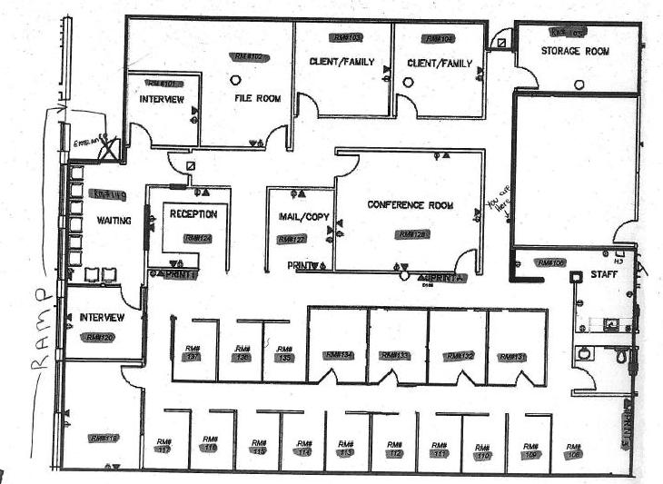
Picture 1

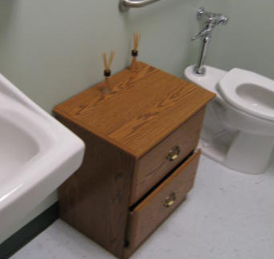

Fragrance Reed Diffuser

Picture 2

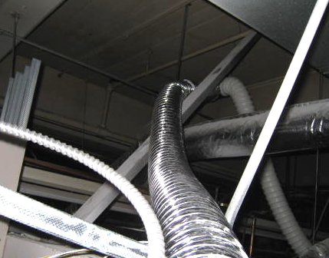

Flexible Duct Connecting Restroom Vent Fan to Another Duct, Likely the Restroom Exhaust Vent for the Department of Transitional Assistance Public Restrooms Which are Located on the Opposite Side of the Restroom Wall
(Note: Other Vent Connected to Restroom Vent as indicated by arrow)

Picture 3

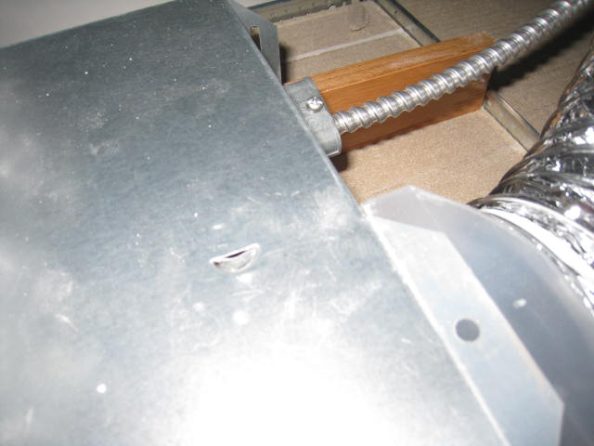

Holes in Top of Restroom Fan Casing That Emitted a Steady Stream of Air When the Fan Was Activated
Location | Occupants  in Room | Temp  (°F) | Relative  Humidity  (%) | Carbon  Dioxide  (ppm) | Carbon Monoxide  (ppm) | PM2.5  (µg/m3) | Windows  Openable | Ventilation |  | Remarks
 |  |  |  |  |  |  |  | Supply | Exhaust | Remarks
Outside
(Background)
128 | 4 | 73 | 42 | 842 | 0 | 3 | N | Y | Y
106 kitchen | 0 | 73 | 43 | 724 | 0 | 2 | N | Y | Y
109 | 1 | 73 | 40 | 780 | 0 | 2 | Y | Y | Y
132 | 0 | 73 | 40 | 689 | 0 | 1 | N | Y | Y
112 | 1 | 73 | 40 | 693 | 0 | 1 | Y | Y | Y
113 | 1 | 74 | 40 | 694 | 0 | 1 | Y | Y | Y
117 | 0 | 73 | 39 | 693 | 0 | 1 | Y | Y | Y
119 | 1 | 73 | 40 | 737 | 0 | 1 | Y | Y | Y
124 | 0 | 73 | 39 | 677 | 0 | 1 | N | Y | N
136 | 0 | 74 | 40 | 730 | 0 | 3
127 | 1 | 74 | 40 | 703 | 6 | 1 | N | Y | N
Print 2 | 0 | 74 | 40 | 682 | 0 | 1 | N | Y | N
104 | 0 | 73 | 41 | 685 | 0 | 1 | N | Y | Y
103 | 0 | 73 | 40 | 629 | 0 | 2 | N | Y | Y
102 | 0 | 73 | 40 | 670 | 0 | 2 | N | Y | Y | DO, cardboard
101 | 0 | 73 | 39 | 63 | 0 | 1 | N | Y | Y | DO
140 | 0 | 73 | 39 | 631 | 0 | 1 | N | Y | Y | DO
120 | 0 | 71 | 39 | 605 | 0 | 1 | N | Y | Y | DO

Transfer air is air transferred from one indoor location to another indoor location

