WATER DAMAGE/MOLD INVESTIGATION

Massachusetts Department of Mental Health
305 Belmont Street
Worcester, Massachusetts

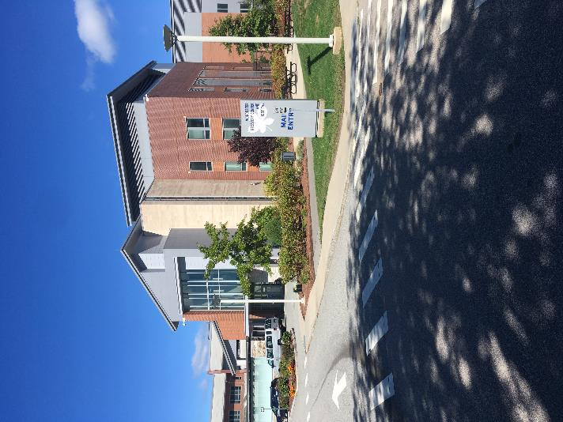

Prepared by:
Massachusetts Department of Public Health
Bureau of Environmental Health
Indoor Air Quality Program
October 2022

BACKGROUND
Building: | Massachusetts Department of Mental Health
Address: | 305 Belmont Street  Worcester, Massachusetts
Assessment Requested by: | Anthony Kim, Assistant Chief Operating Officer, Massachusetts Department of Mental Health
Reason for Request: | Mold concerns in nurses’ stations
Date of Assessment: | September 23, 2022
Massachusetts Department of Public Health/Bureau of Environmental Health (MDPH/BEH) Staff Conducting Assessment: | Michael Feeney, Director, Indoor Air  Quality (IAQ) Program

METHODS
The IAQ Program was asked to examine the reports of possible mold growth in nurses’ stations. Please refer to the IAQ Manual for methods, sampling procedures, and interpretation of results (MDPH, 2015).

RESULTS AND DISCUSSION
The following is a summary of indoor air testing results (Table 1) conducted on September 23, 2022.
- Carbon monoxide (CO) levels were non-detect (ND) in all areas.
- Particulate matter (PM2.5) concentrations measured were below the National Ambient Air Quality (NAAQS) level of 35 µg/m³ in all areas.
- Temperature was within the MDPH recommended range of 70℉ to 78℉ in occupied areas.
- Moisture Measurements of walls/floors in nurses’ stations were dry, with no indication of measurable moisture.
- Relative Humidity Measurements indoors were within the recommended range of 40% to 60% in all areas assessed.

Table 1. Air Testing Results for September 23, 2022
Media sampled |  | MDPH Guideline/  Comparison Value |  | Measured Range |  |  | Comments
 |  |  |  | Outdoors/  Background |  | Indoors
Carbon Monoxide (CO) |  | Non-detectable (ND) or equal to or below background level measured |  | ND |  | ND
Particulate Matter 2.5 (PM2.5) |  | US EPA National Ambient Air Quality Standards (NAAQS) 35 μg/m³ or less |  | 4 μg/m³ |  | 1 to 3 μg/m³ | Levels were all below 35 μg/m³
Temperature |  | 70 to 78 ºF |  | 55 ºF |  | 71 to 73 ºF | All readings were within the MDPH recommended comfort guidelines.
Relative Humidity (RH) |  | 40% to 60% |  | 47% |  | 41 to 43% | All readings were within the MDPH recommended comfort guidelines.
Moisture Measurements |  | Porous building materials should have low (i.e., normal moisture content) |  |  |  | Carpeting was dry (i.e., normal) | No water-damaged materials observed
ppm = parts per million | µg/m³ = microgram per cubic meter |  | ND = non-detectable

Each nurse’s station was examined for the presence of mold/musty odors, water stains in building materials (e.g., ceiling tiles, walls, and flooring coverings), and the presence of possible water vapor sources. No area had any signs of water damage or the presence of a water vapor source that can wet building materials to cause mold growth.
Although inspections include an assessment for mold, DPH does not test for mold and does not recommend mold testing as part of routine water damage remediation for the following reasons:
- The presence of mold does not necessarily indicate a problem. Mold spores waft through the indoor and outdoor air continually. There is no practical way to eliminate all mold and mold spores in the indoor environment; the way to control indoor mold growth is to control moisture (USEPA, 2008).
- There are no established limits (federal or state regulations, building standards or guidelines) on how much mold can exist before health impacts are expected. This means that even if tests are conducted, there is no way to compare results or determine whether the measured level could cause health effects.
- There is no way to determine whether an individual’s symptoms or reactions were caused by mold. While mold, spores, and other associated materials can make allergies and asthma symptoms worse, different people react differently to mold and mold spores. In addition to mold, reactions experienced by individuals could be caused by bacteria, other compounds in the air caused by the breakdown of wet building materials, or something different altogether (Mendell, et al, 2011, NIOSH, 2015).
- The U.S. Environmental Protection Agency (EPA) does not recommend testing for mold. DPH follows the guidelines contained in the U.S. EPA Mold Remediation in Schools and Commercial Buildings report for cleaning and removing water-damaged materials (USEPA, 2008, USEPA, 2019). EPA’s guidelines recommend, in most cases, that if visible mold growth is present, mold sampling is not necessary.

Visual evidence of mold growth and/or the presence of musty odors are reliable indicators of mold problems that are correlated with health risks in buildings where indoor environmental complaints have been made. EPA’s guidelines on mold remediation provide information and helpful pictures on identifying mold. Mold testing may be appropriate if:
- Occupants continue to have symptoms associated with mold after water sources are repaired and moldy building materials and items in the building have been removed or cleaned.
- It would be helpful to identify which materials may be an ongoing source of mold to assist in completing the remediation, or
- An individual has a diagnosed respiratory fungal infection, and the treating medical provider requests mold testing to help direct medical treatment (MDPH, 2022).

DMH staff did not report the presence of any of these conditions. In addition, DPH staff did not identify any of these mold-related conditions during this assessment.

CONCLUSIONS/RECOMMENDATIONS
Based on observations and moisture testing, nursing stations do not appear to have any conditions that would result in mold growth in building components. Based on observations the following recommendations are made:
- Evaluate the HVAC system settings to maintain temperature and relative humidity during extreme hot, humid weather as needed.
- Vacuum carpets in the nurses’ stations daily since these areas are considered high foot traffic locations to remove deposited debris that normally adheres to floor coverings (IICRC, 1997).
- For more information regarding mold, refer to the US EPA’s “Mold Remediation in Schools and Commercial Buildings” available at: http://www.epa.gov/mold/mold-remediation-schools-and-commercial-buildings-guide.
- Refer to resource manuals and other related IAQ documents for further building-wide evaluations and advice on maintaining public buildings. Copies of these materials are located on the MDPH’s website: http://mass.gov/dph/iaq.

REFERENCES
ACGIH. 1989. Guidelines for the Assessment of Bioaerosols in the Indoor Environment. American Conference of Governmental Industrial Hygienists, Cincinnati, OH.
CADPH. 2011. Statement on Building Dampness, Mold, and Health. California Department of Public Health. Last updated February 2016. https://www.cdph.ca.gov/Programs/CCDPHP/DEODC/EHLB/AQS/Pages/Mold.aspx
IICRC. 1997. IICRC S001 Standards Reference Guide for Professional On-location Cleaning of Installed Textile Floor Covering Materials. 3rd ed. The Institute of Inspection, Cleaning and Restoration Certification, Vancouver, WA.
MDPH. 2022. Guidance Regarding Testing for Mold in Water-Damaged Public Buildings. Guidance Regarding Testing for Mold in Water-Damaged Public Buildings | Mass.gov
MDPH. 2015. Massachusetts Department of Public Health. “Indoor Air Quality Manual: Chapters I-III”. Available at: Indoor air quality - manual and appendices | Mass.gov
Mendell, M. J., Mirer, A. G., Cheung, K., & Douwes, J. 2011. Respiratory and allergic health effects of dampness, mold, and dampness-related agents: a review of the epidemiologic evidence. Environmental Health Perspectives 119(6):748.
NIOSH. 2015. Testing and Remediation of Dampness and Mold Contamination. National Institute of Occupational Safety and Health, Cincinnati, OH.
U.S. EPA. 2019. Frequent Questions on Mold and Moisture. https://www.epa.gov/mold/mold-frequently-asked-questions, accessed September 2019.
U.S. EPA. 2008. Mold Remediation in Schools and Commercial Buildings. US Environmental Protection Agency, Office of Air and Radiation, Indoor Environments Division, Washington, D.C. EPA 402-K-01-001. http://www.epa.gov/mold/mold-remediation-s-and-commercial-buildings-guide.
WHO. 2009. WHO Guidelines for Indoor Air Quality: Dampness and Mould. World Health Organization Copenhagen: WHO Europe.

