INDOOR AIR QUALITY ASSESSMENT

Department of Mental Health
Cain Building
Taunton State Hospital Campus
Taunton, Massachusetts

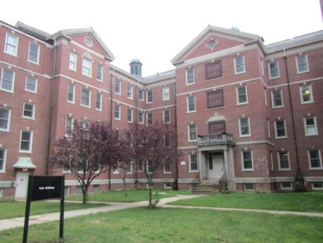

Prepared by:
Massachusetts Department of Public Health
Bureau of Environmental Health
Indoor Air Quality Program
September 2016

Executive Summary:
Elevated relative humidity conditions, resulting from the inadequacy of the mechanical ventilation system to dehumidify outside air, are contributing to condensation/mold growth and comfort concerns experienced in the building. Dehumidification is necessary to improve occupant and building health, as well as extend the life of building components.

Background
Building: | Cain Building Department of Mental Health (DMH)
Address: | Taunton State Hospital Campus
Assessment Requested by: | Deborah Coleman, Facilities Director  Executive Office of Health and Human Services (EOHHS)
Reason for Request: | General indoor air quality (IAQ) assessment
Date of Assessment: | September 8, 2016
Massachusetts Department of Public Health/Bureau of Environmental Health (MDPH/BEH) Staff Conducting Assessment: | Cory Holmes and Sharon Lee, Environmental Analysts/Inspectors
Date of Building Construction: | 1930s
Building Description: | The Cain Building is a four-story, red brick building with basement. Renovations including the installation of heating, air conditioning, and ventilation (HVAC) components were conducted in the 1990s.
Building Population: | Approximately 100 employees work in the building 24/7 in three shifts. The DMH also leases space to private mental health vendors.
Windows: | Many areas do not have openable windows.

Methods
Please refer to the IAQ Manual and appendices for methods, sampling procedures, and interpretation of results (MDPH, 2015).

Results and Discussion
The following is a summary of indoor air testing results (Table 1).
- Carbon dioxide measurements were below the MDPH recommended level of 800 parts per million (ppm) in all but one area surveyed.
- Temperature was within or very close to the MDPH recommended range of 70°F to 78°F in all areas at the time of assessment.
- Relative humidity (RH) was above the MDPH recommended range of 40 to 60% in all areas tested. In some cases, indoor RH exceeded 80%.
- Carbon monoxide levels were non-detectable in all areas tested.
- Particulate matter (PM2.5) concentrations measured were below the National Ambient Air Quality (NAAQS) level of 35 μg/m³ in all areas tested.
These test results, primarily RH levels, indicate that the system is grossly inadequate/unable to remove moisture from the air.

Ventilation
A heating, ventilating, and air conditioning (HVAC) system has several functions. First it provides heating and, if equipped, cooling. Second, it is a source of fresh air. Finally, an HVAC system will dilute and remove normally occurring indoor environmental pollutants by not only introducing fresh air, but also filtering the airstream and ejecting stale air to the outdoors via exhaust ventilation. The act of cooling/providing AC is two-fold; the system chills the air via cooling coils while also typically removing moisture from the air. As seen from the testing results, RH levels were significantly above the recommended guidelines building-wide, indicating that the system in place lacks the ability to dehumidify air supplied to the building.
Moisture removal is important since the sensation of heat conditions increases as RH increases (the relationship between temperature and RH is called the heat index). As indoor temperatures rise, the addition of more RH will make occupants feel hotter. If moisture is removed, the comfort of the individuals is improved.
While temperature is mainly a comfort issue, RH in excess of 70 percent for extended periods of time can provide an environment for mold and fungal growth (ASHRAE, 1989). As discussed further in the Microbial/Moisture Concern portion of the report, visual evidence and staff reports indicate elevated indoor RH levels at the Cain Building have resulted in condensation formation on the surface of metal supply/return vents and poorly insulated HVAC/plumbing components throughout the building. Condensation moistening dust/debris collected on diffuser surfaces can become a source of mold growth.
It should be noted that BEH/IAQ staff observed open windows at the time of the assessment. During periods of high RH (late spring/summer months), windows and exterior doors should be closed to keep moist, unconditioned air out of the building when the HVAC system is in cooling mode.
The HVAC system consists of four main air-handling units (AHUs), two in the attic/two in the basement (Pictures 1 and 2), and over 40 fan coil units (FCUs) located throughout the building (Picture 3). AHUs draw outside air into the building (Pictures 4 and 5). One of the AHU draws air from a subterranean pit into which a condensation pipe was emptying water (Picture 6). Air drawn directly from moist environments makes humidity control increasingly difficult. The FCUs circulate and distribute air to occupied spaces via ducted ceiling vents (Picture 7). Return air is vented through ceiling or wall-mounted vents back to AHUs. Differentiating between supply and return vents was difficult, since both types were fitted with the same vent coverings (e.g., Picture 7). Several areas had weak airflow via both supply and return vents (Table 1).
The AHU/FCUs were reportedly installed in the 1990s, which makes them over 20 years old. Efficient function of equipment of this age is difficult to maintain, since compatible replacement parts are often unavailable. According to the American Society of Heating, Refrigeration, and Air-Conditioning Engineering (ASHRAE), the service life for a unit heater, hot water or steam is 20 years, assuming routine maintenance of the equipment (ASHRAE, 1991). Despite attempts to maintain the equipment, the optimal operational lifespan of this equipment has been exceeded. Due to the inefficacy of the system, additional window AC units are in a number of areas to supplement cooling.

Microbial/Moisture Concerns
As mentioned, reducing indoor humidity is important, since molds can grow when indoor RH levels exceed 70% for longer than 24 hours. Symptoms commonly associated with molds include allergic reactions and respiratory irritation. Some people with chronic respiratory conditions, such as asthma, are more likely to experience health symptoms. Controlling moisture is the key to preventing mold growth and potential health symptoms.
In order for building materials to support mold growth, a source of water is necessary. The main source of water in the building is uncontrolled moisture brought in from the outside by the HVAC system. This moisture is leading to wide-spread condensation issues on cool, uninsulated metal surfaces and pipes throughout the building. In numerous areas, dust/debris has built up on vents, which can grow mold if wet repeatedly (Pictures 7 through 9). Compounding this issue is the security grills installed over vents (Picture 10), which prevents easy access for cleaning. Screws of the security grills are painted over in many areas indicating that the fresh air diffusers have not been recently cleaned. Some areas have a different type of vent cover installed (Picture 11), which appear easier to clean and maintain.
Water-damaged and missing ceiling tiles were observed in a number of areas, which can indicate current or historic roof leaks, plumbing leaks, and/or condensation from HVAC components (Table 1). Active leaks were also reported in some areas (Picture 12). If repeatedly moistened, water-damaged ceiling tiles can provide a source of mold. These tiles should be replaced after a water leak is discovered and repaired.
Visible mold was observed in the 4th floor west women’s shower area along the floor, which appeared in need of re-caulking (Picture 13). Although this room was equipped with a local exhaust vent to remove excess moisture, there was no passive vent installed in the door (nor undercut) to allow for transfer air.
Plants were observed in a number of areas (Table 1). Plants can be a source of pollen and mold, which can be respiratory irritants to some individuals. Plants should be properly maintained and equipped with drip pans and should be located away from air diffusers to prevent aerosolization of dirt, pollen, and mold.

Other Conditions
Other conditions that can affect IAQ were observed during the assessment. Some areas have area carpets. The Institute of Inspection, Cleaning, and Restoration Certification (IICRC) recommends that carpeting be cleaned annually (or semi-annually in soiled high traffic areas) (IICRC, 2012). Regular cleaning with a high efficiency particulate air (HEPA) filtered vacuum in combination with an annual cleaning will help to reduce accumulation and potential aerosolization of materials from carpeting.
In several areas, items were observed on the floor, windowsills, tabletops, counters, bookcases, and desks. The large number stored items provide a source for dusts to accumulate. These items (e.g., papers, folders, boxes) make it difficult for custodial staff to clean. Once aerosolized, they can act as irritants to eyes and the respiratory system. Items should be relocated and/or be cleaned periodically to avoid excessive dust build up.
A supply vent in one area was sealed with cardstock and tape (Picture 14). Blocked supply vents can reduce fresh air supply to the office. As discussed previously, decreases in fresh air can reduce dilution of normally occurring pollutants, which can contribute to headaches.
A space heater was observed operating in an unoccupied office (Picture 15). Space heaters are a fire hazard, particularly when operating unattended.
Items were observed hanging from the ceiling tile system (Picture 16). The weight of hanging items can damage or create gaps in the ceiling tile system, which may result in dust/debris falling from the ceiling plenum.
Air deodorizing and fragrant products were observed in a number of office spaces. Air deodorizers contain chemicals that can be irritating to the eyes, nose, and throat of sensitive individuals. Many air fresheners contain 1,4-dichlorobenzene, a VOC which may cause reductions in lung function (NIH, 2006). Deodorizing agents do not remove materials causing odors, but rather mask odors that may be present in the area. Typically, an adequate HVAC system serves to dilute and remove odors.

Conclusions and Recommendations
The conditions noted at the Cain Building raise a number of IAQ concerns. The general building design and inadequacy of HVAC equipment (AHUs and FCUs), particularly to dehumidify air, present conditions that could affect IAQ. These factors can be associated with a range of IAQ related health and comfort complaints. Some remediation efforts will alteration to the building structure and equipment. For these reasons a two-phase approach is recommended, which consists of short-term measures to improve air quality and long-term measures that would likely need planning and resources to adequately address overall IAQ concerns.

Short-Term Recommendations:
In view of the findings at the time of the visit, the following recommendations are made:
- Continue with plans to have ductwork cleaned. This should be carefully planned in stages for both thermal comfort and work disruption reasons. In addition, the system should be thoroughly “blown out” and all areas should be thoroughly cleaned (using a high efficiency particulate arrestance (HEPA) filter equipped vacuum cleaner in conjunction with wet wiping of all surfaces) to prevent exposure to airborne dust/debris prior to reoccupancy.
- Clean and disinfect supply/return vents and surrounding ceiling tiles throughout the building. If they cannot be adequately cleaned, resurface/paint or replace. Due to the scope of this project building-wide, it may be beneficial to contract out to a professional cleaning/restoration firm.
- Do not drain condensate from AHU/FCUs into air intake pits.
- Ensure vents/louvers are open/adjusted to allow airflow in areas where weak airflow was detected (e.g., end of duct line/rooms 302, 304).
- Ensure windows are closed during times at which the air-conditioning system is operating in the cooling mode.
- Install passive vents in shower room doors (e.g., 4th floor west) or undercut doors to allow transfer air/facilitate exhaust.
- Consider adopting a balancing schedule of every 5 years for all mechanical ventilation systems, as recommended by ventilation industrial standards (SMACNA, 1994).
- For buildings in New England, periods of low RH during the winter are often unavoidable. Therefore, scrupulous cleaning practices should be adopted to minimize common indoor air contaminants whose irritant effects can be enhanced when the RH is low. To control for dusts, a HEPA filter equipped vacuum cleaner in conjunction with wet wiping of all surfaces is recommended. Avoid the use of feather dusters. Drinking water during the day can help ease some symptoms associated with a dry environment (throat and sinus irritation).
- Clean/disinfect visible mold in 4th floor west women’s shower area. Re-caulk wall/floor tiles as needed.
- Ensure that procedures are in place for occupants to report leaks, wet tiles, and other maintenance conditions so that they can be logged and dried/repaired promptly.
- Ensure building envelope/exterior and plumbing leaks are repaired and replace any remaining water-damaged ceiling tiles. Examine the area above these tiles for mold growth. Disinfect areas of water leaks with an appropriate antimicrobial, as needed.
- Clean personal fans periodically of accumulated dust.
- Clean carpeting annually or semi-annually in soiled high traffic areas as per the recommendations of the Institute of Inspection, Cleaning and Restoration Certification (IICRC, 2012).
- Consider reducing the amount of stored materials to allow for more thorough cleaning. Clean items regularly with a wet cloth or sponge to prevent excessive dust build-up.
- Remove items hanging from the ceiling tile system.
- Ensure space heaters are turned off when room is unoccupied, even for short periods of time.
- Discontinue the use of air deodorizing products.
- Refer to resource manual and other related indoor air quality documents located on the MDPH’s website for further building-wide evaluations and advice on maintaining public buildings. These documents are available at http://www.mass.gov/dph/iaq/.

Long-Term Recommendations:
- Work with an HVAC engineering firm to evaluate the system for repair/replacement of the system in a manner that regulates/dehumidifies outside air. This may include methods such as building pressurization, longer cooling coil time/re-heating, latent heat/energy recover, and/or desiccant system.
- Consider replacing supply diffusers/return vents with those shown in Picture 11 to improve regular cleaning.

REFERENCES
American Society of Heating, Refrigerating, and Air-Conditioning Engineers (ASHRAE). 1989. Ventilation for Acceptable Indoor Air Quality. ANSI/ASHRAE 62-1989.
American Society of Heating, Refrigerating, and Air-Conditioning Engineers (ASHRAE). 1991. ASHRAE Applications Handbook, Chapter 33 “Owning and Operating Costs”. American Society of Heating, Refrigeration and Air Conditioning Engineers, Atlanta, GA.
Institute of Inspection, Cleaning and Restoration Certification (IICRC). 2012. Carpet Cleaning: FAQ. Retrieved from http://www.iicrc.org/consumers/care/carpet-cleaning/.
Massachusetts Department of Public Health (MDPH). 2015. Indoor Air Quality Manual: Chapters I-III. Available at: http://www.mass.gov/eohhs/gov/departments/dph/programs/environmental-health/exposure-topics/iaq/iaq-manual/.
National Institute of Health (NIH). 2006. Chemical in Many Air Fresheners May Reduce Lung Function. NIH News. National Institute of Health. July 27, 2006. https://www.nih.gov/news-events/news-releases/chemical-many-air-fresheners-may-reduce-lung-function
Sheet Metal and Air Conditioning Contractors’ National Association, Inc. (SMACNA). 1994. HVAC Systems Commissioning Manual. 1st ed. Sheet Metal and Air Conditioning Contractors’ National Association, Inc., Chantilly, VA.
Picture 1
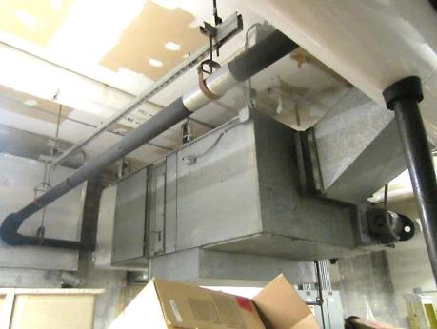
Air handling unit (AHU) in the basement

Picture 2
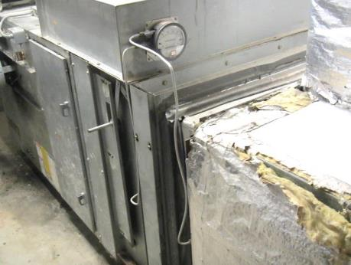
AHU in Attic
Picture 3
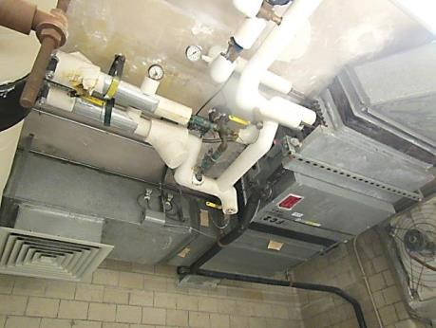
Fan coil unit

Picture 4
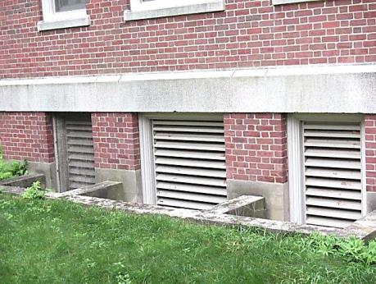
Ground level fresh air intakes
Picture 5
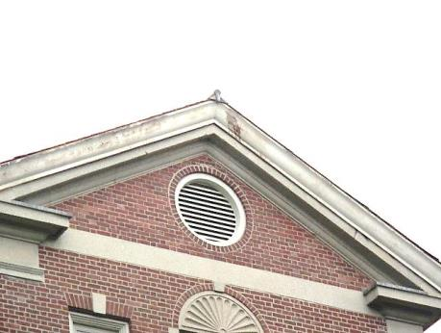
Attic level fresh air intake

Picture 6
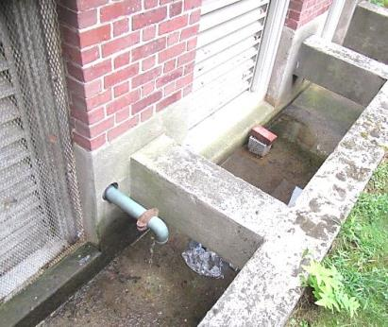
Subterranean air intake pits, note draining condensation pipe
Picture 7
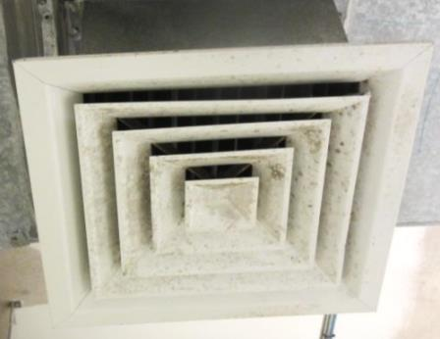
Supply diffuser, note discoloration on louvers from chronic moisture

Picture 8
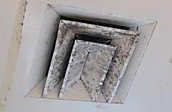
Soiled vent, likely mold/discoloration from chronic moisture
Picture 9
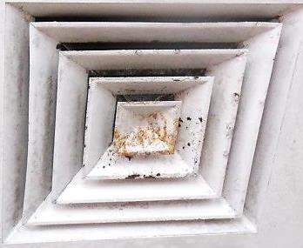
Rust/corrosion on metal supply louver due to chronic moisture

Picture 10
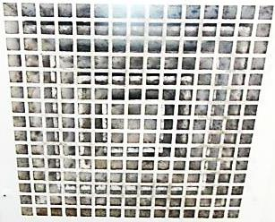
Security grill installed over vent, making access/cleaning difficult
Picture 11
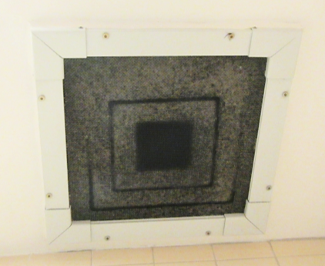
Metal mesh installed over supply and exhaust vents

Picture 12
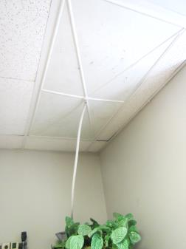
Ceiling tile drainage inset used to divert leak

Picture 13
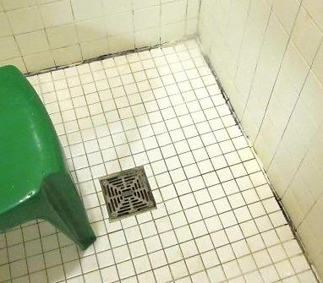
Visible mold (dark staining) along shower floor/wall

Picture 14
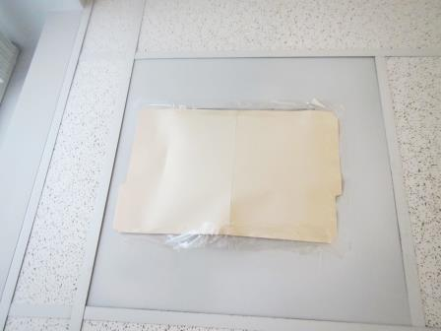
Supply vent sealed with cardstock and tape

Picture 15
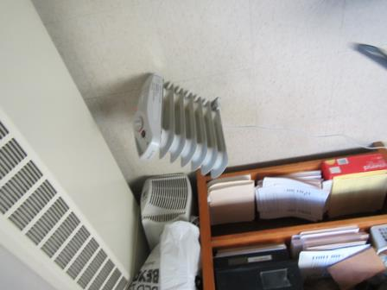
Standalone electric heating unit

Picture 16
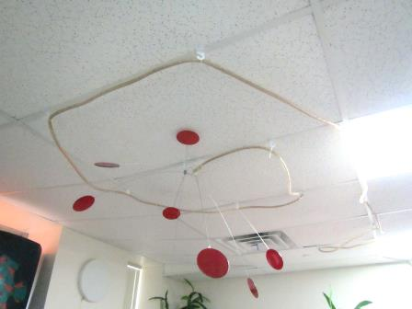
Structure hanging from ceiling tile system

Location | Carbon  Dioxide  (ppm) | Carbon Monoxide  (ppm) | Temp  (°F) | Relative  Humidity  (%) | PM2.5  (µg/m³) | Occupants  in Room | Windows  Openable | Ventilation |  | Remarks
 |  |  |  |  |  |  |  | Supply | Exhaust
Background | 372 | ND | 78 | 82 | 18 |  |  |  |  | Hot, Humid, overcast
4th Floor West
404 | 621 | ND | 73 | 85 | 6 | 1 | N | Y | Y
412 | 586 | ND | 74 | 78 | 5 | 1 | N | Y | Y | PF-dusty, D/D CT
413 | 605 | ND | 73 | 77 | 5 | 1 | N | Y | Y | PF
451 | 546 | ND | 72 | 78 | 5 | 1 | N | Y | Y | D/D vents
460 | 558 | ND | 73 | 82 | 6 | 0 | N | Y | Y
461 | 588 | ND | 73 | 82 | 8 | 2 | N | Y | Y
Womens Restroom |  |  |  |  |  |  | N | Y | Y
Shower |  |  |  |  |  |  | N | N | Y | Recommend passive door vent or undercut door
Nurses Station | 581 | ND | 73 | 77 | 6 | 4 | N | Y | Y
Chart Room | 567 | ND | 73 | 77 | 6 | 2 | N | Y | Y | WAC, 1 WD CT
TV Room | 546 | ND | 73 | 79 | 8 | 5 | N | Y | Y
Med Room | 556 | ND | 71 | 82 | 6 | 0 | N | Y | Y | WAC
Dining Room | 535 | ND | 72 | 85 | 5 | 4 | N | Y | Y | D/D CTs
4th Floor East |  |  |  |  |  |  |  |  |  | WD CT in Patient room hallway below drip pan
Med Room | 600 | ND | 76 | 76 | 9 | 0 | Y | Y | Y | DO, water cooler, refrigerator, WAC
Chart Room | 400 | ND | 75 | 66 | 10 | 1 | Y | Y | Y | WAC, DO, food storage, DEM
Nurses Station | 530 | ND | 75 | 75 | 11 | 3 | N | Y | Y
TV Room | 500 | ND | 75 | 77 | 10 | 4 | Y | Y | Y | Missing floor tile, water cooler, D/D vent
Staff Bath |  |  | 73 | 80 | 9
Shower C434 |  |  | 74 | 85 | 10
428 | 518 | ND | 73 | 80 | 8 | 0 | Y | Y | Y | PF, DO
427 | 582 | ND | 73 | 80 | 20 | 2 | Y | Y | Y | PF, strong deodorant material odor
425 | 556 | ND | 73 | 87 | 7 | 0 | Y | Y | Y
421 | 578 | ND | 73 | 82 | 7 | 0 | Y | Y | Y
420 | 516 | ND | 73 | 83 | 8 | 0 | Y | Y | Y
Soil Work Room | 514 | ND | 73 | 83 | 8 | 0 | Y | Y | Y | Damaged CT
Laundry Room |  | ND
442 Office | 614 | ND | 75 | 80 | 7 | 0 | Y | Y | Y | Fridge, PF, D/D vent
416 | 503 | ND | 75 | 74 | 6 | 0 | Y | Y | Y | Fridge, PF, food storage
441 Staff Room | 635 | ND | 75 | 79 | 12 | 1 | Y | Y | Y | Cooler
3rd Floor West
302 | 715 | ND | 74 | 78 | 5 | 1 | N | Y | Y | Heat complaints, weak airflow from vents
304 | 644 | ND | 73 | 83 | 6 | 0 | N | Y | Y | Weak airflow from vents
307 | 601 | ND | 73 | 78 | 5 | 0 | N | Y | Y
312 | 630 | ND | 74 | 77 | 9 | 0 | N | Y | Y
313 | 612 | ND | 76 | 73 | 5 | 0 | N | Y | Y | D/D vents
Nurses Station | 548 | ND | 74 | 79 | 5 | 2 | N | Y | Y | D/D vents
Med Room | 568 | ND | 74 | 80 | 7 | 1 | N | y | Y | WAC
Chart Room | 591 | ND | 73 | 73 | 7 | 2 | N | Y | Y | WAC
TV Room | 449 | ND | 74 | 85 | 7 | 2 | N | Y | Y | D/D vents/CT
3rd Floor East |  |  |  |  |  |  |  |  |  | WD CT in Patient room hallway below drip pan
Chart Room | 688 | ND | 74 | 69 | 8 | 2 | Y | Y | Y | WAC, photocopier, shredder
Med Room | 615 | ND | 73 | 61 | 4 | 0 | N | Y | N | WD T, WAC
TV Room | 564 | ND | 74 | 76 | 12 | 6 | Y | Y | Y | Water cooler, D/D CT
Bathroom 336A |  |  | 73 | 77 | 12 |  |  | N | Y
Shower 334A |  |  | 73 | 76 | 21 |  |  | N | Y
328 | 612 | ND | 73 | 75 | 7 | 0 |  | Y | Y | DO
327B | 571 | ND | 73 | 74 | 8 | 0 | Y | Y | Y
327A | 555 | ND | 72 | 74 | 7 | 0 | Y | Y | Y | DO
325 | 560 | ND | 72 | 75 | 7 | 0 | Y | Y | Y
324 | 574 | ND | 73 | 75 | 7 | 0 | Y | Y | Y | DO
321 | 578 | ND | 72 | 75 | 8 | 0 | Y | Y | Y
318 | 522 | ND | 71 | 76 | 8 | 0 | Y | Y | Y
316 | 906 | ND | 73 | 83 | 8 | 0 | Y | Y | Y
343 | 620 | ND | 74 | 76 | 8 | 0 | Y | Y | Y
341 | 604 | ND | 75 | 73 | 16 | 0 | Y  Open | Y | Y
2nd Floor West
201 | 436 | ND | 74 | 83 | 6 | 0 | N | Y | Y
204 | 477 | ND | 72 | 78 | 6 | 0 | N | Y | Y | D/D vents
207 | 527 | ND | 72 | 78 | 5 | 0 | N | Y | Y
212 | 529 | ND | 76 | 77 | 4 | 0 | N | Y | Y
213 | 588 | ND | 76 | 78 | 5 | 0 | N | Y | Y
244 | 576 | ND | 75 | 86 | 8 | 5 | N | Y | Y
245 | 550 | ND | 72 | 80 | 13 | 1 | N | Y | Y
Nurses Station | 506 | ND | 73 | 70 | 4 | 4 | N | Y | Y
Chart Room | 540 | ND | 73 | 70 | 4 | 0 | N | Y | Y | D/D vents
Staff Lounge | 560 | ND | 72 | 72 | 4 | 0 | N | Y | Y
TV Room | 429 | ND | 71 | 74 | 6 | 0 | N | Y | Y
2nd Floor East |  |  |  |  |  |  |  |  |  | 2 MT in office hallway
Med Room | 609 | ND | 75 | 77 | 7 | 0 | N | Y | N | WAC off, PF
Chart Room | 500 | ND | 76 | 75 | 4 | 2 | Y | Y | Y | PF, WAC
TV Room | 386 | ND | 73 | 74 | 9 | 0 | Y | Y | Y | D/D CT
C236 Bath |  |  | 73 | 80 | 9 |  | N | N | Y
Visiting Room | 524 | ND | 71 | 80 | 12 | 0 | Y | Y | Y
C234 Shower |  |  | 73 | 84 | 11 |  | N | N | Y
228 | 476 | ND | 73 | 84 | 16 | 0 | Y | Y | Y | AD
227 | 547 | ND | 74 | 84 | 18 | 0 | Y | Y | Y
226 | 431 | ND | 74 | 85 | 9 | 0 | Y | Y | Y
225 | 427 | ND | 74 | 84 | 8 | 0 | Y | Y | Y
224 | 444 | ND | 74 | 79 | 6 | 0 | Y | Y | Y
222 | 621 | ND | 73 | 77 | 5 | 0 | Y | Y | Y
220 | 438 | ND | 72 | 77 | 5 | 0 | Y | Y | Y
218 | 452 | ND | 72 | 79 | 7 | 0 | Y | Y | Y
216 | 500 | ND | 73 | 83 | 5 | 0 | Y | Y | Y | PF, plants
243 | 531 | ND | 74 | 82 | 8 | 0 | Y | Y | Y | 1 WD CT
242 | 444 | ND | 74 | 80 | 8 | 0 | Y | Y | Y | PF
241 | 454 | ND | 75 | 79 | 11 | 0 | Y | Y | Y
1st Floor West
104 | 457 | ND | 74 | 82 | 5 | 0 | N | Y | Y | D/D vents, PF
106 | 445 | ND | 74 | 81 | 5 | 0 | N | Y | Y | D/D vents
111 | 565 | ND | 75 | 75 | 4 | 0 | N | Y | Y
132 | 487 | ND | 75 | 78 | 6 | 0 | N | Y | Y
143 | 424 | ND | 75 | 75 | 7 | 0 | N | Y | Y | D/D vents
149 | 451 | ND | 75 | 83 | 5 | 0 | N | Y | Y | Little airflow, D/D vents
Office 1 | 458 | ND | 74 | 75 | 7 | 0 | N | Y | Y | D/D vents
Reception Area | 488 | ND | 74 | 75 | 6 | 0 | N | Y | Y
Classroom Main Open Area | 494 | ND | 75 | 75 | 7 | 6 | N | Y | Y | D/D vents
Wilkens | 458 | ND | 75 | 76 | 7 | 0 | N | Y | Y | PF
1st Floor East
130 | 597 | ND | 78 | 71 | 6 | 0 | Y | Y  Sealed | Y | Space heater – on, plants, WD and D/D CT
129 | 476 | ND | 74 | 66 | 10 | 0 | Y | Y | Y | D/D vent
128 | 437 | ND | 74 | 69 | 8 | 0 | Y | Y | Y | 1 ajar CT, AD
127 | 449 | ND | 75 | 71 | 8 | 0 | Y | Y | Y | PF, plants
126 | 463 | ND | 74 | 79 | 8 | 0 | Y | Y | Y | AD
125 | 444 | ND | 74 | 79 | 8 | 0 | Y | Y | Y | Plants
124 | 417 | ND | 74 | 84 | 8 | 0 | Y | Y | Y | Plants
123 | 478 | ND | 74 | 81 | 9 | 1 | Y | Y | Y | Plants
122 | 457 | ND | 75 | 81 | 7 | 0 | Y | Y | Y | Plants, PF, musty, WD and D/D CT
119 | 424 | ND | 75 | 79 | 7 | 0 | Y | Y | Y | 5 WD CT, photocopier, water cooler
118 | 478 | ND | 75 | 77 | 6 | 1 | Y | Y | Y | Plants, 1 MT – water leak during wind driven rain
Crafts Room | 568 | ND | 75 | 73 | 7 | 3 | Y | Y | Y | DO, PF
Sensory Room | 586 | ND | 75 | 68 | 6 | 0 | Y | Y | Y | Items hanging from ceiling, PF
Group Room | 529 | ND | 75 | 71 | 7 | 0 | Y | Y | Y
Basement
G 12 | 443 | ND | 76 | 74 | 7 | 0 | N | Y | Y | WD ceiling/CTs
G 26 | 421 | ND | 76 | 78 | 6 | 0 | N | Y | Y | WD ceiling/CTs
G 27 | 391 | ND | 74 | 80 | 6 | 0 | N | Y | Y | Rusty vents
G 30 | 742 | ND | 75 | 71 | 6 | 5 | N | N | N | PF
G 31 | 492 | ND | 72 | 74 | 5 | 0 | N | Y | Y | D/D vents
Womens Locker Room | 419 | ND | 71 | 79 | 7 | 0 | N | Y | Y | D/D vents
Mens Locker Room | 423 | ND | 69 | 78 | 7 | 0 | N | Y | Y | D/D vents

The service life is the median time during which a particular system or component of …[an HVAC]… system remains in its original service application and then is replaced. Replacement may occur for any reason, including, but not limited to, failure, general obsolescence, reduced reliability, excessive maintenance cost, and changed system requirements due to such influences as building characteristics or energy prices (ASHRAE, 1991).

