Background/Introduction

INDOOR AIR QUALITY ASSESSMENT

Massachusetts Department of Mental Health
Gifford Building
Taunton, MA

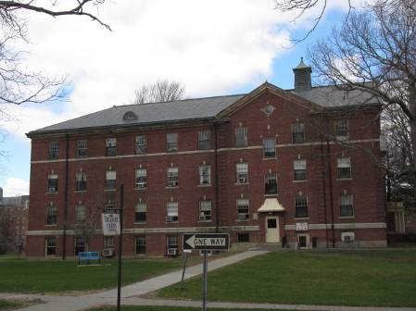

Prepared by:
Massachusetts Department of Public Health
Bureau of Environmental Health
Indoor Air Quality Program
June 2015

In response to a request from Mr. Todd Gundlach, Director, Engineering and Facility Management, Department of Mental Health (DMH), the Massachusetts Department of Public Health (MDPH), Bureau of Environmental Health (BEH) conducted an indoor air quality (IAQ) assessment at the DMH Taunton area office. The DMH Taunton office is located in the Gifford Building on the campus of Taunton State Hospital. On April 23, 2015, a site visit was made by Cory Holmes, Environmental Analyst/Regional Inspector for BEH’s IAQ Program.
The DMH is located on the 1st and 2nd floors of the Gifford Building, which is a red brick building with slate roof that was originally constructed in the early 1900s as a hospital. The space consists of private offices, common areas and conference rooms. At the time of the assessment portions of the 2nd floor were being temporarily occupied by the Department of Developmental Services (DDS). Windows are openable throughout the building; however, several could not be opened due to the installation of portable air conditioners (ACs).

Methods
Air tests for carbon dioxide, carbon monoxide, temperature and relative humidity were taken with the TSI, Q-Trak, IAQ Monitor 7565. Air tests for airborne particle matter with a diameter less than 2.5 micrometers were taken with the TSI, DUSTTRAK™ Aerosol Monitor Model 8520. Screening for total volatile organic compounds was conducted using a Rae Systems, MiniRae Lite photoionization detector (PID). BEH/IAQ staff also performed visual inspection of building materials for water damage and/or microbial growth.

Results
This building currently houses approximately 50 DMH and approximately 20 DDS staff. The tests were taken during normal operations. Test results appear in Table 1.

Discussion

Ventilation
It can be seen from Table 1 that all carbon dioxide levels were below 800 parts per million (ppm), indicating adequate air exchange in all areas surveyed at the time of the assessment (Table 1). Note that the building does not have a means of mechanical ventilation but uses windows to introduce fresh outside air. As mentioned, in some areas windows were unopenable due to the installation of ACs, however in most areas, a second window was openable or windows were modified by facilities staff to open (Picture 1).
Minimum design ventilation rates are mandated by the Massachusetts State Building Code (MSBC). Until 2011, the minimum ventilation rate in Massachusetts was higher for both occupied office spaces and general classrooms, with similar requirements for other occupied spaces (BOCA, 1993). The current version of the MSBC, promulgated in 2011 by the State Board of Building Regulations and Standards (SBBRS), adopted the 2009 International Mechanical Code (IMC) to set minimum ventilation rates. Please note that the MSBC is a minimum standard that is not health-based. At lower rates of cubic feet per minute (cfm) per occupant of fresh air, carbon dioxide levels would be expected to rise significantly. A ventilation rate of 20 cfm per occupant of fresh air provides optimal air exchange resulting in carbon dioxide levels at or below 800 ppm in the indoor environment in each area measured. MDPH recommends that carbon dioxide levels be maintained at 800 ppm or below. This is because most environmental and occupational health scientists involved with research on IAQ and health effects have documented significant increases in indoor air quality complaints and/or health effects when carbon dioxide levels rise above the MDPH guidelines of 800 ppm for schools, office buildings and other occupied spaces (Sundell et al., 2011). The ventilation must be on at all times that the room is occupied. Providing adequate fresh air ventilation with open windows and maintaining the temperature in the comfort range during the cold weather season is impractical. Mechanical ventilation is usually required to provide adequate fresh air ventilation.
Carbon dioxide is not a problem in and of itself. It is used as an indicator of the adequacy of the fresh air ventilation. As carbon dioxide levels rise, it indicates that the ventilating system is malfunctioning or the design occupancy of the room is being exceeded. When this happens, a buildup of common indoor air pollutants can occur, leading to discomfort or health complaints. The Occupational Safety and Health Administration (OSHA) standard for carbon dioxide is 5,000 parts per million parts of air (ppm). Workers may be exposed to this level for 40 hours/week, based on a time-weighted average (OSHA, 1997).
The MDPH uses a guideline of 800 ppm for publicly occupied buildings. A guideline of 600 ppm or less is preferred in schools due to the fact that the majority of occupants are young and considered to be a more sensitive population in the evaluation of environmental health status. Inadequate ventilation and/or elevated temperatures are major causes of complaints such as respiratory, eye, nose and throat irritation, lethargy and headaches. For more information concerning carbon dioxide, please see Appendix A.
Indoor temperature measurements at the time of the assessment ranged from 72°F to 77°F (Table 1), which were within the MDPH recommended comfort range. The MDPH recommends that indoor air temperatures be maintained in a range of 70°F to 78°F in order to provide for the comfort of building occupants. In many cases concerning indoor air quality, fluctuations of temperature in occupied spaces are typically experienced, even in a building with an adequate fresh air supply. Maintaining comfort parameters is also difficult in a building of this age with modern office equipment (computers, printers, copiers, etc.) without mechanical ventilation systems.
Indoor relative humidity measurements at the time of the assessment ranged from 18 to 31 percent (Table 1), which were below the MDPH recommended comfort range. The MDPH recommends a comfort range of 40 to 60 percent for indoor air relative humidity. Relative humidity levels in the building would be expected to drop during the winter months due to heating. The sensation of dryness and irritation is common in a low relative humidity environment. Low relative humidity is a very common problem during the heating season in the northeast part of the United States.

Microbial/Moisture Concerns
Signs of water infiltration were noted as evidenced by damaged plaster, peeling paint and efflorescence on interior walls (Pictures 2 and 3). Efflorescence is a characteristic sign of water damage to brick and mortar, but it is not mold growth. As moisture penetrates and works its way through mortar, brick or plaster, water-soluble compounds dissolve, creating a solution. As the solution moves to the surface of the material, the water evaporates, leaving behind white, powdery mineral deposits.
Plants were observed in several offices (Table 1). Plant soil, standing water and drip pans can be potential sources of mold growth. Drip pans should be inspected periodically for mold growth and overwatering should be avoided.

Other IAQ Evaluations
Indoor air quality can be negatively influenced by the presence of respiratory irritants, such as products of combustion. The process of combustion produces a number of pollutants. Common combustion emissions include carbon monoxide, carbon dioxide, water vapor, and smoke (fine airborne particle material). Of these materials, exposure to carbon monoxide and particulate matter with a diameter of 2.5 micrometers (μm) or less (PM2.5) can produce immediate, acute health effects upon exposure. To determine whether combustion products were present in the indoor environment, BEH/IAQ staff obtained measurements for carbon monoxide and PM2.5.

Carbon Monoxide
Carbon monoxide is a by-product of incomplete combustion of organic matter (e.g., gasoline, wood and tobacco). Exposure to carbon monoxide can produce immediate and acute health effects. Several air quality standards have been established to address carbon monoxide and prevent symptoms from exposure to these substances. The MDPH established a corrective action level concerning carbon monoxide in ice skating rinks that use fossil-fueled ice resurfacing equipment. If an operator of an indoor ice rink measures a carbon monoxide level over 30 ppm, taken 20 minutes after resurfacing within a rink, that operator must take actions to reduce carbon monoxide levels (MDPH, 1997).
The American Society of Heating Refrigeration and Air-Conditioning Engineers (ASHRAE) has adopted the National Ambient Air Quality Standards (NAAQS) as one set of criteria for assessing indoor air quality and monitoring of fresh air introduced by HVAC systems (ASHRAE, 1989). The NAAQS are standards established by the US EPA to protect the public health from six criteria pollutants, including carbon monoxide and particulate matter (US EPA, 2006). As recommended by ASHRAE, pollutant levels of fresh air introduced to a building should not exceed the NAAQS levels (ASHRAE, 1989). The NAAQS were adopted by reference in the Building Officials & Code Administrators (BOCA) National Mechanical Code of 1993 (BOCA, 1993), which is now an HVAC standard included in the Massachusetts State Building Code (SBBRS, 2011). According to the NAAQS, carbon monoxide levels in outdoor air should not exceed 9 ppm in an eight-hour average (US EPA, 2006).
Carbon monoxide should not be present in a typical, indoor environment. If it is present, indoor carbon monoxide levels should be less than or equal to outdoor levels. On the day of the assessment, outdoor carbon monoxide concentrations were non-detect (ND) (Table 1). No measurable levels of carbon monoxide were detected inside the building (Table 1).

Particulate Matter
The US EPA has established NAAQS limits for exposure to particulate matter. Particulate matter includes airborne solids, which can result in eye and respiratory irritation if exposure occurs. The NAAQS originally established exposure limits to particulate matter with a diameter of 10 μm or less (PM10). According to the NAAQS, PM10 levels should not exceed 150 micrograms per cubic meter (μg/m³) in a 24-hour average (US EPA, 2006). These standards were adopted by both ASHRAE and BOCA. Since the issuance of the ASHRAE standard and BOCA Code, US EPA established a more protective standard for fine airborne particles. This more stringent PM2.5 standard requires outdoor air particle levels be maintained below 35 μg/m³ over a 24-hour average (US EPA, 2006). Although both the ASHRAE standard and BOCA Code adopted the PM10 standard for evaluating air quality, MDPH uses the more protective PM2.5 standard for evaluating airborne particulate matter concentrations in the indoor environment.
Outdoor PM2.5 was measured at 6 μg/m³ (Table 1). PM2.5 levels measured indoors ranged from 2 to 9 μg/m³ (Table 1), which were below the NAAQS PM2.5 level of 35 μg/m³. Frequently, indoor air levels of particulate matter (including PM2.5) can be at higher levels than those measured outdoors. A number of mechanical devices and/or activities that occur in buildings can generate particulate matter during normal operations. Sources of indoor airborne particulate matter may include but are not limited to particles generated during the operation of fan belts in the HVAC system, use of stoves and/or microwave ovens in kitchen areas; use of photocopiers, fax machines and computer printing devices; operation of an ordinary vacuum cleaner and heavy foot traffic indoors.

Volatile Organic Compounds
Indoor air concentrations can be greatly impacted by the use of products containing volatile organic compounds (VOCs). VOCs are carbon-containing substances that have the ability to evaporate at room temperature. Total volatile organic compounds (TVOCs) can result in eye and respiratory irritation if exposure occurs. For example, the application of pesticides, the use of certain cleaning products or chemicals evaporating from a paint can stored at room temperature would most likely contain VOCs. In an effort to determine whether VOCs were present in the building, air monitoring for TVOCs was conducted.
Outdoor air samples were taken for comparison. Outdoor TVOC concentrations were non-detect (ND). At the time of the assessment, no measurable levels of TVOCs were detected in the building (Table 1).

Other Conditions
Other conditions that can affect indoor air quality were observed during the assessment. Abandoned sinks were observed in restrooms. Instead of properly sealing the drains or removing the fixtures, they were covered with plastic trash bags (Picture 4). Drains are designed with traps in order to prevent sewer odors/gases from penetrating into occupied spaces. When water enters a drain, the trap fills and forms a watertight seal. Without a periodic input of water (e.g., every other day), traps can dry, breaking the watertight seal. Without a watertight seal, odors/sewer gases can travel up the drain and enter the occupied space.
Some parts of the building contain wall-to-wall carpet that is likely over 15 to 20 years old. The average lifespan of carpeting is approximately eleven years (Bishop, 2002). It was unclear if the building has a regular carpet-cleaning program. The Institute of Inspection, Cleaning and Restoration Certification (IICRC), recommends that carpeting be cleaned annually (or semi-annually in soiled high traffic areas) (IICRC, 2012).
As previously mentioned, the majority of occupied areas are equipped with portable ACs. ACs are typically equipped with filters that need to be cleaned in accordance with manufacturer’s instructions. In addition, gaps around some of these units were observed to have cloth/porous material set around them, presumably to reduce infiltration of outside air. Cloth is not water or air resistant and can become mold-colonized if repeatedly moistened and may also provide access and/or harborage for pests.
Severely damaged walls and damaged/missing floor tiles were observed in one of the main staircases (Pictures 5 and 6). Due to their age, these floor tiles may contain asbestos. As a precaution, this staircase has been deemed “off-limits” to building staff, for use in emergency only. Intact asbestos-containing material (ACM) does not pose a health hazard. If damaged, ACM can be rendered friable and become aerosolized. Friable asbestos is a chronic (long-term) health hazard, but will not produce acute (short-term) health effects (e.g., headaches) typically associated with buildings believed to have indoor air quality problems. Where asbestos-containing materials are found damaged, these materials should be removed or remediated in a manner consistent with Massachusetts asbestos remediation laws (MDLI, 1993).

Conclusions/Recommendations
In view of the findings at the time of the visit, the following recommendations are made:
- This building was designed to use windows to provide air circulation. Open windows (weather permitting) where operable, to temper rooms and provide fresh air. Care should be taken to ensure windows are properly closed at night and on weekends to avoid the freezing of pipes (during winter months) and potential flooding.
- In areas where windows were rendered unopenable in occupied areas, they should be restored to working order or fresh air must be provided via mechanical means such as operating window-mounted ACs in the “fan only” “fresh air” mode.
- For buildings in New England, periods of low relative humidity during the winter are often unavoidable. Therefore, scrupulous cleaning practices should be adopted to minimize common indoor air contaminants whose irritant effects can be enhanced when the relative humidity is low. To control for dusts, a high efficiency particulate arrestance (HEPA) filter equipped vacuum cleaner in conjunction with wet wiping of all surfaces is recommended. Drinking water during the day can help ease some symptoms associated with a dry environment (throat and sinus irritations).
- Explore the source of chronic moisture causing peeling paint and efflorescence and make repairs as necessary. Clean/scape loose paint and efflorescence; the room/stairwell should be sealed and under negative ventilation during these activities. Clean areas with a HEPA filter equipped vacuum cleaner in conjunction with wet wiping of all surfaces.
- If renovation activities (e.g., sanding, painting) are planned for this building (or other buildings on campus) while occupied, follow the recommendations in the MDPH guidance attached as Appendix B: “Methods Used to Reduce/Prevent Exposure to Construction/Renovation Generated Pollutants in Occupied Buildings.”
- Consider consulting with an architect, masonry firm or general contractor regarding the integrity of the building envelope, primarily focusing on water penetration through the roof/exterior walls.
- Plants should be properly maintained and equipped with drip pans to prevent water damage to porous building materials.
- Remove and properly cap any unused utilities (e.g., sinks, toilets, water fountains) to prevent the release sewer gas into occupied areas.
- Consider replacing any old/stained/worn carpeting. Clean existing carpeting annually (or semi-annually in soiled high traffic areas) as per the recommendations of the Institute of Inspection, Cleaning and Restoration Certification (IICRC). Copies of the IICRC fact sheet can be downloaded at: http://www.iicrc.org/consumers/care/carpet-cleaning/#faq (IICRC, 2012).
- Change filters for ACs as per the manufacturers’ instructions or more frequently if needed. Replace cloth/porous material around these units with a suitable water and mold-resistant material.
- Determine if damaged floor tiles in stairwell consist of ACM. Remediate any damaged ACM (e.g., floor tiles, pipe insulation) throughout the building in conformance with Massachusetts asbestos remediation and hazardous waste disposal laws and regulations.
- Refer to resource manual and other related indoor air quality documents located on the MDPH’s website for further building-wide evaluations and advice on maintaining public buildings. These documents are available at http://mass.gov/dph/iaq.

References
ASHRAE. 1989. Ventilation for Acceptable Indoor Air Quality. American Society of Heating, Refrigeration, and Air Conditioning Engineers. ANSI/ASHRAE 62-1989.
Bishop. 2002. Bishop, J. & Institute of Inspection, Cleaning and Restoration Certification. A Life Cycle Cost Analysis for Floor Coverings in School Facilities.
BOCA. 1993. The BOCA National Mechanical Code/1993. 8th ed. Building Officials and Code Administrators International, Inc., Country Club Hill, IL.
IICRC. 2012. Institute of Inspection, Cleaning and Restoration Certification. Carpet Cleaning: FAQ. Retrieved from http://www.iicrc.org/consumers/care/carpet-cleaning/#faq.
IMC. 2009. 2009 International Mechanical Code. International Code Council Inc., Country Club Hills, IL.
MDLI. 1993. Regulation of the Removal, Containment or Encapsulation of Asbestos, Appendix 2. 453 CMR 6,92(I)(i).
MDPH. 1997. Requirements to Maintain Air Quality in Indoor Skating Rinks (State Sanitary Code, Chapter XI). 105 CMR 675.000. Massachusetts Department of Public Health, Boston, MA.
OSHA. 1997. Limits for Air Contaminants. Occupational Safety and Health Administration. Code of Federal Regulations. 29 C.F.R 1910.1000 Table Z-1-A
SBBRS. 2011. Mechanical Ventilation. State Board of Building Regulations and Standards. Code of Massachusetts Regulations, 8th edition. 780 CMR 1209.0
Sundell. 2011. Sundell, J., H. Levin, W. W. Nazaroff, W. S. Cain, W. J. Fisk, D. T. Grimsrud, F. Gyntelberg, Y. Li, A. K. Persily, A. C. Pickering, J. M. Samet, J. D. Spengler, S. T. Taylor, and C. J. Weschler. 2011. Ventilation rates and health: multidisciplinary review of the scientific literature. Indoor Air, Volume 21: pp 191–204.
US EPA. 2006. National Ambient Air Quality Standards (NAAQS). US Environmental Protection Agency, Office of Air Quality Planning and Standards, Washington, DC. http://www.epa.gov/air/criteria.html.
Picture 1
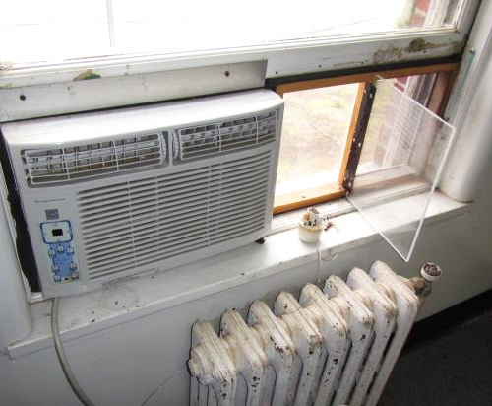
Modified window
Picture 2
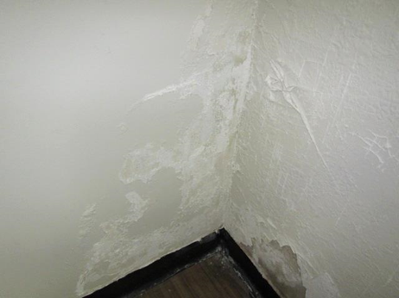
Peeling paint and efflorescence on plaster walls
Picture 3
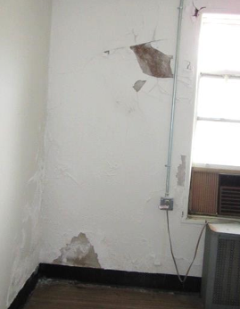
Peeling paint and efflorescence on interior plaster walls
Picture 4
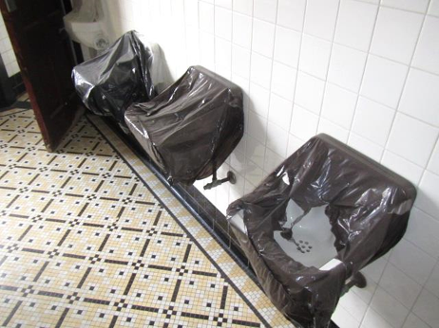
Abandoned sinks sealed with trash bags
Picture 5
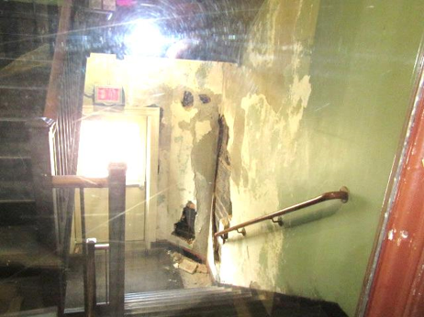
Peeling paint and damaged wall plaster in stairwell
Picture 6
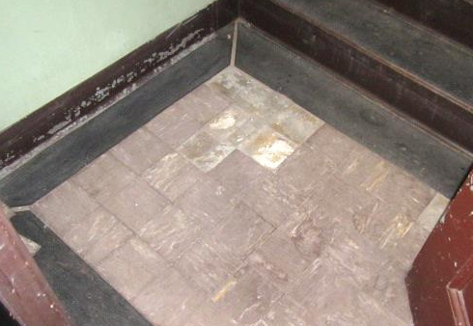
Missing/damaged floor tile in stairwell
Location | Carbon  Dioxide  (ppm) | Carbon Monoxide  (ppm) | Temp  (°F) | Relative  Humidity  (%) | PM2.5  (µg/m³) | TVOCs  (ppm) | Occupants  in Room | Windows  Openable | Ventilation |  |  | Remarks
 |  |  |  |  |  |  |  |  | Intake | Exhaust
Background | 397 | ND | 52 | 33 | 6 | ND |  |  |  |  |  | Cool, windy
1st Floor
101 | 483 | ND | 75 | 30 | 2 | ND | 0 | Y | N |  | N
102 Breakroom | 537 | ND | 72 | 26 | 2 | ND | 0 | Y | N |  | N | AC-cloth
103 | 691 | ND | 73 | 30 | 2 | ND | 0 | Y | N |  | N | Carpet
104 | 446 | ND | 76 | 19 | 2 | ND | 0 | Y | N |  | N | Windows can’t open due to AC installation
105 | 691 | ND | 76 | 31 | 3 | ND | 1 | Y | N |  | N
106 | 444 | ND | 76 | 28 | 2 | ND | 0 | Y | N |  | N
107 | 730 | ND | 77 | 31 | 3 | ND | 0 | Y | N |  | N | PF-dusty, carpet (worn)
108 | 489 | ND | 74 | 24 | 5 | ND | 0 | Y | N |  | N | Carpet
109 | 493 | ND | 77 | 27 | 4 | ND | 0 | Y | N |  | N | Carpet
111 | 583 | ND | 77 | 27 | 4 | ND | 1 | Y | N |  | N | Carpet
113 Copy Room | 499 | ND | 77 | 30 | 2 | ND | 0 | Y | N |  | N | PC, Windows can’t open due to AC installation
114 | 464 | ND | 76 | 27 | 3 | ND | 0 | Y | N |  | N | Plant, carpet, PF
115 | 517 | ND | 76 | 27 | 3 | ND | 0 | Y | N |  | N | Carpet
120 | 482 | ND | 75 | 22 | 3 | ND | 1 | Y | N |  | N | Carpet
121 | 484 | ND | 74 | 26 | 3 | ND | 0 | Y | N |  | N
126 | 499 | ND | 74 | 24 | 3 | ND | 1 | Y | N |  | N
127 | 504 | ND | 74 | 24 | 3 | ND | 1 | Y | N |  | N | PF
Breakroom/Kitchen | 525 | ND | 74 | 26 | 4 | ND | 0 | Y | N |  | N | Abandoned vent
132 | 686 | ND | 74 | 28 | 3 | ND | 1 | Y | N |  | N
134 | 632 | ND | 74 | 28 | 4 | ND | 1 | Y | N |  | N
138 | 666 | ND | 75 | 27 | 9 | ND | 1 | Y | N |  | N | PF
139 | 594 | ND | 75 | 26 | 5 | ND | 0 | Y | N |  | N
151 | 482 | ND | 75 | 28 | 5 | ND | 0 | Y | N |  | N
157 | 517 | ND | 75 | 28 | 5 | ND | 0 | Y | N |  | N | Plant
158 | 563 | ND | 75 | 24 | 5 | ND | 0 | Y | N |  | N | PC
165 | 612 | ND | 74 | 28 | 4 | ND | 1 | N | N |  | N
167 | 651 | ND | 74 | 27 | 4 | ND | 1 | Y | N |  | N
2nd Floor
201 | 470 | ND | 74 | 25 | 4 | ND | 0 | Y | N |  | N | Peeling paint
202 | 508 | ND | 73 | 24 | 4 | ND | 0 | Y | N |  | N
203 | 549 | ND | 74 | 24 | 5 | ND | 0 | Y | N |  | N
204 | 431 | ND | 72 | 18 | 4 | ND | 0 | Y | N |  | N
205 | 564 | ND | 75 | 23 | 4 | ND | 0 | Y | N |  | N | Peeling paint
212 | 478 | ND | 74 | 22 | 4 | ND | 0 | Y | N |  | N | Efflorescence wall
216 | 626 | ND | 74 | 26 | 5 | ND | 1 | Y | N |  | N | Area carpet
225 | 677 | ND | 74 | 25 | 5 | ND | 1 | Y | N |  | N | PF
230 | 552 | ND | 75 | 22 | 6 | ND | 1 | Y | N |  | N | Carpet
231 | 644 | ND | 74 | 24 | 5 | ND | 1 | Y | N |  | N | Carpet
232 | 510 | ND | 75 | 22 | 4 | ND | 0 | Y | N |  | N
235 | 512 | ND | 75 | 22 | 4 | ND | 0 | Y | N |  | N
250 | 773 | ND | 74 | 26 | 4 | ND | 1 | Y | N |  | N | Peeling paint, efflorescence
251 | 547 | ND | 77 | 26 | 4 | ND | 0 | Y | N |  | N | Peeling paint, efflorescence, WD plaster
253 | 718 | ND | 77 | 22 | 4 | ND | 1 | Y | N |  | N | Peeling paint, efflorescence

