# BACKGROUND

**INDOOR AIR QUALITY/WATER DAMAGE ASSESSMENT**

**Department of Mental Health**

**Hadley Building**

**167 Lyman Street**

**Westborough, MA**

Exterior view of 
Department of Mental Health
Hadley Building
167 Lyman Street
Westborough, MA


Prepared by:

Massachusetts Department of Public Health

Bureau of Environmental Health

Indoor Air Quality Program

February 2023

|  |  |
| --- | --- |
| Building: | Department of Mental Health (DMH),  Hadley Building |
| Address: | 167 Lyman Street, Westborough, MA |
| Assessment Requested by: | Sharon Moody, Assistant Director,  Office of Engineering and Facilities Management, DMH |
| Reason for Request: | Assessment of remediation of water-damaged building materials due to frozen pipe/plumbing leak |
| Date of Assessment: | February 15, 2023 |
| Massachusetts Department of Public Health/Bureau of Environmental Health (MDPH/BEH) Staff Conducting Assessment: | Cory Holmes, Assistant Director, Indoor Air  Quality (IAQ) Program |
| Building Description: | The Hadley Building is a multi-story, brick-faced building with basement built in the mid-1940s. It formerly served as the Westborough State Hospital and was converted to office space in 2009. The building is made up of individual offices, multi-occupant offices, conference rooms and common areas. Most areas had plaster/concrete block walls and ceilings with tile floor. Some areas had carpet squares, area rugs, and/or suspended ceiling tiles. |
| Windows: | Openable |

On Sunday February 5, 2023, a pipe burst on the 2nd floor West Wing of the Hadley Building due to extreme cold that occurred in New England over that weekend. Significant water damage was reported in the West Wing ground, 1st, and 2nd floors. The water and boilers were shut off by DMH staff, a plumber repaired the pipe on Monday, February 6 (Pictures 1 and 2), and Service Master, a commercial restoration company, was contacted. Service Master arrived on site Tuesday, February 7 to initiate remediation with drying machines and fans on the effected floors. Drying operations were completed on Thursday, February 9. Sole Source Cleaning arrived on February 9 to clean all affected areas. Although the building was open, it was recommended that staff telework to allow for the drying/cleaning mitigation to be completed. MDPH IAQ staff arrived on-site Wednesday, February 15 to conduct an IAQ Assessment of the West Wing ground, 1st, and 2nd floors.

# METHODS

Please refer to the IAQ Manual for methods, sampling procedures, and interpretation of results (MDPH, 2015).

# RESULTS AND DISCUSSION

| **Media sampled** | | **MDPH Guideline/**  **Comparison Value** | | **Measured Range** | | | **Comments** | |
| --- | --- | --- | --- | --- | --- | --- | --- | --- |
| **Outdoors/**  **Background** | **Indoors** | |
| Water-Damaged Building Materials | | Normal = Dry | |  |  | | All water-damaged materials were either removed (i.e., ceiling tiles), or dried in place (e.g., carpet, ceiling/wall plaster). Carpeting was scheduled to be professionally cleaned. | |
| Carbon Dioxide (CO2) | | < 800 parts per million (ppm) is preferred | | 445 | 530-768 | | HVAC operating providing adequate airflow. | |
| Total Volatile Organic Compounds (TVOCs) | | Equal to or below background level measured | | ND | 0.7 ppm | | Slight readings (<1.0 ppm) on 1st floor due to carpet cleaning. | |
| Carbon Monoxide (CO) | | Non-detectable (ND) or equal to or below background level measured | | ND | ND | |  | |
| Particulate Matter 2.5 (PM2.5) | | US EPA National Ambient Air Quality Standards (NAAQS) 35 μg/m3 or less | | 2 | 1-13 | | Cleaning in progress in some areas | |
| Temperature | | 70 to 78ºF | | 51 | 68-79 | | Within/close to MDPH comfort guidelines | |
| Relative Humidity (RH) | | 40% to 60% | | 56 | 25-34 | | Below outdoor/background conditions, indicating successful drying operations | |
| ppm = parts per million | µg/m3 = microgram per cubic meter | | ND = non-detectable | | | TVOCs = Total Volatile Organic Compounds | |

## Ventilation

A heating, ventilating, and air conditioning (HVAC) system has several functions. First it provides heating and, if equipped, cooling. Second, it is a source of fresh air. Finally, an HVAC system will dilute and remove normally occurring indoor environmental pollutants by not only introducing fresh air, but by filtering the airstream and ejecting stale air to the outdoors via exhaust ventilation. Even if an HVAC system is operating as designed, point sources of respiratory irritation may exist and cause symptoms in sensitive individuals.

The building’s mechanical ventilation system was designed to draw outside air via large air handling units (AHUs), which feed into main hallways via ducted vents. Individual rooms have an exhaust vent that pulls air into the room. Fresh air is supplemented by openable windows. Most offices have two openable windows and a window-mounted air conditioner.

## Microbial/Moisture Concerns

At the time of assessment, all water-damaged materials had been removed or remediated. A number of blowers and stand-up fans, dehumidifiers, and high efficiency particulate arrestance (HEPA) filtration units were observed in operation throughout the space (Pictures 3 through 6).

Moisture measurementsof carpeting and wall/ceiling plaster were taken in areas impacted by the flooding event (Table 1). All moisture measurements were normal (i.e., dry). At the time of assessment, contractors were finalizing cleanup operations and carpeting was scheduled to be cleaned.

Some water-damaged cardboard boxes were observed (Pictures 7 and 8). In addition, file cabinets in the affected area had moist materials in the bottom drawers (Picture 9), these materials should be dried promptly or discarded if they show signs of mold growth including mold stains or musty odors. If mold-colonized documents need to be retained, they can be copied onto fresh paper or scanned. It is recommended that porous material be dried with fans and heating within *24 to 48 hours of becoming wet* (US EPA, 2008, ACGIH, 1989). If porous materials are not dried within this time frame, mold growth may occur. Water-damaged porous materials cannot be adequately cleaned to remove mold growth.

## Other Issues

As a general rule, carpets should be cleaned annually (or semi-annually in soiled/high traffic areas) in accordance with Institute of Inspection, Cleaning and Restoration Certification (IICRC) recommendations, (IICRC, 2012). The service life of carpeting is approximately 10-11 years (IICRC, 2002). Carpeting of this age and condition becomes increasingly difficult to clean and maintain and may be a source of particulate matter to the indoor environment. Regular cleaning with a high efficiency particulate air (HEPA) filtered vacuum in combination with an annual cleaning will help to reduce accumulation and potential aerosolization of materials from carpeting.

As mentioned, a number of areas contained a high efficiency particulate arrestance (HEPA)-filtered air purifiers. It is important to note that filters should be changed, and these units be maintained in accordance with manufacturers’ recommendations.

Water-stained plaster and peeling paint were observed in several office areas (Pictures 10 and 11) and stairwells, as a result of the flooding incident. These areas should be scraped, cleaned, and refinished.

Complaints of environmental tobacco smoke (ETS) were expressed in the building. Smoking is a fire hazard. Evidence of smoking materials were observed in several areas of the ground floor (Pictures 12 through 15), including at the bottom of the stairwell by the rear entrance, which was found propped open at the time of assessment (Picture 16). If smoking occurs in this area (or outside this area) with the door propped open, the interior can become pressurized, forcing ETS odors and particulates into adjacent areas. Stairwells can act as a conduit due to both pressurization and the *stack effect* from the rising of heated air to upper floors. In addition, the propped open door can allow unconditioned air (cold/heat), uncontrolled moisture, as well as rodents, insects, and other pests into the building. This is also a security risk.

The Massachusetts Smoke-free Workplace Law prohibits smoking in schools, restaurants and bars, taxis, private offices, and other places of work. This law (MGL chapter 270, section 22, ["An Act to Improve the Public Health in the Commonwealth"](https://malegislature.gov/Laws/SessionLaws/Acts/2004/Chapter137) went into effect on July 5, 2004 to protect employees and the public from secondhand smoke and amends the 1988 Massachusetts Clean Indoor Air Law.

Finally, damaged pipe insulation was observed near the area of the flooding incident in room 275 (Picture 2). Due to the age of the building, this insulation may be asbestos containing materials (ACM). Intact ACM does not pose a health hazard. If damaged, ACM can be rendered friable and become aerosolized. Friable asbestos is a chronic (long-term) health hazard but will not produce acute (short-term) health effects (e.g., headaches) typically associated with buildings believed to have IAQ problems. Where asbestos-containing materials are found damaged, these materials should be removed or remediated in a manner consistent with Massachusetts asbestos remediation laws. At the time of assessment, it was recommended that these pipes be evaluated and remediated by a certified contractor.

# RECOMMENDATIONS

In view of the findings at the time of the visit, the following recommendations are made:

## Water Damage Recommendations

1. Finalize drying and cleaning operations.
2. Replace missing ceiling tiles so the ceiling tile grid is complete.
3. Refinish water-damaged building materials including scraping loose paint and sealing water-damaged/stained ceiling and wall plaster.
4. Continue with plans to remove unused/abandoned plumbing to prevent further leaks/incidents.
5. Store porous items (i.e., cardboard and paper) off the floor in sealed boxes, bags, or totes to prevent water damage. Discard water-damaged and/or moldy materials.

## Ventilation Recommendations

1. Change HVAC filters using *the best quality/highest* MERV rated filters that can be used with current equipment. During filter changes, vacuum debris from AHU cabinets.
2. Use windows to provide supplemental fresh air during temperate weather. Close windows tightly during wet and hot, humid weather to prevent moisture accumulation or during extreme cold to prevent frozen pipes.

## Other Recommendations

1. Continue with plans to have damaged insulation in room 275 evaluated/remediated in accordance with state and federal regulations for asbestos-containing materials.
2. Prohibit smoking in the building in accordance with (MGL chapter 270, section 22), ["An Act to Improve the Public Health in the Commonwealth"](https://malegislature.gov/Laws/SessionLaws/Acts/2004/Chapter137)
3. Keep exterior doors shut to maintain interior building conditions/security.
4. Clean carpeting annually or semi-annually in soiled high traffic areas as per the recommendations of the Institute of Inspection, Cleaning and Restoration Certification (IICRC 2012).
5. Replace old worn carpeting past its useful life (> 10-11 years).
6. Change/clean filters and maintain HEPA units in accordance with manufacturers’ recommendations.
7. Clean air conditioner filters prior to the start of the cooling season and on a regular basis while in use.
8. Refer to the resource manual and other related indoor air quality documents located on the MDPH’s website for further building-wide evaluations and advice on maintaining public buildings. These documents are available at <http://mass.gov/dph/iaq>.

**REFERENCES**

ACGIH. 1989. Guidelines for the Assessment of Bioaerosols in the Indoor Environment. American Conference of Governmental Industrial Hygienists, Cincinnati, OH.

IICRC. 2002. Institute of Inspection, Cleaning and Restoration Certification. A Life-Cycle Cost Analysis for Floor Coverings in School Facilities.

IICRC. 2012. Institute of Inspection, Cleaning and Restoration Certification. Carpet Cleaning: FAQ.

MDPH. 2015. Massachusetts Department of Public Health. “Indoor Air Quality Manual: Chapters I-III”. Available at: [Indoor air quality - manual and appendices | Mass.gov](https://www.mass.gov/lists/indoor-air-quality-manual-and-appendices)

US EPA. 2008. “Mold Remediation in Schools and Commercial Buildings”. Office of Air and Radiation, Indoor Environments Division, Washington, DC. EPA 402-K-01-001. September 2008. Available at: <http://www.epa.gov/mold/mold-remediation-schools-and-commercial-buildings-guide>.

**Picture 1**

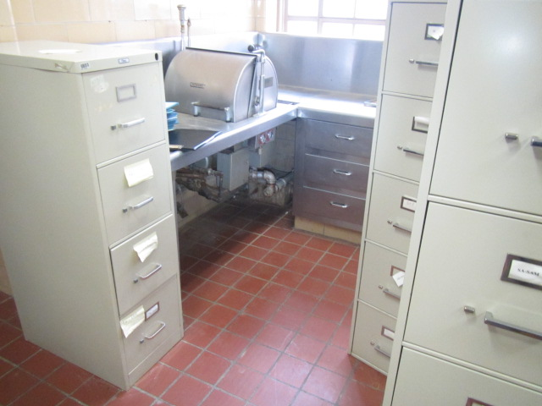

**Area of frozen pipe in room 275 on 2nd floor West Wing Hadley Building**

**Picture 2**

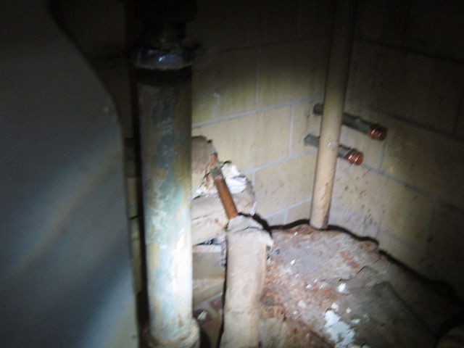

**Fresh caps on damaged pipes (arrows) in room 275, also note exposed insulation material (arrow)**

**Picture 3**

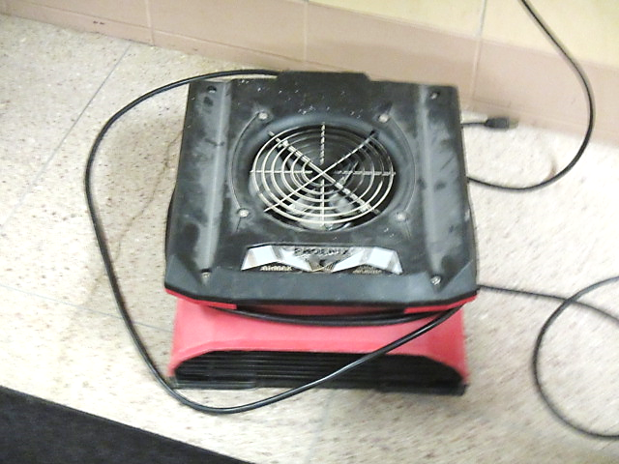

**Drying fan/blower**

**Picture 4**

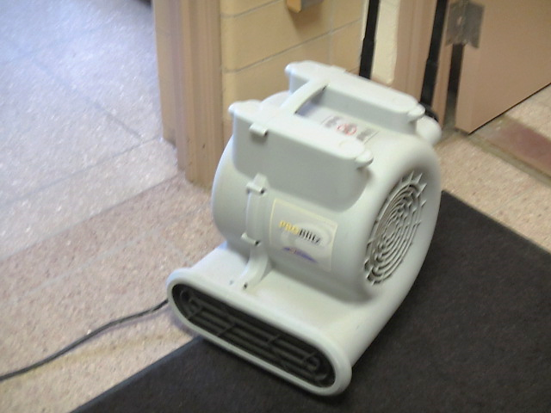

**Drying fan/blower**

**Picture 5**

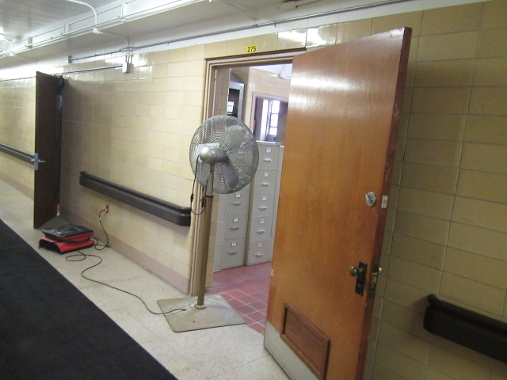

**Pedestal fan in doorway, drying fan on floor**

**Picture 6**

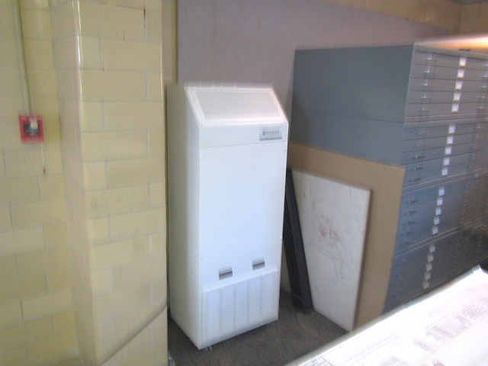

**HEPA filtration unit**

**Picture 7**

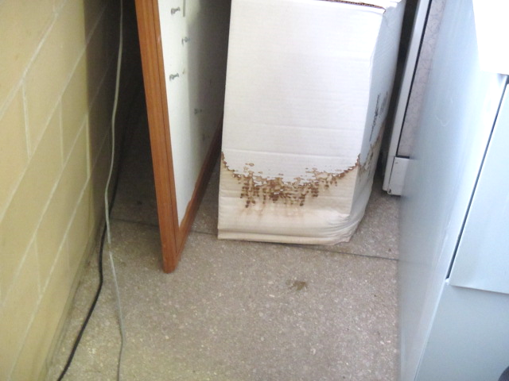

**Water-damaged cardboard box**

**Picture 8**

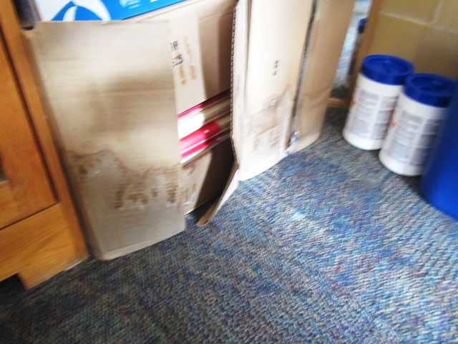

**Water-damaged cardboard boxes**

**Picture 9**

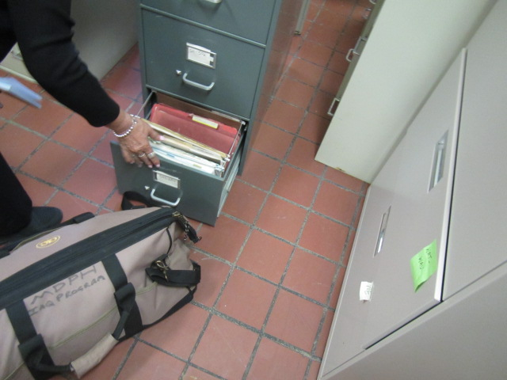

**Wet folders/papers in bottom drawer of file cabinet in room 275**

**Picture 10**

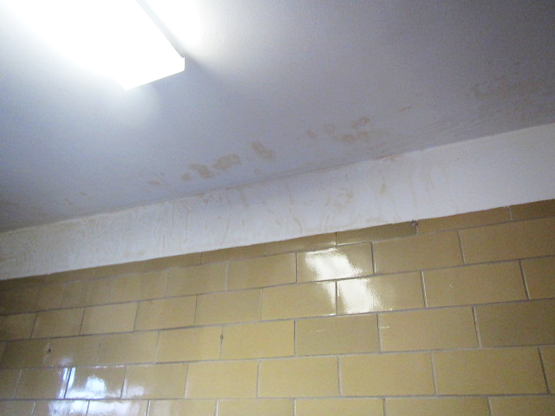

**Water-stained plaster**

**Picture 11**

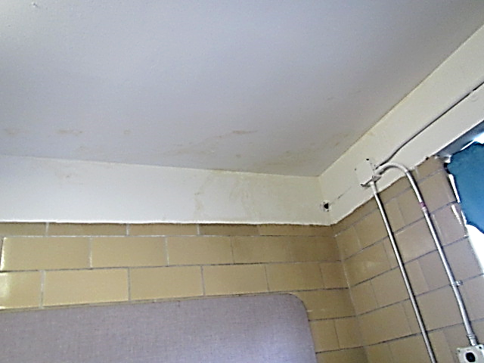

**Water-stained plaster**

**Picture 12**

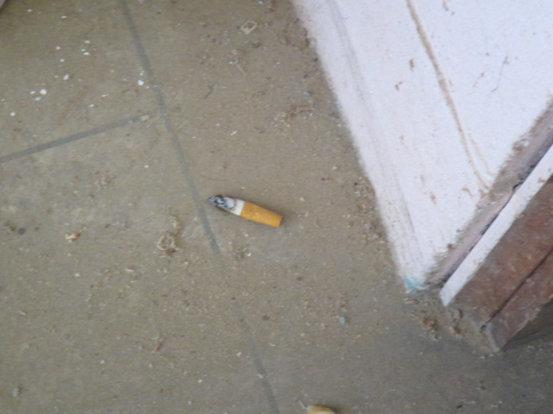

**Cigarette butt on ground floor shop area**

**Picture 13**

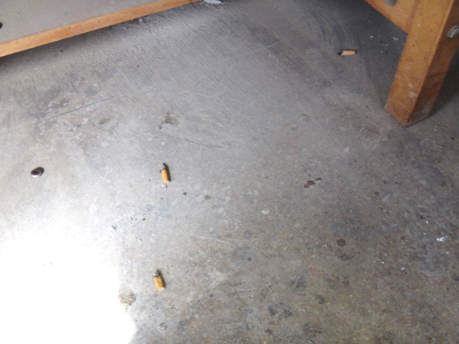

**Cigarette butts on ground floor shop area**

**Picture 14**

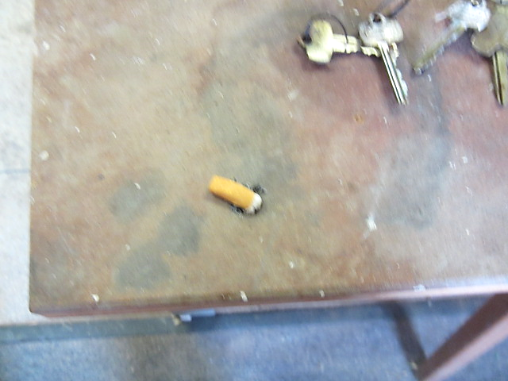

**Cigarette butt on tabletop of ground floor shop area**

**Picture 15**

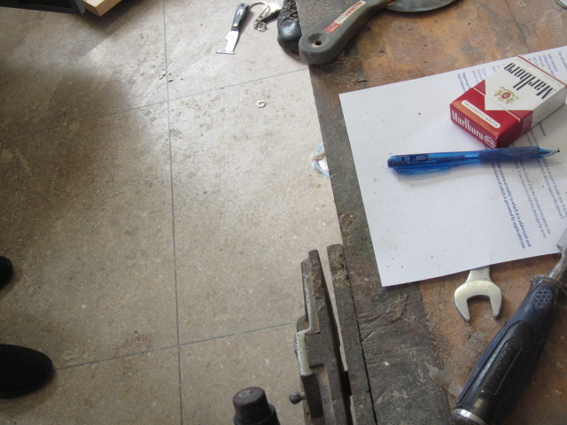

**Smoking materials in ground floor shop area**

**Picture 16**

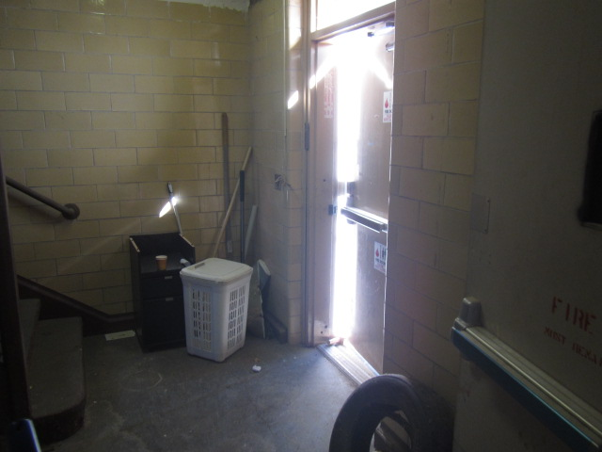

**Rear exterior door propped open**