INDOOR AIR QUALITY ASSESSMENT

Department of Mental Health
Case Management Wing, Hadley Building
167 Lyman Street
Westborough, MA

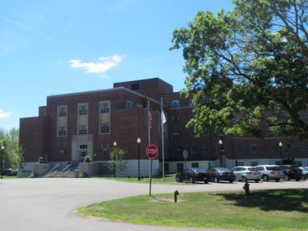

Prepared by:
Massachusetts Department of Public Health
Bureau of Environmental Health
Indoor Air Quality Program
July 2016

Background
Building: | Hadley Building, Case Management Wing
Address: | 167 Lyman Street, Westborough, MA
Assessment Requested by: | Todd Gundlach, Director, Engineering & Facilities Management, Department of Mental Health (DMH)
Reason for Request: | General indoor air quality (IAQ)
Date of Assessment: | June 17, 2016
Massachusetts Department of Public Health/Bureau of Environmental Health (MDPH/BEH) Staff Conducting Assessment: | Cory Holmes, Environmental Analyst/Inspector, IAQ Program
Building Description: | A multi-story, brick-faced building with basement. Formerly served as the Westborough State Hospital, converted to DMH office space in 2009. The case management wing is made up of individual offices, several multi-occupant offices, conference rooms and common areas.
Year Built: | 1945-1947
Building Population: | The case management wing houses approximately 20 staff members
Windows: | Openable

METHODS
Please refer to the IAQ Manual for methods, sampling procedures, and interpretation of results (MDPH, 2015).

IAQ Testing Results
The following is a summary of indoor air testing results (Table 1).
- Carbon dioxide levels were below 800 parts per million (ppm) in all but one of the 20 areas tested, indicating adequate fresh air exchange.
- Temperature was within the recommended range of 70°F to 78°F in all areas tested.
- Relative humidity was within or close to the recommended range of 40 to 60% in most areas tested.
- Carbon monoxide levels were non-detectable (ND) in all areas tested.
- Total volatile organic compound (TVOC) levels were ND in all areas tested.
- Fine particulate matter (PM2.5) concentrations measured were below the National Ambient Air Quality Standard (NAAQS) level of 35 μg/m³ in all areas tested.

Ventilation
A heating, ventilating and air conditioning (HVAC) system has several functions. First it provides heating and, if equipped, cooling. Second, it is a source of fresh air. Finally, an HVAC system will dilute and remove normally occurring indoor environmental pollutants by not only introducing fresh air, but by filtering the airstream and ejecting stale air to the outdoors via exhaust ventilation. Even if an HVAC system is operating as designed, point sources of respiratory irritants may exist and cause symptoms in sensitive individuals.
The Case Management wing is not fully equipped with a central HVAC system. Fresh air for the case management wing is mostly provided by openable windows. Most offices have two openable windows and a window-mounted air conditioner (AC). However, there was a vent at the end of the hallway (Picture 1), which was said to provide a mechanical means of outside air to the hallway. This system was reported to be under repair at the time of the assessment.
Restrooms are equipped with local exhaust vents to remove odors and moisture; however several of these were not operating during the assessment. Several of the restrooms had passive door vents which were found to be sealed (Picture 2). These vents should be restored to provide make-up air while exhaust vents are operating.

Microbial/Moisture Concerns
A few areas (Library and 119) exhibited signs of historic water damage in the form of peeling paint and water-stained plaster (Pictures 3 and 4). At the time of assessment, repointing/waterproofing activities were being conducted on the exterior of the building outside the Library (Picture 5).
While temperature is mainly a comfort issue, relative humidity in excess of 70 percent for extended periods of time can provide an environment for mold and fungal growth (ASHRAE, 1989). During periods of high relative humidity (late spring/summer months), windows and exterior doors should be closed to keep moisture out while ACs are operating to prevent condensation on cool surfaces.
Room 133 was equipped with a two ductless AC units. These units have condensation drains that are typically pumped to the outside of the building. These units should be regularly inspected to insure that the condensation drains and pumps are working properly and are not clogged or leaking. Room 134 had cloth stationed beneath the window AC (Picture 7), to presumably seal drafts or perhaps absorb leaks. This material is porous and can grow mold if wet repeatedly.
A severely water-damaged box was observed in the storeroom (Room 128, Picture 8). This box and its contents should be evaluated and if found to be mold-colonized or odorous, should be discarded.
Water coolers and water fountains were observed on carpeting. Spills and leaks from these appliances can moisten carpeting and lead to microbial growth and odors.
Plants were observed in several areas (Table 1). Plants, soil, and drip pans can serve as sources of mold/bacterial growth (Picture 6). Plants should be properly maintained, over-watering of plants should be avoided, and drip pans should be inspected periodically for mold growth.

Other IAQ Evaluations
Accumulated items were found stored on floors and other flat surfaces which can make it more difficult for custodial staff to clean. Some flat surfaces, exhaust vents, and personal fans were found to be dusty. Dust can be reaerosolized and cause irritation; these items should be cleaned regularly.
Most areas of the office space were carpeted. The Institute of Inspection, Cleaning and Restoration Certification (IICRC) recommends that carpeting be cleaned annually (or semi-annually in soiled high traffic areas) (IICRC, 2012). Regular cleaning with a high efficiency particulate arrestance (HEPA) filtered vacuum in combination with an annual cleaning will help to reduce accumulation and potential aerosolization of materials from the carpeting.
Air conditioning units are typically equipped with filters. Filters for AC units should be cleaned prior to and periodically during the cooling season.

Conclusions/Recommendations
The following recommendations are made to assist in maintaining IAQ:
- Continue with plans to repair hallway air handling unit. Consider long-term plans to work with an HVAC engineer to determine if units can be retrofitted with chiller/AC capabilities.
- Ensure fans/motors for restroom exhaust vents are operational. Restore passive door vents to provide make-up air.
- Use open windows (weather permitting), to temper rooms and provide fresh air.
    - Care should be taken to ensure windows are properly closed at night and on weekends.
    - Keep windows closed during hot, humid weather to maintain indoor temperatures and to avoid condensation problems when air conditioning is activated.
    - Shut windows after hours during winter months to avoid the freezing of pipes and potential flooding.
- For buildings in New England, periods of low relative humidity during the winter are often unavoidable. Therefore, scrupulous cleaning practices should be adopted to minimize common indoor air contaminants whose irritant effects can be enhanced when the relative humidity is low. To control for dusts, a high efficiency particulate arrestance (HEPA) filter equipped vacuum cleaner in conjunction with wet wiping of all surfaces is recommended. Avoid the use of feather dusters. Drinking water during the day can help ease some symptoms associated with a dry environment (throat and sinus irritations).
- Continue with plans to repoint/waterproof the exterior. Once repairs complete, clean and repaint areas of water damage/peeling paint (e.g., 119, Library).
- Consider putting water dispensers on waterproof mats or in areas without carpeting. Consider installing floor tile below/around stationary water fountains.
- Regularly inspect the ductless AC units for proper condensation drainage.
- Ensure window ACs are sealed properly to eliminate drafts and or/water penetration. Refrain from using cloth/porous materials around AC units.
- Indoor plants should be properly maintained and equipped with drip pans to prevent water damage to porous building materials and be located away from ventilation sources to prevent the aerosolization of dirt, pollen or mold.
- Examine water-damaged box/contents in storeroom 128, discard if moldy.
- Clean AC filters prior to and periodically/as needed during the cooling season.
- Clean supply and exhaust vents and personal fans regularly to prevent aerosolization of debris.
- Clean carpeting annually or semi-annually in soiled high traffic areas as per the recommendations of the Institute of Inspection, Cleaning and Restoration Certification (IICRC, 2012).
- Consider reducing the amount of items stored in offices to make cleaning easier. Periodically move items to clean flat surfaces.
- Refer to resource manual and other related IAQ documents located on the MDPH’s website for further building-wide evaluations and advice on maintaining public buildings. These documents are available at: http://mass.gov/dph/iaq.

References
ASHRAE. 1989. Ventilation for Acceptable Indoor Air Quality. American Society of Heating, Refrigeration and Air Conditioning Engineers. ANSI/ASHRAE 62-1989.
IICRC. 2012. Institute of Inspection, Cleaning and Restoration Certification. Carpet Cleaning: FAQ. Retrieved from http://www.iicrc.org/consumers/care/carpet-cleaning/#faq.
MDPH. 2015. Massachusetts Department of Public Health. Indoor Air Quality Manual: Chapters I-III. Available at: http://www.mass.gov/eohhs/gov/departments/dph/programs/environmental-health/exposure-topics/iaq/iaq-manual/.
Picture 1
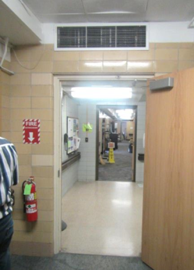
Vent at end of hallway
Picture 2
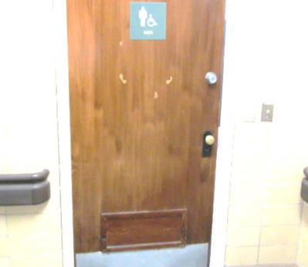
Restroom passive door vent sealed
Picture 3
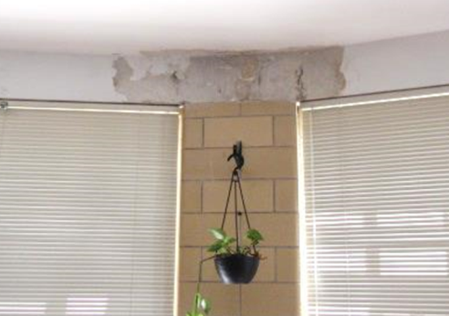
Water-damaged plaster and peeling paint in the Library
Picture 4
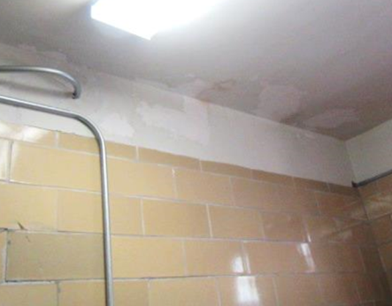
Water-damaged ceiling/wall plaster and peeling paint in Room 119
Picture 5
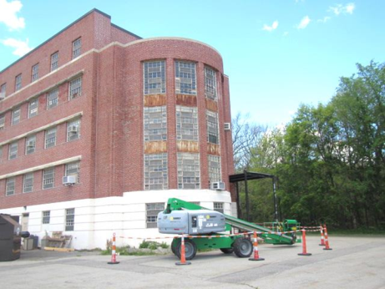
Repointing/waterproofing activities outside of Library
Picture 6
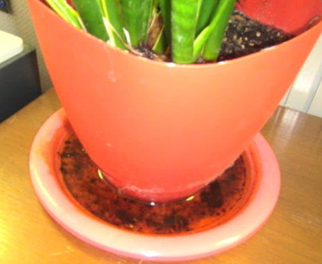
Standing water/debris in drip pan
Picture 7
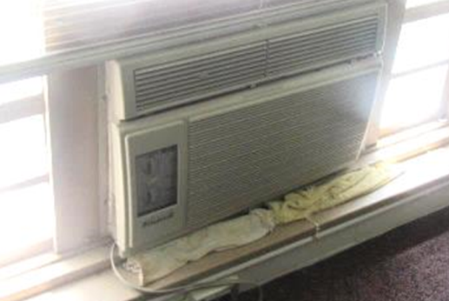
Cloth below AC in room 134
Picture 8
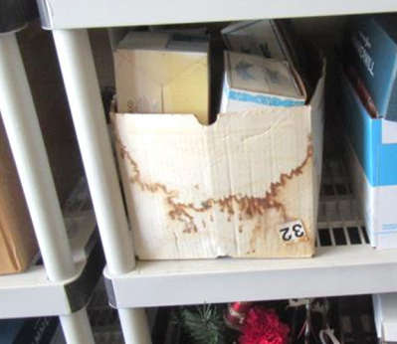
Water-damaged box in storeroom
Location | Carbon  Dioxide  (ppm) | Carbon Monoxide  (ppm) | Temp  (°F) | Relative  Humidity  (%) | PM2.5  (µg/m³) | TVOCs  (ppm) | Occupants  in Room | Windows  Openable | Ventilation |  |  | Remarks
 |  |  |  |  |  |  |  |  | Intake | Exhaust
Background | 376 | ND | 83 | 25 | 10 | ND |  |  |  |  |  | Warm, sunny
Hoffman Office | 645 | ND | 75 | 36 | 8 | ND | 1 | Y | N |  | N | Carpet, plants, AC
107 | 624 | ND | 74 | 35 | 9 | ND | 3 | Y | N |  | N | Plants
Library | 530 | ND | 76 | 40 | 10 | ND | 0 | Y | N |  | N | Peeling paint, WD plaster, plants, repointing project ongoing
111 Kitchen | 611 | ND | 76 | 44 | 7 | ND | 0 | Y | N |  | N
112 | 697 | ND | 77 | 45 | 8 | ND | 4 | Y | N |  | N | Plants
114 Men’s Restroom |  |  |  |  |  |  |  | Y | N |  | Y | Passive door vent-sealed
116 Storage Room | 469 | ND | 76 | 40 | 7 | ND | 0 | Y | N |  | N
118 | 731 | ND | 76 | 41 | 6 | ND | 0 | Y | N |  | N
119 | 475 | ND | 76 | 41 | 7 | ND | 0 | Y | N |  | N | WD plaster, peeling paint
120 | 640 | ND | 77 | 43 | 5 | ND | 0 | Y | N |  | N
121 | 491 | ND | 76 | 44 | 6 | ND | 0 | Y | N |  | N
122 | 688 | ND | 74 | 44 | 9 | ND | 1 | Y | N |  | N | Abandoned vent
123 | 637 | ND | 73 | 46 | 10 | ND | 0 | Y | N |  | N | Plants
124 | 579 | ND | 75 | 41 | 10 | ND | 1 | Y | N |  | N | Plants
126 | 564 | ND | 74 | 39 | 9 | ND | 0 | Y | N |  | N | PFs, plants
127 | 566 | ND | 74 | 45 | 8 | ND | 1 | Y  Open | N |  | N | Plants
128 | 584 | ND | 76 | 41 | 9 | ND | 0 | Y | N |  | N | Holes in wall, dust/debris on flat surfaces
129 Restroom |  |  |  |  |  |  |  | Y | Y |  | Y | Passive door vent, exhaust not operating
130 | 1288 | ND | 77 | 49 | 7 | ND | 7 | Y | N |  | N | Plants
132 | 452 | ND | 77 | 41 | 6 | ND | 2 | Y  Open | N |  | N | PC, DEM, PF, AC
133 | 509 | ND | 76 | 43 | 10 | ND | 0 | Y | N |  | N | Wall-mounted AC units
134 | 447 | ND | 77 | 44 | 7 | ND | 0 | Y | N |  | N | AC-cloth underneath

