INDOOR AIR QUALITY ASSESSMENT

Department of Mental Health
Hadley Building
167 Lyman Street
Westborough, MA

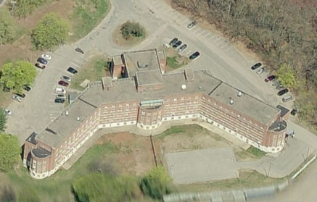

Prepared by:
Massachusetts Department of Public Health
Bureau of Environmental Health
Indoor Air Quality Program
October 2016

Executive Summary:
The building was designed with a mechanical ventilation system that is currently not operating as designed. To improve air quality the system should be restored to its original function or redesigned under the guidance of a heating, ventilating and air conditioning (HVAC) engineering firm.

Background
Building: | Hadley Building
Address: | 167 Lyman Street, Westborough, MA
Assessment Requested by: | Joe Dykers, Northeast Area Facilities Manager, Department of Mental Health (DMH)
Reason for Request: | General indoor air quality (IAQ)
Date of Assessment: | September 16, 2016
Massachusetts Department of Public Health/Bureau of Environmental Health (MDPH/BEH) Staff Conducting Assessment: | Cory Holmes and Jason Dustin, Environmental Analysts/Inspectors, IAQ Program
Building Description: | A multi-story, brick-faced building with basement. Formerly served as the Westborough State Hospital, converted to office space in 2009. The building is made up of individual offices, multi-occupant offices, conference rooms and common areas.
Year Built: | 1945-1947
Building Population: | The building houses approximately 100 employees.
Windows: | Openable

METHODS
Please refer to the IAQ Manual for methods, sampling procedures, and interpretation of results (MDPH, 2015).

IAQ Testing Results
The following is a summary of indoor air testing results (Table 1).
- Carbon dioxide levels were below 800 parts per million (ppm) in all but two areas tested throughout the building.
- Temperature was within the recommended range of 70°F to 78°F in all areas tested.
- Relative humidity was within or close to the recommended range of 40 to 60% in most areas tested.
- Carbon monoxide levels were non-detectable (ND) in all areas tested.
- Fine particulate matter (PM2.5) concentrations measured were below the National Ambient Air Quality Standard (NAAQS) level of 35 μg/m³ in all areas tested.

Ventilation
An HVAC system has several functions. First it provides heating and, if equipped, cooling. Second, it is a source of fresh air. Finally, an HVAC system will dilute and remove normally occurring indoor environmental pollutants by not only introducing fresh air, but by filtering the airstream and ejecting stale air to the outdoors via exhaust ventilation. Even if an HVAC system is operating as designed, point sources of respiratory irritants may exist and cause symptoms in sensitive individuals.
The building’s mechanical ventilation system is not equipped with air conditioning (AC) capabilities. It was designed to draw outside air via large air handling units (AHUs), which feed into main hallways via ducted vents (Pictures 1 through 3). Individual rooms have an exhaust vent that pulls air into the room (Pictures 4 and 5). Doors were designed to have passive vents/grills in order to sustain airflow while shut (Picture 6), however the large majority of them have been sealed throughout the building (Picture 7). This system was reported to be under repair at the time of the assessment, therefore the building is not being ventilated the way it was designed. Currently, fresh air is mostly provided by openable windows. Most offices have two openable windows and a window-mounted AC.
Restrooms are equipped with local exhaust vents to remove odors and moisture; however several of these were not operating during the assessment. Several of the restrooms also had passive door vents sealed. These vents should be restored (or doors undercut) to provide make-up air while exhaust vents are operating.

Microbial/Moisture Concerns
A number of areas (Table 1) exhibited signs of historic water damage in the form of peeling paint; efflorescence and water-damaged ceiling/wall plaster (Pictures 8 through 11). Efflorescence is a characteristic sign of water damage caused by salts and mineral deposits from water filtrating through materials such as brick and concrete, which may become aerosolized, and be a contributing source to eye and respiratory system irritation. Over the summer, repointing/waterproofing activities were conducted in a few areas along the exterior of the building.
Plants were observed in several areas (Table 1). Plants, soil, and drip pans can serve as sources of mold/bacterial growth. In one case plants were observed on paper towels, which are a porous material that can grow mold (Picture 12). Plants should be properly maintained, over-watering of plants should be avoided, and drip pans should be inspected periodically for mold growth. In conference room 260, paper towels were noted around the window, presumably to stop leaks/drafts (Picture 13).
Open seams between the sink countertop and backsplash were observed in kitchen 228 (Picture 14). If seams are not watertight, water can penetrate the seam, causing water damage. Water penetration and chronic exposure of porous and wood-based materials can cause these materials to swell, show signs of water damage and lead to potential mold growth.
In many areas wood is used to seal spaces around ACs. Wood is a semi-porous material, which if subjected to chronic moisture can grow mold. In some cases the wood appears discolored/moldy (Picture 15) and may be in need of replacement.
Several unconditioned rooms are used as storage (G64, 274/275). Without a source of moisture removal (e.g., AC, dehumidification) paper products can become chronically moist/damaged and provide a source of mold growth.

Volatile Organic Compounds (VOCs)
Exposure to low levels of total VOCs (TVOCs) may produce eye, nose, throat, and/or respiratory irritation in some sensitive individuals. To determine if VOCs were present, BEH/IAQ staff examined rooms for products containing VOCs. BEH/IAQ staff noted hand sanitizers, cleaners, air deodorizing materials, nail polish remover, and dry erase materials in use within the building (Table 1). All of these products have the potential to be irritants to the eyes, nose, throat, and respiratory system of sensitive individuals. Air deodorizers, in particular, can serve as a continual source of TVOCs, since the products are designed to continually emit scents.

Other IAQ Evaluations
Accumulated items were found stored on floors and other flat surfaces, which can make it more difficult for custodial staff to clean. Some flat surfaces, exhaust vents (Pictures 4 and 5), and personal fans (Picture 16) were found to be dusty and have cobwebs. Dust can be reaerosolized and cause irritation; flat surfaces and items should be cleaned regularly.
Some areas of the office space were carpeted. The Institute of Inspection, Cleaning and Restoration Certification (IICRC) recommends that carpeting be cleaned annually (or semi-annually in soiled high traffic areas) (IICRC, 2012). Regular cleaning with a high efficiency particulate arrestance (HEPA) filtered vacuum in combination with an annual cleaning will help to reduce accumulation and potential aerosolization of materials from carpeting.
AC units are typically equipped with filters. Filters for AC units should be cleaned prior to and periodically during the cooling season.
Room 458 had an open utility hole in the wall (Picture 17). These breaches can serve as pathways for dirt, dust and odors from the wall cavity into occupied space.
An abandoned toilet was observed in room 256 (Picture 18). If abandoned plumbing fixtures are not removed/capped properly, they can serve as conduits for sewer gasses/odors into occupied areas.
A spray can of insecticide was observed in an office (Picture 19). Pesticides contain harmful chemicals that can cause eye, and respiratory irritation and health effects. Integrated pest management (IPM) should be used in occupied buildings with pesticides as a last resort.

Conclusions/Recommendations
The following recommendations are made to assist in maintaining IAQ:
- Restore the building’s HVAC system, continue with plans to repair hallway AHUs. Consider long-term plans to work with an HVAC engineer to determine if units can be retrofitted with chiller/AC capabilities.
- Ensure fans/motors for restroom exhaust vents are operational. Restore passive door vents or undercut doors to provide make-up air.
- Use open windows (weather permitting), to temper rooms and provide fresh air.
    - Care should be taken to ensure windows are properly closed at night and on weekends.
    - Keep windows closed during hot, humid weather to maintain indoor temperatures and to avoid condensation problems when AC is activated.
    - Shut windows after hours during winter months to avoid the freezing of pipes and potential flooding.
- For buildings in New England, periods of low relative humidity during the winter are often unavoidable. Therefore, scrupulous cleaning practices should be adopted to minimize common indoor air contaminants whose irritant effects can be enhanced when the relative humidity is low. To control for dusts, a high efficiency particulate arrestance (HEPA) filter equipped vacuum cleaner in conjunction with wet wiping of all surfaces is recommended. Avoid the use of feather dusters. Drinking water during the day can help ease some symptoms associated with a dry environment (throat and sinus irritations).
- Continue with plans to repoint/waterproof the exterior.
- Once waterproofing/repairs are complete, clean/scrape and repaint areas of water damage/peeling paint and efflorescence (e.g., walls, ceilings and windowsills). Given the age of the building Lead Safe renovating methods may be warranted.
- Ensure window ACs are sealed properly to eliminate drafts and or/water penetration. Refrain from using cloth/porous materials around AC units and windows (Picture 13).
- Inspect wood around ACs for chronic water damage, clean/refinish/replace as needed.
- Indoor plants should be properly maintained and equipped with drip pans to prevent water damage to porous building materials and be located away from ventilation sources to prevent the aerosolization of dirt, pollen or mold. Do not rest plants on porous materials (e.g., cloth, paper).
- Install ACs and/or use dehumidifiers in storage rooms used for porous materials (e.g., G64, 274/275).
- Seal around sink in kitchen 228 (and any other sinks with similar breaches) to prevent water damage to backsplash/countertop wood.
- Clean AC filters prior to and periodically/as needed during the cooling season.
- Clean supply and exhaust vents and personal fans regularly to prevent aerosolization of debris.
- Clean carpeting annually or semi-annually in soiled high traffic areas as per the recommendations of the Institute of Inspection, Cleaning and Restoration Certification (IICRC, 2012).
- Consider reducing the amount of items stored in offices to make cleaning easier. Periodically move items to clean flat surfaces.
- Remove and cap abandoned toilet in room 256.
- Seal open utility holes/breaches in walls/ceilings.
- Institute an IPM program to manage pests. Insecticides should be used as a last resort.
- Reduce the use of air deodorizers, cleaning products, sanitizers, and other products containing VOCs. Considering adopting green cleaning procedures. Ensure cleaning products are properly labeled, and keep material safety sheets on file.
- Refer to resource manual and other related IAQ documents located on the MDPH’s website for further building-wide evaluations and advice on maintaining public buildings. These documents are available at: http://mass.gov/dph/iaq.

References
IICRC. 2012. Institute of Inspection, Cleaning and Restoration Certification. Carpet Cleaning: FAQ. Retrieved from http://www.iicrc.org/consumers/care/carpet-cleaning.
MDPH. 2015. Massachusetts Department of Public Health. Indoor Air Quality Manual: Chapters I-III. Available at: http://www.mass.gov/eohhs/gov/departments/dph/programs/environmental-health/exposure-topics/iaq/iaq-manual/.
Picture 1
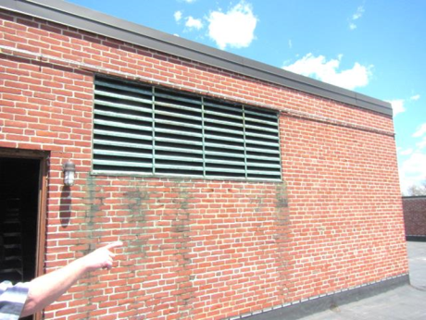
Fresh air intake for AHU
Picture 2
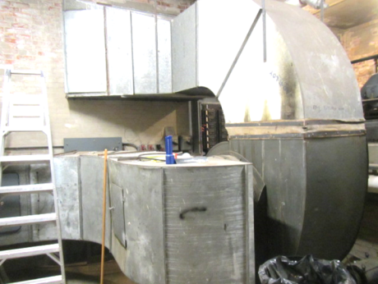
Air handling equipment in attic
Picture 3
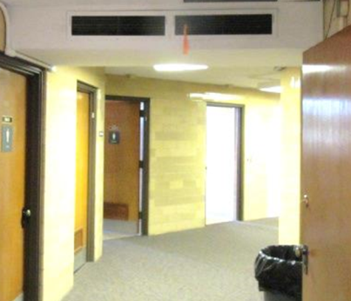
Hallway supply vents
Picture 4
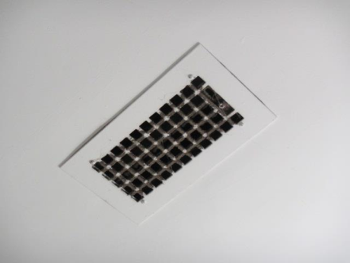
Ceiling exhaust vent, note dust/debris
Picture 5
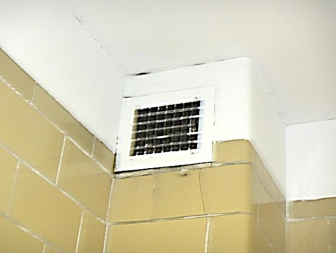
Wall-mounted exhaust vent, note dust/debris
Picture 6
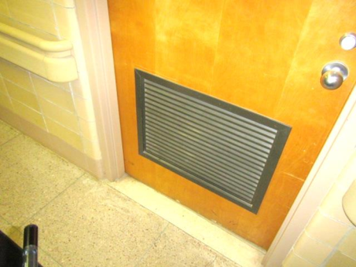
Passive door vent/grill
Picture 7
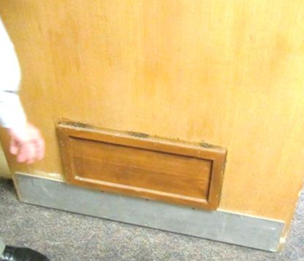
Sealed passive door vent
Picture 8
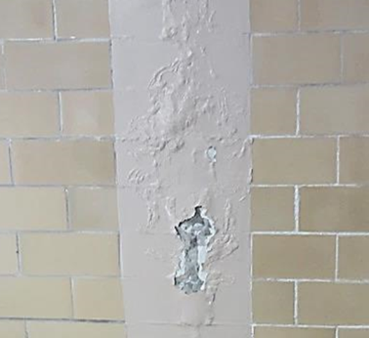
Peeling paint and efflorescence
Picture 9
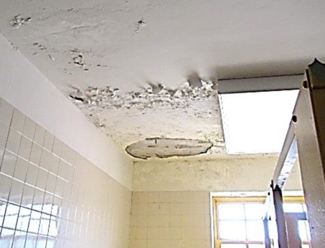
Severely water-damaged ceiling in 3rd floor women’s restroom
Picture 10
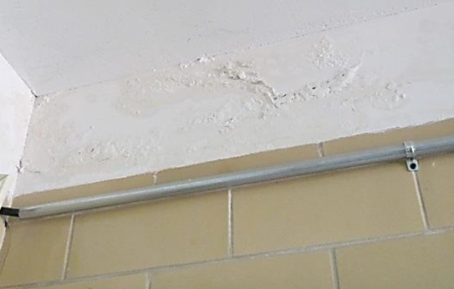
Peeling paint and efflorescence
Picture 11
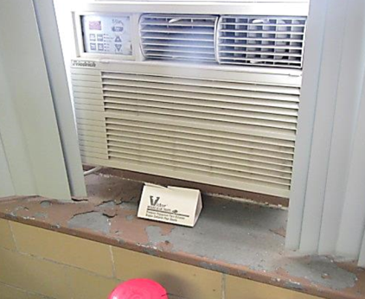
Peeling paint on windowsill
Picture 12
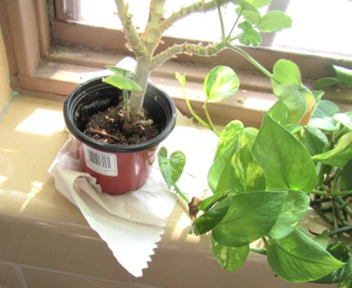
Plant on paper towel
Picture 13
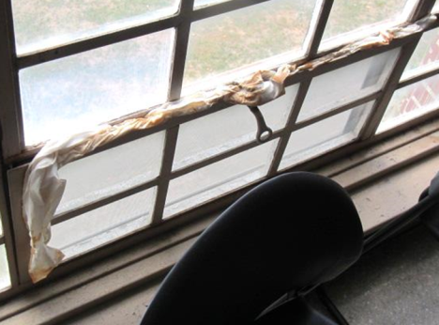
Soiled towels around window
Picture 14
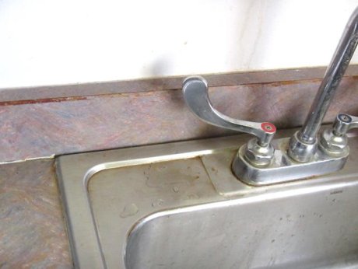
Loose/damaged backsplash kitchen 228
Picture 15
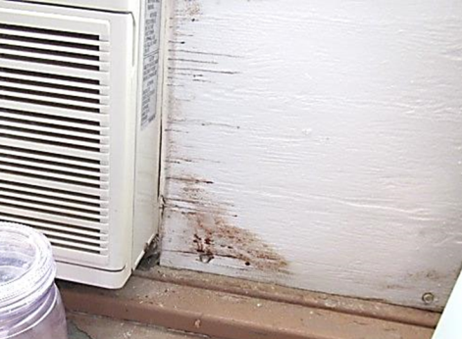
Water-damaged wood/possible mold growth on wood around AC room 456
Picture 16
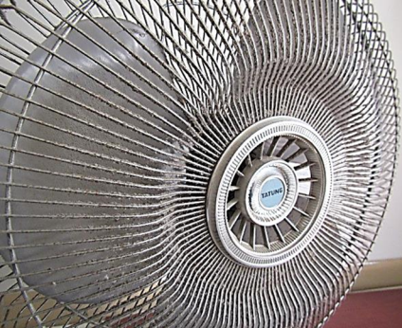
Accumulated dust/debris on personal fan
Picture 17
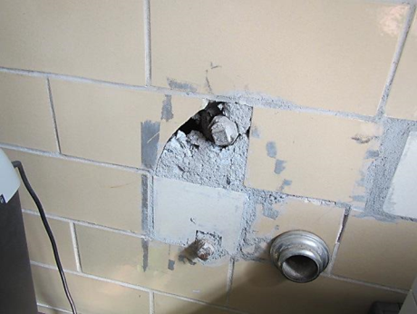
Hole in wall around utility pipe
Picture 18
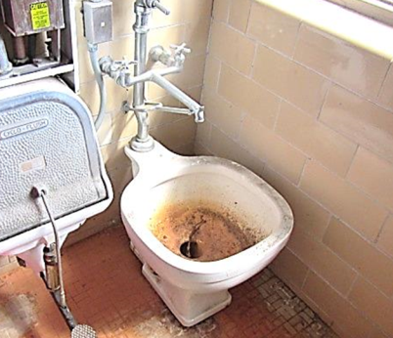
Abandoned toilet in room 256
Picture 19
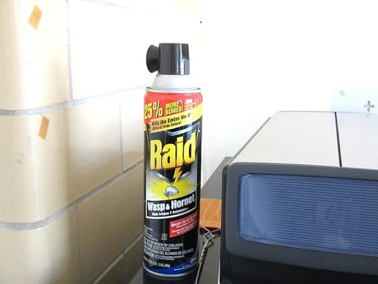
Spray insecticide in office

Location | Carbon  Dioxide  (ppm) | Carbon Monoxide  (ppm) | Temp  (°F) | Relative  Humidity  (%) | PM2.5  (µg/m³) | Occupants  in Room | Windows  Openable | Ventilation |  |  | Remarks
 |  |  |  |  |  |  |  | Intake | Exhaust
Background | 334 | ND | 68 | 55 | 5-10 | - | - | - |  | - | Partly sunny, light breeze
4th Floor
451 | 412 | ND | 76 | 51 | 3 | 1 | Y | N |  | N | Spaces around AC, plexiglass windows
452 | 502 | ND | 76 | 49 | 3 | 2 | Y | N |  | Y | Efflorescence exterior wall, peeling paint windowsill, cobwebs dust/debris
453 | 530 | ND | 75 | 50 | 4 | 1 | Y | N |  | Y | Peeling paint above window
404 Kitchen | 567 | ND | 75 | 51 | 3 | 0 | Y | N |  | N | Peeling paint above window
456 | 427 | ND | 75 | 49 | 3 | 0 | Y | N |  | Y | WD wood around AC
457 | 516 | ND | 76 | 50 | 3 | 1 | Y | N |  | Y | PF, plant
458 | 552 | ND | 75 | 48 | 5 | 0 | Y | N |  | Y | Plant on paper towel, utility hole/wall
464 Conference Room | 500 | ND | 76 | 48 | 3 | 0 | Y | N |  | Y | ~15 occupants just left meeting
463 | 470 | ND | 76 | 48 | 3 | 0 | Y | N |  | Y
461 | 440 | ND | 75 | 48 | 3 | 0 | Y | N |  | Y
462 | 493 | ND | 75 | 49 | 3 | 1 | Y | N |  | Y | Peeling paint window
460 | 470 | ND | 75 | 48 | 3 | 0 | Y | N |  | Y | Dust/debris vent, PF
476 Kitchen | 434 | ND | 77 | 45 | 4 | 0 | N | N |  | Y off | AC, CPs, plant, exhaust back drafting
474 | 702 | ND | 74 | 37 | 7 | 0 | N | N |  | Y | AC (on)
Handicapped restroom |  |  |  |  |  |  | Y open | N |  | Y | Exhaust back drafting
Janitor closet |  |  |  |  |  |  | Y open | N |  | Y off | CPs, feather dusters, mops
468 | 420 | ND | 73 | 50 | 11 | 3 | Y | N |  | Y | AC on, plants, dirty carpet
467 | 421 | ND | 73 | 50 | 8 | 2 | Y | N |  | Y | AC, CPs
3rd Floor
375 | 653 | ND | 77 | 44 | 3 | 0 | Y | N |  | Y | PF
374 | 711 | ND | 77 | 46 | 3 | 1 | Y | N |  | Y | Efflorescence/peeling paint
Women’s Restroom |  |  |  |  |  |  | Y | N |  | Y | Severely damaged plaster ceiling, missing florescent light cover
370 | 482 | ND | 75 | 47 | 3 | 0 | Y | N |  | N
366 | 558 | ND | 76 | 46 | 3 | 0 | Y | N |  | N
365 | 617 | ND | 76 | 48 | 3 | 0 | Y | N |  | N
364 | 524 | ND | 75 | 47 | 3 | 0 | Y | N |  | N | Vent-no airflow
363 | 565 | ND | 76 | 48 | 3 | 0 | Y | N |  | N | PF
362 | 519 | ND | 76 | 46 | 3 | 1 | Y | N |  | N | No AC-on waiting list
361 Storage | 433 | ND | 76 | 46 | 2 | 0 | Y | N |  | N | Efflorescence ceiling/wall plaster
360 Conference Room | 475 | ND | 77 | 46 | 3 | 0 | Y | N |  | N | Efflorescence ceiling/wall plaster
359 | 579 | ND | 78 | 46 | 3 | 0 | Y | N |  | N | PF, insecticide spray “Raid”
358 | 497 | ND | 78 | 44 | 3 | 1 | Y  Open | N |  | N | PF
350 | 771 | ND | 76 | 38 | 4 | 14 | Y | N |  | N | PF
300 | 590 | ND | 77 | 40 | 3 | 0 | Y | N |  | Y | Dust/debris windowsill, peeling paint
301 | 529 | ND | 77 | 38 | 3 | 0 | Y | N |  | Y | Plant
303 IT | 442 | ND | 74 | 36 | 2 | 0 | Y | N |  | Y | Dust/debris, cobwebs
351 | 511 | ND | 78 | 41 | 9 | 1 | Y | N |  | N | Plants, HS, PF, AC
352 | 511 | ND | 78 | 41 | 9 | 1 | Y | N |  | N | Plants, HS, PFs, AC
354 | 533 | ND | 78 | 42 | 12 | 0 | N | N |  | N | AC
355 | 875 | ND | 78 | 41 | 8 | 3 | Y | N |  | N | AC (off), windows closed
356 | 576 | ND | 76 | 44 | 7 | 0 | N | N |  | N | AC
Copy room | 597 | ND | 76 | 43 | 14 | 0 | N | N |  | N | AC
357 | 557 | ND | 78 | 41 | 11 | 1 | N | N |  | N | AC
359 | 493 | ND | 78 | 41 | 8 | 0 | N | N |  | N | AC, HS
308 | 685 | ND | 77 | 39 | 9 | 0 | N | N |  | N | AC, PF, AI
307 | 553 | ND | 74 | 36 | 11 | 1 | N | N |  | Y | AC
306 | 547 | ND | 74 | 38 | 6 | 0 | N | N |  | Y | DEM, AI, exhaust in attached bathroom
2nd Floor
250 | 826 | ND | 76 | 46 | 5 | 4 | Y | N |  | N
251 | 617 | ND | 75 | 35 | 2 | 0 | Y | N |  | N | Humidifier, PF
252 | 439 | ND | 76 | 46 | 3 | 0 | Y | N |  | N
254 | 473 | ND | 77 | 44 | 4 | 0 | Y | N |  | N | PF
255 | 464 | ND | 77 | 44 | 4 | 1 | Y | N |  | N
Restroom |  |  |  |  |  |  | Y  Open | N |  | Y
256 |  |  |  |  |  |  |  |  |  |  | Abandoned toilet-recommend remove/seal
257 | 520 | ND | 77 | 46 | 4 | 0 | Y | N |  | N
258 | 528 | ND | 77 | 45 | 4 | 0 | Y  Open | N |  | N | PF-dusty, plant
259 | 578 | ND | 77 | 45 | 3 | 0 | Y  Open | N |  | N
260 Conference Room | 446 | ND | 77 | 44 | 3 | 0 | Y | N |  | N | Paper towels stuffed around window
233 | 541 | ND | 76 | 41 | 4 | 0 | Y  Open | N |  | N | PF
232 | 393 | ND | 70 | 36 | 3 | 0 | Y | N |  | N
231 | 574 | ND | 74 | 47 | 4 | 0 | Y | N |  | N
230 | 520 | ND | 74 | 47 | 4 | 0 | Y | N |  | N
229 | 511 | ND | 75 | 47 | 3 | 1 | Y | N |  | N
228 Kitchen | 550 | ND | 76 | 47 | 4 | 0 | Y | N |  | Y | Loose/WD backsplash/sink countertop
227 | 542 | ND | 76 | 46 | 3 | 0 | Y | N |  | N
226 | 712 | ND | 76 | 44 | 3 | 0 | Y  Open | N |  | N | Plants, PF
225 | 423 | ND | 76 | 45 | 3 | 0 | Y  Open | N |  | N | Plants
224 Conference Room | 456 | ND | 76 | 46 | 3 | 0 | Y | N |  | N | Plants
223C | 503 | ND | 74 | 43 | 3 | 2 | Y | N |  | N | Plants
223B | 467 | ND | 75 | 47 | 3 | 1 | Y  Open | N |  | N | PF, plant
274 & 275 | 468 | ND | 76 | 43 | 11 | 0 | N | N |  | Y | File storage in unconditioned room, old kitchen
271 Janitor closet |  |  |  |  |  |  | Y  Open | N |  | Y | Standing water in bucket, CPs
269 Bathroom |  |  |  |  |  |  |  | N |  | Y | Exhaust not working
268 Kitchen | 400 | ND | 75 | 45 | 4 | 0 | N | N |  | Y | AC
267 | 465 | ND | 74 | 45 | 7 | 0 | N | N |  | N | AC
266 | 466 | ND | 75 | 46 | 9 | 1 | N | N |  | N | AC, AI
265 Copy room |  |  |  |  |  |  |  | N |  | N | PC, AC
264 | 472 | ND | 75 | 45 | 11 | 1 | N | N |  | Y | AI, AC
263 | 543 | ND | 76 | 45 | 14 | 0 | N | N |  | N | AC
262 | 475 | ND | 76 | 44 | 11 | 0 | N | N |  | N | AC, plush dolls
261 File room | 483 | ND | 76 | 44 | 9 | 0 | N | N |  | N | AC
Auditorium | 613 | ND | 72 | 39 | 4 | 14 | Y | Y |  | Y | Carpet, ACs
204 | 608 | ND | 71 | 44 | 7 | 0 | N | Y |  | N | Non-carpeted
211 Kitchen | 534 | ND | 71 | 41 | 9 | 0 | Y | N |  | Y | AC, dumb waiter
Mail Room | 497 | ND | 73 | 46 | 10 | 0 | N | N |  | N | AC, AI
219 | 601 | ND | 74 | 47 | 12 | 1 | N | N |  | N | AC, non-carpeted
220 | 602 | ND | 74 | 46 | 10 | 0 | N | N |  | N | AC, DEM, AI
221 | 520 | ND | 73 | 49 | 9 | 0 | N | N |  | N | DEM, AI, HS
222 | 480 | ND | 74 | 47 | 15 | 0 | N | N |  | N | DEM
223A | 520 | ND | 74 | 46 | 9 | 1 | Y | N |  | N | DEM, candy, HS, CPs, peeling paint
1st Floor
151 | 478 | ND | 77 | 45 | 5 | 0 | Y | N |  | N
152 | 470 | ND | 77 | 45 | 5 | 0 | Y  Open | N |  | N
154 | 448 | ND | 77 | 45 | 5 | 1 | Y | N |  | N
163 | 452 | ND | 76 | 45 | 5 | 0 | Y | N |  | Y | Room under construction
164 | 473 | ND | 76 | 45 | 5 | 0 | Y | N |  | N
165 | 482 | ND | 76 | 46 | 5 | 0 | Y | N |  | N
100 | 657 | ND | 76 | 45 | 3 | 1 | Y | N |  | N | Plants
Kitchen | 551 | ND | 76 | 41 | 8 | 0 | Y | N |  | Y | CPs, exhaust off
173 Bathroom |  |  |  |  |  |  |  |  |  |  | Badly WD plaster, holes etc.
167 Copy room | 482 | ND | 76 | 44 | 11 | 0 | Y | N |  | N | Paint cans, AI
166 | 455 | ND | 76 | 44 | 9 | 0 | Y | N |  | N | Carpet
108 | 562 | ND | 76 | 42 | 4 | 0 | N | N |  | N | AC, carpet, reed AF
107 | 577 | ND | 76 | 42 | 4 | 0 | N | Y |  | N | AC, carpet, AI, plants, CPs
Ground Floor
G55 | 571 | ND | 76 | 41 | 3 | 0 | Y | N |  | N
G57 | 589 | ND | 71 | 37 | 3 | 0 | Y | N |  | N
G58 | 563 | ND | 73 | 44 | 4 | 2 | Y | N |  | N
G59 | 537 | ND | 74 | 47 | 4 | 0 | Y | N |  | Y | PC, cobwebs
G61 Men’s Restroom |  |  |  |  |  |  | Y  Open | N |  | N
G64 Storage |  |  |  |  |  |  | Y | N |  | N | Paper goods, no AC/dehumidification
G67 | 519 | ND | 74 | 48 | 4 | 0 | Y | N |  | N | Peeling paint exterior wall, PF
G50 | 535 | ND | 75 | 48 | 3 | 1 | Y | N |  | N
G26 Women’s Restroom |  |  |  |  |  |  | Y | N |  | N
G25 Men’s Restroom |  |  |  |  |  |  | Y  Open | N |  | N
G22 | 558 | ND | 75 | 49 | 4 | 0 | Y | N |  | N | Efflorescence ceiling/wall
G63 | 460 | ND | 75 | 44 | 11 | 0 | N | N |  | N | Carpet, AI
G62 | 468 | ND | 74 | 45 | 12 | 3 | N | N |  | N | PFs, AI, PC
G65 | 476 | ND | 74 | 45 | 15 | 0 | N | N |  | N | Carpet, plants
G13 Janitor’s closet |  |  |  |  |  |  |  | N |  | Y | CPs, wet mop heads
G17 | 470 | ND | 74 | 46 | 12 | 0 | N | N |  | N | AC, recycled cans, piles of clothes

