ODOR ASSESSMENT

Department of Mental Health
Conference Room
1 Prince Street
Northampton, Massachusetts

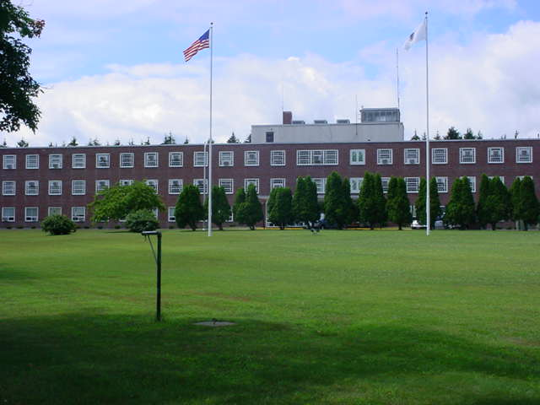

Prepared by:
Massachusetts Department of Public Health
Bureau of Environmental Health
Indoor Air Quality Program
October 2019

BACKGROUND
Building: | Department of Mental Health (DMH)  Haskell Building 2nd Floor Conference Room
Address: | 1 Prince Street, Northampton, MA
Assessment Requested by: | John O’Donnell, DMH
Reason for Request: | Odors
Date of Assessment: | August 2, 2019
Massachusetts Department of Public Health/Bureau of Environmental Health (MDPH/BEH) Staff Conducting Assessment: | Michael Feeney, Director, IAQ Program
Building Description: | The Haskell Building is a large brick building. The conference room is used for meetings. Adjacent spaces in the building are currently used as office space.
Windows: | Windows are openable.

Methods
Please refer to the IAQ Manual for methods, sampling procedures, and interpretation of results (MDPH, 2015).

RESULTS and DISCUSSION

Ventilation
The conference room is connected to the building’s heating, ventilation and air conditioning (HVAC) system, which has an air handling unit (AHU) located at the basement level. This HVAC system only provides heat. Fresh air is drawn through a vent located on a west-facing exterior wall near the loading dock (Picture 1). The AHU is connected to the conference room to supply (Picture 2) and return/exhaust (Picture 3) vents.
This HVAC system was deactivated at the time of this assessment. The HVAC system in the basement was examined and found in poorly modified condition with plywood in place of ductwork (Picture 4). Significant airflow was noted with the HVAC system deactivated which likely indicates that outdoor air dampers are open. In this condition, hot, moist air can enter through the HVAC duct as a means to introduce unconditioned, humid air into the conference room and other areas connected to this HVAC system.
The conference room has two wall-mounted air conditioners (Picture 5) which were in operation during this visit. These units do not supply any fresh air, only cool existing room air.
While separate mechanical exhaust vents exist for restrooms, showers, and other locations which generate moisture and odors, the exhaust vent on the roof was also deactivated. Without a fresh air supply and exhaust ventilation, normally-occurring environmental pollutants can also build up to cause eye, nose, and respiratory system irritation.
To maximize air exchange, the MDPH recommends that both supply and exhaust ventilation operate continuously during periods of occupancy. In order to have proper ventilation with a mechanical supply and exhaust system, the systems must be balanced to provide an adequate amount of fresh air to the interior of a room while removing stale air from the room. It is recommended that HVAC systems be re-balanced every five years to ensure adequate air systems function (SMACNA, 1994). It is not known the last time these systems were balanced and in its current condition, it is unlikely that the HVAC system can be balanced.
Many of the HVAC units in this building are beyond/near the end of their life cycle. Efficient function of equipment of this age is difficult to maintain, since compatible replacement parts are often unavailable. According to the American Society of Heating, Refrigeration, and Air-Conditioning Engineering (ASHRAE), the service life of this type of unit is 15-20 years, assuming routine maintenance of the equipment (ASHRAE, 1991). It appears the optimal operational lifespan of this equipment has been exceeded.

Microbial/Moisture Concerns
Of note is a large wooden closet/cabinet that appears to be water-damaged from a water fountain that had previously been in the space. Inside the wood closet appears to be a disused water chilling system for the fountain. Mold-colonized insulation was noted (Picture 6). An air intake and deactivated water coils were found caked with debris. Water-damaged wood and coil debris can become musty if exposed to significant humidity. Several conditions may exist in the conference room and an adjacent restroom area that would be significant sources of water vapor.
- The restroom did not have an operating exhaust vent. Water vapor from the drains and toilet could them migrate into the conference room via a passive door vent (Picture 7).
- The restroom had a window open (Picture 8), which can allow for hot, moist air to enter the conference room via the passive door vent. It may also pressurize the restroom and push air into the occupied areas outside the restroom through the door vent.
- There are sinks in the restroom and anteroom which may have dry drain traps. Water vapors and odors from the sewer/septic system can migrate into occupied areas if drain traps are dry.
- There was also rolled up carpet over the sink which can become moistened from water vapor exposure (Picture 9).
- Hot, moist air may migrate to the conference room under westerly/southwesterly wind conditions via the deactivated HVAC system (Picture 1).
Some or any of these pathways are means for water vapor to enter the conference room to moisten porous materials that may be subject to mold growth. Of particular concern are open windows during hot, humid weather when the air-conditioning system is in its chilling mode. It is recommended that windows are closed when the HVAC system is in chilling mode, particularly during humid weather as a method to prevent mold growth within the building. If windows are opened during heat wave conditions, hot moist air enters the building, which can result in condensation moistening building components, resulting in mold growth. These types of conditions conducive to mold growth may result in an indoor environment that could adversely affect the health of occupants with respiratory disease such as asthma. Therefore, it is advised that these windows remain closed during the cooling season to maintain the integrity and function of the HVAC system.

CONCLUSIONS/RECOMMENDATIONS
The conditions related to IAQ problems at the DMH raise a number of issues. The general building conditions/design, maintenance, work hygiene practices, and the condition of HVAC equipment, if considered individually, present conditions that could degrade IAQ. When combined, these conditions can serve to further degrade IAQ. Some of these conditions can be remedied by actions of building occupants. Other remediation efforts will require alteration to the building structure and equipment. For these reasons, a two-phase approach is recommended. The first consists of short-term measures to improve air quality and the second consists of long-term measures that will require planning and resources to adequately address overall IAQ concerns.

Short-term measures:
- Consider temporarily sealing the fresh air intake of the HVAC system during hot, humid weather with a non-porous, solid material to prevent wind-driven hot, moist air from entering the building.
- Remove water-damaged wood from the cabinet.
- Clean and or remove debris-caked materials associated with the removed water fountain system.
- Ensure that all drains are wet at least twice a week to maintain the trap seal.
- Do not use windows while AC system is operating in its chilling mode to prevent condensation/mold growth.
- Remove porous materials from bathroom anteroom.
- After consulting with a ventilation engineer, examine the feasibility of changing filters in HVAC units 2-4 times a year with MERV 8 (or higher) filters. Clean HVAC and univent cabinets of debris and dust when filters are changed.
- Ensure that condensation from air conditioning equipment is draining properly. Check collector pans, piping and any associated pumps for clogs and leaks and clean periodically to prevent stagnant water build-up and remove debris that may provide a medium for microbial growth.
- Clean carpeting annually or semi-annually in soiled high traffic areas as per the recommendations of the Institute of Inspection, Cleaning and Restoration Certification (IICRC 2012).
- For more information on mold refer to “Mold Remediation in Schools and Commercial Buildings” published by the US Environmental Protection Agency (US EPA, 2008). http://www.epa.gov/mold/mold-remediation-schools-and-commercial-buildings-guide.

Long-term Recommendations:
- Consideration should be given to replace HVAC units/components as they become past their service life. If not conducted already, consider contacting an HVAC engineering firm for an assessment of the ventilation system’s components and control systems (e.g., controls, air intake louvers, thermostats). Based on the age, physical deterioration, and availability of parts for ventilation components, such an evaluation is necessary to determine the operability and feasibility of repairing/replacing the equipment.

REFERENCES
ASHRAE. 1991. ASHRAE Applications Handbook, Chapter 33 “Owning and Operating Costs”. American Society of Heating, Refrigeration and Air Conditioning Engineers, Atlanta, GA.
IICRC. 2012. Institute of Inspection, Cleaning and Restoration Certification. Carpet Cleaning: FAQ.
MDPH. 2015. Massachusetts Department of Public Health. “Indoor Air Quality Manual: Chapters I-III”. Available at: http://www.mass.gov/eohhs/gov/departments/dph/programs/environmental-health/exposure-topics/iaq/iaq-manual/.
SMACNA. 1994. HVAC Systems Commissioning Manual. 1st ed. Sheet Metal and Air Conditioning Contractors’ National Association, Inc., Chantilly, VA.
US EPA. 2008. “Mold Remediation in Schools and Commercial Buildings”. Office of Air and Radiation, Indoor Environments Division, Washington, DC. EPA 402-K-01-001. September 2008. Available at: http://www.epa.gov/mold/mold-remediation-schools-and-commercial-buildings-guide.

Picture 1
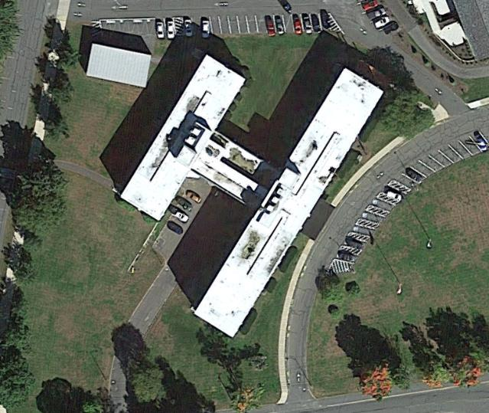
Aerial view of building, fresh air intake is in the courtyard
Picture 2
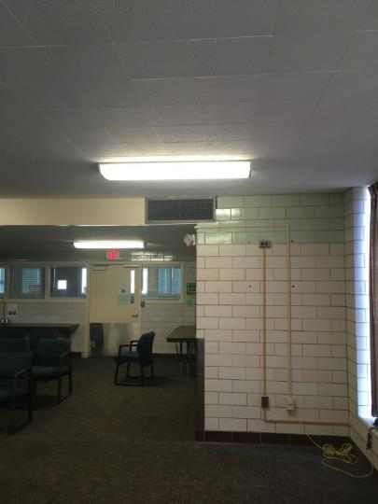
Conference room fresh air supply vent
Picture 3
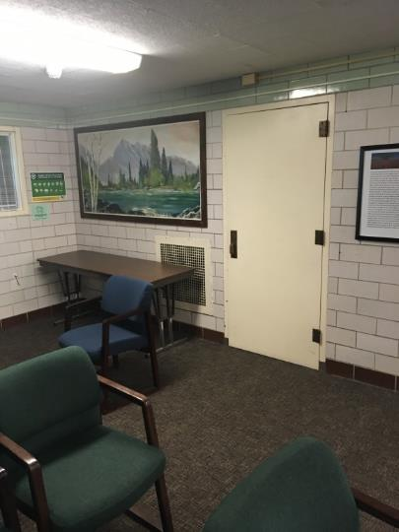
Conference room exhaust/return vent on wall
Picture 4
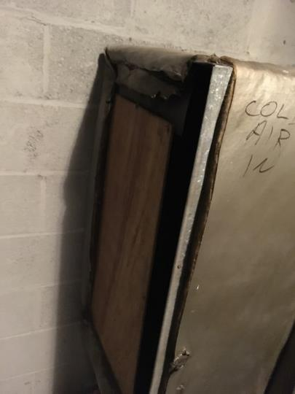
Plywood used in HVAC system ductwork
Picture 5
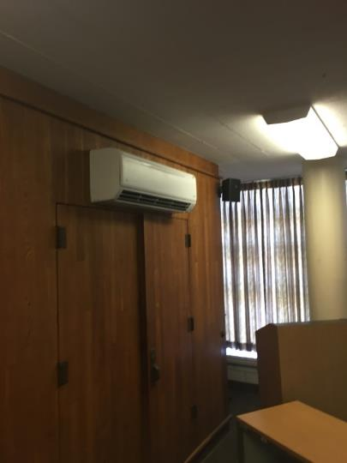
Wall-mounted air conditioner in the conference room
Picture 6
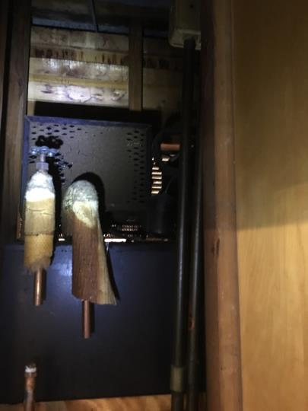
Caked debris on vent inside closet and water-damaged insulation
Picture 7
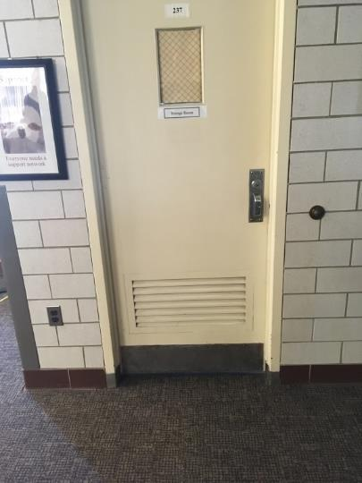
Passive door vent to restroom in conference room
Picture 8
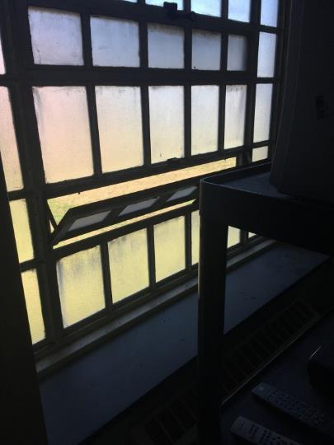
Open window in restroom
Picture 9
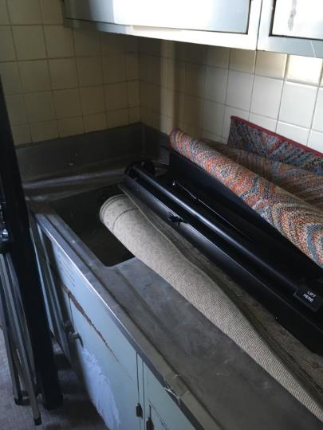
Carpet over sink in restroom anteroom

The service life is the median time during which a particular system or component of …[an HVAC]… system remains in its original service application and then is replaced. Replacement may occur for any reason, including, but not limited to, failure, general obsolescence, reduced reliability, excessive maintenance cost, and changed system requirements due to such influences as building characteristics or energy prices (ASHRAE, 1991).

