INDOOR AIR QUALITY ASSESSMENT

Department of Mental Health
13 Prospect Street
Greenfield, MA
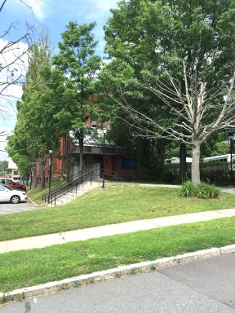
Prepared by:
Massachusetts Department of Public Health
Bureau of Environmental Health
Indoor Air Quality Program
July 2017
BACKGROUND
Building: | Department of Mental Health (DMH)
Address: | 13 Prospect Street, Greenfield, MA
Assessment Requested by: | Deborah Coleman, Facilities Director,  Executive Office of Health and Human Services (EOHHS)
Reason for Request: | Occupational Safety and Health Administration (OSHA) complaint/referral regarding mold in basement
Date of Assessment: | June 23, 2017
Massachusetts Department of Public Health/Bureau of Environmental Health (MDPH/BEH) Staff Conducting Assessment: | Mike Feeney, Director, Indoor Air Quality (IAQ) Program
Date Building Constructed: | Late 1800s, renovation 1990s-2000s
Building Description: | Constructed as a brick building

METHODS
Please refer to the IAQ Manual for methods, sampling procedures, and interpretation of results (MDPH, 2015).

RESULTS and DISCUSSION
The following is a summary of indoor air testing results (Table 1).
- Carbon dioxide measurements were above the MDPH recommended level of 800 parts per million (ppm) in all but 9 areas surveyed, indicating inadequate air exchange in most of the building.
- Temperature was within the MDPH recommended range of 70°F to 78°F in all areas surveyed.
- Relative humidity was within or close to the MDPH recommended range of 40 to 60% in all areas tested.
- Carbon monoxide levels were non-detectable (ND) in all areas tested.
- Particulate matter (PM2.5) concentrations measured were below the National Ambient Air Quality (NAAQS) level of 35 μg/m³ in all but two areas tested. Outdoor levels were above the NAAQS the day of assessment.
- Volatile Organic Compounds concentrations were ND in all areas tested.

Ventilation
It is important to note that the building is not equipped with a full mechanical heating, ventilating and air-conditioning (HVAC) system. The sole source of ventilation in the building is openable windows. Air-conditioning (AC) is provided by window-mounted units. The lobby, hallways and large conference rooms are equipped with a ducted HVAC system that provides heating and cooling, but does not have a fresh air intake.

Microbial/Moisture Concerns
As stated, concerns about mold in the basement prompted this assessment. Basement offices are constructed of gypsum wallboard (GW) covered in vinyl wallpaper. All GW installed along the exterior wall of the building was removed, exposing the foundation wall (Picture 1). GW installed below grade along the foundation has a tendency to become moistened by water penetrating through the wall. With the removal of this GW, the basement was found free of mold/musty odors.
The base of the brick foundation wall was found moistened, likely from water penetration from pooling water against the building due to a lack of a gutter/downspout system along the roof.
Both doors accessing the basement have spaces that allow for basement air to enter the stairwells/foyer (Picture 2). These breaches can provide pathways for drafts, moisture and odors into other parts of the building.
Windowsills were examined in offices. Vinyl wallpaper had become detached from the wall along windows with ACs, indicating water penetration, likely during wind-driven rain events. In some cases, the wallpaper paste had become colonized with mold (Picture 3).
Indoor plants were noted in some areas. Plants can be a source of pollen and mold, which can be respiratory irritants to some individuals. Plants should be equipped with non-porous drip pans. Plants should also be located away from ventilation sources to prevent the entrainment and/or aerosolization of dirt, pollen, or mold.
Water coolers were observed on carpeted areas. Spills or leaks from these appliances can moisten carpeting. They should be located in a non-carpeted area or on waterproof mats.
Ivy was observed on the building’s exterior (Picture 4). Roots growing into the brick mortar can create fissures, which can cause crumbing and deterioration of the building exterior due to freezing and thawing of water trapped in these spaces. Over time, water can enter the building through damage to the exterior wall.

Other IAQ Evaluations
A number of occupied offices contain wall-to-wall carpeting. First floor offices have carpeting that is likely at least 30 years old. The average service life of carpeting is approximately eleven years (Bishop, 2002). It was unclear if the building has a regular carpet cleaning program. The Institute of Inspection, Cleaning and Restoration Certification (IICRC), recommends that carpeting be cleaned annually (or semi-annually in soiled high traffic areas) (IICRC, 2012).

CONCLUSIONS/RECOMMENDATIONS
As noted in a letter dated May 3, 2012 (Appendix A), a recommendation to discontinue use of the basement for storage was made. Based on this letter, no building occupants from upper floors should have materials stored in the basement and have no reason to access the basement. Due to the conditions observed at the time of this assessment, the following recommendations are provided.
- Limit access to the basement to facility management only. Change locks on basement access doors.
- Install door sweeps and weather-stripping on stairwell and lobby access doors.
- Remove water-damaged wallpaper around windows.
- Consider replacing the carpets in offices on the first floor.
- Render window-mounted ACs as watertight as feasible to prevent water penetration during driving rain.
- Consider installing a gutter/downspout system to the roof edge.
- Remove ivy from exterior brick walls.
- Reduce/eliminate odorous products in office space.
- For buildings in New England, periods of low relative humidity during the winter are often unavoidable. Therefore, scrupulous cleaning practices should be adopted to minimize common indoor air contaminants whose irritant effects can be enhanced when the relative humidity is low.
- Use a vacuum cleaner equipped with a high efficiency particulate arrestance (HEPA) filter in conjunction with wet wiping to remove dust from all surfaces. Avoid the use of feather dusters.
- Consider reducing the number of plants. Indoor plants should be properly maintained and equipped with drip pans to prevent water damage to porous building materials and be located away from ventilation sources to prevent the aerosolization of dirt, pollen or mold.
- Replace carpeting that has exceeded its useful life (e.g., > 11 years).
- Drinking water during the day can help ease some symptoms associated with a dry environment (throat and sinus irritations).
- Refer to resource manual and other related indoor air quality documents located on the MDPH’s website for further building-wide evaluations and advice on maintaining public buildings. These documents are available at http://mass.gov/dph/iaq.

REFERENCES
Bishop. 2002. Bishop, J. & Institute of Inspection, Cleaning and Restoration Certification. A Life Cycle Cost Analysis for Floor Coverings in School Facilities.
IICRC. 2012. Institute of Inspection, Cleaning and Restoration Certification. Carpet Cleaning: FAQ. Retrieved from http://www.iicrc.org/consumers/care/carpet-cleaning.
MDPH. 2015. Massachusetts Department of Public Health. “Indoor Air Quality Manual: Chapters I-III”. Available from http://www.mass.gov/eohhs/gov/departments/dph/programs/environmental-health/exposure-topics/iaq/iaq-manual/
Picture 1
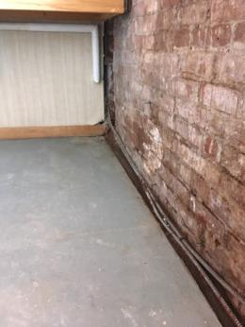
Foundation wall with removed GW
Picture 2
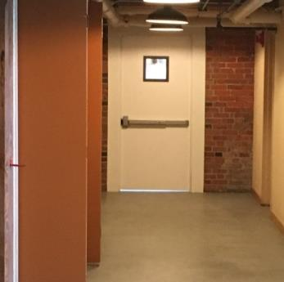
Space under basement access door
Picture 3
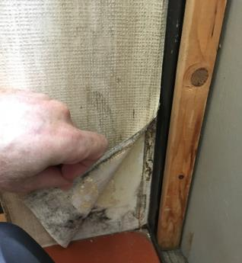
Water-damaged wallpaper
Picture 4
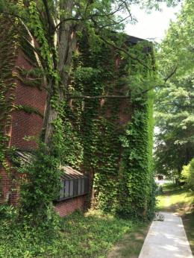
Ivy on exterior of building
Location | Carbon  Dioxide  (ppm) | Carbon Monoxide  (ppm) | Temp  (°F) | Relative  Humidity  (%) | PM2.5  (µg/m³) | Occupants  in Room | Windows  Openable | Ventilation |  |  | Remarks
 |  |  |  |  |  |  |  | Intake | Exhaust
Background | 433 | ND | 82 | 78 | 82
101 | 744 | ND | 76 | 59 | 20 | 0 | N | N |  | N | AC, plants
102 | 948 | ND | 75 | 53 | 34 | 0 | N | N |  | N | Carpet-old, AC
103 | 834 | ND | 76 | 56 | 32 | 0 | Y | N |  | N | AC-on, wall paper-mold
104 | 1029 | ND | 77 | 55 | 34 | 1 | Y | N |  | N | AC-on
106 | 769 | ND | 76 | 52 | 30 | 0 | N | N |  | N
108 | 707 | ND | 76 | 50 | 31 | 0 | Y | N |  | N | AC
110 | 751 | ND | 76 | 54 | 40 | 1 | Y | N |  | N | AC
111 | 767 | ND | 76 | 60 | 32 | 0 | N | N |  | N | AC
112 | 893 | ND | 77 | 52 | 39 | 3 | Y | N |  | N | AC, plants
Reception | 787 | ND | 76 | 52 | 27 | 0 | N | Y |  | Y
201 | 854 | ND | 75 | 44 | 27 | 0 | N | N |  | N | AC
202 | 936 | ND | 76 | 45 | 27 | 0 | Y | N |  | N | AC
203 | 828 | ND | 75 | 43 | 26 | 0 | N | N |  | N | AC
204 | 854 | ND | 75 | 42 | 26 | 0 | N | N |  | N | AC
205 | 1101 | ND | 75 | 43 | 25 | 0 | N | N |  | N | AC, plants
206 | 972 | ND | 76 | 42 | 27 | 0 | N | N |  | N | AC
207 | 933 | ND | 76 | 42 | 27 | 0 | Y | N |  | N | AC, water-damaged carpet
208 | 787 | ND | 74 | 44 | 30 | 0 | Y | N |  | N | AC on, window open
209 | 772 | ND | 74 | 51 | 28 | 0 | N | N |  | N | AC, plants
210 | 800 | ND | 75 | 49 | 29 | 0 | N | N |  | N | AC
211 | 801 | ND | 75 | 50 | 31 | 0 | N | N |  | N | AC
212 | 796 | ND | 75 | 49 | 32 | 0 | N | N |  | N
2nd floor reception | 817 | ND | 74 | 49 | 30 | 2 | N | Y |  | Y | Plants
301 | 835 | ND | 74 | 48 | 27 | 0 | Y | N |  | N | AC, plants
302 | 919 | ND | 77 | 39 | 22 | 0 | Y | N |  | N | AC  Plants
303 | 926 | ND | 76 | 42 | 21 | 0 | N | N |  | N | AC
303A | 850 | ND | 75 | 44 | 22 | 0 | N | N |  | N | AC
303B | 868 | ND | 75 | 40 | 20 | 0 | Y | N |  | N | AC
304 | 1055 | ND | 75 | 41 | 21 | 1 | Y | N |  | N | AC
305 | 959 | ND | 75 | 42 | 23 | 1 | Y | N |  | N | AC on
Conference room | 853 | ND | 75 | 37 | 20 | 0 | Y | N |  | N | AC
307 | 851 | ND | 71 | 36 | 22 | 0 | N | N |  | N | AC
308 | 852 | ND | 72 | 42 | 21 | 0 | Y | N |  | N | AC
Photocopier | 870 | ND | 73 | 45 | 21 | 0 | N | Y |  | Y | AC, photocopier
TDP | 907 | ND | 74 | 48 | 23 | 0 | N | N |  | N | AC, plants
309 | 888 | ND | 74 | 46 | 25 | 1 | N | N |  | N | AC, plants
Reception | 914 | ND |  | 44 | 24 | 1 | N | Y |  | N

