INDOOR AIR QUALITY ASSESSMENT

Department of Mental Health (DMH) Lindemann Building
5th floor
25 Staniford Street, Boston

Prepared by:
Massachusetts Department of Public Health
Bureau of Environmental Health
Indoor Air Quality Program
November 2017

Background
Building: | Department of Mental Health (DMH) Lindemann Building, 5th floor
Address: | 25 Staniford Street, Boston
Assessment Requested by: | Cory Thomas, Executive Office of Health and Human Services (EOHHS) Field Operations
Reason for Request: | General Indoor Air Quality (IAQ) and water damage/mold concerns
Date of Assessment: | November 8, 2017
Massachusetts Department of Public Health/Bureau of Environmental Health (MDPH/BEH) Staff Conducting Assessment: | Ruth Alfasso, Environmental Engineer, indoor air quality (IAQ) Program
Building Description: | The area assessed was the 5th floor of Erich Lindemann Mental Health Center, a Brutalist concrete building constructed in the 1960s.
Windows: | Not openable

Methods
Please refer to the IAQ Manual for methods, sampling procedures, and interpretation of results (MDPH, 2015).

IAQ Testing Results
The following is a summary of indoor air testing results (Table 1).
- Carbon dioxide levels were below 800 parts per million (ppm) in all areas surveyed, indicating adequate air exchange. Note that areas were sparsely populated or empty at the time of the visit.
- Temperature was within the recommended range of 70°F to 78°F in all areas tested.
- Relative humidity was below the recommended range of 40 to 60% in the areas tested.
- Carbon monoxide levels were non-detectable (ND) in all areas tested.
- Fine particulate matter (PM2.5) concentrations measured were below the National Ambient Air Quality (NAAQS) limit of 35 μg/m³ in all areas tested.

Ventilation
A heating, ventilating and air conditioning (HVAC) system has several functions. First it provides heating and, if equipped, cooling. Second, it is a source of fresh air. Finally, an HVAC system will dilute and remove normally-occurring indoor environmental pollutants by not only introducing fresh air, but by filtering the airstream and ejecting stale air to the outdoors via exhaust ventilation. Even if an HVAC system is operating as designed, point sources of respiratory irritation may exist and cause symptoms in sensitive individuals.
Fresh air is provided by air handling units (AHUs). Air from the AHUs is filtered, heated/cooled, and delivered to rooms via ducted supply vents (Pictures 1 and 2). Air is returned/exhausted through vents around lights (Picture 3). Additional heating is provided by radiators along outside edges of the building (Picture 4). In some rooms, particularly those around the outside edge of the building, it was difficult to identify if supply vents were present. Each room should have a source of fresh air. If fresh air is only supplied to these rooms via vents in the hallways outside (Picture 2), doors should be undercut to allow air to be drawn into rooms when the doors are closed. It could also not be determined if restroom vents were connected to the general return system or to a direct vented exhaust system. Direct exhaust venting in restrooms and other areas that generate odors and moisture is important to avoid recirculating them to the rest of the building.
The assessment results indicate that the ventilation system is providing adequate fresh air for the current occupancy. It is recommended that HVAC systems be re-balanced every five years to ensure adequate air systems function (SMACNA, 1994). It is unknown when the last time this system was balanced. Note that when this building was built, the use/occupancy was different, for example old laboratory rooms are now used for offices and conference rooms. It is not known if ventilation was adjusted to take into account these changes.
In a few rooms, sunlight was streaming in windows (Table 1) which may contribute to temperature control issues in the office. The use of adjustable blinds to block sunlight and help control temperature in offices with windows is recommended.

Microbial/Moisture Concerns
The main reason for this visit was concerns about water damage and odors following a recent heavy rainstorm. Past water damage was also of concern. At the time of the visit, significant areas of water damage were observed including ceiling tiles, plaster ceilings/walls and other building materials (Pictures 5 to 9). In a room now used for storage, there was a large hole in the ceiling (Picture 10) and a plastic container of water, reportedly used to collect water during the recent leaks (Picture 11). Water stains on the floor indicate that water had been pooling there (Picture 12). Floor tiles in some offices are also peeling away from the floor, indicating repeated moistening.
Roof leaks are the cause of the water infiltration leading to most or all of this damage. Although the roof has reportedly been patched several times recently, the age of the building and complexity of the building shape leads to continued and sometimes severe leaks depending on the direction of the wind during heavy rain. Reportedly, there have been discussions regarding a complete overhaul of the building’s roof, but no plan or schedule for this work has been developed yet.
Note that many of the building materials used in the Lindemann building, such as concrete, plaster and metal, are not directly conducive to growing mold. However, furnishings, including built-in wooden bookcases, carpeting, and stored materials (e.g., Picture 13) as well as dust and debris on walls, floors, and ceilings can provide a substrate for mold to grow. Prior to the visit, staff in some offices reported strong odors with a moldy or musty character. Since it had been several days since the most recent leaks, and air purifying equipment had been operating in the areas of most concern, no significant odors could be identified during the visit.
The US Environmental Protection Agency (US EPA) and the American Conference of Governmental Industrial Hygienists (ACGIH) recommends that porous materials (e.g., wallboard, carpeting) be dried with fans and heating within 24 to 48 hours of becoming wet (US EPA, 2008; ACGIH, 1989). If porous materials are not dried within this time frame, mold growth may occur. Many areas were examined for mold growth and nothing specific was identified as moldy, however due to the significant amount of water damage observed, it is likely that microbial growth has occurred or will occur on moistened porous materials.
Water-damaged porous materials, such as carpeting and stored materials should be removed and discarded if at all possible. Water-damaged materials such as those seen in Pictures 9 and 13 should also be removed. Any removable water-damaged ceiling tiles should be replaced. In areas where there is significant water damage to ceiling plaster and walls, small holes should be cut to examine interstitial spaces for chronic moisture and mold. Perform removal and replacement of building materials as needed. In other areas, thorough cleaning of water-damaged nonporous walls may be sufficient.
Note that in some areas water has impinged on electrical equipment such as lights and electric outlets. An electrician should examine these areas to ensure that they are safe to use.
Because leaks may reoccur during severe weather, items that are susceptible to water damage should be kept away from areas of known or likely leaks. This includes removing boxes and other items from the floor, storing items away from walls and windows, and removing area rugs in any rooms where leaks have occurred. Because many rooms are currently not occupied on a regular basis, it is important to have a system to identify and report leaks and other problems even in areas not used daily so that drying can begin promptly.
Plants were observed in some offices (Picture 4). Some of these plants were in located on the radiators or on porous surfaces. Plants should be well maintained, not overwatered and kept away from the airstream of ventilation equipment to prevent odors, water damage, and pests.

Other IAQ Evaluations
Exposure to low levels of total volatile organic compounds (TVOCs) may produce eye, nose, throat, and/or respiratory irritation in some sensitive individuals. To determine if VOCs were present, BEH/IAQ staff examined rooms for products containing VOCs. BEH/IAQ staff noted cleaners, hand sanitizers, air fresheners and other products in use within the building (Pictures 14 and 15, Table 1). All of these products have the potential to be irritants to the eyes, nose, throat, and respiratory system of sensitive individuals.
Cooking equipment, including toasters, microwave ovens, and coffee machines, were located in various parts of the office space. Food areas and cooking equipment need to be kept clean to prevent odors and pests.
In some areas, stored materials and accumulated items make it more difficult for custodial staff to clean (Table 1). Items should be stored neatly and moved periodically to allow for wet-wiping and vacuuming of surfaces. Items should also not be stored on top of radiators or in the airstream of ventilation equipment as heating and moving air can cause items to release dusts and odors.
Due to this building’s complex shape and textured surfaces, cleaning is more challenging. A build-up of dust and debris in corners and on walls/ceilings (e.g. Picture 16) can become a substrate for mold growth when moistened. Dust and debris was also found in, on and behind some radiators (Picture 17). Thorough cleaning of ventilation equipment surface should be conducted during the year. Personal fans also had settled dust, which can be reaerosolized when the fan is activated. Air purifiers with high efficiency particulate arrestance (HEPA) filters were being used in some areas to help control odors. These units should be maintained in accordance with manufacturer’s instructions, including filter cleaning/changing to avoid them becoming a source of odors.
Some offices were carpeted. Due to ongoing water issues, carpeting should be removed from any areas with known leaks. Remaining carpets and area rugs should be vacuumed regularly with a HEPA-filter-equipped vacuum cleaner and cleaned annually (or semi-annually in soiled/high traffic areas) in accordance with Institute of Inspection, Cleaning and Restoration Certification (IICRC) recommendations, (IICRC, 2012).

Conclusions/Recommendations
Based on observations at the time of assessment, the following is recommended:
- Make roof repairs to the maximum feasible extent.
- Monitor areas where leaks are known to occur for additional water infiltration during heavy rain or snow events.
- Have an electrician check the function of electric service that may have experienced significant water damage (e.g., lights with water stains or sockets such as shown in Picture 8).
- Remediate areas of water-damaged building materials in accordance with the EPA guideline “Mold Remediation in Schools and Commercial Buildings” (USEPA, 2008). In areas with extensive damage and/or reported odors, the removal of wall and ceiling plaster may be required in order to assess and remediate hidden or internal damage. Carpeting in affected areas should be removed. Any water-damaged porous materials such as boxes should be discarded. Clean non-porous water-stained surfaces, including walls and floors and remove any debris.
- Avoid storing anything in areas with known leaks and avoid placing porous materials on floors, including area rugs.
- Operate supply and exhaust ventilation continuously in all areas during occupied periods. Ensure all HVAC equipment is cleaned/maintained in accordance with manufacturer’s instructions including filter changes. Avoid placing items, especially plants, on top of radiators.
- Investigate function of vents in restrooms to see if they exhaust from the building.
- Determine if there is a fresh air supply for offices along the outside wall. If fresh air is supplied by vents in hallways (such as shown in Picture 2), ensure doors in these offices are undercut by 1 inch to allow for airflow.
- Have the HVAC system balanced every 5 years in accordance with SMACNA recommendations (SMACNA, 1994).
- Use adjustable blinds to control solar heating and glare.
- For buildings in New England, periods of low relative humidity during the winter are often unavoidable. Therefore, scrupulous cleaning practices should be adopted to minimize common indoor air contaminants whose irritant effects can be enhanced when the relative humidity is low. To control for dusts a HEPA-filter-equipped vacuum cleaner in conjunction with wet wiping of all surfaces is recommended. Avoid the use of feather dusters. Drinking water during the day can help ease some symptoms associated with a dry environment (throat and sinus irritations).
- Keep plants in good condition, avoid overwatering, and remove from the airstream of heating and ventilation equipment.
- Consider the use of waterproof mats underneath all water dispensers and refrigerators to protect carpet. Keep refrigerators clean.
- Reduce the use of cleaning products, sanitizers, and other items that contain VOCs. Minimize the use of scented products.
- Ensure that all cooking equipment is kept clean.
- Clean dust and debris from ventilation equipment, including supply and exhaust vents, radiators and the blades of personal fans to prevent aerosolization of dust.
- Clean carpeting annually or more frequently per the recommendations of the Institute of Inspection, Cleaning and Restoration Certification (IICRC).
- Refer to resource manual and other related IAQ documents located on the MDPH’s website for further building-wide evaluations and advice on maintaining public buildings. These documents are available at: http://mass.gov/dph/iaq.

References
ACGIH. 1989. Guidelines for the Assessment of Bioaerosols in the Indoor Environment. American Conference of Governmental Industrial Hygienists, Cincinnati, OH.
IICRC. 2012. Institute of Inspection, Cleaning and Restoration Certification. Carpet Cleaning: FAQ. Retrieved from http://www.iicrc.org/consumers/care/carpet-cleaning.
MDPH. 2015. Massachusetts Department of Public Health. Indoor Air Quality Manual: Chapters I-III. Available at: http://www.mass.gov/eohhs/gov/departments/dph/programs/environmental-health/exposure-topics/iaq/iaq-manual/.
SMACNA. 1994. HVAC Systems Commissioning Manual. 1st ed. Sheet Metal and Air Conditioning Contractors’ National Association, Inc., Chantilly, VA.
US EPA. 2008. “Mold Remediation in Schools and Commercial Buildings”. Office of Air and Radiation, Indoor Environments Division, Washington, DC. EPA 402-K-01-001. September 2008. Available at: http://www.epa.gov/mold/mold-remediation-schools-and-commercial-buildings-guide.

Picture 1
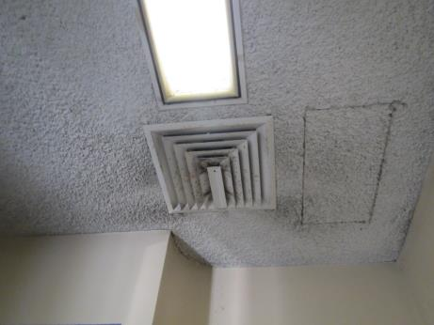
One type of supply vent
Picture 2
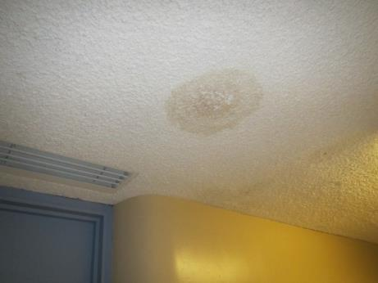
Supply vent outside an office door, also note water stains on ceiling plaster
Picture 3
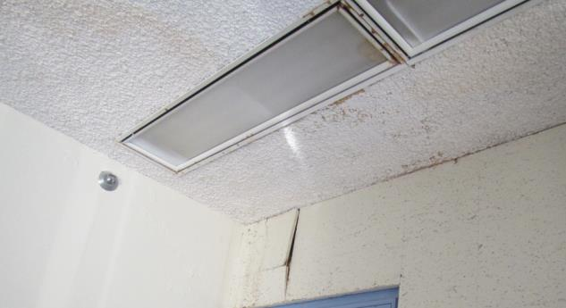
Slot for exhaust vent around light, note rust stains, peeled wall tiles, other water damage
Picture 4
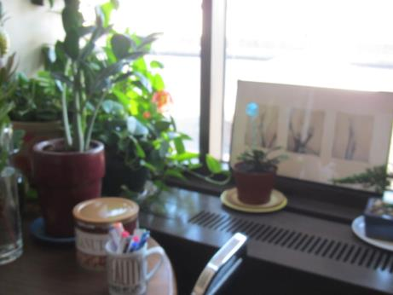
Radiator along window, note items and plants on top
Picture 5
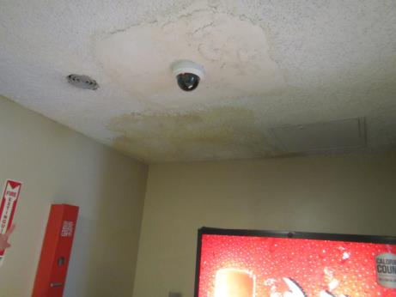
Water stains on ceiling and previously-patched plaster
Picture 6
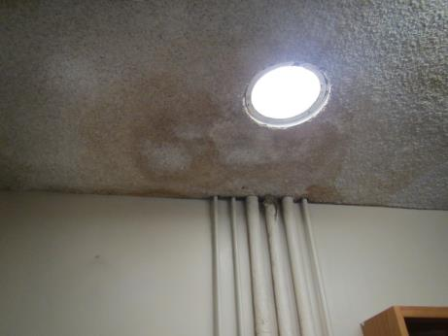
Water-stained plaster
Picture 7
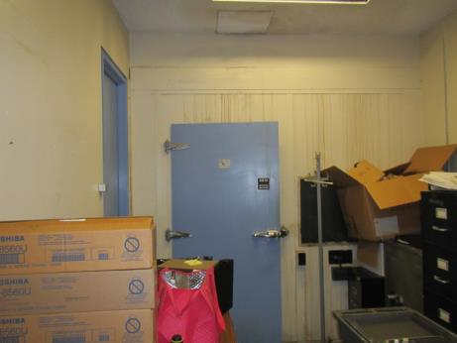
Water stains on wall
Picture 8
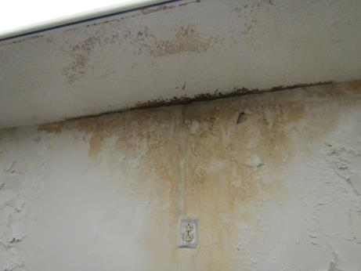
Water stains on ceiling and wall plaster, note electric socket
Picture 9
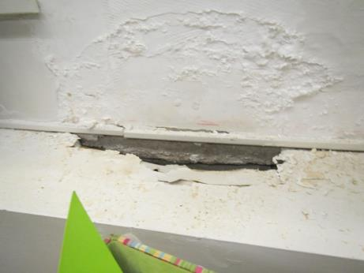
Water-damaged wall and built-in cabinet
Picture 10
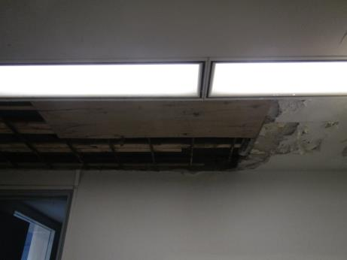
Missing ceiling tiles and water-damaged tiles
Picture 11
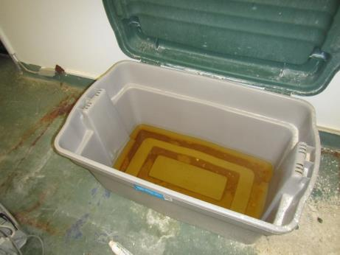
Plastic tote filled with water from recent leaks
Picture 12
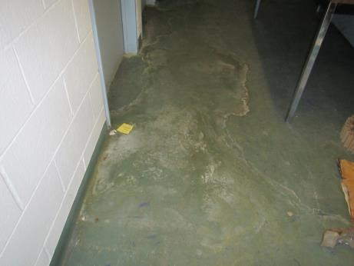
Water stains on floor
Picture 13
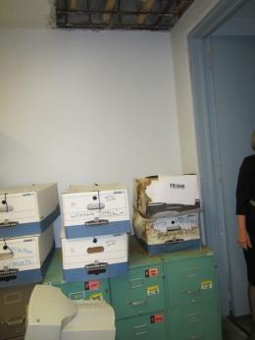
Water-damaged stored items
Picture 14
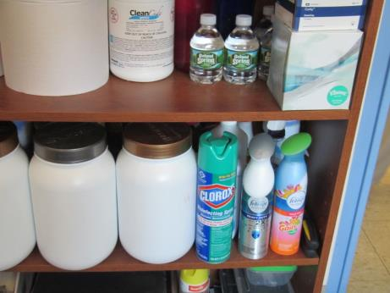
Cleaning products and air fresheners
Picture 15
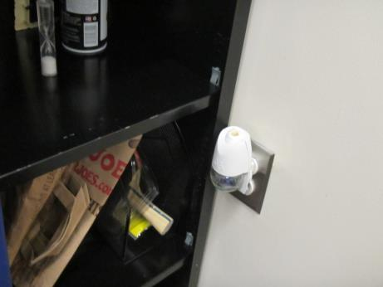
Plug-in air freshener
Picture 16
Dust and debris on supply vent and adjacent textured plaster wall
Picture 17
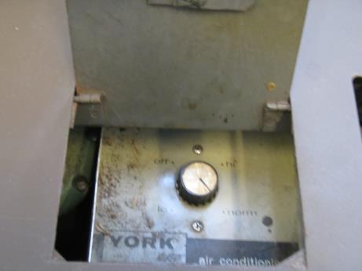
Debris in radiator casing

Location | Carbon  Dioxide  (ppm) | Carbon Monoxide  (ppm) | Temp  (°F) | Relative  Humidity  (%) | PM2.5  (µg/m³) | Occupants  in Room | Windows  Openable | Ventilation |  | Remarks
 |  |  |  |  |  |  |  | Supply | Exhaust
Background | 359 | 0.5 | 50 | 33 | 12 |  |  |  |  | Windy and cold
Area Director’s Office | 418 | ND | 76 | 21 | 5 | 0 | N | Y | Y | Plants, wooden bookcases built in, door to outside patio, WD ceiling and wall, chalk
Health info | 417 | ND | 74 | 22 | 4 | 0 | N | N | Y | NC, WD wall and ceiling, stored old materials
Reception | 562 | ND | 76 | 21 | 3 | 0 | N | Y | Y
Women’s Restroom |  |  |  |  |  |  |  | N | Y? | Slight odor, reported odors
5003 | 451 | ND | 76 | 22 | 7 | 0 | N | Y | Y | Area rug, plant on heater
5004 | 503 | ND | 77 | 24 | 6 | 0 | N | Y | Y | WD ceiling plaster, key cutter
5005 | 412 | ND | 76 | 22 | 5 | 0 | N | Y | Y | PF, CP
5006 | 458 | ND | 76 | 22 | 5 | 2 | N | Y | Y | Plants, food, carpeted, WD ceiling
5007 | 459 | ND | 76 | 22 | 4 | 0 | N | Y | Y | Slight odor, not moldy/musty, carpet, PF
5008 |  |  |  |  | 4 | 0 | N | Y | Y | NC, trash, ceiling/walls water stained
5009 old mailroom | -- | -- | -- | -- | 8 | 0 | N | Y | Y | Rust on supply vent, sink with water/rust stains underneath
5011 storage | 451 | ND | 76 | 24 | 8 | 1 | N | Y | Y | PF – on, dusty, WD wall plaster
5012 | 465 | ND | 77 | 22 | 6 | 0 | N | Y | Y
5027 conference | 454 | ND | 76 | 22 | 4 | 0 | N | Y | Y | PF, NC
5028 | 480 | ND | 74 | 24 | 4 | 0 | N | Y | Y | Plants, WD ceiling, AP, NC – peeling floor tiles, reportedly a lot of water in this room recently
5029 | 515 | ND | 74 | 24 | 4 | 0 | N | Y | Y | PF, plants, air purifier, WD ceiling, area rug
5030 | 525 | ND | 75 | 25 | 4 | 1 | N | Y | Y | CP, plants, PF on, WD ceiling, NC
5031 | 479 | ND | 75 | 24 | 3 | 1 | N | Y | Y | Plant, items on heater, NC
5032 | 463 | ND | 74 | 24 | 3 | 0 | N | Y | Y | PF, NC, items on heater, plants
5035 kitchen | 433 | ND | 75 | 24 | 3 | 0 | N | Y | Y | Dusty ceiling, wood cabinets, reported to have had strong musty/moldy odor, odor not present/masked by coffee odor at time of visit, WD ceiling and wall, refrigerator and microwave, items on floor
5035 A | 454 | ND | 75 | 22 | 4 | 0 | N | Y | Y | PF, NC, WD ceiling
5035 B | 439 | ND | 75 | 23 | 4 | 0 | N | Y | Y | WD ceiling, items on floor, DEM, NC, has studio/vault area attached
5037 | 444 | ND | 74 | 23 | 4 | 0 | N | Y | Y | NC, old lab, dust stains on ceiling
5039 | 517 | ND | 74 | 23 | 3 | 0 | N | Y | Y | NC, WD heater, fridge
5040 | 473 | ND | 74 | 24 | 4 | 1 | N | Y | Y | DO, NC, PF
5041 | 454 | ND | 76 | 25 | 4 | 0 | N | Y | Y | PF, plant on heater, area rug, shelf of CPs
5042 | 466 | ND | 74 | 24 | 3 | 0 | N | Y | Y | Items on heater, NC, microwave
5043 | 539 | ND | 74 | 26 | 8 | 1 | N | Y | Y | Plants and items on heater
5044 | 555 | ND | 77 | 24 | 13 | 1 | N | Y | Y | NC, plants, WD ceiling
5045 | 461 | ND | 76 | 24 | 4 | 0 | N | Y | Y | WD ceiling, built-in bookshelves, PF, plant on heater
5047 supply room | 436 | ND | 74 | 23 | 4 | 0 | N | Y | Y | Severe water damage to ceiling, wall, shelving, items on floor
5048 | 456 | ND | 74 | 23 | 4 | 0 | N | Y | Y | Long room -- old lab, PC, WD wall, PF
5050 | 453 | ND | 75 | 22 | 4 | 0 | N | Y | Y | NC, items stored, built-in bookshelves
5051 | 447 | ND | 75 | 22 | 5 | 0 | N | Y | Y | Carpeted, AF odor, plant
5052 | 526 | ND | 77 | 22 | 4 | 0 | N | Y | Y | NC, WD ceiling plaster
5053 | 603 | ND | 76 | 24 | 4 | 1 | N | Y | Y | NC, vents dusty and have rust spots, AF, PF
5054 restroom |  |  |  |  |  |  | N | N | Y | Vent looks like typical return
5059 | 532 | ND | 76 | 21 | 6 | 0 | N | N | Y | Conference room, NC, old carpet, supply vent dusty
5062 | 436 | ND | 76 | 27 | 6 | 0 | N | N | Y | Missing ceiling plaster, water in a bucket on floor, ceiling/wall debris on floor
Room next to 5062 |  |  |  |  |  |  | N |  |  | Carpeted, probably had been wet, significant amount of debris from ceiling, stored computers

