INDOOR AIR QUALITY ASSESSMENT

Department of Mental Health (DMH) Lindemann Building
Central Office Mezzanine
25 Staniford Street, Boston

Prepared by:
Massachusetts Department of Public Health
Bureau of Environmental Health
Indoor Air Quality Program
October 2018

Background
Building: | Department of Mental Health (DMH) Lindemann Building, Central Office Mezzanine
Address: | 25 Staniford Street, Boston
Assessment Requested by: | Sharon Moody, Assistant Director  Engineering & Facilities Management  DMH
Reason for Request: | Odor, Mold and Indoor Air Quality (IAQ) concerns
Date of Assessment: | October 2, 2018
Massachusetts Department of Public Health/Bureau of Environmental Health (MDPH/BEH) Staff Conducting Assessment: | Ruth Alfasso, Environmental Engineer, indoor air quality (IAQ) Program
Building Description: | The area assessed was the Mezzanine area of Erich Lindemann Mental Health Center, a Brutalist concrete building constructed in the 1960s.
Windows: | Not openable

Methods
Please refer to the IAQ Manual for methods, sampling procedures, and interpretation of results (MDPH, 2015).

IAQ Testing Results
The following is a summary of indoor air testing results (Table 1).
- Carbon dioxide levels were below MDPH guideline of 800 parts per million (ppm) in all areas surveyed, indicating adequate air exchange. Note that the overall occupancy of this area is low.
- Temperature was within or close to the lower end of the recommended range of 70°F to 78°F in all areas tested.
- Relative humidity was close to but above the recommended range of 40 to 60% in the areas tested.
- Carbon monoxide levels were non-detectable (ND) in all indoor areas tested.
- Fine particulate matter (PM2.5) concentrations measured were below the National Ambient Air Quality (NAAQS) limit of 35 μg/m³ in all areas tested.

Ventilation
A heating, ventilating and air conditioning (HVAC) system has several functions. First it provides heating and, if equipped, cooling. Second, it is a source of fresh air. Finally, an HVAC system will dilute and remove normally-occurring indoor environmental pollutants by not only introducing fresh air, but by filtering the airstream and ejecting stale air to the outdoors via exhaust ventilation. Even if an HVAC system is operating as designed, point sources of respiratory irritation may exist and cause symptoms in sensitive individuals.
Fresh air is provided by air handling units (AHUs). Air from the AHUs is filtered, heated/cooled, and delivered to rooms via ducted supply vents (Pictures 1 and 2). Air is returned/exhausted through vents around lights (Picture 3). Additional heating is provided by radiators along outside edges of the building (Picture 4). In some rooms, it was difficult to identify if supply vents were present. Each room should have a source of fresh air. In some cases it appeared that fresh air was supplied in hallways outside offices and drawn into each office through the action of the return or exhaust vent. This may contribute to the distribution of odors, as discussed in the sections below. It could also not be determined if restroom vents were connected to the general return system or to a direct vented exhaust system. Direct exhaust venting in restrooms and other areas that generate odors and moisture is important to avoid recirculating them to the rest of the building.
The assessment results indicate that the ventilation system is providing adequate fresh air for the current occupancy. It is recommended that HVAC systems be re-balanced every five years to ensure adequate air systems function (SMACNA, 1994). It is unknown when the last time this system was balanced. Note that when this building was built, the use/occupancy was different, for example some current offices may have been patient or medical exam rooms. It is not known if ventilation was adjusted to take into account these changes.

Odor/Microbial/Moisture Concerns
The main reason for this visit was concerns about odors which were reported to be strongest in the area adjacent to an employee entrance, but had also been reported throughout the space. These odors were described as “like garbage”, “like sewage” and other terms. In the day between the initial request to MDPH and the visit, cleaning had reportedly occurred of floors and carpeting. Very little odor was noticeable in the space at the time of the visit. However numerous conditions were observed that may contribute to odor, microbial growth and other IAQ issues, as discussed below.
The Lindemann building has a complex shape with a variety of crevices, skylights, oddly-shaped windows and other areas which over time have become sources of leaks. At the time of the visit, it was lightly raining outside, and water was flowing down the inside wall in the employee entrance lobby. While the substrate of this wall is concrete (Picture 5), and not conducive to mold growth, the wall texture makes them prone to collect dust and difficult to clean. Moisture introduced into the building through leaks can moisten floors, items on floors such as carpeting, and can create humid conditions which can lead to condensation on other surfaces such as the leather couch located in this area (Picture 6). Porous items chronically moistened are likely to become mold-colonized and may deteriorate releasing other odors.
Many other signs of water damage were observed, including water-damaged ceiling plaster (Pictures 7 and 8), water-damaged paint, rust on radiators (Picture 4), water stains around windows and skylights (Picture 9) and signs of delaminated carpet. Some of these materials were damaged by infiltration through gaps in the building envelope. Other issues such as rust stains on radiators may be signs that high humidity from building envelope issues and lack of exhaust ventilation, especially in restrooms, has allowed water to condense on materials.
Building staff report that a flood from piping on an upper level had occurred in the past that moistened materials in the kitchen and nearby restroom. No obvious signs of water damage to the carpeting in the kitchen were observed, however, when flooding may be due to black water (e.g. toilet), carpeting and other porous materials in any affected area should be removed rather than attempted to be cleaned. In general, carpeting should not be used in kitchen areas due to the potential for moistening and soiling from spills and other kitchen activities. The lower edge of a door in a men’s restroom was severely corroded (Picture 10), which suggests that a significant flooding event or an extended period of high humidity had occurred in this room in the past.
The US Environmental Protection Agency (US EPA) and the American Conference of Governmental Industrial Hygienists (ACGIH) recommends that porous materials (e.g., wallboard, carpeting) be dried with fans and heating within 24 to 48 hours of becoming wet (US EPA, 2008; ACGIH, 1989). If porous materials are not dried within this time frame, mold growth may occur. Surfaces were examined for mold growth and nothing specific was identified as moldy, however due to the significant amount of water damage observed, it is likely that microbial growth has occurred or will occur on moistened porous materials.
Since leaks may occur during wet weather, items that are susceptible to water damage should be kept away from areas with known or likely leaks. Action should include removing boxes and other items from the floor, storing items away from walls and windows, and removing area rugs in any rooms where leaks have occurred. Because some rooms are currently not occupied on a regular basis, it is important to have a system to inspect, identify and report leaks and other problems even in areas not used daily so that drying can begin promptly.
Plants were observed in some offices. Some of these plants were in located on the radiators or on porous surfaces. Plants should be well maintained, not overwatered and kept away from the airstream of ventilation equipment to prevent odors, water damage, and pests.
Although the specific odors that prompted this request were not detected at the time of the visit, one potential source may have been porous items, particularly carpeting, present in the employee entrance lobby. There are several carpets in this area as well as the leather couch shown in Picture 6. Note that there is a heating unit above the door that activates every time the door is opened. The airflow may contribute to the distribution of odors down the hallway. In addition, the action of exhaust/return vents in individual rooms may carry odors into offices.
Another potential source of odors to the mezzanine may come from the utility/kitchen level below. There are dumpsters stored in this area which collect garbage. A garbage odor was noticeable but not very strong in this area at the time of the assessment. There is also an old grease trap that was reportedly installed at the time of the building construction and not cleaned or otherwise addressed until recently. It will reportedly be a long process of breaking concrete to access and clean the trap (Pictures 11 and 12). This work is typically done on weekends. There was a pile of concrete rubble and other materials next to the trap and the area had an unpleasant odor. Since the grease trap issue is relatively recent, recent issues with odors may be related. Due to the construction and condition of the building, finding and sealing pathways between the utility level and mezzanine may be difficult. Ventilating the utility area to outside mechanically should be performed, and efforts to contain odors from garbage and the grease trap work (e.g., removing waste materials daily, ensuring dumpsters close completely and covering the work area for the grease trap) should be conducted diligently.
Note that in an effort to deal with the odors, staff in the mezzanine had acquired numerous plug-in type air fresheners for use in offices and common areas (Pictures 13 and 14). The BEH IAQ program does not recommend the use of scented products as they emit volatile organic compounds (VOCs) and fragrances. Exposure to low levels of total volatile organic compounds (TVOCs) may produce eye, nose, throat, and/or respiratory irritation in some sensitive individuals. Fragrances can be a source of irritation or allergic reaction. These products do not remove odors, but cover them up with another scent. Finding and removing the sources of odors is more effective.

Other IAQ Evaluations
Cooking equipment, including toasters, microwave ovens, and coffee machines, were located in various parts of the office space. Food areas and cooking equipment need to be kept clean to prevent odors and pests. Mice are an occasional problem in this office, and rodent traps were observed in a few areas (Picture 15). Excluding mice from the building is difficult, so occupants must make sure that conditions that attract mice are minimized by sealing food in mouse-proof containers, cleaning crumbs and preventing conditions that may be used as harborage (e.g., boxes of paper on the floor). If rodent problems persist, a licensed pest contractor should be consulted.
In some areas, stored materials and accumulated items make it more difficult for custodial staff to clean (Table 1). Items should be stored neatly and moved periodically to allow for wet-wiping and vacuuming of surfaces. Items should also not be stored on top of radiators or in the airstream of ventilation equipment as heating and moving air can cause items to release dusts and odors.
The building’s complex shape and textured surfaces make cleaning challenging. A build-up of dust and debris in corners and on walls/ceilings can become a substrate for mold growth when moistened. Thorough cleaning of ventilation equipment surfaces should be conducted during the year. Personal fans also had settled dust, which can be reaerosolized when the fan is activated.
Due to ongoing water issues, carpeting should be removed from any areas with known leaks. Remaining carpets and area rugs should be vacuumed regularly with a high efficiency particulate arrestance (HEPA)-filter-equipped vacuum cleaner and cleaned annually (or semi-annually in soiled/high traffic areas) in accordance with Institute of Inspection, Cleaning and Restoration Certification (IICRC) recommendations, (IICRC, 2012).

Conclusions/Recommendations
Based on observations at the time of assessment, the following is recommended:
- Keep a log of any odors, including time and location of occurrence to better track potential sources.
- Monitor areas where leaks are known to occur for water infiltration during rain or snow events.
- Ensure that carpeting that remains in the employee entrance lobby is odor free and cleaned frequently. Remove other porous materials in this area that show any signs of water damage or odors.
- Any carpeting or other porous materials that may have been moistened by blackwater should be removed and replaced.
- Remediate areas of water-damaged building materials in accordance with the EPA guideline “Mold Remediation in Schools and Commercial Buildings” (US EPA, 2008). In areas with extensive damage and/or reported odors, the removal of wall and ceiling plaster may be required in order to assess and remediate hidden or internal damage. Clean non-porous water-stained surfaces, including walls and floors and remove any debris.
- Avoid storing anything in areas with known leaks and avoid placing porous materials on floors, including area rugs.
- Ensure that sources of odor in the utility space beneath the mezzanine are controlled, including fitted lids on dumpsters, regular removal of waste, and covers/ventilation for work being performed on the grease trap. If further investigation shows that odors from the utility area are being drawn into the mezzanine, take steps to reduce/seal pathways between floors.
- Operate supply and exhaust ventilation continuously in all areas during occupied periods. Ensure all HVAC equipment is cleaned/maintained in accordance with manufacturer’s instructions including filter changes.
- Investigate function of vents in restrooms to see if they exhaust from the building. Ensure they are working.
- Have the HVAC system balanced every 5 years in accordance with SMACNA recommendations (SMACNA, 1994).
- Keep plants in good condition, avoid overwatering, and remove from the airstream of heating and ventilation equipment.
- Reduce the use of cleaning products, sanitizers, and other items that contain VOCs. Minimize the use of scented products.
- Keep refrigerators clean. Use a waterproof mat to prevent spills onto carpeting.
- Ensure that all cooking equipment is kept clean. Ensure all food is enclosed to prevent access by mice and clean up any crumbs or debris.
- Use the services of a licensed pest contractor to assist with mice issues.
- Clean dust and debris from ventilation equipment, including supply and exhaust vents, radiators and the blades of personal fans to prevent aerosolization of dust.
- Clean carpeting annually or more frequently per the recommendations of the Institute of Inspection, Cleaning and Restoration Certification (IICRC).
- Refer to resource manual and other related IAQ documents located on the MDPH’s website for further building-wide evaluations and advice on maintaining public buildings. These documents are available at: http://mass.gov/dph/iaq.

References
ACGIH. 1989. Guidelines for the Assessment of Bioaerosols in the Indoor Environment. American Conference of Governmental Industrial Hygienists, Cincinnati, OH.
IICRC. 2012. Institute of Inspection, Cleaning and Restoration Certification. Carpet Cleaning: FAQ.
MDPH. 2015. Massachusetts Department of Public Health. Indoor Air Quality Manual: Chapters I-III. Available at: http://www.mass.gov/eohhs/gov/departments/dph/programs/environmental-health/exposure-topics/iaq/iaq-manual/.
SMACNA. 1994. HVAC Systems Commissioning Manual. 1st ed. Sheet Metal and Air Conditioning Contractors’ National Association, Inc., Chantilly, VA.
US EPA. 2008. “Mold Remediation in Schools and Commercial Buildings”. Office of Air and Radiation, Indoor Environments Division, Washington, DC. EPA 402-K-01-001. September 2008. Available at: http://www.epa.gov/mold/mold-remediation-schools-and-commercial-buildings-guide.
Picture 1
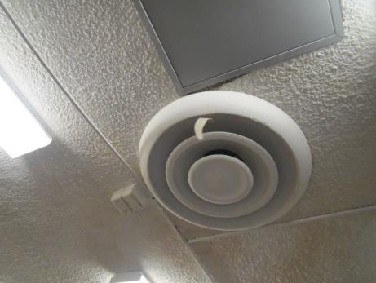
One style of supply vent
Picture 2
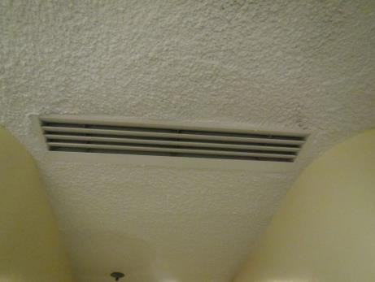
Hallway supply vent
Picture 3
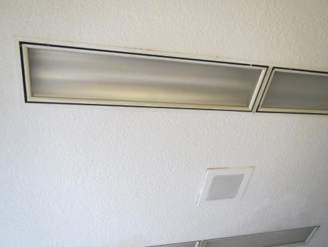
Return vents around lights
Picture 4
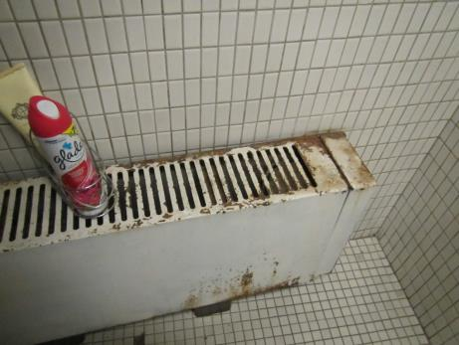
Radiator in bathroom, note rust stains and cleaning products
Picture 5
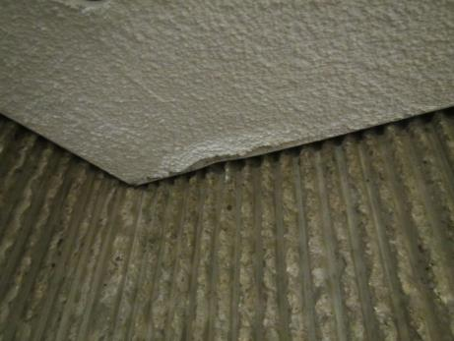
Wall texture and damaged ceiling plaster
Picture 6
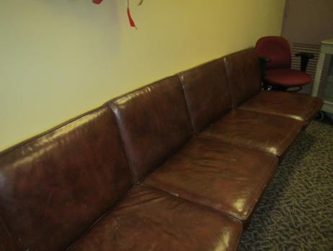
Leather couch in employee entrance lobby
Picture 7
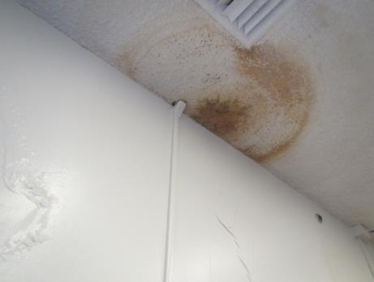
Water-damaged ceiling plaster and paint
Picture 8
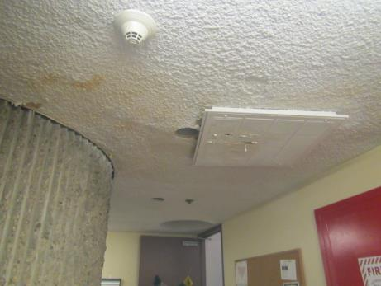
Water-damaged ceiling plaster
Picture 9
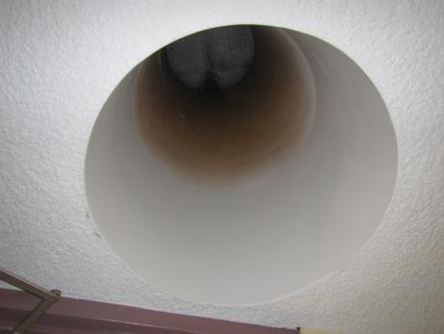
Water stains in skylight
Picture 10
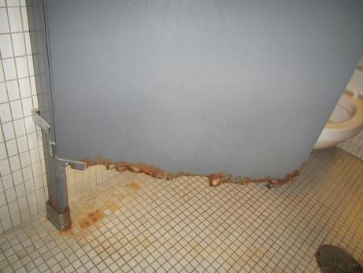
Corroded lower edge of door in men’s restroom
Picture 11
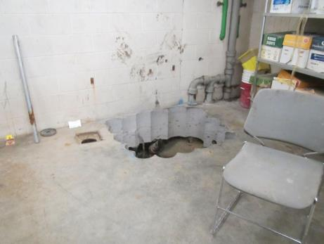
Site of old grease trap
Picture 12
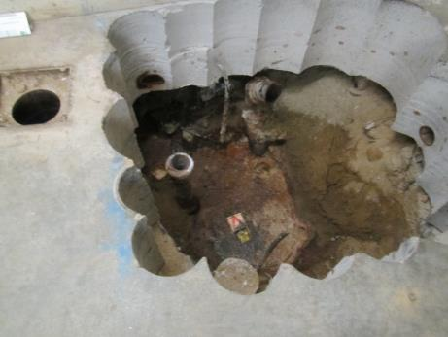
Surface of old grease trap
Picture 13
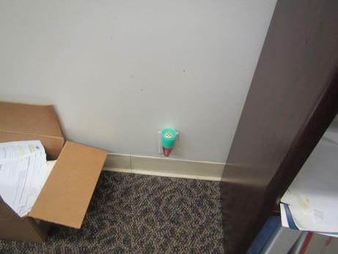
Plug-in air freshener
Picture 14
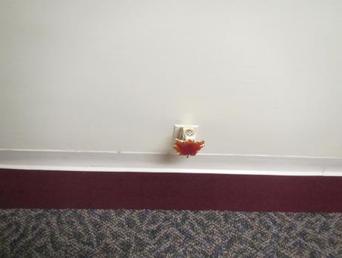
Plug-in air freshener
Picture 15
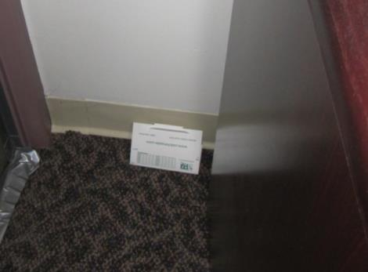
Mousetrap in an office

Location | Carbon  Dioxide  (ppm) | Carbon Monoxide  (ppm) | Temp  (°F) | Relative  Humidity  (%) | PM2.5  (µg/m³) | Occupants  in Room | Windows  Openable | Ventilation |  |  | Remarks
 |  |  |  |  |  |  |  | Supply | Exhaust
Background | 413 | 0.2 | 67 | 66 | 2 |  |  |  |  |  | Light rain
Kitchen | 468 | ND | 70 | 62 | 1 | 0 | N | Y |  | Y | Carpeted, fridge, microwave, toaster. Previously impacted by flood from bathroom on a floor above
Employee entrance lobby | 399 | ND | 70 | 64 | 1 | 3 | N | Y |  | Y | Area rugs, leaks along wall, this is where odor reportedly very prominent
M031 | 428 | ND | 70 | 63 | 1 | 0 | N |  |  | Y | Plug-in
M032 | 677 | ND | 70 | 67 | 2 | 0 | N |  |  | Y | Area rug and items on floor
M034 | 469 | ND | 71 | 62 | 1 | 1 | N | Y |  | Y | DO, plant
M035 | 460 | ND | 71 | 62 | 1 | 1 | N |  |  | Y
M036 | 477 | ND | 71 | 62 | 1 | 0 | N |  |  | Y | DEM, CP, mousetrap
M037 | 492 | ND | 71 | 63 | ND | 0 | N |  |  | Y | Food
M045 | 409 | ND | 70 | 65 | 1 | 1 | N |  |  | Y | DEM
M046 | 359 | ND | 72 |  |  | 0 | N |  |  | Y | Plants
M047 | 437 | ND | 71 | 62 | 1 | 0 | N | y |  | Y | Has attached restroom
M048 | 413 | ND | 71 | 62 | 1-9 | 0 | N | Y |  | Y | Has restroom
M080 | 451 | ND | 70 | 61 | 1 | 0 | N |  |  | Y | Plug-in
M083 | 480 | ND | 70 | 63 | 1 | 1 | N |  |  | Y | DEM, plug-in, dusty wall fan
M084 | 488 | ND | 70 | 62 | 0 | 1 | N |  |  | Y | DEM
M085 |  | ND | 71 | 62 | 2 | 0 | N |  |  | Y | Carpet squares peeling up
M088 | 422 | ND | 70 | 64 | ND | 0 | N |  |  | Y | WD plaster, dusty vent
M093 | 443 | ND | 70 | 64 | 3 | 0 | N |  |  | Y | Flaking plaster, HS
M1070 | 536 | ND | 69 | 71 | 1 | 1 | N |  |  | Y
Mail room | 423 | ND | 70 | 63 | 1 | 0 | N | Y |  | Y | Items, has restroom
Men’s Rr |  |  |  |  |  |  | N | N |  | Y | Corroded door in stall
Mezzanine conference | 411 | ND | 70 | 63 | 1 | 1 | N |  |  | Y | DEM
Office | 694 | ND | 70 | 63 | 1 | 0 | N |  |  | Y
Office | 538 | ND | 70 | 63 | 1 | 0 | N |  |  | Y | Storage
Unisex restroom | 447 | ND | 70 | 66 | 1 | 0 | N |  |  | Y | Slight odor
West conference | 502 | ND | 70 | 62 | 1 | 0 | N |  |  | Y | Leaks and WD plaster, very WD paint
Women’s RR |  |  |  |  |  | 0 | N |  |  | Y | WD plaster

