**INDOOR AIR QUALITY ASSESSMENT**

**Department of Mental Health**

**27 Water Street**

**Wakefield, Massachusetts**

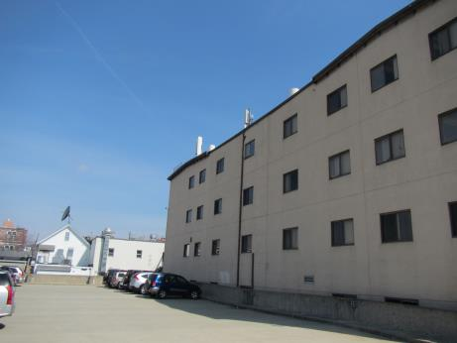

Prepared by:

Massachusetts Department of Public Health

Bureau of Environmental Health

Indoor Air Quality Program

May 2018

# Background

|  |  |
| --- | --- |
| Building: | Department of Mental Health (DMH) |
| Address: | 27 Water Street Wakefield, MA |
| DCAMM Project Manager: | Sharlene Sharif, Field Operations Unit – Facilities, Executive Office of Health and Human Services (EOHHS) |
| Reason for Request: | Health complaints and general indoor air quality (IAQ) concerns |
| Date of Assessment: | April 12, 2018 |
| Massachusetts Department of Public Health/Bureau of Environmental Health (MDPH/BEH) Staff Conducting Assessment: | Jason Dustin, Environmental Analyst/Inspector, IAQ Program |
| Building Description: | The DMH space is located in a four-story office building having a stucco exterior constructed ~1880. The DMH space is composed of private offices, open work areas and conference rooms. Most areas have carpet and dropped ceiling tiles. |
| Windows: | Windows are openable but many screens are in disrepair. |

# Methods

Please refer to the IAQ Manual for methods, sampling procedures, and interpretation of results (MDPH, 2015).

# Results

The following is a summary of indoor air testing results (Table 1).

* ***Carbon dioxide levels*** were below 800 parts per million (ppm) in most areas assessed. The DMH office was sparsely populated which can lower these measurements.
* ***Temperature*** was within the recommended range of 70°F to 78°F in all areas.
* ***Relative humidity*** was below the recommended range of 40% to 60% in all areas as is typical during the heating season in the Northeast.
* ***Carbon monoxide*** levels were non-detectable (ND) in all indoor areas assessed.
* ***Fine particulate matter (PM2.5)*** concentrations measured were below the National Ambient Air Quality Standard (NAAQS) level of 35 micrograms per cubic meter (μg/m3) in all areas.
* ***Total Volatile Organic Compounds (TVOCs)*** were ND in all areas except for the conference room which had a slight measurement of 2.2 ppm likely due to fragrances/perfume and lack of adequate air exchange at the time of the assessment.

# Discussion

## Ventilation

A heating, ventilating, and air conditioning (HVAC) system has several functions. First it provides heating and, if equipped, cooling. Second, it is a source of fresh air. Finally, an HVAC system will dilute and remove normally occurring indoor environmental pollutants by not only introducing fresh air, but by filtering the airstream and ejecting stale air to the outdoors via exhaust ventilation. Even if an HVAC system is operating as designed, point sources of respiratory irritation may exist and cause symptoms in sensitive individuals.

The HVAC system consists of large rooftop air handling units (AHUs) that draw in fresh air from intakes. Conditioned air is ducted to supply diffusers located throughout the office areas (Picture 1). Ceiling-mounted return grates draw air into the ceiling plenum and back to the AHUs (Picture 2).

BEH staff noted that the HVAC fan was set to “auto” rather than the recommended “on” setting (Picture 3). The “auto” setting will shut down ventilation when the system is no longer calling for heat or cooling. This condition will allow normally occurring pollutants to accumulate within occupied spaces and is likely responsible for many of the IAQ complaints experienced. The fairly low carbon dioxide readings shown in Table 1 are more likely due to the very low occupancy rather than adequate ventilation. The need for improved ventilation is shown particularly with the elevated reading for the conference room where there were four people at the time (Table 1).

To maximize air exchange, the MDPH recommends that both supply and exhaust ventilation operate *continuously* during periods of occupancy. In order to have proper ventilation with a mechanical supply and exhaust system, the systems must be balanced to provide an adequate amount of fresh air to the interior of a room while removing stale air from the room. It is recommended that HVAC systems be re-balanced every five years to ensure adequate air systems function (SMACNA, 1994).

## Microbial/Moisture Concerns

BEH staff noted many areas of active or historic water damage. Numerous water-damaged ceiling tiles were noted, some of which had been painted (Pictures 4 to 6). Some areas with water-damaged carpeting were also observed. The US Environmental Protection Agency (US EPA) and the American Conference of Governmental Industrial Hygienists (ACGIH) recommends that porous materials (e.g., wallboard, carpeting, ceiling tiles) be dried with fans and heating within 24 to 48 hours of becoming wet (US EPA, 2008; ACGIH, 1989). If porous materials are not dried within this time frame, mold growth may occur.

The break room was noted to have gaps between the sink and backsplash due to deteriorated caulking. This may allow water behind and under the sink and moisten porous building materials.

The building’s entrance foyer was noted to be enclosed with a solarium which showed evidence of many leaks (Pictures 7 to 10). Although the glass and tile are not conducive to mold growth, the wood, gypsum wallboard, and carpeting are all porous materials. These porous materials may become colonized through exposure to chronic moisture. The foyer is not an occupied area for DMH occupants, however stairwells and elevator shafts may provide pathways to occupied areas.

Indoor plants were observed in some areas (Picture 11). Plants can be a source of pollen and mold, which can be respiratory irritants to some individuals. Plants should be properly maintained and equipped with drip pans and should be located away from air diffusers to prevent the aerosolization of dirt, pollen and mold.

## Other Conditions

Hand sanitizers, scented cleaning products, and air fresheners were noted in some areas. These products can cause irritation of the eyes, nose and respiratory system of some people and may also serve as a trigger for occupants with asthma. Some of these air fresheners were noted to have a particularly overpowering odor (Picture 12). Consideration should be made to adopt a fragrance-free workplace particularly if any of the staff have respiratory issues (e.g., asthma). The MDPH guideline “Clean air is odor-free” is included with this report for informational purposes as [Appendix A](https://www.mass.gov/files/documents/2016/11/vd/fragrances-fact-sheet.docx).

DMH occupants reported a past IAQ incident where a strong oil/solvent odor was experienced in the office. Some staff members stated they were not aware of what was occurring and reported feeling dizziness and headaches. Building maintenance staff disclosed that the odor was from a new AHU heat exchanger. New metal parts are typically coated in machine oil to prevent corrosion. Upon installation, the new unit can give off unpleasant odors when first put into service or heated.

Flooring is primarily covered with carpeting. Most of this carpeting appears soiled and worn (Pictures 13 and 14). Carpeting may aerosolize dust/debris if it is not vacuumed regularly. The MDPH recommends that carpeting be vacuumed daily using a high efficiency particulate arrestance (HEPA) filter equipped vacuum cleaner and cleaned annually (or semi-annually in soiled high traffic areas).

The IAQ in the DMH space would improve with increased housekeeping. Accumulation of dirt and debris on most carpeting and surfaces did not appear to be cleaned regularly. Occupants can contribute to the accessibility of surfaces by organizing accumulated items in a manner to allow custodial staff to easily wet wipe surfaces and HEPA vacuum carpets.

BEH staff noted that several supply diffusers had accumulations of dust and debris (Picture 15). This condition typically results from using an inefficient filter and/or not changing the AHU filters regularly. These diffusers should be cleaned regularly to avoid aerosolizing debris. AHUs should be fitted with pleated filters of a Minimum Efficiency Reporting Value (MERV) of 8, which are adequate in filtering out pollen and mold spores (ASHRAE, 2012). In addition, filters should be changed 2-4 times a year or in accordance with the manufacture’s recommendations.

# Conclusions/Recommendations

Based on the observations made during the visit, the following is recommended:

1. Change HVAC system settings to provide continuous fresh air ventilation during occupied hours (e.g., Fan “On” **not** “auto”). This will help to dilute and remove normally occurring pollutants which trigger many IAQ complaints.
2. Repair remaining leaks (e.g., solarium/foyer) and remove water-damaged gypsum wallboard, carpeting, and colonized wood ceilings in a manner consistent with recommendations found in “Mold Remediation in Schools and Commercial Buildings” published by the US Environmental Protection Agency (US EPA, 2008).
3. Change HVAC filters (using MERV 8 or higher filters) 2-4 times a year or in accordance with the manufacture’s recommendations. Consult AHU manufacturer recommendations to ensure that filters used are compatible with the system to avoid excessive pressure drop.
4. Use windows to supplement fresh air. Any damaged screens should be replaced to avoid allowing insects and pests into the building. Do not open windows while the air conditioning is operating or condensation may wet porous materials.
5. Reduce or eliminate the use of scented cleaners, hand sanitizers, personal air fresheners and humidifiers. Consider adopting a fragrance-free workplace and consult the included MDPH guideline “Clean air is odor-free”.
6. Properly maintain plants, including drip pans, to prevent water damage to porous materials. Plants should also be located away from air diffusers to prevent the aerosolization of dirt, pollen, and mold.
7. Replace any soiled, water-damaged, or worn carpeting. HEPA vacuum daily and clean remaining carpeting at least once per year. Consider carpet tiles when replacing carpeting.
8. Use caulking to seal gap between sink and backsplash to prevent chronic moisture of porous building materials.
9. Reduce the amount of accumulated items and store items in a manner that allows cleaning access by custodial staff.
10. Improve housekeeping to reduce IAQ complaints. For buildings in New England, periods of low relative humidity during the winter are often unavoidable. Therefore, scrupulous cleaning practices should be adopted to minimize common indoor air contaminants whose irritant effects can be enhanced when the relative humidity is low. To control for dusts, a high efficiency particulate arrestance (HEPA) filter equipped vacuum cleaner in conjunction with wet wiping of all surfaces is recommended. Avoid the use of feather dusters. Drinking water during the day can help ease some symptoms associated with a dry environment (throat and sinus irritations).
11. Supply diffusers and exhaust grates should be cleaned regularly to avoid aerosolizing dust/debris.
12. Both building management and DMH management should improve communication during any scheduled maintenance that may disrupt occupants. Work involving unpleasant odors, dust or excessive noise should be performed when the office is unoccupied.
13. Have the HVAC system re-balanced, as recommended (every 5 years) in accordance with SMACNA recommendations (SMACNA, 1994).
14. Refer to resource manuals and other related IAQ documents for further building-wide evaluations and advice on maintaining public buildings. Copies of these materials are located on the MDPH’s website: <http://mass.gov/dph/iaq>.

# References

ACGIH. 1989. Guidelines for the Assessment of Bioaerosols in the Indoor Environment. American Conference of Governmental Industrial Hygienists, Cincinnati, OH.

ASHRAE. 2012. American Society of Heating, Refrigeration and Air Conditioning Engineers (ASHRAE) Standard 52.2-2012 -- Method of Testing General Ventilation Air-Cleaning Devices for Removal Efficiency by Particle Size (ANSI Approved).

MDPH. 2015. Massachusetts Department of Public Health. “Indoor Air Quality Manual: Chapters I-III”. Available at: <http://www.mass.gov/eohhs/gov/departments/dph/programs/environmental-health/exposure-topics/iaq/iaq-manual/>.

SMACNA. 1994. HVAC Systems Commissioning Manual. 1st ed. Sheet Metal and Air Conditioning Contractors’ National Association, Inc., Chantilly, VA.

US EPA. 2008. Mold Remediation in Schools and Commercial Buildings. US Environmental Protection Agency, Office of Air and Radiation, Indoor Environments Division, Washington, D.C. EPA 402-K-01-001. <http://www.epa.gov/mold/mold-remediation-schools-and-commercial-buildings-guide>

**Picture 1**

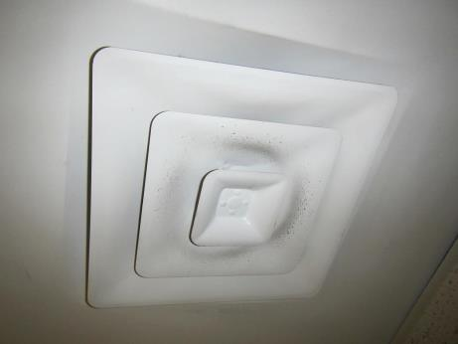

**Supply air diffuser**

**Picture 2**

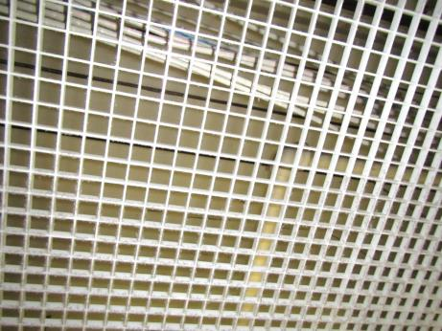

**Return vent utilizing ceiling plenum**

**Picture 3**

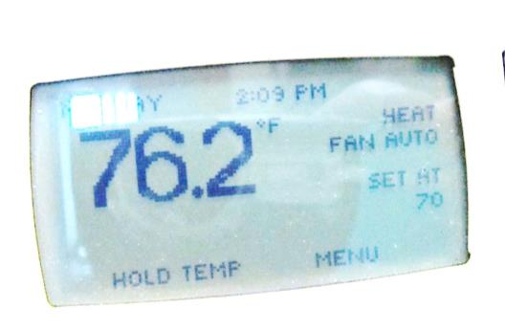

**Thermostat fan setting showing “Auto” instead of “On”**

**Picture 4**

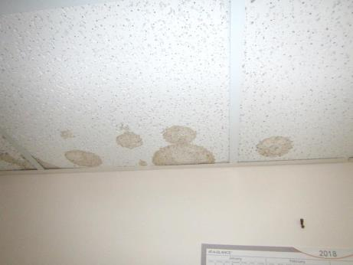

**Water-damaged ceiling tiles**

**Picture 5**

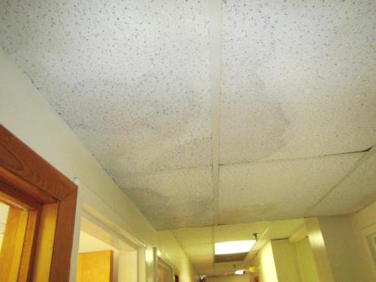

**Water-damaged ceiling tile that were painted over**

**Picture 6**

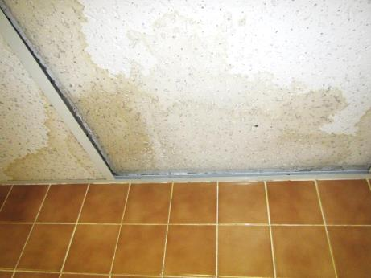

**Water-damaged ceiling tiles in bathroom**

**Picture 7**

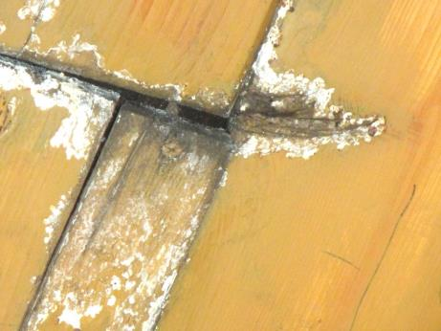

**Water-damaged wood ceiling in foyer/solarium entrance area**

**Picture 8**

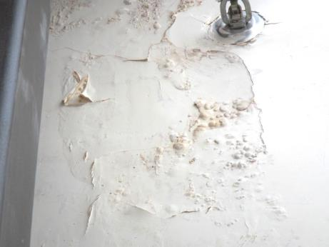

**Water-damaged gypsum wallboard in foyer/solarium area**

**Picture 9**

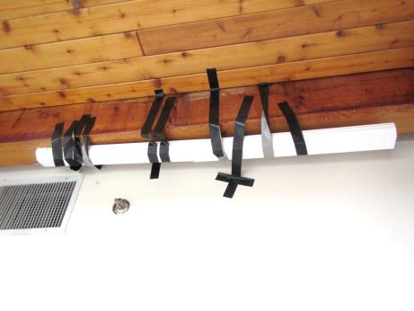

**Gutters and tape used to intercept leaks in solarium foyer**

**Picture 10**

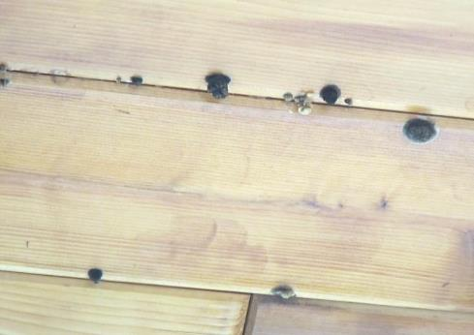

**Apparent fungi (dark spots) growing on wood ceiling in solarium foyer**

**Picture 11**

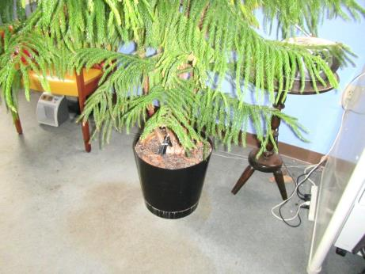

**Large plant on porous carpeting (note stains)**

**Picture 12**

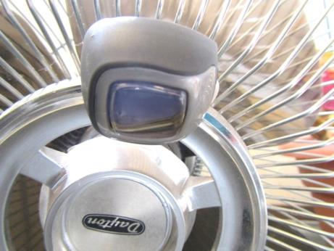

**Air freshener with powerful odor clipped onto personal fan**

**Picture 13**

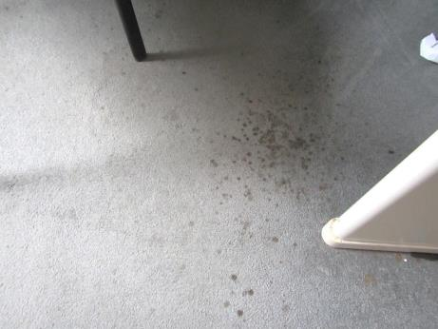

**Soiled carpeting**

**Picture 14**

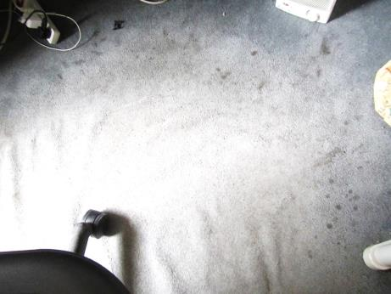

**Wrinkled, soiled/worn carpeting**

**Picture 15**

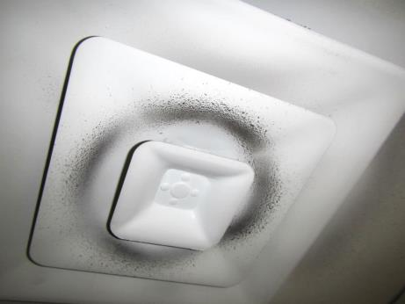

**Supply vent diffuser showing accumulated dust/debris**

| **Location** | **Carbon**  **Dioxide**  **(ppm)** | **Carbon Monoxide**  **(ppm)** | **Temp**  **(°F)** | **Relative**  **Humidity**  **(%)** | **PM2.5**  **(µg/m**3**)** | **TVOCs**  **ppm** | **Occupants**  **in Room** | **Windows**  **Openable** | **Ventilation** | | | **Remarks** |
| --- | --- | --- | --- | --- | --- | --- | --- | --- | --- | --- | --- | --- |
| **Intake** | **Exhaust** | |
| Background (outside) | 327 | ND - 1.0 | 63 | 26 | 34 | ND | - | - | - | | - | Slight exhaust odor (heavy traffic) |
| Conference room | 1363 | ND | 72 | 33 | 5 | 2.2 | 4 | N | Yoff | | N | Old carpet soiled, AHU off at time (intermittent) |
| Reception | 697 | ND | 75 | 23 | 8 | ND | 3 | Y | Yoff | | N | HS, window screens damaged, carpet worn, plant |
| Interview | 738 | ND | 75 | 23 | 6 | ND | 2 | N | Y | | N |  |
| Niki | 789 | ND | 76 | 22 | 4 | ND | 2 | Y | Yoff | | N |  |
| Empty office 1 | 812 | ND | 76 | 22 | 5 | ND | 0 | Y | Yoff | | N |  |
| 2 | 753 | ND | 76 | 22 | 1 | ND | 0 | Y | Y off | | N | Soiled carpet, dirty, candle, damaged screen |
| 3 | 720 | ND | 76 | 21 | 3 | ND | 0 | Y | Y off | | N | Plant, carpet w/ dirt and debris |
| 4 | 827 | ND | 76 | 22 | 5 | ND | 0 | Y | Y | | N |  |
| 5 | 614 | ND | 77 | 21 | 9 | ND | 0 | Y open | Y | | **N** | Dirty carpet, plant, HS |
| 6 | 644 | ND | 76 | 20 | 7 | ND | 2 | Y | Y open | | N | Carpet, strong AF odor |
| 7 | 679 | ND | 76 | 22 | 2 | ND | 2 | Y | Y | | N | Plants, carpet |
| 8 | 652 | ND | 76 | 21 | 1 | ND | 0 | Y | Y | | N | Plants, AT, AF, carpet stained |
| 9 | 600 | ND | 75 | 20 | 2 | ND | 0 | Y | Y | | N | Carpet |
| 10 | 644 | ND | 75 | 21 | 1 | ND | 0 | Y | Y | | Y | Stained carpet, toiletries, CPs |
| 11 | 688 | ND | 76 | 21 | 4 | ND | 0 | Y | Y | | N |  |
| Breakroom | 697 | ND | 76 | 22 | 2 | ND | 0 | N | Y | | Y local | Gap between sink/backsplash, dirty |
| Files | 770 | ND | 76 | 22 | 4 | ND | 2 | N | Y | | Y | AT, carpet |
| Women’s Bathroom | - | - | - | - | - | - | - | - | - | | Y | WD CTs, exhaust off |
| Solarium/Foyer | - | - | - | - | - | - | - | - | - | | - | WD GW, WD colonized wood ceiling, active water leaks |