EXECUTIVE SUMMARY

INDOOR AIR QUALITY
ASSESSMENT

Massachusetts Department of Mental Health
Brockton Multi-Service Center
165 Quincy Street
Brockton, MA

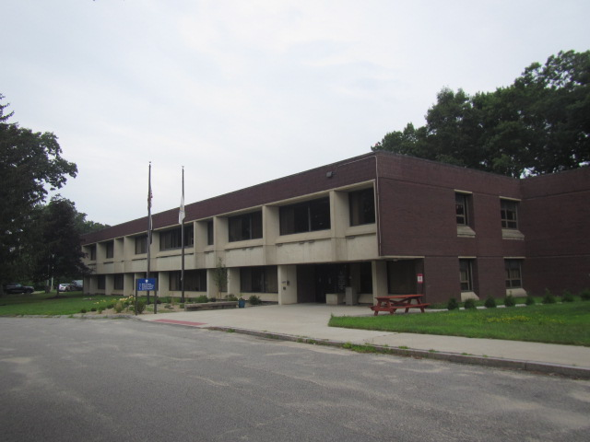

Prepared by:
Massachusetts Department of Public Health
Bureau of Climate and Environmental Health
Indoor Air Quality Program
September 2023
The Brockton Multi-Service Center building needs heating, ventilating, and air conditioning (HVAC) system replacement. Most of the HVAC equipment is original to the building (> 50 years old), well past its service life, with components such as pneumatic controls being corroded and beyond repair. These conditions make it difficult to control outside airflow, temperature, and relative humidity, particularly during hot, humid, summer conditions that have led to widespread condensation and water damage issues. Additionally, other building materials (e.g., carpeting, ceiling tiles, and windows) are mostly original to the building’s construction and are also past their service life and in need of replacement. As climate change and global warming intensifies, the urgent need for modern, energy-efficient solutions becomes clear. Without significant upgrade of HVAC equipment and other interior components, building conditions and indoor air quality will continue to degrade.

BACKGROUND
Building: | Department of Mental Health (DMH), Brockton Multi-Service Center (BMSC)
Address: | 165 Quincy Street, Brockton, MA
Assessment Requested by: | Brendan Thrasher, Building and Site Operations Supervisor, Brockton Multi Service Center DMH
Reason for Request: | To assess the adequacy of the mechanical ventilation system, and to address issues with water damage and mold.
Date of Assessment: | A preliminary walkthrough was conducted to measure temperature and relative humidity and observe interior conditions on July 21, 2023, and a full indoor air quality (IAQ) assessment was conducted on August 3, 2023.
Massachusetts Department of Public Health/Bureau of Climate and Environmental Health (MDPH/BCEH) Staff Conducting Assessment: | Cory Holmes, Assistant Director, and Mike Feeney, Director, IAQ Program
Building Description: | The BMSC was built in 1975, is flat-roofed, multilevel, brick and concrete building with portions built into surrounding terrain. The space contains mainly interlocking ceiling tiles and wall to wall carpet, however these in some areas have been replaced with suspended ceiling tiles and carpet squares.
Windows: | Openable in some areas.

METHODS
Please refer to the IAQ Manual for methods, sampling procedures, and interpretation of results (MDPH, 2015).

RESULTS AND DISCUSSION
The following is a summary of indoor air testing results (Tables 1 & 2).
- Carbon dioxide levels were taken on August 3, 2023 (Table 2) and were above the MDPH guideline of 800 parts per million (ppm) in several areas despite low occupancy, indicating a lack of air exchange at the time of assessment. This is likely due to a combination of the HVAC system components being deactivated, operating in air conditioning mode, which limits outside air intake (due to heat and elevated relative humidity), and the equipment being past its service life, which will be discussed further in the Ventilation section of this report.
- Temperature was below the MDPH recommended range of 70°F to 78°F in some areas tested on both July 21 and August 3, 2023.
- Relative humidity was above the MDPH recommended range of 40 to 60% in all areas on July 21 and most areas on August 3, 2023, indicating the HVAC units are not operating at proper capacity to reduce moisture in indoor air. This is discussed further in both the Ventilation and Moisture Concerns section of this report.
- Carbon monoxide levels measured on August 3, 2023 (Table 2) were non-detectable (ND) in all areas tested.
- Fine particulate matter (PM2.5) concentrations measured on August 3, 2023 (Table 2) were below the National Ambient Air Quality Standard (NAAQS) limit of 35 μg/m³ in all areas tested.

Ventilation
A heating, ventilating, and air conditioning (HVAC) system has several functions. First it provides heating and, if equipped, cooling. Second, it is a source of fresh air. Finally, an HVAC system will dilute and remove normally occurring indoor environmental pollutants by not only introducing fresh air, but by filtering the airstream and ejecting stale air to the outdoors via exhaust ventilation. Even if an HVAC system is operating as designed, point sources of respiratory irritation may exist and cause symptoms in sensitive individuals.
Fresh air in the majority of areas is supplied by wall or ceiling-mounted unit ventilator (univent) systems (Picture 1). A univent is designed to draw air from outdoors through a fresh air intake located on the exterior wall of the building (Pictures 2 and 3) and returns air through an air intake located at the base of the unit (Figure 1). Fresh and return air are mixed and filtered, then heated and provided to rooms through an air diffuser located in the top of the unit. Univents are reportedly original equipment, over 50 years old (Picture 4). Note that these univents are equipped to cool as well as heat air. This is discussed further under Microbial/Moisture Concerns below.
Univents of this age can be difficult to maintain because replacement parts are often unavailable. In some cases, pneumatic controls are corroded/disconnected (Picture 5), which make it impossible to control outside air intake. As reported by Mr. Thrasher, the pneumatic lines have a number of leaks preventing control despite the recent installation of a new compressor.
Due to lack of control, the air intakes must be set by hand and can only be in the wide-open or completely shut positions. If wide open, they draw in uncontrolled hot, humid air in the summer, which can create condensation issues, or excessively cold air, freezing pipes in the winter. In both cases, these conditions can lead to water damage in porous building materials that can lead to mold growth. These conditions are described in further detail in the Microbial/Moisture Concerns section of this report. In other cases, univents were deactivated due to excessive noise. In order for univents to provide fresh air as designed, they must remain activated and allowed to operate while rooms are occupied. Intakes, returns, and air diffusers must also remain free of obstructions.
Please note, this equipment has exceeded its service life. According to the American Society of Heating, Refrigeration, and Air-Conditioning Engineers (ASHRAE), the service life of this type of unit is 15-20 years, assuming routine maintenance of the equipment (ASHRAE, 1991). In their current state, these units have shown they are not sufficient to provide proper air exchange, temperature, and humidity control as evidenced by the condition of air intake louvers, visible water damage, and relative humidity measurements (Tables 1 and 2).
Univents have filters, which should be changed 2-4 times a year or as per the manufacturer’s recommendations. The MDPH recommends pleated filters with a Minimum Efficiency Reporting Value (MERV) of 8, which are adequate in filtering out pollen and mold spores (ASHRAE, 2012). Filters at the BMSC are MERV 13 and reported by Mr. Thrasher, changed twice a year (Picture 6).
Mechanical exhaust ventilation throughout the majority of the building was originally provided by unit exhaust ventilators. The exhaust units at BMSC are built into cabinets and are not visibly apparent (Picture 7). Blueprints indicate these units are meant to draw in room air and eject it out of the building (Picture 8). However, they appeared to not have operated for some time. Without proper supply and exhaust ventilation, normally occurring environmental pollutants can build-up and lead to indoor air quality/comfort complaints. In addition, without proper exhaust ventilation excess moisture cannot be removed from the building, as demonstrated by elevated relative humidity measurements (Tables 1 and 2) and condensation issues (Picture 1).
In order to have proper ventilation with a mechanical ventilation system, the systems must be balanced after installation to provide an adequate amount of fresh air to the interior of a room while removing stale air from the room. It is recommended that HVAC systems be re-balanced every five years to ensure adequate air systems function (SMACNA, 2013). The systems at BMSC likely cannot be balanced in their current condition.

Microbial/Moisture Concerns
The July 21st visit occurred during several days of extended heat and high relative humidity. Condensation was visible dripping from both wall- and ceiling-mounted HVAC units throughout the space, resulting in wet carpeting and damaged ceiling tiles (Pictures 1 and 9 through 13). Attempts were being made to catch condensation in buckets in several areas (Picture 14). Visible mold growth was observed on door jambs in many areas (Picture 15). DPH/IAQ staff recommended cleaning the door jambs and using stand up fans and dehumidifiers to help circulate air and dry out the building. At the time of the follow-up visit on August 3, 2023, stand up fans and dehumidifiers were deployed throughout the space (Pictures 16 and 17) and the majority of door jambs were cleaned, however a few were missed and pointed out to Mr. Thrasher for cleaning. Additionally, dark staining likely indicating mold growth was noted on pipe insulation (Tables 1 and 2; Pictures 18 and 19), and ceiling tiles (Tables 1 and 2; Pictures 20 and 21). DPH/IAQ staff recommended replacement of these materials.
Also of note is that fresh air intakes on the first floor are located 4 inches or less above ground (Picture 3). In this configuration, water vapor from soil, pooling water after rainstorms, or melting snow/ice can be captured by the fresh air intakes to be introduced into occupied space. In addition, any airborne soil particles, microbes (including fungi), odors, and moisture from pooling water may also be drawn in by first floor fresh air intakes. In winter, snow coverage likely buries these intakes, rendering the first floor univents unable to provide fresh air. In New England, fresh air supplies should be located at least above the maximum measured snow accumulation height experienced, which may be over 20 inches on any given year.
As noted above, the univents also provide air conditioning. Operating a univent in cooling mode creates condensation. A drip pan is installed beneath heat transfer coils that are insulated using a Styrofoam insert (Picture 4), which appear to be original. It is likely intended that the insert be replaced at least once a year and the underlying drain pan cleaned. Condensation is allowed to empty in the crawlspace into a drain off the furnace mechanical room.
The crawlspace/tunnel system is also a source of chronic moisture. Reportedly there can be several inches of water accumulated in the tunnel system after heavy rain or snow melt. Open utility holes or other breaches can allow moisture and odors from the crawl space into occupied space making temperature and humidity control difficult.
Windows are also original equipment past their service life. Failing gaskets were observed (Picture 22), which can allow for drafts and moisture penetration, further making temperature and humidity control difficult leading to comfort complaints and condensation issues.
Visible mold was observed on refrigerator gaskets in a few areas (Room 128 and Team 2, Pictures 23 and 24). Refrigerators should be kept clean to prevent microbial growth and odors.
Plants and shrubbery were observed in contact with and near the foundation. Plants near the building can cause water damage to brickwork and mortar. In addition, plants shading exterior walls can slow drying. Water can eventually penetrate the brick, subsequently freezing and thawing during the winter. This freezing/thawing action can weaken and damage bricks and mortar.
The presence of large trees is likely enhancing water retention, preventing drying of the exterior, and affecting drainage as well as overhanging the roof (Pictures 25 through 27). These trees pose several hazards:
- Leaves and other debris accumulate around roof drains, which inhibits rainwater drainage from the roof. Ineffective drains can lead to water leaks inside the building.
- Trees prevent sunlight from drying walls and soil.
- The trees are a possible danger due to the distance from exterior walls:
  - The recommended safe distance that any tree should be planted is the minimum of the expected maximum growth height of the species from the exterior of a building (BI, 2015).
- Soil subsidence may also be caused by tree roots, which can undermine the structure of a building to cause wall and floor cracking and related damage. To prevent subsidence, a sufficient distance appropriate for the tree species is recommended (Williams, 2006).
- Severe weather may result in the tree falling onto the building or the tree roots damaging the foundation. Due to the height of the trees, each is likely located closer than recommended distances.
- In general, a tree root system will spread out in all directions from its trunk. In some cases, tree roots can extend for over 100 feet from its trunk. Any structure disrupting the root structure may make the tree unstable if subjected to high winds from a certain direction. Based on the location, the foundation walls likely disrupt the roots of several trees.
- The Federal Emergency Management Agency (FEMA) provides several recommendations in order to prepare for severe thunderstorms. Of note FEMA recommends “Cut down or trim trees that may be in danger of falling on your [building]” (FEMA, 2018). Given the proximity to exterior walls, removal of trees from the exterior should be strongly considered.

Other Concerns
Most of the floors are covered with wall-to-wall carpet that is past its service life. Carpeting has a service life of approximately 10-11 years (IICRC, 2002). Carpeting that is beyond its service life becomes increasingly difficult to clean and may release fibers which can be irritating if airborne. Carpets should be vacuumed regularly with a high efficiency particulate arrestance (HEPA) filter equipped vacuum cleaner and cleaned annually (or semi-annually in soiled/high traffic areas) in accordance with Institute of Inspection, Cleaning and Restoration Certification (IICRC) recommendations (IICRC, 2012).
Finally, some exhaust and return vents had light accumulations of dust and debris. This dust/debris can be reaerosolized under certain conditions, and should be cleaned periodically (e.g., during regular filter changes).

CONCLUSIONS AND RECOMMENDATIONS
The following documents can provide guidance that can be used to reduce the impact of hot, humid weather. Although some of these docs pertain to schools, the concepts and recommendations can apply to most buildings.
- Mold Growth Prevention During Hot, Humid Weather https://www.mass.gov/service-details/preventing-mold-growth-in-massachusetts-schools-during-hot-humid-weather
- Remediation and Prevention of Mold Growth and Water Damage in Public Schools https://www.mass.gov/service-details/remediation-and-prevention-of-mold-growth-and-water-damage-in-public-schools-and
- Methods for Increasing Comfort in Non-air-conditioned Schools https://www.mass.gov/doc/methods-for-increasing-comfort-in-non-air-conditioned-schools/download

To remedy building problems, two sets of recommendations are made: short-term measures that may be implemented as soon as practicable and long-term measures that will require planning and resources to address overall IAQ concerns:

Short-term recommendations

Ventilation recommendations
- Operate all supply and exhaust ventilation equipment continuously during occupied hours. Make repairs if possible.
- Adjust air intakes as necessary, to avoid uncontrolled outside air during periods of elevated relative humidity (to avoid condensation/mold issues) and during extreme cold weather (to avoid freezing of pipes and associated flooding and mold issues).
- Continue with regular filter changes for HVAC equipment using the best quality/highest MERV rating the ventilation system can accommodate to improve air filtration as much as possible without significantly reducing airflow.
- During filter changes, vacuum dust and debris from univent cabinets.
- Supplement mechanical ventilation with portable air purifiers equipped with high efficiency particulate arrestance (HEPA) filters. While these do not supply fresh air, they can remove particles including mold spores and microbes. If used, ensure filters are changed and equipment is cleaned in accordance with manufacturers’ instructions.
- Have the HVAC system balanced every 5 years in accordance with SMACNA recommendations (SMACNA, 1994).

Water damage recommendations
- Remove carpeting directly around univents to prevent chronic moisture to adjacent carpeting and replace with tile or non-porous flooring material. Please note, due to the age of the building ensure there are no asbestos containing materials (ACM) beneath carpeting (e.g., tile, mastic) prior to removal. If ACMs present, remediate in accordance with state and Federal regulations.
- Ensure all leaks are repaired and remove/replace water-damaged ceiling tiles (if possible).
- Seal all holes, breaches, and penetrations inside univent cabinets (and other areas) with a fire-rated sealant to prevent moisture and odors from the underground tunnel system migrating into occupied areas.
- Ensure mold-colonized pipe insulation and ceiling tiles are removed. Rewrap wet/damaged insulation around HVAC pipes and replace ceiling tiles, if available.
- Ensure all refrigerators are kept clean to prevent microbial growth and odors. Clean gaskets and other surfaces with a mild antimicrobial solution to remove debris and mold. Replace gaskets that cannot be adequately cleaned.
- Remove or clean any mold-contaminated material in accordance with the US EPA’s “Mold Remediation in Schools and Commercial Buildings”. Available at: http://www.epa.gov/mold/mold-remediation-schools-and-commercial-buildings-guide
- Ensure that condensation from air conditioning equipment is draining properly. Check collector pans, piping and any associated pumps for clogs and leaks and clean periodically to prevent stagnant water build-up and remove debris that may provide a medium for microbial growth.
- Until HVAC repairs or replacement can be made to control temperature and relative humidity, continue to use fans and dehumidifiers as needed to circulate air and reduce excessive moisture during summer months.
- Examine the feasibility of installing sump pump or other drainage system to remove standing water from tunnels, and/or examine methods to prevent water infiltration.
- Trim trees from overhanging the building and ensure debris is removed from any drain and gutter systems.
- Remove plants and shrubs to at least 5 feet away from the building.
- It is recommended that porous material be dried with fans and heating within 24 to 48 hours of becoming wet (US EPA, 2008). If porous materials are not dried within this time frame, mold growth may occur. Water-damaged porous materials cannot be adequately cleaned to remove mold growth. If porous materials are not dried within this time frame, they should be removed and discarded.

Other recommendations
- For buildings in New England, periods of low relative humidity during the winter are often unavoidable. Therefore, scrupulous cleaning practices should be adopted to minimize common indoor air contaminants whose irritant effects can be enhanced when the relative humidity is low. To control for dusts, a high efficiency particulate arrestance (HEPA) filter equipped vacuum cleaner in conjunction with wet wiping of all surfaces is recommended. Avoid the use of feather dusters. Drinking water during the day can help ease some symptoms associated with a dry environment (throat and sinus irritations).
- Clean supply, return, and exhaust vents regularly to remove accumulated dust/debris.
- Replace carpeting building-wide with non-porous tile or other non-porous material.
- Until carpet can be replaced, clean in accordance with IICRC recommendations (IICRC, 2012); annually (or semi-annually in soiled/high traffic areas).
- Refer to resource manual and other related IAQ documents located on the MDPH’s website for further building-wide evaluations and advice on maintaining public buildings. These documents are available at: http://mass.gov/dph/iaq.

Long-Term Recommendations
- The age, physical deterioration, and availability of parts for mechanical ventilation system components and controls should be fully evaluated by an HVAC engineering firm to determine the operational lifespan of existing equipment and the feasibility of repair vs. replacement.
- Replace original single-paned windows with modern energy efficient windows.
- Remove trees from close proximity to the building.
- Examine ways to remove/prevent standing water from accumulating in the tunnel system below the building.
- Consult with an HVAC engineer to modify ground-level fresh air intakes to prevent blockage and moisture infiltration.

REFERENCES
ASHRAE. 1991. ASHRAE Applications Handbook, Chapter 33 “Owning and Operating Costs”. American Society of Heating, Refrigeration and Air Conditioning Engineers, Atlanta, GA.
ASHRAE. 2012. American Society of Heating, Refrigeration and Air Conditioning Engineers (ASHRAE) Standard 52.2-2012 -- Method of Testing General Ventilation Air-Cleaning Devices for Removal Efficiency by Particle Size (ANSI Approved).
BI. 2015. A List of Trees and the Recommended Safe Distance from Buildings. Bickers Insurance, Littlehampton, West Sussex, UK. https://www.bickersinsurance.co.uk/about-us/latest-news/property-owners-news/a-list-of-trees-and-the-recommended-safe-distance-from-buildings/
FEMA. 2018. How to Stay Safe When a Thunderstorm Threatens. Federal Emergency Management Agency, Washington, DC. FEMA V-1009/May 2018.
IICRC. 2002. Institute of Inspection, Cleaning and Restoration Certification. A Life-Cycle Cost Analysis for Floor Coverings in School Facilities.
IICRC. 2012. Institute of Inspection, Cleaning and Restoration Certification. Carpet Cleaning: FAQ.
SMACNA. 2013. HVAC Systems Commissioning Manual. 2nd ed. Sheet Metal and Air Conditioning Contractors’ National Association, Inc., Chantilly, VA.
MDPH. 2015. Massachusetts Department of Public Health. “Indoor Air Quality Manual: Chapters I-III”. Available at: Indoor air quality - manual and appendices | Mass.gov
US EPA. 2008. “Mold Remediation in Schools and Commercial Buildings”. Office of Air and Radiation, Indoor Environments Division, Washington, DC. EPA 402-K-01-001. September 2008. Available at: http://www.epa.gov/mold/mold-remediation-schools-and-commercial-buildings-guide
Williams. 2006. The Distance at Which Trees Can Affect a Building is Quite Significant. The Architects’ Journal. https://www.architectsjournal.co.uk/home/the-distance-at-which-trees-can-affect-a-building-is-quite-significant/130858.article
Figure 1

Unit Ventilator (Univent)

Mixed Air

Air Diffuser

Outdoors Indoors

Fan

Heating/Cooling Coil

Air Mixing Plenum

Filter

Outdoor Return
Air Air

Air
Flow
Control
Louvers

Air Flow

= Fresh Air/Return Air

= Mixed Air
Picture 1
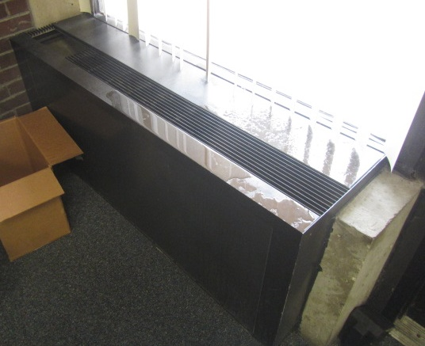
Typical univent, note surface covered in moisture due to condensation

Picture 2
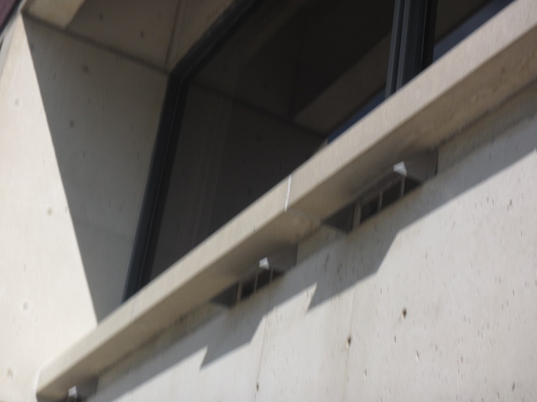
Fresh air intakes for univent system
Picture 3
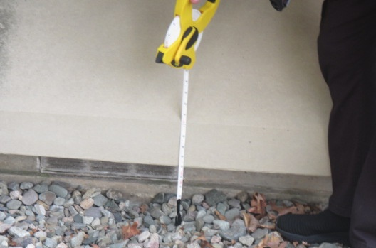
Univent fresh air intake, note proximity to ground (~3-4 inches) making it susceptible to moisture infiltration
Picture 4
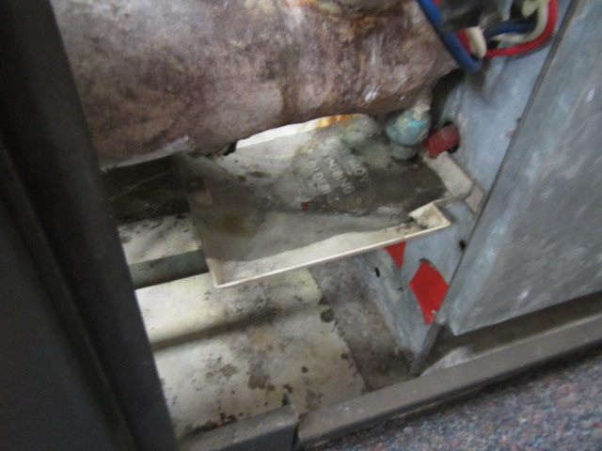
Interior condition of univent
Picture 5
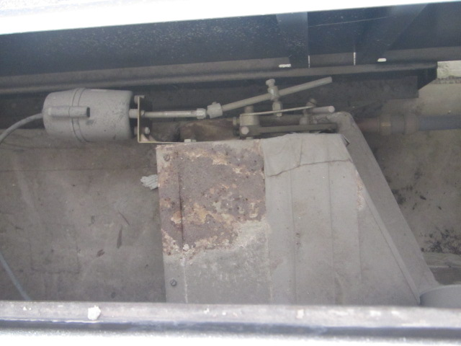
Corroded/damaged 50-year-old pneumatic HVAC components

Picture 6
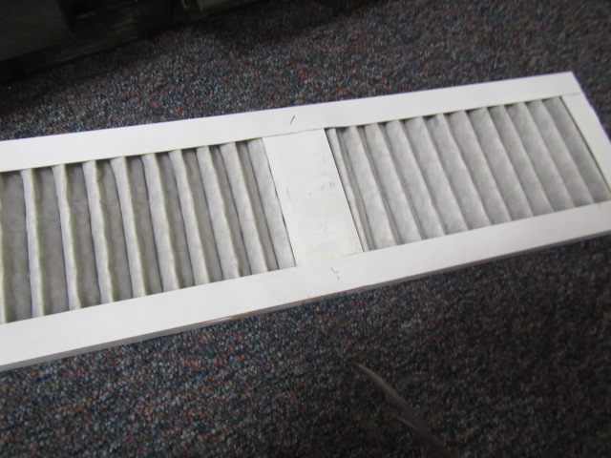
MERV 13 filter installed in univent
Picture 7
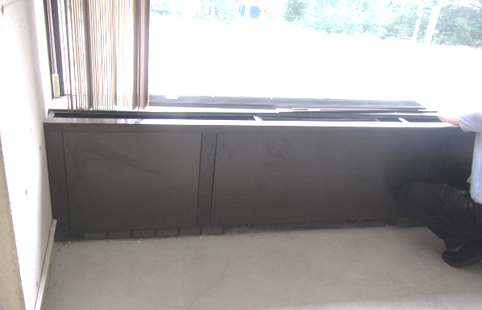
Unit exhaust ventilator (arrow) built into cabinet, note grill at bottom to draw in air

Picture 8
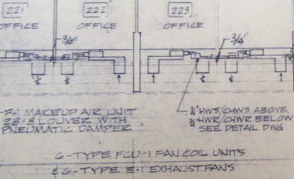
Blueprints indicating the function of unit exhausts (arrows)
Picture 9
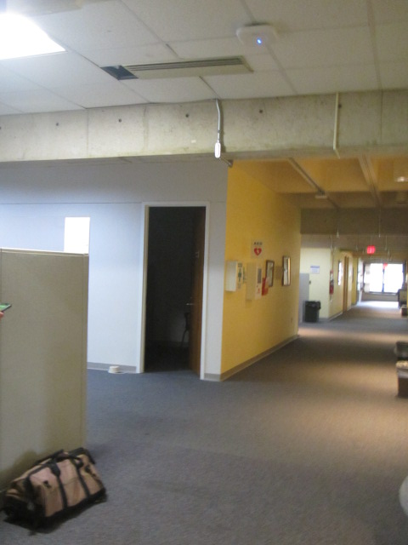
Ceiling unit dripping (from condensation) on carpeting
Picture 10
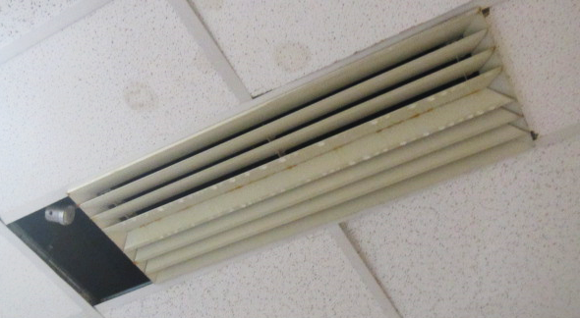
Condensation dripping from ceiling-mounted unit
Picture 11
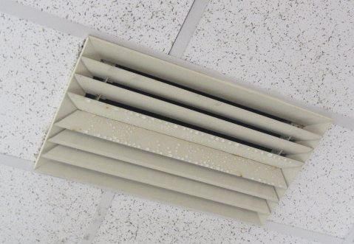
Condensation on supply vent

Picture 12
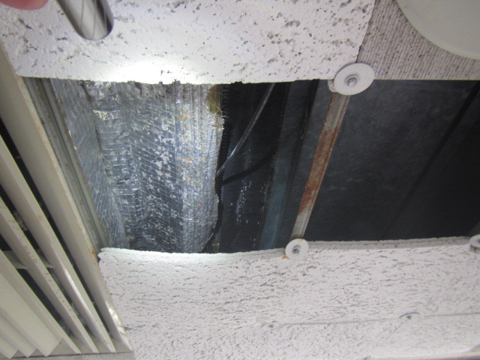
Failing ceiling tiles, from chronic condensation on above-ceiling HVAC unit
Picture 13
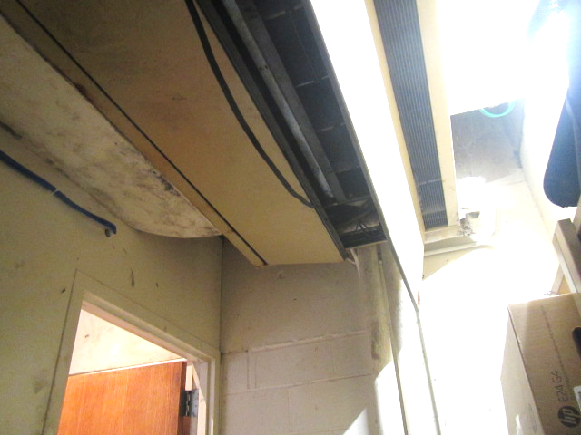
Dripping unit above trash bin (following picture), note mold growth/staining on insulation (arrow)
Picture 14
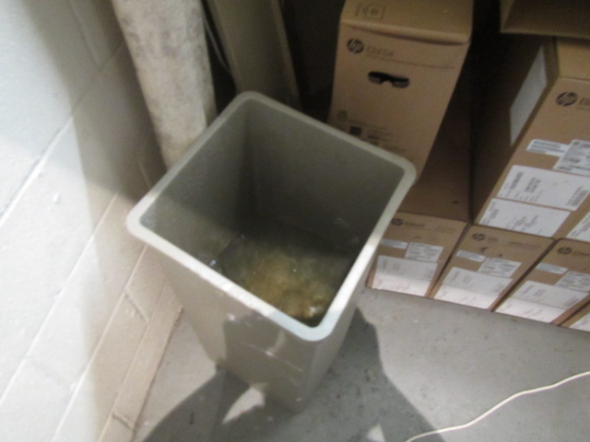
Dripping condensation from ceiling unit collected in trash bin
Picture 15
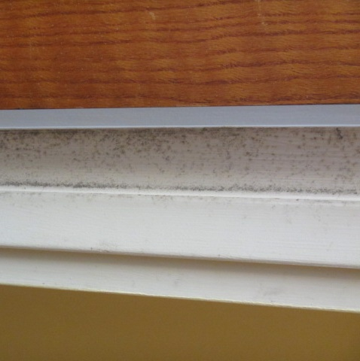
Mold growth on door jamb
Picture 16
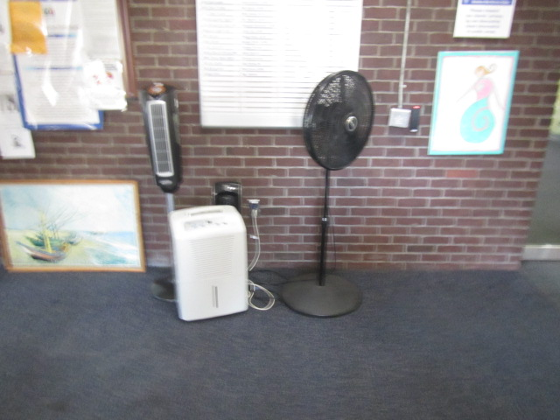
Dehumidifier and stand-up fans in main hallway to move air and increase drying
Picture 17
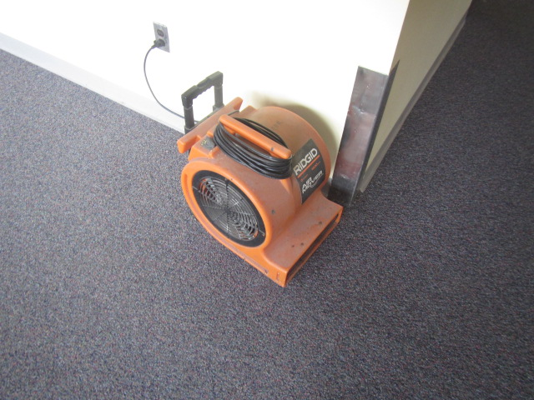
Floor fan in use in hallway to move air and increase drying

Picture 18
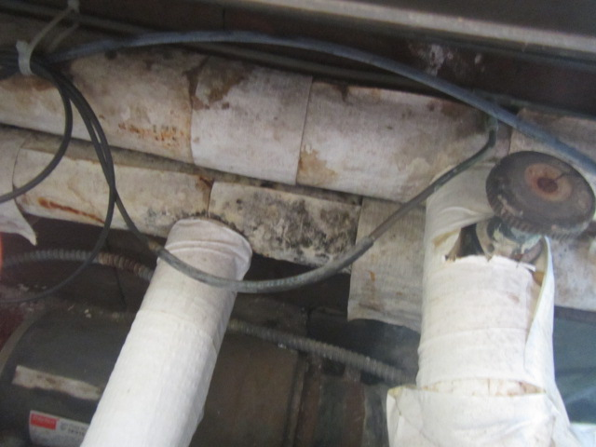
Dark staining/likely mold growth on pipe insulation
Picture 19
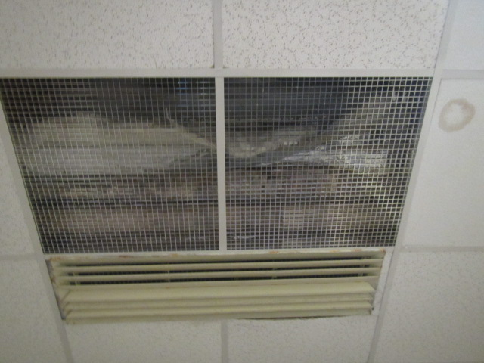
Dark staining/likely mold growth on pipe insulation

Picture 20
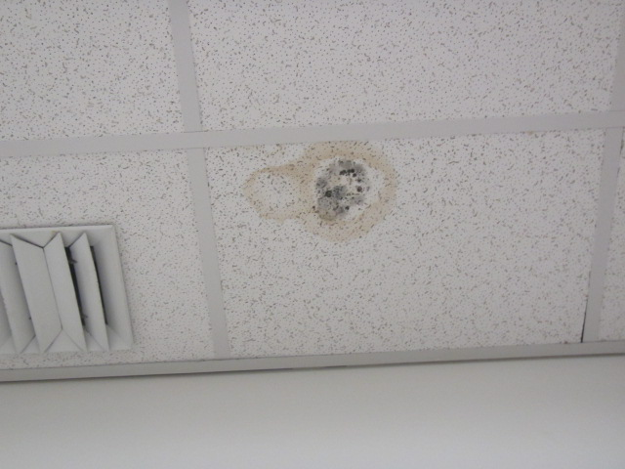
Dark staining/likely mold growth on ceiling tile
Picture 21
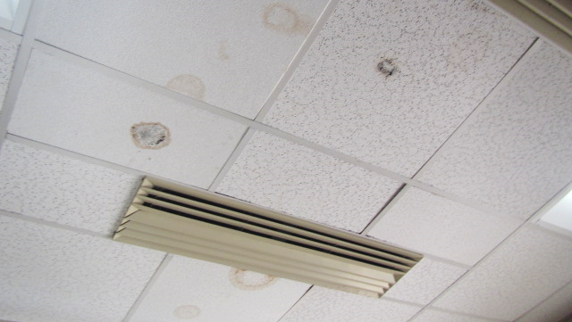
Dark staining/likely mold growth on ceiling tiles

Picture 22
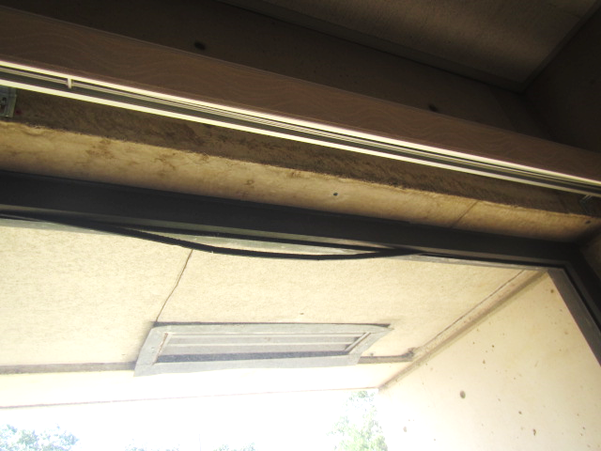
Failing window gasket (arrow)
Picture 23
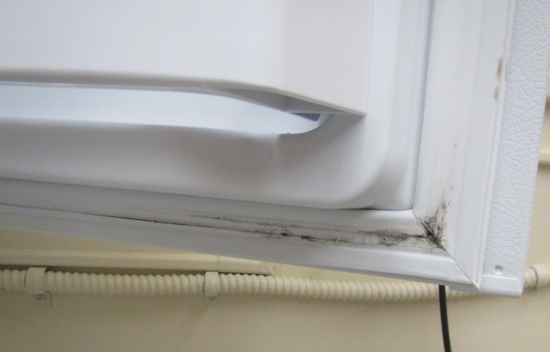
Mold growth on freezer gasket

Picture 24
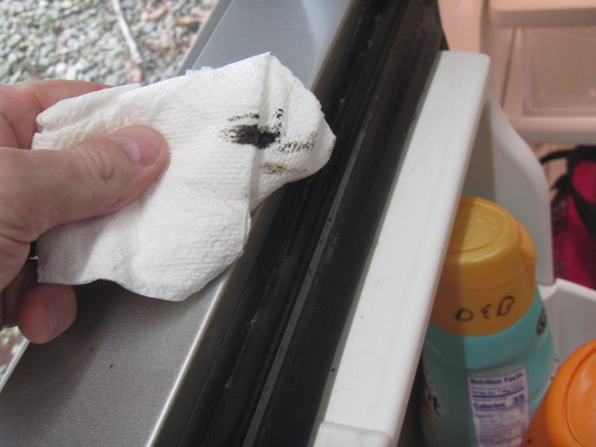
Mold growth on refrigerator gasket
Picture 25
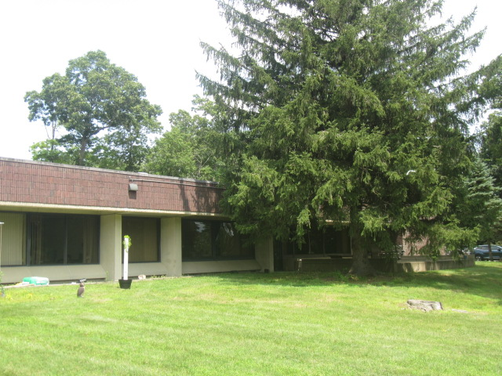
Trees in close proximity to building

Picture 26
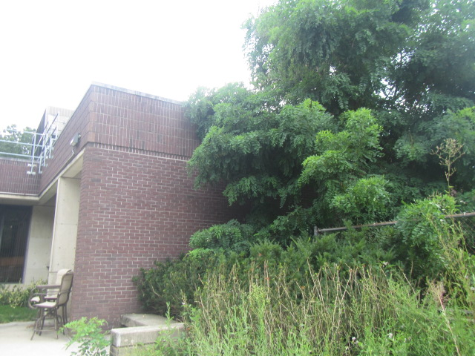
Trees, plants, and shrubbery in close proximity to building
Picture 27
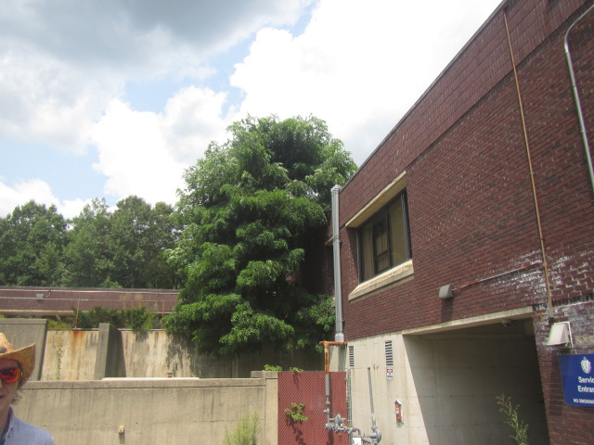
Trees in close proximity to building

Location | Air Temp  (ºF) | Relative Humidity  (%) | Comments
Background (outside) | 87 | 71 | Mostly cloudy, warm & humid
106 | 70 | 73 | Visible mold growth on door jamb
109 | 70 | 72 | Visible mold growth on door jamb, univent off
C116 | 66 | 78 | Condensation on vents, water-damaged ceiling tiles
122 | 71 | 69 | Visible mold growth on metal cabinet
123 | 72 | 70
1st Floor Hallway | 70 | 73 | Condensation on ceiling vents/HVAC unit dripping onto carpeting
126 | 70 | 74 | Buckled carpeting due to chronic moisture
128 | 68 | 73 | Visible mold growth on refrigerator gasket, visible mold growth on ceiling tile outside of room 128 (hallway)
Maintenance Shop | 73 | 76 | Visible mold growth on pipe insulation
2nd Floor Conference Room | 72 | 70 | 4 mini-splits
2nd Floor Conference Room 2 | 72 | 71 | Missing ceiling tiles (failing due to chronic moisture)
Copy Room | 72 | 70 | Dehumidifier/damp rid
211 | 75 | 74
212 | 74 | 73 | Univent off
239 | 70 | 69 | Visible mold growth on surface of univent
Team 3 | 73 | 67 | Carpet moist from spill, old worn carpeting
2nd Floor Conference Room 3 | 74 | 70 | Visible condensation on univent
Team 2 | 74 | 74 | Staff refrigerator visible mold on gaskets, univent off

Location | Carbon  Dioxide  (ppm) | Carbon Monoxide  (ppm) | Temp  (°F) | Relative  Humidity  (%) | PM2.5  (µg/m³) | Occupants  in Room | Windows  Openable | Ventilation |  |  | Remarks
 |  |  |  |  |  |  |  | Intake | Exhaust
Background | 415 | ND | 77 | 58 | 7 |  |  |  |  |  | Warm, sunny, scattered clouds
Lobby | 547 | ND | 73 | 64 | 2 | 2 | Y | Y |  | Y | 10 WD CT-dark stains possible mold on CT
Campus Police Reception | 589 | ND | 72 | 63 | 1 | 1 | N | N |  | N | Wall to wall carpet
110 | 711 | ND | 71 | 66 | 3 | 1 | N | Y, Off |  | Y | Wall to wall carpet, plants
111 | 475 | ND | 70 | 65 | 1 | 0 | N | Y |  | Y | Wall to wall carpet
112 | 562 | ND | 71 | 67 | 1 | 0 | N | Y |  | N | Wall to wall carpet
113 | 678 | ND | 70 | 65 | 1 | 1 | N | Y |  | N | Wall to wall carpet, AP
114 | 588 | ND | 70 | 67 | 1 | 0 | N | Y |  | N | Wall to wall carpet, PF, AP
115 | 854 | ND | 72 | 62 | 2 | 1 | N | Y |  | N | Suspended CTs, carpet squares
116 | 1004 | ND | 73 | 65 | 1 | 1 | N | Y |  | N | 2 WD CTs, carpet squares
C116 | 617 | ND | 69 | 65 | 1 | 0 | N | Y |  | N | 2 WD CTs
C117 | 621 | ND | 69 | 68 | 1 | 0 | N | Y |  | N | 2 WD CTs-dark staining likely mold growth, wall to wall carpet
122 | 544 | ND | 71 | 62 | 2 | 0 | N | Y |  | Y | Wall to wall carpet, MTs
124 | 713 | ND | 71 | 63 | 2 | 1 | N | Y |  | N | Wall to wall carpet
201 | 657 | ND | 71 | 63 | 1 | 1 | N | Y |  | N | MT-wires, carpet squares
202 | 466 | ND | 74 | 61 | 2 | 1 | N | Y |  | Y
203 | 639 | ND | 74 | 61 | 2 | 1 | N | Y, Weak |  | Y, Weak | 6 WD CTs, PF, laminate floor
204 | 771 | ND | 74 | 60 | 1 | 1 | N | Y |  | N | MT, laminate floor
205 | 756 | ND | 74 | 61 | 1 | 1 | N | Y |  | N | MTs, laminate floor
206 | 571 | ND | 73 | 62 | 1 | 0 | N | Y, Off |  | N | Laminate floor, MT
207 | 631 | ND | 73 | 62 | 1 | 0 | N | Y |  | N | MT, laminate floor
208A | 488 | ND | 72 | 63 | 2 | 1 | N | N |  | N | Window AC, wall to wall carpet
208 | 631 | ND | 72 | 63 | 2 | 0 | N | Y |  | N | Suspended CTs, laminate floor
Lennon Office | 662 | ND | 74 | 61 | 2 | 1 | N | Y |  | Y, Off | Wall to wall carpet, PF
All Gender Restroom |  |  |  |  |  |  | N | Y |  | Y, Off
210 | 465 | ND | 69 | 66 | 1 | 0 | N | Y |  | N | MT-due to WD and chronic condensation, wall to wall carpet, PF
211 | 483 | ND | 73 | 64 | 2 | 0 | N | Y, Off |  | N | Wall to wall carpet, PF
212 | 440 | ND | 71 | 66 | 1 | 0 | Y | Y, Off |  | N | Wall to wall carpet-old/worn, dark stained likely mold growth on insulation
213 | 451 | ND | 69 | 68 | 1 | 0 | N | Y, Off |  | N | Paper in UV, plants
214 | 555 | ND | 73 | 63 | 2 | 5 | N | Y |  | Y | UV deactivated due to excessive noise, occupants report chronic moisture against UVs
214 (inner office) | 583 | ND | 73 | 64 | 3 | 1 | N | Y |  | Y | Wall to wall carpet
215 | 473 | ND | 67 | 69 | 1 | 0 | N | Y |  | N | Dust/debris/mold growth on door jamb, wall to wall carpet, plant
216 | 471 | ND | 68 | 70 | 1 | 0 | N | Y |  | N | Dust/debris/mold growth on door jamb, paper inserted into UV
217 | 456 | ND | 69 | 65 | 1 | 0 | N | Y |  | N | Wall to wall carpet
218 | 460 | ND | 69 | 68 | 2 | 0 | N | Y |  | N | Wall to wall, dust/debris/mold growth on door jamb
219 Conference Room | 457 | ND | 69 | 68 | 2 | 0 | Y | Y |  | N | 4 minisplits, ceiling fan, wall to wall carpet
220 | 530 | ND | 73 | 64 | 0 | 1 | N | Y |  | N | Laminate flooring, failing window gasket
C222 | 456 | ND | 69 | 68 | 2 | 0 | N | Y |  | N | Wall to wall carpet, upholstered furniture
Hallway (223/234) |  |  |  |  |  |  |  |  |  |  | Stained/damaged insulation
225 | 466 | ND | 76 | 61 | 1 | 0 | Y | Y |  | N | Unoccupied under renovation
226 | 539 | ND | 74 | 58 | 1 | 0 | N | Y |  | Y | Wall to wall carpet
C226/Workstations | 618 | ND | 73 | 64 | 2 | 1 | N | N |  | N | Open work areas
227/228 | 540 | ND | 72 | 61 | 1 | 0 | N | Y |  | N | UV return blocked, wall to wall carpet
230 | 590 | ND | 72 | 64 | 1 | 0 | N | Y |  | N | Wall to wall carpet, AP, PF(2)
231 | 927 | ND | 72 | 64 | 1 | 0 | N | Y |  | N | Wall to wall carpet
232 | 444 | ND | 71 | 62 | 1 | 0 | Y | Y |  | N | Wall to wall carpet-old/worn, window in disrepair (tape)
233A | 691 | ND | 70 | 67 | 1 | 1 | N | Y |  | N
233B | 441 | ND | 69 | 67 | 2 | 0 | Y | Y |  | N
234 | 921 | ND | 76 | 66 | 1 | 1 | N | Y |  | N | Wall to wall carpet
236 | 482 | ND | 71 | 64 | 2 | 0 | N | Y, Off |  | N | PF-dusty
Open Work Area (outside 237) | 560 | ND | 71 | 65 | 1 | 1 | Y | N |  | N
238 | 459 | ND | 71 | 66 | 1 | 0 | N | Y, Off |  | N | AP
239 | 445 | ND | 73 | 64 | 3 | 1 | N | Y |  | Y | Wall to wall carpet
ACCS Team Leader | 584 | ND | 71 | 65 | 2 | 1 | Y | Y |  | N | Suspended ceiling, carpet squares
242 | 635 | ND | 71 | 64 | 1 | 0 | Y | N |  | Y | Carpet squares, MTs
Conference Room | 476 | ND | 73 | 63 | 3 | 0 | N | Y |  | N | Suspended ceiling tiles, wall to wall carpet
2nd floor Kitchen | 474 | ND | 74 | 61 | 3 | 0 | N | Y, Off |  | Y | Dust/debris on vents
Noah Office | 517 | ND | 72 | 64 | 2 | 0 | N | Y |  | N | PF, wall to wall carpet
Records Room | 533 | ND | 74 | 62 | 1 | 2 | N | Y |  | Y

The service life is the median time during which a particular system or component of … [an HVAC]… system remains in its original service application and then is replaced. Replacement may occur for any reason, including, but not limited to, failure, general obsolescence, reduced reliability, excessive maintenance cost, and changed system requirements due to such influences as building characteristics or energy prices (ASHRAE, 1991).

