INDOOR AIR QUALITY ASSESSMENT

**Department of Mental Health**

**Central Massachusetts Area, South County Site Office**

**40 Institute Road**

**Oaks B Building**

**North Grafton**

**November 2024**

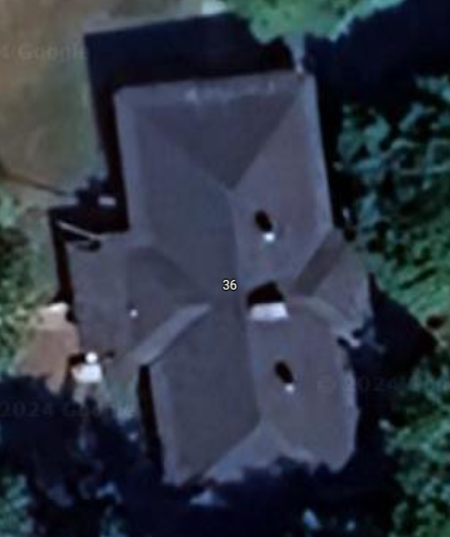

**40**

Prepared by:

Massachusetts Department of Public Health

Bureau of Climate and Environmental Health

Division of Environmental Health Regulations and Standards

Contents

EXECUTIVE SUMMARY 2

BACKGROUND 4

RESULTS AND DISCUSSION 4

Ventilation 5

Water Damage and Moisture Concerns 6

Sources of Respiratory Irritants/Possible Asthma Triggers 8

CONCLUSIONS AND RECOMMENDATIONS 10

REFERENCES 14

PICTURES 15

Ventilation pictures 15

Water Damage pictures 19

Respiratory Irritant pictures 22

Table 1 24

Table 2A 27

Table 2B 28

Table 2C 29

Table 3 30

Table 4 32

# EXECUTIVE SUMMARY

The Massachusetts Department of Public Health’s Division of Environmental Health Regulations and Standards conducted an indoor air quality (IAQ) assessment of the Department of Mental Health (DMH), Central Massachusetts Area, South County Site Office (SCSO), located at 40 Institute Road, Oaks B Building, North Grafton, MA on November 7, 2024. This assessment was requested through Sharon Moody, Assistant Director, Office of Engineering and Facilities Management for DMH.

Any building can have IAQ issues. These issues can be made worse through conditions common to marginalized communities (Environmental Justice communities or EJ) such as inequitable exposure to outdoor air pollution and a greater likelihood of poor building conditions leading to the deterioration of IAQ resulting in higher asthma rates. While the SCSO is not in an EJ community, the populations served by this office are in numerous towns which have EJ populations.

The assessment was conducted by evaluating several key elements within the building; a visual inspection of the heating, cooling, and ventilating (HVAC) systems, water/microbial damage, cleanliness, point sources of respiratory irritants such as chemicals, and electronic measurement of carbon dioxide (CO2), carbon monoxide (CO), temperature, relative humidity (RH), and small particulate matter (PM2.5) all taken with a Qtrak XP monitor. Data is collected in this manner to identify potential asthma triggers, allergens, and other environmental factors that can cause indoor air quality symptoms. Please refer to the [Indoor Air Quality Manual](https://www.mass.gov/lists/indoor-air-quality-manual-and-appendices#indoor-air-quality-manual-) on the MDPH website for methods, sampling procedures, and interpretation of results.

As a result of this walkthrough, there are several findings: conditions in this building are common to buildings of this age and type. Retrofitting of an HVAC system into a building of this age may not be as efficient and may lead to temperature and other comfort complaints, roof leaks have occurred leading to water-damaged ceiling tiles, and reports and evidence of rodents have occurred in this building, which may degrade IAQ. (Results and Discussion)

Based on the results of the assessment, the following primary recommendations are made:

* Operate supply and exhaust ventilation *continuously* when the building is occupied. Use the fan-on setting during occupied hours and ensure thermostats are set to the correct time.
* Use the principles of Integrated Pest Management (IPM) to reduce access, attraction, and harborage of rodents.
* Clean any rodent wastes thoroughly to reduce associated symptoms.
* Reduce the use of scented products such as reed diffusers.

(Conclusions and Recommendations)

Please note: this report contains a series of recommendations that should serve as Best Practices that apply to most public buildings across the Commonwealth and should be shared amongst other buildings for DMH.

# BACKGROUND

|  |  |
| --- | --- |
| Building: | Department of Mental Health (DMH) Central Massachusetts Area, South County Site Office (SCSO) |
| Address: | 40 Institution Road  Oak B Building  North Grafton |
| Coordinated Via: | Sharon Moody, Assistant Director, Office of Engineering and Facilities Management for DMH. |
| Reason for Request: | Concerns about water damage and pests as well as general IAQ |
| Date of Assessment: | November 7, 2024 |
| Massachusetts Department of Public Health/Bureau of Climate and Environmental Health (MDPH/BCEH) Staff Conducting Assessment: | Ruth Alfasso, Environmental Inspector, Division of Environmental Health Regulations and Standards |
| Building Description: | The SCSO is a small wooden building with a fieldstone foundation and a slate roof. It contains two floors of offices including break rooms, cubicle areas, and conference rooms. It was likely built in the 1800s. |
| Windows: | Most windows in the building are openable. |

# RESULTS AND DISCUSSION

The following is a summary of indoor air testing results (Table 1)

|  |  |  |
| --- | --- | --- |
| * ***Carbon dioxide (CO2)*** | *a measure of the adequacy of ventilation* | Levels were below the MDPH guideline of 800 parts per million (ppm) in the areas surveyed. |
| * ***Temperature*** | *a measure of comfort* | Was within the MDPH recommended range of 70°F to 78°F in all occupied areas. |
| * ***Relative humidity*** | *a measure of comfort and, when in excess for an extended period, a way to reflect the potential for mold and fungal growth* | Was within the MDPH recommended range of 40 to 60% in all areas tested. This is reflective of outdoor conditions. Relative humidity would be expected to be lower with cold outdoor temperatures and indoor heating, and higher during hot, humid weather. |
| * ***Carbon monoxide (CO)*** | *a product of combustion that can result in acute and long term cardiovascular, respiratory, and neurological symptoms* | No carbon monoxide was detected during the assessment. |
| * ***Particulate matter (PM2.5)*** | *a way to measure inhalable particle distribution in the air* | Concentrations were below the National Ambient Air Quality Standard (NAAQS) of 35 micrograms per cubic meter (μg/m3) in all areas tested. |

## Ventilation

Ventilation refers to both the supply of fresh air and the removal of stale air from a room. The introduction of fresh air into an occupied space will dilute normally occurring pollutants that are generated by occupancy and other activities. In addition, a heating, ventilating, and air-conditioning (HVAC) system will remove pollutants from a building if operating appropriately. All ventilation systems throughout the building should operate continuously during periods of occupancy.

The SCSO was originally built without mechanical ventilation. At some point, a fresh air supply and return system was installed. There are two air handling units (AHUs) located outside (Picture 1), each serving both floors on one side of the building. Fresh air is supplied to vents in the ceiling (Picture 2) and returned through other ceiling-mounted vents (Picture 3). A large duct transfers air between the top and bottom floor (Picture 4).

Many individual offices had no supply or return vents (Table 1). For mechanical fresh air exchange, doors would need to be open at least part of the time. Openable windows are available in most offices, which can be used for fresh air when the weather outside is temperate. If windows are opened, they should be tightly closed at the end of each day.

A thermostat was examined and found to be set to the fan-auto setting, which would only call for fresh air when the temperature needs adjusting (Picture 5). The Division of Environmental Health Regulations and Standards recommends that thermostats be set to have the fan on for continuous ventilation during occupied periods. This thermostat also appeared to be set to the wrong time, which will prevent appropriate unoccupied-period setbacks from working.

Restrooms are present on both floors of the building. The restrooms on the lower floor had what appeared to be direct-vented restroom-style exhaust vents which were operating during the assessment. The women’s restroom on the upper floor had supply and return vents, but it could not be determined if they were operating, and the style of vent suggests the restroom may be connected to the general return system. The upstairs men’s room has no visible vents at all and is rarely used. This room does have an operable window.

Radiators and electric ceiling-mounted heaters are present (Picture 6), but it is not known if these items are currently functional or used. Several occupants had personal heaters in offices (Table 1). One window-mounted air conditioner (WAC) was noted in an office (Picture 7). WACs have filters that need to be cleaned periodically and should be well sealed with water-resistant material to prevent unconditioned air and pest ingress.

(Table 2B).

The various types of ventilation components as well as devices that can move/redirect airflow are listed in Table 2A, Table 2B and Table 2C.

### HVAC System Maintenance

**Balancing**

To have proper ventilation with a mechanical supply and exhaust system, a system must be balanced to provide an adequate amount of fresh air to the interior of a room while also removing stale air from the room. It is recommended that HVAC systems be re-balanced every five years to ensure adequate air systems function (SMACNA, 1994).

HVAC Types and Specific Conditions

(see Ventilation pictures)

* **Facility staff report that the AHUS are equipped with filters with a minimum efficiency reporting value (MERV) of 8 and are changed 2 times a year.** The MDPH recommends that filters be changed 2-4 times a year (or in accordance with the manufactures recommendations) and be of at least MERV 8, or higher if the equipment can handle them, without a degradation in airflow, as these are adequate to filter out pollen, mold, and similar particulates (ASHRAE, 2012).
* **It is unknown if the HVAC system has been balanced recently.**
* **The large transfer ducts seen on the second floor were at one time equipped with a steam humidification system (Picture 8).** These systems are believed to be long discontinued. Humidification systems can be difficult to control and may lead to mold growth and odors if they increase the humidity too much. If possible, the remains of this system should be disconnected and removed.

## Water Damage and Moisture Concerns

Please note that the MDPH does not recommend conducting mold testing in a typical water damage remediation. For details, please consult [Guidance Regarding Testing for Mold in Water-Damaged Public Buildings](https://www.mass.gov/info-details/guidance-regarding-testing-for-mold-in-water-damaged-public-buildings) | Mass.gov

The application of a mildewcide to moldy porous materials is not recommended.

Molds are found naturally in our environment both indoors and outdoors. Inside, mold growth may occur when items, particularly porous products such as paper or gypsum wallboard, are exposed to moisture. Typical water sources include leaks, floods, and condensation. To prevent mold growth, dry all water-damaged items and affected areas within 24-48 hours and reduce indoor humidity. Some people with chronic respiratory conditions, such as asthma, are more likely to experience health symptoms associated with molds, including allergic reactions and respiratory irritation. Controlling moisture is the key to preventing mold growth and potential health symptoms.

Hot humid summers are becoming more frequent due to climate change. Massachusetts has experienced hot, humid, and rainy summers in 2018, 2021, and 2023. July of 2021 was the wettest ever recorded in Massachusetts, and the three-month period from June through August, known as the meteorological summer, was the fourth wettest on record, according to the National Oceanic and Atmospheric Administration’s (NOAA) Centers for Environmental Information (NOAA, 2021). The summer of 2023 was also hot, and wet, being measured as the second rainiest on record (WBUR, 2023). And the summer of 2024 had periods of wet weather as well as excess heat (NRCC, 2024). These conditions are challenging for buildings, particularly those without air conditioning.

During these hot and wet summers, extended periods of outdoor relative humidity above 70% occurred and public buildings experienced extended periods of water vapor exposure from high relative humidity. When exposed to these conditions, porous materials such as gypsum wallboard, cardboard, and other materials may become prone to developing mold colonization, particularly if located in areas that are prone to developing condensation on floors and walls (e.g., below grade space). In addition, high relative humidity will cause paper to absorb moisture, which in turn cause paper jams in photocopiers and computer printers (Fisher, N., 2024).

* **Water damage has occurred in several areas of the SCSO, mostly due to leaks from the roof.** Water-damaged ceiling tiles were found in several locations (Picture 9; Table 1) mostly on the upper floor. Note that the roof of the building was repaired in the weeks prior to the site visit, which should reduce the chance of leaks. No water-damaged ceiling tiles had dark or fuzzy staining indicating mold growth.
* The ceiling plenum was examined in a few areas on the upper floor**. There is significant air space above the ceiling tile grid, and fiberglass insulation appeared to be in decent condition**. There were no signs of mold or moldy odors in the ceiling plenum. However, one location appeared to have signs of rodents (droppings) (Picture 10). This is discussed further in the Respiratory Irritants section below.
* **Refrigerators were located in carpeted areas (Picture 11; Table 1).** These appliances can spill or leak and moisten carpet. Water dispensers were also located over carpet. Carpet that is repeatedly or chronically moistened can become mold colonized.
* **Several conditions outside the building were noted that can contribute to water infiltration and IAQ issues.**
  + Damage was noted to interior and exterior windowsills and door frames (Pictures 12 and 13). Extensive damage to these areas can lead to gaps which can allow unconditioned air and pests inside. Without an intact coating of paint, deterioration is likely to accelerate. In addition, paint may contain lead, which is a regulated material.
  + Trees were noted in close proximity to, overhanging, and touching the building (Picture 13 and 14), which is important for IAQ for several reasons:
    - Leaves and other debris accumulate around roof drains, which inhibits rainwater drainage from the roof. Ineffective drains can lead to water running off the roof to moisten exterior walls.
    - Trees prevent sunlight from drying building walls and soil.
    - The trees are a possible danger to the SCSO due to the distance from exterior walls. Severe weather may result in the tree falling onto the LPL or the tree roots damaging the foundation. Due to the height of the trees, each is likely located closer than recommended distances. The Federal Emergency Management Agency (FEMA) provides several recommendations in order to prepare for severe thunderstorms. Of note FEMA recommends “Cut down or trim trees that may be in danger of falling on your [building]” (FEMA, 2018). Given the proximity to the SCSO exterior walls, removal of trees should be strongly considered.
    - Tree limbs touching the building are potential transportation for pests.
* **Indoor plants were noted in some areas (Picture 15).** Plants can be a source of pollen or mold, especially if overwatered or not well maintained. Plants should also not be placed in the airstream of ventilation equipment to prevent the aerosolization of pollen and mold. Plants should also not be overwatered to prevent mold growth and should be placed on waterproof drip pans.
* **On the lower level, ceiling tiles were noted to be bowing/sagging in the ceiling tile grid.** This is a sign that either the ceiling plenum is over-pressured, or a sign that the ceiling tiles have been exposed to high relative humidity for a long period of time. While bowing tiles are not a direct IAQ issue, it is a reminder that long periods of high relative humidity may lead to water damage to other materials, particularly those stored in contact with cooler temperatures such as on uninsulated floors, and in the airstream of air conditioning.

A list of water damage issues identified inside and outside the building is included as Table 3.

(see Water Damage Pictures)

**Mold Growth**

Porous materials (e.g., gypsum wallboard, ceiling tiles and carpeting) can be dried with fans and heating within 24 to 48 hours of becoming wet (US EPA, 2008).

If porous materials are not dried within this time frame, mold growth may occur.

## Sources of Respiratory Irritants/Possible Asthma Triggers

Asthma is a lung disease that can make breathing difficult. Without careful management of asthma, some people can have symptoms, like a tight feeling in the chest, shortness of breath, coughing, or wheezing. Although there is no cure for asthma, people with asthma can live healthy, active lives. A safe and healthy environment helps to reduce asthma symptoms.

* **Personal products, particularly those with volatile organic compounds (VOCs) including scents, can also be a source of respiratory irritation.** VOCs are carbon-containing substances that can evaporate at room temperature. Exposure to low levels of total VOCs (TVOCs) may produce eye, nose, throat and/or respiratory irritation in some sensitive individuals. Products noted were cleaners, sanitizers, dry erase materials, and scented products including reed diffusers and essential oil misters (Picture 16; Table 1).
* **Dust, a common respiratory and eye irritant, can collect on surfaces and items.** Although janitorial and maintenance staff perform routine cleaning, they may not be able to clean as effectively if items are not picked up or surfaces are cluttered.
* Even with a properly functioning ventilation system, it is necessary to reduce the use of materials that can be a source of respiratory irritants to prevent symptoms in individuals who have sensitivity to such pollutants.

Possible asthma triggers and/or airborne pollutants exist in the building. These are listed below as well as in (Table 4).

(see Sources of Respiratory Irritant Pictures)

* As mentioned in the Water Damage and Moisture Concerns section above, probable mouse droppings were observed above a ceiling tile on the upper level. Occupants also reported pest sightings in the past. Note that rodent infestation, because of materials present in wastes, can produce indoor air quality-related symptoms. Mouse urine contains a protein that is a known sensitizer (US EPA, 1992). A sensitizer is a material that can produce symptoms in exposed individuals (e.g. running nose or skin rashes) after repeated exposures. To reduce issues related to rodents, the animals first need to be excluded from and removed from a building. Then thorough cleaning needs to be performed to remove wastes and dander. Facility staff reported that there is a pest control contractor and that rodent sightings have been reduced. Unfortunately, given the age and design of the building, and the location near woodlands, removing and excluding rodents will be an ongoing process. Occupants can assist by:
* Keeping all food and food waste in tightly-closed mouse-proof containers,
* Cleaning crumbs and removing trash daily,
* Ensuring doors are closed tightly and open windows are equipped with intact screens, and
* Reporting pest sightings or new gaps in the building envelope to facility management.
* **Food and food preparation equipment were noted in several areas, including sinks (Table 1).** Food preparation equipment should be kept clean to avoid smoke and odors, particularly in areas without exhaust ventilation.
* **Most rooms on the upper floor of the SCSO are carpeted** (Table 1). Carpeting appeared to be carpet squares in good condition. Carpets should be vacuumed regularly with a high efficiency particulate arrestance (HEPA) filter equipped vacuum cleaner and cleaned annually (or semi-annually in soiled/high traffic areas) in accordance with Institute of Inspection, Cleaning and Restoration Certification (IICRC) recommendations (IICRC, 2012).
* On the lower level, **several fluorescent tubes were noted stored in a precarious manner (Picture 17)**. Fluorescent bulbs contain mercury which can be released if they are broken. New and spent tubes should be stored in a sturdy box and spent tubes should be sent for proper disposal regularly.

# 

# CONCLUSIONS AND RECOMMENDATIONS

Please note: this report contains a series of recommendations that should serve as *Best Practices* that apply to many public buildings across the Commonwealth and should be shared amongst similar buildings operated by DMH.

**Short-term recommendations** can be implemented as soon as practicable, however **long-term measures** are more complex and will require planning and resources to adequately address overall indoor air quality issues within the building.

|  |  |  |
| --- | --- | --- |
| **Short-term Recommendations** | | |
| **HVAC System** | | **Helpful Links** |
|  | Ensure the HVAC system is balanced every 5 years. Research the age of the HVAC system. |  |
|  | Ensure windows are closed tightly at the end of the day. |  |
|  | Air handling units should have filters changed at least twice a year using the best Minimum Efficiency Rating Value (MERV) that can work with current equipment. | [ANSI/ASHRAE Standard 52.2-2017](https://www.ashrae.org/File%20Library/Technical%20Resources/COVID-19/52_2_2017_COVID-19_20200401.pdf) |
|  | During filter changes, clean dust and debris from the inside of HVAC system cabinets. |  |
|  | Set thermostats to “fan-on” during occupied periods and ensure that system times are set correctly so that any setbacks occur at the correct times. |  |
|  | Check the function of all restroom exhausts. If the second-floor women’s restroom vents return to the general ventilation system, consider adding a direct-vented exhaust there as well as in the second-floor men’s room. |  |
|  | If radiators and ceiling-mounted heaters are functional and used, ensure they are cleaned periodically to remove dust that can lead to odors during the heating season. |  |
|  | Consider having the unused steam humidification systems removed. |  |
| **Water Damage Sources** | | |
|  | Replace water-damaged ceiling tiles now that the roof has been repaired. Monitor locations where leaks have occurred in the past to see if they reoccur | <http://www.epa.gov/mold/mold-remediation-schools-and-commercial-buildings-guide> |
|  | Consider removing carpeting in areas with refrigerators, water dispensers, or other food-preparation equipment, or use waterproof matting around them to prevent carpet damage due to leaks, spills, and crumbs. |  |
|  | Repair significantly damaged windowsills and doorframes to maintain building envelope tightness. |  |
|  | Trim trees that overhang the roof and contact the building, and remove plants close to the foundation. |  |
|  | Consult with a professional arborist regarding the condition of trees near the building and prioritize removal of any that are a danger to the building or occupants. |  |
|  | Properly maintain indoor plants to avoid mold and odors. Keep plants away from airflow. |  |
|  | Use these guidelines to control for moisture and increase comfort in buildings especially during heatwaves. | * Mold Growth Prevention During Hot, Humid Weather <https://www.mass.gov/service-details/preventing-mold-growth-in-massachusetts-schools-during-hot-humid-weather> * Remediation and Prevention of Mold Growth and Water Damage in Public Schools <https://www.mass.gov/service-details/remediation-and-prevention-of-mold-growth-and-water-damage-in-public-schools-and> * Methods for Increasing Comfort in Non-air-conditioned Schools <https://www.mass.gov/doc/methods-for-increasing-comfort-in-non-air-conditioned-schools/download> |
| **Respiratory Irritants/Possible Asthma Triggers** | | |
| 1. 22. | Clean dust from surfaces, frequently using methods that do not aerosolize the dust, including HEPA-equipped vacuuming or wet wiping. Avoid using feather dusters or sweeping dust into the air. |  |
| 1. 23. | Reduce use of products and equipment that create irritating volatile organic compounds (VOCs) and only use in well-ventilated areas. Minimize the use of air fresheners (e.g., plug-ins), deodorizers and scented products. | <https://www.mass.gov/cleaner-greener-healthier-schools>  [Clean Air Is Odor Free](https://www.mass.gov/doc/clean-air-is-odor-free-removing-fragrances-to-improve-indoor-air-quality-in-schools-and-offices-0/download) |
|  | Use the principles of Integrated Pest Management (IPM) to exclude, discourage, and remove rodents in consultation with a certified pest control contractor. Include staff in efforts to control for food, access, and harborage. | <https://massnrc.org/ipm/docs/ipmkitforbuildingmanagers.pdf> |
|  | Thoroughly clean any areas where rodents have been noted, including above ceiling tiles, using methods that minimize distribution of dusts such as the use of a HEPA-filtered vacuum cleaner, and wet wiping. Perform significant activities such as work above ceiling tiles, during unoccupied periods, and take steps to control dust such as covering furniture with tarps. For areas with significant contamination with rodent wastes, cleaners should have personal protective equipment and training. |  |
|  | Store items in storerooms and file areas neatly and off the floor to reduce dust accumulation and prevent potential moistening by condensation or leaks. |  |
|  | Clean carpeting regularly using a HEPA-equipped vacuum cleaner, and deep clean periodically as recommended by the manufacturer. |  |
|  | Properly store and dispose of fluorescent bulbs to reduce the chance of breakage and exposure to mercury. |  |
| **Long-term Recommendations** | | |
|  | Consider repainting the exterior of the building to remove all flaking paint. |  |
|  | Consider removing trees that extend withing 5 feet of the building either at the crown or roots. |  |

# REFERENCES

ASHRAE. 2012. American Society of Heating, Refrigeration and Air Conditioning Engineers (ASHRAE) Standard 52.2-2012 – Method of Testing General Ventilation Air-Cleaning Devices for Removal Efficiency by Particle Size (ANSI Approved).

FEMA. 2018. How to Stay Safe When a Thunderstorm Threatens. Federal Emergency Management Agency, Washington, DC. FEMA V-1009/May 2018. <https://www.ready.gov/sites/default/files/2020-03/thunderstorm-information-sheet.pdf>

Fisher, N. 2024. How Humidity Affects Your Copier And Paper Quality. Cobb Technologies, Richmond, VA. <https://www.cobbtechnologies.com/blog/how-humidity-affects-your-copier-and-paper-quality>.

IICRC. 2002. Institute of Inspection, Cleaning and Restoration Certification. A Life-Cycle Cost Analysis for Floor Coverings in School Facilities.

NOAA. 2021. Summer 2021 neck and neck with Dust Bowl summer for hottest on record. National Oceanic and Atmospheric Administration, 1401 Constitution Avenue NW, Room 5128, Washington, DC 20230 <https://www.noaa.gov/news/summer-2021-neck-and-neck-with-dust-bowl-summer-for-hottest-on-record>

NRCC. 2024. Summer 2024 - Mostly Hot with Precipitation Extremes. Northeast Regional Climate Center. Cornell University, Ithaca, NY. <https://www.nrcc.cornell.edu/services/blog/2024/09/01/index.html>

SMACNA. 1994. HVAC Systems Commissioning Manual. 1st ed. Sheet Metal and Air Conditioning Contractors’ National Association, Inc., Chantilly, VA.

US EPA. 1992. Indoor Biological Pollutants. US Environmental Protection Agency, Environmental Criteria and Assessment Office, Office of Health and Environmental Assessment, research Triangle Park, NC. EPA 600/8-91/202. January 1992.

US EPA. 2008. Mold Remediation in Schools and Commercial Buildings. US Environmental Protection Agency, Office of Air and Radiation, Indoor Environments Division, Washington, D.C. EPA 402-K-01-001. <http://www.epa.gov/mold/mold-remediation-schools-and-commercial-buildings-guide>.

WBUR. 2023. “It’s been a summer of rain and flooding misery in Mass.” WBUR local news. September 12, 2023. <https://www.wbur.org/news/2023/09/12/summer-flooding-rain-massachusetts>

(Click to link back to report)

# PICTURES

## Ventilation pictures

**Picture 1**

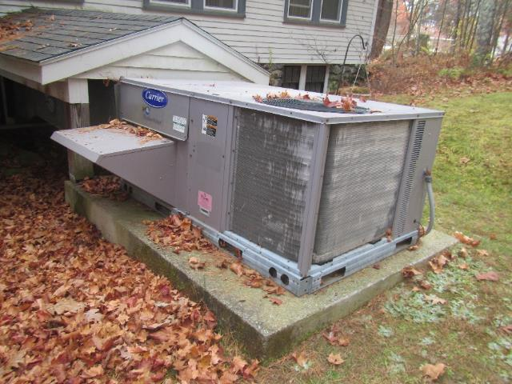

**Air handling unit on the building exterior**

**Picture 2**

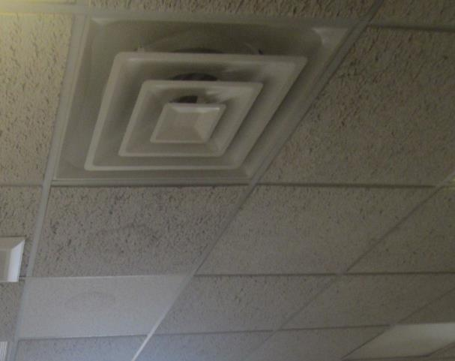

**Typical supply vent, note water-damaged ceiling tiles**

**Picture 3**

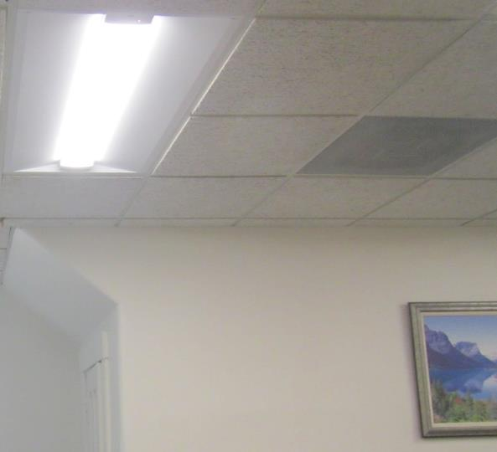

**Return vent in ceiling**

**Picture 4**

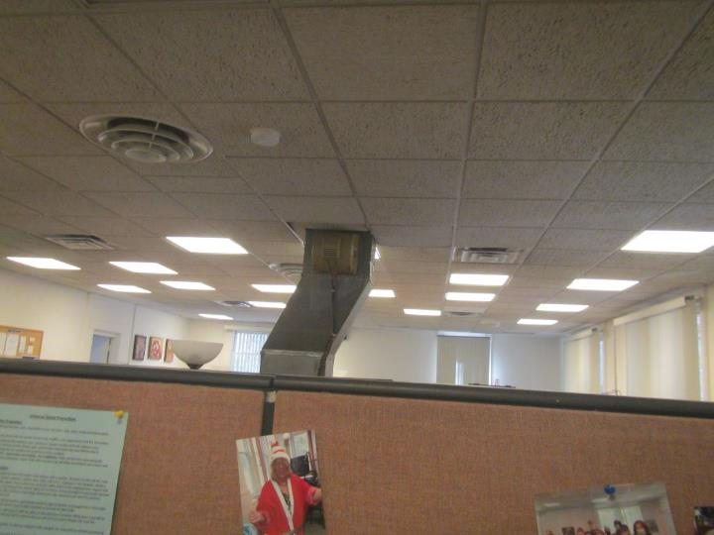

**Duct between ceiling of upper and lower floors**

**Picture 5**

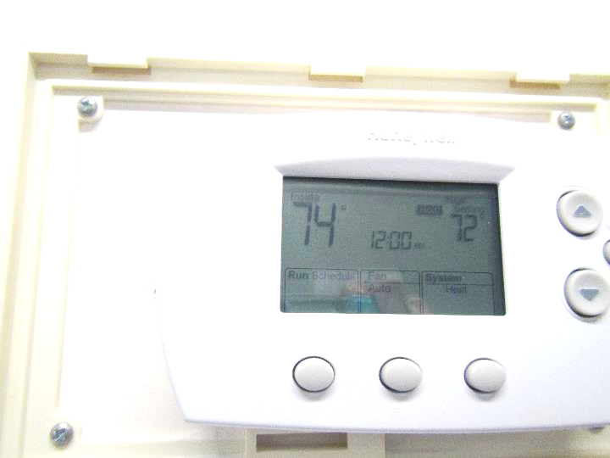

**Thermostat showing fan-auto setting and incorrect time**

**Picture 6**

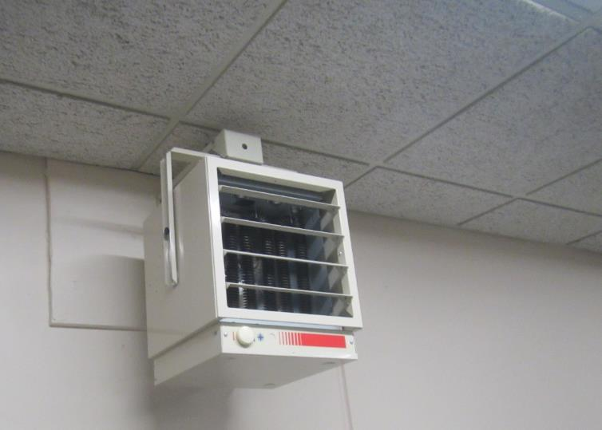

**Electric ceiling-mounted heater**

**Picture 7**

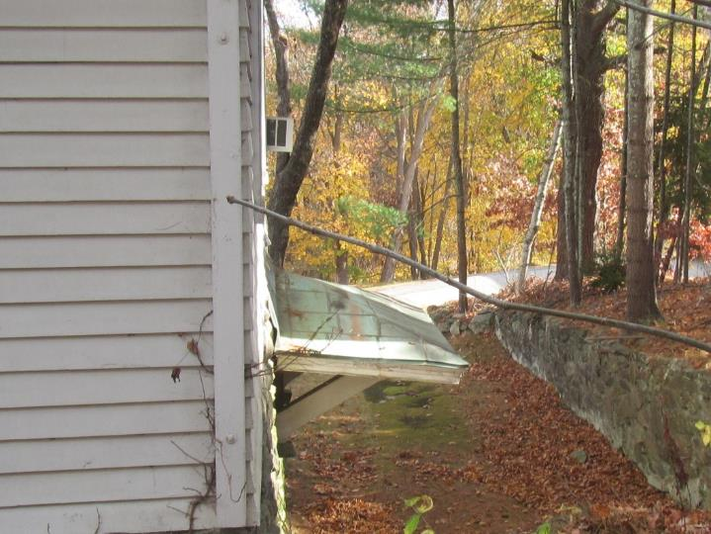

**Window-mounted air conditioner on side of building**

**Picture 8**

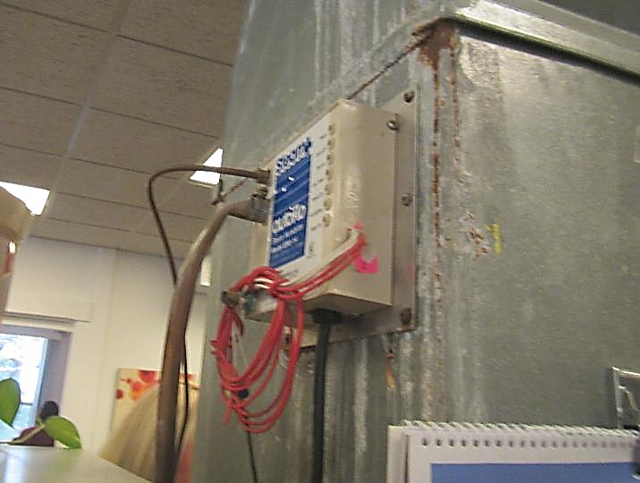

**Decommissioned steam humidification system on side of duct**

## Water Damage pictures

**Picture 9**

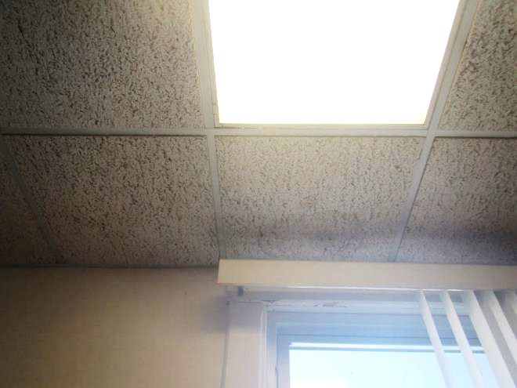

**Water stain on ceiling tile**

**Picture 10**

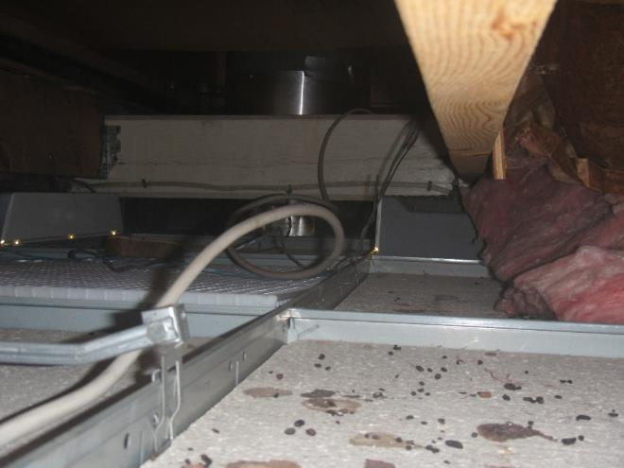

**Probable rodent droppings on ceiling tile in the ceiling plenum**

**Picture 11**

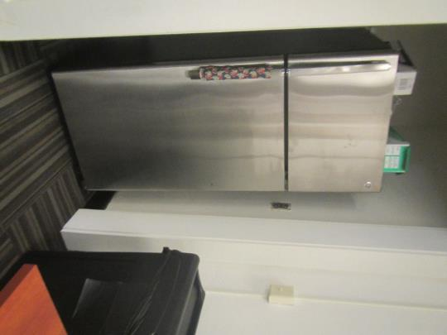

**Refrigerator on carpet**

**Picture 12**

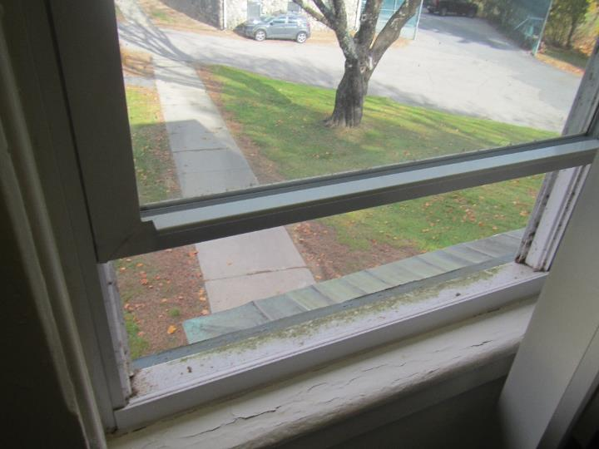

**Flaking paint on interior windowsill**

**Picture 13**

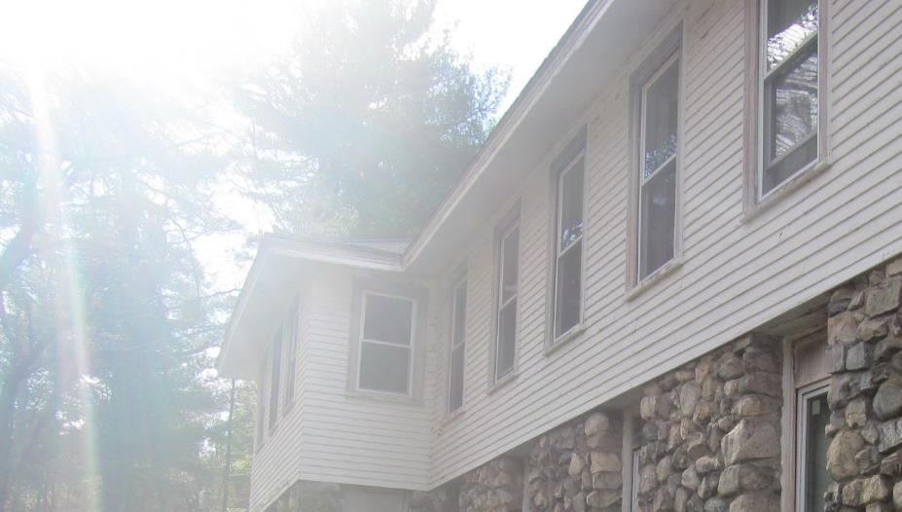

**Flaking paint on exterior windowsills, also note trees directly adjacent to building**

**Picture 14**

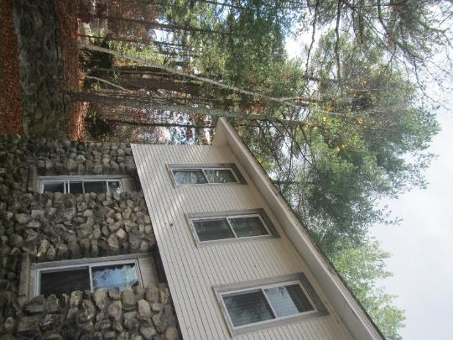

**Trees near and overhanging building**

**Picture 15**

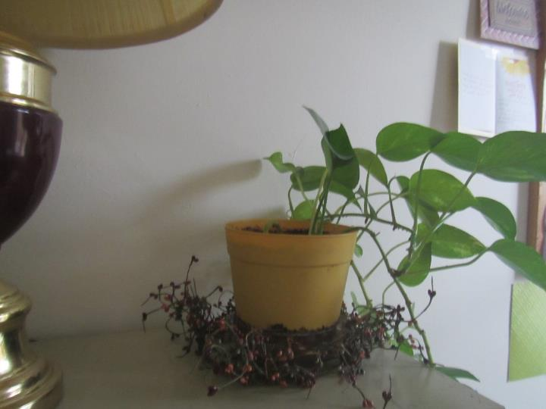

**Plant in an office**

## Respiratory Irritant pictures

**Picture 16**

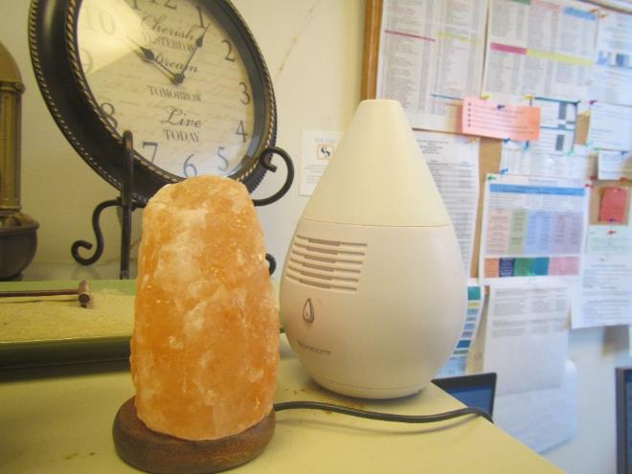

**Essential oil mist diffuser**

**Picture 17**

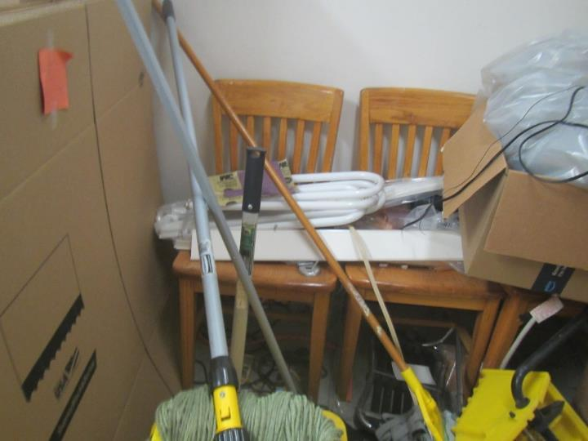

**Poorly stored fluorescent bulbs and other clutter in a storage area**

Click to link back to report

# Table 1

| Location | **Carbon**  **Dioxide**  **(ppm)** | **Carbon Monoxide**  **(ppm)** | **Temp**  **(°F)** | **Relative**  **Humidity**  **(%)** | **PM2.5**  **(µg/m3)** | **Occupants**  **in Room** | **Windows**  **Openable** | **Ventilation** | | **Remarks** |
| --- | --- | --- | --- | --- | --- | --- | --- | --- | --- | --- |
| **Supply** | **Exhaust** |
| Background (outside) | 388 | ND | 68 | 58 | 6 |  |  |  |  | Sunny, windy |
| 2nd floor | | | | | | | | | | |
| Bombadier office | 551 | ND | 74 | 53 | 1 | 1 | Y | N | N | Heater, radiator |
| Grzych | 581 | ND | 75 | 52 | 1 | 1 | Y | N | N | Plants, food |
| Wydra | 521 | ND | 75 |  | 2 | 0 | Y | N | N | HS, heater |
| Francis | 489 | ND | 75 | 51 | 1 | 1 | Y | N | N | Plant, reed diffuser |
| Goodell | 539 | ND | 75 | 52 | 2 | 0 | Y | N | N | Reed diffuser |
| Ryan | 541 | ND | 75 | 51 | 2 | 1 | Y | N | N | HS |
| Burke cube | 532 | ND | 74 | 52 | 3 | 0 | N | Y | Y | Plants, heater |
| Albus cube | 535 | ND | 74 | 51 | 2 | 0 | N | Y | Y | PF |
| Ladies’ restroom | 472 | ND | 74 | 52 | 2 | 0 | Y | Y | Y | Exhaust off |
| Men’s restroom | 449 | ND | 75 | 51 | 1 | 0 | Y | N | N | No vents |
| Welch office | 486 | ND | 75 | 49 | 3 | 0 | Y | N | N | Plant |
| Conference/office | 413 | ND | 75 | 49 | 2 | 0 | Y | N | Y | DEM |
| Hernandez cube | 405 | ND | 75 | 50 | 2 | 0 | Y open | Y | Y | Fridge on floor |
| Master | 410 | ND | 75 | 49 | 3 | 1 | Y open | Y | Y | PF dust |
| Hotelling cube | 420 | ND | 75 | 50 | 3 | 0 | Y | Y | Y | HS |
| Klein cube | 453 | ND | 75 | 50 | 2 | 1 | N | Y | Y | HS/CP |
| First floor | | | | | | | | | | |
| Storage | 493 | ND | 72 | 56 | 2 | 0 | N | N | N | Items, some stored in piles, Fluorescent light bulbs poorly stored |
| Office | 477 | ND | 73 | 54 | 1 | 1 | Y | N | N |  |
| Wrap area | 443 | ND | 73 | 54 | 1 | 0 | N | N | N | Area rugs |
| Men’s restroom |  |  |  |  |  |  | N | N | Y | Exhaust on switch |
| Women’s restroom |  |  |  |  |  |  | N | N | Y | Exhaust on switch, reed diffusers |
| Server room |  |  |  |  |  |  | N | N | Y | Fluorescent bulbs stored improperly |
| Kitchen | 450 | ND | 74 | 53 | 1 | 0 | Y | N | Y | Sink, fridge, microwave |
| Files | 455 | ND | 75 | 51 | 1 | 0 | N | N |  | NC, dust and debris on floor |
| Reception/interview | 466 | ND | 74 | 52 | ND | 0 | N | N | Y | WD CT |
| Conference | 450 | ND | 74 | 51 | 1 | 0 | Y | Y | Y | NC |

(Click to link back to report)

# Table 2A

|  |  |  |  |  |  |
| --- | --- | --- | --- | --- | --- |
| **Equipment Present in Building**  **(X = Yes)** | **Type of Heating/Cooling Ventilation**  **Equipment** | **Fresh**  **Air**  **Supply**  **(X = Yes)** | **Type of Location(s)** | **Air Filters Installed**  **MERV Rating**  **(1-15, U*)**  **(X = Yes)** | **Comments** |
|  | Univents |  |  |  |  |
|  | Roof top Air Handling Units |  |  |  |  |
| X | Outdoor, Ground-Installed Air Handling Units | X | Ground level outside | 8 | Reportedly changed 2x/year |
|  | Attic/Crawlspace Air Handling Units |  |  |  |  |
|  | Ceiling-Mounted Air Handling Units (including inside plenum) |  |  |  |  |
|  | Basement/Crawlspace-Installed Air Handling Units |  |  |  |  |
|  | Mechanical Room-installed Air Handling Units |  |  |  |  |
|  | Fan Coil Units |  |  |  |  |
| X | Window-Mounted Air Conditioners |  | One office |  |  |
|  | Wall Louver-Controlled Gravity Air Supply |  |  |  |  |
| X | Windows |  | Most rooms |  |  |
|  | Fan in window (blowing in) |  |  |  |  |
|  | Built in wall fan (switched) |  |  |  |  |
|  | Heat recovery ventilator unit |  |  |  |  |
|  | Energy recovery ventilator unit |  |  |  |  |
|  | Chilled Beam |  |  |  |  |
|  | Passive combustion supply vent in basement/boiler room |  |  |  |  |

*U = Filter Rating underdetermined due to inaccessibility during building visit

(Click to link back to report)

# Table 2B

|  |  |  |  |  |
| --- | --- | --- | --- | --- |
| **Equipment Present in Building**  **(X = Yes)** | **Type of Exhaust Ventilation**  **Equipment** | **Ducted**  **To Outdoors**  **(X = Yes)** | **Type of Location(s)** | **Comments** |
|  | Rooftop Motors/Fans |  |  |  |
|  | Unit Exhaust |  |  |  |
| X | Ceiling Return Vent |  |  |  |
|  | Ceiling Return Vent, Plenum |  |  |  |
|  | Wall Return Vent |  |  |  |
|  | Kitchen Stove Hood |  |  |  |
| X | Restroom Exhaust Vent | X | Restrooms | Not all restrooms have vents |
|  | Photocopier Exhaust Vent |  |  |  |
|  | Garage |  |  |  |
|  | Chemical Hood(s) |  |  |  |
|  | Locker Rooms |  |  |  |
|  | Showers |  |  |  |
|  | Clothes Dryers |  |  |  |
|  | Gas Water Heaters |  |  |  |
|  | Furnace-Flue to Chimney |  |  |  |
|  | Furnace/Boiler direct vent or power vent (no combustion air supply) |  |  |  |
|  | Kiln, Pottery |  |  |  |
|  | Dark Room |  |  |  |
|  | Generator Room |  |  |  |
|  | Wood Shop Dust Collector |  |  |  |
|  | Spray Paint Booths |  |  |  |
|  | Fan in window (blowing out) |  |  |  |

# Table 2C

|  |  |  |  |
| --- | --- | --- | --- |
| **Equipment Present in Building**  **(X = Yes)** | **Type of Equipment** | **Type of Location(s)** | **Comments** |
|  | Floor Fans, pedestal |  |  |
|  | Floor Fans, portable |  |  |
|  | Air Purifier (HEPA, other) |  |  |
|  | Floor heaters, portable |  |  |
| X | Refrigerators, Cold Beverage Vending Machines | Break rooms/offices | on carpet |
| X | Radiator, wall-mounted |  |  |
|  | Radiator, floor-mounted |  |  |
|  | Passive Vents (Wall/Door) |  |  |
| X | Other: ceiling mounted electric heater | Open areas |  |

(Click to link back to report)

# Table 3

| **Found in Building**  **X = Yes** | **Water-Damaged Materials, Building Components or Stored Materials** | **Location** | **Visible Microbial Growth?**  **X = Yes** | **Musty odor detected?**  **X = Yes** | **Comments** |
| --- | --- | --- | --- | --- | --- |
|  | Books-other bound materials |  |  |  |  |
|  | Brick walls – broken, missing mortar |  |  |  |  |
|  | Brick walls – blocked weep holes |  |  |  |  |
|  | Cardboard boxes |  |  |  |  |
|  | Carpet tiles |  |  |  |  |
|  | Carpet - Area rugs |  |  |  |  |
|  | Carpet wall-to-wall |  |  |  |  |
|  | Ceiling tiles - affixed directly to ceiling surface |  |  |  |  |
|  | Ceiling tiles - bowing-in suspended ceiling |  |  |  |  |
|  | Ceiling tiles - water-stained in splined ceiling |  |  |  |  |
| X | Ceiling tiles - water-stained in suspended ceiling | A few areas | No | No | Rodent droppings above ceiling tiles |
|  | Chairs - laminated |  |  |  |  |
|  | Cloth |  |  |  |  |
|  | Countertops (around sinks) |  |  |  |  |
|  | Curtains |  |  |  |  |
|  | Dust/debris within AHU, uninvent, HVAC, chilled beam units, etc. (WD through condensation, humidity, or leaks) |  |  |  |  |
|  | Efflorescence (i.e., mineral deposits) |  |  |  |  |
|  | Engineered woods - particleboard, plywood, Masonite |  |  |  |  |
|  | Flooring – loosened tiles |  |  |  |  |
|  | Flooring - wooden |  |  |  |  |
|  | Furniture - laminated |  |  |  |  |
|  | Furniture - upholstered |  |  |  |  |
|  | Gypsum wallboard - ceiling |  |  |  |  |
|  | Gypsum wallboard - restroom wall |  |  |  |  |
|  | Gypsum wallboard - interior wall |  |  |  |  |
|  | Gypsum wallboard – located on exterior wall |  |  |  |  |
|  | HVAC drain pan – lack of draining |  |  |  |  |
|  | HVAC filters |  |  |  |  |
|  | Insulation- attic (paper-backed) |  |  |  |  |
|  | Insulation - inside air handling unit |  |  |  |  |
|  | Insulation - on pipe(s) fiberglass |  |  |  |  |
|  | Insulation - on pipe(s) other/plaster-like material |  |  |  |  |
|  | Insulation - wall cavity |  |  |  |  |
|  | Insulation – ceiling plenum |  |  |  |  |
|  | Modular furniture – walls/cloth partitions |  |  |  |  |
|  | Musical instrument cases |  |  |  |  |
|  | Plaster ceilings |  |  |  |  |
|  | Records/files |  |  |  |  |
|  | Refrigerator - door gasket |  |  |  |  |
|  | Refrigerator - drip pan |  |  |  |  |
|  | Refrigerator - Interior surfaces |  |  |  |  |
|  | Room divider - ceiling-mounted, sliding |  |  |  |  |
|  | Sink backsplash |  |  |  |  |
|  | Tables – laminated |  |  |  |  |
|  | Wallpaper |  |  |  |  |
|  | Wood - attic/roof materials |  |  |  |  |
|  | Wood - floor joists in basement ceiling |  |  |  |  |
|  | Wood - wall framing |  |  |  |  |
| X | Wood - window sills | Many in building | N | N | Many windowsills in deteriorated condition inside and outside |
|  | Wood - window-mounted air conditioner framing |  |  |  |  |
|  | OTHER |  |  |  |  |

WHAT ARE ENVIRONMENTAL ASTHMA TRIGGERS?

Asthma triggers are any chemical, pollutant, or allergen that can make your asthma worse. Asthma triggers can also be strong chemical smells, dust, or pets. Your asthma triggers may be different from those of other people. Not all asthma triggers affect people the same way. Environmental asthma triggers are found both indoors and outdoors. DPH link: [Asthma and Your Environment (mass.gov)](https://www.mass.gov/doc/asthma-and-your-environment-english/download)

(click to link back to report)

# Table 4

| **Condition Present**  **X = Yes** | **Possible asthma symptom-inducing environmental pollutant** | **Recommendation to reduce or eliminate the pollutant** |
| --- | --- | --- |
| X | Water Damage and/or Mold  (allergen) | Identify water source and repair to eliminate.  Clean non-porous materials.  Remove and replace porous materials susceptible to mold growth.  Perform regular water damage assessments as a tool to ensure timely mitigation as needed.  Use NIOSH water damage assessment protocol as a guide: [NIOSH water damage assessment guideline](https://www.cdc.gov/niosh/docs/2019-115/pdfs/2019-115.pdf?id=10.26616/NIOSHPUB2019115&inf_contact_key=241b5c2ed98c27d94b530dedc36f1623f651f238aa2edbb9c8b7cff03e0b16a0). |
|  | Moistening of building components during hot, humid weather (>2 days in length) (mold, allergen) | Remove materials not dried in <2 days in a manner consistent with [US EPA Mold Removal in Commercial Buildings guideline](https://www.epa.gov/mold/pdf-version-checklist-mold-remediation-mold-remediation-schools-and-commercial-buildings).  Use dehumidification in occupied basement areas and other areas with chronic dampness. |
| X | Vegetation against exterior of building (water damage-mold) | Remove all vegetation preventing building exterior drying.  Remove all vegetation capable of falling onto a building or depositing debris onto the roof. |
|  | Personal humidifiers (lack of proper maintenance)  (pollutant and allergen) | Clean and maintain properly.  Use distilled water to eliminate metal and water treatment odors.  Maintain hydration by increasing water consumption. |
|  | Drains: Floor drains, Sink drains (abandoned use)  Water bubblers (abandoned use) | If in use, pour water into drain at least twice a week.  If not in use, seal the drain with an appropriate material in accordance with Massachusetts Plumbing Code (248 CMR 10.00). |
|  | Live Animals (turtles, gerbils, birds, rabbits, etc.) | Ensure cleanliness or remove animals from the location. |
|  | Improperly maintained aquariums and terrariums (allergen) | Maintain such equipment properly to eliminate odor.  Discontinue use. |
| X | Plants and flowers  (allergen and mold) | Keep indoor plants well maintained and not overwatered. Monitor for signs of mold and pests.  Ensure water for cut flowers does not become stagnant.  Ensure dried plant material is free of odors, mold, and pests and handled carefully  If asthma risks are high, eliminate plants and flowers. |
|  | HVAC system moisture issues  (mold, allergen) | Consult ASHRAE’s minimum standards for HVAC maintenance and inspection of commercial HVAC systems (<https://www.ashrae.org/technical-resources/bookstore/standards-180-and-211>). |
|  | HVAC system contaminant issues (allergen) | Consult ASHRAE’s minimum standards for HVAC maintenance and inspection of commercial HVAC systems (<https://www.ashrae.org/technical-resources/bookstore/standards-180-and-211>). |
|  | Indoor swimming pool odors outside of swimming pool (mold, chemical) | Maintain and operate pool HVAC systems to vent odors from building.  Ensure locker room exhaust vents are operating during building hours.  All doors leading to pool should be rendered airtight and be closed. |
|  | Pollen (allergen) | Recommend installation of MERV 8 or better filters if HVAC engineer confirms HVAC system can be so equipped without adversely affecting function.  Cut grass after hours.  Cut grass in a pattern to direct clippings away from exterior wall.  Remove trees and shrubs from in front of windows and air intakes. |
|  | Dry air | Maintain hydration.  Avoid overheating of air. |
| X | Dust mites  (allergen) | Recommendation to remove non-official upholstered furniture, area rugs, pillows, cushions, etc.  Cleaning with use of HEPA-filtered vacuum cleaner.  Eliminating clutter, storing items in dust and moisture-proof containers, and regularly removing dust through wet wiping. |
| X | Pests, including rodents and cockroaches  (allergen) | Use of integrated pest management guidelines, including:   * Proper disposal of food containers * Proper storage of food products in airtight containers * Elimination of use of food as art projects * Remove pest harborages/clutter * Regular monitoring for pests   [EPA IPM guideline link](https://www.epa.gov/ipm/introduction-integrated-pest-management) |
|  | Latex-containing materials | Remove tennis balls from furniture legs. |
| X | Fragrances  (chemical) | Eliminate point sources, such as:   * Plug-in air fresheners * Aroma/oil reed diffusers * Scented sprays * Discontinue use of other scented materials * Consult DPH fragrance guideline: [*Clean air is odor-free*](https://www.mass.gov/doc/clean-air-is-odor-free-removing-fragrances-to-improve-indoor-air-quality-in-schools-and-0/download) |
|  | Strong smells from /use of Chemicals (such as cleaning products)  (chemical) | Use building-issued cleaning products.  Use products in accordance with manufacturer’s instructions including dilution, application, and ventilation.  Avoid using products that are stronger than needed for the situation. |
|  | Strong odors from new building materials (carpeting/furniture)  (chemical) | Use low VOC-emitting materials.  Air out materials (outside or in unoccupied area) prior to installation. |
|  | Tobacco smoke  Secondhand Smoke  (pollutant) | Eliminate tobacco smoking.  Seal all shared wall penetrations. |
| X | Products with a strong odor such as paint, perfume, hairspray, air fresheners, bug-spray, laminators, candles, wax melters, dry erase markers and other VOC-containing products  (chemical) | If essential:   * Provide proper exhaust ventilation to eject aerosolized product directly outdoors. * Avoid/reduce use during occupied hours.   If not necessary, remove and eliminate. |
|  | Vehicle exhaust  (pollutant) | Enforce anti-idling regulations and post signs to give notice.  Relocate vehicles away from fresh air intakes.  Require cars to park face-in at building walls.  [MA anti-idling law FAQs](https://www.mass.gov/files/documents/2018/02/20/idling-faq.pdf#:~:text=The%20Massachusetts%20Anti-Idling%20Law%20The%20goal%20of%20the,sometime%20wonder%20when%20idling%20might%20be%20considered%20necessary.) |
|  | Vapors and or fumes from gas, oil, or kerosene stoves  (pollutant) | Operate stove hood when stove in use.  Install stove hood if not present.  Ensure equipment is in good working order. |
|  | Ozone (pollutant) | Eliminate use of ozone generating equipment. |
|  | Window Air Conditioners (if not properly maintained) (allergen) | Equip with proper filter and clean periodically.  Clean drip pans.  Install in window with weathertight, non-mold-growth sustaining material. |
|  | Pottery (pollutant) | Do not operate kiln during occupied hours.  Operate kiln with exhaust system activated.  Seal all seams and holes in kiln vent.  Ensure kiln exhaust discharge terminates outdoors. |
| X | Carpeting (allergen) | Clean carpeting in a manner consistent with IICRC standards, including regular vacuuming with a high efficiency particulate air (HEPA) filtered vacuum in combination with annual cleaning or semi-annual cleaning in soiled high traffic areas. |
|  | Sweeping/dusting vs HEPA vacuuming/wet wiping  (allergen or pollutant) | Refrain from using feather dusters or brooms.  Utilize HEPA vacuums and wet wiping to minimize aerosolizing particulate matter. |
|  | Lack of adequate air exchange/mechanical ventilation | Make repairs as necessary and ensure all HVAC system components are operating continuously when building is occupied. |
|  | Lack of local exhaust at source of pollution (vocational shop activities, kitchen exhaust hood) (all) | Recommend installation of exhaust ventilation to direct pollutants directly outdoors. |
|  | Renovating buildings while occupied  (chemical) | Use all SMACNA guidelines for Renovation While Buildings Are Occupied. For information, visit <https://www.mass.gov/service-details/construction-and-renovation-generated-pollutants-in-occupied-buildings>. |
|  | Chemistry program chemical storage  (chemical) | Repair (if needed) and operate chemical storeroom vents appropriately.  Reduce or eliminate unneeded or overstocked chemicals.  Store all chemicals in a manner to separate incompatible chemicals.  Keep chemical storerooms clean. |
| X | Photocopiers/duplicating machines | All machines should have dedicated exhaust vents. |