INDOOR AIR QUALITY ASSESSMENT

Massachusetts Department of Mental Health
North County Services Site
515 Main Street
Fitchburg, Massachusetts 01420



Prepared by:
Massachusetts Department of Public Health
Bureau of Environmental Health
Indoor Air Quality Program
June 2009

Background/Introduction
At the request of Matthew Broderick, Site Director of the Massachusetts Department of Mental Health, North County Services Site (DMH/NCSS), the Massachusetts Department of Public Health (MDPH), Bureau of Environmental Health (BEH) provided assistance and consultation regarding indoor air quality concerns at the DMH/NCSS, 515 Main Street, Fitchburg, Massachusetts. The request was prompted by employee concerns related to mold odors in the building. On December 8, 2008, a visit to conduct an assessment was made to the DMH/NCSS by Lisa Hébert, Environmental Analyst in BEH’s Indoor Air Quality (IAQ) Program.
The DMH/NCSS is a three story, brick building built in the early 1900s. At the present time, the DMH/NCSS is the sole tenant in the building, occupying the entire second floor. The DMH/NCSS areas of occupancy were substantially renovated in 1985. Subsequent renovations took place in 2006, which included rearranging of partition walls, new carpets and painting in one portion of the suite.

Methods
Air tests for carbon monoxide, carbon dioxide, temperature and relative humidity were conducted with the TSI, Q-Trak, IAQ Monitor, Model 8551. Air tests for airborne particle matter with a diameter less than 2.5 micrometers were taken with the TSI, DUSTTRAK™ Aerosol Monitor Model 8520. BEH staff also performed visual inspection of building materials for water damage and/or microbial growth.

Results
The DMH/NCSS has as employee population of approximately 23 and is visited by approximately 5 people on a daily basis. Tests were taken under normal operating conditions and results appear in Table 1. Air sampling results are listed in the table by location that the air sample was taken.

Discussion
Ventilation
It can be seen from Table 1 that carbon dioxide levels were above 800 parts per million (ppm) in 9 of 30 areas, indicating adequate air exchange in many areas surveyed on December 8, 2008. It is important to note that several offices were empty/sparsely populated, at the time of the assessment, which can greatly reduce carbon dioxide levels. Carbon dioxide levels would be expected to increase with full occupancy.
Ventilation was provided by a large rooftop AHU (Picture 1). In summer 2008, the AHU reportedly failed to operate and could not be repaired. Rather than replacing the faulty unit, the building owner chose to connect an AHU that serviced the vacant third floor suite to the DMH/NCSS ductwork (Picture 2). Fresh air is supplied to the DMH/NCSS through ducted air diffusers, and stale air and contaminants are removed by a plenum exhaust system (Pictures 3, 4). A plenum is the open space above the suspended ceiling through which return air travels back to the AHU. The majority of the offices utilize undercut doors to exhaust air through numerous ceiling mounted exhaust grates located in the hallway. A large number of ceiling tiles were observed to be cracked, broken or ill-fitting, which will reduce the efficiency of the exhaust system (Picture 5). Additionally, these spaces can allow dust and other contaminants to enter the DMH/NCSS.
To maximize air exchange, the MDPH recommends that both supply and exhaust ventilation operate continuously during periods of building occupancy. In order to have proper ventilation with a mechanical supply and exhaust system, the systems must be balanced to provide an adequate amount of fresh air to the interior of a room while removing stale air from the room. It is recommended that HVAC systems be re-balanced every five years to ensure adequate air systems function (SMACNA, 1994). The system at DMH/NCSS was reportedly last balanced in September of 2008.
The Massachusetts Building Code requires a minimum ventilation rate of 20 cubic feet per minute (cfm) per occupant of fresh outside air or have openable windows in each room (SBBRS, 1997; BOCA, 1993). The ventilation must be on at all times that the room is occupied. Providing adequate fresh air ventilation with open windows and maintaining the temperature in the comfort range during the cold weather season is impractical. Mechanical ventilation is usually required to provide adequate fresh air ventilation.
Carbon dioxide is not a problem in and of itself. It is used as an indicator of the adequacy of the fresh air ventilation. As carbon dioxide levels rise, it indicates that the ventilating system is malfunctioning or the design occupancy of the room is being exceeded. When this happens, a buildup of common indoor air pollutants can occur, leading to discomfort or health complaints. The Occupational Safety and Health Administration (OSHA) standard for carbon dioxide is 5,000 parts per million parts of air (ppm). Workers may be exposed to this level for 40 hours/week, based on a time-weighted average (OSHA, 1997).
The MDPH uses a guideline of 800 ppm for publicly occupied buildings. A guideline of 600 ppm or less is preferred in schools due to the fact that the majority of occupants are young and considered to be a more sensitive population in the evaluation of environmental health status. Inadequate ventilation and/or elevated temperatures are major causes of complaints such as respiratory, eye, nose and throat irritation, lethargy and headaches. For more information concerning carbon dioxide, consult Appendix A.
Temperature measurements in the DMH/NCSS ranged from 63° F to 75° F, which were below the MDPH recommended comfort range in the 10 of the 30 areas surveyed (Table 1). The MDPH recommends that indoor air temperatures be maintained in a range of 70º F to 78º F in order to provide for the comfort of building occupants. In many cases concerning indoor air quality, fluctuations of temperature in occupied spaces are typically experienced, even in a building with an adequate fresh air supply. Numerous personal electric heaters were observed throughout the occupied space, which may indicate the AHU does not distribute heated air in an efficient manner to occupied areas.
The relative humidity measured in the building ranged from 15 to 29 percent at the time of the assessment, which was below the MDPH recommended comfort range (Table 1). The MDPH recommends a comfort range of 40 to 60 percent for indoor air relative humidity. It is important to note however, that relative humidity measured indoors exceeded outdoor measurements (range +6-20 percent). This increase in relative humidity can indicate that the exhaust system alone is not operating sufficiently to remove normal indoor air pollutants (e.g., water vapor from respiration). Moisture removal is important since the sensation of heat conditions increases as relative humidity increases (the relationship between temperature and relative humidity is called the heat index). As indoor temperature rises, the addition of more relative humidity will make occupants feel hotter. If moisture is removed, the comfort of the individuals is increased. Removal of moisture from the air, however, can have some negative effects. The sensation of dryness and irritation is common in a low relative humidity environment. Low relative humidity is a very common problem during the heating season in the northeast part of the United States.

Microbial/Moisture Concerns
Several potential sources of water damage and/or mold growth were observed. Standing water was evident on the rubber membrane roof (Picture 6). Standing water allows more contact time of the rain water with the seams on the roof, which can lead to water penetration through the membrane of the roof to the interior of the building.
Upon entering the building, a strong musty odor was observed. Numerous ceiling tiles in the hallway exhibited buckled and water damaged areas (Picture 7). The source of the water damage in the hallway must be identified and remedied prior to the replacement of the tiles.
Musty odors can originate from a variety of sources. BEH was informed that the building adjacent to DMH/NCSS has been unoccupied for approximately 10 years. Approximately 1 ½ years prior to the DPH IAQ assessment, a leak occurred in the building causing water to pour out of the entrance door. At the time of the assessment, it was not clear that water damaged materials had been remediated. Since BEH did not have access to the DMH/NCSS basement, the conditions in this area could not be observed. The basement should be examined to determine to what extent, if any, water damage occurred. If water damage did occur, any porous material stored in damp areas may provide the opportunity for mold colonization to occur, and should be removed. Additionally, if moisture is present in the basement, steps should be taken to identify pathways by which moisture is entering the building and eliminate or reduce the number of those pathways. BEH was informed that DMH/NCSS staff report musty odors increased when basement door was left open.
In order to explain how basement pollutants may be impacting the upper floors, the following concepts concerning heated air and the creation of air movement must be understood.
- Heated air will create upward air movement (called the stack effect).
- Cold air moves to hot air, which creates drafts.
- As heated air rises, negative pressure is created, which draws cold air from outdoors through cracks or crevices in foundation walls.
- As air rises, airborne pollutants will travel in the air stream.
- As the range of temperature between hot and cold air increases, the rate of upward airflow increases.
- The operation of the heating system can create negative air pressure in occupied areas, drawing air and pollutants from the basement. Each of these concepts has influence on the movement of air.
Some conditions noted on the exterior of the building could also contribute to musty odors within the DMH/NCSS. The sealant along the exterior base of the building appears to be damaged (Picture 8). In this condition, water, unconditioned air and pests/insects may enter the building’s envelope. As water penetrates the interior brick surfaces and is exposed to the elements, particularly the conditions of freezing and thawing, the building’s components can further deteriorate. Some plant growth was observed in these areas as well. The growth of roots against exterior walls can bring moisture in contact with the foundation. Plant roots can eventually penetrate, leading to cracks and/or fissures in the sublevel foundation. Over time, this process can undermine the integrity of the building envelope, providing a means of water entry into the building via capillary action through foundation concrete and masonry (Lstiburek & Brennan, 2001).
The interior hallway had stained carpet from a chronic leak that was reportedly repaired approximately six months prior to this visit. Additionally, a utility sink is located in the hallway over a carpeted area (Pictures 9, 10). As can be seen from the picture, the utility sink is located in a small alcove, with drywall in close proximity to the sink on three sides. Spills around the sink can moisten drywall and carpeting, which if not dried, can lead to mold colonization.
The US Environmental Protection Agency (US EPA) and the American Conference of Governmental Industrial Hygienists (ACGIH) recommend that porous materials be dried with fans and heating within 24 to 48 hours of becoming wet (US EPA, 2001; ACGIH, 1989). If not dried within this time frame, mold growth may occur. Once mold has colonized porous materials (ceiling tiles, carpeting) they are difficult to clean and should be removed/discarded.
Several areas throughout the DMH/NCSS contained plants. Plant soil and drip pans can serve as a source of mold growth. Plants should be properly maintained and be equipped with drip pans. Plants should also be located away from the air stream of mechanical ventilation to prevent aerosolization of dirt, pollen or mold.

Other IAQ Evaluations
TVOCs
Indoor air concentrations can be greatly impacted by the use of products containing volatile organic compounds (VOCs). VOCs are carbon-containing substances that have the ability to evaporate at room temperature. Frequently, exposure to low levels of total VOCs (TVOCs) may produce eye, nose, throat and/or respiratory irritation in some sensitive individuals. For example, chemicals evaporating from a paint can stored at room temperature would most likely contain VOCs. In an effort to identify materials that can potentially increase indoor VOC concentrations, BEH staff examined offices for products containing these respiratory irritants.
Some rooms contained dry erase boards and dry erase markers. Materials such as dry erase markers and dry erase board cleaners may contain volatile organic compounds (VOCs) (e.g., methyl isobutyl ketone, n-butyl acetate and butyl-cellusolve), which can be irritating to the eyes, nose and throat (Sanford, 1999).
Air fresheners and deodorizing materials were observed in several areas (Pictures 11, 12). Air deodorizers contain chemicals that can be irritating to the eyes, nose and throat of sensitive individuals. Many air fresheners contain 1,4-dichlorobenzene, a VOC which may cause reductions in lung function (NIH, 2006). Furthermore, deodorizing agents do not remove materials causing odors, but rather mask odors that may be present in the area.
Other conditions that can affect indoor air quality were observed during the assessment. In a several areas, items were observed on the floor, windowsills, tabletops, counters, bookcases and desks (Picture13). The large number of items on flat surfaces provides a source for dusts to accumulate and makes it difficult for custodial staff to clean. Items should be relocated and/or be cleaned periodically to avoid excessive dust build up. Accumulation of these dusts can be re-aerosolized causing further irritation.
Several personal fans and return/exhaust vents had accumulated dust and debris. In the large conference room, the exhaust grate had an accumulation of what appeared to be paint chips from the ceiling above resting upon it (Picture 14). This debris can provide a surface on which dusts can accumulate. Dust can be a source for eye and respiratory irritation. Exhaust vents appeared to be nonfunctioning at the time of the survey. If exhaust vents are not functioning, back-drafting can occur and can re-aerosolize dust particles. Personal fans with dust can serve to distribute particles once activated.
A large open section of the wall beneath the kitchen sink was observed (Picture 15). Interior framing was clearly visible. Additionally, numerous open penetrations and utility holes were observed at the DMH/NCSS, particularly in the back hallway (Picture 16). Open utility holes can provide a means of egress for odors, fumes, dusts and vapors between rooms and floors. In addition, these materials can migrate into the air handling equipment and be distributed to occupied areas.
The condensation line for the air conditioner in the server room appears to be connected directly to the sewer line (Picture 17). This condition may allow sewer gases to enter the building. It may be prudent to contact a plumber to ensure the connection is in compliance with the plumbing code and will not allow migration of sewer gases and odors into the interior of the building.
Fluorescent lights were observed throughout the DMH/NCSS. These bulbs contain mercury, and when broken release mercury vapors. For that reason, they must be stored, utilized and disposed of with care. (Please refer to Appendix B for more information).

Conclusions/Recommendations
The conditions noted at the DMH/NCSS raise a number of indoor air quality issues. The general building conditions, maintenance, work hygiene practices and the age/condition of HVAC equipment, if considered individually, present conditions that could degrade indoor air quality. When combined, these conditions can serve to further degrade indoor air quality. Some of these conditions can be remedied by actions of building occupants. Other remediation efforts will require alteration to the building structure and equipment. For these reasons, a two-phase approach is required for remediation. The first consists of short-term measures to improve air quality and the second consists of long-term measures that will require planning and resources to adequately address the overall indoor air quality concerns.
In view of the findings at the time of the assessment, the following short term recommendations may be considered for implementation:
- Contact an HVAC engineering firm to assess whether the current AHU configuration is providing air distribution in an adequate manner. Ensure that any existing duct openings or connections that could draw air from the vacant third floor unit are sealed.
- Eliminate standing water from roof.
- Ensure roof drains are routinely inspected and maintained.
- Ensure leaks are repaired and replace water damaged ceiling tiles. Examine the area above and around these areas for mold growth. Disinfect areas of water leaks with an appropriate antimicrobial.
- Ensure that all cracked and broken ceiling tiles are replaced and that they fit snugly within their frames.
- Consider providing plants with drip pans and avoid over-watering. Examine drip pans periodically for mold growth. Disinfect with an appropriate antimicrobial where necessary.
- Consider elimination of dry erase materials. If that is not feasible, consider utilizing products that emit fewer VOCs.
- Provide a non-porous mat beneath utility sink on carpeted floor. Consider providing non-porous splash guards against drywall above rim of utility sink to prevent damage to adjacent drywall.
- Discontinue the use of air deodorizers as well as reed diffusers.
- Consider carpet removal in areas of previous leaks.
- Clean personal fans, air diffusers, exhaust and return vents periodically of accumulated dust.
- Remove loose paint chips from exhaust grate.
- Relocate or consider reducing the amount of materials stored on flat surfaces to allow for more thorough cleaning. Clean items regularly with a wet cloth or sponge to prevent excessive dust build-up.
- Replace drywall in kitchen below the sink. Seal spaces around utility holes and breaches in walls/floors with an appropriate fire-rated sealant.
- Survey basement for moisture infiltration. If located, remove any porous, water damaged materials in accordance with EPA Guidelines for Mold Remediation in Schools and Commercial Buildings.
- In basement, seal any utility holes and other potential pathways to eliminate pollutant paths of migration from the basement to the first floor. Ensure tightness by monitoring for light penetration and drafts.
- Ensure basement doors accessible to the first floor shut tightly. Seal doors on all sides with foam tape and/or weather-stripping. Ensure tightness of doors by monitoring for light and penetration drafts.
- Ensure any penetrations through common wall with adjacent property are sealed with an appropriately fire-rated sealant.
- Contact a licensed plumber to examine the connection from the air conditioning unit in the server room to the soil pipe to ensure it is a proper connection and to ensure sewer gas cannot migrate back into the building from the connection.
- Store and dispose of fluorescent lighting materials in accordance with Massachusetts Department of Environmental Protection Guidelines.
- Eliminate or cap old conduit and pipes that are no longer in use.
- Repair sealant on exterior of building and remove plant growth at the base of the building.
- Operate ventilation system continuously during periods of occupancy to maximize air exchange.
- Consider adopting a balancing schedule of every 5 years for all mechanical ventilation systems, as recommended by ventilation industrial standards (SMACNA, 1994).
- Change filters for air-handling equipment (e.g., AHU) as per the manufacturer’s instructions or more frequently if needed. Vacuum interior of units prior to activation to prevent the aerosolization of dirt, dust and particulates. Ensure filters fit flush in their racks with no spaces in between allowing bypass of unfiltered air into the unit.
- For buildings in New England, periods of low relative humidity during the winter are often unavoidable. Therefore, scrupulous cleaning practices should be adopted to minimize common indoor air contaminants whose irritant effects can be enhanced when the relative humidity is low. To control for dusts, a high efficiency particulate arrestance (HEPA) filter equipped vacuum cleaner in conjunction with wet wiping of all surfaces is recommended. Avoid the use of feather dusters. Drinking water during the day can help ease some symptoms associated with a dry environment (throat and sinus irritations).
- Refer to resource manual and other related indoor air quality documents located on the MDPH’s website for further building-wide evaluations and advice on maintaining public buildings. These documents are available at: http://mass.gov/dph/iaq.

The following long term recommendations may be considered for implementation:
- Consider installation of new air handling unit for DMH/NCSS.
- Consider removal of utility sink from hallway.

References

ACGIH. 1989. Guidelines for the Assessment of Bioaerosols in the Indoor Environment. American Conference of Governmental Industrial Hygienists, Cincinnati, OH.
ASHRAE. 1989. Ventilation for Acceptable Indoor Air Quality. American Society of Heating, Refrigeration and Air Conditioning Engineers. ANSI/ASHRAE 62-1989
BOCA. 1993. The BOCA National Mechanical Code/1993. 8th ed. Building Officials and Code Administrators International, Inc., Country Club Hill, IL.

Lstiburek, J. & Brennan, T. 2001. Read This Before You Design, Build or Renovate. Building Science Corporation, Westford, MA. U.S. Department of Housing and Urban Development, Region I, Boston, MA
MDPH. 1997. Requirements to Maintain Air Quality in Indoor Skating Rinks (State Sanitary Code, Chapter XI). 105 CMR 675.000. Massachusetts Department of Public Health, Boston, MA.
NIH. 2006. Chemical in Many Air Fresheners May Reduce Lung Function. NIH News. National Institute of Health. July 27, 2006. http://www.nih.gov/news/pr/jul2006/niehs-27.htm
OSHA. 1997. Limits for Air Contaminants. Occupational Safety and Health Administration. Code of Federal Regulations. 29 C.F.R 1910.1000 Table Z-1-A.
Sanford. 1999. Material Safety Data Sheet (MSDS No: 198-17). Expo® Dry Erase Markers Bullet, Chisel, and Ultra Fine Tip. Sanford Corporation. Bellwood, IL.
SBBRS. 1997. Mechanical Ventilation. State Board of Building Regulations and Standards. Code of Massachusetts Regulations. 780 CMR 1209.0
SMACNA. 1994. HVAC Systems Commissioning Manual. 1st ed. Sheet Metal and Air Conditioning Contractors’ National Association, Inc., Chantilly, VA.

US EPA 2001, Office of Air and Radiation, Indoor Environments Division, Washington, D.C. EPA 402-K-01-001. March 2001.

US EPA. 2006. National Ambient Air Quality Standards (NAAQS). US Environmental Protection Agency, Office of Air Quality Planning and Standards, Washington, DC. http://www.epa.gov/air/criteria.html.
Picture 1

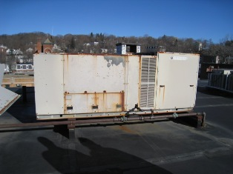

Original Air Handling Unit (AHU) for DMH

Picture 2

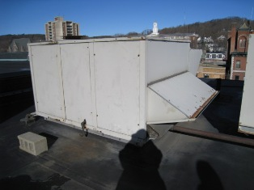

Third Floor AHU, Now Servicing DMH (Second Floor)
Picture 3

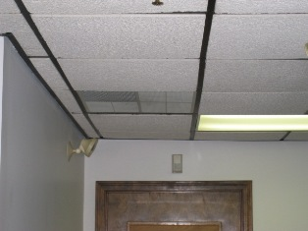

Fresh Air is Supplied Through Ducted Air Diffusers

Picture 4

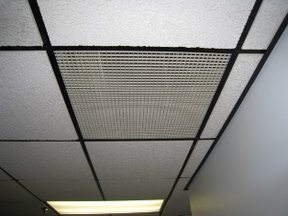

Plenum Exhaust System
Picture 5

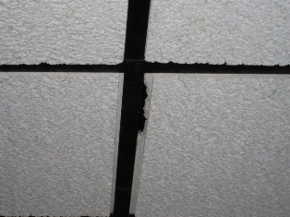

Ceiling Tile in Disrepair

Picture 6

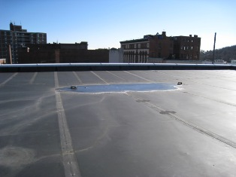

Standing Water on Roof
Picture 7

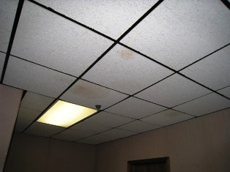

Numerous Buckled and Water Damaged Ceiling
Tiles in Exterior Hallway
Picture 8

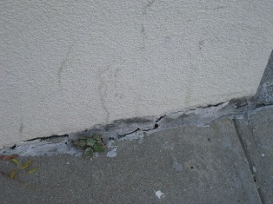

Deteriorated Sealant on Exterior of DMH
Note Plant Growth
Picture 9

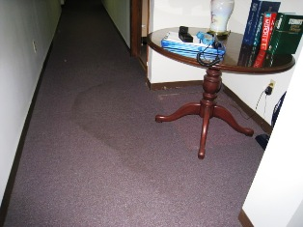

Stained Carpet Due to Chronic Leak
Picture 10

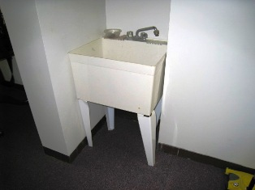

Utility Sink Located Over Carpet

Picture 11

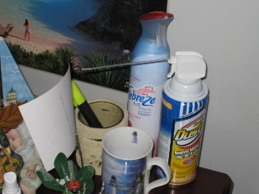

Air Freshener

Picture 12

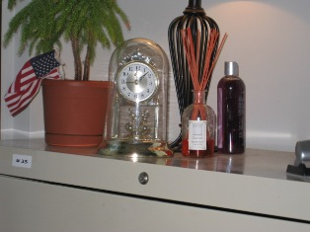

Reed Diffuser
Picture 13



Numerous Items Stored on Flat Surfaces

Picture 14

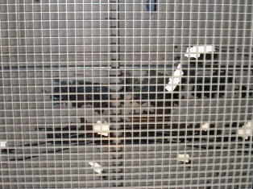

Fallen Debris From Ceiling Above Exhaust Grate
Picture 15

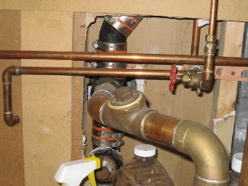

Large Penetration Into the Framing of the Building

Picture 16

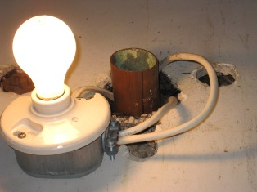

Open Utility Holes
Picture 17

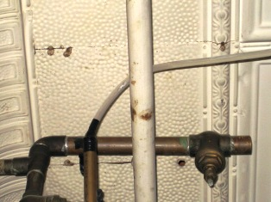

Connection of Condensation Line to Sewer Line
- Location | Occupants  in Room | Carbon  Dioxide  (ppm) | Temp  (°F) | Relative  Humidity  (%) | Carbon Monoxide  (ppm) | PM2.5  (µg/m3) | Windows  Openable | Ventilation |  | Remarks
 |  |  |  |  |  |  |  | Supply | Exhaust | Remarks
Outside  (Background) | - | 425 | 32 | 9 | ND | 3 | - | - | -
Mr. Broderick | 1 | 959 | 67 | 22 | ND | 2 | N | Y | N | DO
Women’s Room | 0 | 593 | 66 | 17 | ND | 1 | N | Y | Y | DC
Conference Room | 0 | 691 | 66 | 19 | ND | 2 | N | Y | N | DO, Carpet
Men’s Room | 0 | 658 | 67 | 19 | ND | 2 | N | Y | Y | DC
Kitchen | 1 | 659 | 68 | 18 | ND | 2 | N | Y | Y | DO
Room 7 | 3 | 1090 | 67 | 20 | ND | 2 | N | Y | N | DO
Room 8 | 0 | 796 | 67 | 18 | ND | 1 | N | Y | N | DO
Room 9 | 0 | 634 | 68 | 17 | ND | 1 | N | Y | N | DO, DEM
Room 10 | 0 | 662 | 70 | 19 | ND | 1 | N | Y | N | DO, AD, Plants, Clutter
Room 11 | 0 | 730 | 71 | 17 | ND | 2 | N | Y | N | DO, AD
Room 12 | 0 | 690 | 71 | 16 | ND | 1 | N | Y | N | DO
Hallway (near room 12) | 0 | 699 | 72 | 16 | ND | 2 | N | N | Y | DO
Room 13 | 0 | 641 | 72 | 16 | ND | 2 | N | Y | N | DO
Room 14 | 2 | 750 | 75 | 16 | ND | 1 | N | Y | N | DO, FC, PF, Plants
Room 15 | 0 | 730 | 75 | 15 | ND | 2 | N | Y | N | DO, DEM, FC
Room 16 | 0 | 742 | 74 | 15 | ND | 2 | N | Y | N | DO, PF, DEM, Plants
Room 17 | 0 | 855 | 73 | 16 | ND | 2 | N | Y | N | DO, DEM
Room 18 | 1 | 1106 | 73 | 20 | ND | 2 | N | Y | N | DC, Air Diffusers
Room 19 | 1 | 771 | 73 | 16 | ND | 2 | N | Y | N | DO, PF, Plants, Air Diffusers
Room 20 | 1 | 715 | 75 | 15 | ND | 2 | N | Y | N | DO, Plants
Large Conference Room | 0 | 821 | 74 | 16 | ND | 2 | N | Y | Y | DC, Debris in exhaust vent
Room 21 | 0 | 909 | 73 | 17 | ND | 2 | N | Y | N | DO, DEM
Room 22 | 1 | 953 | 74 | 16 | ND | 2 | N | Y | N | DO, PF
Copy Room | 0 | 671 | 73 | 15 | ND | 2 | N | Y | N | DO, 2 copiers
Room 24 | 0 | 733 | 72 | 15 | ND | 2 | N | Y | N | DO
Room 25 (Reception) | 3 | 876 | 72 | 15 | ND | 2 | N | Y | N | DO, AD
Waiting Area | 0 | 753 | 72 | 15 | ND | 2 | N | Y | N | DC
File Room | 0 | 841 | 71 | 21 | ND | 2 | N | Y | N | DC
Server Room | 0 | 657 | 63 | 29 | ND | 1 | N | Y | Y | DC
Hallway (ext) | 0 | 457 | 66 | 15 | ND | 6 | N | N | N | DO

