WATER DAMAGE ASSESSMENT
Massachusetts Department of Mental Health
North County Services Site
515 Main Street
Fitchburg, Massachusetts 01420
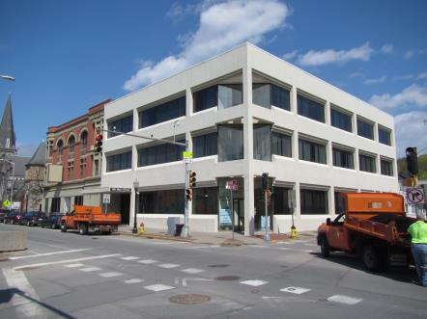
Prepared by:
Massachusetts Department of Public Health
Bureau of Environmental Health
Indoor Air Quality Program
June 2017

Executive Summary
Removal of carpet from basement stairs and landing as well as wallpaper and baseboard above the basement landing is recommended.
Background
Building:  Address: | Massachusetts Department of Mental Health (DMH)  515 Main Street  Fitchburg, Massachusetts 01420
Assessment Requested by: | Cory Thomas, Field Operations, Executive Office of Health and Human Services (EOHHS)
Reason for Request: | Water damage concerns and general indoor air quality (IAQ)
Date of Assessment: | April 28, 2017
Massachusetts Department of Public Health/Bureau of Environmental Health (MDPH/BEH) Staff Conducting Assessment: | Mike Feeney, Director, IAQ Program
Building Description: | The DMH office is located in a three story, brick building built in the late 1800s. DMH occupies the entire second floor. The DMH areas were substantially renovated in 1985. Subsequent renovations took place in 2006, which included the rearranging of partition walls and the installation of new carpet.
Windows: | There are no openable windows in the space.

Methods
Please refer to the IAQ Manual and appendices for methods, sampling procedures, and interpretation of results (MDPH, 2015).

Results and Discussion
Upon entering the front door of the building, a musty odor was detected. This odor was also detected in the first and second floor hallways as well as the connecting hallway. The source of the odor appears to be the stairwell leading to the basement and its landing. IAQ staff examined the basement level to identify a source of this musty odor. IAQ staff found the wallpaper, wooden baseboard (Picture 1) and the carpeting on the basement landing and stairs to be water-damaged and/or moistened.
In order for building materials to support mold growth, a source of water exposure is necessary. Two possible sources of moisture exist that could have caused this water damage:
- As reported by the building’s owner, the adjacent building experienced a flood due to sprinkler activation. It is possible that water from this flood penetrated through the adjacent walls to moisten these materials.
- A second possible source is condensation. As reported by the building owner, the basement stairs are stone. Given when the building was constructed, in the late 1800’s, it is unlikely that the basement floor has either a vapor barrier or insulation. In this situation, the temperature of the basement floor would be the same as the ground it is in contact with. BEH staff measured the surface temperature of the basement landing and the stairs which ranged from 43°F to 48°F. Because the dew point of the air at the basement floor landing was calculated to be 43°F, condensation would be occurring on the stairs which would moisten the carpeting.
The US Environmental Protection Agency (US EPA) and the American Conference of Governmental Industrial Hygienists (ACGIH) recommends that porous materials (e.g., wallboard, carpeting, ceiling tiles) be dried with fans and heating within 24 to 48 hours of becoming wet (US EPA, 2008; ACGIH, 1989). If porous materials are not dried within this time frame, mold growth may occur. Once mold has colonized porous materials, they are difficult to clean and should be removed. As shown above, it is very likely that carpeting on the stairs, as well as wood coving, wallpaper and other porous materials in this area are mold-colonized, resulting in the odor detected.

Conclusions and Recommendations
In view of the findings at the time of the visit, the following recommendations are made:
- Remove carpeting from the basement stairs and landing a manner consistent with US EPA “Mold Remediation in Schools and Commercial Buildings” (US EPA, 2008). This work should be performed when the building is unoccupied.
- Remove the baseboard and wallpaper directly above the basement stair landing. Wallpaper should be removed to at least a height of three feet above the landing floor. Examine wallpaper higher than the three-foot level above the stairwell landing for water damage/mold and odors and remove as needed.
- It is recommended that no carpeting be reinstalled in the basement stairs and the landing due to the likelihood of chronic moistening of these materials. In addition consider avoiding coving and wallpaper at all in this area to allow for more rapid drying.
- Refer to resource manual and other related IAQ documents located on the MDPH’s website for further building-wide evaluations and advice on maintaining public buildings. These documents are available at http://mass.gov/dph/iaq.
REFERENCES
ACGIH. 1989. Guidelines for the Assessment of Bioaerosols in the Indoor Environment. American Conference of Governmental Industrial Hygienists, Cincinnati, OH.
MDPH. 2015. Massachusetts Department of Public Health. Massachusetts Department of Public Health Indoor Air Quality Manual: Chapters I-III. Available at: http://www.mass.gov/eohhs/gov/departments/dph/programs/environmental-health/exposure-topics/iaq/iaq-manual/.
US EPA. 2008. “Mold Remediation in Schools and Commercial Buildings”. Office of Air and Radiation, Indoor Environments Division, Washington, DC. EPA 402-K-01-001. September 2008. Available at: http://www.epa.gov/mold/mold-remediation-schools-and-commercial-buildings-guide.

Picture 1

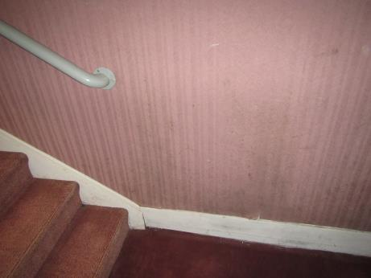

Carpet, wallpaper and wood baseboard; note wallpaper discoloration/peeling

