WATER DAMAGE/REMEDIATION ASSESSMENT

Department of Mental Health
167 Lyman Street
Westborough, Massachusetts

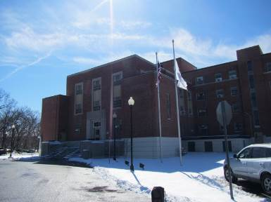

Prepared by:
Massachusetts Department of Public Health
Bureau of Environmental Health
Indoor Air Quality Program
April 2016

BACKGROUND
Building: | Hadley Building
Address: | 167 Lyman Street, Westborough, MA
Assessment Requested by: | Todd Gundlach, Director, Engineering & Facilities Management, Department of Mental Health (DMH)
Reason for Request: | Water damage/remediation
Date of Assessment: | April 5, 2016
Massachusetts Department of Public Health/Bureau of Environmental Health (MDPH/BEH) Staff Conducting Assessment: | Cory Holmes, Environmental Analyst/Inspector, Indoor Air Quality (IAQ) Program
Date of Building Construction: | 1945-1947
Building Description: | A multi-story, brick-faced building with basement. Formerly served as the Westborough State Hospital, converted to DMH office space in 2009.
Building Population: | The affected areas have an employee population of approximately 25.
Windows: | Openable

METHODS
Please refer to the IAQ Manual and appendices for methods, sampling procedures, and interpretation of results (MDPH, 2015).

RESULTS and DISCUSSION
As reported by Mr. Gundlach, during the extreme cold weather in February 2016, heating pipes had frozen and burst on the 2nd floor of the Hadley Building in area 223-C, which resulted in flooding and water damage to building materials directly below. Water-damaged materials included the gypsum wallboard (GW) ceiling and carpeting, primarily in area 124. Once discovered, the water was shut off and the pipes repaired (Pictures 1 and 2). Occupants were relocated and all materials/furniture was reportedly moved in order to conduct remediation efforts.

Microbial/Moisture Concerns
In order for building materials to support mold growth, a source of water exposure is necessary. The US Environmental Protection Agency (US EPA) and the American Conference of Governmental Industrial Hygienists (ACGIH) recommends that porous materials (e.g., wallboard, carpeting) be dried with fans and heating within 24 to 48 hours of becoming wet (US EPA, 2008; ACGIH, 1989). If porous materials are not dried within this time frame, mold growth may occur. At the time of the BEH/IAQ assessment, remediation had been completed and consisted of replacing the damaged GW ceiling and carpeting in room 124 (Pictures 3 and 4). Carpeting in the adjacent hallway was reportedly shampooed and dried.
BEH/IAQ staff performed moisture testing of GW and carpeting in the affected areas, as well as adjacent areas for comparison to determine if porous materials were properly dried. In addition, a visual inspection of building materials for any residual water damage and/or microbial growth was conducted. All tested materials were dry at the time of assessment and no residual water damage, mold growth or associated odors were observed/detected (Table 1). It should also be noted that in many areas walls consist of glazed block, which are water impermeable/mold resistant (Picture 5).

CONCLUSIONS and RECOMMENDATIONS
In view of the findings at the time of the visit, the area appeared to be properly remediated, fit for re-occupancy with no additional recommendations.

REFERENCES
ACGIH. 1989. Guidelines for the Assessment of Bioaerosols in the Indoor Environment. American Conference of Governmental Industrial Hygienists, Cincinnati, OH.
MDPH. 2015. Massachusetts Department of Public Health. Indoor Air Quality Manual: Chapters I-III. Available at: http://www.mass.gov/eohhs/gov/departments/dph/programs/environmental-health/exposure-topics/iaq/iaq-manual/.
US EPA. 2008. Mold Remediation in Schools and Commercial Buildings. US Environmental Protection Agency, Office of Air and Radiation, Indoor Environments Division, Washington, D.C. EPA 402-K-01-001. http://www.epa.gov/mold/mold-remediation-schools-and-commercial-buildings-guide.

Picture 1

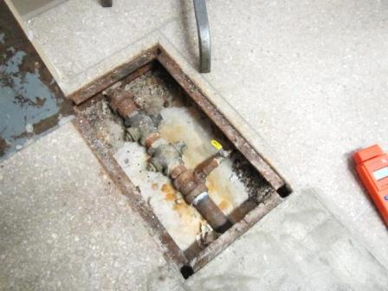

Area of pipe burst in Room 223-C, note several plumbing components have been replaced

Picture 2

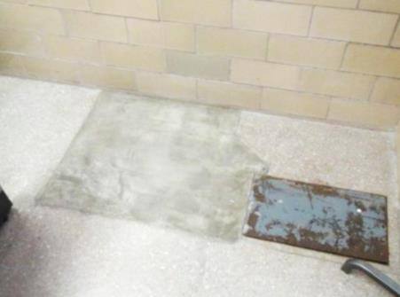

Area of pipe burst in Room 223-C, note concrete patch

Picture 3

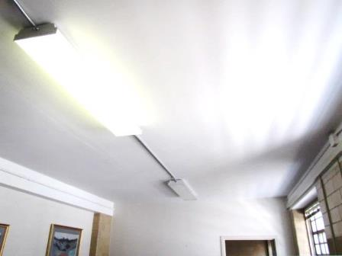

Replaced gypsum wallboard Ceiling in Room 124

Picture 4

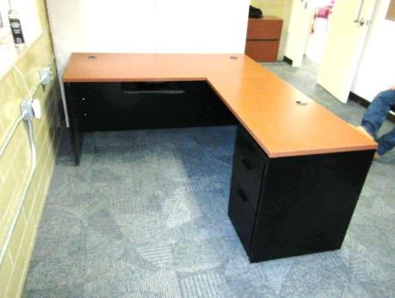

Newly installed carpet squares in Room 124
Picture 5

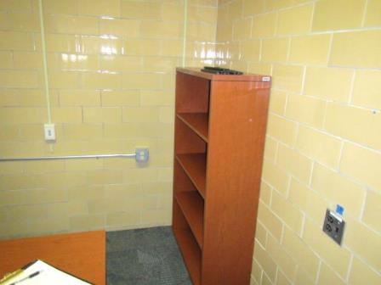

Glazed block walls

Location | Moisture testing |  | Remarks
124 |  | Carpet-replaced (carpet squares)  Ceiling gypsum wallboard-replaced  Gypsum wallboard-normal (i.e., dry) |  | Affected area directly below leak
Hallway adjacent to 124 |  | Gypsum wallboard-normal (i.e., dry)  Carpet-normal (i.e., dry)
Library |  | Carpet-normal (i.e., dry)
126 |  | Gypsum wallboard-normal (i.e., dry)  Carpet-normal (i.e., dry)
223-C |  | Cloth divider/work station- normal (i.e., dry) |  | Area of leak/pipe burst-repaired
Hallway adjacent to 223-C |  | Gypsum wallboard-normal (i.e., dry)  Carpet-normal (i.e., dry)

