INDOOR AIR QUALITY ASSESSMENT

Department of Public Health
Bureau of Health Professions Licensure
239 Causeway Street
Boston, Massachusetts

Prepared by:
Massachusetts Department of Public Health
Bureau of Environmental Health
Indoor Air Quality Program
February 2017

Background
Building: | Department of Public Health (DPH)  Bureau of Health Professions Licensure (BHPL)
Address: | 239 Causeway Street, Boston, MA, 5th floor
Assessment Requested by: | Kyle Marshall, DPH
Reason for Request: | Follow-up after a construction-related incident
Date of Assessment: | January 20, 2017
Massachusetts Department of Public Health/Bureau of Environmental Health (MDPH/BEH) Staff Conducting Assessment: | Ruth Alfasso, Environmental Engineer/Inspector, Indoor Air Quality (IAQ) Program
Building/Site Description: | Five-story brick building located near North Station.
Building Population: | 20 people in areas assessed.
Windows: | Not openable

Methods
Please refer to the IAQ Manual for methods, sampling procedures, and interpretation of results (MDPH, 2015).

Background and IAQ Testing Results
This visit concentrated on an area of concern that was impacted by a construction accident from the building next door. At approximately 7:30 pm on December 29, 2016, a wall segment several feel long fell from the building under construction onto the roof and wall of 239 Causeway Street. This dislodged some ceiling tiles and dust/debris into the space. The affected area, a bank of offices along the impacted wall, was kept free of occupants while the structural integrity was examined and was determined to be safe. On December 30, 2016 the BEH/IAQ program made a visit to this area to assess what additional immediate actions needed to be taken prior to re-occupancy by staff. IAQ staff examined the areas of concern and noted no water damage or obvious breaches in the building envelope. Dust and debris were present on the floor and many surfaces. However, particulate concentrations measured in the air were below MDPH guidelines. BEH/IAQ staff recommended thorough cleaning using wet wiping and HEPA-equipped vacuuming to remove dust and debris without reaerosolizing.
The current visit was conducted just in the impacted area. The following is a summary of indoor air testing results (Table 1).
- Carbon dioxide levels were above 800 parts per million (ppm) in all areas assessed, indicating that more fresh air could be supplied for the occupancy of the space.
- Temperature was within the recommended range of 70°F to 78°F in all areas assessed.
- Relative humidity was below the recommended range of 40% to 60% in all areas assessed.
- Carbon monoxide levels were non-detectable in all indoor areas assessed.
- Fine particulate matter (PM2.5) concentrations measured were below the National Ambient Air Quality Standard (NAAQS) level of 35 μg/m³ in all areas assessed.

Ventilation
A heating, ventilating, and air conditioning (HVAC) system has several functions. First, it provides heating and, if equipped, cooling. Second, it is a source of fresh air. Finally, an HVAC system will dilute and remove normally occurring indoor environmental pollutants by not only introducing fresh air, but also filtering the airstream and ejecting stale air to the outdoors via exhaust ventilation. Even if an HVAC system is operating as designed, point sources of respiratory irritation may exist and affect symptoms in sensitive individuals. The following analysis examines and identifies components of the HVAC system and likely sources of respiratory irritant/allergen exposure due to water damage, aerosolized dust, and/or chemicals found in the indoor environment.
Fresh air is provided by air handling units (AHUs). Air from the AHUs is filtered, heated/cooled, and delivered to rooms via ducted supply vents. Air is returned/exhausted through ducted return vents. Note that a thermostat observed in one office was set to the “auto” position instead of the “on” positon (Picture 1). This means that the air circulation is only on whenever the system calls for temperature adjustment rather than continuously. It is preferred that thermostats be set to “on” during occupied periods to provide circulation. It is recommended that HVAC systems be re-balanced every five years to ensure adequate air systems function (SMACNA, 1994).

Microbial/Moisture Concerns
No signs of water infiltration or water-damaged building materials were observed in the area of concern, suggesting that the incident did not cause breaches in the building envelope. If window/wall leaks occur, they should be reported to building management promptly.
Plants were observed in office areas (Table 1). Plants can be a source of pollen and mold, which can be respiratory irritants to some individuals. Plants should be properly maintained and equipped with drip pans to prevent water damage to porous materials. Plants should also be located away from air diffusers to prevent the aerosolization of dirt, pollen, and mold.
Small refrigerators were observed in carpeted areas (Table 1). These appliances may spill or leak and lead to carpet damage and microbial growth. It is recommended that these appliances be located in areas without carpeting or on waterproof mats.

Other IAQ Evaluations
Occupants reported that some cleaning had been performed by the building management following the incident, and additional cleaning was performed by office occupants when they returned. In some areas, additional debris was observed on carpeting (Picture 2). Additional vacuuming with a HEPA-filter equipped vacuum should be conducted, preferably at a time when occupants have had a chance to remove any items from the floor to allow for more thorough cleaning.
Ceiling tiles were missing or ajar in some of the offices (Pictures 3 and 4). Even though ventilation is provided through ducted supply and return vents, an intact ceiling plenum can reduce sources of dust and debris to occupied areas. Tiles should be intact and flush with the ceiling tile grid.
Exposure to low levels of total volatile organic compounds (TVOCs) may produce eye, nose, throat, and/or respiratory irritation in some sensitive individuals. BEH/IAQ staff examined rooms for products containing VOCs. BEH/IAQ staff noted cleaners, air freshener products, and dry erase materials in use within the building (Table 1). All of these products have the potential to be irritants to the eyes, nose, throat, and respiratory system of sensitive individuals.

Conclusions/Recommendations
Based on observations at the time of assessment, the following is recommended:
- Operate supply and exhaust ventilation in all areas during occupied periods including setting thermostats to the “on” setting.
- Have the HVAC system balanced every 5 years in accordance with SMACNA recommendations (SMACNA, 1994).
- Ensure filters are changed in all AHU units a minimum of twice a year. A log should be kept of filter changes to ensure this occurs. Filters with a MERV value of 8 or higher that properly fit the AHUs should be used.
- For buildings in New England, periods of low relative humidity during the winter are often unavoidable. Therefore, scrupulous cleaning practices should be adopted to minimize common indoor air contaminants whose irritant effects can be enhanced when the relative humidity is low. To control for dusts, a high efficiency particulate arrestance (HEPA) filter equipped vacuum cleaner in conjunction with wet wiping of all surfaces is recommended. Avoid the use of feather dusters. Drinking water during the day can help ease some symptoms associated with a dry environment (throat and sinus irritations).
- Use a reporting system to ensure that any water damage/leaking is reported to building management promptly.
- Keep indoor plants in good condition, avoid overwatering, and avoid placing them on porous items such as carpets or paper. Also, keep plants out of the air stream of supply vents.
- Consider locating refrigerators and water dispensers in non-carpeted areas or place on a waterproof mat. Clean refrigerator spills promptly and clean refrigerators out regularly to avoid odors and microbial growth.
- Have all floors impacted by the damage re-vacuumed using a HEPA-filter equipped vacuum.
- Replace/repair all missing and ajar ceiling tiles so they fit flush in the ceiling tile system.
- Reduce use of products containing VOCs.
- Reduce accumulated materials on flat surfaces and move periodically to allow for thorough cleaning.
- Clean carpeting in accordance with IICRC recommendations (IICRC, 2012).
- Refer to resource manual and other related IAQ documents located on the MDPH’s website for further building-wide evaluations and advice on maintaining public buildings. These documents are available at: http://mass.gov/dph/iaq.

References
IICRC. 2012. Institute of Inspection, Cleaning and Restoration Certification. Carpet Cleaning: FAQ. Retrieved from http://www.iicrc.org/consumers/care/carpet-cleaning.
MDPH. 2015. Massachusetts Department of Public Health. Indoor Air Quality Manual: Chapters I-III. Available at: http://www.mass.gov/eohhs/gov/departments/dph/programs/environmental-health/exposure-topics/iaq/iaq-manual/.
SMACNA. 1994. HVAC Systems Commissioning Manual. 1st ed. Sheet Metal and Air Conditioning Contractors’ National Association, Inc., Chantilly, VA.

Picture 1
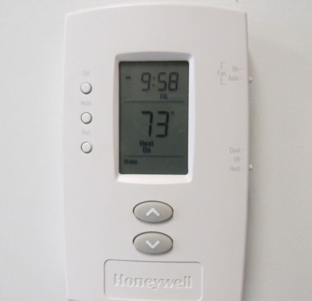
Thermostat set to “auto” (arrow)
Picture 2
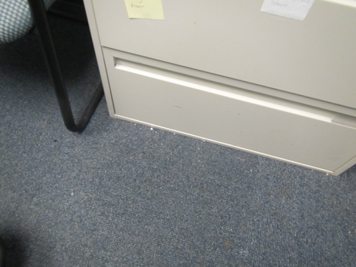
Debris on carpet
Picture 3
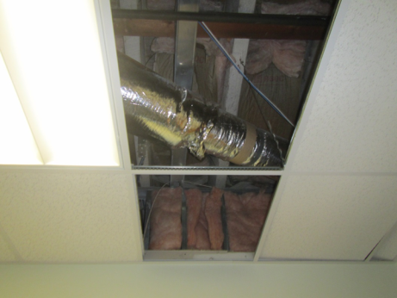
Missing ceiling tiles
Picture 4
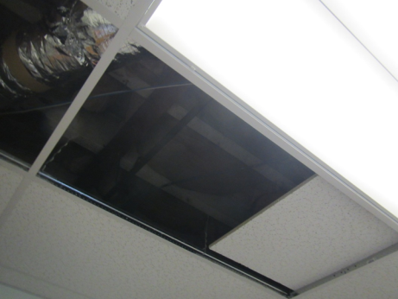
Missing/ajar ceiling tiles
Location | Carbon  Dioxide  (ppm) | Carbon Monoxide  (ppm) | Temp  (°F) | Relative  Humidity  (%) | PM2.5  (µg/m³) | Occupants  in Room | Windows  Openable | Ventilation |  | Remarks
 |  |  |  |  |  |  |  | Supply | Exhaust
Background | 438 | 1.5 | 58 | 23 | 23 |  |  |  |  | Street level, traffic, construction
Carruthers | 939 | ND | 72 | 32 | 10 | 1 | N | Y | Y | Cleaning products
Cube area in front of offices | 961 | ND | 73 | 31 | 9 | 0 | N | Y | N | Reports that fluorescent lights were hanging off ceiling tile grid
Side cube area near windows | 848 | ND | 73 | 29 | 10 | 2 | N | Y | Y | Debris on carpet
513 | 884 | ND | 72 | 30 | 10 | 1 | N | Y | Y | Ajar ceiling tiles, dry erase materials, cleaning products, fridge on carpet
514 | 877 | ND | 72 | 31 | 9 | 2 | N | Y | Y | Missing ceiling tile
515 | 903 | ND | 72 | 30 | 9 | 0 | N | Y | Y | Boxes on floor, dry erase materials
518 | 808 | ND | 72 | 31 | 9 | 0 | N | Y | Y | Plants
519 | 885 | ND | 70 | 34 | 11 | 0 | N | Y | Y | Plants

